Minna — 14-Day Forecast
DNMN · issued 8 Nov 26 00:44Z
Sources: DWD ICON ▲ 1.1
▲ better than the pool · ▽ worse (only when the 95% interval excludes the pool) · ≈ not distinguishable from the pool · unmarked = unproven (accuracy is measured against METAR and SYNOP observations)
Day | 00 | 01 | 02 | 03 | 04 | 05 | 06 | 07 | 08 | 09 | 10 | 11 | 12 | 13 | 14 | 15 | 16 | 17 | 18 | 19 | 20 | 21 | 22 | 23 | Flyable Windows | Conf
Sun 8 Nov 26 | · | · | · | · | · | · | · | · | · | · | · | · | · | · | · | · | · | · | E | · | · | · | · | G | no windows | 53%
Mon 9 Nov 26 | · | · | · | · | · | · | · | · | · | · | F | E | E | E | E | · | · | · | · | · | G | · | G | G | no windows | 55%
Tue 10 Nov 26 | F | · | · | · | G | · | · | · | · | G | G | G | G | G | F | · | G | G | G | G | G | G | G | G | no windows | 55%
Wed 11 Nov 26 | · | G | G | G | G | G | G | G | G | G | F | E | · | · | · | · | · | E | G | G | G | · | · | · | no windows | 55%
Thu 12 Nov 26 | E | G | G | G | G | G | G | G | G | G | G | G | G | G | G | G | G | G | G | G | · | · | · | E | no windows | 55%
Fri 13 Nov 26 | G | G | G | G | G | G | F | · | · | · | · | · | · | · | · | · | · | · | · | · | · | · | · | · | no windows | 55%
Sat 14 Nov 26 | · | · | · | · | · | · | · | · | · | · | · | · | · | · | · | · | · | · | · | · | · | · | · | · | no windows | 55%
Sun 15 Nov 26 | · | · | · | · | · | · | · | · | · | · | · | · | · | · | · | · | · | · | · | · | · | · | · | · | no windows | 2%
A Excellent · B Good · C Fair · D Marginal · E Poor · F Very Poor · G Unacceptable · · No data
Learned corrections (METAR-verified): skill weighting — pooled all-field scores for 206; bias corrections — meteoblue temperature +3.0 °C, meteoblue QNH −3.0 hPa, openmeteo temperature +3.0 °C, openmeteo dewpoint +3.0 °C, metno temperature +3.0 °C, metno dewpoint +3.0 °C (+67 more); hour-of-day bias (local time, shrunk toward the all-hours bias) — aifs afternoon wind +3.6 kt, metcheck afternoon wind +3.2 kt, meteoblue night temperature +3.0 °C, meteoblue morning temperature +3.0 °C, meteoblue afternoon temperature +3.0 °C, meteoblue evening temperature +3.0 °C (+284 more); cloud base estimated as 410 ft per °C of dewpoint spread for sources that report no ceiling (≥60% cloud cover; flagged estimated, weighted ×0.5); probability calibration — rain chance: meteoblue, openmeteo, foreca, metcheck, openweather, visualcrossing, tomorrowio, wttrin, ecmwf, gfs, DWD ICON, ukmo, gem, ecmwfens; storm: openmeteo, metno, foreca, openweather, visualcrossing, tomorrowio, wttrin, ecmwf, gfs, DWD ICON, meteofrance, aviationweather, ukmo, jma, gem, ecmwfens, aifs (each source's stated probability mapped to its verified frequency by an isotonic fit on ≥200 pairs, proven on the holdout); fog risk (n=1050): observed fog frequency by dewpoint spread, wind, local hour and season for the forecast conditions (shown from 10 %), proven on the holdout; plausibility bounds from ERA5 climatology 2016-2025 (mean ± 5 sd; screening only, not observed truth); skill blend 1 auto-tuned over 9526 holdout pairs (consensus beat the best single source, DWD ICON, by 14%); correction gates (newest-7-day holdout; pooled skill is always on) — regional skill: off this week (did not improve holdout); place skill: off this week (did not improve holdout); lead-time skill: off this week (did not improve holdout); small-sample skill shrinkage: off this week (did not improve holdout); bias correction: on (improved holdout by 26.2%); place bias: on (improved holdout by 10.2%); hour-of-day bias: on (improved holdout by 7.1%); QNH bias: on (improved holdout by 57.3%); gust estimates: off this week (did not improve holdout); cloud-base coefficient: off this week (insufficient holdout: 96 of 200 items); recent-form skill: off this week (did not improve holdout); probability calibration: on (improved holdout by 43.1%); nowcast anchor horizon: off this week (did not improve holdout); dust-visibility estimate: off this week (did not improve holdout); fog risk: on (improved holdout by 6.4%).

Outlook
Day | Date | Outlook | Temp | Max wind | Flight windows | Confidence | Notes
(a) | (b) | (c) | (d) | (e) | (f) | (g) | (h)
Sun | 8 Nov 26 | Poor | 21–35°C | 7 kts SW, g 11 | none | 53%
Mon | 9 Nov 26 | Poor | 23–34°C | 5 kts WSW, g 8 | none | 55%
Tue | 10 Nov 26 | Unacceptable | 23–35°C | 7 kts ENE, g 10 | none | 55%
Wed | 11 Nov 26 | Unacceptable | 23–35°C | 7 kts E, g 10 | none | 55%
Thu | 12 Nov 26 | Unacceptable | 18–34°C | 5 kts SSW, g 8 | none | 55%
Fri | 13 Nov 26 | Unacceptable | 19–34°C | 6 kts SSW, g 9 | none | 55%
Sat | 14 Nov 26 | – | 19–34°C | 7 kts SSE, g 11 | none | 55%
Sun | 15 Nov 26 | – | 24–24°C | 4 kts NE, g 5 | none | 2%

Today — Sun 8 Nov 26
Conditions are expected to be generally Poor: mostly clear, winds up to 7 kts SW and temperatures 21–35°C. No flyable windows (Marginal or better, ≥2 consecutive hrs) are forecast. Hazards: thunderstorm risk 0100–2300L.
WEATHER EFFECTS
 | 00–06L | 06–12L | 12–18L | 18–24L
Wind | B | D | D | B
Visibility | · | · | · | ·
Cloud / ceiling | A | B | B | G
Precipitation | A | A | A | A
Thunderstorm | D | D | D | D
Fog | A | A | · | ·
A Excellent · B Good · C Fair · D Marginal (flyable) · E Poor · F Very Poor · G Unacceptable · (worst condition in each period)
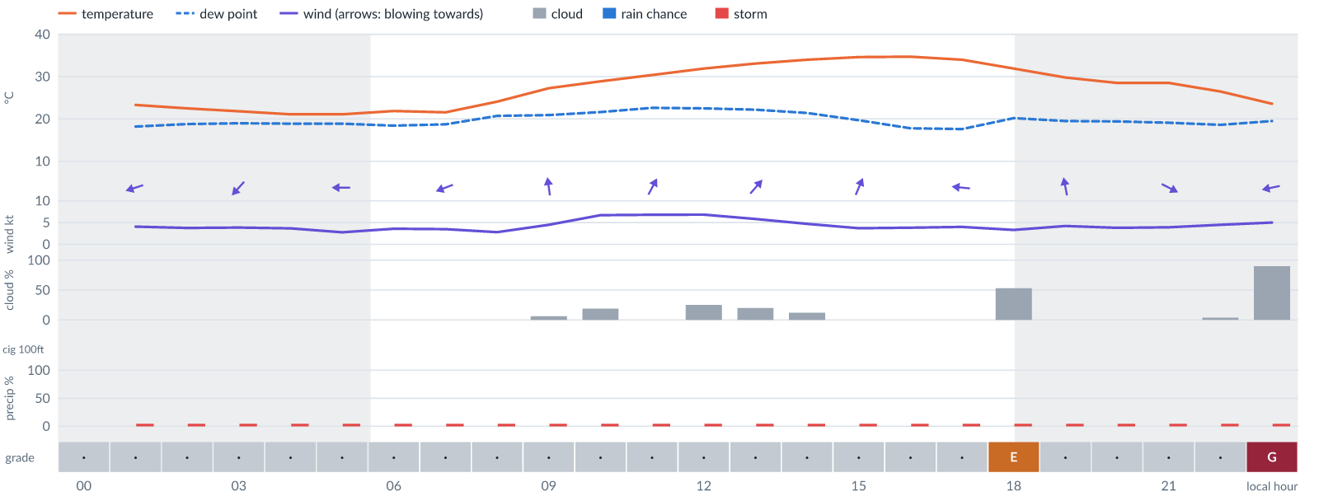
Meteogram — hourly forecast; shaded = before first light / after last light. Gaps mean no data.
Ser | Hrs | Temp | Cloud | Wind | Gust | QNH | Assessment | Driver | Remarks
(a) | (b) | (c) | (d) | (e) | (f) | (g) | (h) | (i) | (j)
1. | 0001 | - | No data | - | - | - | · - No data | cloud, visibility, wind not forecast
2. | 0100 | 23°C | ☀ Clear (0%) | ← 4 kts ENE | 5 kts | 1014 | · - No data | storm 5% · visibility not forecast | ⚠ thunderstorm risk
3. | 0200 | 22°C | ☀ Clear (0%) | ↙ 4 kts ENE | 5 kts | 1013 | · - No data | storm 5% · visibility not forecast | ⚠ thunderstorm risk
4. | 0300 | 22°C | ☀ Clear (0%) | ↙ 4 kts NE | 5 kts | 1013 | · - No data | storm 5% · visibility not forecast | ⚠ thunderstorm risk
5. | 0400 | 21°C | ☀ Clear (0%) | ↙ 4 kts NE | 5 kts | 1012 | · - No data | storm 5% · visibility not forecast | ⚠ thunderstorm risk
6. | 0500 | 21°C | ☀ Clear (0%) | ← 3 kts E | 4 kts | 1013 | · - No data | storm 5% · visibility not forecast | ⚠ thunderstorm risk, fog risk 16 % at dawn
7. | 0600 | 22°C | ☀ Clear (0%) | ↙ 4 kts ENE | 3 kts | 1013 | · - No data | storm 5% · visibility not forecast | ⚠ thunderstorm risk, fog risk 16 % at dawn
8. | 0700 | 22°C | ☀ Clear (0%) | ← 3 kts ENE | 4 kts | 1014 | · - No data | storm 5% · visibility not forecast | ⚠ thunderstorm risk, fog risk 16 % at dawn
9. | 0800 | 24°C | ☀ Clear (0%) | ← 3 kts E | 3 kts | 1015 | · - No data | storm 5% · visibility not forecast | ⚠ thunderstorm risk
10. | 0900 | 27°C | ☀ Clear (6%) | ↑ 4 kts S | 6 kts | 1017 | · - No data | storm 5% · visibility not forecast | ⚠ thunderstorm risk
11. | 1000 | 29°C | ◔ Mostly clear (19%) | ↑ 7 kts SSW | 11 kts | 1018 | · - No data | storm 5% · gust 11 kt · visibility not forecast | ⚠ thunderstorm risk, gusts
12. | 1100 | 30°C | ☀ Clear (0%) | ↗ 7 kts SSW | 11 kts | 1018 | · - No data | storm 5% · CAPE 1690 J/kg · visibility not forecast | ⚠ thunderstorm risk, convective energy, gusts
13. | 1200 | 32°C | ◔ Mostly clear (25%) | ↗ 7 kts SW | 11 kts | 1017 | · - No data | storm 5% · CAPE 1820 J/kg · visibility not forecast | ⚠ thunderstorm risk, convective energy, gusts
14. | 1300 | 33°C | ◔ Mostly clear (20%) | ↗ 6 kts SW | 10 kts | 1016 | · - No data | storm 5% · CAPE 1850 J/kg · visibility not forecast | ⚠ thunderstorm risk, convective energy, gusts
15. | 1400 | 34°C | ☀ Clear (12%) | ↗ 5 kts SW | 9 kts | 1015 | · - No data | storm 5% · CAPE 1660 J/kg · visibility not forecast | ⚠ thunderstorm risk, convective energy, gusts
16. | 1500 | 35°C | ☀ Clear (0%) | ↗ 4 kts SSW | 7 kts | 1014 | · - No data | storm 5% · visibility not forecast | ⚠ thunderstorm risk
17. | 1600 | 35°C | ☀ Clear (0%) | ↖ 4 kts ESE | 5 kts | 1014 | · - No data | storm 5% · visibility not forecast | ⚠ thunderstorm risk
18. | 1700 | 34°C | ☀ Clear (0%) | ← 4 kts E | 4 kts | 1014 | · - No data | storm 5% · visibility not forecast | ⚠ thunderstorm risk
19. | 1800 | 32°C | ◑ Partly cloudy (53%) | ↖ 3 kts ESE | 4 kts | 1014 | E - Poor | cloud 53% · visibility not forecast | ⚠ cloud cover, thunderstorm risk
20. | 1900 | 30°C | ☀ Clear (0%) | ↑ 4 kts S | 3 kts | 1014 | · - No data | storm 5% · visibility not forecast | ⚠ thunderstorm risk
21. | 2000 | 28°C | ☀ Clear (0%) | ↑ 4 kts S | 4 kts | 1015 | · - No data | storm 5% · visibility not forecast | ⚠ thunderstorm risk
22. | 2100 | 28°C | ☀ Clear (0%) | ↘ 4 kts WNW | 3 kts | 1015 | · - No data | storm 5% · visibility not forecast | ⚠ thunderstorm risk
23. | 2200 | 26°C | ☀ Clear (4%) | ↓ 5 kts N | 4 kts | 1015 | · - No data | storm 5% · visibility not forecast | ⚠ thunderstorm risk
24. | 2300 | 24°C | ☁ Overcast (90%) | ← 5 kts ENE | 5 kts | 1015 | G - Unacceptable | cloud 90% · visibility not forecast | ⚠ cloud cover, thunderstorm risk
Confidence: 53% — data for 23 of 24 hours · first light 0603L · last light 1831L · Moon 1 % illuminated, rises 05:33, sets 17:29.

Tomorrow — Mon 9 Nov 26
Conditions are expected to be generally Poor: partly cloudy, winds up to 5 kts WSW and temperatures 23–34°C. No flyable windows (Marginal or better, ≥2 consecutive hrs) are forecast. Hazards: thunderstorm risk 0001–2300L. Overall similar to the previous day.
WEATHER EFFECTS
 | 00–06L | 06–12L | 12–18L | 18–24L
Wind | C | C | C | B
Visibility | · | · | · | ·
Cloud / ceiling | C | F | D | G
Precipitation | A | A | A | A
Thunderstorm | D | D | E | D
Fog | A | A | · | ·
A Excellent · B Good · C Fair · D Marginal (flyable) · E Poor · F Very Poor · G Unacceptable · (worst condition in each period)
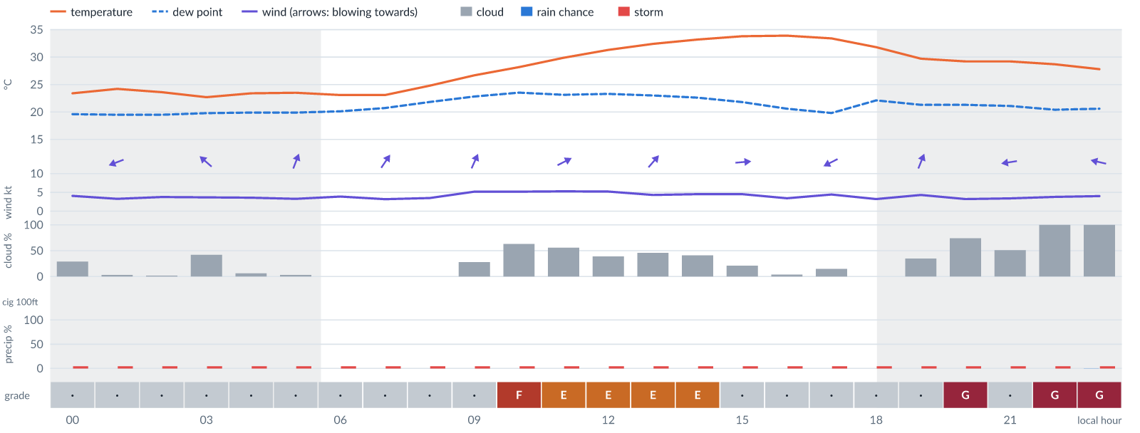
Meteogram — hourly forecast; shaded = before first light / after last light. Gaps mean no data.
Ser | Hrs | Temp | Cloud | Wind | Gust | QNH | Assessment | Driver | Remarks
(a) | (b) | (c) | (d) | (e) | (f) | (g) | (h) | (i) | (j)
1. | 0001 | 23°C | ◔ Mostly clear (29%) | ← 4 kts E | 6 kts | 1015 | · - No data | storm 5% · visibility not forecast | ⚠ thunderstorm risk
2. | 0100 | 24°C | ☀ Clear (3%) | ← 3 kts ENE | 5 kts | 1015 | · - No data | storm 5% · visibility not forecast | ⚠ thunderstorm risk
3. | 0200 | 24°C | ☀ Clear (2%) | ↙ 4 kts NE | 4 kts | 1015 | · - No data | storm 5% · visibility not forecast | ⚠ thunderstorm risk
4. | 0300 | 23°C | ◑ Partly cloudy (42%) | ↖ 4 kts SE | 4 kts | 1015 | · - No data | storm 5% · visibility not forecast | ⚠ thunderstorm risk
5. | 0400 | 23°C | ☀ Clear (6%) | ↖ 4 kts SSE | 6 kts | 1015 | · - No data | storm 5% · visibility not forecast | ⚠ thunderstorm risk
6. | 0500 | 23°C | ☀ Clear (3%) | ↑ 3 kts SSW | 4 kts | 1016 | · - No data | storm 5% · visibility not forecast | ⚠ thunderstorm risk, fog risk 16 % at dawn
7. | 0600 | 23°C | ☀ Clear (0%) | ↑ 4 kts S | 4 kts | 1016 | · - No data | storm 5% · visibility not forecast | ⚠ thunderstorm risk, fog risk 16 % at dawn
8. | 0700 | 23°C | ☀ Clear (0%) | ↗ 3 kts SW | 4 kts | 1017 | · - No data | storm 5% · visibility not forecast | ⚠ thunderstorm risk, fog risk 16 % at dawn
9. | 0800 | 25°C | ☀ Clear (0%) | ↑ 3 kts SSW | 4 kts | 1018 | · - No data | storm 5% · visibility not forecast | ⚠ thunderstorm risk
10. | 0900 | 27°C | ◔ Mostly clear (28%) | ↗ 5 kts SSW | 8 kts | 1019 | · - No data | storm 5% · CAPE 1190 J/kg · visibility not forecast | ⚠ thunderstorm risk, convective energy
11. | 1000 | 28°C | ◕ Cloudy (63%) | ↗ 5 kts SW | 8 kts | 1020 | F - Very Poor | cloud 63% · visibility not forecast | ⚠ cloud cover, thunderstorm risk, convective energy
12. | 1100 | 30°C | ◑ Partly cloudy (56%) | ↗ 5 kts WSW | 8 kts | 1020 | E - Poor | cloud 56% · visibility not forecast | ⚠ cloud cover, thunderstorm risk, convective energy
13. | 1200 | 31°C | ◑ Partly cloudy (39%) | ↗ 5 kts WSW | 8 kts | 1018 | E - Poor | CAPE 2200 J/kg · visibility not forecast | ⚠ convective energy, thunderstorm risk
14. | 1300 | 32°C | ◑ Partly cloudy (46%) | ↗ 4 kts SW | 8 kts | 1018 | E - Poor | CAPE 2350 J/kg · visibility not forecast | ⚠ convective energy, cloud cover, thunderstorm risk
15. | 1400 | 33°C | ◑ Partly cloudy (41%) | ↗ 5 kts WSW | 6 kts | 1017 | E - Poor | CAPE 2230 J/kg · visibility not forecast | ⚠ convective energy, thunderstorm risk
16. | 1500 | 34°C | ◔ Mostly clear (21%) | → 5 kts W | 6 kts | 1016 | · - No data | storm 5% · CAPE 1860 J/kg · visibility not forecast | ⚠ thunderstorm risk, convective energy
17. | 1600 | 34°C | ☀ Clear (4%) | ↘ 3 kts NW | 6 kts | 1015 | · - No data | storm 5% · CAPE 1110 J/kg · visibility not forecast | ⚠ thunderstorm risk, convective energy
18. | 1700 | 33°C | ◔ Mostly clear (15%) | ↙ 4 kts ENE | 5 kts | 1015 | · - No data | storm 5% · visibility not forecast | ⚠ thunderstorm risk
19. | 1800 | 32°C | ☀ Clear (0%) | ↑ 3 kts S | 5 kts | 1015 | · - No data | storm 5% · CAPE 1010 J/kg · visibility not forecast | ⚠ thunderstorm risk, convective energy
20. | 1900 | 30°C | ◔ Partly cloudy (35%) | ↑ 4 kts SSW | 4 kts | 1016 | · - No data | storm 5% · visibility not forecast | ⚠ thunderstorm risk
21. | 2000 | 29°C | ◕ Cloudy (74%) | ↑ 3 kts SSE | 4 kts | 1017 | G - Unacceptable | cloud 74% · visibility not forecast | ⚠ cloud cover, thunderstorm risk
22. | 2100 | 29°C | ◑ Partly cloudy (51%) | ← 3 kts E | 2 kts | 1018 | · - No data | storm 5% · cloud 51% · visibility not forecast | ⚠ cloud cover, thunderstorm risk
23. | 2200 | 29°C | ☁ Overcast (100%) | ← 4 kts E | 3 kts | 1018 | G - Unacceptable | cloud 100% · visibility not forecast | ⚠ cloud cover, thunderstorm risk
24. | 2300 | 28°C | ☁ Overcast (100%) | ← 4 kts ESE | 3 kts | 1018 | G - Unacceptable | cloud 100% · visibility not forecast | ⚠ cloud cover, thunderstorm risk
Confidence: 55% — data for 24 of 24 hours · first light 0604L · last light 1831L · Moon 0 % illuminated, rises 06:24, sets 18:14.

Extended Outlook
WEATHER EFFECTS BY DAY
 | Tue | Wed | Thu | Fri | Sat | Sun
Wind | D | D | C | D | D | B
Visibility | · | · | · | · | · | ·
Cloud / ceiling | G | G | G | G | A | A
Precipitation | A | A | A | A | A | A
Thunderstorm | E | D | D | D | D | D
Fog | A | A | A | A | A | ·
Overall | G | G | G | G | D | D
A Excellent · B Good · C Fair · D Marginal (flyable) · E Poor · F Very Poor · G Unacceptable · (worst condition in each period)

Tue 10 Nov 26
Conditions are expected to be generally Unacceptable: cloudy, winds up to 7 kts ENE and temperatures 23–35°C. No flyable windows (Marginal or better, ≥2 consecutive hrs) are forecast. Hazards: thunderstorm risk 0001–2300L. Overall a deterioration from the previous day.
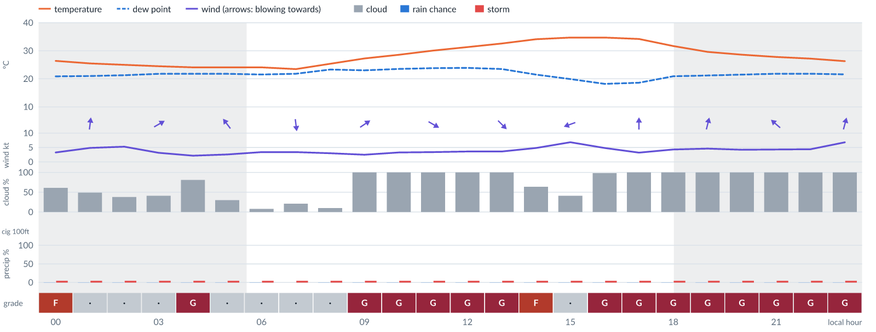
Meteogram — hourly forecast; shaded = before first light / after last light. Gaps mean no data.
Ser | Hrs | Temp | Cloud | Wind | Gust | QNH | Assessment | Driver | Remarks
(a) | (b) | (c) | (d) | (e) | (f) | (g) | (h) | (i) | (j)
1. | 0001 | 26°C | ◑ Cloudy (61%) | ← 3 kts ENE | 3 kts | 1018 | F - Very Poor | cloud 61% · visibility not forecast | ⚠ cloud cover, thunderstorm risk
2. | 0100 | 25°C | ◑ Partly cloudy (49%) | ↑ 5 kts S | 7 kts | 1018 | · - No data | storm 5% · cloud 49% · visibility not forecast | ⚠ cloud cover, thunderstorm risk
3. | 0200 | 25°C | ◑ Partly cloudy (38%) | ↑ 5 kts S | 8 kts | 1018 | · - No data | storm 5% · CAPE 1090 J/kg · visibility not forecast | ⚠ thunderstorm risk, convective energy
4. | 0300 | 24°C | ◑ Partly cloudy (41%) | ↗ 3 kts WSW | 8 kts | 1017 | · - No data | storm 5% · CAPE 1050 J/kg · visibility not forecast | ⚠ thunderstorm risk, convective energy, wind shear
5. | 0400 | 24°C | ◕ Cloudy (81%) | ↑ 2 kts SSW | 3 kts | 1017 | G - Unacceptable | cloud 81% · visibility not forecast | ⚠ cloud cover, thunderstorm risk, convective energy
6. | 0500 | 24°C | ◔ Mostly clear (30%) | ↖ 3 kts SE | 2 kts | 1018 | · - No data | storm 5% · visibility not forecast | ⚠ thunderstorm risk, fog risk 16 % at dawn
7. | 0600 | 24°C | ☀ Clear (8%) | → 3 kts W | 3 kts | 1017 | · - No data | storm 5% · visibility not forecast | ⚠ thunderstorm risk, fog risk 16 % at dawn
8. | 0700 | 23°C | ◔ Mostly clear (21%) | ↓ 3 kts N | 3 kts | 1018 | · - No data | storm 5% · visibility not forecast | ⚠ thunderstorm risk, fog risk 16 % at dawn
9. | 0800 | 25°C | ☀ Clear (10%) | ← 3 kts E | 3 kts | 1019 | · - No data | storm 5% · CAPE 1170 J/kg · visibility not forecast | ⚠ thunderstorm risk, convective energy
10. | 0900 | 27°C | ☁ Overcast (100%) | ↗ 2 kts SW | 3 kts | 1020 | G - Unacceptable | cloud 100% · visibility not forecast | ⚠ cloud cover, thunderstorm risk, convective energy
11. | 1000 | 29°C | ☁ Overcast (100%) | ↘ 3 kts WNW | 4 kts | 1020 | G - Unacceptable | cloud 100% · visibility not forecast | ⚠ cloud cover, thunderstorm risk, convective energy
12. | 1100 | 30°C | ☁ Overcast (100%) | ↘ 3 kts WNW | 5 kts | 1020 | G - Unacceptable | cloud 100% · visibility not forecast | ⚠ cloud cover, convective energy, thunderstorm risk
13. | 1200 | 31°C | ☁ Overcast (100%) | ↘ 4 kts NW | 5 kts | 1019 | G - Unacceptable | cloud 100% · visibility not forecast | ⚠ cloud cover, convective energy, thunderstorm risk
14. | 1300 | 33°C | ☁ Overcast (100%) | ↘ 4 kts NW | 5 kts | 1017 | G - Unacceptable | cloud 100% · visibility not forecast | ⚠ cloud cover, convective energy, thunderstorm risk
15. | 1400 | 34°C | ◕ Cloudy (64%) | ↙ 5 kts NE | 7 kts | 1017 | F - Very Poor | cloud 64% · visibility not forecast | ⚠ cloud cover, thunderstorm risk, convective energy
16. | 1500 | 35°C | ◑ Partly cloudy (41%) | ← 7 kts ENE | 10 kts | 1015 | · - No data | storm 5% · CAPE 1000 J/kg · visibility not forecast | ⚠ thunderstorm risk, convective energy, gusts
17. | 1600 | 35°C | ☁ Overcast (98%) | ← 5 kts ENE | 10 kts | 1015 | G - Unacceptable | cloud 98% · visibility not forecast | ⚠ cloud cover, thunderstorm risk, gusts, wind shear
18. | 1700 | 34°C | ☁ Overcast (100%) | ↑ 3 kts S | 5 kts | 1015 | G - Unacceptable | cloud 100% · visibility not forecast | ⚠ cloud cover, thunderstorm risk
19. | 1800 | 32°C | ☁ Overcast (100%) | ↑ 4 kts S | 4 kts | 1015 | G - Unacceptable | cloud 100% · visibility not forecast | ⚠ cloud cover, thunderstorm risk
20. | 1900 | 30°C | ☁ Overcast (100%) | ↑ 5 kts SSW | 5 kts | 1015 | G - Unacceptable | cloud 100% · visibility not forecast | ⚠ cloud cover, thunderstorm risk, convective energy
21. | 2000 | 29°C | ☁ Overcast (100%) | ↑ 4 kts S | 5 kts | 1016 | G - Unacceptable | cloud 100% · visibility not forecast | ⚠ cloud cover, thunderstorm risk, convective energy
22. | 2100 | 28°C | ☁ Overcast (100%) | ↖ 4 kts SE | 4 kts | 1017 | G - Unacceptable | cloud 100% · visibility not forecast | ⚠ cloud cover, thunderstorm risk, convective energy
23. | 2200 | 27°C | ☁ Overcast (100%) | ↑ 4 kts S | 5 kts | 1018 | G - Unacceptable | cloud 100% · visibility not forecast | ⚠ cloud cover, thunderstorm risk, convective energy
24. | 2300 | 26°C | ☁ Overcast (100%) | ↑ 7 kts SSW | 9 kts | 1018 | G - Unacceptable | cloud 100% · visibility not forecast | ⚠ cloud cover, thunderstorm risk, convective energy, gusts
Confidence: 55% — data for 24 of 24 hours · first light 0604L · last light 1831L · Moon 2 % illuminated, rises 07:16, sets 19:02.

Wed 11 Nov 26
Conditions are expected to be generally Unacceptable: cloudy, winds up to 7 kts E and temperatures 23–35°C. No flyable windows (Marginal or better, ≥2 consecutive hrs) are forecast. Hazards: thunderstorm risk 0001–2300L. Overall similar to the previous day.
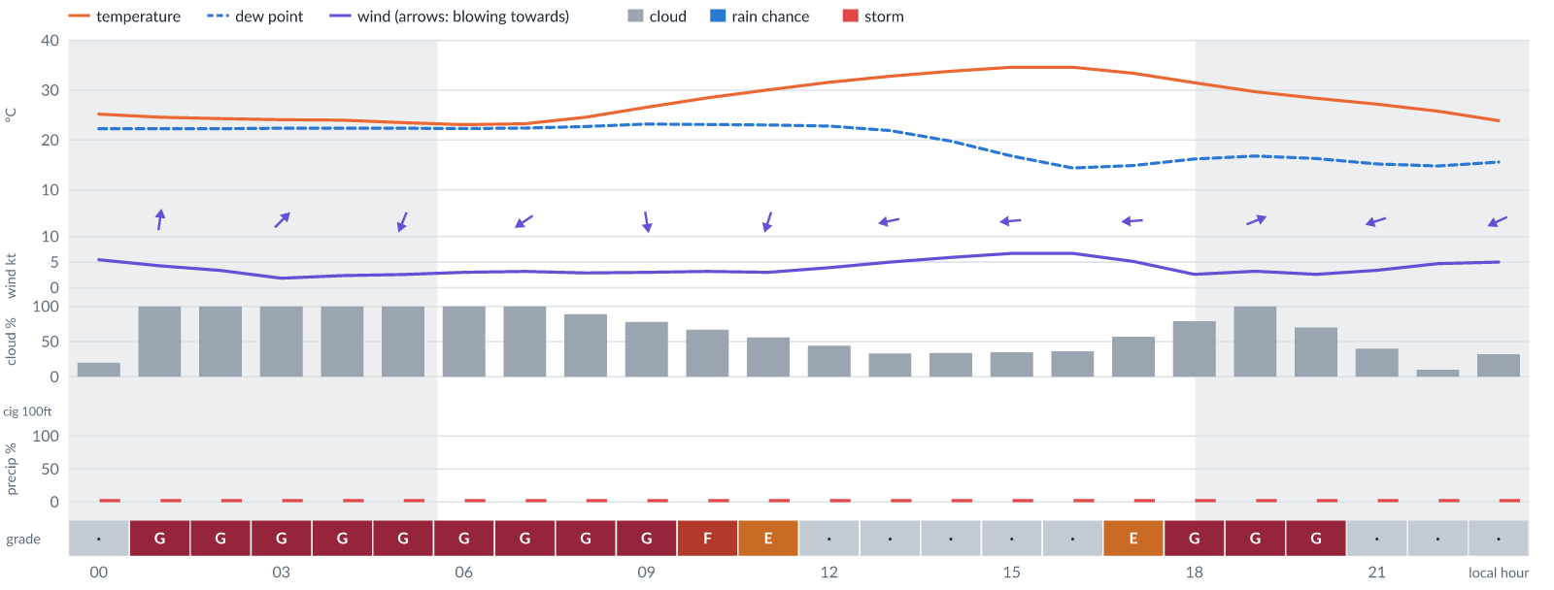
Meteogram — hourly forecast; shaded = before first light / after last light. Gaps mean no data.
Ser | Hrs | Temp | Cloud | Wind | Gust | QNH | Assessment | Driver | Remarks
(a) | (b) | (c) | (d) | (e) | (f) | (g) | (h) | (i) | (j)
1. | 0001 | 25°C | ◔ Mostly clear (20%) | ↑ 5 kts S | 9 kts | 1018 | · - No data | storm 5% · CAPE 1460 J/kg · visibility not forecast | ⚠ thunderstorm risk, convective energy, gusts
2. | 0100 | 25°C | ☁ Overcast (100%) | ↑ 4 kts S | 8 kts | 1018 | G - Unacceptable | cloud 100% · visibility not forecast | ⚠ cloud cover, thunderstorm risk, convective energy
3. | 0200 | 24°C | ☁ Overcast (100%) | ↑ 3 kts SSW | 6 kts | 1018 | G - Unacceptable | cloud 100% · visibility not forecast | ⚠ cloud cover, thunderstorm risk, convective energy
4. | 0300 | 24°C | ☁ Overcast (100%) | ↗ 2 kts SW | 4 kts | 1017 | G - Unacceptable | cloud 100% · visibility not forecast | ⚠ cloud cover, thunderstorm risk, convective energy
5. | 0400 | 24°C | ☁ Overcast (100%) | ↓ 2 kts N | 2 kts | 1017 | G - Unacceptable | cloud 100% · visibility not forecast | ⚠ cloud cover, thunderstorm risk, convective energy
6. | 0500 | 23°C | ☁ Overcast (100%) | ↓ 3 kts NNE | 2 kts | 1017 | G - Unacceptable | cloud 100% · visibility not forecast | ⚠ cloud cover, thunderstorm risk, convective energy, fog risk 16 % at dawn
7. | 0600 | 23°C | ☁ Overcast (100%) | ↙ 3 kts NE | 3 kts | 1017 | G - Unacceptable | cloud 100% · visibility not forecast | ⚠ cloud cover, thunderstorm risk, convective energy
8. | 0700 | 23°C | ☁ Overcast (100%) | ↙ 3 kts NE | 3 kts | 1018 | G - Unacceptable | cloud 100% · visibility not forecast | ⚠ cloud cover, thunderstorm risk, convective energy
9. | 0800 | 25°C | ☁ Cloudy (89%) | ↙ 3 kts NNE | 3 kts | 1019 | G - Unacceptable | cloud 89% · visibility not forecast | ⚠ cloud cover, thunderstorm risk, convective energy
10. | 0900 | 27°C | ◕ Cloudy (78%) | ↓ 3 kts N | 4 kts | 1020 | G - Unacceptable | cloud 78% · visibility not forecast | ⚠ cloud cover, thunderstorm risk, convective energy
11. | 1000 | 28°C | ◕ Cloudy (67%) | ↓ 3 kts NNW | 4 kts | 1020 | F - Very Poor | cloud 67% · visibility not forecast | ⚠ cloud cover, thunderstorm risk, convective energy
12. | 1100 | 30°C | ◑ Partly cloudy (56%) | ↓ 3 kts NNE | 5 kts | 1020 | E - Poor | cloud 56% · visibility not forecast | ⚠ cloud cover, thunderstorm risk, convective energy
13. | 1200 | 32°C | ◑ Partly cloudy (44%) | ↙ 4 kts ENE | 6 kts | 1019 | · - No data | storm 5% · CAPE 1810 J/kg · visibility not forecast | ⚠ cloud cover, thunderstorm risk, convective energy
14. | 1300 | 33°C | ◔ Partly cloudy (33%) | ← 5 kts ENE | 7 kts | 1018 | · - No data | storm 5% · CAPE 1600 J/kg · visibility not forecast | ⚠ thunderstorm risk, convective energy
15. | 1400 | 34°C | ◔ Partly cloudy (34%) | ← 6 kts E | 8 kts | 1017 | · - No data | storm 5% · CAPE 1110 J/kg · visibility not forecast | ⚠ thunderstorm risk, convective energy
16. | 1500 | 35°C | ◔ Partly cloudy (35%) | ← 7 kts E | 10 kts | 1016 | · - No data | storm 5% · gust 10 kt · visibility not forecast | ⚠ thunderstorm risk, gusts
17. | 1600 | 35°C | ◔ Partly cloudy (36%) | ← 7 kts E | 10 kts | 1015 | · - No data | storm 5% · gust 10 kt · visibility not forecast | ⚠ thunderstorm risk, gusts
18. | 1700 | 33°C | ◑ Partly cloudy (57%) | ← 5 kts E | 8 kts | 1015 | E - Poor | cloud 57% · visibility not forecast | ⚠ cloud cover, thunderstorm risk
19. | 1800 | 31°C | ◕ Cloudy (79%) | ↖ 3 kts ESE | 4 kts | 1015 | G - Unacceptable | cloud 79% · visibility not forecast | ⚠ cloud cover, thunderstorm risk
20. | 1900 | 30°C | ☁ Overcast (100%) | → 3 kts WSW | 2 kts | 1015 | G - Unacceptable | cloud 100% · visibility not forecast | ⚠ cloud cover, thunderstorm risk
21. | 2000 | 28°C | ◕ Cloudy (70%) | ↗ 3 kts WSW | 2 kts | 1015 | G - Unacceptable | cloud 70% · visibility not forecast | ⚠ cloud cover, thunderstorm risk
22. | 2100 | 27°C | ◑ Partly cloudy (40%) | ← 3 kts ENE | 3 kts | 1016 | · - No data | storm 5% · visibility not forecast | ⚠ thunderstorm risk
23. | 2200 | 26°C | ☀ Clear (10%) | ← 5 kts ENE | 4 kts | 1016 | · - No data | storm 5% · visibility not forecast | ⚠ thunderstorm risk
24. | 2300 | 24°C | ◔ Mostly clear (32%) | ↙ 5 kts ENE | 5 kts | 1016 | · - No data | storm 5% · visibility not forecast | ⚠ thunderstorm risk
Confidence: 55% — data for 24 of 24 hours · first light 0604L · last light 1831L · Moon 5 % illuminated, rises 08:08, sets 19:52.

Thu 12 Nov 26
Conditions are expected to be generally Unacceptable: overcast, winds up to 5 kts SSW and temperatures 18–34°C. No flyable windows (Marginal or better, ≥2 consecutive hrs) are forecast. Hazards: thunderstorm risk 0001–2300L. Overall similar to the previous day.
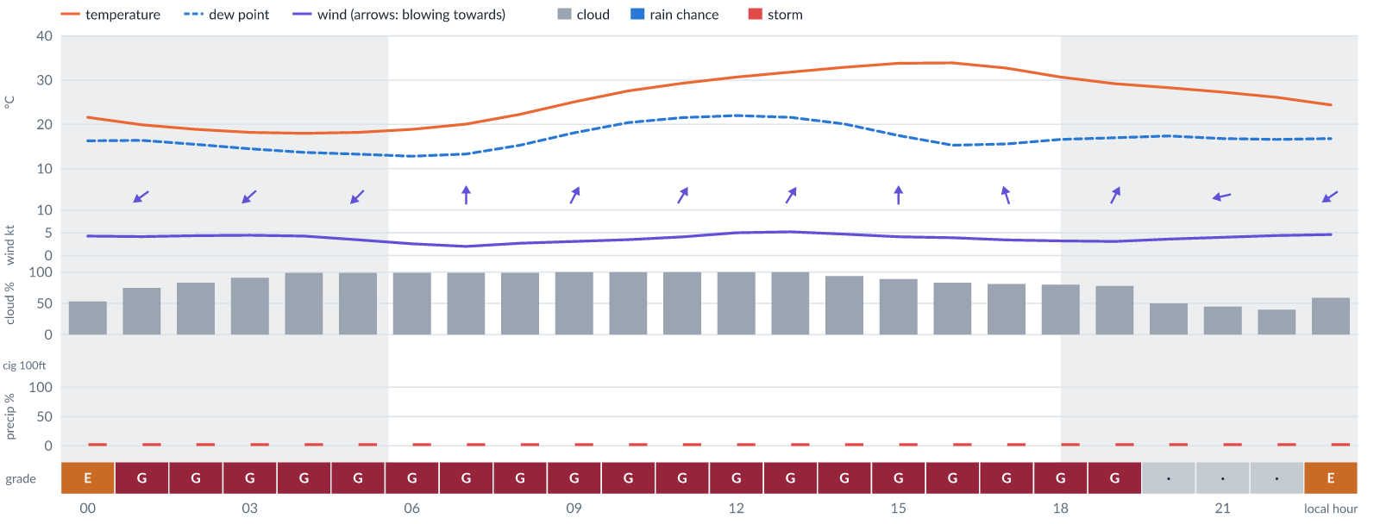
Meteogram — hourly forecast; shaded = before first light / after last light. Gaps mean no data.
Ser | Hrs | Temp | Cloud | Wind | Gust | QNH | Assessment | Driver | Remarks
(a) | (b) | (c) | (d) | (e) | (f) | (g) | (h) | (i) | (j)
1. | 0001 | 22°C | ◑ Partly cloudy (53%) | ↙ 4 kts ENE | 5 kts | 1016 | E - Poor | cloud 53% · visibility not forecast | ⚠ cloud cover, thunderstorm risk
2. | 0100 | 20°C | ◕ Cloudy (75%) | ↙ 4 kts NE | 5 kts | 1015 | G - Unacceptable | cloud 75% · visibility not forecast | ⚠ cloud cover, thunderstorm risk
3. | 0200 | 19°C | ◕ Cloudy (83%) | ↙ 4 kts NE | 5 kts | 1015 | G - Unacceptable | cloud 83% · visibility not forecast | ⚠ cloud cover, thunderstorm risk
4. | 0300 | 18°C | ☁ Overcast (91%) | ↙ 4 kts NE | 5 kts | 1014 | G - Unacceptable | cloud 91% · visibility not forecast | ⚠ cloud cover, thunderstorm risk
5. | 0400 | 18°C | ☁ Overcast (99%) | ↙ 4 kts NE | 5 kts | 1014 | G - Unacceptable | cloud 99% · visibility not forecast | ⚠ cloud cover, thunderstorm risk
6. | 0500 | 18°C | ☁ Overcast (99%) | ↙ 3 kts NE | 5 kts | 1014 | G - Unacceptable | cloud 99% · visibility not forecast | ⚠ cloud cover, thunderstorm risk, fog risk 16 % at dawn
7. | 0600 | 19°C | ☁ Overcast (99%) | ↙ 3 kts NE | 5 kts | 1015 | G - Unacceptable | cloud 99% · visibility not forecast | ⚠ cloud cover, thunderstorm risk, fog risk 16 % at dawn
8. | 0700 | 20°C | ☁ Overcast (99%) | ↑ 2 kts S | 4 kts | 1016 | G - Unacceptable | cloud 99% · visibility not forecast | ⚠ cloud cover, thunderstorm risk, fog risk 16 % at dawn
9. | 0800 | 22°C | ☁ Overcast (99%) | ↗ 3 kts SSW | 4 kts | 1017 | G - Unacceptable | cloud 99% · visibility not forecast | ⚠ cloud cover, thunderstorm risk
10. | 0900 | 25°C | ☁ Overcast (100%) | ↗ 3 kts SSW | 4 kts | 1019 | G - Unacceptable | cloud 100% · visibility not forecast | ⚠ cloud cover, thunderstorm risk
11. | 1000 | 28°C | ☁ Overcast (100%) | ↗ 3 kts SSW | 5 kts | 1020 | G - Unacceptable | cloud 100% · visibility not forecast | ⚠ cloud cover, thunderstorm risk
12. | 1100 | 29°C | ☁ Overcast (100%) | ↗ 4 kts SSW | 6 kts | 1019 | G - Unacceptable | cloud 100% · visibility not forecast | ⚠ cloud cover, thunderstorm risk
13. | 1200 | 31°C | ☁ Overcast (100%) | ↗ 5 kts SW | 7 kts | 1018 | G - Unacceptable | cloud 100% · visibility not forecast | ⚠ cloud cover, thunderstorm risk, convective energy
14. | 1300 | 32°C | ☁ Overcast (100%) | ↗ 5 kts SSW | 8 kts | 1018 | G - Unacceptable | cloud 100% · visibility not forecast | ⚠ cloud cover, thunderstorm risk, convective energy
15. | 1400 | 33°C | ☁ Overcast (94%) | ↗ 5 kts SSW | 7 kts | 1017 | G - Unacceptable | cloud 94% · visibility not forecast | ⚠ cloud cover, thunderstorm risk
16. | 1500 | 34°C | ☁ Cloudy (89%) | ↑ 4 kts S | 6 kts | 1016 | G - Unacceptable | cloud 89% · visibility not forecast | ⚠ cloud cover, thunderstorm risk
17. | 1600 | 34°C | ◕ Cloudy (83%) | ↑ 4 kts SSE | 5 kts | 1015 | G - Unacceptable | cloud 83% · visibility not forecast | ⚠ cloud cover, thunderstorm risk
18. | 1700 | 33°C | ◕ Cloudy (81%) | ↑ 3 kts SSE | 5 kts | 1015 | G - Unacceptable | cloud 81% · visibility not forecast | ⚠ cloud cover, thunderstorm risk
19. | 1800 | 31°C | ◕ Cloudy (80%) | ↑ 3 kts S | 4 kts | 1015 | G - Unacceptable | cloud 80% · visibility not forecast | ⚠ cloud cover, thunderstorm risk
20. | 1900 | 29°C | ◕ Cloudy (78%) | ↗ 3 kts SSW | 3 kts | 1015 | G - Unacceptable | cloud 78% · visibility not forecast | ⚠ cloud cover, thunderstorm risk
21. | 2000 | 28°C | ◑ Partly cloudy (50%) | ← 4 kts E | 3 kts | 1016 | · - No data | storm 5% · cloud 50% · visibility not forecast | ⚠ cloud cover, thunderstorm risk
22. | 2100 | 27°C | ◑ Partly cloudy (45%) | ← 4 kts ENE | 3 kts | 1016 | · - No data | storm 5% · cloud 45% · visibility not forecast | ⚠ cloud cover, thunderstorm risk
23. | 2200 | 26°C | ◑ Partly cloudy (40%) | ↙ 4 kts ENE | 4 kts | 1016 | · - No data | storm 5% · visibility not forecast | ⚠ thunderstorm risk
24. | 2300 | 24°C | ◑ Partly cloudy (59%) | ↙ 5 kts NE | 4 kts | 1016 | E - Poor | cloud 59% · visibility not forecast | ⚠ cloud cover, thunderstorm risk
Confidence: 55% — data for 24 of 24 hours · first light 0604L · last light 1830L · Moon 9 % illuminated, rises 09:01, sets 20:43.

Fri 13 Nov 26
Conditions are expected to be generally Unacceptable: partly cloudy, winds up to 6 kts SSW and temperatures 19–34°C. No flyable windows (Marginal or better, ≥2 consecutive hrs) are forecast. Hazards: thunderstorm risk 0001–2300L. Overall similar to the previous day.
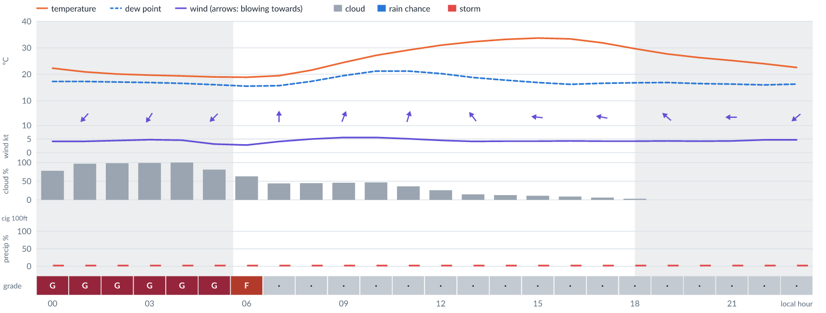
Meteogram — hourly forecast; shaded = before first light / after last light. Gaps mean no data.
Ser | Hrs | Temp | Cloud | Wind | Gust | QNH | Assessment | Driver | Remarks
(a) | (b) | (c) | (d) | (e) | (f) | (g) | (h) | (i) | (j)
1. | 0001 | 22°C | ◕ Cloudy (78%) | ↙ 4 kts NE | 5 kts | 1016 | G - Unacceptable | cloud 78% · visibility not forecast | ⚠ cloud cover, thunderstorm risk
2. | 0100 | 21°C | ☁ Overcast (97%) | ↙ 4 kts NE | 5 kts | 1015 | G - Unacceptable | cloud 97% · visibility not forecast | ⚠ cloud cover, thunderstorm risk
3. | 0200 | 20°C | ☁ Overcast (98%) | ↙ 4 kts NE | 5 kts | 1015 | G - Unacceptable | cloud 98% · visibility not forecast | ⚠ cloud cover, thunderstorm risk
4. | 0300 | 20°C | ☁ Overcast (99%) | ↙ 5 kts NNE | 6 kts | 1014 | G - Unacceptable | cloud 99% · visibility not forecast | ⚠ cloud cover, thunderstorm risk
5. | 0400 | 19°C | ☁ Overcast (100%) | ↙ 5 kts NNE | 6 kts | 1014 | G - Unacceptable | cloud 100% · visibility not forecast | ⚠ cloud cover, thunderstorm risk
6. | 0500 | 19°C | ◕ Cloudy (81%) | ↙ 3 kts NE | 5 kts | 1014 | G - Unacceptable | cloud 81% · visibility not forecast | ⚠ cloud cover, thunderstorm risk, fog risk 16 % at dawn
7. | 0600 | 19°C | ◕ Cloudy (63%) | ↖ 3 kts SE | 4 kts | 1015 | F - Very Poor | cloud 63% · visibility not forecast | ⚠ cloud cover, thunderstorm risk, fog risk 16 % at dawn
8. | 0700 | 19°C | ◑ Partly cloudy (44%) | ↑ 4 kts S | 4 kts | 1015 | · - No data | storm 5% · cloud 44% · visibility not forecast | ⚠ cloud cover, thunderstorm risk, fog risk 16 % at dawn
9. | 0800 | 22°C | ◑ Partly cloudy (45%) | ↑ 5 kts S | 5 kts | 1017 | · - No data | storm 5% · cloud 45% · visibility not forecast | ⚠ cloud cover, thunderstorm risk
10. | 0900 | 24°C | ◑ Partly cloudy (46%) | ↑ 6 kts SSW | 7 kts | 1018 | · - No data | storm 5% · cloud 46% · visibility not forecast | ⚠ cloud cover, thunderstorm risk
11. | 1000 | 27°C | ◑ Partly cloudy (47%) | ↗ 6 kts SSW | 9 kts | 1020 | · - No data | storm 5% · cloud 47% · visibility not forecast | ⚠ cloud cover, thunderstorm risk, gusts
12. | 1100 | 29°C | ◔ Partly cloudy (36%) | ↑ 5 kts SSW | 8 kts | 1019 | · - No data | storm 5% · visibility not forecast | ⚠ thunderstorm risk
13. | 1200 | 31°C | ◔ Mostly clear (26%) | ↑ 5 kts S | 7 kts | 1018 | · - No data | storm 5% · visibility not forecast | ⚠ thunderstorm risk
14. | 1300 | 32°C | ◔ Mostly clear (15%) | ↖ 4 kts SE | 6 kts | 1018 | · - No data | storm 5% · visibility not forecast | ⚠ thunderstorm risk
15. | 1400 | 33°C | ◔ Mostly clear (13%) | ↖ 4 kts ESE | 6 kts | 1017 | · - No data | storm 5% · visibility not forecast | ⚠ thunderstorm risk
16. | 1500 | 34°C | ☀ Clear (11%) | ← 4 kts E | 5 kts | 1016 | · - No data | storm 5% · visibility not forecast | ⚠ thunderstorm risk
17. | 1600 | 33°C | ☀ Clear (9%) | ← 4 kts E | 5 kts | 1016 | · - No data | storm 5% · visibility not forecast | ⚠ thunderstorm risk
18. | 1700 | 32°C | ☀ Clear (6%) | ← 4 kts E | 5 kts | 1015 | · - No data | storm 5% · visibility not forecast | ⚠ thunderstorm risk
19. | 1800 | 30°C | ☀ Clear (3%) | ↖ 4 kts ESE | 5 kts | 1015 | · - No data | storm 5% · visibility not forecast | ⚠ thunderstorm risk
20. | 1900 | 28°C | ☀ Clear (0%) | ↖ 4 kts SE | 5 kts | 1015 | · - No data | storm 5% · visibility not forecast | ⚠ thunderstorm risk
21. | 2000 | 26°C | ☀ Clear (0%) | ↖ 4 kts ESE | 5 kts | 1016 | · - No data | storm 5% · visibility not forecast | ⚠ thunderstorm risk
22. | 2100 | 25°C | ☀ Clear (0%) | ← 4 kts E | 5 kts | 1016 | · - No data | storm 5% · visibility not forecast | ⚠ thunderstorm risk
23. | 2200 | 24°C | ☀ Clear (0%) | ← 5 kts ENE | 5 kts | 1016 | · - No data | storm 5% · visibility not forecast | ⚠ thunderstorm risk
24. | 2300 | 23°C | ☀ Clear (0%) | ↙ 5 kts NE | 5 kts | 1016 | · - No data | storm 5% · visibility not forecast | ⚠ thunderstorm risk
Confidence: 55% — data for 24 of 24 hours · first light 0605L · last light 1830L · Moon 15 % illuminated, rises 09:51, sets 21:35.

Sat 14 Nov 26
Conditions are expected to be variable: clear, winds up to 7 kts SSE and temperatures 19–34°C. No flyable windows (Marginal or better, ≥2 consecutive hrs) are forecast. Hazards: thunderstorm risk 0001–2300L.
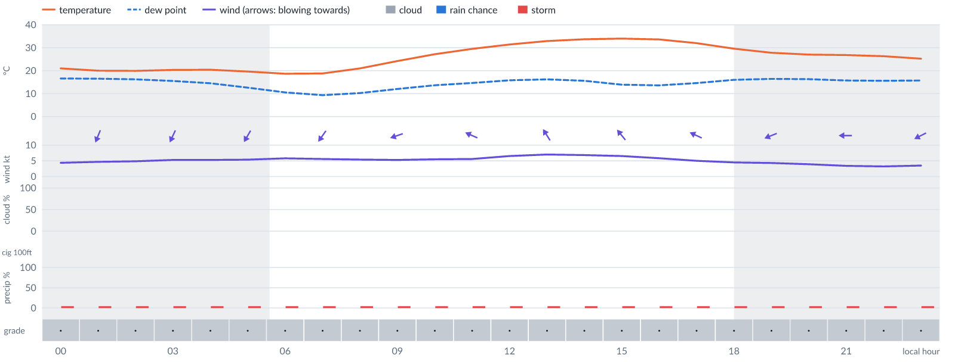
Meteogram — hourly forecast; shaded = before first light / after last light. Gaps mean no data.
Ser | Hrs | Temp | Cloud | Wind | Gust | QNH | Assessment | Driver | Remarks
(a) | (b) | (c) | (d) | (e) | (f) | (g) | (h) | (i) | (j)
1. | 0001 | 21°C | ☀ Clear (0%) | ↙ 4 kts NE | 6 kts | 1016 | · - No data | storm 5% · visibility not forecast | ⚠ thunderstorm risk
2. | 0100 | 20°C | ☀ Clear (0%) | ↓ 5 kts NNE | 6 kts | 1015 | · - No data | storm 5% · visibility not forecast | ⚠ thunderstorm risk
3. | 0200 | 20°C | ☀ Clear (0%) | ↓ 5 kts NNE | 7 kts | 1015 | · - No data | storm 5% · visibility not forecast | ⚠ thunderstorm risk
4. | 0300 | 20°C | ☀ Clear (0%) | ↙ 5 kts NNE | 7 kts | 1015 | · - No data | storm 5% · visibility not forecast | ⚠ thunderstorm risk
5. | 0400 | 20°C | ☀ Clear (0%) | ↙ 5 kts NNE | 8 kts | 1015 | · - No data | storm 5% · visibility not forecast | ⚠ thunderstorm risk
6. | 0500 | 20°C | ☀ Clear (0%) | ↙ 5 kts NNE | 8 kts | 1015 | · - No data | storm 5% · visibility not forecast | ⚠ thunderstorm risk, fog risk 16 % at dawn
7. | 0600 | 19°C | ☀ Clear (0%) | ↙ 6 kts NNE | 8 kts | 1015 | · - No data | storm 5% · visibility not forecast | ⚠ thunderstorm risk, fog risk 16 % at dawn
8. | 0700 | 19°C | ☀ Clear (0%) | ↙ 6 kts NE | 8 kts | 1015 | · - No data | storm 5% · visibility not forecast | ⚠ thunderstorm risk, fog risk 16 % at dawn
9. | 0800 | 21°C | ☀ Clear (0%) | ↙ 5 kts NE | 8 kts | 1017 | · - No data | storm 5% · visibility not forecast | ⚠ thunderstorm risk
10. | 0900 | 24°C | ☀ Clear (0%) | ← 5 kts ENE | 8 kts | 1018 | · - No data | storm 5% · visibility not forecast | ⚠ thunderstorm risk
11. | 1000 | 27°C | ☀ Clear (0%) | ← 5 kts E | 8 kts | 1020 | · - No data | storm 5% · visibility not forecast | ⚠ thunderstorm risk
12. | 1100 | 29°C | ☀ Clear (0%) | ↖ 6 kts ESE | 9 kts | 1020 | · - No data | storm 5% · gust 9 kt · visibility not forecast | ⚠ thunderstorm risk, gusts
13. | 1200 | 31°C | ☀ Clear (0%) | ↖ 7 kts SE | 11 kts | 1019 | · - No data | storm 5% · gust 11 kt · visibility not forecast | ⚠ thunderstorm risk, gusts
14. | 1300 | 33°C | ☀ Clear (0%) | ↖ 7 kts SSE | 11 kts | 1018 | · - No data | storm 5% · gust 11 kt · visibility not forecast | ⚠ thunderstorm risk, gusts
15. | 1400 | 34°C | ☀ Clear (0%) | ↖ 7 kts SSE | 11 kts | 1017 | · - No data | storm 5% · gust 11 kt · visibility not forecast | ⚠ thunderstorm risk, gusts
16. | 1500 | 34°C | ☀ Clear (0%) | ↖ 7 kts SE | 10 kts | 1016 | · - No data | storm 5% · gust 10 kt · visibility not forecast | ⚠ thunderstorm risk, gusts
17. | 1600 | 34°C | ☀ Clear (0%) | ↖ 6 kts SE | 8 kts | 1016 | · - No data | storm 5% · visibility not forecast | ⚠ thunderstorm risk
18. | 1700 | 32°C | ☀ Clear (0%) | ↖ 5 kts ESE | 7 kts | 1015 | · - No data | storm 5% · visibility not forecast | ⚠ thunderstorm risk
19. | 1800 | 30°C | ☀ Clear (0%) | ← 5 kts E | 5 kts | 1015 | · - No data | storm 5% · visibility not forecast | ⚠ thunderstorm risk
20. | 1900 | 28°C | ☀ Clear (0%) | ← 4 kts ENE | 4 kts | 1015 | · - No data | storm 5% · visibility not forecast | ⚠ thunderstorm risk
21. | 2000 | 27°C | ☀ Clear (0%) | ← 4 kts ENE | 3 kts | 1016 | · - No data | storm 5% · visibility not forecast | ⚠ thunderstorm risk
22. | 2100 | 27°C | ☀ Clear (0%) | ← 3 kts E | 2 kts | 1016 | · - No data | storm 5% · visibility not forecast | ⚠ thunderstorm risk
23. | 2200 | 26°C | ☀ Clear (0%) | ← 3 kts E | 2 kts | 1016 | · - No data | storm 5% · visibility not forecast | ⚠ thunderstorm risk
24. | 2300 | 25°C | ☀ Clear (0%) | ↙ 4 kts ENE | 3 kts | 1016 | · - No data | storm 5% · visibility not forecast | ⚠ thunderstorm risk
Confidence: 55% — data for 24 of 24 hours · first light 0605L · last light 1830L · Moon 23 % illuminated, rises 10:39, sets 22:26.

Sun 15 Nov 26
Conditions are expected to be variable: clear, winds up to 4 kts NE and temperatures 24–24°C. No flyable windows (Marginal or better, ≥2 consecutive hrs) are forecast. Hazards: thunderstorm risk 0001L.
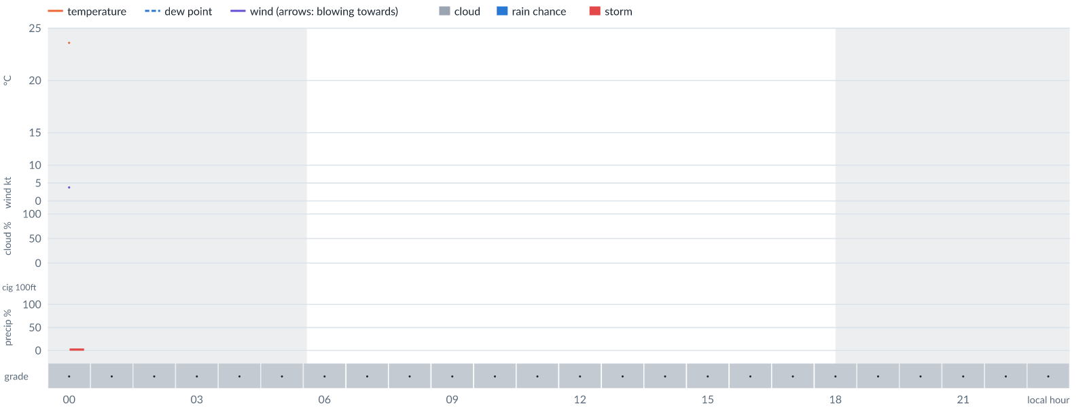
Meteogram — hourly forecast; shaded = before first light / after last light. Gaps mean no data.
Ser | Hrs | Temp | Cloud | Wind | Gust | QNH | Assessment | Driver | Remarks
(a) | (b) | (c) | (d) | (e) | (f) | (g) | (h) | (i) | (j)
1. | 0001 | 24°C | ☀ Clear (0%) | ↙ 4 kts NE | 5 kts | 1016 | · - No data | storm 5% · visibility not forecast | ⚠ thunderstorm risk
2. | 0100 | - | No data | - | - | - | · - No data | cloud, visibility, wind not forecast
3. | 0200 | - | No data | - | - | - | · - No data | cloud, visibility, wind not forecast
4. | 0300 | - | No data | - | - | - | · - No data | cloud, visibility, wind not forecast
5. | 0400 | - | No data | - | - | - | · - No data | cloud, visibility, wind not forecast
6. | 0500 | - | No data | - | - | - | · - No data | cloud, visibility, wind not forecast
7. | 0600 | - | No data | - | - | - | · - No data | cloud, visibility, wind not forecast
8. | 0700 | - | No data | - | - | - | · - No data | cloud, visibility, wind not forecast
9. | 0800 | - | No data | - | - | - | · - No data | cloud, visibility, wind not forecast
10. | 0900 | - | No data | - | - | - | · - No data | cloud, visibility, wind not forecast
11. | 1000 | - | No data | - | - | - | · - No data | cloud, visibility, wind not forecast
12. | 1100 | - | No data | - | - | - | · - No data | cloud, visibility, wind not forecast
13. | 1200 | - | No data | - | - | - | · - No data | cloud, visibility, wind not forecast
14. | 1300 | - | No data | - | - | - | · - No data | cloud, visibility, wind not forecast
15. | 1400 | - | No data | - | - | - | · - No data | cloud, visibility, wind not forecast
16. | 1500 | - | No data | - | - | - | · - No data | cloud, visibility, wind not forecast
17. | 1600 | - | No data | - | - | - | · - No data | cloud, visibility, wind not forecast
18. | 1700 | - | No data | - | - | - | · - No data | cloud, visibility, wind not forecast
19. | 1800 | - | No data | - | - | - | · - No data | cloud, visibility, wind not forecast
20. | 1900 | - | No data | - | - | - | · - No data | cloud, visibility, wind not forecast
21. | 2000 | - | No data | - | - | - | · - No data | cloud, visibility, wind not forecast
22. | 2100 | - | No data | - | - | - | · - No data | cloud, visibility, wind not forecast
23. | 2200 | - | No data | - | - | - | · - No data | cloud, visibility, wind not forecast
24. | 2300 | - | No data | - | - | - | · - No data | cloud, visibility, wind not forecast
Confidence: 2% — data for 1 of 24 hours · first light 0605L · last light 1830L · Moon 31 % illuminated, rises 11:24, sets 23:15.

TAF
No TAF available for this location.

Imagery

Dust RGB (pink/magenta = airborne dust) — captured 8 Nov 01:43 WAT (2 min ago) · ©EUMETSAT (screenshot via EUMETView)

Convection RGB (yellow = vigorous storms) — captured 8 Nov 01:43 WAT (2 min ago) · ©EUMETSAT (screenshot via EUMETView)
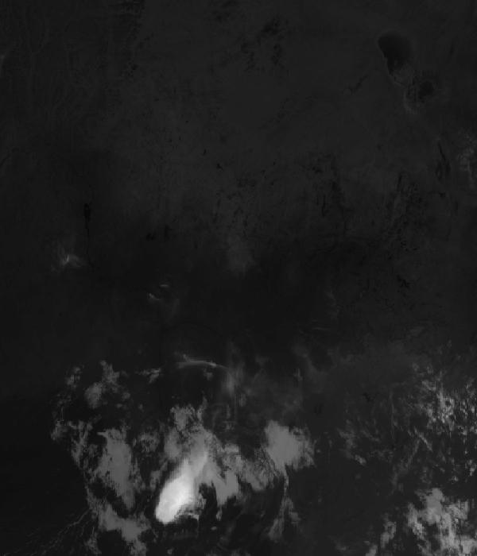
Infrared 10.5 µm (cold tops = deep cloud) — captured 8 Nov 01:43 WAT (2 min ago) · ©EUMETSAT (screenshot via EUMETView)

Accumulated lightning flash area (MTG-LI) — captured 8 Nov 01:43 WAT (2 min ago) · ©EUMETSAT (screenshot via EUMETView)

Source panel
Source | Accuracy | Skill n | Temp °C | Wind kt | Visibility | Storm
(a) | (b) | (c) | (d) | (e) | (f) | (g)
DWD ICON | ▲ 1.1 | 3846 | 18–21 | 1–3 | — | 0 %
Each source's own raw values, min–max over the next 6 hours from the issue hour (before any weighting or bias correction). — means the source does not publish that metric in the window. Wide gaps between rows are real disagreement; the forecast above weights sources by measured skill.

Reading this report
Grades: each hour carries one grade, set by its WORST factor. The bands below are the thresholds in force for this report (Settings); a value in a band earns that grade, and "-" means the factor never produces that grade. Cloud is graded on the worse of cover and ceiling. The Driver column names the limiting factor with its value; open it in the web report for the boundary and sources.
Grade | Cloud cover | Cloud ceiling | Visibility | Wind | Gust | Rain chance | Thunderstorm probability
(a) | (b) | (c) | (d) | (e) | (f) | (g) | (h)
A Excellent | ≤ 17.1% | ≥ 30000 ft | ≥ 8000 m | < 3 kt | < 3 kt | < 5% | 0%
B Good | 17.1–34.3% | 26000–30000 ft | 6666.7–8000 m | 3–6 kt | 3–6 kt | 5–10% | -
C Fair | 34.3–42.9% | 24000–26000 ft | 5333.3–6666.7 m | 6–9 kt | 6–9 kt | 10–15% | -
D Marginal | 42.9–51.4% | 22000–24000 ft | 4000–5333.3 m | 9–12 kt | 9–12 kt | 15–20% | >0–15%
E Poor | 51.4–60% | 16000–22000 ft | 2666.7–4000 m | 12–15 kt | 12–15 kt | 20–25% | 15–30%
F Very Poor | 60–68.6% | 10000–16000 ft | 1333.3–2666.7 m | 15–18 kt | 15–18 kt | 25–30% | 30–60%
G Unacceptable | > 68.6% | < 10000 ft | < 1333.3 m | ≥ 18 kt | ≥ 18 kt | ≥ 30% | > 60%
Flight windows: a window is at least 2 consecutive hours graded Marginal or better; an hour with insufficient data never counts toward one. ☾ marks a window outside first-to-last light.
Time: hours are local time (WAT, UTC+1) unless suffixed Z, which is UTC (TAF, METAR and issue times). Local midnight is labelled 0001.
Units: temperature °C · wind and gusts knots · visibility metres (km in text) · cloud ceiling feet · cloud cover % · rain chance and thunderstorm probability % · QNH hPa (altimeter setting at the field) · CAPE J/kg. A figure like "28 (26–30)°C" gives the p10–p90 range; "spread" marks disagreement between sources.
Symbols: ▲ better than the pool · ▽ worse (only when the 95% interval excludes the pool) · ≈ not distinguishable from the pool · unmarked = unproven (accuracy is measured against METAR and SYNOP observations). ⚠ on a remark means a low-confidence hour; a ⚠ paragraph on the first page is a convective-warning or data-age advisory. ⚡ is lightning observed by satellite near the field (©EUMETSAT).
Hourly glyphs: the wind arrow points the way the air moves (a north wind is ↓, an east wind ←); cloud cover shows as ☀ ◔ ◑ ◕ ☁ (clear, few, scattered, broken, overcast); a shaded hour label is wholly before first light or after last light.
Terms: "No data" - no source forecast the hour, or a core group (cloud, visibility, wind) is missing and the hour could still be flyable; missing data is never given a good grade. "Low-confidence" - few or weak sources behind the load-bearing metrics; treat the grade as indicative. "Insufficient data" - too little to grade at all. "Estimated" (est.) - the value is derived, not reported by a source (dust visibility, cloud base, gusts); it is declared where used and weighted at half. "Derived" - an hour interpolated from a coarser (3-hourly or daily) source, weighted at half and never used to score accuracy.

Data provenance
Source | Fetched (Z) | Age | Skill n | Accuracy
(a) | (b) | (c) | (d) | (e)
DWD ICON | 8 Nov 00:44Z | 1 min | 3846 | ▲ 1.1
Corrections applied (detailed under Learned corrections on the first page): skill weighting, bias correction, hour-of-day bias, cloud-base estimate, probability calibration, fog risk, climatology bounds, skill blend.

How accurate have we been
Measured against observations (METAR/SYNOP), minna only. Verification table computed 2026-11-08. Mean absolute error (MAE): lower is better; "beats persistence" compares the best source with "it will stay as it is now" on the same hours.
Metric | Best source | Best MAE | Typical MAE | Persistence MAE | Beats persistence by | Pairs
(a) | (b) | (c) | (d) | (e) | (f) | (g)
Temperature (°C) | foreca | 0.9 | 3.4 | 5.4 | 78 % | 170
Dew point (°C) | accuweather | 1.3 | 4.2 | 2.5 | -30 % | 35
Wind speed (kt) | gem | 1.6 | 2.1 | 2.7 | 22 % | 711
Visibility (m) | visualcrossing | 200 | 308 | 1282 | -1 % | 1465
Cloud cover (%) | accuweather | 16 | 47 | 9 | - | 35
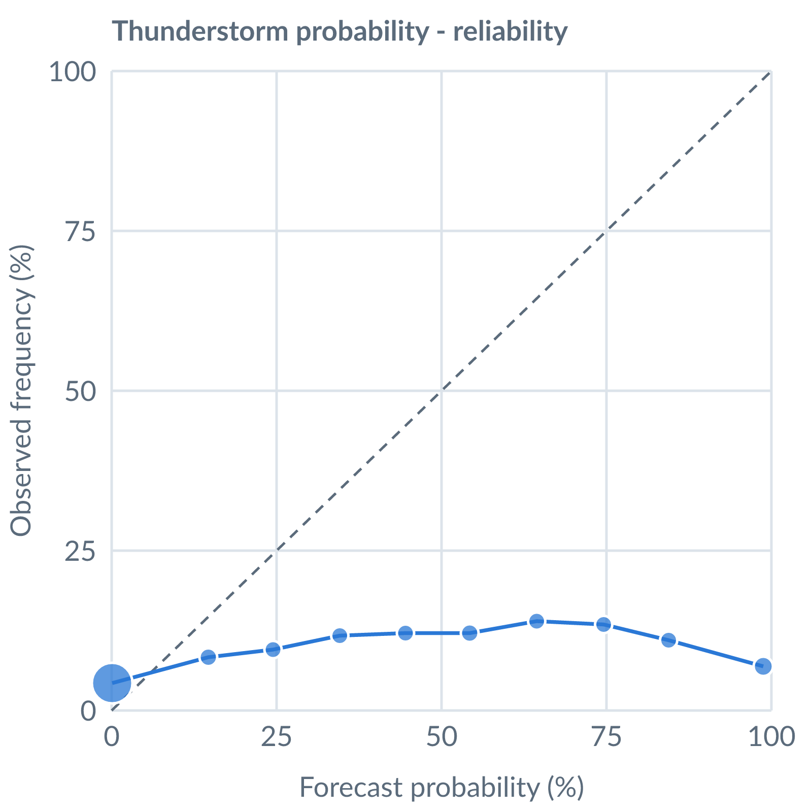
Thunderstorm probability: dots on the dashed line mean a stated probability matched how often it happened (181194 pairs, all places pooled).
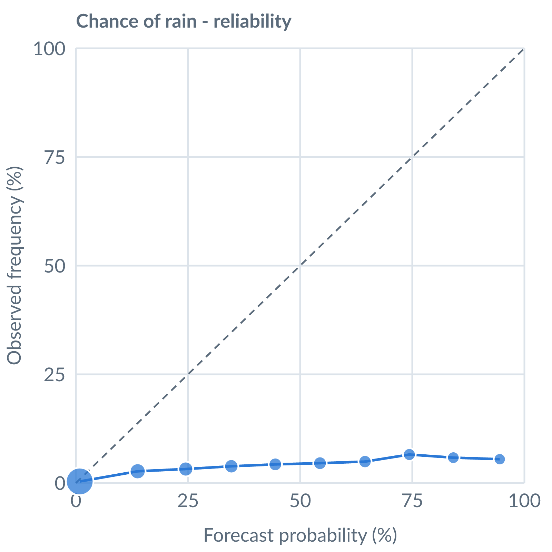
Chance of rain: dots on the dashed line mean a stated probability matched how often it happened (169663 pairs, all places pooled).
Learned bias (forecast minus observed; positive = sources run high), mean over scored sources, by local time of day. These are corrected for before sources are averaged.
Metric | Overall | Night | Morning | Afternoon | Evening | Pairs
(a) | (b) | (c) | (d) | (e) | (f) | (g)
Temperature (°C) | -3.2 | -3.1 | -3.0 | -3.1 | -3.5 | 15580
Dew point (°C) | -4.0 | -3.5 | -3.6 | -3.9 | -4.5 | 14675
Wind speed (kt) | -1.5 | -0.3 | -1.2 | -2.2 | -1.3 | 15598
Not yet available: Scores are decayed over the verification window (half-life 14 days); separate last-7-day and last-30-day windows are not stored. Bias is the current learned value; the history needed for a trend over time is not stored. Flight-window hit / bust / miss is not yet recorded.

