Gusau — 14-Day Forecast
DNGU · issued 8 Nov 26 03:24Z
Sources: Open-Meteo Ensemble (ECMWF IFS + GEFS) ▲ 1.4 · Foreca ▽ 0.8 · NOAA GFS ▽ 0.8 · Met.no (Yr) ▲ 1.2 · Open-Meteo ≈ 1.0 · OpenWeather ≈ 1.0 · Tomorrow.io ▲ 1.2 · Visual Crossing ▽ 1.0
▲ better than the pool · ▽ worse (only when the 95% interval excludes the pool) · ≈ not distinguishable from the pool · unmarked = unproven (accuracy is measured against METAR and SYNOP observations)
Day | 00 | 01 | 02 | 03 | 04 | 05 | 06 | 07 | 08 | 09 | 10 | 11 | 12 | 13 | 14 | 15 | 16 | 17 | 18 | 19 | 20 | 21 | 22 | 23 | Flyable Windows | Conf
Sun 8 Nov 26 | · | D | D | D | D | D | D | D | D | D | D | E | E | E | E | E | E | E | E | E | E | D | D | D | 0100–1000L (Marginal, 10 h) ☾ · 2100–2300L (Marginal, 3 h) ☾ | 81%
Mon 9 Nov 26 | D | D | D | D | D | D | D | D | D | D | E | E | E | E | F | F | E | E | E | D | D | D | D | D | best window: 0001–0900L (Marginal, 10 h) ☾ · 1900–2300L (Marginal, 5 h) ☾ | 85%
Tue 10 Nov 26 | D | D | D | D | D | E | D | E | E | E | F | F | G | G | G | G | F | F | D | D | D | D | D | D | 0001–0400L (Marginal, 5 h) ☾ · 1800–2300L (Marginal, 6 h) ☾ | 82%
Wed 11 Nov 26 | G | G | G | G | G | G | G | G | G | G | G | G | G | G | G | G | G | G | G | G | G | F | E | D | no windows | 81%
Thu 12 Nov 26 | D | D | D | E | F | E | D | D | E | E | F | F | E | F | E | E | E | D | D | D | E | D | D | D | 0001–0200L (Marginal, 3 h) ☾ · 0600–0700L (Marginal, 2 h) ☾ · 1700–1900L (Marginal, 3 h) ☾ · 2100–2300L (Marginal, 3 h) ☾ | 81%
Fri 13 Nov 26 | D | D | D | D | E | E | E | E | F | F | F | F | G | G | G | F | F | F | F | F | F | E | E | E | 0001–0300L (Marginal, 4 h) ☾ | 78%
Sat 14 Nov 26 | E | D | D | D | D | D | E | E | F | F | G | G | G | G | G | G | G | G | G | G | G | F | E | E | 0100–0500L (Marginal, 5 h) ☾ | 77%
Sun 15 Nov 26 | D | D | D | D | E | E | E | F | F | F | F | F | F | F | G | F | E | E | G | G | F | E | E | D | 0001–0300L (Marginal, 4 h) ☾ | 76%
Mon 16 Nov 26 | E | D | D | D | D | D | D | D | E | E | F | F | F | G | G | G | E | E | F | F | F | E | E | E | 0100–0700L (Marginal, 7 h) ☾ | 75%
Tue 17 Nov 26 | E | D | D | D | D | D | D | E | E | F | F | F | E | F | G | F | F | F | G | E | E | E | E | D | 0100–0600L (Marginal, 6 h) ☾ | 75%
Wed 18 Nov 26 | D | D | D | D | D | D | D | E | E | F | F | F | F | F | F | G | G | G | G | G | G | E | E | F | 0001–0600L (Marginal, 7 h) ☾ | 69%
Thu 19 Nov 26 | F | G | F | E | D | D | D | D | D | E | F | F | G | G | G | G | G | G | G | G | G | G | E | D | 0400–0800L (Marginal, 5 h) ☾ | 69%
Fri 20 Nov 26 | D | D | D | D | D | D | D | E | E | E | F | F | G | G | G | G | G | G | G | G | G | F | E | D | 0001–0600L (Marginal, 7 h) ☾ | 69%
Sat 21 Nov 26 | E | E | E | E | E | E | E | E | F | F | G | G | G | G | G | G | G | G | G | G | G | G | G | G | no windows | 69%
A Excellent · B Good · C Fair · D Marginal · E Poor · F Very Poor · G Unacceptable · · No data
Best window (highest confidence, then grade, then length): Mon 9 Nov 26 0001–0900L (Marginal, 10 h) ☾, confidence 85%.
Learned corrections (METAR-verified): skill weighting — pooled all-field scores for 206; bias corrections — Open-Meteo dewpoint +3.0 °C, Foreca dewpoint +3.0 °C, metcheck dewpoint +3.0 °C, OpenWeather dewpoint +3.0 °C, wttrin dewpoint +3.0 °C, NOAA GFS dewpoint +3.0 °C (+67 more); hour-of-day bias (local time, shrunk toward the all-hours bias) — Visual Crossing night wind −4.1 kt, wttrin evening wind −3.7 kt, wttrin night wind −3.5 kt, Visual Crossing evening wind −3.5 kt, NOAA GFS night wind −3.4 kt, NOAA GFS evening wind −3.2 kt (+284 more); cloud base estimated as 410 ft per °C of dewpoint spread for sources that report no ceiling (≥60% cloud cover; flagged estimated, weighted ×0.5); probability calibration — rain chance: meteoblue, Open-Meteo, Foreca, metcheck, OpenWeather, Visual Crossing, Tomorrow.io, wttrin, ecmwf, NOAA GFS, icon, ukmo, gem, Open-Meteo Ensemble (ECMWF IFS + GEFS); storm: Open-Meteo, Met.no (Yr), Foreca, OpenWeather, Visual Crossing, Tomorrow.io, wttrin, ecmwf, NOAA GFS, icon, meteofrance, aviationweather, ukmo, jma, gem, Open-Meteo Ensemble (ECMWF IFS + GEFS), aifs (each source's stated probability mapped to its verified frequency by an isotonic fit on ≥200 pairs, proven on the holdout); fog risk (n=1578): observed fog frequency by dewpoint spread, wind, local hour and season for the forecast conditions (shown from 10 %), proven on the holdout; plausibility bounds from ERA5 climatology 2016-2025 (mean ± 5 sd; screening only, not observed truth); skill blend 1 auto-tuned over 9538 holdout pairs (consensus beat the best single source, icon, by 14%); correction gates (newest-7-day holdout; pooled skill is always on) — regional skill: off this week (did not improve holdout); place skill: off this week (did not improve holdout); lead-time skill: off this week (did not improve holdout); small-sample skill shrinkage: off this week (did not improve holdout); bias correction: on (improved holdout by 26.2%); place bias: on (improved holdout by 10.2%); hour-of-day bias: on (improved holdout by 7.1%); QNH bias: on (improved holdout by 57.5%); gust estimates: off this week (did not improve holdout); cloud-base coefficient: off this week (insufficient holdout: 96 of 200 items); recent-form skill: off this week (did not improve holdout); probability calibration: on (improved holdout by 43.1%); nowcast anchor horizon: off this week (did not improve holdout); dust-visibility estimate: off this week (did not improve holdout); fog risk: on (improved holdout by 6.4%).

Outlook
Day | Date | Outlook | Temp | Max wind | Flight windows | Confidence | Notes
(a) | (b) | (c) | (d) | (e) | (f) | (g) | (h)
Sun | 8 Nov 26 | Marginal | 21–38°C | 8 kts ENE, g 14 | 0100–1000L (Marginal, 10 h) ☾; 2100–2300L (Marginal, 3 h) ☾ | 81% | 6% interpolated
Mon | 9 Nov 26 | Marginal | 22–38°C | 9 kts E, g 15 | 0001–0900L (Marginal, 10 h) ☾; 1900–2300L (Marginal, 5 h) ☾ | 85% | 8% interpolated
Tue | 10 Nov 26 | Marginal | 21–38°C | 12 kts E, g 21 | 0001–0400L (Marginal, 5 h) ☾; 1800–2300L (Marginal, 6 h) ☾ | 82% | 10% interpolated
Wed | 11 Nov 26 | Unacceptable | 22–37°C | 11 kts ESE, g 18 | none | 81% | 17% interpolated
Thu | 12 Nov 26 | Marginal | 20–36°C | 8 kts ESE, g 15 | 0001–0200L (Marginal, 3 h) ☾; 0600–0700L (Marginal, 2 h) ☾; 1700–1900L (Marginal, 3 h) ☾; 2100–2300L (Marginal, 3 h) ☾ | 81% | 16% interpolated
Fri | 13 Nov 26 | Very Poor | 19–35°C | 10 kts E, g 19 | 0001–0300L (Marginal, 4 h) ☾ | 78% | 13% interpolated
Sat | 14 Nov 26 | Unacceptable | 17–34°C | 10 kts E, g 20 | 0100–0500L (Marginal, 5 h) ☾ | 77% | 13% interpolated
Sun | 15 Nov 26 | Very Poor | 18–35°C | 10 kts E, g 20 | 0001–0300L (Marginal, 4 h) ☾ | 76% | 13% interpolated
Mon | 16 Nov 26 | Poor | 18–36°C | 9 kts E, g 18 | 0100–0700L (Marginal, 7 h) ☾ | 75% | 13% interpolated
Tue | 17 Nov 26 | Poor | 19–36°C | 8 kts E, g 19 | 0100–0600L (Marginal, 6 h) ☾ | 75% | 7% interpolated
Wed | 18 Nov 26 | Marginal | 18–36°C | 8 kts E, g 19 | 0001–0600L (Marginal, 7 h) ☾ | 69%
Thu | 19 Nov 26 | Unacceptable | 18–36°C | 8 kts E, g 20 | 0400–0800L (Marginal, 5 h) ☾ | 69%
Fri | 20 Nov 26 | Unacceptable | 20–36°C | 8 kts E, g 21 | 0001–0600L (Marginal, 7 h) ☾ | 69%
Sat | 21 Nov 26 | Unacceptable | 19–37°C | 9 kts E, g 22 | none | 69%

Today — Sun 8 Nov 26
Conditions are expected to be generally Marginal: clear, winds up to 8 kts ENE, gusting 14 kts and temperatures 21–38°C. Flyable windows: 0100–1000L (Marginal, 10 h) and 2100–2300L (Marginal, 3 h). Hazards: thunderstorm risk 0001–2300L.
WEATHER EFFECTS
 | 00–06L | 06–12L | 12–18L | 18–24L
Wind | C | E | E | E
Visibility | A | A | A | A
Cloud / ceiling | A | A | B | A
Precipitation | A | A | A | A
Thunderstorm | D | D | D | D
Fog | · | · | · | ·
A Excellent · B Good · C Fair · D Marginal (flyable) · E Poor · F Very Poor · G Unacceptable · (worst condition in each period)
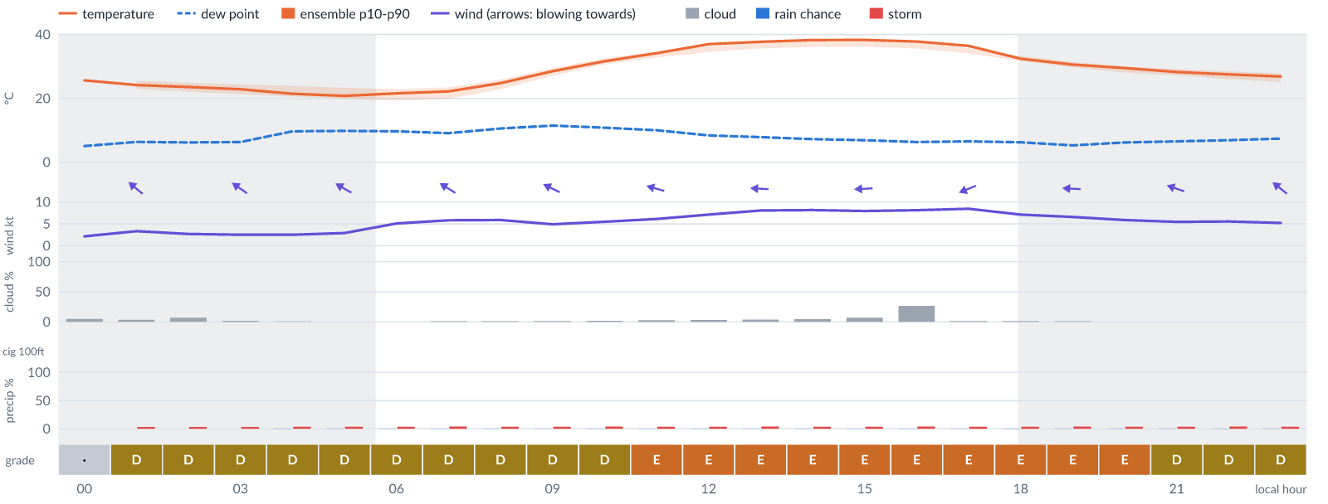
Meteogram — hourly forecast; shaded = before first light / after last light. Gaps mean no data.
Ser | Hrs | Temp | Cloud | Wind | Gust | QNH | Assessment | Driver | Remarks
(a) | (b) | (c) | (d) | (e) | (f) | (g) | (h) | (i) | (j)
1. | 0001 | 26°C | ☀ Clear (5%) | ↖ 2 kts ESE | 6 kts | 1014 | · - No data | storm 0% · visibility not forecast | ⚠ thunderstorm risk
2. | 0100 | 24 (23–26)°C | ☀ Clear (3%) | ↖ 3 (4–6) kts SE | 7 kts | 1013 | D - Marginal | storm 3% | ⚠ thunderstorm risk
3. | 0200 | 24 (22–25)°C | ☀ Clear (7%) | ↖ 3 (3–5) kts SE | 7 kts | 1013 | D - Marginal | storm 3% | ⚠ thunderstorm risk
4. | 0300 | 23 (21–24)°C | ☀ Clear (2%) | ↖ 3 (3–5) kts SE | 6 kts | 1012 | D - Marginal | storm 3% | ⚠ thunderstorm risk
5. | 0400 | 21 (21–24)°C | ☀ Clear (1%) | ↖ 3 (3–5) kts ESE | 7 kts | 1012 | D - Marginal | storm 4% | thunderstorm risk
6. | 0500 | 21 (20–23)°C | ☀ Clear (0%) | ↖ 3 (4–5) kts ESE | 6 kts | 1012 | D - Marginal | storm 4% | thunderstorm risk
7. | 0600 | 22 (19–23)°C | ☀ Clear (0%) | ↖ 5 (4–6) kts ESE | 7 kts | 1013 | D - Marginal | storm 4% | thunderstorm risk
8. | 0700 | 22 (20–23)°C | ☀ Clear (1%) | ↖ 6 (4–7) kts ESE | 9 kts | 1014 | D - Marginal | storm 4% · gust 9 kt | thunderstorm risk, gusts
9. | 0800 | 25 (23–26)°C | ☀ Clear (1%) | ↖ 6 (4–7) kts ESE | 9 kts | 1015 | D - Marginal | storm 4% · gust 9 kt | thunderstorm risk, gusts
10. | 0900 | 29 (27–29)°C | ☀ Clear (1%) | ↖ 5 (4–7) kts ESE | 9 kts | 1016 | D - Marginal | storm 4% · gust 9 kt | thunderstorm risk, gusts
11. | 1000 | 32 (31–33)°C | ☀ Clear (2%) | ← 5 (4–7) kts ESE | 11 kts | 1017 | D - Marginal | storm 4% · gust 11 kt | thunderstorm risk, gusts, wind shear
12. | 1100 | 34 (33–35)°C | ☀ Clear (3%) | ← 6 (4–8) kts ESE | 12 kts | 1016 | E - Poor | gust 12 kt | gusts, thunderstorm risk, wind shear
13. | 1200 | 37 (35–36)°C | ☀ Clear (3%) | ← 7 (5–9) kts E | 13 kts | 1015 | E - Poor | gust 13 kt | gusts, thunderstorm risk, wind shear
14. | 1300 | 38 (36–37)°C | ☀ Clear (4%) | ← 8 (6–10) kts E | 14 kts | 1014 | E - Poor | gust 14 kt | gusts, thunderstorm risk, wind shear
15. | 1400 | 38 (36–38)°C | ☀ Clear (5%) | ← 8 (6–10) kts E | 14 kts | 1013 | E - Poor | gust 14 kt | gusts, thunderstorm risk, wind shear
16. | 1500 | 38 (36–38)°C | ☀ Clear (7%) | ← 8 (7–10) kts E | 14 kts | 1013 | E - Poor | gust 14 kt | gusts, thunderstorm risk, wind shear
17. | 1600 | 38 (36–38)°C | ◔ Mostly clear (27%) | ← 8 (7–10) kts E | 13 kts | 1013 | E - Poor | gust 13 kt | gusts, thunderstorm risk, wind shear
18. | 1700 | 36 (34–36)°C | ☀ Clear (1%) | ← 8 (7–10) kts ENE | 13 kts | 1013 | E - Poor | gust 13 kt | gusts, thunderstorm risk, wind shear
19. | 1800 | 32 (32–33)°C | ☀ Clear (1%) | ← 7 (7–9) kts ENE | 13 kts | 1013 | E - Poor | gust 13 kt | gusts, thunderstorm risk, wind shear
20. | 1900 | 31 (30–31)°C | ☀ Clear (1%) | ← 7 (6–9) kts E | 13 kts | 1014 | E - Poor | gust 13 kt | gusts, thunderstorm risk, wind shear
21. | 2000 | 29 (28–30)°C | ☀ Clear (0%) | ← 6 (6–8) kts E | 12 kts | 1015 | E - Poor | gust 12 kt | gusts, thunderstorm risk, wind shear
22. | 2100 | 28 (27–29)°C | ☀ Clear (0%) | ← 5 (5–8) kts ESE | 11 kts | 1015 | D - Marginal | storm 4% · gust 11 kt | thunderstorm risk, gusts, wind shear
23. | 2200 | 27 (26–28)°C | ☀ Clear (0%) | ↖ 6 (5–8) kts ESE | 11 kts | 1015 | D - Marginal | storm 4% · gust 11 kt | thunderstorm risk, gusts, wind shear
24. | 2300 | 27 (25–28)°C | ☀ Clear (0%) | ↖ 5 (5–8) kts SE | 10 kts | 1015 | D - Marginal | storm 4% · gust 10 kt | thunderstorm risk, gusts, wind shear
Confidence: 81% — data for 24 of 24 hours; 6% of readings interpolated · first light 0606L · last light 1827L · Moon 1 % illuminated, rises 05:36, sets 17:25.

Tomorrow — Mon 9 Nov 26
Conditions are expected to be generally Marginal: clear, winds up to 9 kts E, gusting 15 kts and temperatures 22–38°C. Flyable windows: 0001–0900L (Marginal, 10 h) and 1900–2300L (Marginal, 5 h). Hazards: thunderstorm risk 0001–2300L. Overall similar to the previous day.
WEATHER EFFECTS
 | 00–06L | 06–12L | 12–18L | 18–24L
Wind | D | E | F | E
Visibility | A | A | A | A
Cloud / ceiling | A | A | A | A
Precipitation | A | A | A | A
Thunderstorm | D | D | D | D
Fog | · | · | · | ·
A Excellent · B Good · C Fair · D Marginal (flyable) · E Poor · F Very Poor · G Unacceptable · (worst condition in each period)
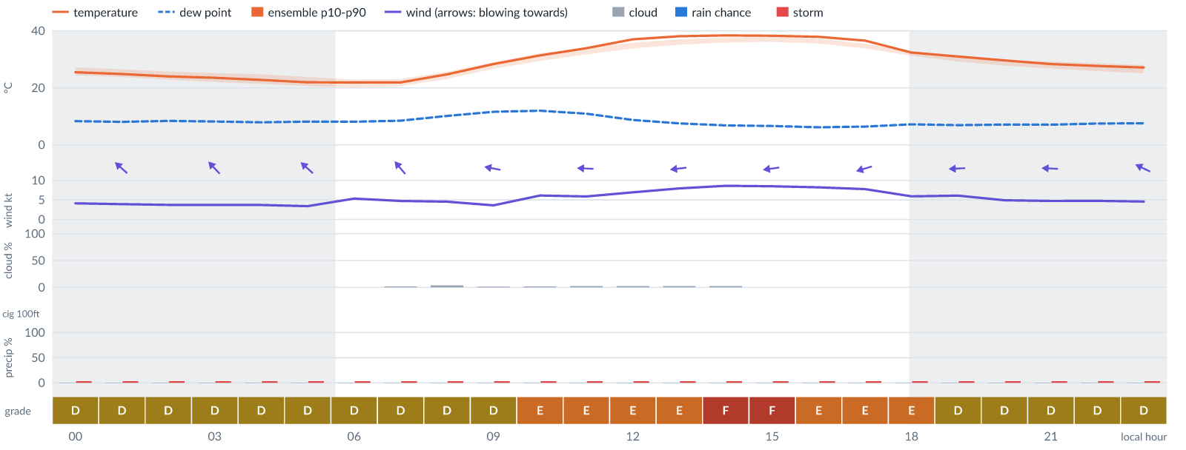
Meteogram — hourly forecast; shaded = before first light / after last light. Gaps mean no data.
Ser | Hrs | Temp | Cloud | Wind | Gust | QNH | Assessment | Driver | Remarks
(a) | (b) | (c) | (d) | (e) | (f) | (g) | (h) | (i) | (j)
1. | 0001 | 25 (24–27)°C | ☀ Clear (0%) | ↖ 4 (5–7) kts SE | 9 kts | 1015 | D - Marginal | storm 3% · gust 9 kt | thunderstorm risk, gusts, wind shear
2. | 0100 | 25 (24–26)°C | ☀ Clear (0%) | ↖ 4 (4–7) kts SE | 9 kts | 1015 | D - Marginal | storm 4% · gust 9 kt | thunderstorm risk, gusts, wind shear
3. | 0200 | 24 (23–26)°C | ☀ Clear (0%) | ↖ 4 (4–7) kts SE | 8 kts | 1014 | D - Marginal | storm 3% | thunderstorm risk
4. | 0300 | 24 (22–25)°C | ☀ Clear (0%) | ↖ 4 (4–8) kts SE | 8 kts | 1014 | D - Marginal | storm 3% | thunderstorm risk
5. | 0400 | 23 (21–25)°C | ☀ Clear (0%) | ↖ 4 (4–8) kts SE | 8 kts | 1014 | D - Marginal | storm 4% | thunderstorm risk
6. | 0500 | 22 (21–24)°C | ☀ Clear (0%) | ↖ 3 (4–8) kts SE | 9 kts | 1014 | D - Marginal | storm 3% · gust 9 kt | thunderstorm risk, gusts, wind shear
7. | 0600 | 22 (20–23)°C | ☀ Clear (0%) | ↖ 5 (3–7) kts SE | 8 kts | 1015 | D - Marginal | storm 3% | thunderstorm risk
8. | 0700 | 22 (21–23)°C | ☀ Clear (2%) | ↖ 5 (3–7) kts SE | 8 kts | 1016 | D - Marginal | storm 4% | thunderstorm risk
9. | 0800 | 25 (23–26)°C | ☀ Clear (4%) | ↖ 5 (3–7) kts SE | 8 kts | 1017 | D - Marginal | storm 3% | thunderstorm risk
10. | 0900 | 28 (27–29)°C | ☀ Clear (2%) | ← 4 (2–8) kts ESE | 8 kts | 1018 | D - Marginal | storm 3% | thunderstorm risk
11. | 1000 | 31 (29–32)°C | ☀ Clear (2%) | ← 6 (3–9) kts E | 12 kts | 1019 | E - Poor | gust 12 kt | gusts, thunderstorm risk, wind shear
12. | 1100 | 34 (32–34)°C | ☀ Clear (2%) | ← 6 (3–9) kts E | 12 kts | 1019 | E - Poor | gust 12 kt | gusts, thunderstorm risk, wind shear
13. | 1200 | 37 (34–36)°C | ☀ Clear (2%) | ← 7 (3–9) kts E | 13 kts | 1018 | E - Poor | gust 13 kt | gusts, thunderstorm risk, wind shear
14. | 1300 | 38 (35–37)°C | ☀ Clear (3%) | ← 8 (3–10) kts E | 14 kts | 1017 | E - Poor | gust 14 kt | gusts, thunderstorm risk, wind shear
15. | 1400 | 38 (36–38)°C | ☀ Clear (2%) | ← 9 (4–10) kts E | 15 kts | 1016 | F - Very Poor | gust 15 kt | gusts, thunderstorm risk, strong wind, wind shear
16. | 1500 | 38 (36–38)°C | ☀ Clear (0%) | ← 8 (6–10) kts E | 15 kts | 1015 | F - Very Poor | gust 15 kt | gusts, wind shear, thunderstorm risk
17. | 1600 | 38 (36–37)°C | ☀ Clear (0%) | ← 8 (6–10) kts ENE | 14 kts | 1015 | E - Poor | gust 14 kt | gusts, thunderstorm risk, wind shear
18. | 1700 | 37 (34–35)°C | ☀ Clear (0%) | ← 8 (6–10) kts ENE | 13 kts | 1015 | E - Poor | gust 13 kt | gusts, thunderstorm risk, wind shear
19. | 1800 | 32 (31–33)°C | ☀ Clear (0%) | ← 6 (5–9) kts E | 12 kts | 1015 | E - Poor | gust 12 kt | gusts, thunderstorm risk, wind shear
20. | 1900 | 31 (29–31)°C | ☀ Clear (0%) | ← 6 (4–8) kts E | 10 kts | 1016 | D - Marginal | storm 4% · gust 10 kt | thunderstorm risk, gusts
21. | 2000 | 30 (28–30)°C | ☀ Clear (0%) | ← 5 (4–7) kts E | 9 kts | 1017 | D - Marginal | storm 3% · gust 9 kt | thunderstorm risk, gusts
22. | 2100 | 28 (27–29)°C | ☀ Clear (0%) | ← 5 (4–7) kts E | 8 kts | 1018 | D - Marginal | storm 3% | thunderstorm risk
23. | 2200 | 28 (26–29)°C | ☀ Clear (0%) | ← 5 (4–7) kts ESE | 8 kts | 1018 | D - Marginal | storm 4% | thunderstorm risk
24. | 2300 | 27 (25–28)°C | ☀ Clear (0%) | ↖ 5 (4–6) kts ESE | 8 kts | 1018 | D - Marginal | storm 3% | thunderstorm risk
Confidence: 85% — data for 24 of 24 hours; 8% of readings interpolated · first light 0606L · last light 1827L · Moon 0 % illuminated, rises 06:27, sets 18:09.

Extended Outlook
WEATHER EFFECTS BY DAY
 | Tue | Wed | Thu | Fri | Sat | Sun | Mon | Tue | Wed | Thu | Fri | Sat
Wind | G | G | F | G | G | G | G | G | G | G | G | G
Visibility | A | A | A | A | A | A | A | A | A | A | A | A
Cloud / ceiling | F | G | F | D | A | A | A | B | F | G | C | A
Precipitation | A | A | A | A | A | A | A | A | A | A | A | A
Thunderstorm | D | D | D | D | D | D | D | D | D | D | D | D
Fog | · | · | · | · | · | · | · | · | · | · | · | ·
Overall | G | G | F | G | G | G | G | G | G | G | G | G
A Excellent · B Good · C Fair · D Marginal (flyable) · E Poor · F Very Poor · G Unacceptable · (worst condition in each period)

Tue 10 Nov 26
Conditions are expected to be generally Marginal: mostly clear, winds up to 12 kts E, gusting 21 kts and temperatures 21–38°C. Flyable windows: 0001–0400L (Marginal, 5 h) and 1800–2300L (Marginal, 6 h). Hazards: thunderstorm risk 0001–2300L. Overall similar to the previous day.
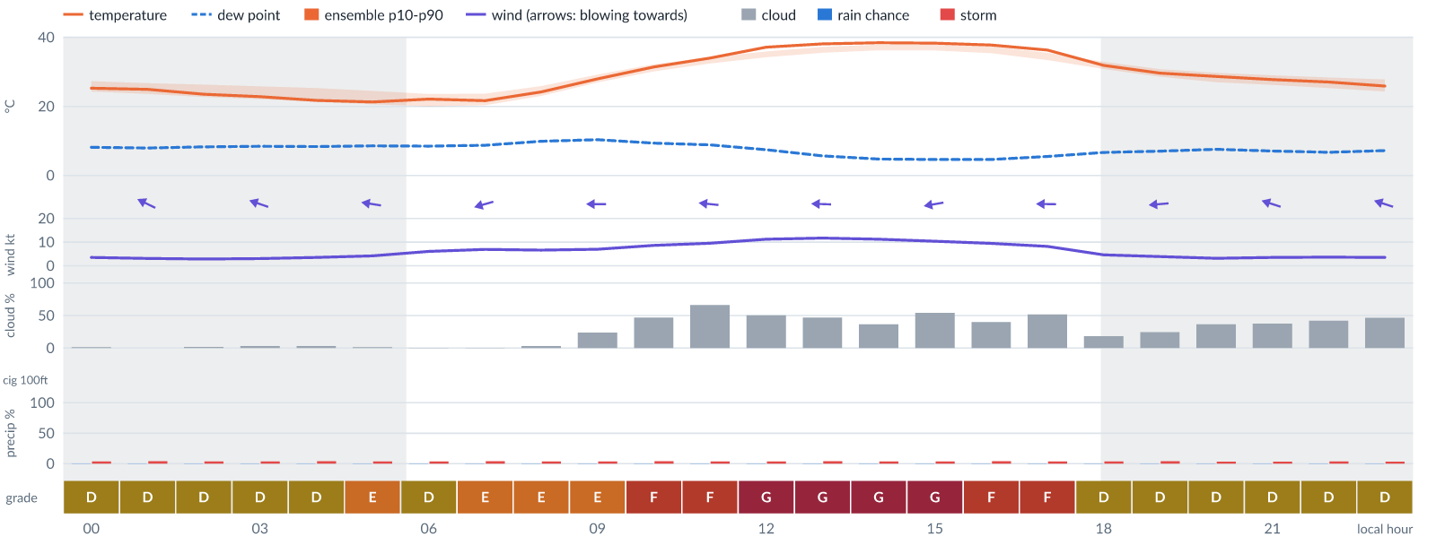
Meteogram — hourly forecast; shaded = before first light / after last light. Gaps mean no data.
Ser | Hrs | Temp | Cloud | Wind | Gust | QNH | Assessment | Driver | Remarks
(a) | (b) | (c) | (d) | (e) | (f) | (g) | (h) | (i) | (j)
1. | 0001 | 25 (24–27)°C | ☀ Clear (1%) | ↖ 4 (4–6) kts ESE | 8 kts | 1017 | D - Marginal | storm 4% | thunderstorm risk
2. | 0100 | 25 (24–27)°C | ☀ Clear (0%) | ↖ 3 (4–6) kts ESE | 7 kts | 1017 | D - Marginal | storm 4% | thunderstorm risk
3. | 0200 | 24 (23–26)°C | ☀ Clear (2%) | ↖ 3 (3–6) kts ESE | 8 kts | 1016 | D - Marginal | storm 4% · gust spread +5 kt | thunderstorm risk, wind shear
4. | 0300 | 23 (22–26)°C | ☀ Clear (3%) | ← 3 (3–7) kts ESE | 8 kts | 1015 | D - Marginal | storm 4% · gust spread +5 kt | thunderstorm risk, wind shear
5. | 0400 | 22 (21–25)°C | ☀ Clear (3%) | ← 4 (3–8) kts ESE | 10 kts | 1015 | D - Marginal | storm 4% · gust 10 kt | thunderstorm risk, gusts, wind shear
6. | 0500 | 21 (21–24)°C | ☀ Clear (1%) | ← 4 (3–8) kts E | 11 kts | 1016 | E - Poor | gust spread +7 kt | wind shear, thunderstorm risk, gusts
7. | 0600 | 22 (20–24)°C | ☀ Clear (0%) | ← 6 (4–8) kts ESE | 11 kts | 1016 | D - Marginal | storm 4% · gust 11 kt | thunderstorm risk, gusts, wind shear
8. | 0700 | 22 (20–24)°C | ☀ Clear (0%) | ← 7 (4–8) kts ENE | 12 kts | 1017 | E - Poor | gust 12 kt | gusts, thunderstorm risk, wind shear
9. | 0800 | 24 (23–26)°C | ☀ Clear (3%) | ← 7 (4–9) kts E | 13 kts | 1018 | E - Poor | gust 13 kt | gusts, thunderstorm risk, wind shear
10. | 0900 | 28 (27–29)°C | ◔ Mostly clear (24%) | ← 7 (3–11) kts E | 13 kts | 1019 | E - Poor | gust 13 kt | gusts, thunderstorm risk, wind shear
11. | 1000 | 31 (30–32)°C | ◑ Partly cloudy (47%) | ← 9 (4–12) kts E | 15 kts | 1020 | F - Very Poor | gust 15 kt | gusts, cloud cover, thunderstorm risk, strong wind, wind shear
12. | 1100 | 34 (32–34)°C | ◕ Cloudy (66%) | ← 10 (5–12) kts E | 17 kts | 1019 | F - Very Poor | cloud 66% · gust 17 kt | cloud cover, gusts, wind shear, thunderstorm risk, strong wind
13. | 1200 | 37 (34–36)°C | ◑ Partly cloudy (50%) | ← 11 (7–13) kts E | 18 kts | 1018 | G - Unacceptable | gust 18 kt | gusts, wind shear, cloud cover, thunderstorm risk, strong wind
14. | 1300 | 38 (36–37)°C | ◑ Partly cloudy (47%) | ← 12 (9–14) kts E | 21 kts | 1017 | G - Unacceptable | gust 21 kt | gusts, wind shear, strong wind, cloud cover, thunderstorm risk
15. | 1400 | 38 (36–38)°C | ◔ Partly cloudy (37%) | ← 11 (9–13) kts E | 19 kts | 1016 | G - Unacceptable | gust 19 kt | gusts, wind shear, thunderstorm risk, strong wind
16. | 1500 | 38 (36–38)°C | ◑ Partly cloudy (54%) | ← 10 (8–12) kts E | 19 kts | 1015 | G - Unacceptable | gust 19 kt | gusts, wind shear, cloud cover, thunderstorm risk, strong wind
17. | 1600 | 38 (35–37)°C | ◑ Partly cloudy (40%) | ← 10 (8–11) kts E | 17 kts | 1015 | F - Very Poor | gust 17 kt | gusts, wind shear, thunderstorm risk, strong wind
18. | 1700 | 36 (33–36)°C | ◑ Partly cloudy (52%) | ← 8 (7–10) kts E | 15 kts | 1015 | F - Very Poor | gust 15 kt | gusts, cloud cover, wind shear, thunderstorm risk
19. | 1800 | 32 (31–33)°C | ◔ Mostly clear (18%) | ← 5 (5–8) kts E | 11 kts | 1015 | D - Marginal | storm 4% · gust 11 kt | thunderstorm risk, gusts, wind shear
20. | 1900 | 30 (29–31)°C | ◔ Mostly clear (25%) | ← 4 (3–8) kts E | 8 kts | 1015 | D - Marginal | storm 4% | thunderstorm risk
21. | 2000 | 29 (27–30)°C | ◔ Partly cloudy (37%) | ← 3 (3–7) kts E | 6 kts | 1016 | D - Marginal | storm 4% | thunderstorm risk
22. | 2100 | 28 (26–29)°C | ◑ Partly cloudy (38%) | ← 4 (4–7) kts ESE | 6 kts | 1017 | D - Marginal | storm 4% | thunderstorm risk
23. | 2200 | 27 (25–28)°C | ◑ Partly cloudy (42%) | ↖ 4 (4–7) kts ESE | 7 kts | 1017 | D - Marginal | storm 4% | thunderstorm risk
24. | 2300 | 26 (24–28)°C | ◑ Partly cloudy (47%) | ← 4 (4–7) kts ESE | 7 kts | 1017 | D - Marginal | storm 4% · cloud 47% | cloud cover, thunderstorm risk
Confidence: 82% — data for 24 of 24 hours; 10% of readings interpolated · first light 0606L · last light 1827L · Moon 2 % illuminated, rises 07:20, sets 18:56.

Wed 11 Nov 26
Conditions are expected to be generally Unacceptable: overcast, winds up to 11 kts ESE, gusting 18 kts and temperatures 22–37°C. No flyable windows (Marginal or better, ≥2 consecutive hrs) are forecast. Hazards: thunderstorm risk 0001–2300L. Overall a deterioration from the previous day.
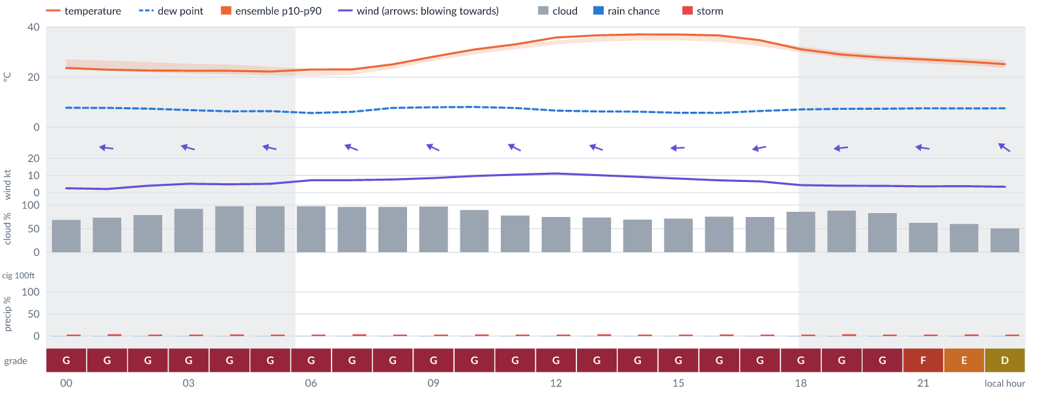
Meteogram — hourly forecast; shaded = before first light / after last light. Gaps mean no data.
Ser | Hrs | Temp | Cloud | Wind | Gust | QNH | Assessment | Driver | Remarks
(a) | (b) | (c) | (d) | (e) | (f) | (g) | (h) | (i) | (j)
1. | 0001 | 24 (23–27)°C | ◕ Cloudy (69%) | ← 3 (3–7) kts ESE | 7 kts | 1016 | G - Unacceptable | cloud 69% | cloud cover, thunderstorm risk
2. | 0100 | 23 (23–27)°C | ◕ Cloudy (74%) | ← 2 (3–7) kts E | 7 kts | 1016 | G - Unacceptable | cloud 74% | cloud cover, thunderstorm risk, wind shear
3. | 0200 | 23 (22–26)°C | ◕ Cloudy (79%) | ← 4 (3–8) kts E | 10 kts | 1016 | G - Unacceptable | cloud 79% | cloud cover, thunderstorm risk, gusts, wind shear
4. | 0300 | 23 (22–25)°C | ☁ Overcast (92%) | ← 5 (4–8) kts ESE | 12 kts | 1016 | G - Unacceptable | cloud 92% | cloud cover, gusts, wind shear, thunderstorm risk
5. | 0400 | 22 (21–25)°C | ☁ Overcast (97%) | ← 5 (4–9) kts ESE | 13 kts | 1016 | G - Unacceptable | cloud 97% | cloud cover, gusts, wind shear, thunderstorm risk
6. | 0500 | 22 (21–24)°C | ☁ Overcast (98%) | ← 5 (5–9) kts ESE | 13 kts | 1016 | G - Unacceptable | cloud 98% | cloud cover, gusts, wind shear, thunderstorm risk
7. | 0600 | 23 (20–23)°C | ☁ Overcast (98%) | ← 7 (4–9) kts ESE | 14 kts | 1016 | G - Unacceptable | cloud 98% | cloud cover, gusts, wind shear, thunderstorm risk
8. | 0700 | 23 (21–24)°C | ☁ Overcast (96%) | ← 7 (4–9) kts ESE | 14 kts | 1017 | G - Unacceptable | cloud 96% | cloud cover, gusts, wind shear, thunderstorm risk
9. | 0800 | 25 (23–25)°C | ☁ Overcast (96%) | ← 8 (4–10) kts ESE | 15 kts | 1018 | G - Unacceptable | cloud 96% | cloud cover, gusts, wind shear, thunderstorm risk
10. | 0900 | 28 (27–28)°C | ☁ Overcast (97%) | ↖ 9 (4–12) kts ESE | 16 kts | 1019 | G - Unacceptable | cloud 97% | cloud cover, gusts, wind shear, thunderstorm risk, strong wind
11. | 1000 | 31 (29–31)°C | ☁ Overcast (90%) | ↖ 10 (5–13) kts ESE | 18 kts | 1019 | G - Unacceptable | cloud 90% · gust 18 kt | cloud cover, gusts, wind shear, thunderstorm risk, strong wind
12. | 1100 | 33 (31–33)°C | ◕ Cloudy (78%) | ↖ 11 (5–13) kts ESE | 18 kts | 1019 | G - Unacceptable | cloud 78% · gust 18 kt | cloud cover, gusts, wind shear, thunderstorm risk, strong wind
13. | 1200 | 36 (33–35)°C | ◕ Cloudy (75%) | ↖ 11 (5–12) kts ESE | 18 kts | 1017 | G - Unacceptable | cloud 75% · gust 18 kt | cloud cover, gusts, wind shear, thunderstorm risk, strong wind
14. | 1300 | 37 (34–36)°C | ◕ Cloudy (74%) | ← 10 (6–11) kts ESE | 17 kts | 1017 | G - Unacceptable | cloud 74% | cloud cover, gusts, wind shear, thunderstorm risk, strong wind
15. | 1400 | 37 (35–37)°C | ◕ Cloudy (69%) | ← 9 (6–11) kts E | 16 kts | 1016 | G - Unacceptable | cloud 69% | cloud cover, gusts, wind shear, thunderstorm risk, strong wind
16. | 1500 | 37 (35–37)°C | ◕ Cloudy (71%) | ← 8 (5–10) kts E | 16 kts | 1015 | G - Unacceptable | cloud 71% | cloud cover, gusts, wind shear, thunderstorm risk
17. | 1600 | 37 (34–36)°C | ◕ Cloudy (75%) | ← 7 (5–10) kts ENE | 15 kts | 1014 | G - Unacceptable | cloud 75% | cloud cover, gusts, wind shear, thunderstorm risk
18. | 1700 | 35 (32–35)°C | ◕ Cloudy (75%) | ← 7 (5–9) kts ENE | 12 kts | 1015 | G - Unacceptable | cloud 75% | cloud cover, gusts, thunderstorm risk, wind shear
19. | 1800 | 31 (30–32)°C | ◕ Cloudy (86%) | ← 4 (4–8) kts E | 10 kts | 1016 | G - Unacceptable | cloud 86% | cloud cover, thunderstorm risk, gusts, wind shear
20. | 1900 | 29 (28–30)°C | ☁ Cloudy (88%) | ← 4 (3–7) kts E | 8 kts | 1016 | G - Unacceptable | cloud 88% | cloud cover, thunderstorm risk
21. | 2000 | 28 (26–29)°C | ◕ Cloudy (83%) | ← 4 (3–7) kts E | 8 kts | 1016 | G - Unacceptable | cloud 83% | cloud cover, thunderstorm risk
22. | 2100 | 27 (26–28)°C | ◕ Cloudy (63%) | ← 4 (3–7) kts E | 10 kts | 1016 | F - Very Poor | cloud 63% | cloud cover, thunderstorm risk, gusts, wind shear
23. | 2200 | 26 (25–27)°C | ◑ Cloudy (60%) | ← 4 (3–8) kts ESE | 10 kts | 1016 | E - Poor | cloud 60% | cloud cover, thunderstorm risk, gusts, wind shear
24. | 2300 | 25 (24–27)°C | ◑ Partly cloudy (51%) | ↖ 3 (3–7) kts SE | 9 kts | 1017 | D - Marginal | storm 4% · cloud 51% | cloud cover, thunderstorm risk, gusts, wind shear
Confidence: 81% — data for 24 of 24 hours; 17% of readings interpolated · first light 0607L · last light 1827L · Moon 5 % illuminated, rises 08:13, sets 19:46.

Thu 12 Nov 26
Conditions are expected to be generally Marginal: partly cloudy, winds up to 8 kts ESE, gusting 15 kts and temperatures 20–36°C. Flyable windows: 0001–0200L (Marginal, 3 h), 0600–0700L (Marginal, 2 h), 1700–1900L (Marginal, 3 h) and 2100–2300L (Marginal, 3 h). Hazards: thunderstorm risk 0001–2300L. Overall an improvement on the previous day.
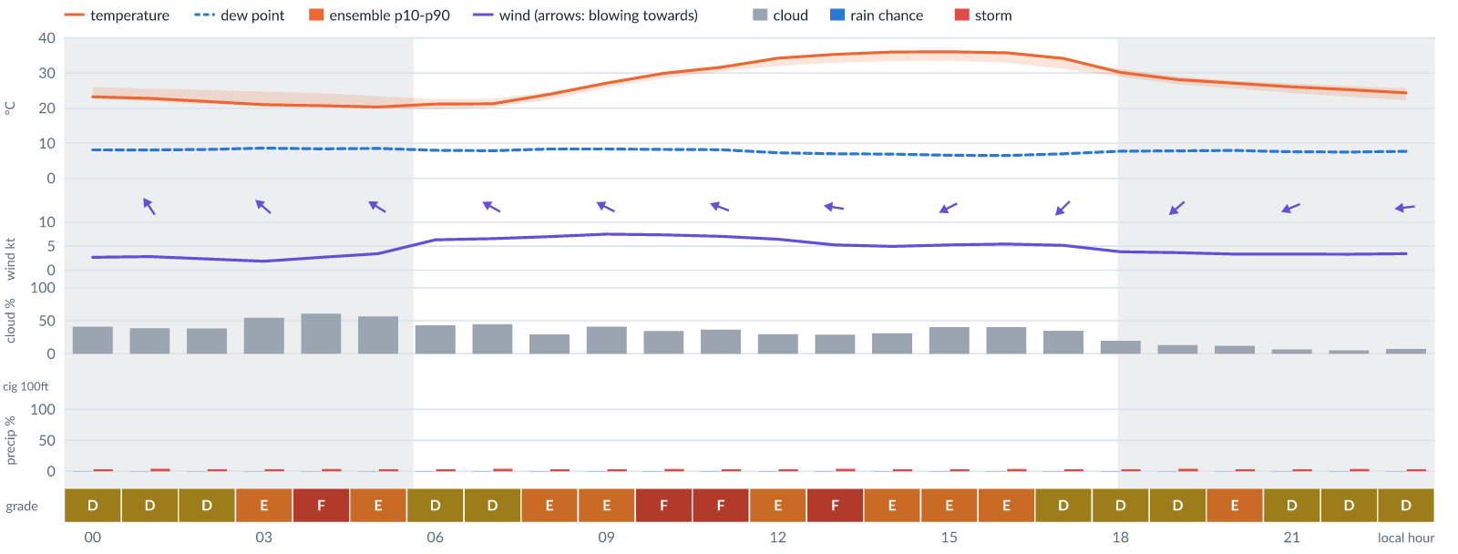
Meteogram — hourly forecast; shaded = before first light / after last light. Gaps mean no data.
Ser | Hrs | Temp | Cloud | Wind | Gust | QNH | Assessment | Driver | Remarks
(a) | (b) | (c) | (d) | (e) | (f) | (g) | (h) | (i) | (j)
1. | 0001 | 23 (23–26)°C | ◑ Partly cloudy (41%) | ↖ 3 (3–7) kts SE | 8 kts | 1016 | D - Marginal | storm 4% · gust spread +6 kt | thunderstorm risk, wind shear
2. | 0100 | 23 (22–26)°C | ◑ Partly cloudy (39%) | ↖ 3 (3–7) kts SE | 8 kts | 1016 | D - Marginal | storm 4% · gust spread +5 kt | thunderstorm risk, wind shear
3. | 0200 | 22 (21–25)°C | ◑ Partly cloudy (38%) | ↖ 2 (2–8) kts SE | 7 kts | 1016 | D - Marginal | storm 4% · gust spread +5 kt | thunderstorm risk, wind shear
4. | 0300 | 21 (21–25)°C | ◑ Partly cloudy (54%) | ↖ 2 (2–9) kts SE | 7 kts | 1015 | E - Poor | cloud 54% | cloud cover, thunderstorm risk, wind shear
5. | 0400 | 21 (20–24)°C | ◑ Cloudy (61%) | ↖ 3 (3–9) kts SE | 8 kts | 1015 | F - Very Poor | cloud 61% | cloud cover, thunderstorm risk, wind shear
6. | 0500 | 20 (20–23)°C | ◑ Partly cloudy (56%) | ↖ 3 (4–9) kts ESE | 7 kts | 1016 | E - Poor | cloud 56% | cloud cover, thunderstorm risk
7. | 0600 | 21 (20–23)°C | ◑ Partly cloudy (43%) | ↖ 6 (5–9) kts ESE | 10 kts | 1016 | D - Marginal | storm 4% · cloud 43% | cloud cover, thunderstorm risk, gusts
8. | 0700 | 21 (20–23)°C | ◑ Partly cloudy (45%) | ↖ 7 (6–10) kts ESE | 11 kts | 1017 | D - Marginal | storm 4% · cloud 45% | cloud cover, thunderstorm risk, gusts
9. | 0800 | 24 (22–25)°C | ◔ Mostly clear (30%) | ↖ 7 (7–11) kts ESE | 13 kts | 1017 | E - Poor | gust 13 kt | gusts, thunderstorm risk, wind shear
10. | 0900 | 27 (26–27)°C | ◑ Partly cloudy (41%) | ↖ 8 (7–12) kts ESE | 14 kts | 1018 | E - Poor | gust 14 kt | gusts, thunderstorm risk, wind shear
11. | 1000 | 30 (29–30)°C | ◔ Partly cloudy (35%) | ↖ 7 (7–12) kts ESE | 15 kts | 1019 | F - Very Poor | gust 15 kt | gusts, wind shear, thunderstorm risk
12. | 1100 | 32 (30–32)°C | ◔ Partly cloudy (37%) | ← 7 (7–12) kts ESE | 15 kts | 1019 | F - Very Poor | gust 15 kt | gusts, wind shear, thunderstorm risk
13. | 1200 | 34 (32–34)°C | ◔ Mostly clear (30%) | ← 6 (5–11) kts ESE | 14 kts | 1017 | E - Poor | gust 14 kt · gust spread +8 kt | gusts, wind shear, thunderstorm risk
14. | 1300 | 35 (33–35)°C | ◔ Mostly clear (29%) | ← 5 (4–10) kts E | 14 kts | 1017 | F - Very Poor | gust spread +9 kt | wind shear, gusts, thunderstorm risk
15. | 1400 | 36 (33–36)°C | ◔ Mostly clear (31%) | ← 5 (4–9) kts E | 13 kts | 1016 | E - Poor | gust 13 kt · gust spread +8 kt | gusts, wind shear, thunderstorm risk
16. | 1500 | 36 (34–36)°C | ◑ Partly cloudy (41%) | ↙ 5 (4–9) kts ENE | 13 kts | 1015 | E - Poor | gust 13 kt · gust spread +7 kt | gusts, wind shear, thunderstorm risk
17. | 1600 | 36 (33–35)°C | ◑ Partly cloudy (40%) | ↙ 5 (4–10) kts NE | 12 kts | 1015 | E - Poor | gust 12 kt · gust spread +6 kt | gusts, wind shear, thunderstorm risk
18. | 1700 | 34 (31–34)°C | ◔ Partly cloudy (35%) | ↙ 5 (4–9) kts NE | 11 kts | 1014 | D - Marginal | storm 4% · gust 11 kt | thunderstorm risk, gusts, wind shear
19. | 1800 | 30 (29–31)°C | ◔ Mostly clear (20%) | ↙ 4 (4–8) kts NE | 10 kts | 1015 | D - Marginal | storm 4% · gust 10 kt | thunderstorm risk, gusts, wind shear
20. | 1900 | 28 (27–29)°C | ◔ Mostly clear (13%) | ↙ 4 (4–7) kts NE | 10 kts | 1015 | D - Marginal | storm 4% · gust 10 kt | thunderstorm risk, gusts, wind shear
21. | 2000 | 27 (26–28)°C | ☀ Clear (12%) | ↙ 3 (3–7) kts ENE | 10 kts | 1016 | E - Poor | gust spread +6 kt | wind shear, thunderstorm risk, gusts
22. | 2100 | 26 (24–27)°C | ☀ Clear (7%) | ↙ 3 (3–7) kts ENE | 9 kts | 1016 | D - Marginal | storm 4% · gust 9 kt | thunderstorm risk, gusts, wind shear
23. | 2200 | 25 (23–26)°C | ☀ Clear (5%) | ← 3 (3–7) kts ENE | 8 kts | 1016 | D - Marginal | storm 4% · gust spread +5 kt | thunderstorm risk, wind shear
24. | 2300 | 24 (22–26)°C | ☀ Clear (7%) | ← 3 (3–7) kts E | 8 kts | 1016 | D - Marginal | storm 4% · gust spread +4 kt | thunderstorm risk, wind shear
Confidence: 81% — data for 24 of 24 hours; 16% of readings interpolated · first light 0607L · last light 1827L · Moon 9 % illuminated, rises 09:06, sets 20:37.

Fri 13 Nov 26
Conditions are expected to be generally Very Poor: mostly clear, winds up to 10 kts E, gusting 19 kts and temperatures 19–35°C. Flyable windows: 0001–0300L (Marginal, 4 h). Hazards: thunderstorm risk 0001–2300L. Overall a deterioration from the previous day.
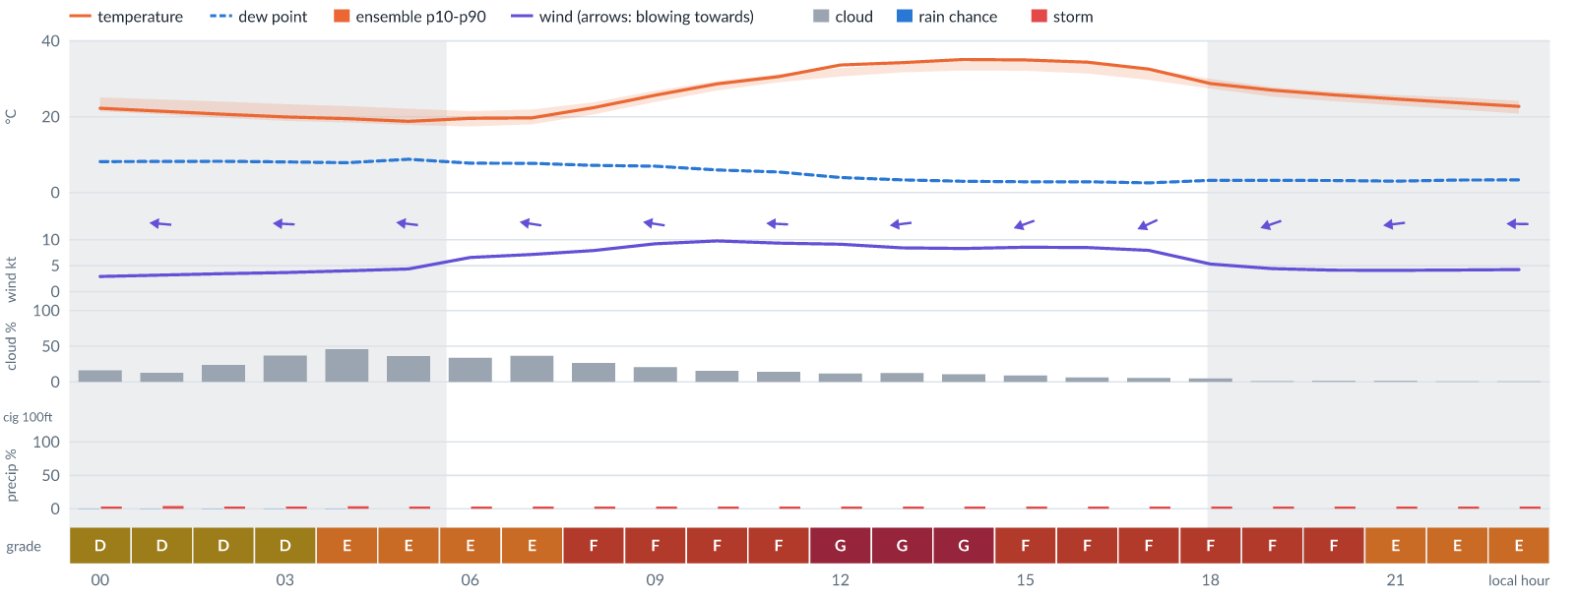
Meteogram — hourly forecast; shaded = before first light / after last light. Gaps mean no data.
Ser | Hrs | Temp | Cloud | Wind | Gust | QNH | Assessment | Driver | Remarks
(a) | (b) | (c) | (d) | (e) | (f) | (g) | (h) | (i) | (j)
1. | 0001 | 22 (21–25)°C | ◔ Mostly clear (16%) | ← 3 (3–7) kts E | 8 kts | 1016 | D - Marginal | storm 4% · gust spread +5 kt | thunderstorm risk, wind shear
2. | 0100 | 21 (21–25)°C | ◔ Mostly clear (13%) | ← 3 (4–7) kts E | 8 kts | 1015 | D - Marginal | storm 4% · gust spread +4 kt | thunderstorm risk, wind shear
3. | 0200 | 21 (20–24)°C | ◔ Mostly clear (24%) | ← 3 (4–7) kts E | 9 kts | 1015 | D - Marginal | storm 4% · gust 9 kt | thunderstorm risk, gusts, wind shear
4. | 0300 | 20 (19–23)°C | ◔ Partly cloudy (37%) | ← 4 (4–7) kts E | 9 kts | 1015 | D - Marginal | storm 4% · gust 9 kt | thunderstorm risk, gusts, wind shear
5. | 0400 | 20 (19–23)°C | ◑ Partly cloudy (46%) | ← 4 (4–8) kts E | 11 kts | 1015 | E - Poor | gust spread +7 kt | wind shear, cloud cover, thunderstorm risk, gusts
6. | 0500 | 19 (18–22)°C | ◔ Partly cloudy (36%) | ← 4 (5–8) kts E | 12 kts | 1015 | E - Poor | gust 12 kt · gust spread +8 kt | gusts, wind shear, thunderstorm risk
7. | 0600 | 20 (17–22)°C | ◔ Partly cloudy (34%) | ← 7 (5–9) kts E | 13 kts | 1016 | E - Poor | gust 13 kt | gusts, thunderstorm risk, wind shear
8. | 0700 | 20 (18–22)°C | ◔ Partly cloudy (37%) | ← 7 (6–9) kts E | 14 kts | 1016 | E - Poor | gust 14 kt · gust spread +7 kt | gusts, wind shear, thunderstorm risk
9. | 0800 | 22 (21–24)°C | ◔ Mostly clear (26%) | ← 8 (6–10) kts E | 15 kts | 1018 | F - Very Poor | gust 15 kt | gusts, wind shear, thunderstorm risk
10. | 0900 | 26 (24–27)°C | ◔ Mostly clear (21%) | ← 9 (7–12) kts E | 15 kts | 1018 | F - Very Poor | gust 15 kt | gusts, thunderstorm risk, strong wind, wind shear
11. | 1000 | 29 (27–29)°C | ◔ Mostly clear (15%) | ← 10 (7–12) kts E | 16 kts | 1018 | F - Very Poor | gust 16 kt | gusts, thunderstorm risk, strong wind, wind shear
12. | 1100 | 31 (29–31)°C | ◔ Mostly clear (14%) | ← 9 (7–12) kts E | 17 kts | 1018 | F - Very Poor | gust 17 kt | gusts, wind shear, thunderstorm risk, strong wind
13. | 1200 | 34 (31–33)°C | ☀ Clear (12%) | ← 9 (6–12) kts E | 18 kts | 1017 | G - Unacceptable | gust 18 kt | gusts, wind shear, thunderstorm risk, strong wind
14. | 1300 | 34 (32–34)°C | ☀ Clear (12%) | ← 8 (5–12) kts E | 19 kts | 1016 | G - Unacceptable | gust 19 kt · gust spread +10 kt | gusts, wind shear, thunderstorm risk
15. | 1400 | 35 (32–35)°C | ☀ Clear (11%) | ← 8 (5–12) kts ENE | 19 kts | 1015 | G - Unacceptable | gust 19 kt · gust spread +10 kt | gusts, wind shear, thunderstorm risk
16. | 1500 | 35 (32–35)°C | ☀ Clear (9%) | ← 9 (5–12) kts ENE | 17 kts | 1015 | F - Very Poor | gust 17 kt | gusts, wind shear, thunderstorm risk, strong wind
17. | 1600 | 34 (31–35)°C | ☀ Clear (6%) | ↙ 9 (5–12) kts ENE | 17 kts | 1015 | F - Very Poor | gust 17 kt | gusts, wind shear, thunderstorm risk, strong wind
18. | 1700 | 33 (30–33)°C | ☀ Clear (5%) | ↙ 8 (5–11) kts ENE | 16 kts | 1015 | F - Very Poor | gust 16 kt | gusts, wind shear, thunderstorm risk
19. | 1800 | 29 (27–30)°C | ☀ Clear (5%) | ← 5 (5–9) kts ENE | 14 kts | 1015 | F - Very Poor | gust spread +8 kt | wind shear, gusts, thunderstorm risk
20. | 1900 | 27 (25–28)°C | ☀ Clear (1%) | ← 4 (4–7) kts ENE | 13 kts | 1015 | F - Very Poor | gust spread +8 kt | wind shear, gusts, thunderstorm risk
21. | 2000 | 26 (24–27)°C | ☀ Clear (1%) | ← 4 (4–7) kts E | 13 kts | 1016 | F - Very Poor | gust spread +8 kt | wind shear, gusts, thunderstorm risk
22. | 2100 | 25 (23–26)°C | ☀ Clear (1%) | ← 4 (4–7) kts E | 12 kts | 1016 | E - Poor | gust 12 kt · gust spread +8 kt | gusts, wind shear, thunderstorm risk
23. | 2200 | 24 (22–25)°C | ☀ Clear (1%) | ← 4 (4–7) kts E | 12 kts | 1016 | E - Poor | gust 12 kt · gust spread +8 kt | gusts, wind shear, thunderstorm risk
24. | 2300 | 23 (21–24)°C | ☀ Clear (1%) | ← 4 (4–7) kts E | 11 kts | 1016 | E - Poor | gust spread +7 kt | wind shear, thunderstorm risk, gusts
Confidence: 78% — data for 24 of 24 hours; 13% of readings interpolated · first light 0607L · last light 1827L · Moon 15 % illuminated, rises 09:56, sets 21:29.

Sat 14 Nov 26
Conditions are expected to be generally Unacceptable: clear, winds up to 10 kts E, gusting 20 kts and temperatures 17–34°C. Flyable windows: 0100–0500L (Marginal, 5 h). Hazards: thunderstorm risk 0001–2300L. Overall a deterioration from the previous day.
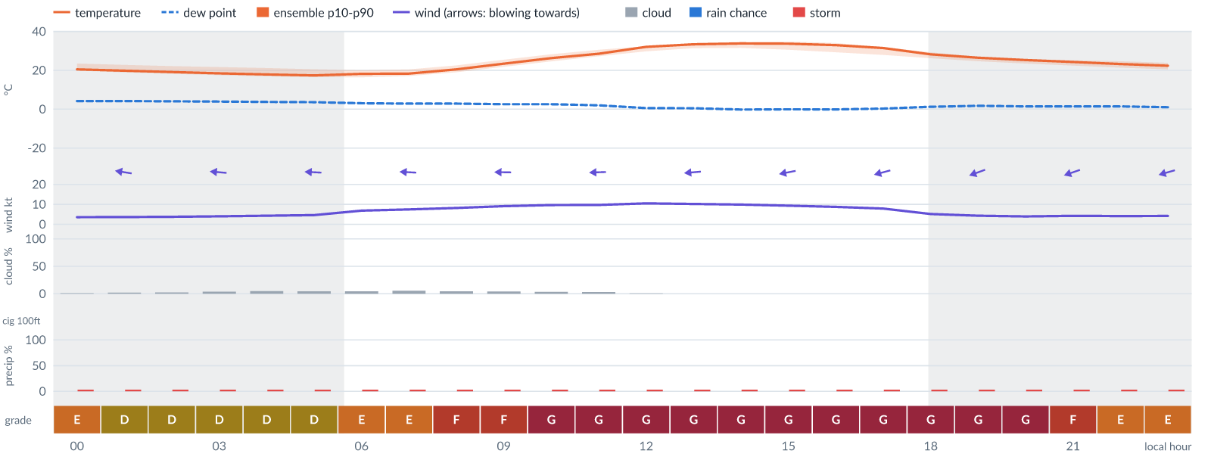
Meteogram — hourly forecast; shaded = before first light / after last light. Gaps mean no data.
Ser | Hrs | Temp | Cloud | Wind | Gust | QNH | Assessment | Driver | Remarks
(a) | (b) | (c) | (d) | (e) | (f) | (g) | (h) | (i) | (j)
1. | 0001 | 20 (20–24)°C | ☀ Clear (1%) | ← 4 (4–7) kts E | 11 kts | 1016 | E - Poor | gust spread +7 kt | wind shear, thunderstorm risk, gusts
2. | 0100 | 20 (19–23)°C | ☀ Clear (2%) | ← 4 (4–7) kts E | 10 kts | 1016 | D - Marginal | storm 4% · gust 10 kt | ⚠ thunderstorm risk, gusts, wind shear
3. | 0200 | 19 (18–22)°C | ☀ Clear (2%) | ← 4 (4–7) kts E | 10 kts | 1015 | D - Marginal | storm 3% · gust 10 kt | ⚠ thunderstorm risk, gusts, wind shear
4. | 0300 | 18 (18–22)°C | ☀ Clear (4%) | ← 4 (5–8) kts E | 10 kts | 1015 | D - Marginal | storm 3% · gust 10 kt | ⚠ thunderstorm risk, gusts, wind shear
5. | 0400 | 18 (17–21)°C | ☀ Clear (5%) | ← 4 (5–8) kts E | 10 kts | 1015 | D - Marginal | storm 3% · gust 10 kt | ⚠ thunderstorm risk, gusts, wind shear
6. | 0500 | 17 (17–21)°C | ☀ Clear (4%) | ← 5 (6–9) kts E | 11 kts | 1016 | D - Marginal | storm 3% · gust 11 kt | ⚠ thunderstorm risk, gusts, wind shear
7. | 0600 | 18 (16–20)°C | ☀ Clear (5%) | ← 7 (6–9) kts E | 12 kts | 1017 | E - Poor | gust 12 kt | gusts, thunderstorm risk, wind shear
8. | 0700 | 18 (17–20)°C | ☀ Clear (5%) | ← 7 (6–10) kts E | 14 kts | 1017 | E - Poor | gust 14 kt · gust spread +6 kt | gusts, wind shear, thunderstorm risk
9. | 0800 | 21 (19–23)°C | ☀ Clear (4%) | ← 8 (7–10) kts E | 15 kts | 1017 | F - Very Poor | gust 15 kt | gusts, wind shear, thunderstorm risk
10. | 0900 | 23 (22–25)°C | ☀ Clear (4%) | ← 9 (7–12) kts E | 16 kts | 1017 | F - Very Poor | gust 16 kt | gusts, wind shear, thunderstorm risk, strong wind
11. | 1000 | 26 (25–28)°C | ☀ Clear (3%) | ← 10 (8–14) kts E | 18 kts | 1018 | G - Unacceptable | gust 18 kt | gusts, wind shear, thunderstorm risk, strong wind
12. | 1100 | 29 (27–31)°C | ☀ Clear (3%) | ← 10 (8–14) kts E | 18 kts | 1017 | G - Unacceptable | gust 18 kt | gusts, wind shear, thunderstorm risk, strong wind
13. | 1200 | 32 (30–32)°C | ☀ Clear (1%) | ← 10 (8–13) kts E | 20 kts | 1017 | G - Unacceptable | gust 20 kt · gust spread +10 kt | gusts, wind shear, thunderstorm risk, strong wind
14. | 1300 | 33 (31–34)°C | ☀ Clear (0%) | ← 10 (7–13) kts E | 20 kts | 1017 | G - Unacceptable | gust 20 kt · gust spread +9 kt | gusts, wind shear, thunderstorm risk, strong wind
15. | 1400 | 34 (32–35)°C | ☀ Clear (0%) | ← 10 (7–13) kts E | 20 kts | 1016 | G - Unacceptable | gust 20 kt · gust spread +10 kt | gusts, wind shear, thunderstorm risk, strong wind
16. | 1500 | 34 (31–35)°C | ☀ Clear (0%) | ← 9 (7–13) kts E | 20 kts | 1016 | G - Unacceptable | gust 20 kt · gust spread +10 kt | gusts, wind shear, thunderstorm risk, strong wind
17. | 1600 | 33 (29–34)°C | ☀ Clear (0%) | ← 9 (6–12) kts ENE | 19 kts | 1015 | G - Unacceptable | gust 19 kt · gust spread +10 kt | gusts, wind shear, thunderstorm risk, strong wind
18. | 1700 | 31 (28–32)°C | ☀ Clear (0%) | ← 8 (5–10) kts ENE | 18 kts | 1015 | G - Unacceptable | gust 18 kt · gust spread +10 kt | gusts, wind shear, thunderstorm risk
19. | 1800 | 28 (26–29)°C | ☀ Clear (0%) | ← 5 (4–8) kts ENE | 17 kts | 1015 | G - Unacceptable | gust spread +11 kt | wind shear, gusts, thunderstorm risk
20. | 1900 | 26 (25–27)°C | ☀ Clear (0%) | ← 4 (4–7) kts ENE | 17 kts | 1015 | G - Unacceptable | gust spread +13 kt | wind shear, gusts, thunderstorm risk
21. | 2000 | 25 (24–26)°C | ☀ Clear (0%) | ← 4 (4–6) kts ENE | 16 kts | 1015 | G - Unacceptable | gust spread +12 kt | wind shear, gusts, thunderstorm risk
22. | 2100 | 24 (22–25)°C | ☀ Clear (0%) | ← 4 (4–7) kts ENE | 13 kts | 1015 | F - Very Poor | gust spread +9 kt | wind shear, gusts, thunderstorm risk
23. | 2200 | 23 (21–25)°C | ☀ Clear (0%) | ← 4 (4–7) kts ENE | 12 kts | 1016 | E - Poor | gust 12 kt · gust spread +8 kt | gusts, wind shear, thunderstorm risk
24. | 2300 | 22 (21–24)°C | ☀ Clear (0%) | ← 4 (4–7) kts ENE | 11 kts | 1016 | E - Poor | gust spread +7 kt | wind shear, thunderstorm risk, gusts
Confidence: 77% — data for 24 of 24 hours; 13% of readings interpolated · first light 0608L · last light 1827L · Moon 23 % illuminated, rises 10:44, sets 22:20.

Sun 15 Nov 26
Conditions are expected to be generally Very Poor: clear, winds up to 10 kts E, gusting 20 kts and temperatures 18–35°C. Flyable windows: 0001–0300L (Marginal, 4 h). Hazards: thunderstorm risk 0001–2300L. Overall an improvement on the previous day.
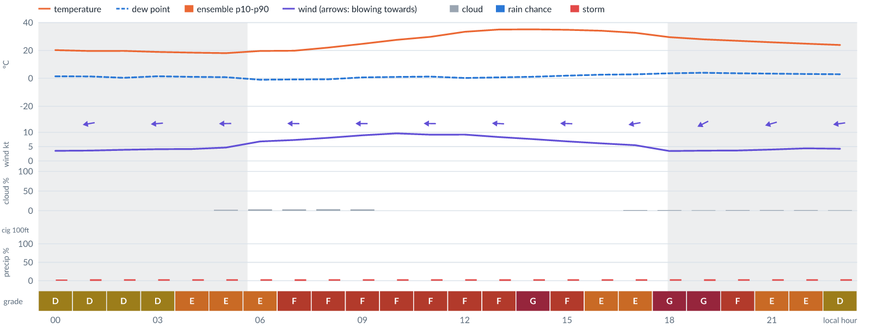
Meteogram — hourly forecast; shaded = before first light / after last light. Gaps mean no data.
Ser | Hrs | Temp | Cloud | Wind | Gust | QNH | Assessment | Driver | Remarks
(a) | (b) | (c) | (d) | (e) | (f) | (g) | (h) | (i) | (j)
1. | 0001 | 20 (20–23)°C | ☀ Clear (0%) | ← 4 (4–7) kts ENE | 10 kts | 1015 | D - Marginal | storm 3% · gust 10 kt | ⚠ thunderstorm risk, gusts, wind shear
2. | 0100 | 20 (spread 19–20)°C | ☀ Clear (0%) | ← 4 (spread 3–4) kts E | 10 kts | 1015 | D - Marginal | storm 4% · gust 10 kt | ⚠ thunderstorm risk, gusts, wind shear
3. | 0200 | 20°C | ☀ Clear (0%) | ← 4 (spread 3–4) kts E | 10 kts | 1015 | D - Marginal | storm 4% · gust 10 kt | ⚠ thunderstorm risk, gusts, wind shear
4. | 0300 | 19°C | ☀ Clear (0%) | ← 4 kts E | 10 kts | 1015 | D - Marginal | storm 4% · gust 10 kt | ⚠ thunderstorm risk, gusts, wind shear
5. | 0400 | 18 (spread 18–19)°C | ☀ Clear (0%) | ← 4 kts E | 11 kts | 1015 | E - Poor | gust spread +7 kt | wind shear, thunderstorm risk, gusts
6. | 0500 | 18 (spread 17–19)°C | ☀ Clear (3%) | ← 5 (spread 4–5) kts E | 12 kts | 1015 | E - Poor | gust 12 kt · gust spread +7 kt | gusts, wind shear, thunderstorm risk
7. | 0600 | 20 (spread 19–20)°C | ☀ Clear (3%) | ← 7 (spread 6–8) kts E | 14 kts | 1016 | E - Poor | gust 14 kt · gust spread +7 kt | gusts, wind shear, thunderstorm risk
8. | 0700 | 20°C | ☀ Clear (3%) | ← 7 (spread 6–8) kts E | 15 kts | 1016 | F - Very Poor | gust 15 kt | gusts, wind shear, thunderstorm risk
9. | 0800 | 22°C | ☀ Clear (4%) | ← 8 (spread 7–9) kts E | 16 kts | 1017 | F - Very Poor | gust 16 kt | gusts, wind shear, thunderstorm risk
10. | 0900 | 25°C | ☀ Clear (3%) | ← 9 kts E | 17 kts | 1017 | F - Very Poor | gust 17 kt | gusts, wind shear, thunderstorm risk, strong wind
11. | 1000 | 28°C | ☀ Clear (0%) | ← 10 (spread 9–10) kts E | 17 kts | 1017 | F - Very Poor | gust 17 kt | gusts, wind shear, thunderstorm risk, strong wind
12. | 1100 | 30 (spread 29–30)°C | ☀ Clear (0%) | ← 9 kts E | 16 kts | 1017 | F - Very Poor | gust 16 kt | gusts, wind shear, thunderstorm risk, strong wind
13. | 1200 | 33 (spread 33–34)°C | ☀ Clear (0%) | ← 9 (spread 9–10) kts E | 15 kts | 1016 | F - Very Poor | gust 15 kt | gusts, thunderstorm risk, strong wind, wind shear
14. | 1300 | 35 (spread 34–36)°C | ☀ Clear (0%) | ← 8 (spread 7–9) kts E | 17 kts | 1016 | F - Very Poor | gust 17 kt · gust spread +8 kt | gusts, wind shear, thunderstorm risk
15. | 1400 | 35 (spread 35–36)°C | ☀ Clear (0%) | ← 8 (spread 6–9) kts E | 20 kts | 1015 | G - Unacceptable | gust 20 kt · gust spread +13 kt | gusts, wind shear, thunderstorm risk
16. | 1500 | 35°C | ☀ Clear (0%) | ← 7 (spread 6–8) kts E | 16 kts | 1015 | F - Very Poor | gust 16 kt · gust spread +9 kt | gusts, wind shear, thunderstorm risk
17. | 1600 | 34°C | ☀ Clear (0%) | ← 6 (spread 5–7) kts E | 13 kts | 1014 | E - Poor | gust 13 kt · gust spread +7 kt | gusts, wind shear, thunderstorm risk
18. | 1700 | 33 (spread 32–33)°C | ☀ Clear (2%) | ← 6 (spread 4–7) kts E | 12 kts | 1014 | E - Poor | gust 12 kt | gusts, thunderstorm risk, wind shear
19. | 1800 | 30 (spread 29–30)°C | ☀ Clear (2%) | ← 3 (spread 2–5) kts ENE | 14 kts | 1015 | G - Unacceptable | gust spread +11 kt | wind shear, gusts, thunderstorm risk
20. | 1900 | 28 (spread 27–29)°C | ☀ Clear (1%) | ↙ 4 (spread 3–4) kts ENE | 14 kts | 1015 | G - Unacceptable | gust spread +10 kt | wind shear, gusts, thunderstorm risk
21. | 2000 | 27 (spread 26–28)°C | ☀ Clear (2%) | ↙ 4 (spread 3–4) kts ENE | 13 kts | 1014 | F - Very Poor | gust spread +10 kt | wind shear, gusts, thunderstorm risk
22. | 2100 | 26 (spread 25–26)°C | ☀ Clear (2%) | ← 4 kts ENE | 11 kts | 1015 | E - Poor | gust spread +7 kt | wind shear, thunderstorm risk, gusts
23. | 2200 | 25°C | ☀ Clear (2%) | ← 4 (spread 4–5) kts E | 11 kts | 1015 | E - Poor | gust spread +6 kt | wind shear, thunderstorm risk, gusts
24. | 2300 | 24°C | ☀ Clear (2%) | ← 4 (spread 4–5) kts E | 10 kts | 1015 | D - Marginal | storm 4% · gust 10 kt | ⚠ thunderstorm risk, gusts, wind shear
Confidence: 76% — data for 24 of 24 hours; 13% of readings interpolated · first light 0608L · last light 1827L · Moon 31 % illuminated, rises 11:28, sets 23:11.

Mon 16 Nov 26
Conditions are expected to be generally Poor: clear, winds up to 9 kts E, gusting 18 kts and temperatures 18–36°C. Flyable windows: 0100–0700L (Marginal, 7 h). Hazards: thunderstorm risk 0001–2300L. Overall an improvement on the previous day.
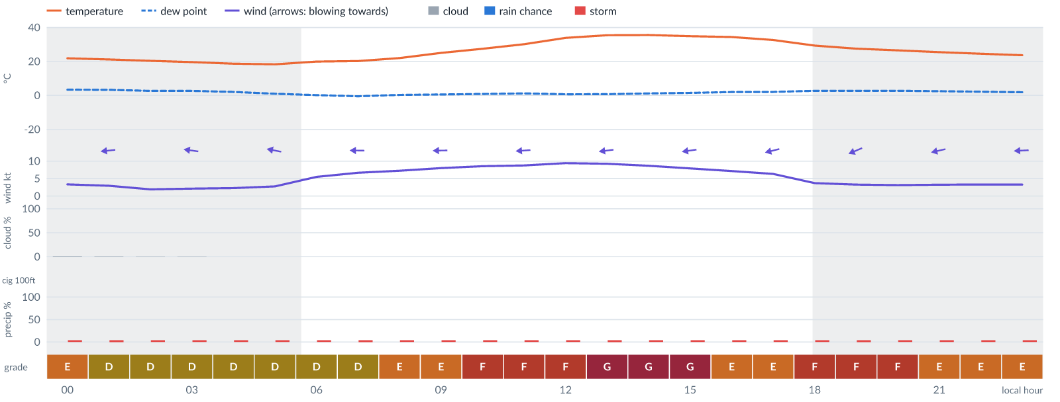
Meteogram — hourly forecast; shaded = before first light / after last light. Gaps mean no data.
Ser | Hrs | Temp | Cloud | Wind | Gust | QNH | Assessment | Driver | Remarks
(a) | (b) | (c) | (d) | (e) | (f) | (g) | (h) | (i) | (j)
1. | 0001 | 22°C | ☀ Clear (1%) | ← 3 (spread 3–4) kts E | 10 kts | 1014 | E - Poor | gust spread +7 kt | wind shear, thunderstorm risk, gusts
2. | 0100 | 21°C | ☀ Clear (1%) | ← 3 kts E | 9 kts | 1014 | D - Marginal | storm 4% · gust 9 kt | ⚠ thunderstorm risk, gusts, wind shear
3. | 0200 | 20 (spread 20–21)°C | ☀ Clear (1%) | ← 2 kts E | 8 kts | 1014 | D - Marginal | storm 4% · gust spread +6 kt | ⚠ thunderstorm risk, wind shear
4. | 0300 | 20 (spread 19–20)°C | ☀ Clear (1%) | ← 2 (spread 1–4) kts E | 8 kts | 1014 | D - Marginal | storm 4% · gust spread +5 kt | ⚠ thunderstorm risk, wind shear
5. | 0400 | 19°C | ☀ Clear (0%) | ← 2 (spread 0–4) kts ESE | 8 kts | 1014 | D - Marginal | storm 4% · gust spread +5 kt | ⚠ thunderstorm risk, wind shear
6. | 0500 | 18°C | ☀ Clear (0%) | ← 3 (spread 1–5) kts E | 8 kts | 1014 | D - Marginal | storm 4% · gust spread +5 kt | ⚠ thunderstorm risk, wind shear
7. | 0600 | 20 (spread 19–21)°C | ☀ Clear (0%) | ← 6 (spread 3–8) kts E | 9 kts | 1015 | D - Marginal | storm 4% · gust 9 kt | ⚠ thunderstorm risk, gusts
8. | 0700 | 20 (spread 20–21)°C | ☀ Clear (0%) | ← 7 (spread 4–9) kts E | 10 kts | 1015 | D - Marginal | storm 4% · gust 10 kt | ⚠ thunderstorm risk, gusts
9. | 0800 | 22°C | ☀ Clear (0%) | ← 7 (spread 5–9) kts E | 12 kts | 1015 | E - Poor | gust 12 kt | gusts, thunderstorm risk, wind shear
10. | 0900 | 25 (spread 25–26)°C | ☀ Clear (0%) | ← 8 (spread 7–9) kts E | 14 kts | 1016 | E - Poor | gust 14 kt | gusts, thunderstorm risk, wind shear
11. | 1000 | 27 (spread 27–28)°C | ☀ Clear (0%) | ← 9 (spread 7–10) kts E | 16 kts | 1016 | F - Very Poor | gust 16 kt | gusts, wind shear, thunderstorm risk, strong wind
12. | 1100 | 30 (spread 30–31)°C | ☀ Clear (0%) | ← 9 (spread 8–10) kts E | 16 kts | 1016 | F - Very Poor | gust 16 kt | gusts, wind shear, thunderstorm risk, strong wind
13. | 1200 | 34 (spread 33–34)°C | ☀ Clear (0%) | ← 9 (spread 9–10) kts E | 16 kts | 1015 | F - Very Poor | gust 16 kt | gusts, wind shear, thunderstorm risk, strong wind
14. | 1300 | 35 (spread 35–36)°C | ☀ Clear (0%) | ← 9 (spread 8–10) kts E | 18 kts | 1015 | G - Unacceptable | gust 18 kt | gusts, wind shear, thunderstorm risk, strong wind
15. | 1400 | 36 (spread 35–36)°C | ☀ Clear (0%) | ← 9 (spread 8–10) kts E | 18 kts | 1014 | G - Unacceptable | gust 18 kt | gusts, wind shear, thunderstorm risk, strong wind
16. | 1500 | 35°C | ☀ Clear (0%) | ← 8 (spread 7–9) kts E | 18 kts | 1014 | G - Unacceptable | gust 18 kt · gust spread +10 kt | gusts, wind shear, thunderstorm risk
17. | 1600 | 34 (spread 34–35)°C | ☀ Clear (0%) | ← 7 (spread 6–8) kts E | 14 kts | 1014 | E - Poor | gust 14 kt · gust spread +7 kt | gusts, wind shear, thunderstorm risk
18. | 1700 | 33 (spread 32–33)°C | ☀ Clear (0%) | ← 6 (spread 6–7) kts ENE | 14 kts | 1013 | E - Poor | gust 14 kt · gust spread +7 kt | gusts, wind shear, thunderstorm risk
19. | 1800 | 29 (spread 29–30)°C | ☀ Clear (0%) | ← 4 (spread 3–4) kts ENE | 13 kts | 1014 | F - Very Poor | gust spread +9 kt | wind shear, gusts, thunderstorm risk
20. | 1900 | 28 (spread 27–28)°C | ☀ Clear (0%) | ↙ 3 (spread 2–4) kts ENE | 12 kts | 1014 | F - Very Poor | gust spread +9 kt | wind shear, gusts, thunderstorm risk
21. | 2000 | 27 (spread 26–27)°C | ☀ Clear (0%) | ← 3 (spread 3–4) kts ENE | 12 kts | 1014 | F - Very Poor | gust spread +9 kt | wind shear, gusts, thunderstorm risk
22. | 2100 | 26 (spread 25–26)°C | ☀ Clear (0%) | ← 3 (spread 3–4) kts ENE | 11 kts | 1014 | E - Poor | gust spread +8 kt | wind shear, thunderstorm risk, gusts
23. | 2200 | 25 (spread 24–25)°C | ☀ Clear (0%) | ← 3 (spread 3–4) kts E | 11 kts | 1014 | E - Poor | gust spread +8 kt | wind shear, thunderstorm risk, gusts
24. | 2300 | 24 (spread 22–25)°C | ☀ Clear (0%) | ← 3 (spread 3–4) kts E | 10 kts | 1014 | E - Poor | gust spread +7 kt | wind shear, thunderstorm risk, gusts
Confidence: 75% — data for 24 of 24 hours; 13% of readings interpolated · first light 0608L · last light 1827L · Moon 40 % illuminated, rises 12:09.

Tue 17 Nov 26
Conditions are expected to be generally Poor: clear, winds up to 8 kts E, gusting 19 kts and temperatures 19–36°C. Flyable windows: 0100–0600L (Marginal, 6 h). Hazards: thunderstorm risk 0001–2300L. Overall similar to the previous day.
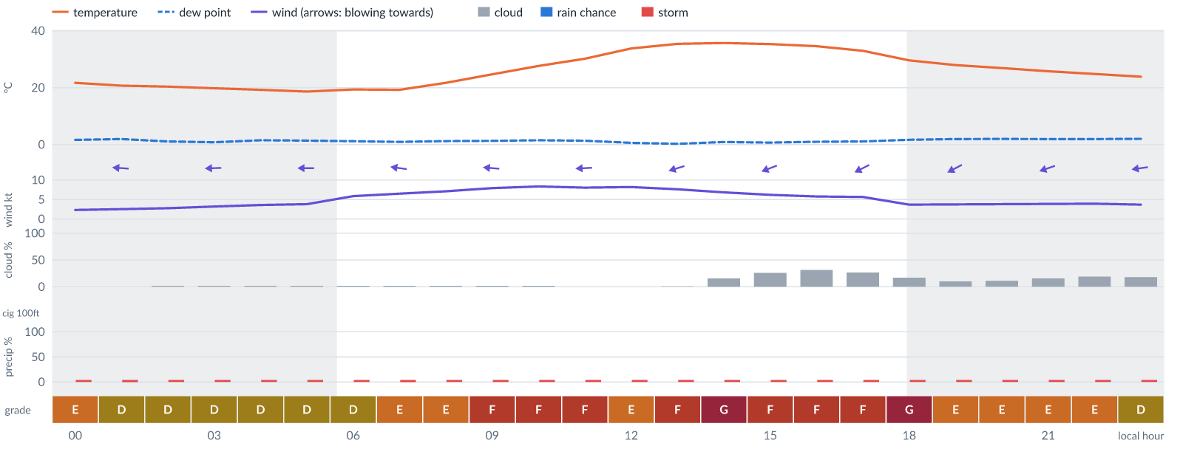
Meteogram — hourly forecast; shaded = before first light / after last light. Gaps mean no data.
Ser | Hrs | Temp | Cloud | Wind | Gust | QNH | Assessment | Driver | Remarks
(a) | (b) | (c) | (d) | (e) | (f) | (g) | (h) | (i) | (j)
1. | 0001 | 22 (spread 20–23)°C | ☀ Clear (0%) | ← 2 kts E | 9 kts | 1013 | E - Poor | gust spread +6 kt | wind shear, thunderstorm risk, gusts
2. | 0100 | 21 (spread 19–22)°C | ☀ Clear (0%) | ← 3 (spread 2–3) kts E | 8 kts | 1013 | D - Marginal | storm 4% · gust spread +6 kt | ⚠ thunderstorm risk, wind shear
3. | 0200 | 20 (spread 19–22)°C | ☀ Clear (2%) | ← 3 (spread 2–3) kts E | 8 kts | 1013 | D - Marginal | storm 4% · gust spread +5 kt | ⚠ thunderstorm risk, wind shear
4. | 0300 | 20 (spread 18–21)°C | ☀ Clear (2%) | ← 3 (spread 3–4) kts E | 8 kts | 1013 | D - Marginal | storm 4% · gust spread +5 kt | ⚠ thunderstorm risk, wind shear
5. | 0400 | 19 (spread 17–21)°C | ☀ Clear (2%) | ← 4 (spread 3–4) kts E | 9 kts | 1013 | D - Marginal | storm 4% · gust 9 kt | ⚠ thunderstorm risk, gusts, wind shear
6. | 0500 | 19 (spread 17–20)°C | ☀ Clear (2%) | ← 4 (spread 3–5) kts E | 10 kts | 1013 | D - Marginal | storm 4% · gust 10 kt | ⚠ thunderstorm risk, gusts, wind shear
7. | 0600 | 19 (spread 18–21)°C | ☀ Clear (2%) | ← 6 (spread 4–8) kts E | 11 kts | 1014 | D - Marginal | storm 4% · gust 11 kt | ⚠ thunderstorm risk, gusts, wind shear
8. | 0700 | 19 (spread 18–20)°C | ☀ Clear (2%) | ← 6 (spread 5–8) kts E | 12 kts | 1014 | E - Poor | gust 12 kt | gusts, thunderstorm risk, wind shear
9. | 0800 | 22 (spread 20–23)°C | ☀ Clear (2%) | ← 7 (spread 6–8) kts E | 13 kts | 1014 | E - Poor | gust 13 kt | gusts, thunderstorm risk, wind shear
10. | 0900 | 25 (spread 23–26)°C | ☀ Clear (2%) | ← 8 (spread 7–9) kts E | 15 kts | 1015 | F - Very Poor | gust 15 kt | gusts, wind shear, thunderstorm risk
11. | 1000 | 28 (spread 27–29)°C | ☀ Clear (2%) | ← 8 (spread 8–9) kts E | 15 kts | 1015 | F - Very Poor | gust 15 kt | gusts, wind shear, thunderstorm risk
12. | 1100 | 30 (spread 29–31)°C | ☀ Clear (0%) | ← 8 (spread 7–9) kts E | 15 kts | 1015 | F - Very Poor | gust 15 kt | gusts, wind shear, thunderstorm risk
13. | 1200 | 34 (spread 33–34)°C | ☀ Clear (0%) | ← 8 (spread 7–9) kts E | 14 kts | 1014 | E - Poor | gust 14 kt | gusts, thunderstorm risk, wind shear
14. | 1300 | 35 (spread 35–36)°C | ☀ Clear (1%) | ← 8 (spread 6–9) kts ENE | 15 kts | 1014 | F - Very Poor | gust 15 kt | gusts, wind shear, thunderstorm risk
15. | 1400 | 36°C | ◔ Mostly clear (15%) | ← 7 (spread 5–8) kts ENE | 19 kts | 1013 | G - Unacceptable | gust 19 kt · gust spread +12 kt | gusts, wind shear, thunderstorm risk
16. | 1500 | 35 (spread 35–36)°C | ◔ Mostly clear (26%) | ← 6 (spread 5–8) kts ENE | 15 kts | 1013 | F - Very Poor | gust 15 kt · gust spread +9 kt | gusts, wind shear, thunderstorm risk
17. | 1600 | 35 (spread 34–35)°C | ◔ Mostly clear (31%) | ↙ 6 (spread 4–7) kts ENE | 15 kts | 1012 | F - Very Poor | gust 15 kt · gust spread +9 kt | gusts, wind shear, thunderstorm risk
18. | 1700 | 33 (spread 32–34)°C | ◔ Mostly clear (27%) | ↙ 6 (spread 4–7) kts ENE | 15 kts | 1012 | F - Very Poor | gust 15 kt · gust spread +9 kt | gusts, wind shear, thunderstorm risk
19. | 1800 | 30 (spread 29–30)°C | ◔ Mostly clear (17%) | ↙ 4 (spread 3–5) kts ENE | 14 kts | 1013 | G - Unacceptable | gust spread +11 kt | wind shear, gusts, thunderstorm risk
20. | 1900 | 28°C | ☀ Clear (10%) | ↙ 4 (spread 3–4) kts ENE | 12 kts | 1013 | E - Poor | gust 12 kt · gust spread +8 kt | gusts, wind shear, thunderstorm risk
21. | 2000 | 27°C | ☀ Clear (11%) | ↙ 4 kts ENE | 12 kts | 1013 | E - Poor | gust 12 kt · gust spread +8 kt | gusts, wind shear, thunderstorm risk
22. | 2100 | 26 (spread 25–26)°C | ◔ Mostly clear (16%) | ← 4 kts ENE | 12 kts | 1013 | E - Poor | gust 12 kt · gust spread +8 kt | gusts, wind shear, thunderstorm risk
23. | 2200 | 25 (spread 24–25)°C | ◔ Mostly clear (19%) | ← 4 kts ENE | 11 kts | 1013 | E - Poor | gust spread +7 kt | wind shear, thunderstorm risk, gusts
24. | 2300 | 24 (spread 23–25)°C | ◔ Mostly clear (18%) | ← 4 kts E | 10 kts | 1013 | D - Marginal | storm 4% · gust 10 kt | ⚠ thunderstorm risk, gusts, wind shear
Confidence: 75% — data for 24 of 24 hours; 7% of readings interpolated · first light 0609L · last light 1827L · Moon 50 % illuminated, rises 12:48, sets 00:00.

Wed 18 Nov 26
Conditions are expected to be generally Marginal: mostly clear, winds up to 8 kts E, gusting 19 kts and temperatures 18–36°C. Flyable windows: 0001–0600L (Marginal, 7 h). Hazards: thunderstorm risk 0001–2300L. Overall an improvement on the previous day.
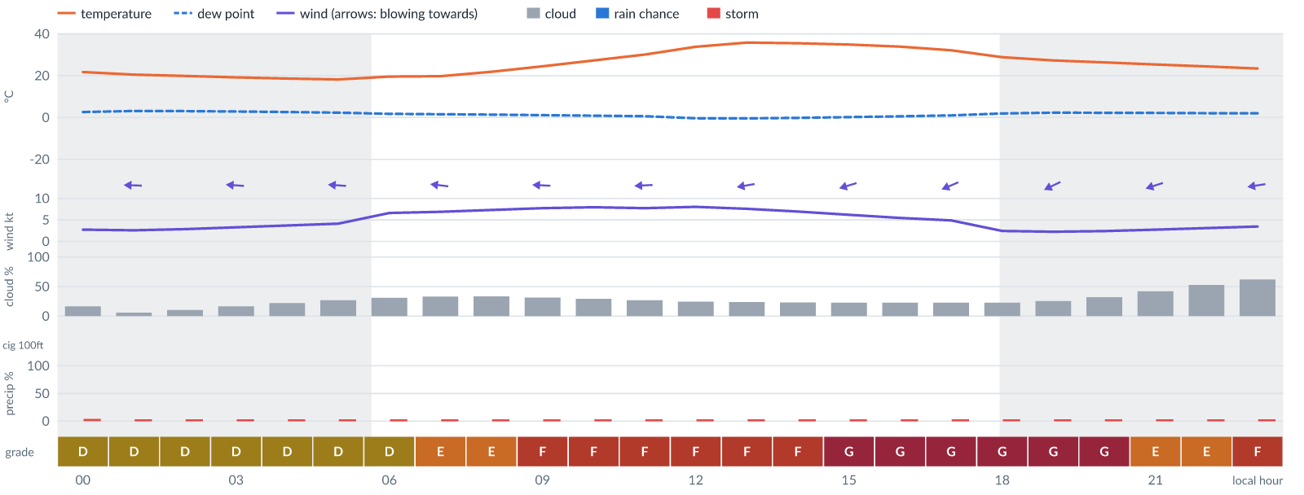
Meteogram — hourly forecast; shaded = before first light / after last light. Gaps mean no data.
Ser | Hrs | Temp | Cloud | Wind | Gust | QNH | Assessment | Driver | Remarks
(a) | (b) | (c) | (d) | (e) | (f) | (g) | (h) | (i) | (j)
1. | 0001 | 22 (spread 21–23)°C | ◔ Mostly clear (16%) | ← 3 kts E | 8 kts | 1012 | D - Marginal | storm 4% · gust spread +6 kt | ⚠ thunderstorm risk, wind shear
2. | 0100 | 20°C | ☀ Clear (6%) | ← 3 kts E | 8 kts | 1012 | D - Marginal | storm 3% · gust spread +6 kt | ⚠ thunderstorm risk, wind shear
3. | 0200 | 20°C | ☀ Clear (10%) | ← 3 kts E | 8 kts | 1012 | D - Marginal | storm 3% · gust spread +5 kt | ⚠ thunderstorm risk, wind shear
4. | 0300 | 19°C | ◔ Mostly clear (16%) | ← 3 kts E | 8 kts | 1012 | D - Marginal | storm 3% · gust spread +5 kt | ⚠ thunderstorm risk, wind shear
5. | 0400 | 19°C | ◔ Mostly clear (22%) | ← 4 kts E | 9 kts | 1012 | D - Marginal | storm 3% · gust 9 kt | ⚠ thunderstorm risk, gusts, wind shear
6. | 0500 | 18°C | ◔ Mostly clear (27%) | ← 4 kts E | 10 kts | 1012 | D - Marginal | storm 3% · gust 10 kt | ⚠ thunderstorm risk, gusts, wind shear
7. | 0600 | 20°C | ◔ Mostly clear (31%) | ← 7 kts E | 11 kts | 1014 | D - Marginal | storm 3% · gust 11 kt | ⚠ thunderstorm risk, gusts
8. | 0700 | 20°C | ◔ Partly cloudy (33%) | ← 7 kts E | 12 kts | 1014 | E - Poor | gust 12 kt | gusts, thunderstorm risk, wind shear
9. | 0800 | 22°C | ◔ Partly cloudy (33%) | ← 7 kts E | 14 kts | 1014 | E - Poor | gust 14 kt · gust spread +6 kt | gusts, wind shear, thunderstorm risk
10. | 0900 | 24°C | ◔ Mostly clear (31%) | ← 8 kts E | 15 kts | 1014 | F - Very Poor | gust 15 kt | gusts, wind shear, thunderstorm risk
11. | 1000 | 27°C | ◔ Mostly clear (29%) | ← 8 kts E | 16 kts | 1015 | F - Very Poor | gust 16 kt | gusts, wind shear, thunderstorm risk
12. | 1100 | 30°C | ◔ Mostly clear (27%) | ← 8 kts E | 16 kts | 1015 | F - Very Poor | gust 16 kt | gusts, wind shear, thunderstorm risk
13. | 1200 | 34°C | ◔ Mostly clear (25%) | ← 8 kts E | 16 kts | 1014 | F - Very Poor | gust 16 kt | gusts, wind shear, thunderstorm risk
14. | 1300 | 36°C | ◔ Mostly clear (24%) | ← 8 kts E | 16 kts | 1014 | F - Very Poor | gust 16 kt | gusts, wind shear, thunderstorm risk
15. | 1400 | 36°C | ◔ Mostly clear (23%) | ← 7 kts ENE | 16 kts | 1014 | F - Very Poor | gust 16 kt · gust spread +9 kt | gusts, wind shear, thunderstorm risk
16. | 1500 | 35°C | ◔ Mostly clear (23%) | ← 6 kts ENE | 19 kts | 1014 | G - Unacceptable | gust 19 kt · gust spread +13 kt | gusts, wind shear, thunderstorm risk
17. | 1600 | 34°C | ◔ Mostly clear (23%) | ← 5 kts ENE | 19 kts | 1013 | G - Unacceptable | gust 19 kt · gust spread +13 kt | gusts, wind shear, thunderstorm risk
18. | 1700 | 32°C | ◔ Mostly clear (23%) | ↙ 5 kts ENE | 18 kts | 1013 | G - Unacceptable | gust 18 kt · gust spread +13 kt | gusts, wind shear, thunderstorm risk
19. | 1800 | 29°C | ◔ Mostly clear (23%) | ↙ 2 kts ENE | 17 kts | 1014 | G - Unacceptable | gust spread +15 kt | wind shear, gusts, thunderstorm risk
20. | 1900 | 27°C | ◔ Mostly clear (25%) | ↙ 2 kts ENE | 16 kts | 1013 | G - Unacceptable | gust spread +14 kt | wind shear, gusts, thunderstorm risk
21. | 2000 | 26°C | ◔ Mostly clear (32%) | ↙ 2 kts ENE | 12 kts | 1013 | G - Unacceptable | gust spread +10 kt | wind shear, gusts, thunderstorm risk
22. | 2100 | 25°C | ◑ Partly cloudy (42%) | ← 3 kts ENE | 11 kts | 1014 | E - Poor | gust spread +9 kt | wind shear, thunderstorm risk, gusts
23. | 2200 | 24°C | ◑ Partly cloudy (53%) | ← 3 kts ENE | 11 kts | 1014 | E - Poor | cloud 53% · gust spread +7 kt | cloud cover, wind shear, thunderstorm risk, gusts
24. | 2300 | 23°C | ◑ Cloudy (62%) | ← 3 kts E | 10 kts | 1014 | F - Very Poor | cloud 62% | cloud cover, wind shear, thunderstorm risk, gusts
Confidence: 69% — data for 24 of 24 hours · first light 0609L · last light 1827L · Moon 60 % illuminated, rises 13:26, sets 00:48.

Thu 19 Nov 26
Conditions are expected to be generally Unacceptable: partly cloudy, winds up to 8 kts E, gusting 20 kts and temperatures 18–36°C. Flyable windows: 0400–0800L (Marginal, 5 h). Hazards: thunderstorm risk 0001–2300L. Overall a deterioration from the previous day.
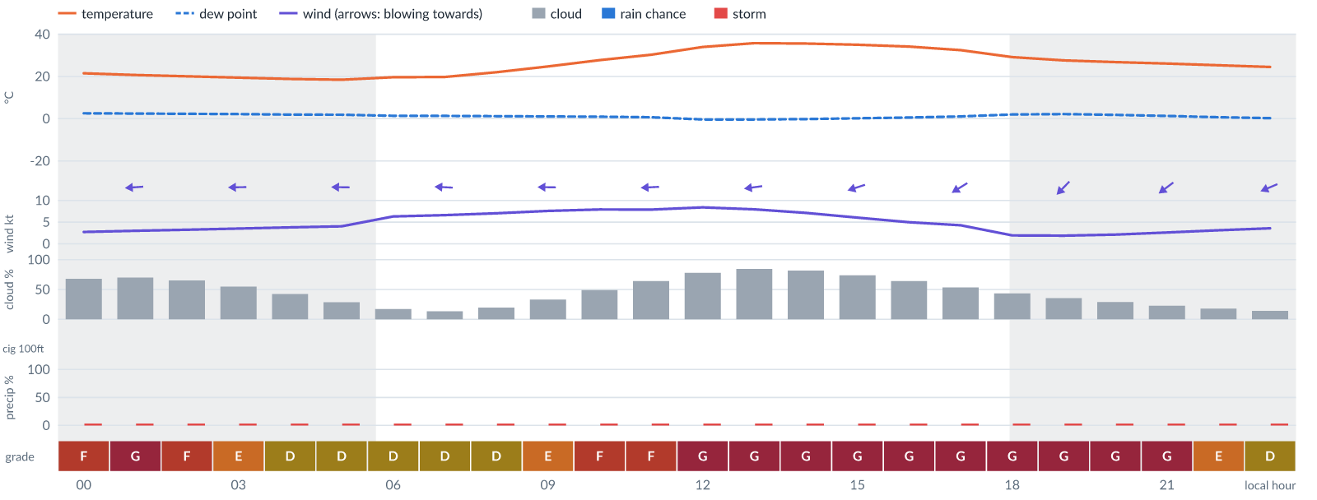
Meteogram — hourly forecast; shaded = before first light / after last light. Gaps mean no data.
Ser | Hrs | Temp | Cloud | Wind | Gust | QNH | Assessment | Driver | Remarks
(a) | (b) | (c) | (d) | (e) | (f) | (g) | (h) | (i) | (j)
1. | 0001 | 22°C | ◕ Cloudy (68%) | ← 3 kts E | 9 kts | 1013 | F - Very Poor | cloud 68% | cloud cover, thunderstorm risk, gusts, wind shear
2. | 0100 | 21°C | ◕ Cloudy (70%) | ← 3 kts E | 9 kts | 1013 | G - Unacceptable | cloud 70% | cloud cover, thunderstorm risk, gusts, wind shear
3. | 0200 | 20°C | ◕ Cloudy (65%) | ← 3 kts E | 9 kts | 1014 | F - Very Poor | cloud 65% | cloud cover, thunderstorm risk, gusts, wind shear
4. | 0300 | 19°C | ◑ Partly cloudy (55%) | ← 4 kts E | 9 kts | 1013 | E - Poor | cloud 55% | cloud cover, thunderstorm risk, gusts, wind shear
5. | 0400 | 19°C | ◑ Partly cloudy (42%) | ← 4 kts E | 9 kts | 1014 | D - Marginal | storm 3% · gust 9 kt | ⚠ thunderstorm risk, gusts, wind shear
6. | 0500 | 18°C | ◔ Mostly clear (29%) | ← 4 kts E | 9 kts | 1014 | D - Marginal | storm 3% · gust 9 kt | ⚠ thunderstorm risk, gusts, wind shear
7. | 0600 | 20°C | ◔ Mostly clear (17%) | ← 6 kts E | 10 kts | 1014 | D - Marginal | storm 3% · gust 10 kt | ⚠ thunderstorm risk, gusts
8. | 0700 | 20°C | ◔ Mostly clear (13%) | ← 7 kts E | 10 kts | 1015 | D - Marginal | storm 3% · gust 10 kt | ⚠ thunderstorm risk, gusts
9. | 0800 | 22°C | ◔ Mostly clear (20%) | ← 7 kts E | 11 kts | 1015 | D - Marginal | storm 3% · gust 11 kt | ⚠ thunderstorm risk, gusts
10. | 0900 | 25°C | ◔ Partly cloudy (33%) | ← 8 kts E | 13 kts | 1015 | E - Poor | gust 13 kt | gusts, thunderstorm risk, wind shear
11. | 1000 | 28°C | ◑ Partly cloudy (49%) | ← 8 kts E | 15 kts | 1015 | F - Very Poor | gust 15 kt | gusts, wind shear, cloud cover, thunderstorm risk
12. | 1100 | 30°C | ◕ Cloudy (64%) | ← 8 kts E | 15 kts | 1016 | F - Very Poor | cloud 64% · gust 15 kt | cloud cover, gusts, wind shear, thunderstorm risk
13. | 1200 | 34°C | ◕ Cloudy (78%) | ← 8 kts E | 16 kts | 1015 | G - Unacceptable | cloud 78% | cloud cover, gusts, wind shear, thunderstorm risk
14. | 1300 | 36°C | ◕ Cloudy (84%) | ← 8 kts E | 20 kts | 1015 | G - Unacceptable | cloud 84% · gust 20 kt | cloud cover, gusts, wind shear, thunderstorm risk
15. | 1400 | 36°C | ◕ Cloudy (82%) | ← 7 kts ENE | 20 kts | 1014 | G - Unacceptable | cloud 82% · gust 20 kt | cloud cover, gusts, wind shear, thunderstorm risk
16. | 1500 | 35°C | ◕ Cloudy (74%) | ← 6 kts ENE | 20 kts | 1014 | G - Unacceptable | cloud 74% · gust 20 kt | cloud cover, gusts, wind shear, thunderstorm risk
17. | 1600 | 34°C | ◕ Cloudy (64%) | ↙ 5 kts ENE | 20 kts | 1014 | G - Unacceptable | gust 20 kt · gust spread +15 kt | gusts, wind shear, cloud cover, thunderstorm risk
18. | 1700 | 32°C | ◑ Partly cloudy (54%) | ↙ 4 kts ENE | 19 kts | 1014 | G - Unacceptable | gust 19 kt · gust spread +15 kt | gusts, wind shear, cloud cover, thunderstorm risk
19. | 1800 | 29°C | ◑ Partly cloudy (43%) | ↙ 2 kts NE | 19 kts | 1014 | G - Unacceptable | gust 19 kt · gust spread +17 kt | gusts, wind shear, cloud cover, thunderstorm risk
20. | 1900 | 28°C | ◔ Partly cloudy (35%) | ↙ 2 kts NE | 18 kts | 1014 | G - Unacceptable | gust 18 kt · gust spread +16 kt | gusts, wind shear, thunderstorm risk
21. | 2000 | 27°C | ◔ Mostly clear (29%) | ↙ 2 kts NE | 17 kts | 1014 | G - Unacceptable | gust spread +15 kt | wind shear, gusts, thunderstorm risk
22. | 2100 | 26°C | ◔ Mostly clear (23%) | ↙ 3 kts NE | 15 kts | 1014 | G - Unacceptable | gust spread +13 kt | wind shear, gusts, thunderstorm risk
23. | 2200 | 25°C | ◔ Mostly clear (18%) | ↙ 3 kts ENE | 11 kts | 1014 | E - Poor | gust spread +8 kt | wind shear, thunderstorm risk, gusts
24. | 2300 | 24°C | ◔ Mostly clear (14%) | ↙ 4 kts ENE | 10 kts | 1015 | D - Marginal | storm 3% · gust 10 kt | ⚠ thunderstorm risk, gusts, wind shear
Confidence: 69% — data for 24 of 24 hours · first light 0610L · last light 1827L · Moon 69 % illuminated, rises 14:03, sets 01:35.

Fri 20 Nov 26
Conditions are expected to be generally Unacceptable: mostly clear, winds up to 8 kts E, gusting 21 kts and temperatures 20–36°C. Flyable windows: 0001–0600L (Marginal, 7 h). Hazards: thunderstorm risk 0001–2300L. Overall similar to the previous day.
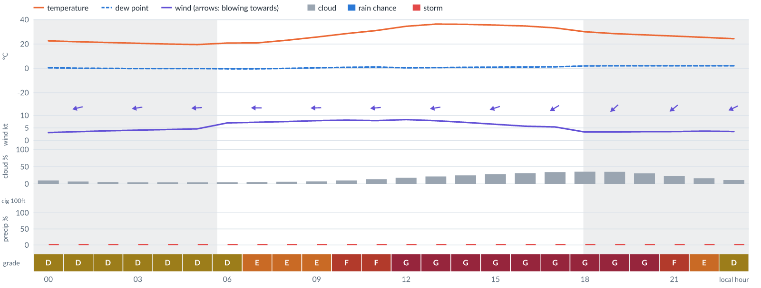
Meteogram — hourly forecast; shaded = before first light / after last light. Gaps mean no data.
Ser | Hrs | Temp | Cloud | Wind | Gust | QNH | Assessment | Driver | Remarks
(a) | (b) | (c) | (d) | (e) | (f) | (g) | (h) | (i) | (j)
1. | 0001 | 23°C | ☀ Clear (10%) | ← 3 kts ENE | 9 kts | 1014 | D - Marginal | storm 3% · gust 9 kt | ⚠ thunderstorm risk, gusts, wind shear
2. | 0100 | 22°C | ☀ Clear (7%) | ← 4 kts ENE | 9 kts | 1014 | D - Marginal | storm 3% · gust 9 kt | ⚠ thunderstorm risk, gusts, wind shear
3. | 0200 | 21°C | ☀ Clear (5%) | ← 4 kts ENE | 9 kts | 1014 | D - Marginal | storm 3% · gust 9 kt | ⚠ thunderstorm risk, gusts, wind shear
4. | 0300 | 21°C | ☀ Clear (4%) | ← 4 kts E | 10 kts | 1014 | D - Marginal | storm 3% · gust 10 kt | ⚠ thunderstorm risk, gusts, wind shear
5. | 0400 | 20°C | ☀ Clear (4%) | ← 4 kts E | 9 kts | 1014 | D - Marginal | storm 3% · gust 9 kt | ⚠ thunderstorm risk, gusts, wind shear
6. | 0500 | 20°C | ☀ Clear (4%) | ← 5 kts E | 10 kts | 1015 | D - Marginal | storm 3% · gust 10 kt | ⚠ thunderstorm risk, gusts, wind shear
7. | 0600 | 21°C | ☀ Clear (5%) | ← 7 kts E | 11 kts | 1015 | D - Marginal | storm 3% · gust 11 kt | ⚠ thunderstorm risk, gusts
8. | 0700 | 21°C | ☀ Clear (5%) | ← 7 kts E | 12 kts | 1015 | E - Poor | gust 12 kt | gusts, thunderstorm risk, wind shear
9. | 0800 | 23°C | ☀ Clear (6%) | ← 8 kts E | 13 kts | 1016 | E - Poor | gust 13 kt | gusts, thunderstorm risk, wind shear
10. | 0900 | 26°C | ☀ Clear (7%) | ← 8 kts E | 14 kts | 1016 | E - Poor | gust 14 kt | gusts, thunderstorm risk, wind shear
11. | 1000 | 29°C | ☀ Clear (10%) | ← 8 kts E | 15 kts | 1016 | F - Very Poor | gust 15 kt | gusts, wind shear, thunderstorm risk
12. | 1100 | 31°C | ◔ Mostly clear (14%) | ← 8 kts E | 16 kts | 1016 | F - Very Poor | gust 16 kt | gusts, wind shear, thunderstorm risk
13. | 1200 | 35°C | ◔ Mostly clear (18%) | ← 8 kts E | 20 kts | 1015 | G - Unacceptable | gust 20 kt · gust spread +12 kt | gusts, wind shear, thunderstorm risk
14. | 1300 | 36°C | ◔ Mostly clear (22%) | ← 8 kts E | 21 kts | 1015 | G - Unacceptable | gust 21 kt · gust spread +13 kt | gusts, wind shear, thunderstorm risk
15. | 1400 | 36°C | ◔ Mostly clear (25%) | ← 7 kts ENE | 21 kts | 1014 | G - Unacceptable | gust 21 kt · gust spread +14 kt | gusts, wind shear, thunderstorm risk
16. | 1500 | 36°C | ◔ Mostly clear (28%) | ← 6 kts ENE | 21 kts | 1014 | G - Unacceptable | gust 21 kt · gust spread +15 kt | gusts, wind shear, thunderstorm risk
17. | 1600 | 35°C | ◔ Mostly clear (31%) | ↙ 6 kts ENE | 21 kts | 1014 | G - Unacceptable | gust 21 kt · gust spread +15 kt | gusts, wind shear, thunderstorm risk
18. | 1700 | 33°C | ◔ Partly cloudy (34%) | ↙ 5 kts ENE | 20 kts | 1014 | G - Unacceptable | gust 20 kt · gust spread +15 kt | gusts, wind shear, thunderstorm risk
19. | 1800 | 30°C | ◔ Partly cloudy (36%) | ↙ 3 kts NE | 19 kts | 1014 | G - Unacceptable | gust 19 kt · gust spread +16 kt | gusts, wind shear, thunderstorm risk
20. | 1900 | 29°C | ◔ Partly cloudy (35%) | ↙ 3 kts NE | 19 kts | 1014 | G - Unacceptable | gust 19 kt · gust spread +15 kt | gusts, wind shear, thunderstorm risk
21. | 2000 | 28°C | ◔ Mostly clear (31%) | ↙ 4 kts NE | 17 kts | 1014 | G - Unacceptable | gust spread +14 kt | wind shear, gusts, thunderstorm risk
22. | 2100 | 27°C | ◔ Mostly clear (23%) | ↙ 4 kts NE | 13 kts | 1014 | F - Very Poor | gust spread +9 kt | wind shear, gusts, thunderstorm risk
23. | 2200 | 25°C | ◔ Mostly clear (16%) | ↙ 4 kts ENE | 11 kts | 1015 | E - Poor | gust spread +8 kt | wind shear, thunderstorm risk, gusts
24. | 2300 | 24°C | ☀ Clear (11%) | ↙ 4 kts ENE | 10 kts | 1015 | D - Marginal | storm 3% · gust 10 kt | ⚠ thunderstorm risk, gusts, wind shear
Confidence: 69% — data for 24 of 24 hours · first light 0610L · last light 1827L · Moon 79 % illuminated, rises 14:42, sets 02:24.

Sat 21 Nov 26
Conditions are expected to be generally Unacceptable: clear, winds up to 9 kts E, gusting 22 kts and temperatures 19–37°C. No flyable windows (Marginal or better, ≥2 consecutive hrs) are forecast. Hazards: thunderstorm risk 0001–2300L. Overall similar to the previous day.
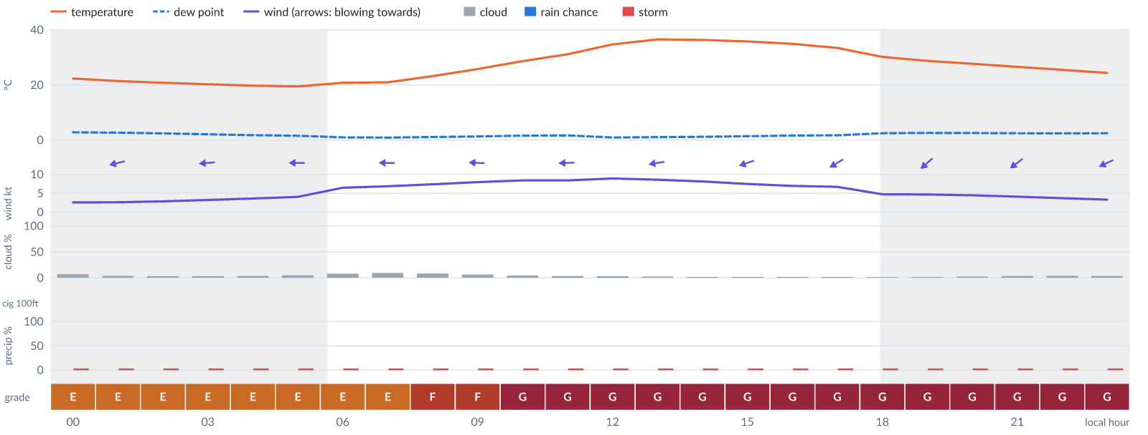
Meteogram — hourly forecast; shaded = before first light / after last light. Gaps mean no data.
Ser | Hrs | Temp | Cloud | Wind | Gust | QNH | Assessment | Driver | Remarks
(a) | (b) | (c) | (d) | (e) | (f) | (g) | (h) | (i) | (j)
1. | 0001 | 22°C | ☀ Clear (7%) | ← 3 kts ENE | 11 kts | 1014 | E - Poor | gust spread +8 kt | wind shear, thunderstorm risk, gusts
2. | 0100 | 21°C | ☀ Clear (4%) | ← 3 kts ENE | 10 kts | 1014 | E - Poor | gust spread +7 kt | wind shear, thunderstorm risk, gusts
3. | 0200 | 21°C | ☀ Clear (3%) | ← 3 kts E | 10 kts | 1014 | E - Poor | gust spread +7 kt | wind shear, thunderstorm risk, gusts
4. | 0300 | 20°C | ☀ Clear (3%) | ← 3 kts E | 10 kts | 1014 | E - Poor | gust spread +7 kt | wind shear, thunderstorm risk, gusts
5. | 0400 | 20°C | ☀ Clear (3%) | ← 4 kts E | 11 kts | 1014 | E - Poor | gust spread +7 kt | wind shear, thunderstorm risk, gusts
6. | 0500 | 19°C | ☀ Clear (5%) | ← 4 kts E | 12 kts | 1014 | E - Poor | gust 12 kt · gust spread +7 kt | gusts, wind shear, thunderstorm risk
7. | 0600 | 21°C | ☀ Clear (8%) | ← 6 kts E | 12 kts | 1016 | E - Poor | gust 12 kt | gusts, thunderstorm risk, wind shear
8. | 0700 | 21°C | ☀ Clear (9%) | ← 7 kts E | 13 kts | 1016 | E - Poor | gust 13 kt | gusts, thunderstorm risk, wind shear
9. | 0800 | 23°C | ☀ Clear (8%) | ← 7 kts E | 15 kts | 1016 | F - Very Poor | gust 15 kt | gusts, wind shear, thunderstorm risk
10. | 0900 | 26°C | ☀ Clear (6%) | ← 8 kts E | 16 kts | 1016 | F - Very Poor | gust 16 kt | gusts, wind shear, thunderstorm risk
11. | 1000 | 29°C | ☀ Clear (4%) | ← 8 kts E | 18 kts | 1016 | G - Unacceptable | gust 18 kt · gust spread +10 kt | gusts, wind shear, thunderstorm risk
12. | 1100 | 31°C | ☀ Clear (3%) | ← 8 kts E | 19 kts | 1016 | G - Unacceptable | gust 19 kt · gust spread +11 kt | gusts, wind shear, thunderstorm risk
13. | 1200 | 35°C | ☀ Clear (3%) | ← 9 kts E | 21 kts | 1015 | G - Unacceptable | gust 21 kt · gust spread +12 kt | gusts, wind shear, thunderstorm risk, strong wind
14. | 1300 | 37°C | ☀ Clear (2%) | ← 9 kts E | 22 kts | 1015 | G - Unacceptable | gust 22 kt · gust spread +13 kt | gusts, wind shear, thunderstorm risk, strong wind
15. | 1400 | 36°C | ☀ Clear (2%) | ← 8 kts ENE | 22 kts | 1014 | G - Unacceptable | gust 22 kt · gust spread +14 kt | gusts, wind shear, thunderstorm risk
16. | 1500 | 36°C | ☀ Clear (2%) | ← 7 kts ENE | 22 kts | 1014 | G - Unacceptable | gust 22 kt · gust spread +15 kt | gusts, wind shear, thunderstorm risk
17. | 1600 | 35°C | ☀ Clear (2%) | ↙ 7 kts ENE | 22 kts | 1014 | G - Unacceptable | gust 22 kt · gust spread +15 kt | gusts, wind shear, thunderstorm risk
18. | 1700 | 33°C | ☀ Clear (2%) | ↙ 7 kts ENE | 21 kts | 1014 | G - Unacceptable | gust 21 kt · gust spread +15 kt | gusts, wind shear, thunderstorm risk
19. | 1800 | 30°C | ☀ Clear (1%) | ↙ 5 kts NE | 21 kts | 1014 | G - Unacceptable | gust 21 kt · gust spread +16 kt | gusts, wind shear, thunderstorm risk
20. | 1900 | 29°C | ☀ Clear (2%) | ↙ 5 kts NE | 20 kts | 1014 | G - Unacceptable | gust 20 kt · gust spread +15 kt | gusts, wind shear, thunderstorm risk
21. | 2000 | 28°C | ☀ Clear (2%) | ↙ 4 kts NE | 19 kts | 1014 | G - Unacceptable | gust 19 kt · gust spread +14 kt | gusts, wind shear, thunderstorm risk
22. | 2100 | 27°C | ☀ Clear (3%) | ↙ 4 kts NE | 18 kts | 1014 | G - Unacceptable | gust 18 kt · gust spread +13 kt | gusts, wind shear, thunderstorm risk
23. | 2200 | 25°C | ☀ Clear (4%) | ↙ 4 kts ENE | 16 kts | 1014 | G - Unacceptable | gust spread +12 kt | wind shear, gusts, thunderstorm risk
24. | 2300 | 24°C | ☀ Clear (3%) | ↙ 3 kts ENE | 14 kts | 1014 | G - Unacceptable | gust spread +11 kt | wind shear, gusts, thunderstorm risk
Confidence: 69% — data for 24 of 24 hours · first light 0610L · last light 1827L · Moon 87 % illuminated, rises 15:23, sets 03:15.

TAF
No TAF available for this location.

Imagery

Dust RGB (pink/magenta = airborne dust) — captured 8 Nov 04:18 WAT (6 min ago) · ©EUMETSAT (screenshot via EUMETView)

Convection RGB (yellow = vigorous storms) — captured 8 Nov 04:18 WAT (6 min ago) · ©EUMETSAT (screenshot via EUMETView)
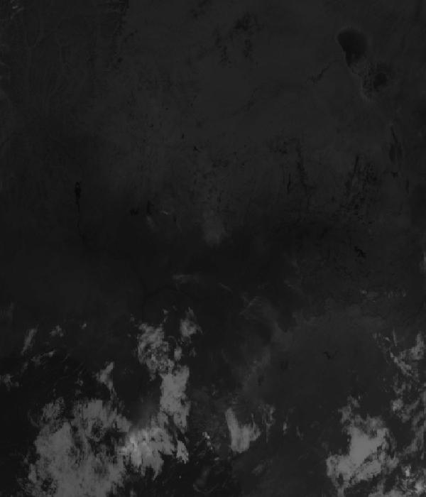
Infrared 10.5 µm (cold tops = deep cloud) — captured 8 Nov 04:18 WAT (6 min ago) · ©EUMETSAT (screenshot via EUMETView)

Accumulated lightning flash area (MTG-LI) — captured 8 Nov 04:18 WAT (6 min ago) · ©EUMETSAT (screenshot via EUMETView)

Source panel
Source | Accuracy | Skill n | Temp °C | Wind kt | Visibility | Storm
(a) | (b) | (c) | (d) | (e) | (f) | (g)
Open-Meteo Ensemble (ECMWF IFS + GEFS) | ▲ 1.4 | 5290 | 20–28 | 4–5 | — | 0 %
NOAA GFS | ▽ 0.8 | 8420 | 24–30 | 5–7 | 10+ km | 0 %
Met.no (Yr) | ▲ 1.2 | 3541 | 21–29 | 4–7 | — | 0 %
Open-Meteo | ≈ 1.0 | 10393 | 22–29 | 4–6 | 10+ km | 0 %
OpenWeather | ≈ 1.0 | 1680 | 25–28 | 6–7 | 10+ km | 0 %
Tomorrow.io | ▲ 1.2 | 4565 | 21–28 | 4–6 | 10+ km | 0 %
Visual Crossing | ▽ 1.0 | 8857 | 21–28 | 6–7 | 10+ km | 0 %
Each source's own raw values, min–max over the next 6 hours from the issue hour (before any weighting or bias correction). — means the source does not publish that metric in the window. Wide gaps between rows are real disagreement; the forecast above weights sources by measured skill.

Reading this report
Grades: each hour carries one grade, set by its WORST factor. The bands below are the thresholds in force for this report (Settings); a value in a band earns that grade, and "-" means the factor never produces that grade. Cloud is graded on the worse of cover and ceiling. The Driver column names the limiting factor with its value; open it in the web report for the boundary and sources.
Grade | Cloud cover | Cloud ceiling | Visibility | Wind | Gust | Rain chance | Thunderstorm probability
(a) | (b) | (c) | (d) | (e) | (f) | (g) | (h)
A Excellent | ≤ 17.1% | ≥ 30000 ft | ≥ 8000 m | < 3 kt | < 3 kt | < 5% | 0%
B Good | 17.1–34.3% | 26000–30000 ft | 6666.7–8000 m | 3–6 kt | 3–6 kt | 5–10% | -
C Fair | 34.3–42.9% | 24000–26000 ft | 5333.3–6666.7 m | 6–9 kt | 6–9 kt | 10–15% | -
D Marginal | 42.9–51.4% | 22000–24000 ft | 4000–5333.3 m | 9–12 kt | 9–12 kt | 15–20% | >0–15%
E Poor | 51.4–60% | 16000–22000 ft | 2666.7–4000 m | 12–15 kt | 12–15 kt | 20–25% | 15–30%
F Very Poor | 60–68.6% | 10000–16000 ft | 1333.3–2666.7 m | 15–18 kt | 15–18 kt | 25–30% | 30–60%
G Unacceptable | > 68.6% | < 10000 ft | < 1333.3 m | ≥ 18 kt | ≥ 18 kt | ≥ 30% | > 60%
Flight windows: a window is at least 2 consecutive hours graded Marginal or better; an hour with insufficient data never counts toward one. ☾ marks a window outside first-to-last light.
Time: hours are local time (WAT, UTC+1) unless suffixed Z, which is UTC (TAF, METAR and issue times). Local midnight is labelled 0001.
Units: temperature °C · wind and gusts knots · visibility metres (km in text) · cloud ceiling feet · cloud cover % · rain chance and thunderstorm probability % · QNH hPa (altimeter setting at the field) · CAPE J/kg. A figure like "28 (26–30)°C" gives the p10–p90 range; "spread" marks disagreement between sources.
Symbols: ▲ better than the pool · ▽ worse (only when the 95% interval excludes the pool) · ≈ not distinguishable from the pool · unmarked = unproven (accuracy is measured against METAR and SYNOP observations). ⚠ on a remark means a low-confidence hour; a ⚠ paragraph on the first page is a convective-warning or data-age advisory. ⚡ is lightning observed by satellite near the field (©EUMETSAT).
Hourly glyphs: the wind arrow points the way the air moves (a north wind is ↓, an east wind ←); cloud cover shows as ☀ ◔ ◑ ◕ ☁ (clear, few, scattered, broken, overcast); a shaded hour label is wholly before first light or after last light.
Terms: "No data" - no source forecast the hour, or a core group (cloud, visibility, wind) is missing and the hour could still be flyable; missing data is never given a good grade. "Low-confidence" - few or weak sources behind the load-bearing metrics; treat the grade as indicative. "Insufficient data" - too little to grade at all. "Estimated" (est.) - the value is derived, not reported by a source (dust visibility, cloud base, gusts); it is declared where used and weighted at half. "Derived" - an hour interpolated from a coarser (3-hourly or daily) source, weighted at half and never used to score accuracy.

Data provenance
Source | Fetched (Z) | Age | Skill n | Accuracy
(a) | (b) | (c) | (d) | (e)
Open-Meteo Ensemble (ECMWF IFS + GEFS) | 8 Nov 03:20Z | 4 min | 5290 | ▲ 1.4
Foreca | 8 Nov 03:20Z | 4 min | 345 | ▽ 0.8
NOAA GFS | 8 Nov 03:19Z | 5 min | 8420 | ▽ 0.8
Met.no (Yr) | 8 Nov 03:20Z | 4 min | 3541 | ▲ 1.2
Open-Meteo | 8 Nov 03:19Z | 5 min | 10393 | ≈ 1.0
OpenWeather | 8 Nov 03:19Z | 5 min | 1680 | ≈ 1.0
Tomorrow.io | 8 Nov 03:21Z | 3 min | 4565 | ▲ 1.2
Visual Crossing | 8 Nov 03:19Z | 5 min | 8857 | ▽ 1.0
Corrections applied (detailed under Learned corrections on the first page): skill weighting, bias correction, hour-of-day bias, cloud-base estimate, probability calibration, fog risk, climatology bounds, skill blend.

How accurate have we been
Measured against observations (METAR/SYNOP), sahel region. Verification table computed 2026-11-08. Mean absolute error (MAE): lower is better; "beats persistence" compares the best source with "it will stay as it is now" on the same hours.
Metric | Best source | Best MAE | Typical MAE | Persistence MAE | Beats persistence by | Pairs
(a) | (b) | (c) | (d) | (e) | (f) | (g)
Temperature (°C) | meteoblue | 1.1 | 2.0 | 5.4 | 84 % | 4932
Dew point (°C) | accuweather | 2.1 | 4.7 | 2.5 | -21 % | 46
Wind speed (kt) | aifs | 1.9 | 2.8 | 2.7 | 30 % | 843
Visibility (m) | aviationweather | 1368 | 2279 | 1282 | 6 % | 1507
Cloud cover (%) | accuweather | 10 | 38 | 9 | - | 27
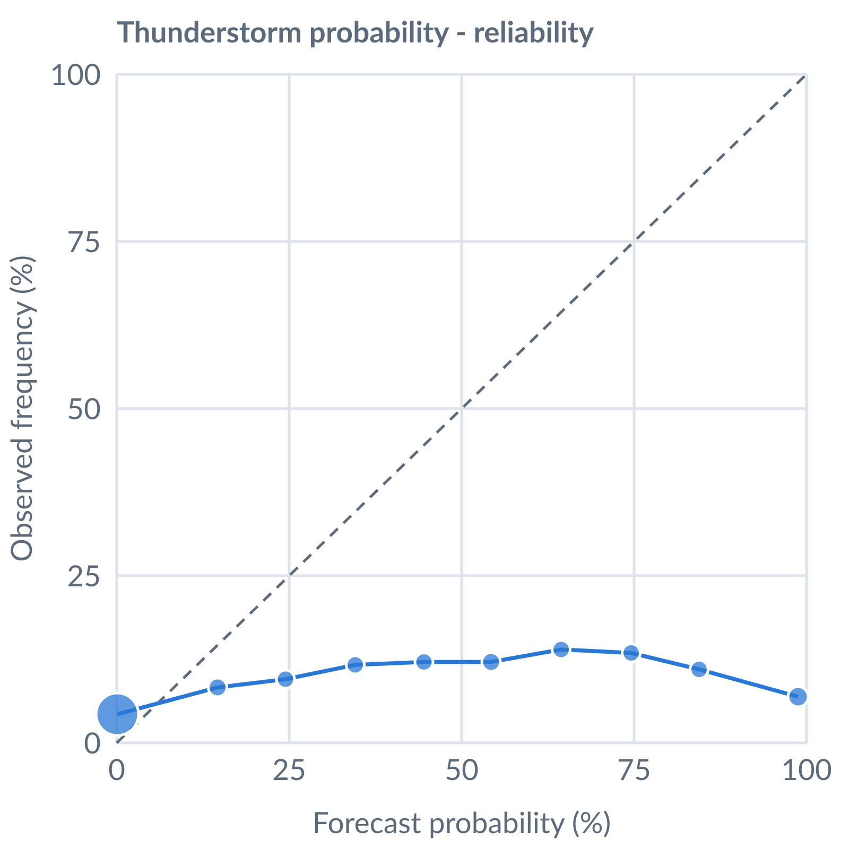
Thunderstorm probability: dots on the dashed line mean a stated probability matched how often it happened (181316 pairs, all places pooled).
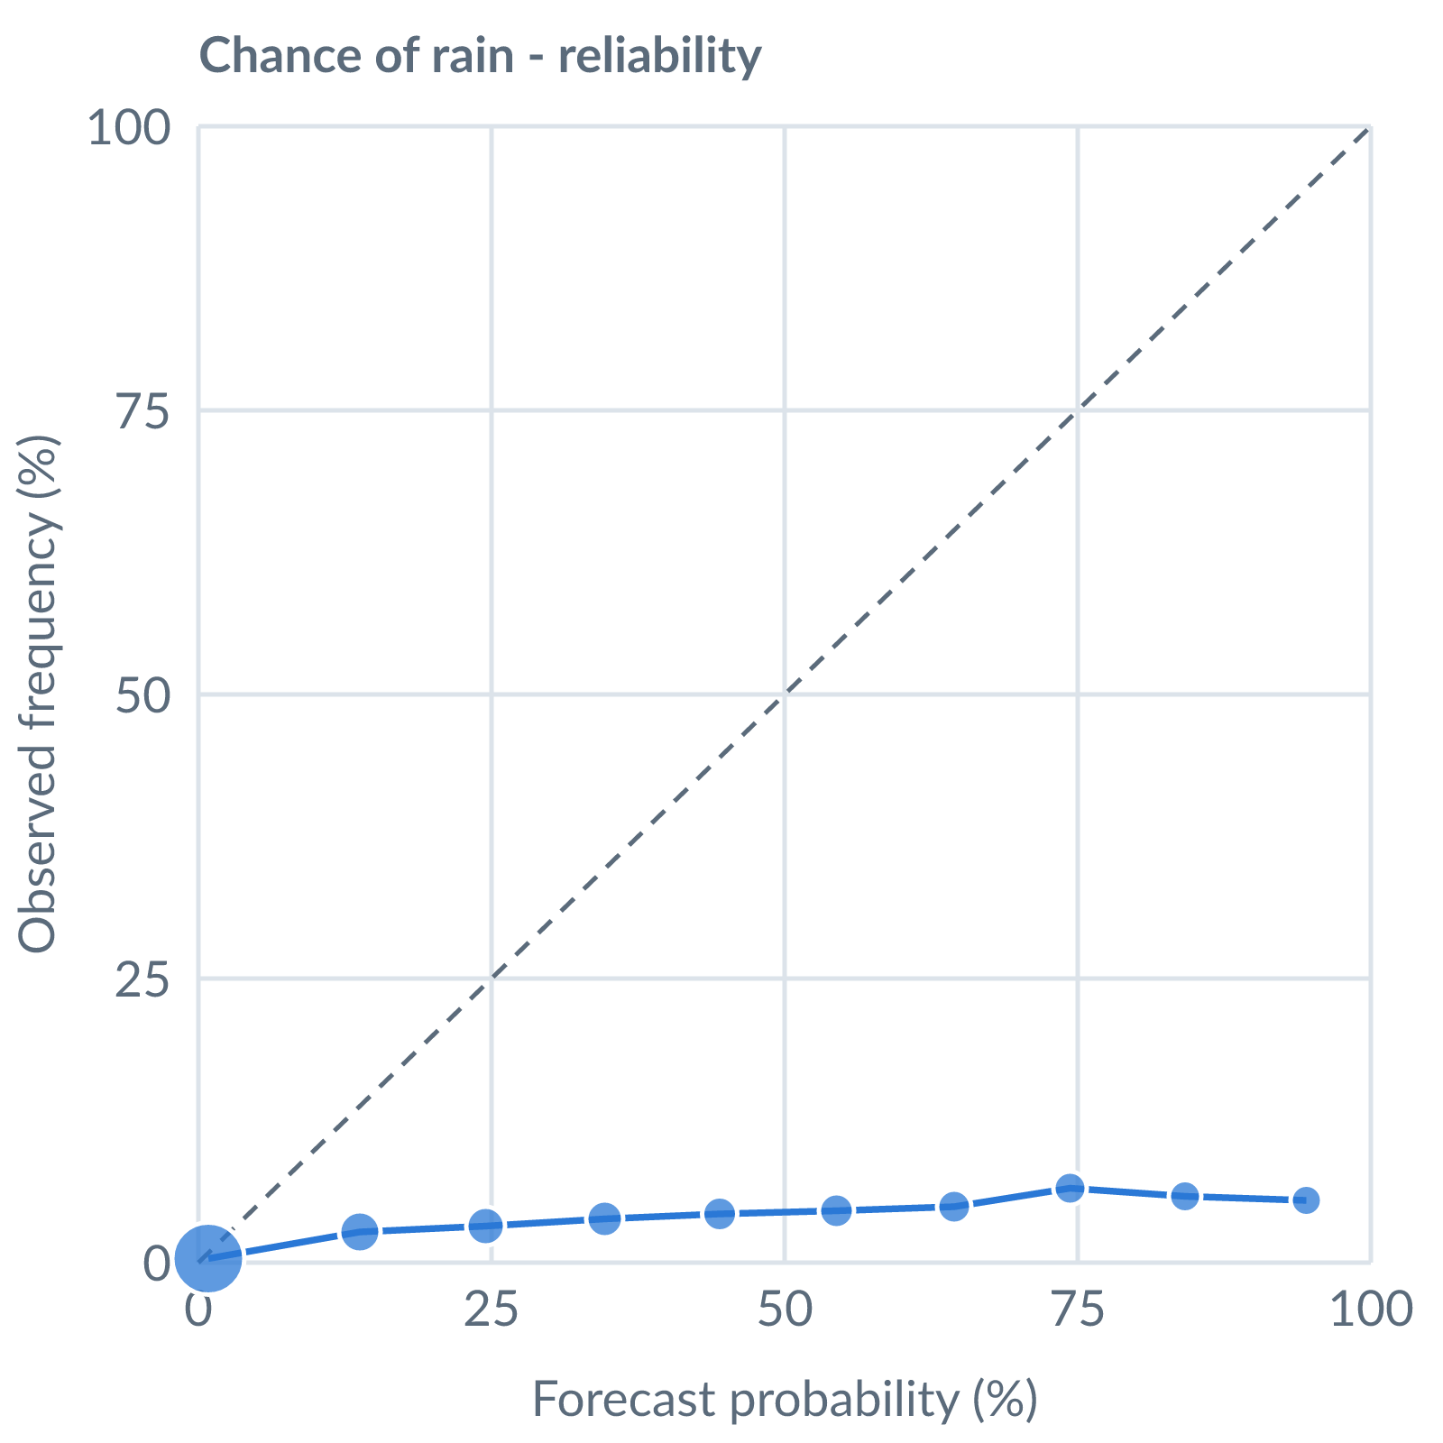
Chance of rain: dots on the dashed line mean a stated probability matched how often it happened (169772 pairs, all places pooled).
Learned bias (forecast minus observed; positive = sources run high), mean over scored sources, by local time of day. These are corrected for before sources are averaged.
Metric | Overall | Night | Morning | Afternoon | Evening | Pairs
(a) | (b) | (c) | (d) | (e) | (f) | (g)
Temperature (°C) | +0.0 | +1.1 | -0.0 | -0.8 | +0.1 | 101124
Dew point (°C) | -3.6 | -4.7 | -3.7 | -2.8 | -3.5 | 89451
Wind speed (kt) | +0.6 | +1.8 | +0.2 | -0.2 | +1.1 | 89199
Pressure (QNH) (hPa) | +0.5 | +0.5 | +0.5 | +0.9 | +0.3 | 45563
Not yet available: Scores are decayed over the verification window (half-life 14 days); separate last-7-day and last-30-day windows are not stored. Bias is the current learned value; the history needed for a trend over time is not stored. Flight-window hit / bust / miss is not yet recorded.

