Minna — 14-Day Forecast
DNMN · issued 7 Nov 26 00:23Z
Sources: Foreca ≈ 1.1 · Met.no (Yr) ≈ 1.0 · Open-Meteo ≈ 1.0 · OpenWeather ≈ 1.0 · Tomorrow.io ▲ 1.1 · Visual Crossing ≈ 1.1
▲ better than the pool · ▽ worse (only when the 95% interval excludes the pool) · ≈ not distinguishable from the pool · unmarked = unproven (accuracy is measured against METAR and SYNOP observations)
Day | 00 | 01 | 02 | 03 | 04 | 05 | 06 | 07 | 08 | 09 | 10 | 11 | 12 | 13 | 14 | 15 | 16 | 17 | 18 | 19 | 20 | 21 | 22 | 23 | Flyable Windows | Conf
Sat 7 Nov 26 | · | G | G | G | F | G | F | D | D | E | E | E | E | E | E | E | E | E | E | D | D | D | D | D | 0700–0800L (Marginal, 2 h) · 1900–2300L (Marginal, 5 h) ☾ | 74%
Sun 8 Nov 26 | D | D | D | D | D | D | D | D | D | D | D | E | E | E | E | E | E | D | D | D | D | D | D | D | best window: 0001–1000L (Marginal, 11 h) ☾ · 1700–2300L (Marginal, 7 h) ☾ | 78%
Mon 9 Nov 26 | F | D | D | D | D | D | D | D | D | D | D | E | E | E | E | D | E | D | D | D | D | D | D | D | 0100–1000L (Marginal, 10 h) ☾ · 1700–2300L (Marginal, 7 h) ☾ | 74%
Tue 10 Nov 26 | D | D | D | D | D | F | G | G | E | D | E | E | E | E | E | G | G | G | G | G | G | G | G | G | 0001–0400L (Marginal, 5 h) ☾ | 73%
Wed 11 Nov 26 | G | G | G | G | G | G | E | E | E | G | G | G | G | G | G | G | G | G | D | D | D | D | D | D | 1800–2300L (Marginal, 6 h) ☾ | 73%
Thu 12 Nov 26 | D | E | D | D | D | D | D | D | D | D | D | D | D | D | D | D | D | D | E | D | D | D | D | D | 0200–1700L (Marginal, 16 h) ☾ · 1900–2300L (Marginal, 5 h) ☾ | 68%
Fri 13 Nov 26 | D | D | E | F | G | G | G | G | G | G | E | E | E | E | E | E | D | D | D | D | D | D | D | D | 0001–0100L (Marginal, 2 h) ☾ · 1600–2300L (Marginal, 8 h) ☾ | 69%
Sat 14 Nov 26 | D | D | D | D | D | D | D | D | D | E | E | E | E | F | F | F | F | E | E | E | F | E | E | D | 0001–0800L (Marginal, 9 h) ☾ | 68%
Sun 15 Nov 26 | D | D | D | D | D | D | E | E | E | D | E | E | E | E | E | D | D | D | D | D | D | D | D | E | 0001–0500L (Marginal, 6 h) ☾ · 1500–2200L (Marginal, 8 h) ☾ | 69%
Mon 16 Nov 26 | E | E | E | D | D | D | D | D | D | D | D | D | D | D | D | D | D | D | E | E | D | D | D | D | 0300–1700L (Marginal, 15 h) ☾ · 2000–2300L (Marginal, 4 h) ☾ | 68%
Tue 17 Nov 26 | D | D | D | D | D | D | D | E | E | E | D | E | E | E | D | D | D | D | D | D | D | D | D | D | 0001–0600L (Marginal, 7 h) ☾ · 1400–2300L (Marginal, 10 h) ☾ | 68%
Wed 18 Nov 26 | D | D | D | D | D | D | D | D | D | D | D | D | D | D | D | D | D | D | D | D | D | D | D | D | 0001–2300L (Marginal, 24 h) ☾ | 68%
Thu 19 Nov 26 | D | D | D | D | D | F | G | G | G | G | G | G | G | G | G | G | E | D | D | D | D | D | D | D | 0001–0400L (Marginal, 5 h) ☾ · 1700–2300L (Marginal, 7 h) ☾ | 68%
Fri 20 Nov 26 | D | D | D | D | D | D | D | D | D | D | E | E | E | F | F | F | E | E | D | D | E | E | E | F | 0001–0900L (Marginal, 10 h) ☾ · 1800–1900L (Marginal, 2 h) ☾ | 67%
A Excellent · B Good · C Fair · D Marginal · E Poor · F Very Poor · G Unacceptable · · No data
Best window (highest confidence, then grade, then length): Sun 8 Nov 26 0001–1000L (Marginal, 11 h) ☾, confidence 78%.
Learned corrections (METAR-verified): skill weighting — pooled all-field scores for 206; bias corrections — meteoblue temperature +3.0 °C, meteoblue QNH −3.0 hPa, Open-Meteo temperature +3.0 °C, Open-Meteo dewpoint +3.0 °C, Met.no (Yr) temperature +3.0 °C, Met.no (Yr) dewpoint +3.0 °C (+67 more); hour-of-day bias (local time, shrunk toward the all-hours bias) — aifs afternoon wind +3.2 kt, metcheck afternoon wind +3.2 kt, meteoblue night temperature +3.0 °C, meteoblue morning temperature +3.0 °C, meteoblue afternoon temperature +3.0 °C, meteoblue evening temperature +3.0 °C (+284 more); cloud base estimated as 410 ft per °C of dewpoint spread for sources that report no ceiling (≥60% cloud cover; flagged estimated, weighted ×0.5); probability calibration — rain chance: meteoblue, Open-Meteo, Foreca, metcheck, OpenWeather, Visual Crossing, Tomorrow.io, wttrin, ecmwf, gfs, icon, ukmo, gem, ecmwfens; storm: Open-Meteo, Met.no (Yr), Foreca, OpenWeather, Visual Crossing, Tomorrow.io, wttrin, ecmwf, gfs, icon, meteofrance, aviationweather, ukmo, jma, gem, ecmwfens, aifs (each source's stated probability mapped to its verified frequency by an isotonic fit on ≥200 pairs, proven on the holdout); plausibility bounds from ERA5 climatology 2016-2025 (mean ± 5 sd; screening only, not observed truth); skill blend 1 auto-tuned over 9222 holdout pairs (consensus beat the best single source, icon, by 13%); correction gates (newest-7-day holdout; pooled skill is always on) — regional skill: off this week (did not improve holdout); place skill: off this week (did not improve holdout); lead-time skill: off this week (did not improve holdout); small-sample skill shrinkage: off this week (did not improve holdout); bias correction: on (improved holdout by 25.6%); place bias: on (improved holdout by 10.9%); hour-of-day bias: on (improved holdout by 7.0%); QNH bias: on (improved holdout by 57.4%); gust estimates: off this week (did not improve holdout); cloud-base coefficient: off this week (insufficient holdout: 79 of 200 items); recent-form skill: off this week (did not improve holdout); probability calibration: on (improved holdout by 36.3%); nowcast anchor horizon: off this week (did not improve holdout); dust-visibility estimate: off this week (did not improve holdout); fog risk: off this week (did not improve holdout).

Outlook
Day | Date | Outlook | Temp | Max wind | Flight windows | Confidence | Notes
(a) | (b) | (c) | (d) | (e) | (f) | (g) | (h)
Sat | 7 Nov 26 | Poor | 23–34°C | 5 kts S, g 10 | 0700–0800L (Marginal, 2 h); 1900–2300L (Marginal, 5 h) ☾ | 74% | 9% interpolated
Sun | 8 Nov 26 | Marginal | 23–34°C | 6 kts SSW, g 11 | 0001–1000L (Marginal, 11 h) ☾; 1700–2300L (Marginal, 7 h) ☾ | 78% | 9% interpolated
Mon | 9 Nov 26 | Marginal | 24–35°C | 6 kts SW, g 11 | 0100–1000L (Marginal, 10 h) ☾; 1700–2300L (Marginal, 7 h) ☾ | 74% | 15% interpolated
Tue | 10 Nov 26 | Unacceptable | 24–35°C | 6 kts WNW, g 11 | 0001–0400L (Marginal, 5 h) ☾ | 73% | 21% interpolated
Wed | 11 Nov 26 | Unacceptable | 24–34°C | 6 kts SSE, g 10 | 1800–2300L (Marginal, 6 h) ☾ | 73% | 21% interpolated
Thu | 12 Nov 26 | Marginal | 22–33°C | 6 kts S, g 11 | 0200–1700L (Marginal, 16 h) ☾; 1900–2300L (Marginal, 5 h) ☾ | 68% | 16% interpolated
Fri | 13 Nov 26 | Marginal | 21–33°C | 5 kts ENE, g 12 | 0001–0100L (Marginal, 2 h) ☾; 1600–2300L (Marginal, 8 h) ☾ | 69% | 16% interpolated
Sat | 14 Nov 26 | Marginal | 21–34°C | 9 kts ENE, g 16 | 0001–0800L (Marginal, 9 h) ☾ | 68% | 16% interpolated
Sun | 15 Nov 26 | Marginal | 21–34°C | 8 kts ENE, g 13 | 0001–0500L (Marginal, 6 h) ☾; 1500–2200L (Marginal, 8 h) ☾ | 69% | 16% interpolated
Mon | 16 Nov 26 | Marginal | 22–36°C | 6 kts NE, g 11 | 0300–1700L (Marginal, 15 h) ☾; 2000–2300L (Marginal, 4 h) ☾ | 68% | 8% interpolated
Tue | 17 Nov 26 | Marginal | 22–35°C | 7 kts NE, g 13 | 0001–0600L (Marginal, 7 h) ☾; 1400–2300L (Marginal, 10 h) ☾ | 68%
Wed | 18 Nov 26 | Marginal | 22–35°C | 5 kts NE, g 9 | 0001–2300L (Marginal, 24 h) ☾ | 68%
Thu | 19 Nov 26 | Marginal | 23–36°C | 5 kts ENE, g 9 | 0001–0400L (Marginal, 5 h) ☾; 1700–2300L (Marginal, 7 h) ☾ | 68%
Fri | 20 Nov 26 | Marginal | 23–36°C | 5 kts SE, g 11 | 0001–0900L (Marginal, 10 h) ☾; 1800–1900L (Marginal, 2 h) ☾ | 67%

Today — Sat 7 Nov 26
Conditions are expected to be generally Poor: partly cloudy, winds up to 5 kts S and temperatures 23–34°C. Flyable windows: 0700–0800L (Marginal, 2 h) and 1900–2300L (Marginal, 5 h). Hazards: thunderstorm risk 0001–2300L.
WEATHER EFFECTS
 | 00–06L | 06–12L | 12–18L | 18–24L
Wind | B | D | C | B
Visibility | A | A | A | A
Cloud / ceiling | G | F | D | D
Precipitation | A | A | A | A
Thunderstorm | D | E | E | E
Fog | · | · | · | ·
A Excellent · B Good · C Fair · D Marginal (flyable) · E Poor · F Very Poor · G Unacceptable · (worst condition in each period)
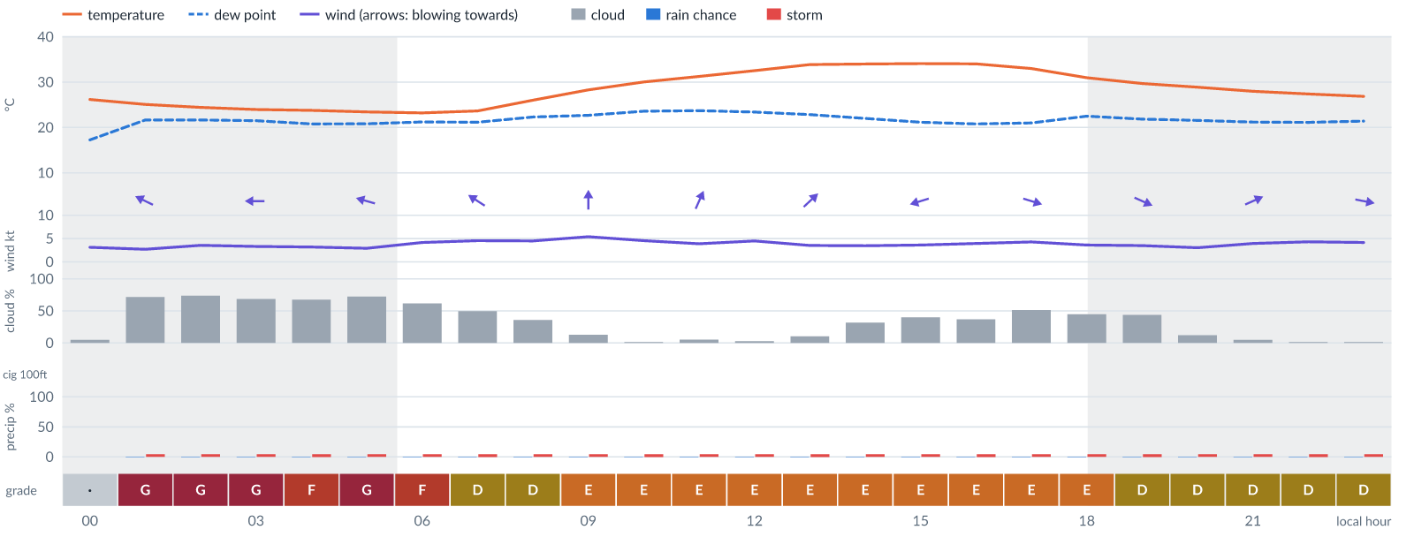
Meteogram — hourly forecast; shaded = before first light / after last light. Gaps mean no data.
Ser | Hrs | Temp | Cloud | Wind | Gust | QNH | Assessment | Driver | Remarks
(a) | (b) | (c) | (d) | (e) | (f) | (g) | (h) | (i) | (j)
1. | 0001 | 26°C | ☀ Clear (5%) | ↙ 3 kts NE | - | 1014 | · - No data | storm 0% · visibility not forecast | ⚠ thunderstorm risk
2. | 0100 | 25 (spread 24–26)°C | ◕ Cloudy (72%) | ↖ 3 (spread 2–3) kts ESE | 3 kts | 1013 | G - Unacceptable | cloud 72% | cloud cover, thunderstorm risk
3. | 0200 | 24 (spread 23–26)°C | ◕ Cloudy (74%) | ← 4 (spread 3–4) kts ESE | 4 kts | 1013 | G - Unacceptable | cloud 74% | cloud cover, thunderstorm risk
4. | 0300 | 24 (spread 23–25)°C | ◕ Cloudy (69%) | ← 3 (spread 3–4) kts E | 5 kts | 1012 | G - Unacceptable | cloud 69% | cloud cover, thunderstorm risk
5. | 0400 | 24 (spread 23–25)°C | ◕ Cloudy (68%) | ← 3 kts E | 4 kts | 1012 | F - Very Poor | cloud 68% | cloud cover, thunderstorm risk, convective energy
6. | 0500 | 23 (spread 23–24)°C | ◕ Cloudy (72%) | ← 3 kts ESE | 3 kts | 1013 | G - Unacceptable | cloud 72% | cloud cover, thunderstorm risk, convective energy
7. | 0600 | 23 (spread 23–24)°C | ◑ Cloudy (62%) | ↖ 4 (spread 3–5) kts ESE | 5 kts | 1013 | F - Very Poor | cloud 62% | cloud cover, thunderstorm risk, convective energy
8. | 0700 | 24 (spread 23–24)°C | ◑ Partly cloudy (50%) | ↖ 5 (spread 3–6) kts ESE | 6 kts | 1014 | D - Marginal | storm 5% · cloud 50% | cloud cover, thunderstorm risk
9. | 0800 | 26 (spread 25–27)°C | ◔ Partly cloudy (36%) | ↑ 5 (spread 3–5) kts SSE | 7 kts | 1015 | D - Marginal | storm 4% | thunderstorm risk
10. | 0900 | 28 (spread 27–30)°C | ◔ Mostly clear (13%) | ↑ 5 (spread 4–6) kts S | 10 kts | 1016 | E - Poor | CAPE 2020 J/kg | convective energy, thunderstorm risk, gusts, wind shear
11. | 1000 | 30 (spread 28–32)°C | ☀ Clear (1%) | ↑ 5 (spread 3–5) kts SSW | 9 kts | 1017 | E - Poor | CAPE 2680 J/kg | convective energy, thunderstorm risk, gusts
12. | 1100 | 31 (spread 30–33)°C | ☀ Clear (5%) | ↗ 4 (spread 3–4) kts SSW | 9 kts | 1017 | E - Poor | CAPE 2990 J/kg | convective energy, thunderstorm risk, gusts, wind shear
13. | 1200 | 33 (spread 31–35)°C | ☀ Clear (3%) | ↗ 4 (spread 3–5) kts SW | 8 kts | 1016 | E - Poor | CAPE 2960 J/kg | convective energy, thunderstorm risk
14. | 1300 | 34 (spread 31–36)°C | ☀ Clear (11%) | ↗ 4 (spread 3–4) kts SW | 8 kts | 1015 | E - Poor | CAPE 2840 J/kg | convective energy, thunderstorm risk
15. | 1400 | 34 (spread 32–36)°C | ◔ Mostly clear (32%) | ↗ 3 (spread 3–4) kts SW | 7 kts | 1014 | E - Poor | CAPE 2530 J/kg | convective energy, thunderstorm risk
16. | 1500 | 34 (spread 32–36)°C | ◑ Partly cloudy (40%) | ← 4 kts ENE | 7 kts | 1013 | E - Poor | CAPE 2420 J/kg | convective energy, thunderstorm risk
17. | 1600 | 34 (spread 32–36)°C | ◔ Partly cloudy (37%) | ↘ 4 (spread 3–5) kts NNW | 6 kts | 1013 | E - Poor | CAPE 2470 J/kg | convective energy, thunderstorm risk
18. | 1700 | 33 (spread 31–34)°C | ◑ Partly cloudy (51%) | → 4 (spread 3–5) kts WNW | 5 kts | 1013 | E - Poor | CAPE 2140 J/kg | convective energy, cloud cover, thunderstorm risk
19. | 1800 | 31 (spread 30–33)°C | ◑ Partly cloudy (45%) | ↘ 4 (spread 3–4) kts NW | 4 kts | 1013 | E - Poor | CAPE 2140 J/kg | convective energy, cloud cover, thunderstorm risk
20. | 1900 | 30 (spread 28–31)°C | ◑ Partly cloudy (44%) | ↘ 3 (spread 3–4) kts WNW | 3 kts | 1014 | D - Marginal | storm 5% · CAPE 1760 J/kg | cloud cover, thunderstorm risk, convective energy
21. | 2000 | 29 (spread 28–30)°C | ☀ Clear (12%) | → 3 (spread 3–4) kts WSW | 2 kts | 1014 | D - Marginal | storm 4% | thunderstorm risk
22. | 2100 | 28 (spread 27–29)°C | ☀ Clear (5%) | ↗ 4 (spread 3–5) kts WSW | 4 kts | 1015 | D - Marginal | storm 4% | thunderstorm risk
23. | 2200 | 27 (spread 26–28)°C | ☀ Clear (2%) | → 4 (spread 3–5) kts WSW | 5 kts | 1015 | D - Marginal | storm 5% | thunderstorm risk
24. | 2300 | 27 (spread 26–28)°C | ☀ Clear (1%) | → 4 (spread 3–5) kts W | 5 kts | 1014 | D - Marginal | storm 4% · CAPE 1640 J/kg | thunderstorm risk, convective energy
Confidence: 74% — data for 24 of 24 hours; 9% of readings interpolated · first light 0603L · last light 1831L · Moon 4 % illuminated, rises 04:44, sets 16:47.

Tomorrow — Sun 8 Nov 26
Conditions are expected to be generally Marginal: clear, winds up to 6 kts SSW and temperatures 23–34°C. Flyable windows: 0001–1000L (Marginal, 11 h) and 1700–2300L (Marginal, 7 h). Hazards: thunderstorm risk 0001–2300L. Overall an improvement on the previous day.
WEATHER EFFECTS
 | 00–06L | 06–12L | 12–18L | 18–24L
Wind | B | D | D | B
Visibility | A | A | A | A
Cloud / ceiling | A | A | B | D
Precipitation | A | A | A | A
Thunderstorm | D | E | E | D
Fog | · | · | · | ·
A Excellent · B Good · C Fair · D Marginal (flyable) · E Poor · F Very Poor · G Unacceptable · (worst condition in each period)
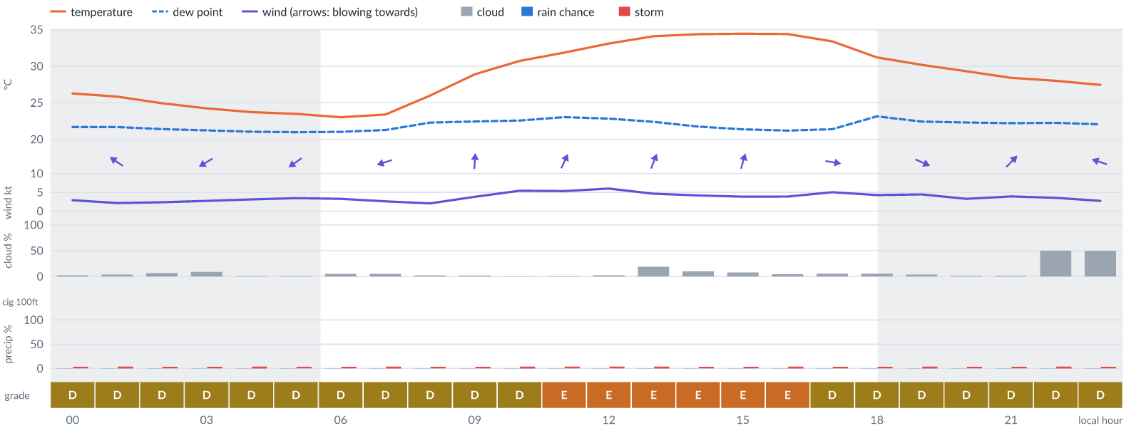
Meteogram — hourly forecast; shaded = before first light / after last light. Gaps mean no data.
Ser | Hrs | Temp | Cloud | Wind | Gust | QNH | Assessment | Driver | Remarks
(a) | (b) | (c) | (d) | (e) | (f) | (g) | (h) | (i) | (j)
1. | 0001 | 26 (spread 26–27)°C | ☀ Clear (3%) | ↑ 3 (spread 2–4) kts S | 4 kts | 1014 | D - Marginal | storm 4% | thunderstorm risk
2. | 0100 | 26 (spread 25–27)°C | ☀ Clear (4%) | ↖ 2 kts ESE | 2 kts | 1014 | D - Marginal | storm 4% | thunderstorm risk
3. | 0200 | 25 (spread 24–26)°C | ☀ Clear (7%) | ← 2 (spread 2–3) kts ENE | 3 kts | 1013 | D - Marginal | storm 4% | thunderstorm risk
4. | 0300 | 24 (spread 23–25)°C | ☀ Clear (9%) | ↙ 3 (spread 2–3) kts ENE | 4 kts | 1013 | D - Marginal | storm 4% | thunderstorm risk
5. | 0400 | 24 (spread 23–24)°C | ☀ Clear (1%) | ↙ 3 (spread 2–4) kts ENE | 4 kts | 1013 | D - Marginal | storm 4% | thunderstorm risk
6. | 0500 | 23 (spread 23–24)°C | ☀ Clear (1%) | ↙ 3 (spread 2–4) kts NE | 5 kts | 1013 | D - Marginal | storm 4% | thunderstorm risk
7. | 0600 | 23 (spread 22–24)°C | ☀ Clear (5%) | ↙ 3 (spread 3–4) kts NE | 4 kts | 1014 | D - Marginal | storm 4% | thunderstorm risk
8. | 0700 | 23 (spread 23–24)°C | ☀ Clear (5%) | ← 3 (spread 2–3) kts ENE | 3 kts | 1015 | D - Marginal | storm 4% · CAPE 1020 J/kg | thunderstorm risk, convective energy
9. | 0800 | 26 (spread 25–27)°C | ☀ Clear (2%) | ↖ 2 (spread 1–3) kts SE | 5 kts | 1016 | D - Marginal | storm 4% | thunderstorm risk
10. | 0900 | 29 (spread 28–30)°C | ☀ Clear (2%) | ↑ 4 (spread 3–5) kts S | 7 kts | 1018 | D - Marginal | storm 4% · CAPE 1760 J/kg | thunderstorm risk, convective energy
11. | 1000 | 31 (spread 29–32)°C | ☀ Clear (0%) | ↑ 5 (spread 5–6) kts SSW | 10 kts | 1018 | D - Marginal | storm 4% · CAPE 1990 J/kg | thunderstorm risk, convective energy, gusts, wind shear
12. | 1100 | 32 (spread 31–33)°C | ☀ Clear (1%) | ↗ 5 (spread 5–6) kts SSW | 11 kts | 1018 | E - Poor | CAPE 2470 J/kg | convective energy, thunderstorm risk, gusts, wind shear
13. | 1200 | 33 (spread 32–35)°C | ☀ Clear (3%) | ↗ 6 (spread 6–7) kts SSW | 11 kts | 1017 | E - Poor | CAPE 2610 J/kg | convective energy, thunderstorm risk, gusts, wind shear
14. | 1300 | 34 (spread 32–36)°C | ◔ Mostly clear (19%) | ↑ 5 (spread 4–5) kts SSW | 9 kts | 1016 | E - Poor | CAPE 2620 J/kg | convective energy, thunderstorm risk, gusts
15. | 1400 | 34 (spread 33–37)°C | ☀ Clear (10%) | ↑ 4 (spread 4–5) kts SSW | 8 kts | 1015 | E - Poor | CAPE 2180 J/kg | convective energy, thunderstorm risk
16. | 1500 | 34 (spread 33–36)°C | ☀ Clear (8%) | ↑ 4 kts SSW | 7 kts | 1015 | E - Poor | CAPE 2190 J/kg | convective energy, thunderstorm risk
17. | 1600 | 34 (spread 33–36)°C | ☀ Clear (4%) | ↗ 4 (spread 3–4) kts SW | 6 kts | 1014 | E - Poor | CAPE 2090 J/kg | convective energy, thunderstorm risk
18. | 1700 | 33 (spread 32–35)°C | ☀ Clear (6%) | → 5 (spread 4–6) kts W | 5 kts | 1014 | D - Marginal | storm 4% · CAPE 1770 J/kg | thunderstorm risk, convective energy
19. | 1800 | 31 (spread 30–33)°C | ☀ Clear (5%) | ↘ 4 (spread 4–5) kts WNW | 5 kts | 1014 | D - Marginal | storm 4% · CAPE 1820 J/kg | thunderstorm risk, convective energy
20. | 1900 | 30 (spread 29–31)°C | ☀ Clear (4%) | ↘ 4 (spread 4–5) kts WNW | 5 kts | 1015 | D - Marginal | storm 4% · CAPE 1560 J/kg | thunderstorm risk, convective energy
21. | 2000 | 29 (spread 28–30)°C | ☀ Clear (2%) | → 3 (spread 3–4) kts W | 3 kts | 1015 | D - Marginal | storm 4% · CAPE 1250 J/kg | thunderstorm risk, convective energy
22. | 2100 | 28 (spread 27–29)°C | ☀ Clear (1%) | ↗ 4 kts SW | 4 kts | 1015 | D - Marginal | storm 4% · CAPE 1050 J/kg | thunderstorm risk, convective energy
23. | 2200 | 28 (spread 27–29)°C | ◑ Partly cloudy (50%) | ↗ 4 (spread 3–4) kts SW | 3 kts | 1016 | D - Marginal | storm 4% · CAPE 1320 J/kg | cloud cover, thunderstorm risk, convective energy
24. | 2300 | 27 (spread 26–28)°C | ◑ Partly cloudy (50%) | ← 3 (spread 2–4) kts ESE | 3 kts | 1016 | D - Marginal | storm 4% · CAPE 1350 J/kg | cloud cover, thunderstorm risk, convective energy
Confidence: 78% — data for 24 of 24 hours; 9% of readings interpolated · first light 0603L · last light 1831L · Moon 1 % illuminated, rises 05:33, sets 17:29.

Extended Outlook
WEATHER EFFECTS BY DAY
 | Mon | Tue | Wed | Thu | Fri | Sat | Sun | Mon | Tue | Wed | Thu | Fri
Wind | D | D | D | E | E | F | E | E | E | D | D | D
Visibility | A | A | A | A | A | A | A | A | A | A | A | A
Cloud / ceiling | F | G | G | E | G | A | A | A | A | B | G | F
Precipitation | A | A | A | A | A | A | A | A | A | A | A | A
Thunderstorm | E | E | E | D | D | D | D | D | D | D | D | D
Fog | · | · | · | · | · | · | · | · | · | · | · | ·
Overall | F | G | G | E | G | F | E | E | E | D | G | F
A Excellent · B Good · C Fair · D Marginal (flyable) · E Poor · F Very Poor · G Unacceptable · (worst condition in each period)

Mon 9 Nov 26
Conditions are expected to be generally Marginal: mostly clear, winds up to 6 kts SW and temperatures 24–35°C. Flyable windows: 0100–1000L (Marginal, 10 h) and 1700–2300L (Marginal, 7 h). Hazards: thunderstorm risk 0001–2300L. Overall similar to the previous day.
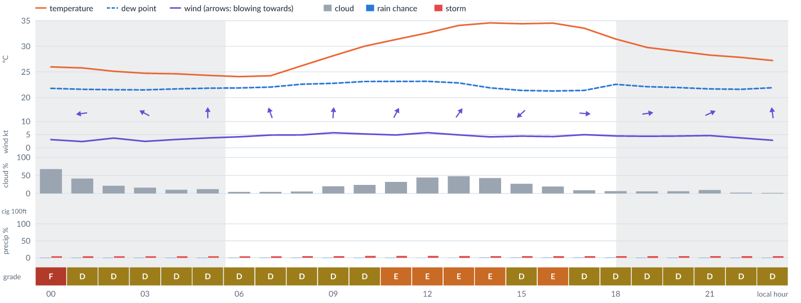
Meteogram — hourly forecast; shaded = before first light / after last light. Gaps mean no data.
Ser | Hrs | Temp | Cloud | Wind | Gust | QNH | Assessment | Driver | Remarks
(a) | (b) | (c) | (d) | (e) | (f) | (g) | (h) | (i) | (j)
1. | 0001 | 26°C | ◕ Cloudy (68%) | ↖ 3 kts SE | 4 kts | 1015 | F - Very Poor | cloud 68% | cloud cover, thunderstorm risk, convective energy
2. | 0100 | 26 (spread 25–26)°C | ◑ Partly cloudy (41%) | ← 2 (spread 2–3) kts E | 3 kts | 1015 | D - Marginal | storm 5% · CAPE 1260 J/kg | thunderstorm risk, convective energy
3. | 0200 | 25 (spread 25–26)°C | ◔ Mostly clear (21%) | ↙ 4 (spread 3–4) kts NE | 5 kts | 1015 | D - Marginal | storm 4% · CAPE 1220 J/kg | thunderstorm risk, convective energy
4. | 0300 | 25 (spread 24–26)°C | ◔ Mostly clear (16%) | ↖ 2 (spread 2–3) kts ESE | 4 kts | 1014 | D - Marginal | storm 4% · CAPE 1140 J/kg | thunderstorm risk, convective energy
5. | 0400 | 25 (spread 24–25)°C | ☀ Clear (10%) | ↑ 3 (spread 2–4) kts SSE | 3 kts | 1015 | D - Marginal | storm 5% · CAPE 1200 J/kg | thunderstorm risk, convective energy
6. | 0500 | 24 (spread 24–25)°C | ☀ Clear (12%) | ↑ 4 (spread 3–4) kts S | 5 kts | 1015 | D - Marginal | storm 4% · CAPE 1110 J/kg | thunderstorm risk, convective energy
7. | 0600 | 24 (spread 23–25)°C | ☀ Clear (4%) | ↑ 4 (spread 4–5) kts S | 5 kts | 1016 | D - Marginal | storm 4% · CAPE 1040 J/kg | thunderstorm risk, convective energy
8. | 0700 | 24 (spread 23–25)°C | ☀ Clear (4%) | ↑ 5 kts SSE | 6 kts | 1016 | D - Marginal | storm 5% · CAPE 1020 J/kg | thunderstorm risk, convective energy
9. | 0800 | 26 (spread 25–27)°C | ☀ Clear (5%) | ↑ 5 (spread 4–5) kts SSE | 9 kts | 1018 | D - Marginal | storm 5% · CAPE 1000 J/kg | thunderstorm risk, convective energy, gusts
10. | 0900 | 28 (spread 27–29)°C | ◔ Mostly clear (20%) | ↑ 6 (spread 5–6) kts S | 10 kts | 1019 | D - Marginal | storm 5% · gust 10 kt | thunderstorm risk, gusts
11. | 1000 | 30 (spread 29–31)°C | ◔ Mostly clear (24%) | ↗ 5 (spread 5–6) kts SSW | 11 kts | 1020 | D - Marginal | storm 5% · gust 11 kt | thunderstorm risk, gusts, wind shear
12. | 1100 | 31 (spread 30–34)°C | ◔ Mostly clear (32%) | ↗ 5 (spread 4–5) kts SSW | 10 kts | 1019 | E - Poor | CAPE 2040 J/kg | convective energy, thunderstorm risk, gusts, wind shear
13. | 1200 | 33 (spread 31–35)°C | ◑ Partly cloudy (44%) | ↗ 6 (spread 4–7) kts SW | 10 kts | 1018 | E - Poor | CAPE 2400 J/kg | convective energy, cloud cover, thunderstorm risk, gusts
14. | 1300 | 34 (spread 32–37)°C | ◑ Partly cloudy (48%) | ↗ 5 (spread 4–6) kts SW | 10 kts | 1018 | E - Poor | CAPE 2670 J/kg | convective energy, cloud cover, thunderstorm risk, gusts, wind shear
15. | 1400 | 35 (spread 33–37)°C | ◑ Partly cloudy (43%) | ↑ 4 kts S | 10 kts | 1017 | E - Poor | CAPE 2350 J/kg | convective energy, cloud cover, thunderstorm risk, gusts, wind shear
16. | 1500 | 34 (spread 32–37)°C | ◔ Mostly clear (27%) | ↙ 4 (spread 4–5) kts NE | 10 kts | 1017 | D - Marginal | storm 5% · CAPE 1930 J/kg | thunderstorm risk, convective energy, gusts, wind shear
17. | 1600 | 35 (spread 32–36)°C | ◔ Mostly clear (19%) | ↓ 4 kts NNW | 8 kts | 1016 | E - Poor | CAPE 2010 J/kg | convective energy, thunderstorm risk
18. | 1700 | 34 (spread 32–35)°C | ☀ Clear (9%) | → 5 (spread 4–6) kts W | 5 kts | 1015 | D - Marginal | storm 5% · CAPE 1690 J/kg | thunderstorm risk, convective energy
19. | 1800 | 31 (spread 30–33)°C | ☀ Clear (6%) | → 5 (spread 4–5) kts W | 5 kts | 1015 | D - Marginal | storm 5% · CAPE 1890 J/kg | thunderstorm risk, convective energy
20. | 1900 | 30 (spread 28–31)°C | ☀ Clear (6%) | → 4 (spread 4–5) kts W | 6 kts | 1016 | D - Marginal | storm 5% | thunderstorm risk
21. | 2000 | 29 (spread 28–30)°C | ☀ Clear (6%) | → 4 (spread 4–5) kts WSW | 5 kts | 1016 | D - Marginal | storm 5% | thunderstorm risk
22. | 2100 | 28 (spread 27–29)°C | ☀ Clear (10%) | ↗ 5 kts WSW | 5 kts | 1017 | D - Marginal | storm 5% | thunderstorm risk
23. | 2200 | 28 (spread 26–29)°C | ☀ Clear (2%) | ↑ 4 (spread 3–4) kts SSW | 3 kts | 1017 | D - Marginal | storm 5% | thunderstorm risk
24. | 2300 | 27 (spread 26–28)°C | ☀ Clear (2%) | ↑ 3 kts S | 3 kts | 1017 | D - Marginal | storm 5% | thunderstorm risk
Confidence: 74% — data for 24 of 24 hours; 15% of readings interpolated · first light 0604L · last light 1831L · Moon 0 % illuminated, rises 06:24, sets 18:14.

Tue 10 Nov 26
Conditions are expected to be generally Unacceptable: cloudy, winds up to 6 kts WNW and temperatures 24–35°C. Flyable windows: 0001–0400L (Marginal, 5 h). Hazards: thunderstorm risk 0001–2300L. Overall a deterioration from the previous day.
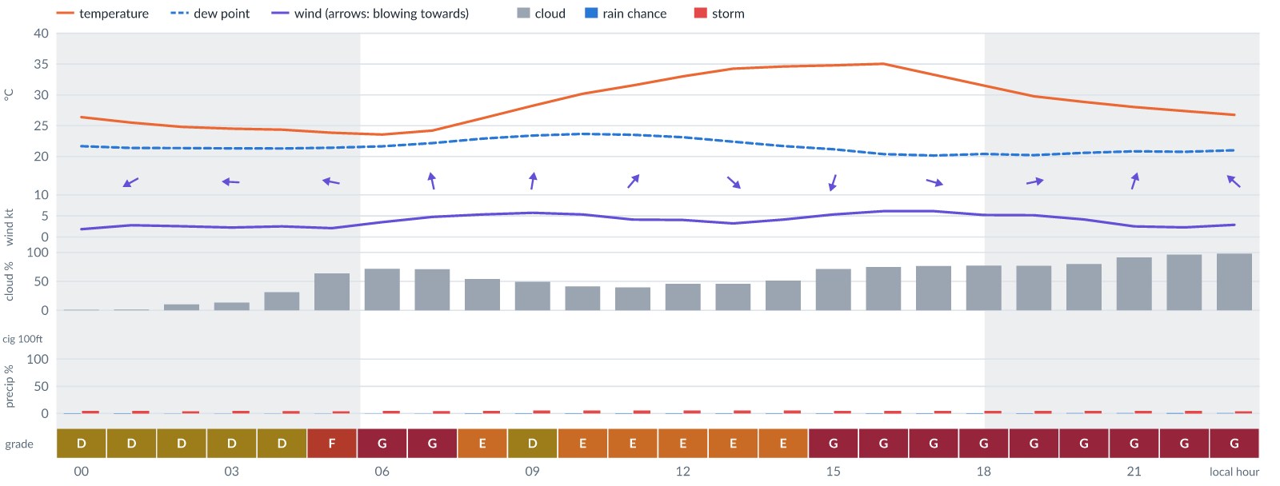
Meteogram — hourly forecast; shaded = before first light / after last light. Gaps mean no data.
Ser | Hrs | Temp | Cloud | Wind | Gust | QNH | Assessment | Driver | Remarks
(a) | (b) | (c) | (d) | (e) | (f) | (g) | (h) | (i) | (j)
1. | 0001 | 26 (spread 26–27)°C | ☀ Clear (1%) | ← 2 (spread 1–3) kts ENE | 3 kts | 1017 | D - Marginal | storm 5% | thunderstorm risk
2. | 0100 | 25 (spread 24–27)°C | ☀ Clear (1%) | ↙ 3 (spread 2–3) kts ENE | 4 kts | 1017 | D - Marginal | storm 5% | thunderstorm risk
3. | 0200 | 25 (spread 24–26)°C | ☀ Clear (11%) | ← 3 (spread 2–3) kts E | 4 kts | 1016 | D - Marginal | storm 4% | thunderstorm risk
4. | 0300 | 25 (spread 23–26)°C | ◔ Mostly clear (14%) | ← 2 (spread 2–3) kts E | 3 kts | 1016 | D - Marginal | storm 5% | thunderstorm risk
5. | 0400 | 24 (spread 23–25)°C | ◔ Mostly clear (31%) | ← 3 (spread 2–4) kts ESE | 3 kts | 1016 | D - Marginal | storm 5% | thunderstorm risk
6. | 0500 | 24 (spread 23–25)°C | ◕ Cloudy (64%) | ← 2 (spread 1–3) kts E | 3 kts | 1016 | F - Very Poor | cloud 64% | cloud cover, thunderstorm risk
7. | 0600 | 24 (spread 23–25)°C | ◕ Cloudy (72%) | ↖ 4 (spread 3–4) kts SSE | 4 kts | 1017 | G - Unacceptable | cloud 72% | cloud cover, thunderstorm risk
8. | 0700 | 24 (spread 23–25)°C | ◕ Cloudy (71%) | ↑ 5 (spread 4–6) kts SSE | 7 kts | 1017 | G - Unacceptable | cloud 71% | cloud cover, thunderstorm risk
9. | 0800 | 26 (spread 25–27)°C | ◑ Partly cloudy (54%) | ↑ 5 (spread 4–6) kts S | 9 kts | 1019 | E - Poor | cloud 54% | cloud cover, thunderstorm risk, gusts
10. | 0900 | 28 (spread 27–29)°C | ◑ Partly cloudy (49%) | ↑ 6 (spread 5–7) kts S | 11 kts | 1019 | D - Marginal | storm 6% · cloud 49% | cloud cover, thunderstorm risk, gusts, wind shear
11. | 1000 | 30 (spread 29–31)°C | ◑ Partly cloudy (41%) | ↗ 5 (spread 5–6) kts SSW | 11 kts | 1020 | E - Poor | CAPE 2520 J/kg | convective energy, thunderstorm risk, gusts, wind shear
12. | 1100 | 32 (spread 30–33)°C | ◑ Partly cloudy (40%) | ↗ 4 (spread 4–5) kts SW | 9 kts | 1020 | E - Poor | CAPE 2590 J/kg | convective energy, thunderstorm risk, gusts, wind shear
13. | 1200 | 33 (spread 31–35)°C | ◑ Partly cloudy (46%) | ↗ 4 kts WSW | 9 kts | 1019 | E - Poor | CAPE 2520 J/kg | convective energy, cloud cover, thunderstorm risk, gusts, wind shear
14. | 1300 | 34 (spread 32–36)°C | ◑ Partly cloudy (46%) | ↘ 3 kts NW | 9 kts | 1018 | E - Poor | CAPE 2400 J/kg | convective energy, cloud cover, thunderstorm risk, gusts, wind shear
15. | 1400 | 35 (spread 33–37)°C | ◑ Partly cloudy (52%) | ↓ 4 (spread 3–5) kts NNW | 9 kts | 1017 | E - Poor | CAPE 2290 J/kg · cloud 52% | cloud cover, convective energy, thunderstorm risk, gusts, wind shear
16. | 1500 | 35 (spread 33–37)°C | ◕ Cloudy (71%) | ↓ 5 (spread 5–6) kts NNE | 9 kts | 1016 | G - Unacceptable | cloud 71% | cloud cover, convective energy, thunderstorm risk, gusts
17. | 1600 | 35 (spread 33–37)°C | ◕ Cloudy (75%) | ↓ 6 (spread 5–7) kts NNW | 9 kts | 1016 | G - Unacceptable | cloud 75% | cloud cover, thunderstorm risk, convective energy, gusts
18. | 1700 | 33 (spread 32–35)°C | ◕ Cloudy (77%) | → 6 (spread 6–7) kts WNW | 9 kts | 1016 | G - Unacceptable | cloud 77% | cloud cover, thunderstorm risk, convective energy, gusts
19. | 1800 | 31 (spread 30–33)°C | ◕ Cloudy (77%) | ↗ 5 (spread 5–6) kts WSW | 10 kts | 1016 | G - Unacceptable | cloud 77% | cloud cover, thunderstorm risk, gusts, wind shear
20. | 1900 | 30 (spread 28–31)°C | ◕ Cloudy (77%) | → 5 (spread 5–6) kts WSW | 10 kts | 1016 | G - Unacceptable | cloud 77% | cloud cover, thunderstorm risk, gusts, wind shear
21. | 2000 | 29 (spread 27–30)°C | ◕ Cloudy (80%) | ↗ 4 (spread 4–5) kts WSW | 7 kts | 1016 | G - Unacceptable | cloud 80% | cloud cover, thunderstorm risk
22. | 2100 | 28 (spread 26–29)°C | ☁ Overcast (91%) | ↑ 3 (spread 2–3) kts SSW | 4 kts | 1017 | G - Unacceptable | cloud 91% | cloud cover, thunderstorm risk
23. | 2200 | 27 (spread 26–28)°C | ☁ Overcast (96%) | ↖ 2 (spread 1–3) kts SSE | 2 kts | 1017 | G - Unacceptable | cloud 96% | cloud cover, thunderstorm risk
24. | 2300 | 27 (spread 25–28)°C | ☁ Overcast (98%) | ↖ 3 (spread 2–4) kts SE | 4 kts | 1017 | G - Unacceptable | cloud 98% | cloud cover, thunderstorm risk
Confidence: 73% — data for 24 of 24 hours; 21% of readings interpolated · first light 0604L · last light 1831L · Moon 2 % illuminated, rises 07:16, sets 19:02.

Wed 11 Nov 26
Conditions are expected to be generally Unacceptable: cloudy, winds up to 6 kts SSE and temperatures 24–34°C. Flyable windows: 1800–2300L (Marginal, 6 h). Hazards: thunderstorm risk 0001–2300L. Overall similar to the previous day.
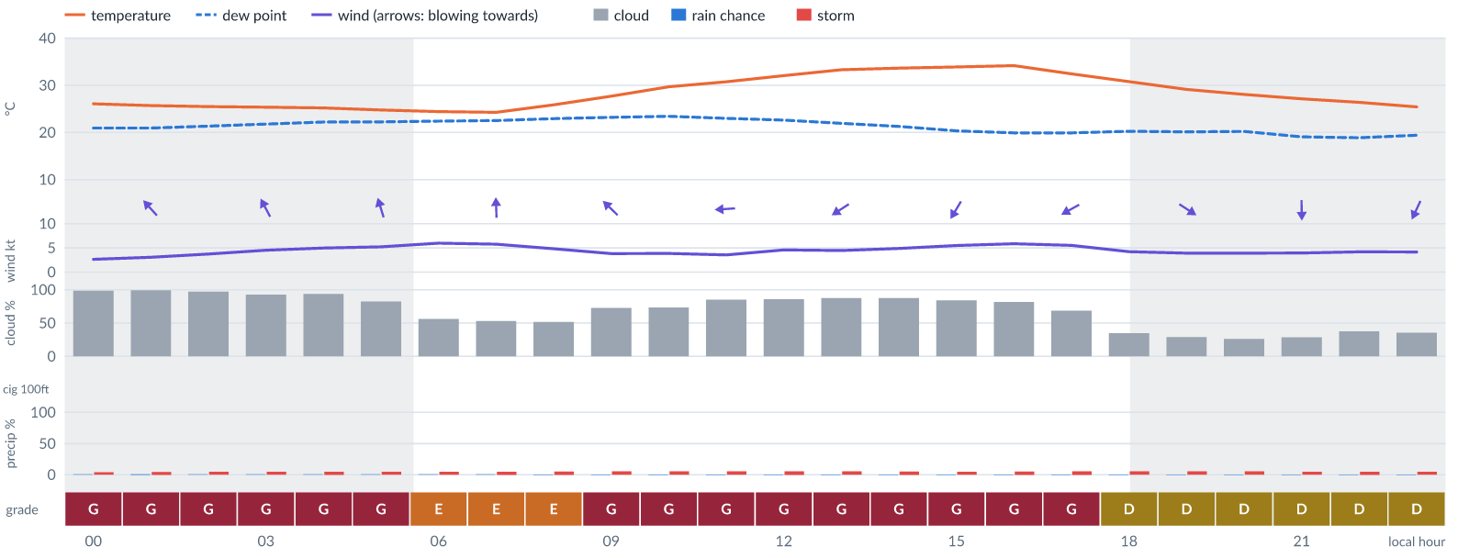
Meteogram — hourly forecast; shaded = before first light / after last light. Gaps mean no data.
Ser | Hrs | Temp | Cloud | Wind | Gust | QNH | Assessment | Driver | Remarks
(a) | (b) | (c) | (d) | (e) | (f) | (g) | (h) | (i) | (j)
1. | 0001 | 26 (spread 25–27)°C | ☁ Overcast (99%) | ↖ 3 (spread 2–3) kts SE | 4 kts | 1017 | G - Unacceptable | cloud 99% | cloud cover, thunderstorm risk
2. | 0100 | 26 (spread 25–27)°C | ☁ Overcast (99%) | ↖ 3 kts SE | 5 kts | 1016 | G - Unacceptable | cloud 99% | cloud cover, thunderstorm risk
3. | 0200 | 25 (spread 25–26)°C | ☁ Overcast (97%) | ↖ 4 (spread 3–4) kts SE | 6 kts | 1016 | G - Unacceptable | cloud 97% | cloud cover, thunderstorm risk
4. | 0300 | 25 (spread 25–26)°C | ☁ Overcast (93%) | ↖ 5 (spread 4–5) kts SSE | 8 kts | 1016 | G - Unacceptable | cloud 93% | cloud cover, thunderstorm risk
5. | 0400 | 25 (spread 24–26)°C | ☁ Overcast (94%) | ↑ 5 (spread 4–6) kts SSE | 10 kts | 1016 | G - Unacceptable | cloud 94% | cloud cover, thunderstorm risk, gusts, wind shear
6. | 0500 | 25 (spread 24–26)°C | ◕ Cloudy (82%) | ↑ 5 (spread 4–6) kts SSE | 9 kts | 1016 | G - Unacceptable | cloud 82% | cloud cover, thunderstorm risk, gusts
7. | 0600 | 24 (spread 23–25)°C | ◑ Partly cloudy (56%) | ↑ 6 kts SSE | 10 kts | 1017 | E - Poor | cloud 56% | cloud cover, thunderstorm risk, gusts
8. | 0700 | 24 (spread 23–25)°C | ◑ Partly cloudy (53%) | ↑ 6 (spread 5–6) kts S | 10 kts | 1017 | E - Poor | cloud 53% | cloud cover, thunderstorm risk, gusts
9. | 0800 | 26 (spread 25–27)°C | ◑ Partly cloudy (52%) | ↑ 5 (spread 4–6) kts SSE | 9 kts | 1018 | E - Poor | cloud 52% | cloud cover, thunderstorm risk, gusts
10. | 0900 | 28 (spread 27–29)°C | ◕ Cloudy (73%) | ↖ 4 (spread 2–6) kts SE | 9 kts | 1019 | G - Unacceptable | cloud 73% | cloud cover, thunderstorm risk, convective energy, gusts, wind shear
11. | 1000 | 30 (spread 28–31)°C | ◕ Cloudy (73%) | ↖ 4 (spread 3–6) kts ESE | 8 kts | 1020 | G - Unacceptable | cloud 73% | cloud cover, convective energy, thunderstorm risk
12. | 1100 | 31 (spread 29–33)°C | ◕ Cloudy (85%) | ← 4 (spread 3–5) kts E | 8 kts | 1020 | G - Unacceptable | cloud 85% | cloud cover, convective energy, thunderstorm risk
13. | 1200 | 32 (spread 30–34)°C | ◕ Cloudy (86%) | ↙ 5 (spread 4–5) kts ENE | 8 kts | 1019 | G - Unacceptable | cloud 86% | cloud cover, convective energy, thunderstorm risk
14. | 1300 | 33 (spread 31–35)°C | ☁ Cloudy (88%) | ↙ 4 (spread 4–5) kts ENE | 8 kts | 1018 | G - Unacceptable | cloud 88% | cloud cover, convective energy, thunderstorm risk
15. | 1400 | 34 (spread 32–36)°C | ☁ Cloudy (88%) | ↙ 5 (spread 4–5) kts NE | 8 kts | 1017 | G - Unacceptable | cloud 88% | cloud cover, thunderstorm risk, convective energy
16. | 1500 | 34 (spread 32–36)°C | ◕ Cloudy (84%) | ↙ 6 (spread 5–6) kts NNE | 8 kts | 1017 | G - Unacceptable | cloud 84% | cloud cover, thunderstorm risk, convective energy
17. | 1600 | 34 (spread 32–36)°C | ◕ Cloudy (81%) | ↓ 6 (spread 5–6) kts NNE | 9 kts | 1016 | G - Unacceptable | cloud 81% | cloud cover, thunderstorm risk, convective energy, gusts
18. | 1700 | 32 (spread 31–34)°C | ◕ Cloudy (69%) | ↙ 6 (spread 5–6) kts ENE | 7 kts | 1016 | G - Unacceptable | cloud 69% | cloud cover, thunderstorm risk
19. | 1800 | 31 (spread 29–32)°C | ◔ Partly cloudy (35%) | → 4 kts W | 6 kts | 1016 | D - Marginal | storm 6% | thunderstorm risk
20. | 1900 | 29 (spread 28–31)°C | ◔ Mostly clear (29%) | ↘ 4 kts WNW | 5 kts | 1016 | D - Marginal | storm 5% | thunderstorm risk
21. | 2000 | 28 (spread 27–29)°C | ◔ Mostly clear (26%) | ↘ 4 kts NW | 5 kts | 1016 | D - Marginal | storm 6% | thunderstorm risk
22. | 2100 | 27 (spread 26–28)°C | ◔ Mostly clear (29%) | ↓ 4 kts N | 5 kts | 1016 | D - Marginal | storm 5% | thunderstorm risk
23. | 2200 | 26 (spread 25–27)°C | ◔ Partly cloudy (37%) | ↙ 4 kts NNE | 4 kts | 1016 | D - Marginal | storm 5% | thunderstorm risk
24. | 2300 | 25 (spread 24–27)°C | ◔ Partly cloudy (36%) | ↙ 4 (spread 4–5) kts NNE | 4 kts | 1016 | D - Marginal | storm 5% | thunderstorm risk
Confidence: 73% — data for 24 of 24 hours; 21% of readings interpolated · first light 0604L · last light 1831L · Moon 5 % illuminated, rises 08:08, sets 19:52.

Thu 12 Nov 26
Conditions are expected to be generally Marginal: partly cloudy, winds up to 6 kts S and temperatures 22–33°C. Flyable windows: 0200–1700L (Marginal, 16 h) and 1900–2300L (Marginal, 5 h). Hazards: thunderstorm risk 0001–2300L. Overall an improvement on the previous day.
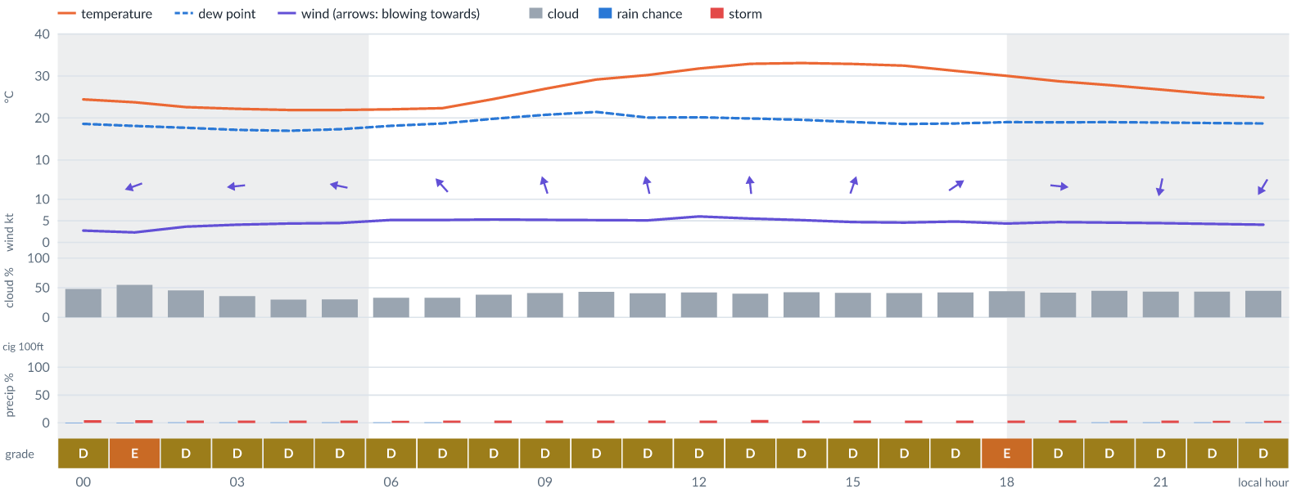
Meteogram — hourly forecast; shaded = before first light / after last light. Gaps mean no data.
Ser | Hrs | Temp | Cloud | Wind | Gust | QNH | Assessment | Driver | Remarks
(a) | (b) | (c) | (d) | (e) | (f) | (g) | (h) | (i) | (j)
1. | 0001 | 24 (spread 23–26)°C | ◑ Partly cloudy (48%) | ← 3 (spread 2–3) kts E | 6 kts | 1016 | D - Marginal | storm 5% · cloud 48% | cloud cover, thunderstorm risk
2. | 0100 | 24 (spread 22–26)°C | ◑ Partly cloudy (55%) | ← 2 (spread 2–3) kts ENE | 5 kts | 1016 | E - Poor | cloud 55% | cloud cover, thunderstorm risk
3. | 0200 | 23 (spread 21–24)°C | ◑ Partly cloudy (45%) | ← 4 (spread 3–5) kts ENE | 8 kts | 1015 | D - Marginal | storm 4% · cloud 45% | ⚠ cloud cover, thunderstorm risk
4. | 0300 | 22 (spread 21–23)°C | ◔ Partly cloudy (36%) | ← 4 (spread 4–5) kts E | 8 kts | 1015 | D - Marginal | storm 4% | ⚠ thunderstorm risk
5. | 0400 | 22 (spread 21–23)°C | ◔ Mostly clear (30%) | ← 4 (spread 4–5) kts E | 8 kts | 1015 | D - Marginal | storm 4% | ⚠ thunderstorm risk
6. | 0500 | 22 (spread 21–23)°C | ◔ Mostly clear (30%) | ← 5 (spread 4–5) kts ESE | 9 kts | 1015 | D - Marginal | storm 4% · gust 9 kt | ⚠ thunderstorm risk, gusts
7. | 0600 | 22 (spread 21–23)°C | ◔ Partly cloudy (33%) | ↖ 5 (spread 4–6) kts ESE | 9 kts | 1016 | D - Marginal | storm 4% · gust 9 kt | ⚠ thunderstorm risk, gusts
8. | 0700 | 22 (spread 22–23)°C | ◔ Partly cloudy (33%) | ↖ 5 (spread 4–6) kts SE | 10 kts | 1016 | D - Marginal | storm 4% · gust 10 kt | ⚠ thunderstorm risk, gusts, wind shear
9. | 0800 | 25 (spread 24–25)°C | ◑ Partly cloudy (38%) | ↖ 5 (spread 4–6) kts SSE | 10 kts | 1017 | D - Marginal | storm 4% · gust 10 kt | ⚠ thunderstorm risk, gusts, wind shear
10. | 0900 | 27 (spread 26–27)°C | ◑ Partly cloudy (41%) | ↑ 5 (spread 5–6) kts SSE | 10 kts | 1018 | D - Marginal | storm 4% · CAPE 1190 J/kg | ⚠ thunderstorm risk, convective energy, gusts, wind shear
11. | 1000 | 29 (spread 29–30)°C | ◑ Partly cloudy (43%) | ↑ 5 (spread 5–6) kts S | 10 kts | 1019 | D - Marginal | storm 4% · CAPE 1420 J/kg | ⚠ cloud cover, thunderstorm risk, convective energy, gusts, wind shear
12. | 1100 | 30 (spread 29–31)°C | ◑ Partly cloudy (41%) | ↑ 5 (spread 4–5) kts SSE | 10 kts | 1018 | D - Marginal | storm 4% · gust 10 kt | ⚠ thunderstorm risk, gusts, wind shear
13. | 1200 | 32 (spread 31–33)°C | ◑ Partly cloudy (42%) | ↑ 6 kts S | 10 kts | 1018 | D - Marginal | storm 4% · gust 10 kt | ⚠ thunderstorm risk, gusts
14. | 1300 | 33 (spread 32–34)°C | ◑ Partly cloudy (40%) | ↑ 6 (spread 5–6) kts S | 10 kts | 1018 | D - Marginal | storm 5% · gust 10 kt | ⚠ thunderstorm risk, gusts
15. | 1400 | 33 (spread 32–34)°C | ◑ Partly cloudy (42%) | ↑ 5 kts S | 11 kts | 1017 | D - Marginal | storm 4% · gust 11 kt | ⚠ thunderstorm risk, gusts, wind shear
16. | 1500 | 33 (spread 32–34)°C | ◑ Partly cloudy (41%) | ↑ 5 (spread 4–5) kts SSW | 11 kts | 1017 | D - Marginal | storm 4% · gust 11 kt | ⚠ thunderstorm risk, gusts, wind shear
17. | 1600 | 32 (spread 31–34)°C | ◑ Partly cloudy (41%) | ↗ 5 (spread 4–5) kts SW | 11 kts | 1016 | D - Marginal | storm 4% · gust 11 kt | ⚠ thunderstorm risk, gusts, wind shear
18. | 1700 | 31 (spread 30–32)°C | ◑ Partly cloudy (42%) | ↗ 5 kts SW | 11 kts | 1016 | D - Marginal | storm 4% · gust 11 kt | ⚠ thunderstorm risk, gusts, wind shear
19. | 1800 | 30 (spread 29–31)°C | ◑ Partly cloudy (44%) | → 4 (spread 4–5) kts WSW | 11 kts | 1016 | E - Poor | gust spread +6 kt | wind shear, cloud cover, thunderstorm risk, gusts
20. | 1900 | 29 (spread 28–30)°C | ◑ Partly cloudy (42%) | → 5 (spread 4–5) kts W | 11 kts | 1016 | D - Marginal | storm 5% · gust 11 kt | ⚠ thunderstorm risk, gusts, wind shear
21. | 2000 | 28 (spread 27–29)°C | ◑ Partly cloudy (45%) | → 5 kts W | 10 kts | 1015 | D - Marginal | storm 4% · cloud 45% | ⚠ cloud cover, thunderstorm risk, gusts, wind shear
22. | 2100 | 27 (spread 26–28)°C | ◑ Partly cloudy (44%) | ↓ 4 (spread 4–5) kts NNE | 9 kts | 1016 | D - Marginal | storm 4% · cloud 44% | ⚠ cloud cover, thunderstorm risk, gusts, wind shear
23. | 2200 | 26 (spread 25–26)°C | ◑ Partly cloudy (44%) | ↓ 4 (spread 4–5) kts NNE | 9 kts | 1016 | D - Marginal | storm 4% · cloud 44% | ⚠ cloud cover, thunderstorm risk, gusts, wind shear
24. | 2300 | 25 (spread 24–25)°C | ◑ Partly cloudy (45%) | ↙ 4 kts NNE | 8 kts | 1016 | D - Marginal | storm 4% · cloud 45% | ⚠ cloud cover, thunderstorm risk
Confidence: 68% — data for 24 of 24 hours; 16% of readings interpolated · first light 0604L · last light 1830L · Moon 9 % illuminated, rises 09:01, sets 20:43.

Fri 13 Nov 26
Conditions are expected to be generally Marginal: partly cloudy, winds up to 5 kts ENE, gusting 12 kts and temperatures 21–33°C. Flyable windows: 0001–0100L (Marginal, 2 h) and 1600–2300L (Marginal, 8 h). Hazards: thunderstorm risk 0001–2300L. Overall similar to the previous day.
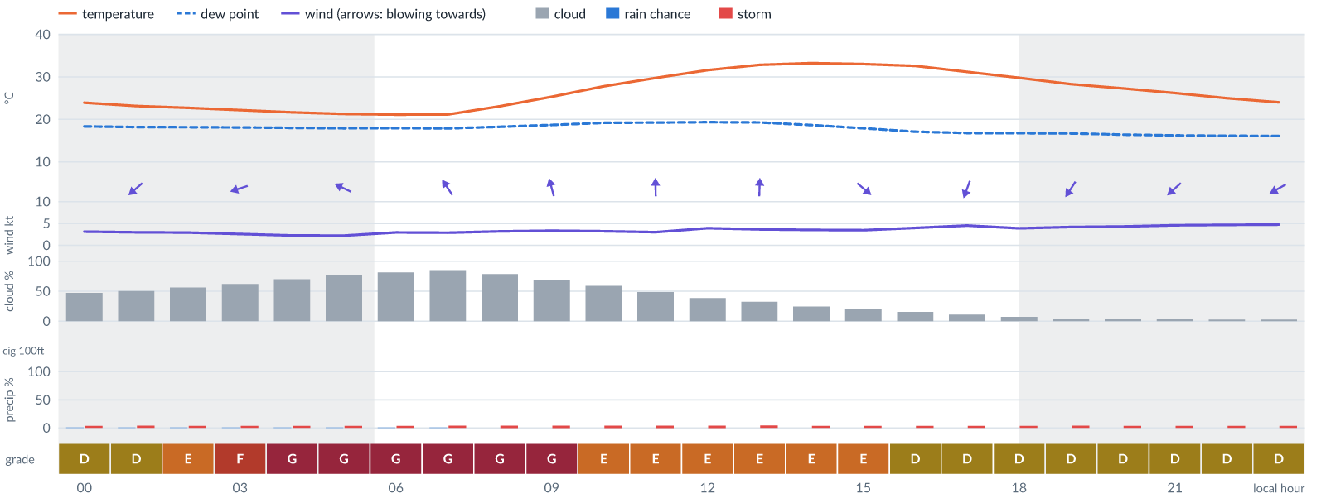
Meteogram — hourly forecast; shaded = before first light / after last light. Gaps mean no data.
Ser | Hrs | Temp | Cloud | Wind | Gust | QNH | Assessment | Driver | Remarks
(a) | (b) | (c) | (d) | (e) | (f) | (g) | (h) | (i) | (j)
1. | 0001 | 24 (spread 23–24)°C | ◑ Partly cloudy (47%) | ↙ 3 (spread 3–4) kts NE | 7 kts | 1015 | D - Marginal | storm 4% · cloud 47% | ⚠ cloud cover, thunderstorm risk
2. | 0100 | 23 (spread 23–24)°C | ◑ Partly cloudy (50%) | ↙ 3 (spread 3–4) kts NE | 6 kts | 1015 | D - Marginal | storm 4% · cloud 50% | ⚠ cloud cover, thunderstorm risk
3. | 0200 | 23 (spread 22–23)°C | ◑ Partly cloudy (56%) | ↙ 3 (spread 2–3) kts ENE | 6 kts | 1015 | E - Poor | cloud 56% | cloud cover, thunderstorm risk
4. | 0300 | 22 (spread 22–23)°C | ◑ Cloudy (62%) | ← 3 (spread 2–3) kts ENE | 7 kts | 1015 | F - Very Poor | cloud 62% | cloud cover, thunderstorm risk
5. | 0400 | 22 (spread 21–22)°C | ◕ Cloudy (70%) | ← 2 (spread 2–3) kts E | 8 kts | 1016 | G - Unacceptable | cloud 70% | cloud cover, thunderstorm risk, wind shear
6. | 0500 | 21 (spread 20–22)°C | ◕ Cloudy (76%) | ↖ 2 (spread 2–3) kts ESE | 8 kts | 1015 | G - Unacceptable | cloud 76% | cloud cover, thunderstorm risk, wind shear
7. | 0600 | 21 (spread 20–22)°C | ◕ Cloudy (81%) | ↖ 3 (spread 2–4) kts SE | 9 kts | 1016 | G - Unacceptable | cloud 81% | cloud cover, thunderstorm risk, gusts, wind shear
8. | 0700 | 21 (spread 21–22)°C | ◕ Cloudy (85%) | ↖ 3 (spread 2–4) kts SE | 10 kts | 1016 | G - Unacceptable | cloud 85% | cloud cover, wind shear, thunderstorm risk, gusts
9. | 0800 | 23 (spread 22–24)°C | ◕ Cloudy (78%) | ↖ 3 (spread 3–4) kts SSE | 10 kts | 1016 | G - Unacceptable | cloud 78% | cloud cover, wind shear, thunderstorm risk, gusts
10. | 0900 | 25 (spread 24–27)°C | ◕ Cloudy (70%) | ↑ 3 (spread 3–4) kts SSE | 10 kts | 1017 | G - Unacceptable | cloud 70% | cloud cover, wind shear, thunderstorm risk, gusts
11. | 1000 | 28 (spread 26–29)°C | ◑ Partly cloudy (59%) | ↑ 3 (spread 3–4) kts S | 10 kts | 1017 | E - Poor | cloud 59% · gust spread +7 kt | cloud cover, wind shear, thunderstorm risk, gusts
12. | 1100 | 30 (spread 29–31)°C | ◑ Partly cloudy (49%) | ↑ 3 kts S | 11 kts | 1018 | E - Poor | gust spread +8 kt | wind shear, cloud cover, thunderstorm risk, gusts
13. | 1200 | 32 (spread 30–33)°C | ◑ Partly cloudy (39%) | ↑ 4 kts S | 11 kts | 1017 | E - Poor | gust spread +7 kt | wind shear, thunderstorm risk, gusts
14. | 1300 | 33 (spread 31–34)°C | ◔ Mostly clear (32%) | ↑ 4 (spread 3–4) kts S | 12 kts | 1018 | E - Poor | gust 12 kt · gust spread +8 kt | gusts, wind shear, thunderstorm risk
15. | 1400 | 33 (spread 32–35)°C | ◔ Mostly clear (25%) | ↑ 4 (spread 3–4) kts S | 12 kts | 1017 | E - Poor | gust 12 kt · gust spread +8 kt | gusts, wind shear, thunderstorm risk
16. | 1500 | 33 (spread 31–34)°C | ◔ Mostly clear (20%) | ↘ 3 (spread 3–4) kts NW | 11 kts | 1017 | E - Poor | gust spread +8 kt | wind shear, thunderstorm risk, gusts
17. | 1600 | 33 (spread 31–34)°C | ◔ Mostly clear (15%) | ↓ 4 (spread 4–5) kts N | 10 kts | 1016 | D - Marginal | storm 4% · gust 10 kt | ⚠ thunderstorm risk, gusts, wind shear
18. | 1700 | 31 (spread 30–33)°C | ☀ Clear (11%) | ↓ 5 kts NNE | 9 kts | 1016 | D - Marginal | storm 4% · gust 9 kt | ⚠ thunderstorm risk, gusts
19. | 1800 | 30 (spread 28–31)°C | ☀ Clear (7%) | ↙ 4 (spread 3–4) kts NNE | 8 kts | 1016 | D - Marginal | storm 4% | ⚠ thunderstorm risk
20. | 1900 | 28 (spread 27–29)°C | ☀ Clear (3%) | ↙ 4 (spread 3–5) kts NNE | 7 kts | 1015 | D - Marginal | storm 4% | ⚠ thunderstorm risk
21. | 2000 | 27 (spread 27–28)°C | ☀ Clear (4%) | ↙ 4 (spread 4–5) kts NE | 7 kts | 1015 | D - Marginal | storm 4% | ⚠ thunderstorm risk
22. | 2100 | 26 (spread 25–27)°C | ☀ Clear (3%) | ↙ 5 (spread 4–5) kts NE | 7 kts | 1015 | D - Marginal | storm 4% | ⚠ thunderstorm risk
23. | 2200 | 25 (spread 24–26)°C | ☀ Clear (3%) | ↙ 5 kts NE | 8 kts | 1015 | D - Marginal | storm 4% | ⚠ thunderstorm risk
24. | 2300 | 24 (spread 23–25)°C | ☀ Clear (3%) | ↙ 5 kts ENE | 8 kts | 1015 | D - Marginal | storm 4% | ⚠ thunderstorm risk
Confidence: 69% — data for 24 of 24 hours; 16% of readings interpolated · first light 0605L · last light 1830L · Moon 15 % illuminated, rises 09:51, sets 21:35.

Sat 14 Nov 26
Conditions are expected to be generally Marginal: clear, winds up to 9 kts ENE, gusting 16 kts and temperatures 21–34°C. Flyable windows: 0001–0800L (Marginal, 9 h). Hazards: thunderstorm risk 0001–2300L. Overall similar to the previous day.
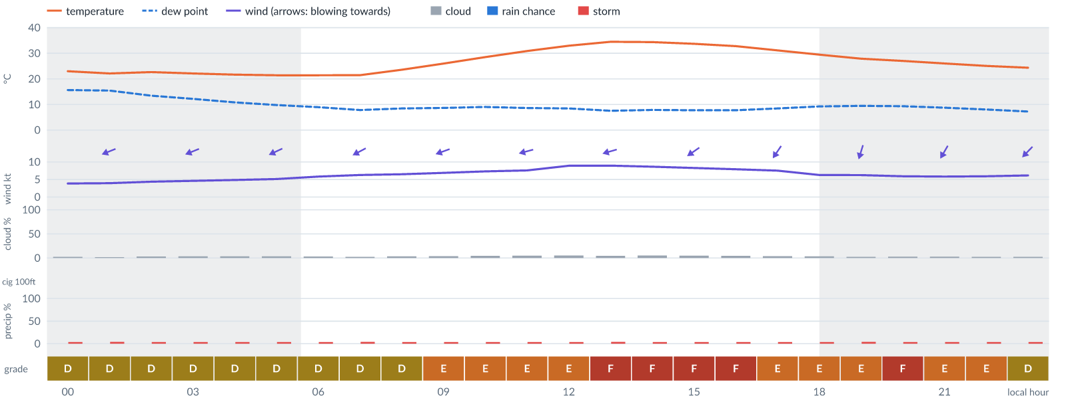
Meteogram — hourly forecast; shaded = before first light / after last light. Gaps mean no data.
Ser | Hrs | Temp | Cloud | Wind | Gust | QNH | Assessment | Driver | Remarks
(a) | (b) | (c) | (d) | (e) | (f) | (g) | (h) | (i) | (j)
1. | 0001 | 23 (spread 22–24)°C | ☀ Clear (2%) | ↙ 4 (spread 3–5) kts ENE | 9 kts | 1015 | D - Marginal | storm 4% · gust 9 kt | ⚠ thunderstorm risk, gusts, wind shear
2. | 0100 | 22 (spread 22–23)°C | ☀ Clear (2%) | ← 4 (spread 4–5) kts ENE | 9 kts | 1015 | D - Marginal | storm 4% · gust 9 kt | ⚠ thunderstorm risk, gusts, wind shear
3. | 0200 | 23 (spread 21–24)°C | ☀ Clear (3%) | ← 4 (spread 4–5) kts ENE | 8 kts | 1015 | D - Marginal | storm 4% | ⚠ thunderstorm risk
4. | 0300 | 22 (spread 21–23)°C | ☀ Clear (4%) | ← 5 (spread 4–5) kts ENE | 9 kts | 1015 | D - Marginal | storm 4% · gust 9 kt | ⚠ thunderstorm risk, gusts
5. | 0400 | 22 (spread 20–23)°C | ☀ Clear (4%) | ↙ 5 kts ENE | 9 kts | 1015 | D - Marginal | storm 4% · gust 9 kt | ⚠ thunderstorm risk, gusts
6. | 0500 | 21 (spread 20–23)°C | ☀ Clear (4%) | ↙ 5 kts ENE | 9 kts | 1015 | D - Marginal | storm 4% · gust 9 kt | ⚠ thunderstorm risk, gusts
7. | 0600 | 21 (spread 20–22)°C | ☀ Clear (3%) | ↙ 6 (spread 5–6) kts ENE | 9 kts | 1015 | D - Marginal | storm 4% · gust 9 kt | ⚠ thunderstorm risk, gusts
8. | 0700 | 21 (spread 21–22)°C | ☀ Clear (3%) | ↙ 6 (spread 5–7) kts ENE | 10 kts | 1015 | D - Marginal | storm 4% · gust 10 kt | ⚠ thunderstorm risk, gusts
9. | 0800 | 24 (spread 22–25)°C | ☀ Clear (4%) | ↙ 6 (spread 6–7) kts ENE | 11 kts | 1016 | D - Marginal | storm 4% · gust 11 kt | ⚠ thunderstorm risk, gusts, wind shear
10. | 0900 | 26 (spread 25–27)°C | ☀ Clear (4%) | ← 7 (spread 6–8) kts ENE | 12 kts | 1016 | E - Poor | gust 12 kt | gusts, thunderstorm risk, wind shear
11. | 1000 | 28 (spread 27–29)°C | ☀ Clear (4%) | ← 7 (spread 6–8) kts ENE | 14 kts | 1017 | E - Poor | gust 14 kt · gust spread +6 kt | gusts, wind shear, thunderstorm risk
12. | 1100 | 31 (spread 30–32)°C | ☀ Clear (5%) | ← 8 (spread 7–8) kts ENE | 13 kts | 1017 | E - Poor | gust 13 kt | gusts, thunderstorm risk, wind shear
13. | 1200 | 33 (spread 32–34)°C | ☀ Clear (5%) | ← 9 (spread 7–10) kts ENE | 14 kts | 1017 | E - Poor | gust 14 kt | gusts, thunderstorm risk, strong wind, wind shear
14. | 1300 | 34 (spread 33–36)°C | ☀ Clear (4%) | ← 9 (spread 7–10) kts ENE | 15 kts | 1017 | F - Very Poor | gust 15 kt | gusts, thunderstorm risk, strong wind, wind shear
15. | 1400 | 34 (spread 33–35)°C | ☀ Clear (5%) | ↙ 9 (spread 7–10) kts ENE | 16 kts | 1017 | F - Very Poor | gust 16 kt | gusts, wind shear, thunderstorm risk, strong wind
16. | 1500 | 34 (spread 33–35)°C | ☀ Clear (5%) | ↙ 8 (spread 8–9) kts NE | 16 kts | 1016 | F - Very Poor | gust 16 kt | gusts, wind shear, thunderstorm risk
17. | 1600 | 33 (spread 31–34)°C | ☀ Clear (4%) | ↙ 8 (spread 7–9) kts NE | 15 kts | 1016 | F - Very Poor | gust 15 kt | gusts, wind shear, thunderstorm risk
18. | 1700 | 31 (spread 30–32)°C | ☀ Clear (4%) | ↙ 8 (spread 7–8) kts NE | 14 kts | 1015 | E - Poor | gust 14 kt | gusts, thunderstorm risk, wind shear
19. | 1800 | 29 (spread 28–31)°C | ☀ Clear (4%) | ↙ 6 (spread 5–7) kts NNE | 13 kts | 1015 | E - Poor | gust 13 kt · gust spread +7 kt | gusts, wind shear, thunderstorm risk
20. | 1900 | 28 (spread 27–29)°C | ☀ Clear (3%) | ↓ 6 (spread 5–7) kts NNE | 12 kts | 1014 | E - Poor | gust 12 kt | gusts, thunderstorm risk, wind shear
21. | 2000 | 27 (spread 26–28)°C | ☀ Clear (3%) | ↙ 6 (spread 5–7) kts NNE | 15 kts | 1014 | F - Very Poor | gust 15 kt · gust spread +9 kt | gusts, wind shear, thunderstorm risk
22. | 2100 | 26 (spread 25–27)°C | ☀ Clear (3%) | ↙ 6 (spread 5–7) kts NNE | 14 kts | 1014 | E - Poor | gust 14 kt · gust spread +8 kt | gusts, wind shear, thunderstorm risk
23. | 2200 | 25 (spread 24–26)°C | ☀ Clear (2%) | ↙ 6 (spread 5–7) kts NE | 12 kts | 1014 | E - Poor | gust 12 kt | gusts, thunderstorm risk, wind shear
24. | 2300 | 24 (spread 23–25)°C | ☀ Clear (2%) | ↙ 6 (spread 6–7) kts NE | 11 kts | 1014 | D - Marginal | storm 4% · gust 11 kt | ⚠ thunderstorm risk, gusts, wind shear
Confidence: 68% — data for 24 of 24 hours; 16% of readings interpolated · first light 0605L · last light 1830L · Moon 23 % illuminated, rises 10:39, sets 22:26.

Sun 15 Nov 26
Conditions are expected to be generally Marginal: clear, winds up to 8 kts ENE and temperatures 21–34°C. Flyable windows: 0001–0500L (Marginal, 6 h) and 1500–2200L (Marginal, 8 h). Hazards: thunderstorm risk 0001–2300L. Overall similar to the previous day.
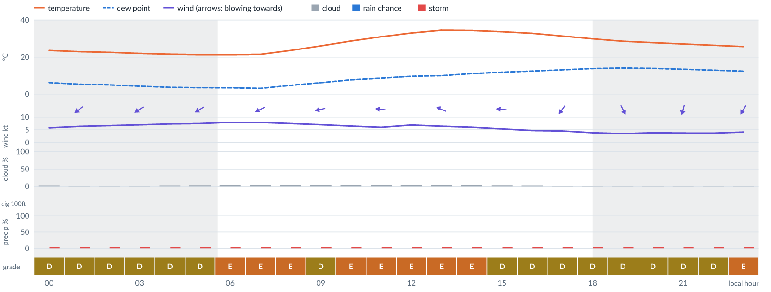
Meteogram — hourly forecast; shaded = before first light / after last light. Gaps mean no data.
Ser | Hrs | Temp | Cloud | Wind | Gust | QNH | Assessment | Driver | Remarks
(a) | (b) | (c) | (d) | (e) | (f) | (g) | (h) | (i) | (j)
1. | 0001 | 24 (spread 22–25)°C | ☀ Clear (2%) | ↙ 6 kts NE | 10 kts | 1014 | D - Marginal | storm 4% · gust 10 kt | ⚠ thunderstorm risk, gusts
2. | 0100 | 23 (spread 22–24)°C | ☀ Clear (2%) | ↙ 6 (spread 6–7) kts NE | 10 kts | 1015 | D - Marginal | storm 4% · gust 10 kt | ⚠ thunderstorm risk, gusts
3. | 0200 | 22 (spread 21–24)°C | ☀ Clear (2%) | ↙ 7 kts NE | 9 kts | 1015 | D - Marginal | storm 4% · gust 9 kt | ⚠ thunderstorm risk, gusts
4. | 0300 | 22 (spread 21–23)°C | ☀ Clear (2%) | ↙ 7 kts NE | 10 kts | 1015 | D - Marginal | storm 4% · gust 10 kt | ⚠ thunderstorm risk, gusts
5. | 0400 | 21 (spread 20–22)°C | ☀ Clear (2%) | ↙ 7 (spread 7–8) kts ENE | 10 kts | 1014 | D - Marginal | storm 4% · gust 10 kt | ⚠ thunderstorm risk, gusts
6. | 0500 | 21 (spread 20–22)°C | ☀ Clear (3%) | ↙ 7 (spread 7–8) kts ENE | 10 kts | 1014 | D - Marginal | storm 4% · gust 10 kt | ⚠ thunderstorm risk, gusts
7. | 0600 | 21 (spread 20–22)°C | ☀ Clear (4%) | ↙ 8 (spread 7–8) kts ENE | 12 kts | 1015 | E - Poor | gust 12 kt | gusts, thunderstorm risk
8. | 0700 | 21 (spread 21–22)°C | ☀ Clear (3%) | ↙ 8 (spread 7–8) kts ENE | 12 kts | 1015 | E - Poor | gust 12 kt | gusts, thunderstorm risk
9. | 0800 | 23 (spread 23–24)°C | ☀ Clear (4%) | ← 7 (spread 7–8) kts ENE | 13 kts | 1015 | E - Poor | gust 13 kt | gusts, thunderstorm risk, wind shear
10. | 0900 | 26 (spread 25–27)°C | ☀ Clear (4%) | ← 7 kts ENE | 11 kts | 1016 | D - Marginal | storm 4% · gust 11 kt | ⚠ thunderstorm risk, gusts
11. | 1000 | 29 (spread 28–29)°C | ☀ Clear (4%) | ← 6 (spread 6–7) kts E | 12 kts | 1016 | E - Poor | gust 12 kt | gusts, thunderstorm risk, wind shear
12. | 1100 | 31 (spread 30–32)°C | ☀ Clear (4%) | ← 6 (spread 6–7) kts E | 12 kts | 1017 | E - Poor | gust 12 kt | gusts, thunderstorm risk, wind shear
13. | 1200 | 33 (spread 32–34)°C | ☀ Clear (4%) | ← 7 kts ESE | 12 kts | 1016 | E - Poor | gust 12 kt | gusts, thunderstorm risk, wind shear
14. | 1300 | 34 (spread 34–36)°C | ☀ Clear (3%) | ↖ 6 (spread 6–7) kts ESE | 12 kts | 1016 | E - Poor | gust 12 kt | gusts, thunderstorm risk, wind shear
15. | 1400 | 34 (spread 33–35)°C | ☀ Clear (3%) | ← 6 (spread 5–7) kts ESE | 12 kts | 1016 | E - Poor | gust 12 kt | gusts, thunderstorm risk, wind shear
16. | 1500 | 34 (spread 33–35)°C | ☀ Clear (3%) | ← 5 (spread 4–7) kts E | 11 kts | 1016 | D - Marginal | storm 4% · gust 11 kt | ⚠ thunderstorm risk, gusts, wind shear
17. | 1600 | 33 (spread 32–34)°C | ☀ Clear (2%) | ← 5 (spread 4–6) kts ENE | 11 kts | 1015 | D - Marginal | storm 4% · gust 11 kt | ⚠ thunderstorm risk, gusts, wind shear
18. | 1700 | 31 (spread 30–32)°C | ☀ Clear (2%) | ↙ 5 (spread 3–6) kts NE | 10 kts | 1015 | D - Marginal | storm 4% · gust 10 kt | ⚠ thunderstorm risk, gusts, wind shear
19. | 1800 | 30 (spread 28–31)°C | ☀ Clear (2%) | ↓ 4 (spread 3–5) kts N | 10 kts | 1015 | D - Marginal | storm 4% · gust 10 kt | ⚠ thunderstorm risk, gusts, wind shear
20. | 1900 | 28 (spread 27–30)°C | ☀ Clear (1%) | ↘ 3 (spread 3–4) kts NNW | 9 kts | 1015 | D - Marginal | storm 4% · gust 9 kt | ⚠ thunderstorm risk, gusts, wind shear
21. | 2000 | 28 (spread 27–29)°C | ☀ Clear (1%) | ↓ 4 (spread 3–5) kts N | 9 kts | 1015 | D - Marginal | storm 4% · gust 9 kt | ⚠ thunderstorm risk, gusts, wind shear
22. | 2100 | 27 (spread 26–28)°C | ☀ Clear (1%) | ↓ 4 (spread 3–5) kts NNE | 8 kts | 1015 | D - Marginal | storm 4% | ⚠ thunderstorm risk
23. | 2200 | 26 (spread 25–27)°C | ☀ Clear (1%) | ↓ 4 (spread 3–4) kts NNE | 10 kts | 1014 | D - Marginal | storm 4% · gust 10 kt | ⚠ thunderstorm risk, gusts, wind shear
24. | 2300 | 26 (spread 25–27)°C | ☀ Clear (1%) | ↙ 4 (spread 3–5) kts NNE | 11 kts | 1014 | E - Poor | gust spread +6 kt | wind shear, thunderstorm risk, gusts
Confidence: 69% — data for 24 of 24 hours; 16% of readings interpolated · first light 0605L · last light 1830L · Moon 31 % illuminated, rises 11:24, sets 23:15.

Mon 16 Nov 26
Conditions are expected to be generally Marginal: clear, winds up to 6 kts NE and temperatures 22–36°C. Flyable windows: 0300–1700L (Marginal, 15 h) and 2000–2300L (Marginal, 4 h). Hazards: thunderstorm risk 0001–2300L. Overall similar to the previous day.
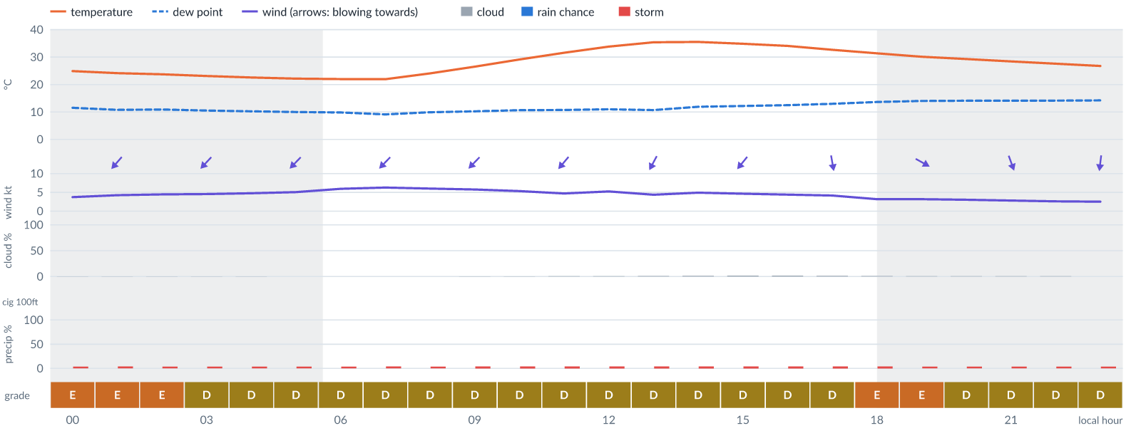
Meteogram — hourly forecast; shaded = before first light / after last light. Gaps mean no data.
Ser | Hrs | Temp | Cloud | Wind | Gust | QNH | Assessment | Driver | Remarks
(a) | (b) | (c) | (d) | (e) | (f) | (g) | (h) | (i) | (j)
1. | 0001 | 25 (spread 24–26)°C | ☀ Clear (0%) | ↙ 4 (spread 3–4) kts NE | 11 kts | 1014 | E - Poor | gust spread +7 kt | wind shear, thunderstorm risk, gusts
2. | 0100 | 24 (spread 23–25)°C | ☀ Clear (0%) | ↙ 4 kts NE | 11 kts | 1015 | E - Poor | gust spread +6 kt | wind shear, thunderstorm risk, gusts
3. | 0200 | 24 (spread 23–25)°C | ☀ Clear (0%) | ↙ 4 (spread 4–5) kts NE | 11 kts | 1015 | E - Poor | gust spread +6 kt | wind shear, thunderstorm risk, gusts
4. | 0300 | 23 (spread 22–24)°C | ☀ Clear (0%) | ↙ 5 (spread 4–5) kts NE | 11 kts | 1014 | D - Marginal | storm 4% · gust 11 kt | ⚠ thunderstorm risk, gusts, wind shear
5. | 0400 | 23 (spread 21–24)°C | ☀ Clear (0%) | ↙ 5 (spread 3–6) kts NE | 10 kts | 1014 | D - Marginal | storm 4% · gust 10 kt | ⚠ thunderstorm risk, gusts, wind shear
6. | 0500 | 22 (spread 21–23)°C | ☀ Clear (0%) | ↙ 5 (spread 4–6) kts NE | 10 kts | 1014 | D - Marginal | storm 4% · gust 10 kt | ⚠ thunderstorm risk, gusts, wind shear
7. | 0600 | 22 (spread 21–23)°C | ☀ Clear (0%) | ↙ 6 (spread 5–7) kts NE | 10 kts | 1014 | D - Marginal | storm 4% · gust 10 kt | ⚠ thunderstorm risk, gusts
8. | 0700 | 22 (spread 21–23)°C | ☀ Clear (0%) | ↙ 6 (spread 5–7) kts NE | 10 kts | 1014 | D - Marginal | storm 4% · gust 10 kt | ⚠ thunderstorm risk, gusts
9. | 0800 | 24 (spread 23–25)°C | ☀ Clear (0%) | ↙ 6 (spread 5–7) kts NE | 10 kts | 1014 | D - Marginal | storm 4% · gust 10 kt | ⚠ thunderstorm risk, gusts
10. | 0900 | 26 (spread 25–28)°C | ☀ Clear (0%) | ↙ 6 (spread 5–6) kts NE | 10 kts | 1015 | D - Marginal | storm 4% · gust 10 kt | ⚠ thunderstorm risk, gusts
11. | 1000 | 29 (spread 28–30)°C | ☀ Clear (0%) | ↙ 5 (spread 5–6) kts NE | 11 kts | 1016 | D - Marginal | storm 4% · gust 11 kt | ⚠ thunderstorm risk, gusts, wind shear
12. | 1100 | 32 (spread 31–32)°C | ☀ Clear (1%) | ↙ 5 (spread 4–5) kts NE | 9 kts | 1016 | D - Marginal | storm 4% · gust 9 kt | ⚠ thunderstorm risk, gusts
13. | 1200 | 34 (spread 33–35)°C | ☀ Clear (1%) | ↙ 5 (spread 4–6) kts NE | 9 kts | 1016 | D - Marginal | storm 4% · gust 9 kt | ⚠ thunderstorm risk, gusts
14. | 1300 | 35 (spread 34–37)°C | ☀ Clear (1%) | ↙ 4 (spread 3–6) kts NNE | 9 kts | 1016 | D - Marginal | storm 4% · gust 9 kt | ⚠ thunderstorm risk, gusts, wind shear
15. | 1400 | 36°C | ☀ Clear (1%) | ↙ 5 kts NE | 9 kts | 1016 | D - Marginal | storm 4% · gust 9 kt | ⚠ thunderstorm risk, gusts
16. | 1500 | 35°C | ☀ Clear (2%) | ↙ 5 kts NE | 9 kts | 1015 | D - Marginal | storm 4% · gust 9 kt | ⚠ thunderstorm risk, gusts
17. | 1600 | 34°C | ☀ Clear (2%) | ↙ 4 kts NNE | 10 kts | 1014 | D - Marginal | storm 4% · gust 10 kt | ⚠ thunderstorm risk, gusts, wind shear
18. | 1700 | 33°C | ☀ Clear (1%) | ↓ 4 kts N | 10 kts | 1014 | D - Marginal | storm 4% · gust 10 kt | ⚠ thunderstorm risk, gusts, wind shear
19. | 1800 | 31°C | ☀ Clear (1%) | ↘ 3 kts NW | 10 kts | 1014 | E - Poor | gust spread +7 kt | wind shear, thunderstorm risk, gusts
20. | 1900 | 30°C | ☀ Clear (0%) | ↘ 3 kts WNW | 10 kts | 1013 | E - Poor | gust spread +6 kt | wind shear, thunderstorm risk, gusts
21. | 2000 | 29°C | ☀ Clear (0%) | ↘ 3 kts NW | 9 kts | 1014 | D - Marginal | storm 4% · gust 9 kt | ⚠ thunderstorm risk, gusts, wind shear
22. | 2100 | 28°C | ☀ Clear (0%) | ↓ 3 kts NNW | 8 kts | 1013 | D - Marginal | storm 4% · gust spread +5 kt | ⚠ thunderstorm risk, wind shear
23. | 2200 | 28°C | ☀ Clear (0%) | ↓ 3 kts N | 7 kts | 1013 | D - Marginal | storm 4% | ⚠ thunderstorm risk
24. | 2300 | 27°C | ☀ Clear (0%) | ↓ 3 kts N | 6 kts | 1014 | D - Marginal | storm 4% | ⚠ thunderstorm risk
Confidence: 68% — data for 24 of 24 hours; 8% of readings interpolated · first light 0606L · last light 1830L · Moon 40 % illuminated, rises 12:06.

Tue 17 Nov 26
Conditions are expected to be generally Marginal: clear, winds up to 7 kts NE, gusting 13 kts and temperatures 22–35°C. Flyable windows: 0001–0600L (Marginal, 7 h) and 1400–2300L (Marginal, 10 h). Hazards: thunderstorm risk 0001–2300L. Overall similar to the previous day.
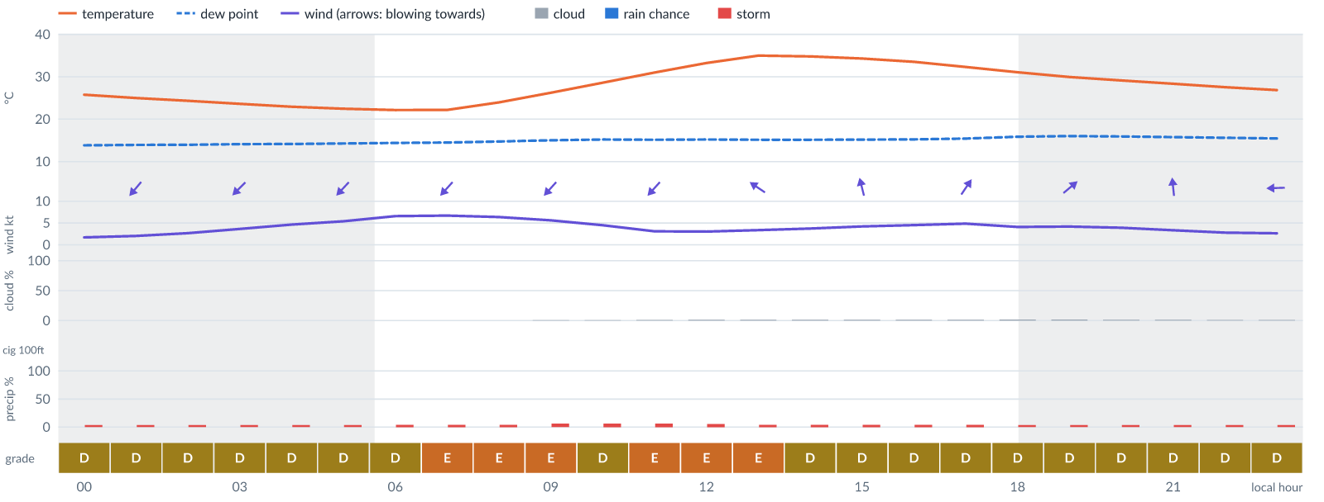
Meteogram — hourly forecast; shaded = before first light / after last light. Gaps mean no data.
Ser | Hrs | Temp | Cloud | Wind | Gust | QNH | Assessment | Driver | Remarks
(a) | (b) | (c) | (d) | (e) | (f) | (g) | (h) | (i) | (j)
1. | 0001 | 26°C | ☀ Clear (0%) | ↙ 2 kts NNE | 5 kts | 1014 | D - Marginal | storm 4% | ⚠ thunderstorm risk
2. | 0100 | 25°C | ☀ Clear (0%) | ↙ 2 kts NE | 6 kts | 1013 | D - Marginal | storm 4% | ⚠ thunderstorm risk
3. | 0200 | 24°C | ☀ Clear (0%) | ↙ 3 kts NE | 7 kts | 1013 | D - Marginal | storm 4% | ⚠ thunderstorm risk
4. | 0300 | 24°C | ☀ Clear (0%) | ↙ 4 kts NE | 8 kts | 1013 | D - Marginal | storm 4% | ⚠ thunderstorm risk
5. | 0400 | 23°C | ☀ Clear (0%) | ↙ 5 kts NE | 9 kts | 1013 | D - Marginal | storm 4% · gust 9 kt | ⚠ thunderstorm risk, gusts
6. | 0500 | 22°C | ☀ Clear (0%) | ↙ 5 kts NE | 10 kts | 1013 | D - Marginal | storm 4% · gust 10 kt | ⚠ thunderstorm risk, gusts, wind shear
7. | 0600 | 22°C | ☀ Clear (0%) | ↙ 7 kts NE | 11 kts | 1013 | D - Marginal | storm 4% · gust 11 kt | ⚠ thunderstorm risk, gusts
8. | 0700 | 22°C | ☀ Clear (0%) | ↙ 7 kts NE | 12 kts | 1013 | E - Poor | gust 12 kt | gusts, thunderstorm risk, wind shear
9. | 0800 | 24°C | ☀ Clear (0%) | ↙ 6 kts NE | 12 kts | 1013 | E - Poor | gust 12 kt | gusts, thunderstorm risk, wind shear
10. | 0900 | 26°C | ☀ Clear (0%) | ↙ 6 kts NE | 13 kts | 1014 | E - Poor | gust 13 kt · gust spread +7 kt | gusts, wind shear, thunderstorm risk
11. | 1000 | 29°C | ☀ Clear (0%) | ↙ 4 kts NE | 10 kts | 1014 | D - Marginal | storm 6% · gust 10 kt | ⚠ thunderstorm risk, gusts, wind shear
12. | 1100 | 31°C | ☀ Clear (1%) | ↙ 3 kts NE | 10 kts | 1015 | E - Poor | gust spread +7 kt | wind shear, thunderstorm risk, gusts
13. | 1200 | 33°C | ☀ Clear (1%) | ← 3 kts ESE | 10 kts | 1015 | E - Poor | gust spread +7 kt | wind shear, thunderstorm risk, gusts
14. | 1300 | 35°C | ☀ Clear (1%) | ↖ 3 kts SE | 10 kts | 1015 | E - Poor | gust spread +6 kt | wind shear, thunderstorm risk, gusts
15. | 1400 | 35°C | ☀ Clear (1%) | ↖ 4 kts SE | 9 kts | 1014 | D - Marginal | storm 4% · gust 9 kt | ⚠ thunderstorm risk, gusts, wind shear
16. | 1500 | 34°C | ☀ Clear (1%) | ↑ 4 kts SSE | 9 kts | 1014 | D - Marginal | storm 4% · gust 9 kt | ⚠ thunderstorm risk, gusts, wind shear
17. | 1600 | 34°C | ☀ Clear (1%) | ↑ 5 kts SSW | 8 kts | 1013 | D - Marginal | storm 4% | ⚠ thunderstorm risk
18. | 1700 | 32°C | ☀ Clear (1%) | ↗ 5 kts SSW | 7 kts | 1013 | D - Marginal | storm 4% | ⚠ thunderstorm risk
19. | 1800 | 31°C | ☀ Clear (2%) | ↗ 4 kts SW | 7 kts | 1013 | D - Marginal | storm 4% | ⚠ thunderstorm risk
20. | 1900 | 30°C | ☀ Clear (2%) | ↗ 4 kts SW | 6 kts | 1012 | D - Marginal | storm 4% | ⚠ thunderstorm risk
21. | 2000 | 29°C | ☀ Clear (1%) | ↗ 4 kts SSW | 6 kts | 1013 | D - Marginal | storm 4% | ⚠ thunderstorm risk
22. | 2100 | 28°C | ☀ Clear (1%) | ↑ 3 kts S | 6 kts | 1012 | D - Marginal | storm 4% | ⚠ thunderstorm risk
23. | 2200 | 28°C | ☀ Clear (1%) | ↖ 3 kts SE | 6 kts | 1013 | D - Marginal | storm 4% | ⚠ thunderstorm risk
24. | 2300 | 27°C | ☀ Clear (1%) | ← 3 kts E | 6 kts | 1013 | D - Marginal | storm 4% | ⚠ thunderstorm risk
Confidence: 68% — data for 24 of 24 hours · first light 0606L · last light 1831L · Moon 50 % illuminated, rises 12:46, sets 00:03.

Wed 18 Nov 26
Conditions are expected to be generally Marginal: mostly clear, winds up to 5 kts NE and temperatures 22–35°C. Flyable windows: 0001–2300L (Marginal, 24 h). Hazards: thunderstorm risk 0001–2300L. Overall similar to the previous day.
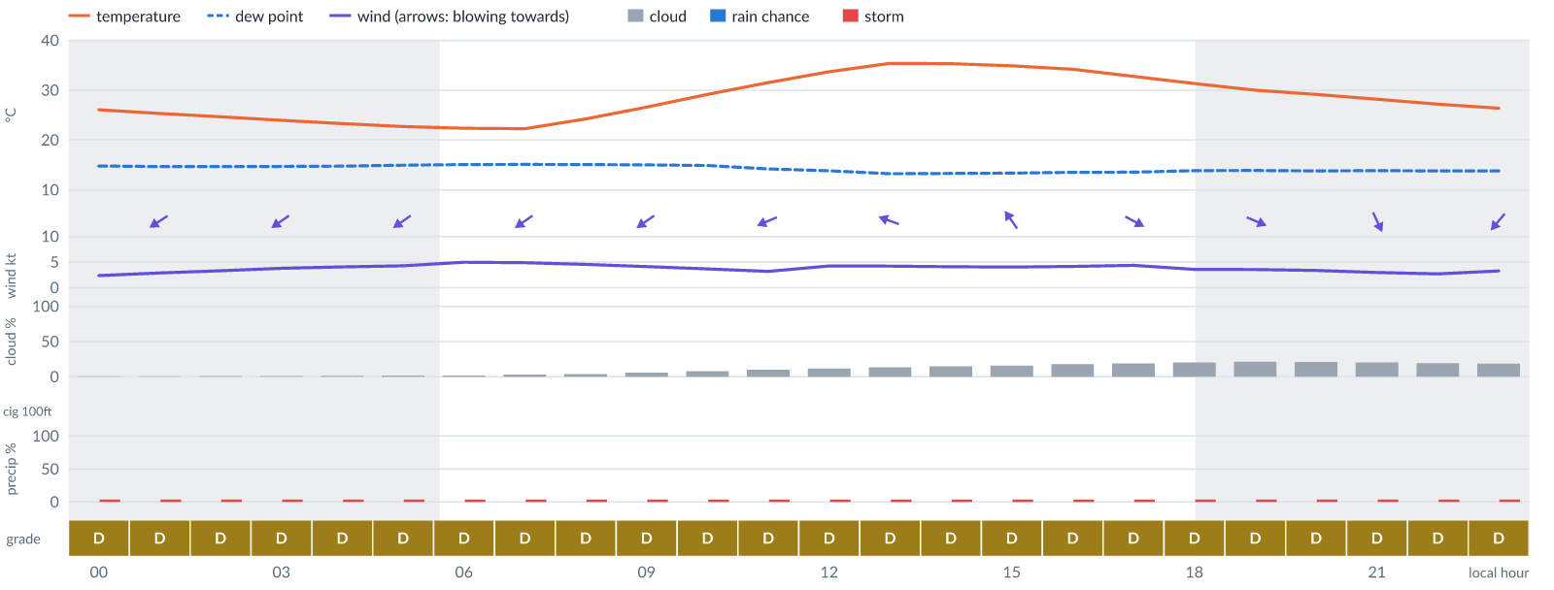
Meteogram — hourly forecast; shaded = before first light / after last light. Gaps mean no data.
Ser | Hrs | Temp | Cloud | Wind | Gust | QNH | Assessment | Driver | Remarks
(a) | (b) | (c) | (d) | (e) | (f) | (g) | (h) | (i) | (j)
1. | 0001 | 26°C | ☀ Clear (0%) | ↙ 2 kts ENE | 6 kts | 1012 | D - Marginal | storm 4% | ⚠ thunderstorm risk
2. | 0100 | 25°C | ☀ Clear (0%) | ↙ 3 kts ENE | 6 kts | 1012 | D - Marginal | storm 4% | ⚠ thunderstorm risk
3. | 0200 | 25°C | ☀ Clear (1%) | ↙ 3 kts NE | 6 kts | 1012 | D - Marginal | storm 4% | ⚠ thunderstorm risk
4. | 0300 | 24°C | ☀ Clear (1%) | ↙ 4 kts NE | 6 kts | 1012 | D - Marginal | storm 4% | ⚠ thunderstorm risk
5. | 0400 | 23°C | ☀ Clear (1%) | ↙ 4 kts NE | 7 kts | 1012 | D - Marginal | storm 4% | ⚠ thunderstorm risk
6. | 0500 | 23°C | ☀ Clear (2%) | ↙ 4 kts NE | 8 kts | 1012 | D - Marginal | storm 4% | ⚠ thunderstorm risk
7. | 0600 | 22°C | ☀ Clear (2%) | ↙ 5 kts NE | 8 kts | 1012 | D - Marginal | storm 4% | ⚠ thunderstorm risk
8. | 0700 | 22°C | ☀ Clear (3%) | ↙ 5 kts NE | 9 kts | 1012 | D - Marginal | storm 4% · gust 9 kt | ⚠ thunderstorm risk, gusts
9. | 0800 | 24°C | ☀ Clear (4%) | ↙ 5 kts NE | 9 kts | 1013 | D - Marginal | storm 4% · gust 9 kt | ⚠ thunderstorm risk, gusts
10. | 0900 | 27°C | ☀ Clear (6%) | ↙ 4 kts NE | 9 kts | 1013 | D - Marginal | storm 4% · gust 9 kt | ⚠ thunderstorm risk, gusts, wind shear
11. | 1000 | 29°C | ☀ Clear (8%) | ↙ 4 kts ENE | 7 kts | 1014 | D - Marginal | storm 4% | ⚠ thunderstorm risk
12. | 1100 | 32°C | ☀ Clear (10%) | ↙ 3 kts ENE | 8 kts | 1014 | D - Marginal | storm 4% · gust spread +5 kt | ⚠ thunderstorm risk, wind shear
13. | 1200 | 34°C | ☀ Clear (12%) | ← 4 kts E | 8 kts | 1014 | D - Marginal | storm 4% | ⚠ thunderstorm risk
14. | 1300 | 35°C | ◔ Mostly clear (13%) | ← 4 kts ESE | 9 kts | 1014 | D - Marginal | storm 4% · gust 9 kt | ⚠ thunderstorm risk, gusts, wind shear
15. | 1400 | 35°C | ◔ Mostly clear (15%) | ↖ 4 kts SE | 9 kts | 1014 | D - Marginal | storm 4% · gust 9 kt | ⚠ thunderstorm risk, gusts, wind shear
16. | 1500 | 35°C | ◔ Mostly clear (16%) | ↖ 4 kts SE | 9 kts | 1014 | D - Marginal | storm 4% · gust 9 kt | ⚠ thunderstorm risk, gusts, wind shear
17. | 1600 | 34°C | ◔ Mostly clear (18%) | ↘ 4 kts NW | 9 kts | 1013 | D - Marginal | storm 4% · gust 9 kt | ⚠ thunderstorm risk, gusts, wind shear
18. | 1700 | 33°C | ◔ Mostly clear (19%) | ↘ 4 kts WNW | 8 kts | 1013 | D - Marginal | storm 4% | ⚠ thunderstorm risk
19. | 1800 | 31°C | ◔ Mostly clear (20%) | ↘ 4 kts WNW | 7 kts | 1013 | D - Marginal | storm 4% | ⚠ thunderstorm risk
20. | 1900 | 30°C | ◔ Mostly clear (21%) | ↘ 4 kts WNW | 6 kts | 1013 | D - Marginal | storm 4% | ⚠ thunderstorm risk
21. | 2000 | 29°C | ◔ Mostly clear (21%) | ↘ 3 kts NW | 6 kts | 1013 | D - Marginal | storm 4% | ⚠ thunderstorm risk
22. | 2100 | 28°C | ◔ Mostly clear (20%) | ↘ 3 kts NNW | 5 kts | 1012 | D - Marginal | storm 4% | ⚠ thunderstorm risk
23. | 2200 | 27°C | ◔ Mostly clear (19%) | ↓ 3 kts N | 6 kts | 1013 | D - Marginal | storm 4% | ⚠ thunderstorm risk
24. | 2300 | 26°C | ◔ Mostly clear (19%) | ↙ 3 kts NE | 6 kts | 1013 | D - Marginal | storm 4% | ⚠ thunderstorm risk
Confidence: 68% — data for 24 of 24 hours · first light 0606L · last light 1831L · Moon 60 % illuminated, rises 13:25, sets 00:50.

Thu 19 Nov 26
Conditions are expected to be generally Marginal: cloudy, winds up to 5 kts ENE and temperatures 23–36°C. Flyable windows: 0001–0400L (Marginal, 5 h) and 1700–2300L (Marginal, 7 h). Hazards: thunderstorm risk 0001–2300L. Overall similar to the previous day.
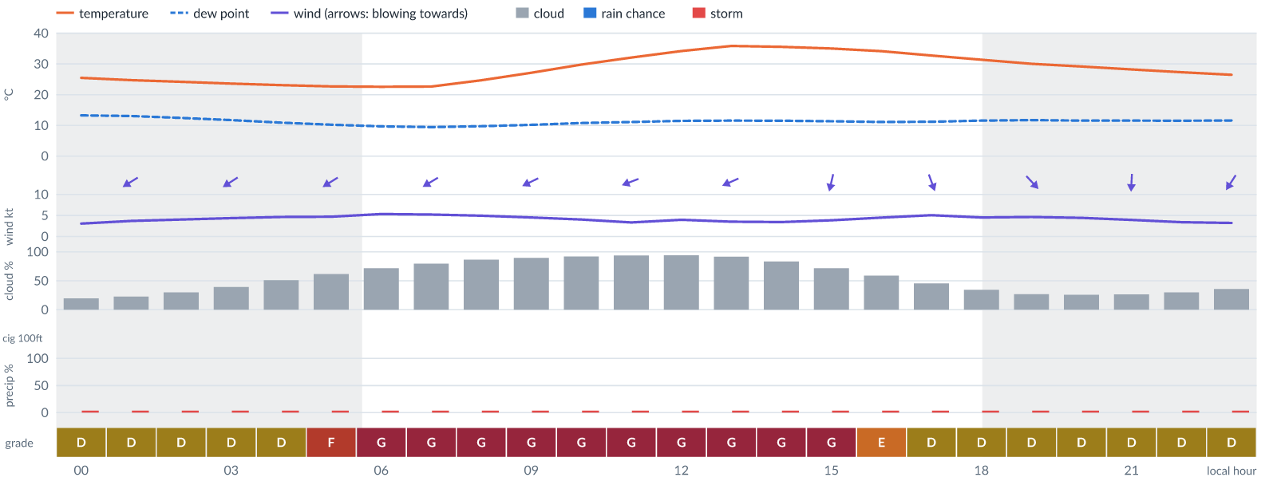
Meteogram — hourly forecast; shaded = before first light / after last light. Gaps mean no data.
Ser | Hrs | Temp | Cloud | Wind | Gust | QNH | Assessment | Driver | Remarks
(a) | (b) | (c) | (d) | (e) | (f) | (g) | (h) | (i) | (j)
1. | 0001 | 25°C | ◔ Mostly clear (20%) | ↙ 3 kts NE | 6 kts | 1012 | D - Marginal | storm 4% | ⚠ thunderstorm risk
2. | 0100 | 25°C | ◔ Mostly clear (23%) | ↙ 4 kts ENE | 6 kts | 1012 | D - Marginal | storm 4% | ⚠ thunderstorm risk
3. | 0200 | 24°C | ◔ Mostly clear (30%) | ↙ 4 kts ENE | 6 kts | 1012 | D - Marginal | storm 4% | ⚠ thunderstorm risk
4. | 0300 | 24°C | ◑ Partly cloudy (39%) | ↙ 4 kts ENE | 6 kts | 1012 | D - Marginal | storm 4% | ⚠ thunderstorm risk
5. | 0400 | 23°C | ◑ Partly cloudy (51%) | ↙ 5 kts ENE | 7 kts | 1012 | D - Marginal | storm 4% · cloud 51% | ⚠ cloud cover, thunderstorm risk
6. | 0500 | 23°C | ◑ Cloudy (62%) | ↙ 5 kts ENE | 7 kts | 1012 | F - Very Poor | cloud 62% | cloud cover, thunderstorm risk
7. | 0600 | 23°C | ◕ Cloudy (72%) | ↙ 5 kts ENE | 8 kts | 1012 | G - Unacceptable | cloud 72% | cloud cover, thunderstorm risk
8. | 0700 | 23°C | ◕ Cloudy (80%) | ↙ 5 kts ENE | 8 kts | 1013 | G - Unacceptable | cloud 80% | cloud cover, thunderstorm risk
9. | 0800 | 25°C | ◕ Cloudy (86%) | ↙ 5 kts ENE | 9 kts | 1013 | G - Unacceptable | cloud 86% | cloud cover, thunderstorm risk, gusts
10. | 0900 | 27°C | ☁ Overcast (90%) | ↙ 5 kts ENE | 9 kts | 1014 | G - Unacceptable | cloud 90% | cloud cover, thunderstorm risk, gusts
11. | 1000 | 30°C | ☁ Overcast (92%) | ↙ 4 kts ENE | 9 kts | 1015 | G - Unacceptable | cloud 92% | cloud cover, thunderstorm risk, gusts, wind shear
12. | 1100 | 32°C | ☁ Overcast (94%) | ← 3 kts ENE | 7 kts | 1015 | G - Unacceptable | cloud 94% | cloud cover, thunderstorm risk
13. | 1200 | 34°C | ☁ Overcast (94%) | ← 4 kts ENE | 8 kts | 1015 | G - Unacceptable | cloud 94% | cloud cover, thunderstorm risk
14. | 1300 | 36°C | ☁ Overcast (92%) | ↙ 4 kts ENE | 8 kts | 1015 | G - Unacceptable | cloud 92% | cloud cover, thunderstorm risk
15. | 1400 | 36°C | ◕ Cloudy (84%) | ↙ 3 kts NE | 8 kts | 1015 | G - Unacceptable | cloud 84% | cloud cover, thunderstorm risk, wind shear
16. | 1500 | 35°C | ◕ Cloudy (72%) | ↓ 4 kts NNE | 9 kts | 1015 | G - Unacceptable | cloud 72% | cloud cover, thunderstorm risk, gusts, wind shear
17. | 1600 | 34°C | ◑ Partly cloudy (59%) | ↓ 4 kts N | 9 kts | 1014 | E - Poor | cloud 59% | cloud cover, thunderstorm risk, gusts, wind shear
18. | 1700 | 33°C | ◑ Partly cloudy (46%) | ↓ 5 kts NNW | 9 kts | 1013 | D - Marginal | storm 4% · cloud 46% | ⚠ cloud cover, thunderstorm risk, gusts
19. | 1800 | 31°C | ◔ Partly cloudy (34%) | ↘ 5 kts NW | 9 kts | 1013 | D - Marginal | storm 4% · gust 9 kt | ⚠ thunderstorm risk, gusts
20. | 1900 | 30°C | ◔ Mostly clear (27%) | ↘ 5 kts NW | 9 kts | 1013 | D - Marginal | storm 4% · gust 9 kt | ⚠ thunderstorm risk, gusts
21. | 2000 | 29°C | ◔ Mostly clear (26%) | ↘ 4 kts NNW | 8 kts | 1013 | D - Marginal | storm 4% | ⚠ thunderstorm risk
22. | 2100 | 28°C | ◔ Mostly clear (26%) | ↓ 4 kts N | 7 kts | 1013 | D - Marginal | storm 4% | ⚠ thunderstorm risk
23. | 2200 | 27°C | ◔ Mostly clear (30%) | ↓ 3 kts NNE | 8 kts | 1013 | D - Marginal | storm 4% · gust spread +5 kt | ⚠ thunderstorm risk, wind shear
24. | 2300 | 26°C | ◔ Partly cloudy (36%) | ↙ 3 kts NNE | 7 kts | 1013 | D - Marginal | storm 4% | ⚠ thunderstorm risk
Confidence: 68% — data for 24 of 24 hours · first light 0607L · last light 1831L · Moon 69 % illuminated, rises 14:03, sets 01:37.

Fri 20 Nov 26
Conditions are expected to be generally Marginal: partly cloudy, winds up to 5 kts SE, gusting 11 kts and temperatures 23–36°C. Flyable windows: 0001–0900L (Marginal, 10 h) and 1800–1900L (Marginal, 2 h). Hazards: thunderstorm risk 0001–2300L. Overall similar to the previous day.
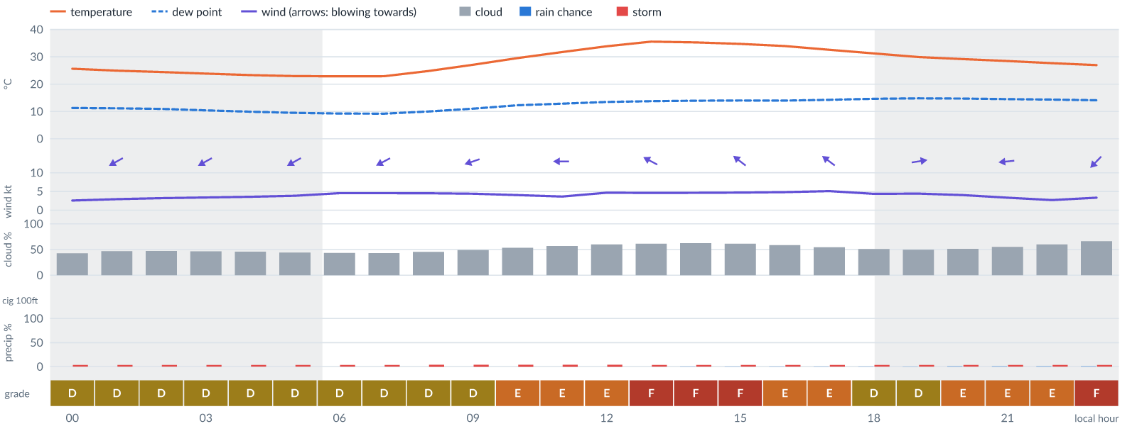
Meteogram — hourly forecast; shaded = before first light / after last light. Gaps mean no data.
Ser | Hrs | Temp | Cloud | Wind | Gust | QNH | Assessment | Driver | Remarks
(a) | (b) | (c) | (d) | (e) | (f) | (g) | (h) | (i) | (j)
1. | 0001 | 26°C | ◑ Partly cloudy (43%) | ↙ 3 kts NE | 6 kts | 1013 | D - Marginal | storm 4% · cloud 43% | ⚠ cloud cover, thunderstorm risk
2. | 0100 | 25°C | ◑ Partly cloudy (47%) | ↙ 3 kts ENE | 6 kts | 1013 | D - Marginal | storm 4% · cloud 47% | ⚠ cloud cover, thunderstorm risk
3. | 0200 | 24°C | ◑ Partly cloudy (47%) | ↙ 3 kts ENE | 6 kts | 1013 | D - Marginal | storm 4% · cloud 47% | ⚠ cloud cover, thunderstorm risk
4. | 0300 | 24°C | ◑ Partly cloudy (46%) | ↙ 3 kts ENE | 7 kts | 1013 | D - Marginal | storm 4% · cloud 46% | ⚠ cloud cover, thunderstorm risk
5. | 0400 | 23°C | ◑ Partly cloudy (46%) | ↙ 4 kts ENE | 8 kts | 1014 | D - Marginal | storm 4% · cloud 46% | ⚠ cloud cover, thunderstorm risk
6. | 0500 | 23°C | ◑ Partly cloudy (44%) | ↙ 4 kts ENE | 9 kts | 1013 | D - Marginal | storm 4% · cloud 44% | ⚠ cloud cover, thunderstorm risk, gusts, wind shear
7. | 0600 | 23°C | ◑ Partly cloudy (43%) | ↙ 5 kts ENE | 10 kts | 1014 | D - Marginal | storm 4% · cloud 43% | ⚠ cloud cover, thunderstorm risk, gusts, wind shear
8. | 0700 | 23°C | ◑ Partly cloudy (43%) | ↙ 5 kts ENE | 11 kts | 1014 | D - Marginal | storm 4% · cloud 43% | ⚠ cloud cover, thunderstorm risk, gusts, wind shear
9. | 0800 | 25°C | ◑ Partly cloudy (46%) | ↙ 5 kts ENE | 11 kts | 1014 | D - Marginal | storm 4% · cloud 46% | ⚠ cloud cover, thunderstorm risk, gusts, wind shear
10. | 0900 | 27°C | ◑ Partly cloudy (49%) | ← 4 kts ENE | 8 kts | 1015 | D - Marginal | storm 4% · cloud 49% | ⚠ cloud cover, thunderstorm risk
11. | 1000 | 30°C | ◑ Partly cloudy (53%) | ← 4 kts ENE | 8 kts | 1015 | E - Poor | cloud 53% | cloud cover, thunderstorm risk
12. | 1100 | 32°C | ◑ Partly cloudy (57%) | ← 4 kts E | 8 kts | 1016 | E - Poor | cloud 57% | cloud cover, thunderstorm risk
13. | 1200 | 34°C | ◑ Cloudy (60%) | ← 5 kts ESE | 8 kts | 1016 | E - Poor | cloud 60% | cloud cover, thunderstorm risk
14. | 1300 | 36°C | ◑ Cloudy (62%) | ↖ 5 kts ESE | 8 kts | 1016 | F - Very Poor | cloud 62% | cloud cover, thunderstorm risk
15. | 1400 | 35°C | ◑ Cloudy (62%) | ↖ 5 kts SE | 7 kts | 1015 | F - Very Poor | cloud 62% | cloud cover, thunderstorm risk
16. | 1500 | 35°C | ◑ Cloudy (61%) | ↖ 5 kts SE | 7 kts | 1015 | F - Very Poor | cloud 61% | cloud cover, thunderstorm risk
17. | 1600 | 34°C | ◑ Partly cloudy (59%) | ↖ 5 kts SE | 7 kts | 1015 | E - Poor | cloud 59% | cloud cover, thunderstorm risk
18. | 1700 | 33°C | ◑ Partly cloudy (55%) | ↖ 5 kts SE | 7 kts | 1015 | E - Poor | cloud 55% | cloud cover, thunderstorm risk
19. | 1800 | 31°C | ◑ Partly cloudy (51%) | ↘ 4 kts WNW | 7 kts | 1015 | D - Marginal | storm 4% · cloud 51% | ⚠ cloud cover, thunderstorm risk
20. | 1900 | 30°C | ◑ Partly cloudy (49%) | → 4 kts W | 7 kts | 1014 | D - Marginal | storm 4% · cloud 49% | ⚠ cloud cover, thunderstorm risk
21. | 2000 | 29°C | ◑ Partly cloudy (52%) | ↘ 4 kts NW | 7 kts | 1014 | E - Poor | cloud 52% | cloud cover, thunderstorm risk
22. | 2100 | 28°C | ◑ Partly cloudy (55%) | ← 3 kts E | 8 kts | 1014 | E - Poor | cloud 55% | cloud cover, thunderstorm risk, wind shear
23. | 2200 | 28°C | ◑ Cloudy (60%) | ↓ 3 kts N | 8 kts | 1014 | E - Poor | cloud 60% | cloud cover, thunderstorm risk, wind shear
24. | 2300 | 27°C | ◕ Cloudy (66%) | ↙ 3 kts NE | 8 kts | 1014 | F - Very Poor | cloud 66% | cloud cover, thunderstorm risk, wind shear
Confidence: 67% — data for 24 of 24 hours · first light 0607L · last light 1831L · Moon 79 % illuminated, rises 14:43, sets 02:24.

TAF
No TAF available for this location.

Imagery

Dust RGB (pink/magenta = airborne dust) — captured 7 Nov 01:18 WAT (5 min ago) · ©EUMETSAT (screenshot via EUMETView)

Convection RGB (yellow = vigorous storms) — captured 7 Nov 01:18 WAT (5 min ago) · ©EUMETSAT (screenshot via EUMETView)
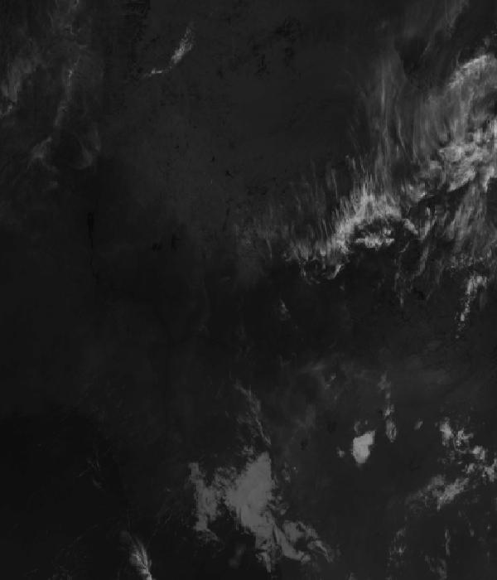
Infrared 10.5 µm (cold tops = deep cloud) — captured 7 Nov 01:18 WAT (5 min ago) · ©EUMETSAT (screenshot via EUMETView)

Accumulated lightning flash area (MTG-LI) — captured 7 Nov 01:18 WAT (5 min ago) · ©EUMETSAT (screenshot via EUMETView)

Source panel
Source | Accuracy | Skill n | Temp °C | Wind kt | Visibility | Storm
(a) | (b) | (c) | (d) | (e) | (f) | (g)
Met.no (Yr) | ≈ 1.0 | 1591 | 20–21 | 3–4 | — | 0 %
Open-Meteo | ≈ 1.0 | 4685 | 20–21 | 2–4 | 10+ km | 0 %
OpenWeather | ≈ 1.0 | 734 | 24 | 2 | 10+ km | 0 %
Tomorrow.io | ▲ 1.1 | 2102 | 23–25 | 2–3 | 10+ km | 0 %
Visual Crossing | ≈ 1.1 | 3770 | 23–25 | 3 | 10+ km | 0 %
Each source's own raw values, min–max over the next 6 hours from the issue hour (before any weighting or bias correction). — means the source does not publish that metric in the window. Wide gaps between rows are real disagreement; the forecast above weights sources by measured skill.

Reading this report
Grades: each hour carries one grade, set by its WORST factor. The bands below are the thresholds in force for this report (Settings); a value in a band earns that grade, and "-" means the factor never produces that grade. Cloud is graded on the worse of cover and ceiling. The Driver column names the limiting factor with its value; open it in the web report for the boundary and sources.
Grade | Cloud cover | Cloud ceiling | Visibility | Wind | Gust | Rain chance | Thunderstorm probability
(a) | (b) | (c) | (d) | (e) | (f) | (g) | (h)
A Excellent | ≤ 17.1% | ≥ 30000 ft | ≥ 8000 m | < 3 kt | < 3 kt | < 5% | 0%
B Good | 17.1–34.3% | 26000–30000 ft | 6666.7–8000 m | 3–6 kt | 3–6 kt | 5–10% | -
C Fair | 34.3–42.9% | 24000–26000 ft | 5333.3–6666.7 m | 6–9 kt | 6–9 kt | 10–15% | -
D Marginal | 42.9–51.4% | 22000–24000 ft | 4000–5333.3 m | 9–12 kt | 9–12 kt | 15–20% | >0–15%
E Poor | 51.4–60% | 16000–22000 ft | 2666.7–4000 m | 12–15 kt | 12–15 kt | 20–25% | 15–30%
F Very Poor | 60–68.6% | 10000–16000 ft | 1333.3–2666.7 m | 15–18 kt | 15–18 kt | 25–30% | 30–60%
G Unacceptable | > 68.6% | < 10000 ft | < 1333.3 m | ≥ 18 kt | ≥ 18 kt | ≥ 30% | > 60%
Flight windows: a window is at least 2 consecutive hours graded Marginal or better; an hour with insufficient data never counts toward one. ☾ marks a window outside first-to-last light.
Time: hours are local time (WAT, UTC+1) unless suffixed Z, which is UTC (TAF, METAR and issue times). Local midnight is labelled 0001.
Units: temperature °C · wind and gusts knots · visibility metres (km in text) · cloud ceiling feet · cloud cover % · rain chance and thunderstorm probability % · QNH hPa (altimeter setting at the field) · CAPE J/kg. A figure like "28 (26–30)°C" gives the p10–p90 range; "spread" marks disagreement between sources.
Symbols: ▲ better than the pool · ▽ worse (only when the 95% interval excludes the pool) · ≈ not distinguishable from the pool · unmarked = unproven (accuracy is measured against METAR and SYNOP observations). ⚠ on a remark means a low-confidence hour; a ⚠ paragraph on the first page is a convective-warning or data-age advisory. ⚡ is lightning observed by satellite near the field (©EUMETSAT).
Hourly glyphs: the wind arrow points the way the air moves (a north wind is ↓, an east wind ←); cloud cover shows as ☀ ◔ ◑ ◕ ☁ (clear, few, scattered, broken, overcast); a shaded hour label is wholly before first light or after last light.
Terms: "No data" - no source forecast the hour, or a core group (cloud, visibility, wind) is missing and the hour could still be flyable; missing data is never given a good grade. "Low-confidence" - few or weak sources behind the load-bearing metrics; treat the grade as indicative. "Insufficient data" - too little to grade at all. "Estimated" (est.) - the value is derived, not reported by a source (dust visibility, cloud base, gusts); it is declared where used and weighted at half. "Derived" - an hour interpolated from a coarser (3-hourly or daily) source, weighted at half and never used to score accuracy.

Data provenance
Source | Fetched (Z) | Age | Skill n | Accuracy
(a) | (b) | (c) | (d) | (e)
Foreca | 7 Nov 00:19Z | 4 min | 363 | ≈ 1.1
Met.no (Yr) | 7 Nov 00:20Z | 3 min | 1591 | ≈ 1.0
Open-Meteo | 7 Nov 00:18Z | 5 min | 4685 | ≈ 1.0
OpenWeather | 7 Nov 00:20Z | 3 min | 734 | ≈ 1.0
Tomorrow.io | 7 Nov 00:20Z | 4 min | 2102 | ▲ 1.1
Visual Crossing | 7 Nov 00:19Z | 5 min | 3770 | ≈ 1.1
Corrections applied (detailed under Learned corrections on the first page): skill weighting, bias correction, hour-of-day bias, cloud-base estimate, probability calibration, climatology bounds, skill blend.

How accurate have we been
Measured against observations (METAR/SYNOP), minna only. Verification table computed 2026-11-06. Mean absolute error (MAE): lower is better; "beats persistence" compares the best source with "it will stay as it is now" on the same hours.
Metric | Best source | Best MAE | Typical MAE | Persistence MAE | Beats persistence by | Pairs
(a) | (b) | (c) | (d) | (e) | (f) | (g)
Temperature (°C) | foreca | 0.9 | 3.4 | 5.3 | 78 % | 154
Dew point (°C) | accuweather | 1.3 | 4.1 | 2.6 | -30 % | 35
Wind speed (kt) | gem | 1.5 | 2.0 | 2.7 | 21 % | 655
Visibility (m) | visualcrossing | 232 | 351 | 1315 | -1 % | 1345
Cloud cover (%) | accuweather | 16 | 46 | 9 | - | 35
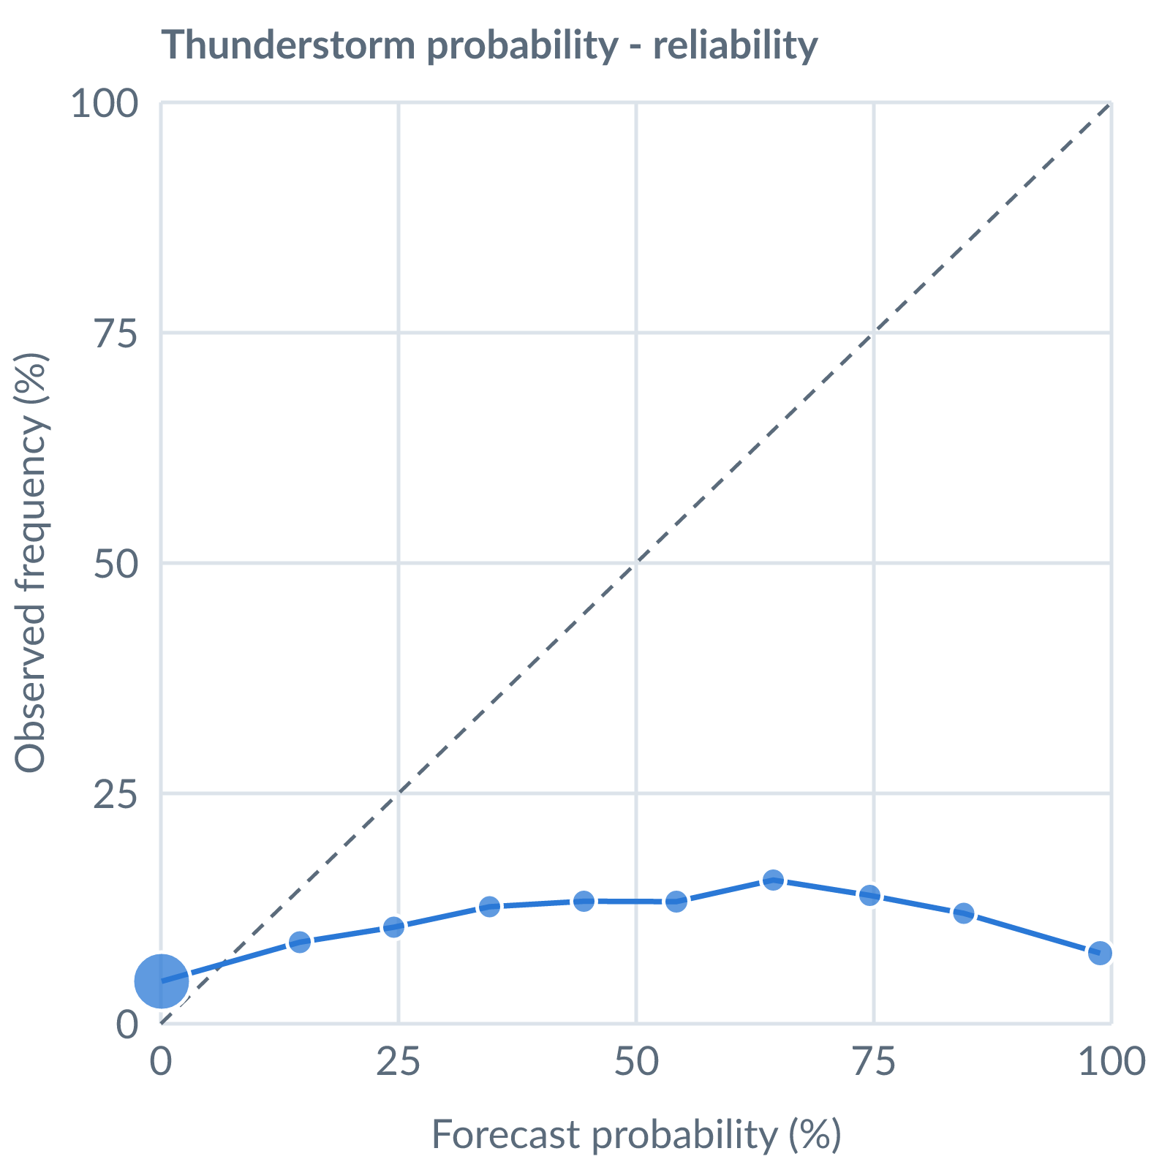
Thunderstorm probability: dots on the dashed line mean a stated probability matched how often it happened (164538 pairs, all places pooled).
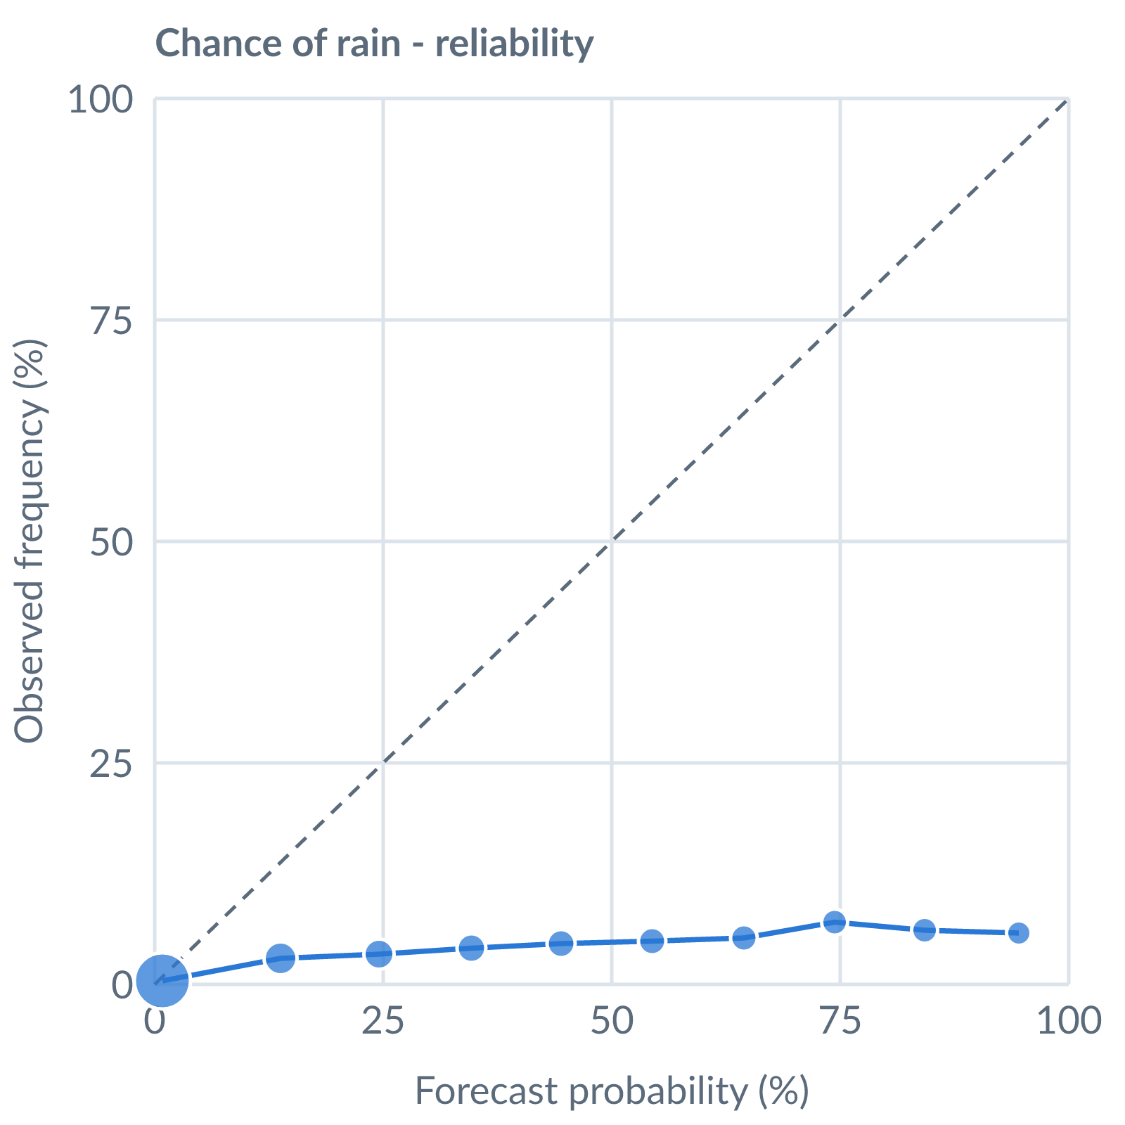
Chance of rain: dots on the dashed line mean a stated probability matched how often it happened (153642 pairs, all places pooled).
Learned bias (forecast minus observed; positive = sources run high), mean over scored sources, by local time of day. These are corrected for before sources are averaged.
Metric | Overall | Night | Morning | Afternoon | Evening | Pairs
(a) | (b) | (c) | (d) | (e) | (f) | (g)
Temperature (°C) | -3.1 | -3.1 | -3.0 | -3.1 | -3.4 | 14656
Dew point (°C) | -3.9 | -3.5 | -3.4 | -3.8 | -4.4 | 13807
Wind speed (kt) | -1.4 | -0.3 | -1.1 | -2.1 | -1.2 | 14674
Not yet available: Scores are decayed over the verification window (half-life 14 days); separate last-7-day and last-30-day windows are not stored. Bias is the current learned value; the history needed for a trend over time is not stored. Flight-window hit / bust / miss is not yet recorded.

