Maiduguri — 14-Day Forecast
DNMA · issued 7 Nov 26 00:23Z
Sources: Aviation Weather Center (aviationweather.gov) ≈ 1.0 · Foreca ▽ 0.8 · Met.no (Yr) ▲ 1.2 · Open-Meteo ≈ 1.0 · OpenWeather ≈ 1.0 · Tomorrow.io ▲ 1.2 · Visual Crossing ▽ 1.0
▲ better than the pool · ▽ worse (only when the 95% interval excludes the pool) · ≈ not distinguishable from the pool · unmarked = unproven (accuracy is measured against METAR and SYNOP observations)
Day | 00 | 01 | 02 | 03 | 04 | 05 | 06 | 07 | 08 | 09 | 10 | 11 | 12 | 13 | 14 | 15 | 16 | 17 | 18 | 19 | 20 | 21 | 22 | 23 | Flyable Windows | Conf
Sat 7 Nov 26 | G | G | G | G | G | G | G | F | D | E | G | G | G | G | G | G | D | D | D | D | D | D | D | D | 1600–2300L (Marginal, 8 h) ☾ | 74%
Sun 8 Nov 26 | D | D | D | D | D | D | D | D | D | E | F | F | F | G | G | F | E | D | D | D | D | D | D | D | best window: 0001–0800L (Marginal, 9 h) ☾ · 1700–2300L (Marginal, 7 h) ☾ | 77%
Mon 9 Nov 26 | D | D | D | D | D | D | E | E | F | G | G | G | G | G | G | G | F | G | E | F | E | E | F | F | 0001–0500L (Marginal, 6 h) ☾ | 74%
Tue 10 Nov 26 | E | D | E | E | D | D | D | E | E | G | G | G | G | G | G | G | G | G | G | G | G | G | F | E | 0400–0600L (Marginal, 3 h) ☾ | 73%
Wed 11 Nov 26 | F | G | F | E | E | E | G | G | G | G | G | G | G | G | G | G | G | G | G | G | G | F | E | D | no windows | 73%
Thu 12 Nov 26 | D | D | · | · | · | · | · | · | E | E | F | F | G | G | G | F | E | F | F | F | F | F | E | E | 0001–0100L (Marginal, 2 h) ☾ | 70%
Fri 13 Nov 26 | E | · | · | · | · | · | · | · | · | · | E | E | E | E | E | E | E | E | E | E | E | E | E | · | no windows | 70%
Sat 14 Nov 26 | · | · | · | · | · | · | · | · | · | · | · | · | · | E | F | F | E | · | E | E | E | E | E | · | no windows | 70%
Sun 15 Nov 26 | · | · | · | · | · | · | · | · | · | · | E | E | E | E | E | E | E | E | F | G | F | E | E | E | no windows | 70%
Mon 16 Nov 26 | E | · | · | · | · | · | · | · | · | E | E | E | F | F | F | F | F | F | G | G | G | G | E | E | no windows | 71%
Tue 17 Nov 26 | · | · | · | · | · | · | · | · | · | E | E | E | E | E | E | E | E | G | G | G | G | G | G | G | no windows | 70%
Wed 18 Nov 26 | G | G | F | E | E | E | · | · | · | E | E | E | E | E | E | E | F | F | G | G | G | G | F | F | no windows | 69%
Thu 19 Nov 26 | F | E | E | · | · | · | · | · | · | E | E | E | E | E | E | E | E | E | F | F | F | F | E | E | no windows | 70%
Fri 20 Nov 26 | E | E | · | · | · | · | E | F | F | F | E | E | E | E | E | E | E | E | F | F | F | F | F | F | no windows | 70%
A Excellent · B Good · C Fair · D Marginal · E Poor · F Very Poor · G Unacceptable · · No data
Best window (highest confidence, then grade, then length): Sun 8 Nov 26 0001–0800L (Marginal, 9 h) ☾, confidence 77%.
Learned corrections (METAR-verified): skill weighting — pooled all-field scores for 206; bias corrections — OpenWeather wind −4.0 kt, wttrin wind −3.8 kt, meteoblue dewpoint +3.0 °C, Open-Meteo dewpoint +3.0 °C, Met.no (Yr) dewpoint +3.0 °C, Foreca dewpoint +3.0 °C (+67 more); hour-of-day bias (local time, shrunk toward the all-hours bias) — OpenWeather afternoon wind −4.3 kt, wttrin evening wind −4.3 kt, wttrin night wind −3.7 kt, OpenWeather evening wind −3.7 kt, OpenWeather night wind −3.7 kt, wttrin afternoon wind −3.6 kt (+284 more); cloud base estimated as 410 ft per °C of dewpoint spread for sources that report no ceiling (≥60% cloud cover; flagged estimated, weighted ×0.5); probability calibration — rain chance: meteoblue, Open-Meteo, Foreca, metcheck, OpenWeather, Visual Crossing, Tomorrow.io, wttrin, ecmwf, gfs, icon, ukmo, gem, ecmwfens; storm: Open-Meteo, Met.no (Yr), Foreca, OpenWeather, Visual Crossing, Tomorrow.io, wttrin, ecmwf, gfs, icon, meteofrance, Aviation Weather Center (aviationweather.gov), ukmo, jma, gem, ecmwfens, aifs (each source's stated probability mapped to its verified frequency by an isotonic fit on ≥200 pairs, proven on the holdout); plausibility bounds from ERA5 climatology 2016-2025 (mean ± 5 sd; screening only, not observed truth); skill blend 1 auto-tuned over 9222 holdout pairs (consensus beat the best single source, icon, by 13%); correction gates (newest-7-day holdout; pooled skill is always on) — regional skill: off this week (did not improve holdout); place skill: off this week (did not improve holdout); lead-time skill: off this week (did not improve holdout); small-sample skill shrinkage: off this week (did not improve holdout); bias correction: on (improved holdout by 25.6%); place bias: on (improved holdout by 10.9%); hour-of-day bias: on (improved holdout by 7.0%); QNH bias: on (improved holdout by 57.4%); gust estimates: off this week (did not improve holdout); cloud-base coefficient: off this week (insufficient holdout: 79 of 200 items); recent-form skill: off this week (did not improve holdout); probability calibration: on (improved holdout by 36.3%); nowcast anchor horizon: off this week (did not improve holdout); dust-visibility estimate: off this week (did not improve holdout); fog risk: off this week (did not improve holdout).

Outlook
Day | Date | Outlook | Temp | Max wind | Flight windows | Confidence | Notes
(a) | (b) | (c) | (d) | (e) | (f) | (g) | (h)
Sat | 7 Nov 26 | Unacceptable | 22–39°C | 8 kts ENE, g 15 | 1600–2300L (Marginal, 8 h) ☾ | 74% | 10% interpolated
Sun | 8 Nov 26 | Marginal | 21–40°C | 10 kts ENE, g 19 | 0001–0800L (Marginal, 9 h) ☾; 1700–2300L (Marginal, 7 h) ☾ | 77% | 10% interpolated
Mon | 9 Nov 26 | Unacceptable | 21–39°C | 11 kts ENE, g 19 | 0001–0500L (Marginal, 6 h) ☾ | 74% | 17% interpolated
Tue | 10 Nov 26 | Unacceptable | 22–38°C | 13 kts ENE, g 22 | 0400–0600L (Marginal, 3 h) ☾ | 73% | 22% interpolated
Wed | 11 Nov 26 | Unacceptable | 21–36°C | 11 kts NE, g 19 | none | 73% | 21% interpolated
Thu | 12 Nov 26 | Very Poor | 17–35°C | 8 kts NE, g 16 | 0001–0100L (Marginal, 2 h) ☾ | 70% | 17% interpolated
Fri | 13 Nov 26 | Poor | 16–34°C | 6 kts NE, g 14 | none | 70% | 16% interpolated
Sat | 14 Nov 26 | Poor | 17–35°C | 6 kts N, g 14 | none | 70% | 16% interpolated
Sun | 15 Nov 26 | Poor | 18–37°C | 7 kts N, g 16 | none | 70% | 16% interpolated
Mon | 16 Nov 26 | Poor | 19–38°C | 8 kts NE, g 18 | none | 71% | 9% interpolated
Tue | 17 Nov 26 | Poor | 19–37°C | 8 kts NE, g 17 | none | 70%
Wed | 18 Nov 26 | Poor | 19–37°C | 8 kts NNE, g 18 | none | 69%
Thu | 19 Nov 26 | Poor | 18–37°C | 7 kts NNE, g 15 | none | 70%
Fri | 20 Nov 26 | Poor | 19–38°C | 7 kts NNE, g 16 | none | 70%

Today — Sat 7 Nov 26
Conditions are expected to be generally Unacceptable: cloudy, winds up to 8 kts ENE, gusting 15 kts and temperatures 22–39°C. Flyable windows: 1600–2300L (Marginal, 8 h). Hazards: thunderstorm risk 0001–2300L.
WEATHER EFFECTS
 | 00–06L | 06–12L | 12–18L | 18–24L
Wind | D | E | F | C
Visibility | A | A | A | A
Cloud / ceiling | G | G | G | B
Precipitation | A | A | A | A
Thunderstorm | D | D | D | D
Fog | · | · | · | ·
A Excellent · B Good · C Fair · D Marginal (flyable) · E Poor · F Very Poor · G Unacceptable · (worst condition in each period)
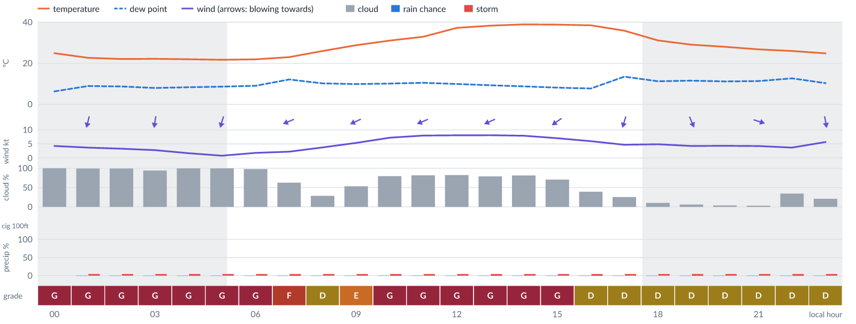
Meteogram — hourly forecast; shaded = before first light / after last light. Gaps mean no data.
Ser | Hrs | Temp | Cloud | Wind | Gust | QNH | Assessment | Driver | Remarks
(a) | (b) | (c) | (d) | (e) | (f) | (g) | (h) | (i) | (j)
1. | 0001 | 25°C | ☁ Overcast (100%) | ↓ 4 kts NNE | 10 kts | 1011 | G - Unacceptable | cloud 100% · visibility not forecast | ⚠ cloud cover, thunderstorm risk, gusts, wind shear
2. | 0100 | 23 (spread 22–24)°C | ☁ Overcast (100%) | ↓ 4 (spread 3–5) kts NNE | 6 kts | 1010 | G - Unacceptable | cloud 100% | cloud cover, thunderstorm risk
3. | 0200 | 22 (spread 21–23)°C | ☁ Overcast (99%) | ↓ 3 (spread 2–4) kts N | 6 kts | 1010 | G - Unacceptable | cloud 99% | cloud cover, thunderstorm risk
4. | 0300 | 22 (spread 22–23)°C | ☁ Overcast (94%) | ↓ 3 (spread 2–4) kts N | 5 kts | 1010 | G - Unacceptable | cloud 94% | cloud cover, thunderstorm risk
5. | 0400 | 22°C | ☁ Overcast (100%) | ↓ 2 (spread 1–3) kts NNE | 4 kts | 1010 | G - Unacceptable | cloud 100% | cloud cover, thunderstorm risk
6. | 0500 | 22 (spread 21–22)°C | ☁ Overcast (100%) | ↓ 1 (spread 0–2) kts NNE | 3 kts | 1010 | G - Unacceptable | cloud 100% | cloud cover, thunderstorm risk
7. | 0600 | 22°C | ☁ Overcast (98%) | ↙ 2 (spread 0–3) kts NE | 2 kts | 1011 | G - Unacceptable | cloud 98% | cloud cover, thunderstorm risk
8. | 0700 | 23°C | ◕ Cloudy (63%) | ↙ 2 (spread 1–3) kts ENE | 3 kts | 1012 | F - Very Poor | cloud 63% | cloud cover, thunderstorm risk
9. | 0800 | 26°C | ◔ Mostly clear (29%) | ← 4 (spread 3–4) kts ENE | 7 kts | 1013 | D - Marginal | storm 4% | thunderstorm risk
10. | 0900 | 29°C | ◑ Partly cloudy (53%) | ↙ 5 (spread 5–6) kts ENE | 10 kts | 1014 | E - Poor | cloud 53% | cloud cover, thunderstorm risk, gusts, wind shear
11. | 1000 | 31°C | ◕ Cloudy (80%) | ← 7 (spread 7–8) kts ENE | 14 kts | 1014 | G - Unacceptable | cloud 80% | cloud cover, gusts, wind shear, thunderstorm risk
12. | 1100 | 33°C | ◕ Cloudy (82%) | ↙ 8 (spread 7–9) kts ENE | 14 kts | 1013 | G - Unacceptable | cloud 82% | cloud cover, gusts, thunderstorm risk, wind shear
13. | 1200 | 37 (spread 37–38)°C | ◕ Cloudy (83%) | ↙ 8 (spread 7–9) kts ENE | 15 kts | 1012 | G - Unacceptable | cloud 83% | cloud cover, gusts, wind shear, thunderstorm risk
14. | 1300 | 38 (spread 38–39)°C | ◕ Cloudy (79%) | ↙ 8 kts ENE | 15 kts | 1011 | G - Unacceptable | cloud 79% | cloud cover, gusts, wind shear, thunderstorm risk
15. | 1400 | 39°C | ◕ Cloudy (81%) | ↙ 8 (spread 7–9) kts ENE | 14 kts | 1010 | G - Unacceptable | cloud 81% | cloud cover, gusts, thunderstorm risk, wind shear
16. | 1500 | 39°C | ◕ Cloudy (71%) | ↙ 7 (spread 6–9) kts NE | 13 kts | 1010 | G - Unacceptable | cloud 71% | cloud cover, gusts, thunderstorm risk, wind shear
17. | 1600 | 38 (spread 38–39)°C | ◑ Partly cloudy (39%) | ↙ 6 (spread 6–7) kts NE | 10 kts | 1009 | D - Marginal | storm 5% · gust 10 kt | thunderstorm risk, gusts
18. | 1700 | 36°C | ◔ Mostly clear (26%) | ↓ 5 (spread 4–7) kts NNE | 7 kts | 1009 | D - Marginal | storm 4% | thunderstorm risk
19. | 1800 | 31 (spread 31–32)°C | ☀ Clear (10%) | ↓ 5 (spread 4–6) kts N | 6 kts | 1010 | D - Marginal | storm 4% | thunderstorm risk
20. | 1900 | 29 (spread 28–30)°C | ☀ Clear (6%) | ↘ 4 kts NNW | 6 kts | 1010 | D - Marginal | storm 5% | thunderstorm risk
21. | 2000 | 28 (spread 27–29)°C | ☀ Clear (4%) | ↘ 4 (spread 4–5) kts NW | 5 kts | 1011 | D - Marginal | storm 4% | thunderstorm risk
22. | 2100 | 27 (spread 26–28)°C | ☀ Clear (3%) | → 4 kts WNW | 5 kts | 1011 | D - Marginal | storm 4% | thunderstorm risk
23. | 2200 | 26 (spread 25–27)°C | ◔ Partly cloudy (34%) | ↓ 4 (spread 2–5) kts N | 4 kts | 1012 | D - Marginal | storm 5% | thunderstorm risk
24. | 2300 | 25 (spread 24–25)°C | ◔ Mostly clear (21%) | ↓ 6 (spread 5–6) kts N | 7 kts | 1012 | D - Marginal | storm 4% | thunderstorm risk
Confidence: 74% — data for 24 of 24 hours; 10% of readings interpolated · first light 0539L · last light 1802L · Moon 4 % illuminated, rises 04:19, sets 16:18.

Tomorrow — Sun 8 Nov 26
Conditions are expected to be generally Marginal: clear, winds up to 10 kts ENE, gusting 19 kts and temperatures 21–40°C. Flyable windows: 0001–0800L (Marginal, 9 h) and 1700–2300L (Marginal, 7 h). Hazards: thunderstorm risk 0001–2300L. Overall an improvement on the previous day.
WEATHER EFFECTS
 | 00–06L | 06–12L | 12–18L | 18–24L
Wind | D | F | G | C
Visibility | A | A | A | A
Cloud / ceiling | A | A | A | A
Precipitation | A | A | A | A
Thunderstorm | D | D | D | D
Fog | · | · | · | ·
A Excellent · B Good · C Fair · D Marginal (flyable) · E Poor · F Very Poor · G Unacceptable · (worst condition in each period)
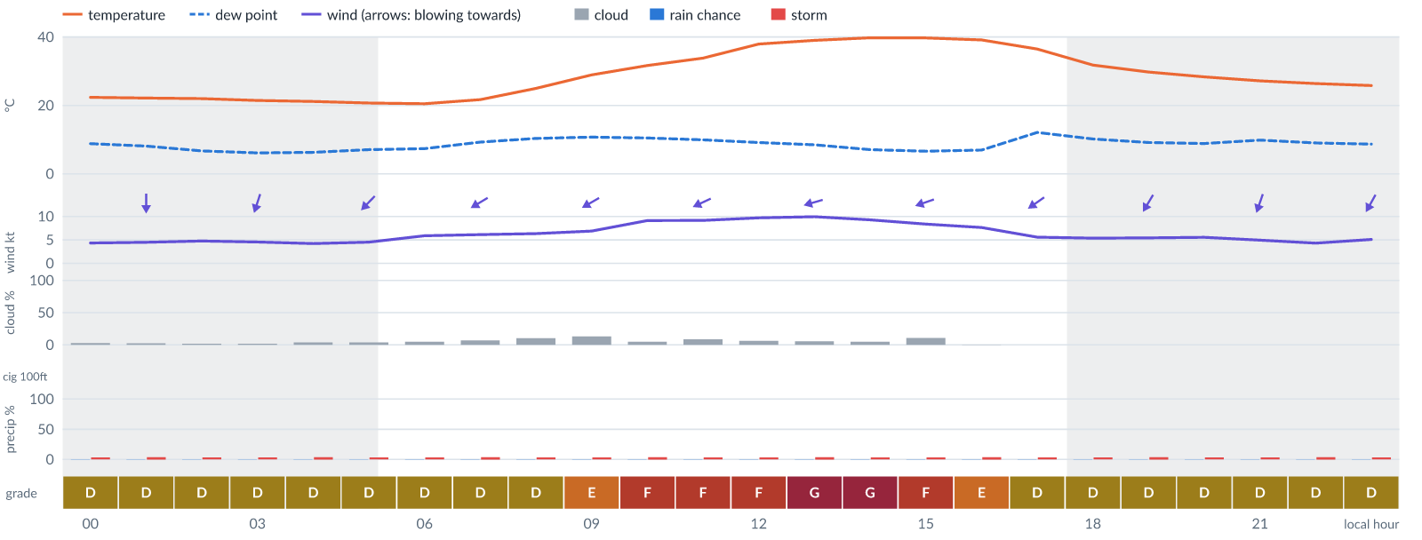
Meteogram — hourly forecast; shaded = before first light / after last light. Gaps mean no data.
Ser | Hrs | Temp | Cloud | Wind | Gust | QNH | Assessment | Driver | Remarks
(a) | (b) | (c) | (d) | (e) | (f) | (g) | (h) | (i) | (j)
1. | 0001 | 22 (spread 22–23)°C | ☀ Clear (3%) | ↓ 4 (spread 4–5) kts N | 8 kts | 1011 | D - Marginal | storm 4% | thunderstorm risk
2. | 0100 | 22°C | ☀ Clear (2%) | ↓ 5 (spread 4–5) kts N | 9 kts | 1011 | D - Marginal | storm 4% · gust 9 kt | thunderstorm risk, gusts
3. | 0200 | 22°C | ☀ Clear (2%) | ↓ 5 kts N | 9 kts | 1011 | D - Marginal | storm 4% · gust 9 kt | thunderstorm risk, gusts
4. | 0300 | 21 (spread 21–22)°C | ☀ Clear (2%) | ↓ 5 (spread 4–5) kts NNE | 9 kts | 1011 | D - Marginal | storm 4% · gust 9 kt | thunderstorm risk, gusts
5. | 0400 | 21°C | ☀ Clear (4%) | ↙ 4 (spread 4–5) kts NE | 10 kts | 1011 | D - Marginal | storm 4% · gust 10 kt | thunderstorm risk, gusts, wind shear
6. | 0500 | 21 (spread 20–21)°C | ☀ Clear (4%) | ↙ 5 (spread 3–6) kts NE | 8 kts | 1012 | D - Marginal | storm 4% | thunderstorm risk
7. | 0600 | 21 (spread 20–21)°C | ☀ Clear (5%) | ↙ 6 (spread 4–7) kts NE | 8 kts | 1013 | D - Marginal | storm 4% | thunderstorm risk
8. | 0700 | 22 (spread 21–23)°C | ☀ Clear (7%) | ↙ 6 (spread 5–7) kts ENE | 9 kts | 1013 | D - Marginal | storm 4% · gust 9 kt | thunderstorm risk, gusts
9. | 0800 | 25 (spread 24–26)°C | ☀ Clear (10%) | ↙ 6 (spread 5–7) kts ENE | 11 kts | 1014 | D - Marginal | storm 4% · gust 11 kt | thunderstorm risk, gusts, wind shear
10. | 0900 | 29°C | ◔ Mostly clear (13%) | ↙ 7 (spread 6–8) kts ENE | 13 kts | 1015 | E - Poor | gust 13 kt | gusts, thunderstorm risk, wind shear
11. | 1000 | 32 (spread 31–32)°C | ☀ Clear (5%) | ↙ 9 (spread 8–11) kts ENE | 16 kts | 1015 | F - Very Poor | gust 16 kt | gusts, wind shear, thunderstorm risk, strong wind
12. | 1100 | 34°C | ☀ Clear (9%) | ↙ 9 (spread 8–11) kts ENE | 16 kts | 1014 | F - Very Poor | gust 16 kt | gusts, wind shear, thunderstorm risk, strong wind
13. | 1200 | 38°C | ☀ Clear (6%) | ← 10 (spread 9–10) kts ENE | 17 kts | 1013 | F - Very Poor | gust 17 kt | gusts, wind shear, thunderstorm risk, strong wind
14. | 1300 | 39 (spread 38–39)°C | ☀ Clear (6%) | ← 10 (spread 9–11) kts ENE | 19 kts | 1012 | G - Unacceptable | gust 19 kt | gusts, wind shear, thunderstorm risk, strong wind
15. | 1400 | 40 (spread 39–40)°C | ☀ Clear (5%) | ← 9 (spread 8–10) kts ENE | 18 kts | 1011 | G - Unacceptable | gust 18 kt | gusts, wind shear, thunderstorm risk, strong wind
16. | 1500 | 40 (spread 39–40)°C | ☀ Clear (11%) | ← 8 (spread 8–9) kts ENE | 16 kts | 1011 | F - Very Poor | gust 16 kt | gusts, wind shear, thunderstorm risk
17. | 1600 | 39 (spread 39–40)°C | ☀ Clear (0%) | ↙ 8 (spread 7–8) kts ENE | 12 kts | 1011 | E - Poor | gust 12 kt | gusts, thunderstorm risk
18. | 1700 | 36 (spread 36–37)°C | ☀ Clear (0%) | ↙ 6 (spread 5–7) kts NE | 9 kts | 1010 | D - Marginal | storm 4% · gust 9 kt | thunderstorm risk, gusts
19. | 1800 | 32 (spread 31–32)°C | ☀ Clear (0%) | ↙ 5 (spread 4–7) kts NNE | 8 kts | 1011 | D - Marginal | storm 4% | thunderstorm risk
20. | 1900 | 30 (spread 29–31)°C | ☀ Clear (0%) | ↙ 5 (spread 4–6) kts NNE | 8 kts | 1012 | D - Marginal | storm 4% | thunderstorm risk
21. | 2000 | 28 (spread 27–29)°C | ☀ Clear (0%) | ↓ 6 (spread 4–7) kts NNE | 7 kts | 1012 | D - Marginal | storm 4% | thunderstorm risk
22. | 2100 | 27 (spread 26–28)°C | ☀ Clear (0%) | ↓ 5 (spread 4–6) kts NNE | 7 kts | 1013 | D - Marginal | storm 4% | thunderstorm risk
23. | 2200 | 26 (spread 25–28)°C | ☀ Clear (0%) | ↓ 4 (spread 4–5) kts NNE | 6 kts | 1013 | D - Marginal | storm 4% | thunderstorm risk
24. | 2300 | 26 (spread 25–27)°C | ☀ Clear (0%) | ↙ 5 (spread 4–6) kts NNE | 6 kts | 1013 | D - Marginal | storm 4% | thunderstorm risk
Confidence: 77% — data for 24 of 24 hours; 10% of readings interpolated · first light 0540L · last light 1802L · Moon 1 % illuminated, rises 05:09, sets 16:59.

Extended Outlook
WEATHER EFFECTS BY DAY
 | Mon | Tue | Wed | Thu | Fri | Sat | Sun | Mon | Tue | Wed | Thu | Fri
Wind | G | G | G | F | E | F | G | G | G | G | F | F
Visibility | A | A | A | A | · | · | · | · | · | · | · | ·
Cloud / ceiling | G | G | G | G | C | A | A | A | A | A | E | F
Precipitation | A | A | A | A | A | A | A | A | A | A | A | A
Thunderstorm | D | D | D | D | D | D | D | D | D | D | D | D
Fog | · | · | · | · | · | · | · | · | · | · | · | ·
Overall | G | G | G | G | E | F | G | G | G | G | F | F
A Excellent · B Good · C Fair · D Marginal (flyable) · E Poor · F Very Poor · G Unacceptable · (worst condition in each period)

Mon 9 Nov 26
Conditions are expected to be generally Unacceptable: partly cloudy, winds up to 11 kts ENE, gusting 19 kts and temperatures 21–39°C. Flyable windows: 0001–0500L (Marginal, 6 h). Hazards: thunderstorm risk 0001–2300L. Overall a deterioration from the previous day.
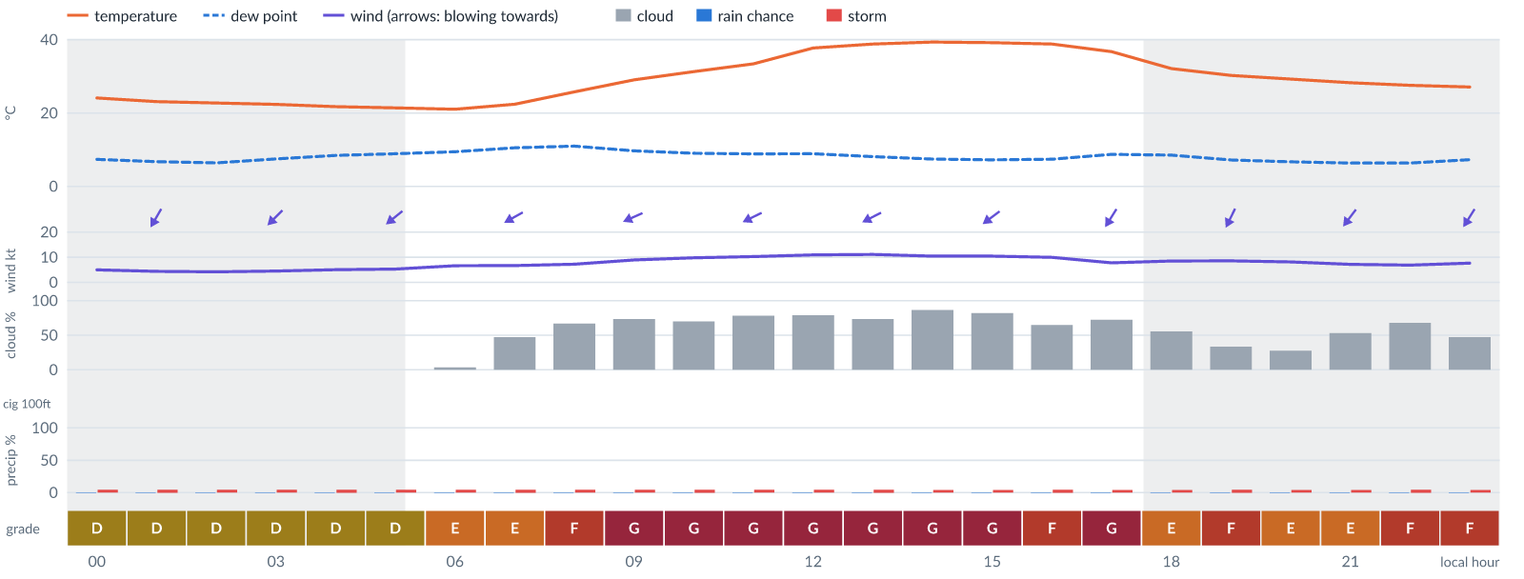
Meteogram — hourly forecast; shaded = before first light / after last light. Gaps mean no data.
Ser | Hrs | Temp | Cloud | Wind | Gust | QNH | Assessment | Driver | Remarks
(a) | (b) | (c) | (d) | (e) | (f) | (g) | (h) | (i) | (j)
1. | 0001 | 24°C | ☀ Clear (0%) | ↙ 5 (spread 4–6) kts NNE | 9 kts | 1013 | D - Marginal | storm 4% · gust 9 kt | thunderstorm risk, gusts
2. | 0100 | 23°C | ☀ Clear (0%) | ↙ 4 (spread 4–5) kts NNE | 9 kts | 1012 | D - Marginal | storm 5% · gust 9 kt | thunderstorm risk, gusts, wind shear
3. | 0200 | 23 (spread 22–23)°C | ☀ Clear (0%) | ↙ 4 kts NE | 9 kts | 1012 | D - Marginal | storm 4% · gust 9 kt | thunderstorm risk, gusts, wind shear
4. | 0300 | 22 (spread 22–23)°C | ☀ Clear (0%) | ↙ 4 (spread 4–5) kts NE | 9 kts | 1012 | D - Marginal | storm 4% · gust 9 kt | thunderstorm risk, gusts, wind shear
5. | 0400 | 22 (spread 21–22)°C | ☀ Clear (0%) | ↙ 5 kts NE | 10 kts | 1013 | D - Marginal | storm 5% · gust 10 kt | thunderstorm risk, gusts, wind shear
6. | 0500 | 21 (spread 21–22)°C | ☀ Clear (0%) | ↙ 5 (spread 5–6) kts NE | 11 kts | 1013 | D - Marginal | storm 4% · gust 11 kt | thunderstorm risk, gusts, wind shear
7. | 0600 | 21°C | ☀ Clear (3%) | ↙ 7 (spread 6–7) kts NE | 12 kts | 1014 | E - Poor | gust 12 kt | gusts, thunderstorm risk, wind shear
8. | 0700 | 22 (spread 22–23)°C | ◑ Partly cloudy (47%) | ↙ 7 (spread 5–8) kts ENE | 13 kts | 1015 | E - Poor | gust 13 kt | gusts, cloud cover, thunderstorm risk, wind shear
9. | 0800 | 26°C | ◕ Cloudy (67%) | ↙ 7 (spread 7–8) kts ENE | 13 kts | 1016 | F - Very Poor | cloud 67% | cloud cover, gusts, thunderstorm risk, wind shear
10. | 0900 | 29°C | ◕ Cloudy (73%) | ↙ 9 kts ENE | 15 kts | 1017 | G - Unacceptable | cloud 73% | cloud cover, gusts, thunderstorm risk, strong wind, wind shear
11. | 1000 | 31 (spread 31–32)°C | ◕ Cloudy (70%) | ↙ 10 (spread 9–10) kts ENE | 18 kts | 1017 | G - Unacceptable | cloud 70% · gust 18 kt | cloud cover, gusts, wind shear, thunderstorm risk, strong wind
12. | 1100 | 33 (spread 33–34)°C | ◕ Cloudy (78%) | ↙ 10 (spread 10–11) kts ENE | 18 kts | 1016 | G - Unacceptable | cloud 78% · gust 18 kt | cloud cover, gusts, wind shear, thunderstorm risk, strong wind
13. | 1200 | 38°C | ◕ Cloudy (79%) | ↙ 11 kts ENE | 19 kts | 1015 | G - Unacceptable | cloud 79% · gust 19 kt | cloud cover, gusts, wind shear, thunderstorm risk, strong wind
14. | 1300 | 39°C | ◕ Cloudy (73%) | ↙ 11 (spread 11–12) kts ENE | 19 kts | 1014 | G - Unacceptable | cloud 73% · gust 19 kt | cloud cover, gusts, wind shear, thunderstorm risk, strong wind
15. | 1400 | 39 (spread 39–40)°C | ◕ Cloudy (86%) | ↙ 10 (spread 10–11) kts ENE | 18 kts | 1013 | G - Unacceptable | cloud 86% · gust 18 kt | cloud cover, gusts, wind shear, thunderstorm risk, strong wind
16. | 1500 | 39°C | ◕ Cloudy (82%) | ↙ 10 (spread 10–11) kts NE | 18 kts | 1013 | G - Unacceptable | cloud 82% · gust 18 kt | cloud cover, gusts, wind shear, thunderstorm risk, strong wind
17. | 1600 | 39°C | ◕ Cloudy (65%) | ↙ 10 kts NE | 16 kts | 1012 | F - Very Poor | cloud 65% · gust 16 kt | cloud cover, gusts, thunderstorm risk, strong wind, wind shear
18. | 1700 | 37°C | ◕ Cloudy (72%) | ↙ 8 (spread 7–10) kts NNE | 14 kts | 1012 | G - Unacceptable | cloud 72% | cloud cover, gusts, thunderstorm risk, wind shear
19. | 1800 | 32 (spread 32–33)°C | ◑ Partly cloudy (55%) | ↓ 9 (spread 8–10) kts NNE | 14 kts | 1013 | E - Poor | cloud 55% · gust 14 kt | cloud cover, gusts, thunderstorm risk, strong wind, wind shear
20. | 1900 | 30 (spread 29–32)°C | ◔ Partly cloudy (33%) | ↙ 9 (spread 8–9) kts NNE | 15 kts | 1013 | F - Very Poor | gust 15 kt | gusts, thunderstorm risk, strong wind, wind shear
21. | 2000 | 29 (spread 28–30)°C | ◔ Mostly clear (28%) | ↙ 8 kts NNE | 14 kts | 1014 | E - Poor | gust 14 kt | gusts, thunderstorm risk, wind shear
22. | 2100 | 28 (spread 27–29)°C | ◑ Partly cloudy (53%) | ↙ 7 (spread 7–8) kts NE | 13 kts | 1014 | E - Poor | cloud 53% · gust 13 kt | cloud cover, gusts, thunderstorm risk, wind shear
23. | 2200 | 28 (spread 26–29)°C | ◕ Cloudy (68%) | ↙ 7 (spread 5–9) kts NE | 15 kts | 1015 | F - Very Poor | cloud 68% · gust 15 kt | cloud cover, gusts, wind shear, thunderstorm risk
24. | 2300 | 27 (spread 26–28)°C | ◑ Partly cloudy (47%) | ↙ 8 (spread 5–9) kts NNE | 15 kts | 1015 | F - Very Poor | gust 15 kt | gusts, wind shear, cloud cover, thunderstorm risk
Confidence: 74% — data for 24 of 24 hours; 17% of readings interpolated · first light 0540L · last light 1802L · Moon 0 % illuminated, rises 06:00, sets 17:43.

Tue 10 Nov 26
Conditions are expected to be generally Unacceptable: partly cloudy, winds up to 13 kts ENE, gusting 22 kts and temperatures 22–38°C. Flyable windows: 0400–0600L (Marginal, 3 h). Hazards: thunderstorm risk 0001–2300L. Overall similar to the previous day.
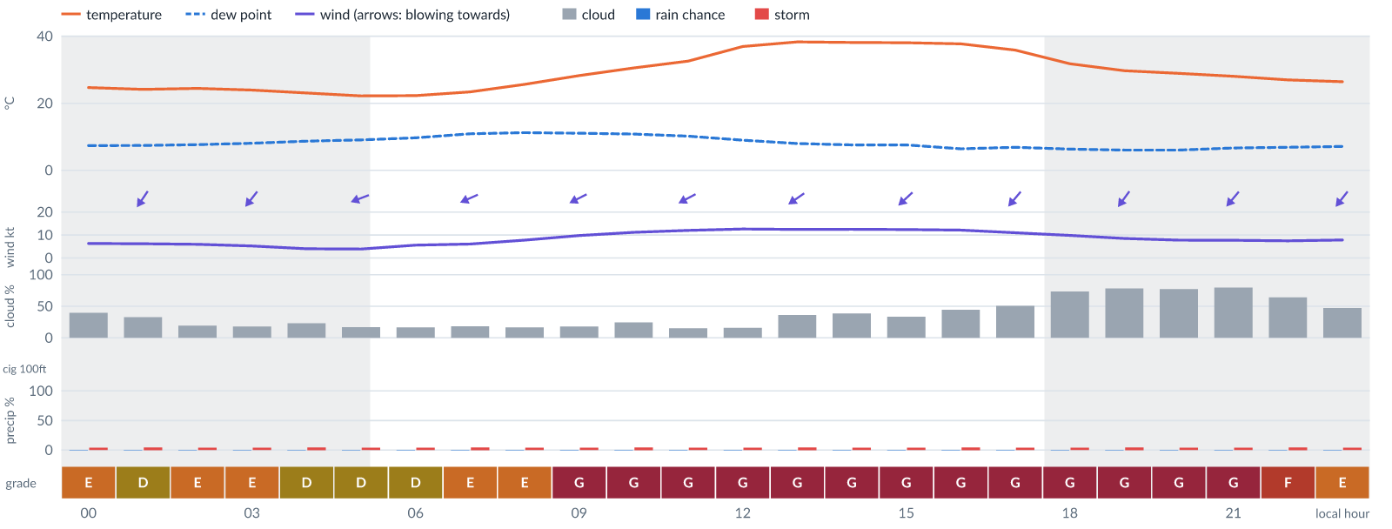
Meteogram — hourly forecast; shaded = before first light / after last light. Gaps mean no data.
Ser | Hrs | Temp | Cloud | Wind | Gust | QNH | Assessment | Driver | Remarks
(a) | (b) | (c) | (d) | (e) | (f) | (g) | (h) | (i) | (j)
1. | 0001 | 25 (spread 23–26)°C | ◑ Partly cloudy (40%) | ↙ 6 (spread 6–7) kts NNE | 12 kts | 1015 | E - Poor | gust 12 kt | gusts, thunderstorm risk, wind shear
2. | 0100 | 24 (spread 23–26)°C | ◔ Partly cloudy (33%) | ↙ 6 (spread 6–7) kts NE | 11 kts | 1014 | D - Marginal | storm 5% · gust 11 kt | thunderstorm risk, gusts, wind shear
3. | 0200 | 24 (spread 24–25)°C | ◔ Mostly clear (19%) | ↙ 6 (spread 5–7) kts NE | 12 kts | 1015 | E - Poor | gust 12 kt | gusts, thunderstorm risk, wind shear
4. | 0300 | 24°C | ◔ Mostly clear (18%) | ↙ 5 (spread 3–6) kts NE | 12 kts | 1015 | E - Poor | gust 12 kt · gust spread +6 kt | gusts, wind shear, thunderstorm risk
5. | 0400 | 23°C | ◔ Mostly clear (23%) | ↙ 4 (spread 3–5) kts NE | 10 kts | 1015 | D - Marginal | storm 5% · gust 10 kt | thunderstorm risk, gusts, wind shear
6. | 0500 | 22 (spread 22–23)°C | ◔ Mostly clear (17%) | ← 4 (spread 3–5) kts ENE | 8 kts | 1015 | D - Marginal | storm 4% | thunderstorm risk
7. | 0600 | 22 (spread 22–23)°C | ◔ Mostly clear (16%) | ↙ 6 (spread 4–7) kts ENE | 8 kts | 1016 | D - Marginal | storm 4% | thunderstorm risk
8. | 0700 | 23 (spread 23–24)°C | ◔ Mostly clear (19%) | ↙ 6 (spread 5–8) kts ENE | 12 kts | 1017 | E - Poor | gust 12 kt | gusts, thunderstorm risk, wind shear
9. | 0800 | 26°C | ◔ Mostly clear (17%) | ↙ 8 (spread 7–9) kts ENE | 14 kts | 1017 | E - Poor | gust 14 kt | gusts, thunderstorm risk, wind shear
10. | 0900 | 28 (spread 27–29)°C | ◔ Mostly clear (18%) | ↙ 10 (spread 9–10) kts ENE | 18 kts | 1018 | G - Unacceptable | gust 18 kt | gusts, wind shear, thunderstorm risk, strong wind
11. | 1000 | 31 (spread 30–31)°C | ◔ Mostly clear (25%) | ↙ 11 kts ENE | 20 kts | 1017 | G - Unacceptable | gust 20 kt | gusts, wind shear, thunderstorm risk, strong wind
12. | 1100 | 33 (spread 32–33)°C | ◔ Mostly clear (15%) | ↙ 12 kts ENE | 22 kts | 1017 | G - Unacceptable | gust 22 kt · gust spread +10 kt | gusts, wind shear, strong wind, thunderstorm risk
13. | 1200 | 37 (spread 36–37)°C | ◔ Mostly clear (16%) | ↙ 13 (spread 12–13) kts ENE | 22 kts | 1015 | G - Unacceptable | gust 22 kt | gusts, wind shear, strong wind, thunderstorm risk
14. | 1300 | 38 (spread 38–39)°C | ◔ Partly cloudy (36%) | ↙ 12 (spread 12–13) kts NE | 21 kts | 1015 | G - Unacceptable | gust 21 kt | gusts, wind shear, strong wind, thunderstorm risk
15. | 1400 | 38°C | ◑ Partly cloudy (38%) | ↙ 12 (spread 12–13) kts NE | 21 kts | 1014 | G - Unacceptable | gust 21 kt | gusts, wind shear, strong wind, thunderstorm risk
16. | 1500 | 38 (spread 38–39)°C | ◔ Partly cloudy (33%) | ↙ 12 (spread 12–13) kts NE | 20 kts | 1014 | G - Unacceptable | gust 20 kt | gusts, strong wind, wind shear, thunderstorm risk
17. | 1600 | 38°C | ◑ Partly cloudy (44%) | ↙ 12 kts NE | 20 kts | 1013 | G - Unacceptable | gust 20 kt | gusts, strong wind, wind shear, cloud cover, thunderstorm risk
18. | 1700 | 36 (spread 35–37)°C | ◑ Partly cloudy (51%) | ↙ 11 (spread 10–12) kts NE | 19 kts | 1013 | G - Unacceptable | gust 19 kt | gusts, wind shear, cloud cover, thunderstorm risk, strong wind
19. | 1800 | 32 (spread 30–33)°C | ◕ Cloudy (73%) | ↙ 10 kts NE | 18 kts | 1013 | G - Unacceptable | cloud 73% · gust 18 kt | cloud cover, gusts, wind shear, thunderstorm risk, strong wind
20. | 1900 | 30 (spread 28–31)°C | ◕ Cloudy (78%) | ↙ 8 (spread 8–9) kts NE | 17 kts | 1013 | G - Unacceptable | cloud 78% | cloud cover, gusts, wind shear, thunderstorm risk
21. | 2000 | 29 (spread 27–30)°C | ◕ Cloudy (77%) | ↙ 8 (spread 5–9) kts NE | 19 kts | 1014 | G - Unacceptable | cloud 77% · gust 19 kt | cloud cover, gusts, wind shear, thunderstorm risk
22. | 2100 | 28 (spread 26–29)°C | ◕ Cloudy (79%) | ↙ 8 (spread 5–9) kts NE | 14 kts | 1015 | G - Unacceptable | cloud 79% | cloud cover, gusts, thunderstorm risk, wind shear
23. | 2200 | 27 (spread 25–29)°C | ◕ Cloudy (64%) | ↙ 7 (spread 5–9) kts NE | 14 kts | 1015 | F - Very Poor | cloud 64% | cloud cover, gusts, wind shear, thunderstorm risk
24. | 2300 | 26 (spread 25–28)°C | ◑ Partly cloudy (47%) | ↙ 8 (spread 5–9) kts NE | 14 kts | 1015 | E - Poor | gust 14 kt | gusts, cloud cover, thunderstorm risk, wind shear
Confidence: 73% — data for 24 of 24 hours; 22% of readings interpolated · first light 0540L · last light 1802L · Moon 2 % illuminated, rises 06:53, sets 18:30.

Wed 11 Nov 26
Conditions are expected to be generally Unacceptable: cloudy, winds up to 11 kts NE, gusting 19 kts and temperatures 21–36°C. No flyable windows (Marginal or better, ≥2 consecutive hrs) are forecast. Hazards: thunderstorm risk 0001–2300L. Overall similar to the previous day.
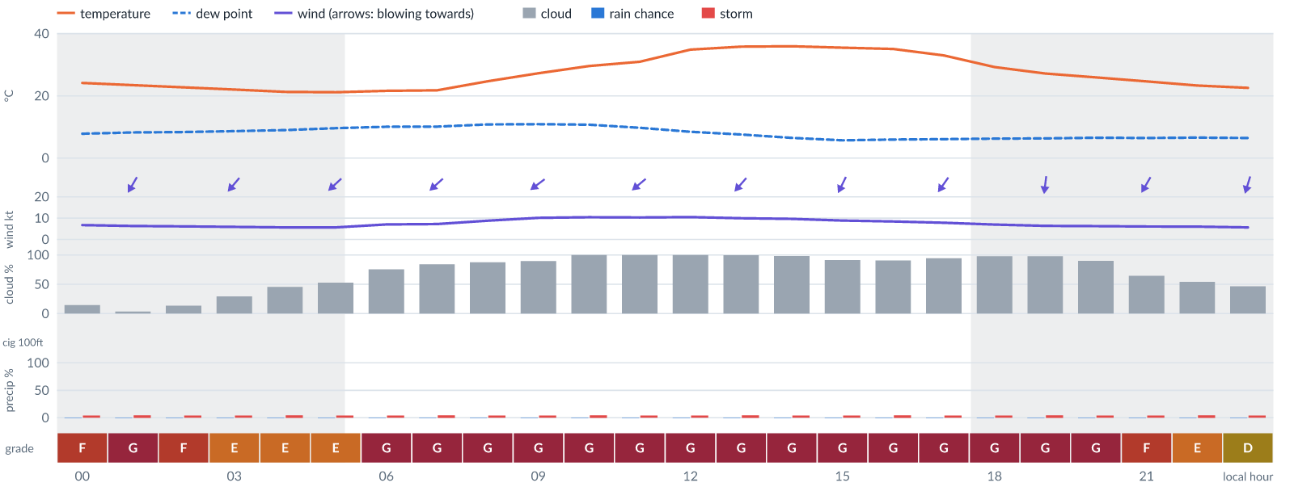
Meteogram — hourly forecast; shaded = before first light / after last light. Gaps mean no data.
Ser | Hrs | Temp | Cloud | Wind | Gust | QNH | Assessment | Driver | Remarks
(a) | (b) | (c) | (d) | (e) | (f) | (g) | (h) | (i) | (j)
1. | 0001 | 24 (spread 22–26)°C | ◔ Mostly clear (15%) | ↙ 7 (spread 6–7) kts NE | 15 kts | 1015 | F - Very Poor | gust 15 kt | gusts, wind shear, thunderstorm risk
2. | 0100 | 23 (spread 21–25)°C | ☀ Clear (3%) | ↙ 6 (spread 5–7) kts NNE | 16 kts | 1015 | G - Unacceptable | gust spread +9 kt | wind shear, gusts, thunderstorm risk
3. | 0200 | 23 (spread 21–24)°C | ◔ Mostly clear (14%) | ↙ 6 (spread 5–7) kts NE | 15 kts | 1015 | F - Very Poor | gust 15 kt · gust spread +9 kt | gusts, wind shear, thunderstorm risk
4. | 0300 | 22 (spread 20–24)°C | ◔ Mostly clear (29%) | ↙ 6 (spread 5–6) kts NE | 14 kts | 1015 | E - Poor | gust 14 kt · gust spread +8 kt | gusts, wind shear, thunderstorm risk
5. | 0400 | 21 (spread 20–23)°C | ◑ Partly cloudy (46%) | ↙ 6 (spread 5–6) kts NE | 14 kts | 1015 | E - Poor | gust 14 kt · gust spread +8 kt | gusts, wind shear, cloud cover, thunderstorm risk
6. | 0500 | 21 (spread 20–23)°C | ◑ Partly cloudy (53%) | ↙ 6 (spread 5–6) kts NE | 13 kts | 1015 | E - Poor | cloud 53% · gust 13 kt | cloud cover, gusts, wind shear, thunderstorm risk
7. | 0600 | 22 (spread 20–23)°C | ◕ Cloudy (76%) | ↙ 7 (spread 5–8) kts NE | 13 kts | 1016 | G - Unacceptable | cloud 76% | cloud cover, gusts, thunderstorm risk, wind shear
8. | 0700 | 22 (spread 21–23)°C | ◕ Cloudy (84%) | ↙ 7 (spread 6–8) kts NE | 15 kts | 1017 | G - Unacceptable | cloud 84% | cloud cover, gusts, wind shear, thunderstorm risk
9. | 0800 | 25 (spread 24–25)°C | ☁ Cloudy (88%) | ↙ 9 (spread 8–9) kts NE | 15 kts | 1017 | G - Unacceptable | cloud 88% | cloud cover, gusts, thunderstorm risk, strong wind, wind shear
10. | 0900 | 27°C | ☁ Overcast (90%) | ↙ 10 (spread 10–11) kts NE | 17 kts | 1018 | G - Unacceptable | cloud 90% | cloud cover, gusts, wind shear, thunderstorm risk, strong wind
11. | 1000 | 30°C | ☁ Overcast (100%) | ↙ 10 (spread 10–11) kts NE | 18 kts | 1018 | G - Unacceptable | cloud 100% · gust 18 kt | cloud cover, gusts, wind shear, thunderstorm risk, strong wind
12. | 1100 | 31°C | ☁ Overcast (100%) | ↙ 10 (spread 10–11) kts NE | 18 kts | 1017 | G - Unacceptable | cloud 100% · gust 18 kt | cloud cover, gusts, wind shear, thunderstorm risk, strong wind
13. | 1200 | 35°C | ☁ Overcast (100%) | ↙ 11 (spread 10–11) kts NE | 19 kts | 1016 | G - Unacceptable | cloud 100% · gust 19 kt | cloud cover, gusts, wind shear, thunderstorm risk, strong wind
14. | 1300 | 36°C | ☁ Overcast (100%) | ↙ 10 (spread 9–11) kts NE | 19 kts | 1015 | G - Unacceptable | cloud 100% · gust 19 kt | cloud cover, gusts, wind shear, thunderstorm risk, strong wind
15. | 1400 | 36°C | ☁ Overcast (98%) | ↙ 10 (spread 9–10) kts NE | 18 kts | 1015 | G - Unacceptable | cloud 98% · gust 18 kt | cloud cover, gusts, wind shear, thunderstorm risk, strong wind
16. | 1500 | 35 (spread 35–36)°C | ☁ Overcast (91%) | ↙ 9 (spread 8–9) kts NNE | 17 kts | 1014 | G - Unacceptable | cloud 91% | cloud cover, gusts, wind shear, thunderstorm risk, strong wind
17. | 1600 | 35°C | ☁ Overcast (91%) | ↓ 8 (spread 8–9) kts NNE | 15 kts | 1013 | G - Unacceptable | cloud 91% | cloud cover, gusts, wind shear, thunderstorm risk
18. | 1700 | 33°C | ☁ Overcast (94%) | ↙ 8 (spread 7–9) kts NE | 14 kts | 1013 | G - Unacceptable | cloud 94% | cloud cover, gusts, thunderstorm risk, wind shear
19. | 1800 | 29 (spread 28–30)°C | ☁ Overcast (98%) | ↓ 7 (spread 6–7) kts N | 13 kts | 1014 | G - Unacceptable | cloud 98% | cloud cover, gusts, thunderstorm risk, wind shear
20. | 1900 | 27 (spread 26–28)°C | ☁ Overcast (98%) | ↓ 6 (spread 6–7) kts N | 12 kts | 1014 | G - Unacceptable | cloud 98% | cloud cover, gusts, thunderstorm risk, wind shear
21. | 2000 | 26 (spread 25–27)°C | ☁ Overcast (90%) | ↓ 6 (spread 6–7) kts N | 11 kts | 1015 | G - Unacceptable | cloud 90% | cloud cover, thunderstorm risk, gusts, wind shear
22. | 2100 | 25 (spread 24–25)°C | ◕ Cloudy (65%) | ↙ 6 (spread 6–7) kts NNE | 10 kts | 1015 | F - Very Poor | cloud 65% | cloud cover, thunderstorm risk, gusts
23. | 2200 | 23 (spread 23–24)°C | ◑ Partly cloudy (54%) | ↓ 6 (spread 5–7) kts NNE | 9 kts | 1015 | E - Poor | cloud 54% | cloud cover, thunderstorm risk, gusts
24. | 2300 | 23 (spread 22–23)°C | ◑ Partly cloudy (47%) | ↓ 6 (spread 4–7) kts NNE | 8 kts | 1015 | D - Marginal | storm 4% · cloud 47% | cloud cover, thunderstorm risk
Confidence: 73% — data for 24 of 24 hours; 21% of readings interpolated · first light 0541L · last light 1802L · Moon 5 % illuminated, rises 07:46, sets 19:20.

Thu 12 Nov 26
Conditions are expected to be generally Very Poor: partly cloudy, winds up to 8 kts NE, gusting 16 kts and temperatures 17–35°C. Flyable windows: 0001–0100L (Marginal, 2 h). Hazards: thunderstorm risk 0001–2300L. Overall an improvement on the previous day.
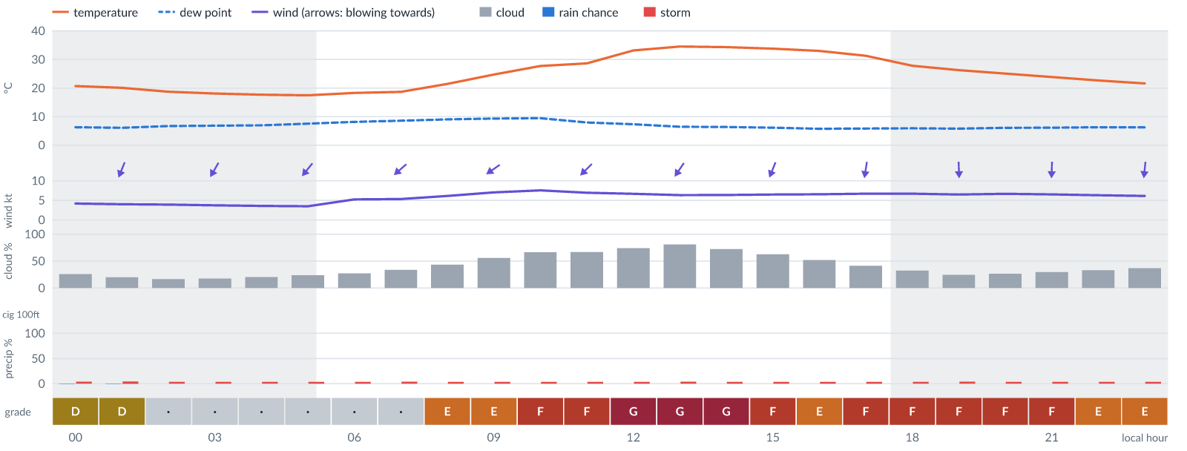
Meteogram — hourly forecast; shaded = before first light / after last light. Gaps mean no data.
Ser | Hrs | Temp | Cloud | Wind | Gust | QNH | Assessment | Driver | Remarks
(a) | (b) | (c) | (d) | (e) | (f) | (g) | (h) | (i) | (j)
1. | 0001 | 21°C | ◔ Mostly clear (26%) | ↓ 4 (spread 3–5) kts NNE | 8 kts | 1015 | D - Marginal | storm 4% | thunderstorm risk
2. | 0100 | 20°C | ◔ Mostly clear (20%) | ↓ 4 (spread 3–5) kts NNE | 8 kts | 1014 | D - Marginal | storm 5% | thunderstorm risk
3. | 0200 | 19 (spread 18–20)°C | ◔ Mostly clear (17%) | ↙ 4 (spread 3–4) kts NNE | 9 kts | 1014 | · - No data | storm 4% · gust 9 kt · visibility not forecast | thunderstorm risk, gusts, wind shear
4. | 0300 | 18 (spread 18–19)°C | ◔ Mostly clear (18%) | ↙ 4 (spread 3–4) kts NNE | 9 kts | 1015 | · - No data | storm 4% · gust 9 kt · visibility not forecast | thunderstorm risk, gusts, wind shear
5. | 0400 | 18 (spread 17–19)°C | ◔ Mostly clear (21%) | ↙ 4 (spread 3–4) kts NNE | 9 kts | 1015 | · - No data | storm 4% · gust 9 kt · visibility not forecast | thunderstorm risk, gusts, wind shear
6. | 0500 | 17 (spread 17–18)°C | ◔ Mostly clear (24%) | ↙ 4 (spread 3–4) kts NE | 9 kts | 1015 | · - No data | storm 4% · gust 9 kt · visibility not forecast | thunderstorm risk, gusts, wind shear
7. | 0600 | 18 (spread 18–19)°C | ◔ Mostly clear (27%) | ↙ 5 (spread 4–6) kts NE | 10 kts | 1016 | · - No data | storm 4% · gust 10 kt · visibility not forecast | thunderstorm risk, gusts, wind shear
8. | 0700 | 19 (spread 18–19)°C | ◔ Partly cloudy (34%) | ↙ 5 (spread 5–6) kts NE | 10 kts | 1016 | · - No data | storm 4% · gust 10 kt · visibility not forecast | thunderstorm risk, gusts, wind shear
9. | 0800 | 21 (spread 21–22)°C | ◑ Partly cloudy (44%) | ↙ 6 (spread 5–7) kts NE | 12 kts | 1017 | E - Poor | gust 12 kt · visibility not forecast | gusts, cloud cover, thunderstorm risk, wind shear
10. | 0900 | 25 (spread 24–25)°C | ◑ Partly cloudy (56%) | ↙ 7 kts NE | 13 kts | 1017 | E - Poor | cloud 56% · gust 13 kt · visibility not forecast | cloud cover, gusts, thunderstorm risk, wind shear
11. | 1000 | 28°C | ◕ Cloudy (67%) | ↙ 8 (spread 7–8) kts NE | 14 kts | 1017 | F - Very Poor | cloud 67% · visibility not forecast | cloud cover, gusts, thunderstorm risk, wind shear
12. | 1100 | 29 (spread 28–29)°C | ◕ Cloudy (67%) | ↙ 7 kts NE | 13 kts | 1016 | F - Very Poor | cloud 67% · visibility not forecast | cloud cover, gusts, thunderstorm risk, wind shear
13. | 1200 | 33°C | ◕ Cloudy (74%) | ↙ 7 (spread 6–7) kts NE | 14 kts | 1015 | G - Unacceptable | cloud 74% · visibility not forecast | cloud cover, gusts, wind shear, thunderstorm risk
14. | 1300 | 35 (spread 34–35)°C | ◕ Cloudy (81%) | ↙ 6 (spread 5–7) kts NE | 14 kts | 1015 | G - Unacceptable | cloud 81% · visibility not forecast | cloud cover, gusts, wind shear, thunderstorm risk
15. | 1400 | 34 (spread 34–35)°C | ◕ Cloudy (72%) | ↙ 6 (spread 5–7) kts NNE | 14 kts | 1014 | G - Unacceptable | cloud 72% · visibility not forecast | cloud cover, gusts, wind shear, thunderstorm risk
16. | 1500 | 34 (spread 33–34)°C | ◕ Cloudy (63%) | ↓ 7 (spread 6–7) kts NNE | 14 kts | 1014 | F - Very Poor | cloud 63% · visibility not forecast | cloud cover, gusts, wind shear, thunderstorm risk
17. | 1600 | 33°C | ◑ Partly cloudy (52%) | ↓ 7 (spread 6–7) kts NNE | 14 kts | 1014 | E - Poor | cloud 52% · gust 14 kt · visibility not forecast | cloud cover, gusts, wind shear, thunderstorm risk
18. | 1700 | 31 (spread 31–32)°C | ◑ Partly cloudy (41%) | ↓ 7 (spread 6–7) kts N | 15 kts | 1013 | F - Very Poor | gust 15 kt · visibility not forecast | gusts, wind shear, thunderstorm risk
19. | 1800 | 28°C | ◔ Mostly clear (32%) | ↓ 7 (spread 6–7) kts N | 16 kts | 1014 | F - Very Poor | gust 16 kt · gust spread +9 kt · visibility not forecast | gusts, wind shear, thunderstorm risk
20. | 1900 | 26 (spread 26–27)°C | ◔ Mostly clear (24%) | ↓ 7 (spread 6–7) kts N | 16 kts | 1014 | F - Very Poor | gust 16 kt · gust spread +10 kt · visibility not forecast | gusts, wind shear, thunderstorm risk
21. | 2000 | 25 (spread 24–26)°C | ◔ Mostly clear (27%) | ↓ 7 (spread 6–7) kts N | 16 kts | 1014 | F - Very Poor | gust 16 kt · gust spread +9 kt · visibility not forecast | gusts, wind shear, thunderstorm risk
22. | 2100 | 24 (spread 23–25)°C | ◔ Mostly clear (30%) | ↓ 7 (spread 6–7) kts N | 15 kts | 1014 | F - Very Poor | gust 15 kt · visibility not forecast | gusts, wind shear, thunderstorm risk
23. | 2200 | 23 (spread 22–23)°C | ◔ Partly cloudy (33%) | ↓ 6 (spread 6–7) kts N | 14 kts | 1014 | E - Poor | gust 14 kt · gust spread +8 kt · visibility not forecast | gusts, wind shear, thunderstorm risk
24. | 2300 | 22 (spread 21–22)°C | ◔ Partly cloudy (37%) | ↓ 6 (spread 6–7) kts N | 13 kts | 1014 | E - Poor | gust 13 kt · gust spread +7 kt · visibility not forecast | gusts, wind shear, thunderstorm risk
Confidence: 70% — data for 24 of 24 hours; 17% of readings interpolated · first light 0541L · last light 1802L · Moon 9 % illuminated, rises 08:38, sets 20:11.

Fri 13 Nov 26
Conditions are expected to be generally Poor: mostly clear, winds up to 6 kts NE, gusting 14 kts and temperatures 16–34°C. No flyable windows (Marginal or better, ≥2 consecutive hrs) are forecast. Hazards: thunderstorm risk 0001–2300L. Overall an improvement on the previous day.
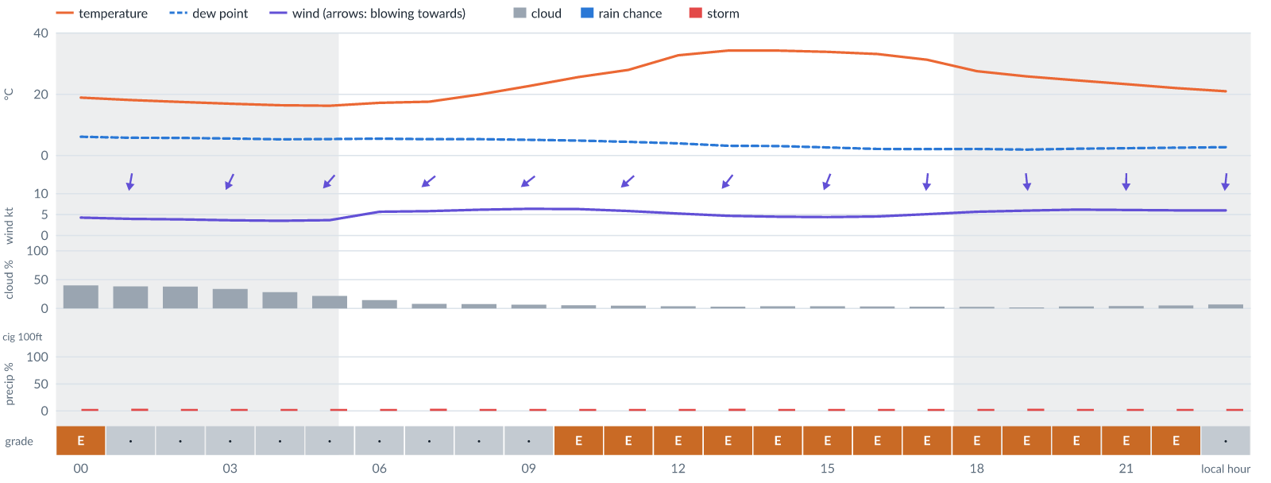
Meteogram — hourly forecast; shaded = before first light / after last light. Gaps mean no data.
Ser | Hrs | Temp | Cloud | Wind | Gust | QNH | Assessment | Driver | Remarks
(a) | (b) | (c) | (d) | (e) | (f) | (g) | (h) | (i) | (j)
1. | 0001 | 19°C | ◑ Partly cloudy (40%) | ↓ 4 (spread 4–5) kts N | 11 kts | 1014 | E - Poor | gust spread +7 kt · visibility not forecast | wind shear, thunderstorm risk, gusts
2. | 0100 | 18 (spread 18–19)°C | ◑ Partly cloudy (38%) | ↓ 4 kts N | 10 kts | 1014 | · - No data | storm 4% · gust 10 kt · visibility not forecast | thunderstorm risk, gusts, wind shear
3. | 0200 | 17 (spread 17–18)°C | ◑ Partly cloudy (38%) | ↓ 4 (spread 3–4) kts NNE | 9 kts | 1014 | · - No data | storm 4% · gust 9 kt · visibility not forecast | thunderstorm risk, gusts, wind shear
4. | 0300 | 17°C | ◔ Partly cloudy (34%) | ↙ 4 (spread 3–4) kts NNE | 8 kts | 1015 | · - No data | storm 4% · visibility not forecast | thunderstorm risk
5. | 0400 | 16 (spread 16–17)°C | ◔ Mostly clear (28%) | ↙ 4 (spread 3–4) kts NE | 8 kts | 1015 | · - No data | storm 4% · visibility not forecast | thunderstorm risk
6. | 0500 | 16 (spread 16–17)°C | ◔ Mostly clear (22%) | ↙ 4 (spread 3–5) kts NE | 8 kts | 1015 | · - No data | storm 4% · visibility not forecast | thunderstorm risk
7. | 0600 | 17 (spread 17–18)°C | ◔ Mostly clear (15%) | ↙ 6 (spread 4–7) kts NE | 9 kts | 1016 | · - No data | storm 4% · gust 9 kt · visibility not forecast | thunderstorm risk, gusts
8. | 0700 | 18 (spread 17–18)°C | ☀ Clear (8%) | ↙ 6 (spread 5–7) kts NE | 10 kts | 1016 | · - No data | storm 4% · gust 10 kt · visibility not forecast | thunderstorm risk, gusts
9. | 0800 | 20°C | ☀ Clear (8%) | ↙ 6 (spread 5–7) kts NE | 11 kts | 1016 | · - No data | storm 4% · gust 11 kt · visibility not forecast | thunderstorm risk, gusts, wind shear
10. | 0900 | 23 (spread 22–23)°C | ☀ Clear (7%) | ↙ 6 (spread 6–7) kts NE | 11 kts | 1016 | · - No data | storm 4% · gust 11 kt · visibility not forecast | thunderstorm risk, gusts, wind shear
11. | 1000 | 26 (spread 25–26)°C | ☀ Clear (6%) | ↙ 6 (spread 6–7) kts NE | 12 kts | 1016 | E - Poor | gust 12 kt · visibility not forecast | gusts, thunderstorm risk, wind shear
12. | 1100 | 28°C | ☀ Clear (5%) | ↙ 6 kts NE | 12 kts | 1016 | E - Poor | gust 12 kt · visibility not forecast | gusts, thunderstorm risk, wind shear
13. | 1200 | 33°C | ☀ Clear (4%) | ↙ 5 (spread 4–6) kts NE | 13 kts | 1015 | E - Poor | gust 13 kt · gust spread +7 kt · visibility not forecast | gusts, wind shear, thunderstorm risk
14. | 1300 | 34 (spread 34–35)°C | ☀ Clear (3%) | ↙ 5 (spread 3–6) kts NE | 13 kts | 1015 | E - Poor | gust 13 kt · gust spread +8 kt · visibility not forecast | gusts, wind shear, thunderstorm risk
15. | 1400 | 34°C | ☀ Clear (4%) | ↙ 5 (spread 3–6) kts NNE | 12 kts | 1014 | E - Poor | gust 12 kt · gust spread +8 kt · visibility not forecast | gusts, wind shear, thunderstorm risk
16. | 1500 | 34°C | ☀ Clear (4%) | ↓ 4 (spread 3–5) kts NNE | 12 kts | 1014 | E - Poor | gust 12 kt · gust spread +8 kt · visibility not forecast | gusts, wind shear, thunderstorm risk
17. | 1600 | 33 (spread 33–34)°C | ☀ Clear (4%) | ↓ 5 (spread 4–5) kts NNE | 12 kts | 1014 | E - Poor | gust 12 kt · gust spread +7 kt · visibility not forecast | gusts, wind shear, thunderstorm risk
18. | 1700 | 31°C | ☀ Clear (3%) | ↓ 5 (spread 4–6) kts N | 13 kts | 1014 | E - Poor | gust 13 kt · gust spread +7 kt · visibility not forecast | gusts, wind shear, thunderstorm risk
19. | 1800 | 28 (spread 27–28)°C | ☀ Clear (3%) | ↓ 6 (spread 5–6) kts N | 14 kts | 1014 | E - Poor | gust 14 kt · gust spread +8 kt · visibility not forecast | gusts, wind shear, thunderstorm risk
20. | 1900 | 26 (spread 25–26)°C | ☀ Clear (2%) | ↓ 6 kts N | 14 kts | 1014 | E - Poor | gust 14 kt · gust spread +8 kt · visibility not forecast | gusts, wind shear, thunderstorm risk
21. | 2000 | 25 (spread 24–25)°C | ☀ Clear (3%) | ↓ 6 kts N | 14 kts | 1014 | E - Poor | gust 14 kt · gust spread +8 kt · visibility not forecast | gusts, wind shear, thunderstorm risk
22. | 2100 | 23 (spread 23–24)°C | ☀ Clear (4%) | ↓ 6 kts N | 13 kts | 1014 | E - Poor | gust 13 kt · gust spread +7 kt · visibility not forecast | gusts, wind shear, thunderstorm risk
23. | 2200 | 22 (spread 22–23)°C | ☀ Clear (5%) | ↓ 6 (spread 5–7) kts N | 12 kts | 1014 | E - Poor | gust 12 kt · visibility not forecast | gusts, thunderstorm risk, wind shear
24. | 2300 | 21 (spread 21–22)°C | ☀ Clear (7%) | ↓ 6 (spread 5–7) kts N | 11 kts | 1014 | · - No data | storm 4% · gust 11 kt · visibility not forecast | thunderstorm risk, gusts, wind shear
Confidence: 70% — data for 24 of 24 hours; 16% of readings interpolated · first light 0541L · last light 1802L · Moon 15 % illuminated, rises 09:29, sets 21:03.

Sat 14 Nov 26
Conditions are expected to be generally Poor: clear, winds up to 6 kts N, gusting 14 kts and temperatures 17–35°C. No flyable windows (Marginal or better, ≥2 consecutive hrs) are forecast. Hazards: thunderstorm risk 0001–2300L. Overall similar to the previous day.
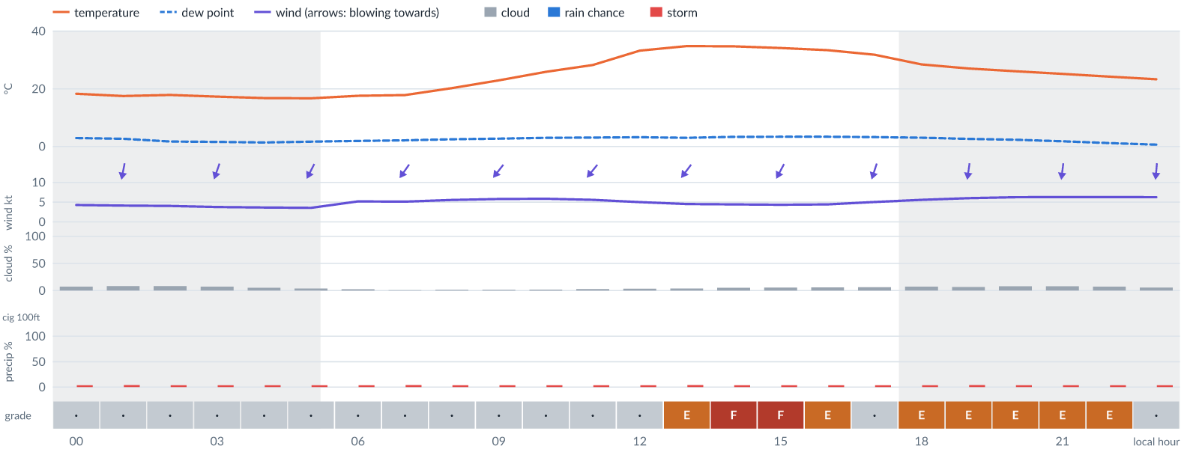
Meteogram — hourly forecast; shaded = before first light / after last light. Gaps mean no data.
Ser | Hrs | Temp | Cloud | Wind | Gust | QNH | Assessment | Driver | Remarks
(a) | (b) | (c) | (d) | (e) | (f) | (g) | (h) | (i) | (j)
1. | 0001 | 18 (spread 18–19)°C | ☀ Clear (8%) | ↓ 4 (spread 4–5) kts N | 10 kts | 1014 | · - No data | storm 4% · gust 10 kt · visibility not forecast | thunderstorm risk, gusts, wind shear
2. | 0100 | 17 (spread 17–18)°C | ☀ Clear (8%) | ↓ 4 (spread 4–5) kts N | 9 kts | 1014 | · - No data | storm 4% · gust 9 kt · visibility not forecast | thunderstorm risk, gusts, wind shear
3. | 0200 | 18 (spread 17–18)°C | ☀ Clear (8%) | ↓ 4 (spread 3–5) kts NNE | 8 kts | 1014 | · - No data | storm 4% · visibility not forecast | thunderstorm risk
4. | 0300 | 17 (spread 17–18)°C | ☀ Clear (7%) | ↓ 4 (spread 3–4) kts NNE | 8 kts | 1015 | · - No data | storm 4% · visibility not forecast | thunderstorm risk
5. | 0400 | 17 (spread 16–17)°C | ☀ Clear (5%) | ↓ 4 (spread 3–4) kts NNE | 8 kts | 1015 | · - No data | storm 4% · visibility not forecast | thunderstorm risk
6. | 0500 | 17 (spread 16–17)°C | ☀ Clear (4%) | ↙ 4 (spread 3–4) kts NNE | 8 kts | 1015 | · - No data | storm 4% · visibility not forecast | thunderstorm risk
7. | 0600 | 18 (spread 17–18)°C | ☀ Clear (2%) | ↙ 5 (spread 4–6) kts NNE | 9 kts | 1016 | · - No data | storm 4% · gust 9 kt · visibility not forecast | thunderstorm risk, gusts
8. | 0700 | 18 (spread 17–18)°C | ☀ Clear (1%) | ↙ 5 (spread 4–6) kts NE | 10 kts | 1016 | · - No data | storm 4% · gust 10 kt · visibility not forecast | thunderstorm risk, gusts, wind shear
9. | 0800 | 20 (spread 19–21)°C | ☀ Clear (1%) | ↙ 6 (spread 5–6) kts NE | 10 kts | 1016 | · - No data | storm 4% · gust 10 kt · visibility not forecast | thunderstorm risk, gusts
10. | 0900 | 23 (spread 22–24)°C | ☀ Clear (1%) | ↙ 6 kts NE | 11 kts | 1016 | · - No data | storm 4% · gust 11 kt · visibility not forecast | thunderstorm risk, gusts, wind shear
11. | 1000 | 26 (spread 25–27)°C | ☀ Clear (2%) | ↙ 6 kts NE | 11 kts | 1016 | · - No data | storm 4% · gust 11 kt · visibility not forecast | thunderstorm risk, gusts, wind shear
12. | 1100 | 28 (spread 28–29)°C | ☀ Clear (3%) | ↙ 6 (spread 5–6) kts NE | 11 kts | 1015 | · - No data | storm 4% · gust 11 kt · visibility not forecast | thunderstorm risk, gusts, wind shear
13. | 1200 | 33°C | ☀ Clear (4%) | ↙ 5 kts NE | 11 kts | 1014 | · - No data | storm 4% · gust 11 kt · visibility not forecast | thunderstorm risk, gusts, wind shear
14. | 1300 | 35 (spread 34–35)°C | ☀ Clear (4%) | ↙ 5 (spread 4–5) kts NE | 13 kts | 1014 | E - Poor | gust 13 kt · gust spread +8 kt · visibility not forecast | gusts, wind shear, thunderstorm risk
15. | 1400 | 35 (spread 34–35)°C | ☀ Clear (5%) | ↙ 4 (spread 4–5) kts NNE | 13 kts | 1014 | F - Very Poor | gust spread +9 kt · visibility not forecast | wind shear, gusts, thunderstorm risk
16. | 1500 | 34°C | ☀ Clear (6%) | ↙ 4 (spread 3–5) kts NNE | 13 kts | 1014 | F - Very Poor | gust spread +8 kt · visibility not forecast | wind shear, gusts, thunderstorm risk
17. | 1600 | 33 (spread 33–34)°C | ☀ Clear (6%) | ↓ 4 (spread 3–5) kts NNE | 12 kts | 1013 | E - Poor | gust 12 kt · gust spread +8 kt · visibility not forecast | gusts, wind shear, thunderstorm risk
18. | 1700 | 32°C | ☀ Clear (6%) | ↓ 5 (spread 4–6) kts NNE | 11 kts | 1013 | · - No data | storm 4% · gust 11 kt · visibility not forecast | thunderstorm risk, gusts, wind shear
19. | 1800 | 28 (spread 28–29)°C | ☀ Clear (7%) | ↓ 6 (spread 5–6) kts NNE | 13 kts | 1014 | E - Poor | gust 13 kt · gust spread +8 kt · visibility not forecast | gusts, wind shear, thunderstorm risk
20. | 1900 | 27 (spread 27–28)°C | ☀ Clear (7%) | ↓ 6 kts N | 14 kts | 1013 | E - Poor | gust 14 kt · gust spread +8 kt · visibility not forecast | gusts, wind shear, thunderstorm risk
21. | 2000 | 26 (spread 26–27)°C | ☀ Clear (8%) | ↓ 6 kts N | 14 kts | 1014 | E - Poor | gust 14 kt · gust spread +8 kt · visibility not forecast | gusts, wind shear, thunderstorm risk
22. | 2100 | 25 (spread 25–26)°C | ☀ Clear (8%) | ↓ 6 (spread 6–7) kts N | 13 kts | 1014 | E - Poor | gust 13 kt · gust spread +6 kt · visibility not forecast | gusts, wind shear, thunderstorm risk
23. | 2200 | 24 (spread 24–25)°C | ☀ Clear (7%) | ↓ 6 (spread 5–7) kts N | 12 kts | 1014 | E - Poor | gust 12 kt · visibility not forecast | gusts, thunderstorm risk, wind shear
24. | 2300 | 23 (spread 23–24)°C | ☀ Clear (6%) | ↓ 6 (spread 5–7) kts N | 11 kts | 1014 | · - No data | storm 4% · gust 11 kt · visibility not forecast | thunderstorm risk, gusts, wind shear
Confidence: 70% — data for 24 of 24 hours; 16% of readings interpolated · first light 0542L · last light 1801L · Moon 23 % illuminated, rises 10:17, sets 21:54.

Sun 15 Nov 26
Conditions are expected to be generally Poor: clear, winds up to 7 kts N, gusting 16 kts and temperatures 18–37°C. No flyable windows (Marginal or better, ≥2 consecutive hrs) are forecast. Hazards: thunderstorm risk 0001–2300L. Overall similar to the previous day.
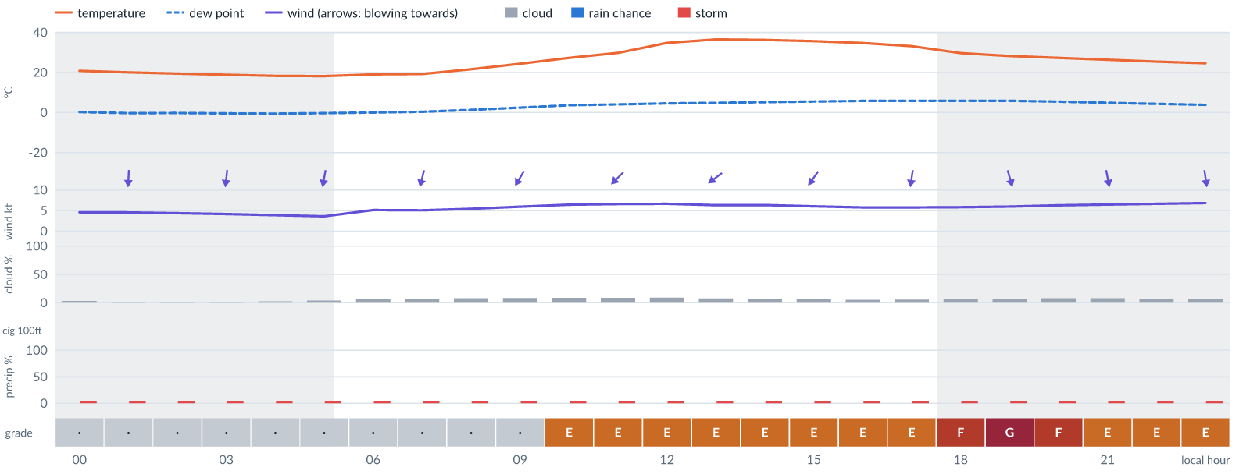
Meteogram — hourly forecast; shaded = before first light / after last light. Gaps mean no data.
Ser | Hrs | Temp | Cloud | Wind | Gust | QNH | Assessment | Driver | Remarks
(a) | (b) | (c) | (d) | (e) | (f) | (g) | (h) | (i) | (j)
1. | 0001 | 21°C | ☀ Clear (3%) | ↓ 5 (spread 4–5) kts N | 10 kts | 1013 | · - No data | storm 4% · gust 10 kt · visibility not forecast | thunderstorm risk, gusts, wind shear
2. | 0100 | 20°C | ☀ Clear (1%) | ↓ 5 (spread 3–5) kts N | 9 kts | 1013 | · - No data | storm 4% · gust 9 kt · visibility not forecast | thunderstorm risk, gusts
3. | 0200 | 19 (spread 19–20)°C | ☀ Clear (1%) | ↓ 4 (spread 3–5) kts N | 9 kts | 1013 | · - No data | storm 4% · gust 9 kt · visibility not forecast | thunderstorm risk, gusts, wind shear
4. | 0300 | 19°C | ☀ Clear (2%) | ↓ 4 (spread 3–5) kts N | 9 kts | 1014 | · - No data | storm 4% · gust 9 kt · visibility not forecast | thunderstorm risk, gusts, wind shear
5. | 0400 | 18 (spread 18–19)°C | ☀ Clear (2%) | ↓ 4 (spread 3–5) kts N | 9 kts | 1014 | · - No data | storm 4% · gust 9 kt · visibility not forecast | thunderstorm risk, gusts, wind shear
6. | 0500 | 18 (spread 18–19)°C | ☀ Clear (4%) | ↓ 4 (spread 2–5) kts N | 9 kts | 1014 | · - No data | storm 4% · gust 9 kt · visibility not forecast | thunderstorm risk, gusts, wind shear
7. | 0600 | 19 (spread 18–20)°C | ☀ Clear (6%) | ↓ 5 (spread 4–6) kts NNE | 9 kts | 1014 | · - No data | storm 4% · gust 9 kt · visibility not forecast | thunderstorm risk, gusts
8. | 0700 | 19 (spread 19–20)°C | ☀ Clear (6%) | ↓ 5 (spread 4–6) kts NNE | 9 kts | 1014 | · - No data | storm 4% · gust 9 kt · visibility not forecast | thunderstorm risk, gusts
9. | 0800 | 22 (spread 21–22)°C | ☀ Clear (8%) | ↓ 5 (spread 5–6) kts NNE | 10 kts | 1015 | · - No data | storm 4% · gust 10 kt · visibility not forecast | thunderstorm risk, gusts, wind shear
10. | 0900 | 24 (spread 24–25)°C | ☀ Clear (8%) | ↙ 6 kts NNE | 11 kts | 1015 | · - No data | storm 4% · gust 11 kt · visibility not forecast | thunderstorm risk, gusts, wind shear
11. | 1000 | 27 (spread 27–28)°C | ☀ Clear (9%) | ↙ 6 (spread 6–7) kts NE | 12 kts | 1014 | E - Poor | gust 12 kt · visibility not forecast | gusts, thunderstorm risk, wind shear
12. | 1100 | 30 (spread 29–30)°C | ☀ Clear (9%) | ↙ 7 (spread 6–7) kts NE | 12 kts | 1014 | E - Poor | gust 12 kt · visibility not forecast | gusts, thunderstorm risk, wind shear
13. | 1200 | 35°C | ☀ Clear (9%) | ↙ 7 (spread 6–7) kts NE | 12 kts | 1013 | E - Poor | gust 12 kt · visibility not forecast | gusts, thunderstorm risk, wind shear
14. | 1300 | 37 (spread 36–37)°C | ☀ Clear (8%) | ↙ 6 (spread 6–7) kts NE | 12 kts | 1013 | E - Poor | gust 12 kt · visibility not forecast | gusts, thunderstorm risk, wind shear
15. | 1400 | 36 (spread 36–37)°C | ☀ Clear (7%) | ↙ 6 (spread 6–7) kts NE | 12 kts | 1013 | E - Poor | gust 12 kt · visibility not forecast | gusts, thunderstorm risk, wind shear
16. | 1500 | 36 (spread 35–36)°C | ☀ Clear (6%) | ↙ 6 (spread 5–7) kts NE | 12 kts | 1013 | E - Poor | gust 12 kt · visibility not forecast | gusts, thunderstorm risk, wind shear
17. | 1600 | 35°C | ☀ Clear (5%) | ↙ 6 (spread 5–7) kts NNE | 13 kts | 1013 | E - Poor | gust 13 kt · gust spread +7 kt · visibility not forecast | gusts, wind shear, thunderstorm risk
18. | 1700 | 33 (spread 33–34)°C | ☀ Clear (6%) | ↓ 6 (spread 5–7) kts N | 14 kts | 1012 | E - Poor | gust 14 kt · gust spread +8 kt · visibility not forecast | gusts, wind shear, thunderstorm risk
19. | 1800 | 30 (spread 29–30)°C | ☀ Clear (7%) | ↓ 6 (spread 5–6) kts N | 15 kts | 1013 | F - Very Poor | gust 15 kt · gust spread +9 kt · visibility not forecast | gusts, wind shear, thunderstorm risk
20. | 1900 | 28 (spread 28–29)°C | ☀ Clear (6%) | ↓ 6 kts NNW | 16 kts | 1013 | G - Unacceptable | gust spread +10 kt · visibility not forecast | wind shear, gusts, thunderstorm risk
21. | 2000 | 27 (spread 27–28)°C | ☀ Clear (8%) | ↓ 6 (spread 6–7) kts NNW | 15 kts | 1012 | F - Very Poor | gust 15 kt · gust spread +9 kt · visibility not forecast | gusts, wind shear, thunderstorm risk
22. | 2100 | 26 (spread 26–27)°C | ☀ Clear (8%) | ↓ 6 (spread 6–7) kts N | 14 kts | 1013 | E - Poor | gust 14 kt · gust spread +8 kt · visibility not forecast | gusts, wind shear, thunderstorm risk
23. | 2200 | 25 (spread 25–26)°C | ☀ Clear (7%) | ↓ 7 (spread 6–7) kts N | 14 kts | 1013 | E - Poor | gust 14 kt · gust spread +7 kt · visibility not forecast | gusts, wind shear, thunderstorm risk
24. | 2300 | 25°C | ☀ Clear (6%) | ↓ 7 (spread 6–8) kts N | 13 kts | 1013 | E - Poor | gust 13 kt · visibility not forecast | gusts, thunderstorm risk, wind shear
Confidence: 70% — data for 24 of 24 hours; 16% of readings interpolated · first light 0542L · last light 1801L · Moon 31 % illuminated, rises 11:01, sets 22:45.

Mon 16 Nov 26
Conditions are expected to be generally Poor: clear, winds up to 8 kts NE, gusting 18 kts and temperatures 19–38°C. No flyable windows (Marginal or better, ≥2 consecutive hrs) are forecast. Hazards: thunderstorm risk 0001–2300L. Overall similar to the previous day.
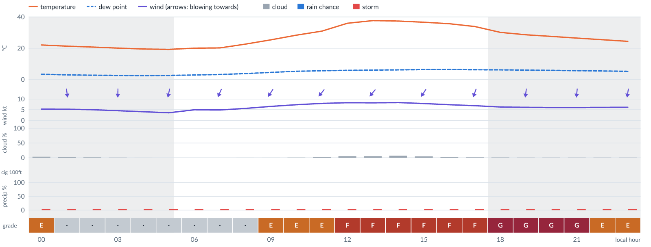
Meteogram — hourly forecast; shaded = before first light / after last light. Gaps mean no data.
Ser | Hrs | Temp | Cloud | Wind | Gust | QNH | Assessment | Driver | Remarks
(a) | (b) | (c) | (d) | (e) | (f) | (g) | (h) | (i) | (j)
1. | 0001 | 22°C | ☀ Clear (4%) | ↓ 5 (spread 5–6) kts N | 12 kts | 1012 | E - Poor | gust 12 kt · gust spread +6 kt · visibility not forecast | gusts, wind shear, thunderstorm risk
2. | 0100 | 21°C | ☀ Clear (2%) | ↓ 5 (spread 5–6) kts N | 11 kts | 1012 | · - No data | storm 4% · gust 11 kt · visibility not forecast | thunderstorm risk, gusts, wind shear
3. | 0200 | 21°C | ☀ Clear (1%) | ↓ 5 (spread 4–6) kts N | 10 kts | 1012 | · - No data | storm 4% · gust 10 kt · visibility not forecast | thunderstorm risk, gusts, wind shear
4. | 0300 | 20°C | ☀ Clear (1%) | ↓ 5 (spread 4–5) kts N | 10 kts | 1013 | · - No data | storm 4% · gust 10 kt · visibility not forecast | thunderstorm risk, gusts, wind shear
5. | 0400 | 19 (spread 19–20)°C | ☀ Clear (0%) | ↓ 4 (spread 4–5) kts N | 10 kts | 1013 | · - No data | storm 4% · gust 10 kt · visibility not forecast | thunderstorm risk, gusts, wind shear
6. | 0500 | 19 (spread 19–20)°C | ☀ Clear (0%) | ↓ 4 (spread 3–4) kts NNE | 10 kts | 1013 | · - No data | storm 4% · gust 10 kt · visibility not forecast | thunderstorm risk, gusts, wind shear
7. | 0600 | 20 (spread 19–20)°C | ☀ Clear (0%) | ↓ 5 (spread 4–6) kts NNE | 10 kts | 1014 | · - No data | storm 4% · gust 10 kt · visibility not forecast | thunderstorm risk, gusts, wind shear
8. | 0700 | 20 (spread 20–21)°C | ☀ Clear (0%) | ↙ 5 (spread 4–6) kts NNE | 11 kts | 1014 | · - No data | storm 4% · gust 11 kt · visibility not forecast | thunderstorm risk, gusts, wind shear
9. | 0800 | 23 (spread 22–23)°C | ☀ Clear (0%) | ↙ 6 (spread 5–6) kts NNE | 11 kts | 1014 | · - No data | storm 4% · gust 11 kt · visibility not forecast | thunderstorm risk, gusts, wind shear
10. | 0900 | 25 (spread 25–26)°C | ☀ Clear (0%) | ↙ 7 (spread 6–7) kts NNE | 13 kts | 1014 | E - Poor | gust 13 kt · visibility not forecast | gusts, thunderstorm risk, wind shear
11. | 1000 | 28 (spread 28–29)°C | ☀ Clear (1%) | ↙ 7 (spread 7–8) kts NE | 14 kts | 1013 | E - Poor | gust 14 kt · gust spread +7 kt · visibility not forecast | gusts, wind shear, thunderstorm risk
12. | 1100 | 31°C | ☀ Clear (3%) | ↙ 8 kts NE | 14 kts | 1013 | E - Poor | gust 14 kt · visibility not forecast | gusts, thunderstorm risk, wind shear
13. | 1200 | 36°C | ☀ Clear (5%) | ↙ 8 (spread 7–9) kts NE | 15 kts | 1012 | F - Very Poor | gust 15 kt · visibility not forecast | gusts, wind shear, thunderstorm risk
14. | 1300 | 38°C | ☀ Clear (5%) | ↙ 8 (spread 8–9) kts NE | 15 kts | 1012 | F - Very Poor | gust 15 kt · visibility not forecast | gusts, wind shear, thunderstorm risk
15. | 1400 | 37°C | ☀ Clear (7%) | ↙ 8 kts NE | 15 kts | 1012 | F - Very Poor | gust 15 kt · visibility not forecast | gusts, wind shear, thunderstorm risk
16. | 1500 | 37°C | ☀ Clear (4%) | ↙ 8 kts NNE | 15 kts | 1011 | F - Very Poor | gust 15 kt · visibility not forecast | gusts, wind shear, thunderstorm risk
17. | 1600 | 36°C | ☀ Clear (2%) | ↙ 7 kts NNE | 15 kts | 1011 | F - Very Poor | gust 15 kt · visibility not forecast | gusts, wind shear, thunderstorm risk
18. | 1700 | 34°C | ☀ Clear (1%) | ↓ 7 kts NNE | 16 kts | 1011 | F - Very Poor | gust 16 kt · gust spread +9 kt · visibility not forecast | gusts, wind shear, thunderstorm risk
19. | 1800 | 30°C | ☀ Clear (1%) | ↓ 6 kts NNE | 18 kts | 1011 | G - Unacceptable | gust 18 kt · gust spread +11 kt · visibility not forecast | gusts, wind shear, thunderstorm risk
20. | 1900 | 29°C | ☀ Clear (0%) | ↓ 6 kts N | 18 kts | 1011 | G - Unacceptable | gust 18 kt · gust spread +12 kt · visibility not forecast | gusts, wind shear, thunderstorm risk
21. | 2000 | 28°C | ☀ Clear (0%) | ↓ 6 kts N | 18 kts | 1011 | G - Unacceptable | gust 18 kt · gust spread +12 kt · visibility not forecast | gusts, wind shear, thunderstorm risk
22. | 2100 | 26°C | ☀ Clear (0%) | ↓ 6 kts N | 16 kts | 1012 | G - Unacceptable | gust spread +10 kt · visibility not forecast | wind shear, gusts, thunderstorm risk
23. | 2200 | 25°C | ☀ Clear (0%) | ↓ 6 kts N | 14 kts | 1012 | E - Poor | gust 14 kt · gust spread +8 kt · visibility not forecast | gusts, wind shear, thunderstorm risk
24. | 2300 | 24°C | ☀ Clear (0%) | ↓ 6 kts N | 13 kts | 1012 | E - Poor | gust 13 kt · gust spread +6 kt · visibility not forecast | gusts, wind shear, thunderstorm risk
Confidence: 71% — data for 24 of 24 hours; 9% of readings interpolated · first light 0542L · last light 1801L · Moon 40 % illuminated, rises 11:43, sets 23:33.

Tue 17 Nov 26
Conditions are expected to be generally Poor: clear, winds up to 8 kts NE, gusting 17 kts and temperatures 19–37°C. No flyable windows (Marginal or better, ≥2 consecutive hrs) are forecast. Hazards: thunderstorm risk 0001–2300L. Overall similar to the previous day.
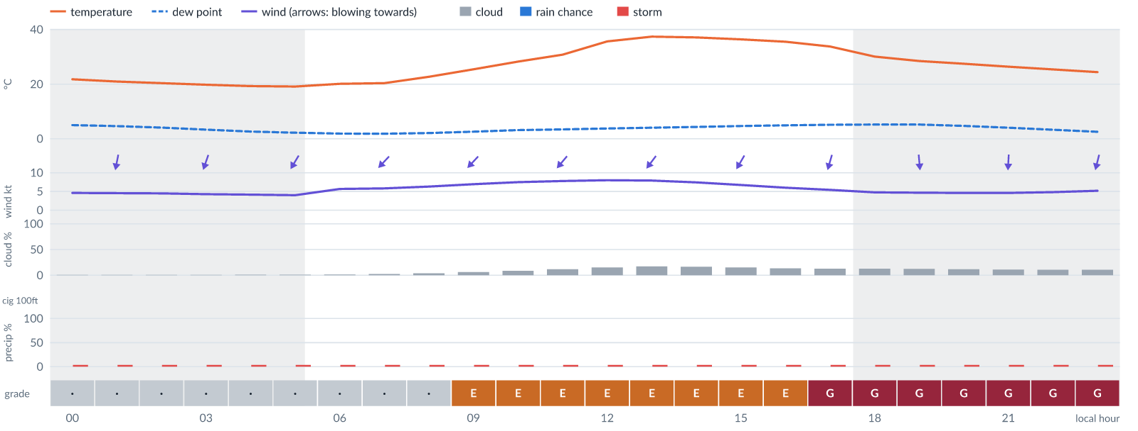
Meteogram — hourly forecast; shaded = before first light / after last light. Gaps mean no data.
Ser | Hrs | Temp | Cloud | Wind | Gust | QNH | Assessment | Driver | Remarks
(a) | (b) | (c) | (d) | (e) | (f) | (g) | (h) | (i) | (j)
1. | 0001 | 22°C | ☀ Clear (0%) | ↓ 5 kts N | 11 kts | 1011 | · - No data | storm 4% · gust 11 kt · visibility not forecast | thunderstorm risk, gusts, wind shear
2. | 0100 | 21°C | ☀ Clear (0%) | ↓ 5 kts NNE | 10 kts | 1011 | · - No data | storm 4% · gust 10 kt · visibility not forecast | thunderstorm risk, gusts, wind shear
3. | 0200 | 20°C | ☀ Clear (0%) | ↓ 4 kts NNE | 9 kts | 1011 | · - No data | storm 4% · gust 9 kt · visibility not forecast | thunderstorm risk, gusts, wind shear
4. | 0300 | 20°C | ☀ Clear (0%) | ↓ 4 kts NNE | 9 kts | 1011 | · - No data | storm 4% · gust 9 kt · visibility not forecast | thunderstorm risk, gusts, wind shear
5. | 0400 | 19°C | ☀ Clear (1%) | ↙ 4 kts NNE | 9 kts | 1012 | · - No data | storm 4% · gust 9 kt · visibility not forecast | thunderstorm risk, gusts, wind shear
6. | 0500 | 19°C | ☀ Clear (1%) | ↙ 4 kts NNE | 9 kts | 1012 | · - No data | storm 4% · gust 9 kt · visibility not forecast | thunderstorm risk, gusts, wind shear
7. | 0600 | 20°C | ☀ Clear (1%) | ↙ 6 kts NE | 10 kts | 1013 | · - No data | storm 4% · gust 10 kt · visibility not forecast | thunderstorm risk, gusts
8. | 0700 | 20°C | ☀ Clear (2%) | ↙ 6 kts NE | 10 kts | 1013 | · - No data | storm 4% · gust 10 kt · visibility not forecast | thunderstorm risk, gusts
9. | 0800 | 23°C | ☀ Clear (4%) | ↙ 6 kts NE | 11 kts | 1013 | · - No data | storm 4% · gust 11 kt · visibility not forecast | thunderstorm risk, gusts, wind shear
10. | 0900 | 25°C | ☀ Clear (6%) | ↙ 7 kts NE | 12 kts | 1013 | E - Poor | gust 12 kt · visibility not forecast | gusts, thunderstorm risk, wind shear
11. | 1000 | 28°C | ☀ Clear (9%) | ↙ 8 kts NE | 13 kts | 1012 | E - Poor | gust 13 kt · visibility not forecast | gusts, thunderstorm risk, wind shear
12. | 1100 | 31°C | ☀ Clear (12%) | ↙ 8 kts NE | 14 kts | 1012 | E - Poor | gust 14 kt · visibility not forecast | gusts, thunderstorm risk, wind shear
13. | 1200 | 36°C | ◔ Mostly clear (15%) | ↙ 8 kts NE | 14 kts | 1011 | E - Poor | gust 14 kt · visibility not forecast | gusts, thunderstorm risk, wind shear
14. | 1300 | 37°C | ◔ Mostly clear (17%) | ↙ 8 kts NE | 14 kts | 1011 | E - Poor | gust 14 kt · visibility not forecast | gusts, thunderstorm risk, wind shear
15. | 1400 | 37°C | ◔ Mostly clear (17%) | ↙ 7 kts NNE | 13 kts | 1011 | E - Poor | gust 13 kt · visibility not forecast | gusts, thunderstorm risk, wind shear
16. | 1500 | 36°C | ◔ Mostly clear (15%) | ↙ 7 kts NNE | 13 kts | 1010 | E - Poor | gust 13 kt · visibility not forecast | gusts, thunderstorm risk, wind shear
17. | 1600 | 35°C | ◔ Mostly clear (14%) | ↙ 6 kts NNE | 14 kts | 1010 | E - Poor | gust 14 kt · gust spread +8 kt · visibility not forecast | gusts, wind shear, thunderstorm risk
18. | 1700 | 34°C | ◔ Mostly clear (13%) | ↓ 5 kts NNE | 15 kts | 1010 | G - Unacceptable | gust spread +9 kt · visibility not forecast | wind shear, gusts, thunderstorm risk
19. | 1800 | 30°C | ◔ Mostly clear (13%) | ↓ 5 kts N | 16 kts | 1010 | G - Unacceptable | gust spread +12 kt · visibility not forecast | wind shear, gusts, thunderstorm risk
20. | 1900 | 28°C | ☀ Clear (12%) | ↓ 5 kts N | 17 kts | 1011 | G - Unacceptable | gust spread +13 kt · visibility not forecast | wind shear, gusts, thunderstorm risk
21. | 2000 | 27°C | ☀ Clear (12%) | ↓ 5 kts N | 17 kts | 1011 | G - Unacceptable | gust spread +13 kt · visibility not forecast | wind shear, gusts, thunderstorm risk
22. | 2100 | 26°C | ☀ Clear (11%) | ↓ 5 kts N | 17 kts | 1011 | G - Unacceptable | gust spread +12 kt · visibility not forecast | wind shear, gusts, thunderstorm risk
23. | 2200 | 25°C | ☀ Clear (11%) | ↓ 5 kts NNE | 16 kts | 1011 | G - Unacceptable | gust spread +11 kt · visibility not forecast | wind shear, gusts, thunderstorm risk
24. | 2300 | 24°C | ☀ Clear (11%) | ↓ 5 kts NNE | 15 kts | 1011 | G - Unacceptable | gust spread +10 kt · visibility not forecast | wind shear, gusts, thunderstorm risk
Confidence: 70% — data for 24 of 24 hours · first light 0543L · last light 1801L · Moon 50 % illuminated, rises 12:22.

Wed 18 Nov 26
Conditions are expected to be generally Poor: mostly clear, winds up to 8 kts NNE, gusting 18 kts and temperatures 19–37°C. No flyable windows (Marginal or better, ≥2 consecutive hrs) are forecast. Hazards: thunderstorm risk 0001–2300L. Overall similar to the previous day.
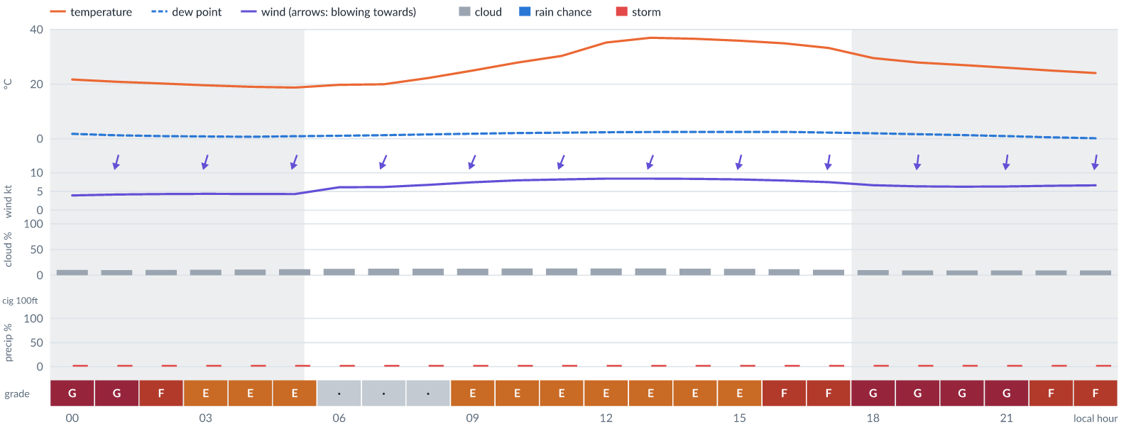
Meteogram — hourly forecast; shaded = before first light / after last light. Gaps mean no data.
Ser | Hrs | Temp | Cloud | Wind | Gust | QNH | Assessment | Driver | Remarks
(a) | (b) | (c) | (d) | (e) | (f) | (g) | (h) | (i) | (j)
1. | 0001 | 22°C | ☀ Clear (10%) | ↓ 4 kts NNE | 14 kts | 1010 | G - Unacceptable | gust spread +10 kt · visibility not forecast | wind shear, gusts, thunderstorm risk
2. | 0100 | 21°C | ☀ Clear (10%) | ↓ 4 kts NNE | 14 kts | 1011 | G - Unacceptable | gust spread +9 kt · visibility not forecast | wind shear, gusts, thunderstorm risk
3. | 0200 | 20°C | ☀ Clear (10%) | ↓ 4 kts NNE | 13 kts | 1011 | F - Very Poor | gust spread +9 kt · visibility not forecast | wind shear, gusts, thunderstorm risk
4. | 0300 | 20°C | ☀ Clear (11%) | ↓ 4 kts NNE | 12 kts | 1011 | E - Poor | gust 12 kt · gust spread +8 kt · visibility not forecast | gusts, wind shear, thunderstorm risk
5. | 0400 | 19°C | ☀ Clear (11%) | ↓ 4 kts NNE | 11 kts | 1011 | E - Poor | gust spread +7 kt · visibility not forecast | wind shear, thunderstorm risk, gusts
6. | 0500 | 19°C | ☀ Clear (12%) | ↓ 4 kts NNE | 11 kts | 1012 | E - Poor | gust spread +6 kt · visibility not forecast | wind shear, thunderstorm risk, gusts
7. | 0600 | 20°C | ☀ Clear (12%) | ↓ 6 kts NNE | 10 kts | 1012 | · - No data | storm 4% · gust 10 kt · visibility not forecast | thunderstorm risk, gusts
8. | 0700 | 20°C | ◔ Mostly clear (13%) | ↙ 6 kts NNE | 10 kts | 1012 | · - No data | storm 4% · gust 10 kt · visibility not forecast | thunderstorm risk, gusts
9. | 0800 | 22°C | ◔ Mostly clear (13%) | ↙ 7 kts NNE | 10 kts | 1013 | · - No data | storm 4% · gust 10 kt · visibility not forecast | thunderstorm risk, gusts
10. | 0900 | 25°C | ◔ Mostly clear (13%) | ↙ 7 kts NNE | 12 kts | 1013 | E - Poor | gust 12 kt · visibility not forecast | gusts, thunderstorm risk, wind shear
11. | 1000 | 28°C | ◔ Mostly clear (13%) | ↙ 8 kts NNE | 13 kts | 1012 | E - Poor | gust 13 kt · visibility not forecast | gusts, thunderstorm risk, wind shear
12. | 1100 | 30°C | ◔ Mostly clear (13%) | ↓ 8 kts NNE | 14 kts | 1012 | E - Poor | gust 14 kt · visibility not forecast | gusts, thunderstorm risk, wind shear
13. | 1200 | 35°C | ◔ Mostly clear (13%) | ↓ 8 kts NNE | 14 kts | 1011 | E - Poor | gust 14 kt · visibility not forecast | gusts, thunderstorm risk, wind shear
14. | 1300 | 37°C | ◔ Mostly clear (13%) | ↓ 8 kts NNE | 14 kts | 1011 | E - Poor | gust 14 kt · visibility not forecast | gusts, thunderstorm risk, wind shear
15. | 1400 | 37°C | ◔ Mostly clear (13%) | ↓ 8 kts NNE | 14 kts | 1010 | E - Poor | gust 14 kt · visibility not forecast | gusts, thunderstorm risk, wind shear
16. | 1500 | 36°C | ☀ Clear (12%) | ↓ 8 kts NNE | 14 kts | 1010 | E - Poor | gust 14 kt · visibility not forecast | gusts, thunderstorm risk, wind shear
17. | 1600 | 35°C | ☀ Clear (12%) | ↓ 8 kts N | 15 kts | 1010 | F - Very Poor | gust 15 kt · visibility not forecast | gusts, wind shear, thunderstorm risk
18. | 1700 | 33°C | ☀ Clear (11%) | ↓ 7 kts N | 16 kts | 1010 | F - Very Poor | gust 16 kt · gust spread +8 kt · visibility not forecast | gusts, wind shear, thunderstorm risk
19. | 1800 | 30°C | ☀ Clear (10%) | ↓ 7 kts N | 17 kts | 1011 | G - Unacceptable | gust spread +10 kt · visibility not forecast | wind shear, gusts, thunderstorm risk
20. | 1900 | 28°C | ☀ Clear (9%) | ↓ 6 kts N | 18 kts | 1011 | G - Unacceptable | gust 18 kt · gust spread +11 kt · visibility not forecast | gusts, wind shear, thunderstorm risk
21. | 2000 | 27°C | ☀ Clear (9%) | ↓ 6 kts N | 18 kts | 1011 | G - Unacceptable | gust 18 kt · gust spread +11 kt · visibility not forecast | gusts, wind shear, thunderstorm risk
22. | 2100 | 26°C | ☀ Clear (9%) | ↓ 6 kts N | 17 kts | 1011 | G - Unacceptable | gust spread +11 kt · visibility not forecast | wind shear, gusts, thunderstorm risk
23. | 2200 | 25°C | ☀ Clear (9%) | ↓ 7 kts N | 16 kts | 1011 | F - Very Poor | gust 16 kt · gust spread +10 kt · visibility not forecast | gusts, wind shear, thunderstorm risk
24. | 2300 | 24°C | ☀ Clear (9%) | ↓ 7 kts N | 15 kts | 1011 | F - Very Poor | gust 15 kt · visibility not forecast | gusts, wind shear, thunderstorm risk
Confidence: 69% — data for 24 of 24 hours · first light 0543L · last light 1801L · Moon 60 % illuminated, rises 12:59, sets 00:21.

Thu 19 Nov 26
Conditions are expected to be generally Poor: mostly clear, winds up to 7 kts NNE, gusting 15 kts and temperatures 18–37°C. No flyable windows (Marginal or better, ≥2 consecutive hrs) are forecast. Hazards: thunderstorm risk 0001–2300L. Overall similar to the previous day.
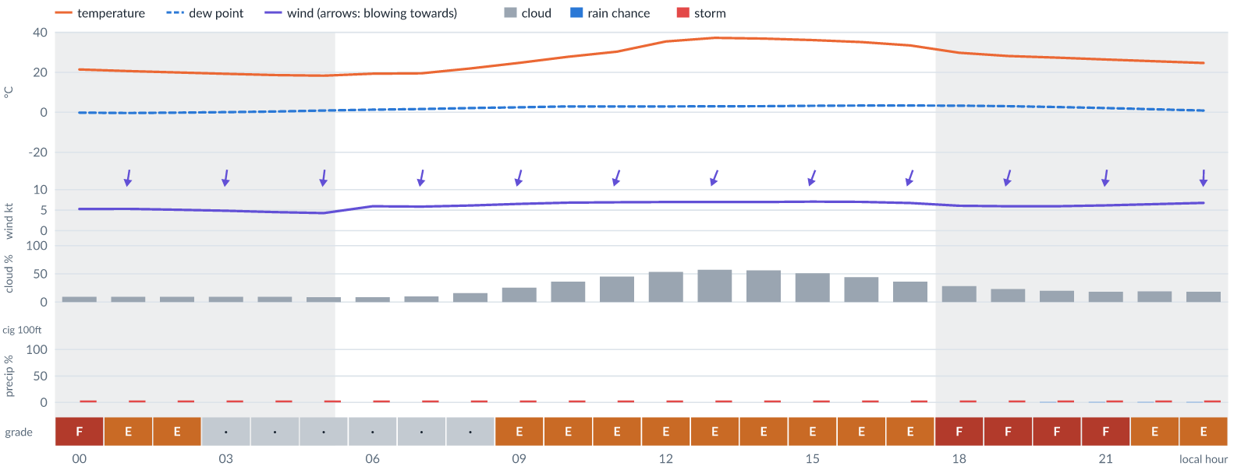
Meteogram — hourly forecast; shaded = before first light / after last light. Gaps mean no data.
Ser | Hrs | Temp | Cloud | Wind | Gust | QNH | Assessment | Driver | Remarks
(a) | (b) | (c) | (d) | (e) | (f) | (g) | (h) | (i) | (j)
1. | 0001 | 21°C | ☀ Clear (9%) | ↓ 5 kts N | 14 kts | 1011 | F - Very Poor | gust spread +9 kt · visibility not forecast | wind shear, gusts, thunderstorm risk
2. | 0100 | 21°C | ☀ Clear (9%) | ↓ 5 kts N | 13 kts | 1011 | E - Poor | gust 13 kt · gust spread +7 kt · visibility not forecast | gusts, wind shear, thunderstorm risk
3. | 0200 | 20°C | ☀ Clear (9%) | ↓ 5 kts N | 12 kts | 1011 | E - Poor | gust 12 kt · gust spread +7 kt · visibility not forecast | gusts, wind shear, thunderstorm risk
4. | 0300 | 19°C | ☀ Clear (9%) | ↓ 5 kts N | 11 kts | 1011 | · - No data | storm 4% · gust 11 kt · visibility not forecast | thunderstorm risk, gusts, wind shear
5. | 0400 | 19°C | ☀ Clear (9%) | ↓ 5 kts N | 10 kts | 1012 | · - No data | storm 4% · gust 10 kt · visibility not forecast | thunderstorm risk, gusts, wind shear
6. | 0500 | 18°C | ☀ Clear (9%) | ↓ 4 kts N | 9 kts | 1012 | · - No data | storm 4% · gust 9 kt · visibility not forecast | thunderstorm risk, gusts, wind shear
7. | 0600 | 19°C | ☀ Clear (9%) | ↓ 6 kts N | 10 kts | 1012 | · - No data | storm 4% · gust 10 kt · visibility not forecast | thunderstorm risk, gusts
8. | 0700 | 20°C | ☀ Clear (10%) | ↓ 6 kts N | 10 kts | 1013 | · - No data | storm 4% · gust 10 kt · visibility not forecast | thunderstorm risk, gusts
9. | 0800 | 22°C | ◔ Mostly clear (16%) | ↓ 6 kts NNE | 11 kts | 1013 | · - No data | storm 4% · gust 11 kt · visibility not forecast | thunderstorm risk, gusts, wind shear
10. | 0900 | 25°C | ◔ Mostly clear (25%) | ↓ 7 kts NNE | 12 kts | 1013 | E - Poor | gust 12 kt · visibility not forecast | gusts, thunderstorm risk, wind shear
11. | 1000 | 28°C | ◔ Partly cloudy (36%) | ↓ 7 kts NNE | 13 kts | 1013 | E - Poor | gust 13 kt · visibility not forecast | gusts, thunderstorm risk, wind shear
12. | 1100 | 30°C | ◑ Partly cloudy (45%) | ↓ 7 kts NNE | 13 kts | 1012 | E - Poor | gust 13 kt · visibility not forecast | gusts, cloud cover, thunderstorm risk, wind shear
13. | 1200 | 35°C | ◑ Partly cloudy (53%) | ↓ 7 kts NNE | 13 kts | 1012 | E - Poor | cloud 53% · gust 13 kt · visibility not forecast | cloud cover, gusts, thunderstorm risk, wind shear
14. | 1300 | 37°C | ◑ Partly cloudy (57%) | ↓ 7 kts NNE | 13 kts | 1011 | E - Poor | cloud 57% · gust 13 kt · visibility not forecast | cloud cover, gusts, thunderstorm risk, wind shear
15. | 1400 | 37°C | ◑ Partly cloudy (56%) | ↓ 7 kts NNE | 13 kts | 1011 | E - Poor | cloud 56% · gust 13 kt · visibility not forecast | cloud cover, gusts, thunderstorm risk, wind shear
16. | 1500 | 36°C | ◑ Partly cloudy (51%) | ↓ 7 kts NNE | 13 kts | 1011 | E - Poor | gust 13 kt · visibility not forecast | gusts, cloud cover, thunderstorm risk, wind shear
17. | 1600 | 35°C | ◑ Partly cloudy (44%) | ↓ 7 kts NNE | 13 kts | 1011 | E - Poor | gust 13 kt · visibility not forecast | gusts, cloud cover, thunderstorm risk, wind shear
18. | 1700 | 33°C | ◔ Partly cloudy (36%) | ↓ 7 kts NNE | 13 kts | 1011 | E - Poor | gust 13 kt · visibility not forecast | gusts, thunderstorm risk, wind shear
19. | 1800 | 30°C | ◔ Mostly clear (28%) | ↓ 6 kts NNE | 15 kts | 1011 | F - Very Poor | gust 15 kt · gust spread +8 kt · visibility not forecast | gusts, wind shear, thunderstorm risk
20. | 1900 | 28°C | ◔ Mostly clear (23%) | ↓ 6 kts NNE | 15 kts | 1011 | F - Very Poor | gust 15 kt · gust spread +10 kt · visibility not forecast | gusts, wind shear, thunderstorm risk
21. | 2000 | 27°C | ◔ Mostly clear (20%) | ↓ 6 kts N | 15 kts | 1011 | F - Very Poor | gust 15 kt · gust spread +10 kt · visibility not forecast | gusts, wind shear, thunderstorm risk
22. | 2100 | 26°C | ◔ Mostly clear (19%) | ↓ 6 kts N | 15 kts | 1012 | F - Very Poor | gust 15 kt · gust spread +9 kt · visibility not forecast | gusts, wind shear, thunderstorm risk
23. | 2200 | 26°C | ◔ Mostly clear (19%) | ↓ 6 kts N | 14 kts | 1012 | E - Poor | gust 14 kt · gust spread +8 kt · visibility not forecast | gusts, wind shear, thunderstorm risk
24. | 2300 | 25°C | ◔ Mostly clear (19%) | ↓ 7 kts N | 14 kts | 1012 | E - Poor | gust 14 kt · gust spread +7 kt · visibility not forecast | gusts, wind shear, thunderstorm risk
Confidence: 70% — data for 24 of 24 hours · first light 0544L · last light 1801L · Moon 69 % illuminated, rises 13:37, sets 01:09.

Fri 20 Nov 26
Conditions are expected to be generally Poor: partly cloudy, winds up to 7 kts NNE, gusting 16 kts and temperatures 19–38°C. No flyable windows (Marginal or better, ≥2 consecutive hrs) are forecast. Hazards: thunderstorm risk 0001–2300L. Overall similar to the previous day.
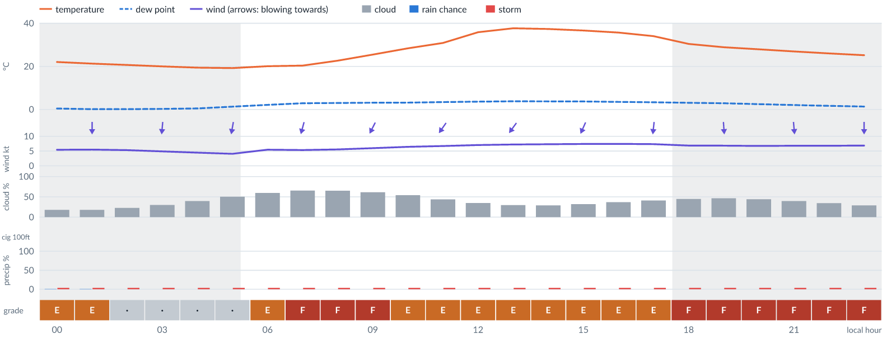
Meteogram — hourly forecast; shaded = before first light / after last light. Gaps mean no data.
Ser | Hrs | Temp | Cloud | Wind | Gust | QNH | Assessment | Driver | Remarks
(a) | (b) | (c) | (d) | (e) | (f) | (g) | (h) | (i) | (j)
1. | 0001 | 22°C | ◔ Mostly clear (18%) | ↓ 5 kts N | 13 kts | 1012 | E - Poor | gust 13 kt · gust spread +8 kt · visibility not forecast | gusts, wind shear, thunderstorm risk
2. | 0100 | 21°C | ◔ Mostly clear (18%) | ↓ 5 kts N | 12 kts | 1012 | E - Poor | gust 12 kt · gust spread +7 kt · visibility not forecast | gusts, wind shear, thunderstorm risk
3. | 0200 | 21°C | ◔ Mostly clear (23%) | ↓ 5 kts N | 11 kts | 1012 | · - No data | storm 4% · gust 11 kt · visibility not forecast | thunderstorm risk, gusts, wind shear
4. | 0300 | 20°C | ◔ Mostly clear (30%) | ↓ 5 kts N | 11 kts | 1012 | · - No data | storm 4% · gust 11 kt · visibility not forecast | thunderstorm risk, gusts, wind shear
5. | 0400 | 19°C | ◑ Partly cloudy (40%) | ↓ 4 kts N | 10 kts | 1012 | · - No data | storm 4% · gust 10 kt · visibility not forecast | thunderstorm risk, gusts, wind shear
6. | 0500 | 19°C | ◑ Partly cloudy (50%) | ↓ 4 kts N | 10 kts | 1013 | · - No data | storm 4% · cloud 50% · visibility not forecast | cloud cover, thunderstorm risk, gusts, wind shear
7. | 0600 | 20°C | ◑ Partly cloudy (59%) | ↓ 5 kts NNE | 10 kts | 1013 | E - Poor | cloud 59% · visibility not forecast | cloud cover, thunderstorm risk, gusts, wind shear
8. | 0700 | 20°C | ◕ Cloudy (65%) | ↓ 5 kts NNE | 10 kts | 1013 | F - Very Poor | cloud 65% · visibility not forecast | cloud cover, thunderstorm risk, gusts, wind shear
9. | 0800 | 23°C | ◕ Cloudy (65%) | ↓ 6 kts NNE | 11 kts | 1014 | F - Very Poor | cloud 65% · visibility not forecast | cloud cover, thunderstorm risk, gusts, wind shear
10. | 0900 | 25°C | ◑ Cloudy (61%) | ↙ 6 kts NNE | 11 kts | 1014 | F - Very Poor | cloud 61% · visibility not forecast | cloud cover, thunderstorm risk, gusts, wind shear
11. | 1000 | 28°C | ◑ Partly cloudy (54%) | ↙ 6 kts NNE | 12 kts | 1013 | E - Poor | cloud 54% · gust 12 kt · visibility not forecast | cloud cover, gusts, thunderstorm risk, wind shear
12. | 1100 | 31°C | ◑ Partly cloudy (44%) | ↙ 7 kts NE | 12 kts | 1013 | E - Poor | gust 12 kt · visibility not forecast | gusts, cloud cover, thunderstorm risk, wind shear
13. | 1200 | 36°C | ◔ Partly cloudy (35%) | ↙ 7 kts NE | 12 kts | 1012 | E - Poor | gust 12 kt · visibility not forecast | gusts, thunderstorm risk, wind shear
14. | 1300 | 38°C | ◔ Mostly clear (30%) | ↙ 7 kts NE | 12 kts | 1012 | E - Poor | gust 12 kt · visibility not forecast | gusts, thunderstorm risk, wind shear
15. | 1400 | 37°C | ◔ Mostly clear (29%) | ↙ 7 kts NNE | 13 kts | 1012 | E - Poor | gust 13 kt · visibility not forecast | gusts, thunderstorm risk, wind shear
16. | 1500 | 37°C | ◔ Mostly clear (32%) | ↙ 7 kts NNE | 13 kts | 1012 | E - Poor | gust 13 kt · visibility not forecast | gusts, thunderstorm risk, wind shear
17. | 1600 | 36°C | ◔ Partly cloudy (37%) | ↓ 7 kts NNE | 13 kts | 1011 | E - Poor | gust 13 kt · visibility not forecast | gusts, thunderstorm risk, wind shear
18. | 1700 | 34°C | ◑ Partly cloudy (41%) | ↓ 7 kts N | 13 kts | 1011 | E - Poor | gust 13 kt · visibility not forecast | gusts, thunderstorm risk, wind shear
19. | 1800 | 30°C | ◑ Partly cloudy (45%) | ↓ 7 kts N | 15 kts | 1012 | F - Very Poor | gust 15 kt · visibility not forecast | gusts, wind shear, cloud cover, thunderstorm risk
20. | 1900 | 29°C | ◑ Partly cloudy (47%) | ↓ 7 kts N | 16 kts | 1012 | F - Very Poor | gust 16 kt · gust spread +9 kt · visibility not forecast | gusts, wind shear, cloud cover, thunderstorm risk
21. | 2000 | 28°C | ◑ Partly cloudy (44%) | ↓ 7 kts N | 16 kts | 1012 | F - Very Poor | gust 16 kt · gust spread +9 kt · visibility not forecast | gusts, wind shear, cloud cover, thunderstorm risk
22. | 2100 | 27°C | ◑ Partly cloudy (40%) | ↓ 7 kts N | 15 kts | 1012 | F - Very Poor | gust 15 kt · visibility not forecast | gusts, wind shear, thunderstorm risk
23. | 2200 | 26°C | ◔ Partly cloudy (35%) | ↓ 7 kts N | 15 kts | 1013 | F - Very Poor | gust 15 kt · visibility not forecast | gusts, wind shear, thunderstorm risk
24. | 2300 | 25°C | ◔ Mostly clear (29%) | ↓ 7 kts N | 15 kts | 1013 | F - Very Poor | gust 15 kt · visibility not forecast | gusts, wind shear, thunderstorm risk
Confidence: 70% — data for 24 of 24 hours · first light 0544L · last light 1802L · Moon 79 % illuminated, rises 14:16, sets 01:57.

TAF
No current TAF — last issued 4 Nov 05:00Z, expired 5 Nov 12:00Z

Imagery

Dust RGB (pink/magenta = airborne dust) — captured 7 Nov 01:18 WAT (5 min ago) · ©EUMETSAT (screenshot via EUMETView)

Convection RGB (yellow = vigorous storms) — captured 7 Nov 01:18 WAT (5 min ago) · ©EUMETSAT (screenshot via EUMETView)
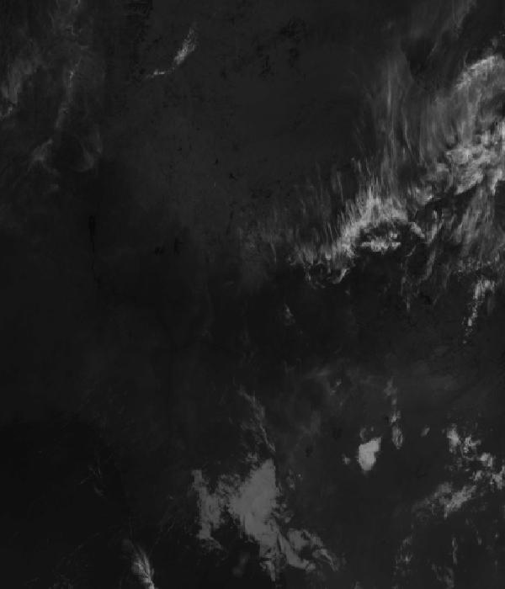
Infrared 10.5 µm (cold tops = deep cloud) — captured 7 Nov 01:18 WAT (5 min ago) · ©EUMETSAT (screenshot via EUMETView)

Accumulated lightning flash area (MTG-LI) — captured 7 Nov 01:18 WAT (5 min ago) · ©EUMETSAT (screenshot via EUMETView)

Source panel
Source | Accuracy | Skill n | Temp °C | Wind kt | Visibility | Storm
(a) | (b) | (c) | (d) | (e) | (f) | (g)
Met.no (Yr) | ▲ 1.2 | 3264 | 23–25 | 1–5 | — | 0 %
Open-Meteo | ≈ 1.0 | 9391 | 23–25 | 1–4 | 10+ km | 0 %
OpenWeather | ≈ 1.0 | 1555 | 25 | 4–5 | 10+ km | 0 %
Tomorrow.io | ▲ 1.2 | 4197 | 23–25 | 1–5 | 10+ km | 0 %
Visual Crossing | ▽ 1.0 | 7937 | 21–23 | 3–6 | 10+ km | 0 %
Each source's own raw values, min–max over the next 6 hours from the issue hour (before any weighting or bias correction). — means the source does not publish that metric in the window. Wide gaps between rows are real disagreement; the forecast above weights sources by measured skill.

Reading this report
Grades: each hour carries one grade, set by its WORST factor. The bands below are the thresholds in force for this report (Settings); a value in a band earns that grade, and "-" means the factor never produces that grade. Cloud is graded on the worse of cover and ceiling. The Driver column names the limiting factor with its value; open it in the web report for the boundary and sources.
Grade | Cloud cover | Cloud ceiling | Visibility | Wind | Gust | Rain chance | Thunderstorm probability
(a) | (b) | (c) | (d) | (e) | (f) | (g) | (h)
A Excellent | ≤ 17.1% | ≥ 30000 ft | ≥ 8000 m | < 3 kt | < 3 kt | < 5% | 0%
B Good | 17.1–34.3% | 26000–30000 ft | 6666.7–8000 m | 3–6 kt | 3–6 kt | 5–10% | -
C Fair | 34.3–42.9% | 24000–26000 ft | 5333.3–6666.7 m | 6–9 kt | 6–9 kt | 10–15% | -
D Marginal | 42.9–51.4% | 22000–24000 ft | 4000–5333.3 m | 9–12 kt | 9–12 kt | 15–20% | >0–15%
E Poor | 51.4–60% | 16000–22000 ft | 2666.7–4000 m | 12–15 kt | 12–15 kt | 20–25% | 15–30%
F Very Poor | 60–68.6% | 10000–16000 ft | 1333.3–2666.7 m | 15–18 kt | 15–18 kt | 25–30% | 30–60%
G Unacceptable | > 68.6% | < 10000 ft | < 1333.3 m | ≥ 18 kt | ≥ 18 kt | ≥ 30% | > 60%
Flight windows: a window is at least 2 consecutive hours graded Marginal or better; an hour with insufficient data never counts toward one. ☾ marks a window outside first-to-last light.
Time: hours are local time (WAT, UTC+1) unless suffixed Z, which is UTC (TAF, METAR and issue times). Local midnight is labelled 0001.
Units: temperature °C · wind and gusts knots · visibility metres (km in text) · cloud ceiling feet · cloud cover % · rain chance and thunderstorm probability % · QNH hPa (altimeter setting at the field) · CAPE J/kg. A figure like "28 (26–30)°C" gives the p10–p90 range; "spread" marks disagreement between sources.
Symbols: ▲ better than the pool · ▽ worse (only when the 95% interval excludes the pool) · ≈ not distinguishable from the pool · unmarked = unproven (accuracy is measured against METAR and SYNOP observations). ⚠ on a remark means a low-confidence hour; a ⚠ paragraph on the first page is a convective-warning or data-age advisory. ⚡ is lightning observed by satellite near the field (©EUMETSAT).
Hourly glyphs: the wind arrow points the way the air moves (a north wind is ↓, an east wind ←); cloud cover shows as ☀ ◔ ◑ ◕ ☁ (clear, few, scattered, broken, overcast); a shaded hour label is wholly before first light or after last light.
Terms: "No data" - no source forecast the hour, or a core group (cloud, visibility, wind) is missing and the hour could still be flyable; missing data is never given a good grade. "Low-confidence" - few or weak sources behind the load-bearing metrics; treat the grade as indicative. "Insufficient data" - too little to grade at all. "Estimated" (est.) - the value is derived, not reported by a source (dust visibility, cloud base, gusts); it is declared where used and weighted at half. "Derived" - an hour interpolated from a coarser (3-hourly or daily) source, weighted at half and never used to score accuracy.

Data provenance
Source | Fetched (Z) | Age | Skill n | Accuracy
(a) | (b) | (c) | (d) | (e)
Aviation Weather Center (aviationweather.gov) | 7 Nov 00:19Z | 4 min | 1255 | ≈ 1.0
Foreca | 7 Nov 00:19Z | 5 min | 302 | ▽ 0.8
Met.no (Yr) | 7 Nov 00:20Z | 3 min | 3264 | ▲ 1.2
Open-Meteo | 7 Nov 00:18Z | 5 min | 9391 | ≈ 1.0
OpenWeather | 7 Nov 00:20Z | 3 min | 1555 | ≈ 1.0
Tomorrow.io | 7 Nov 00:19Z | 4 min | 4197 | ▲ 1.2
Visual Crossing | 7 Nov 00:19Z | 5 min | 7937 | ▽ 1.0
Corrections applied (detailed under Learned corrections on the first page): skill weighting, bias correction, hour-of-day bias, cloud-base estimate, probability calibration, climatology bounds, skill blend.

How accurate have we been
Measured against observations (METAR/SYNOP), maiduguri only. Verification table computed 2026-11-06. Mean absolute error (MAE): lower is better; "beats persistence" compares the best source with "it will stay as it is now" on the same hours.
Metric | Best source | Best MAE | Typical MAE | Persistence MAE | Beats persistence by | Pairs
(a) | (b) | (c) | (d) | (e) | (f) | (g)
Temperature (°C) | meteoblue | 1.5 | 2.4 | 5.3 | 82 % | 1561
Dew point (°C) | aifs | 1.7 | 6.5 | 2.6 | 45 % | 235
Wind speed (kt) | aifs | 1.6 | 3.2 | 2.7 | 48 % | 152
Visibility (m) | ukmo | 513 | 684 | 1315 | 62 % | 1483
Cloud cover (%) | accuweather | 10 | 57 | 9 | - | 27
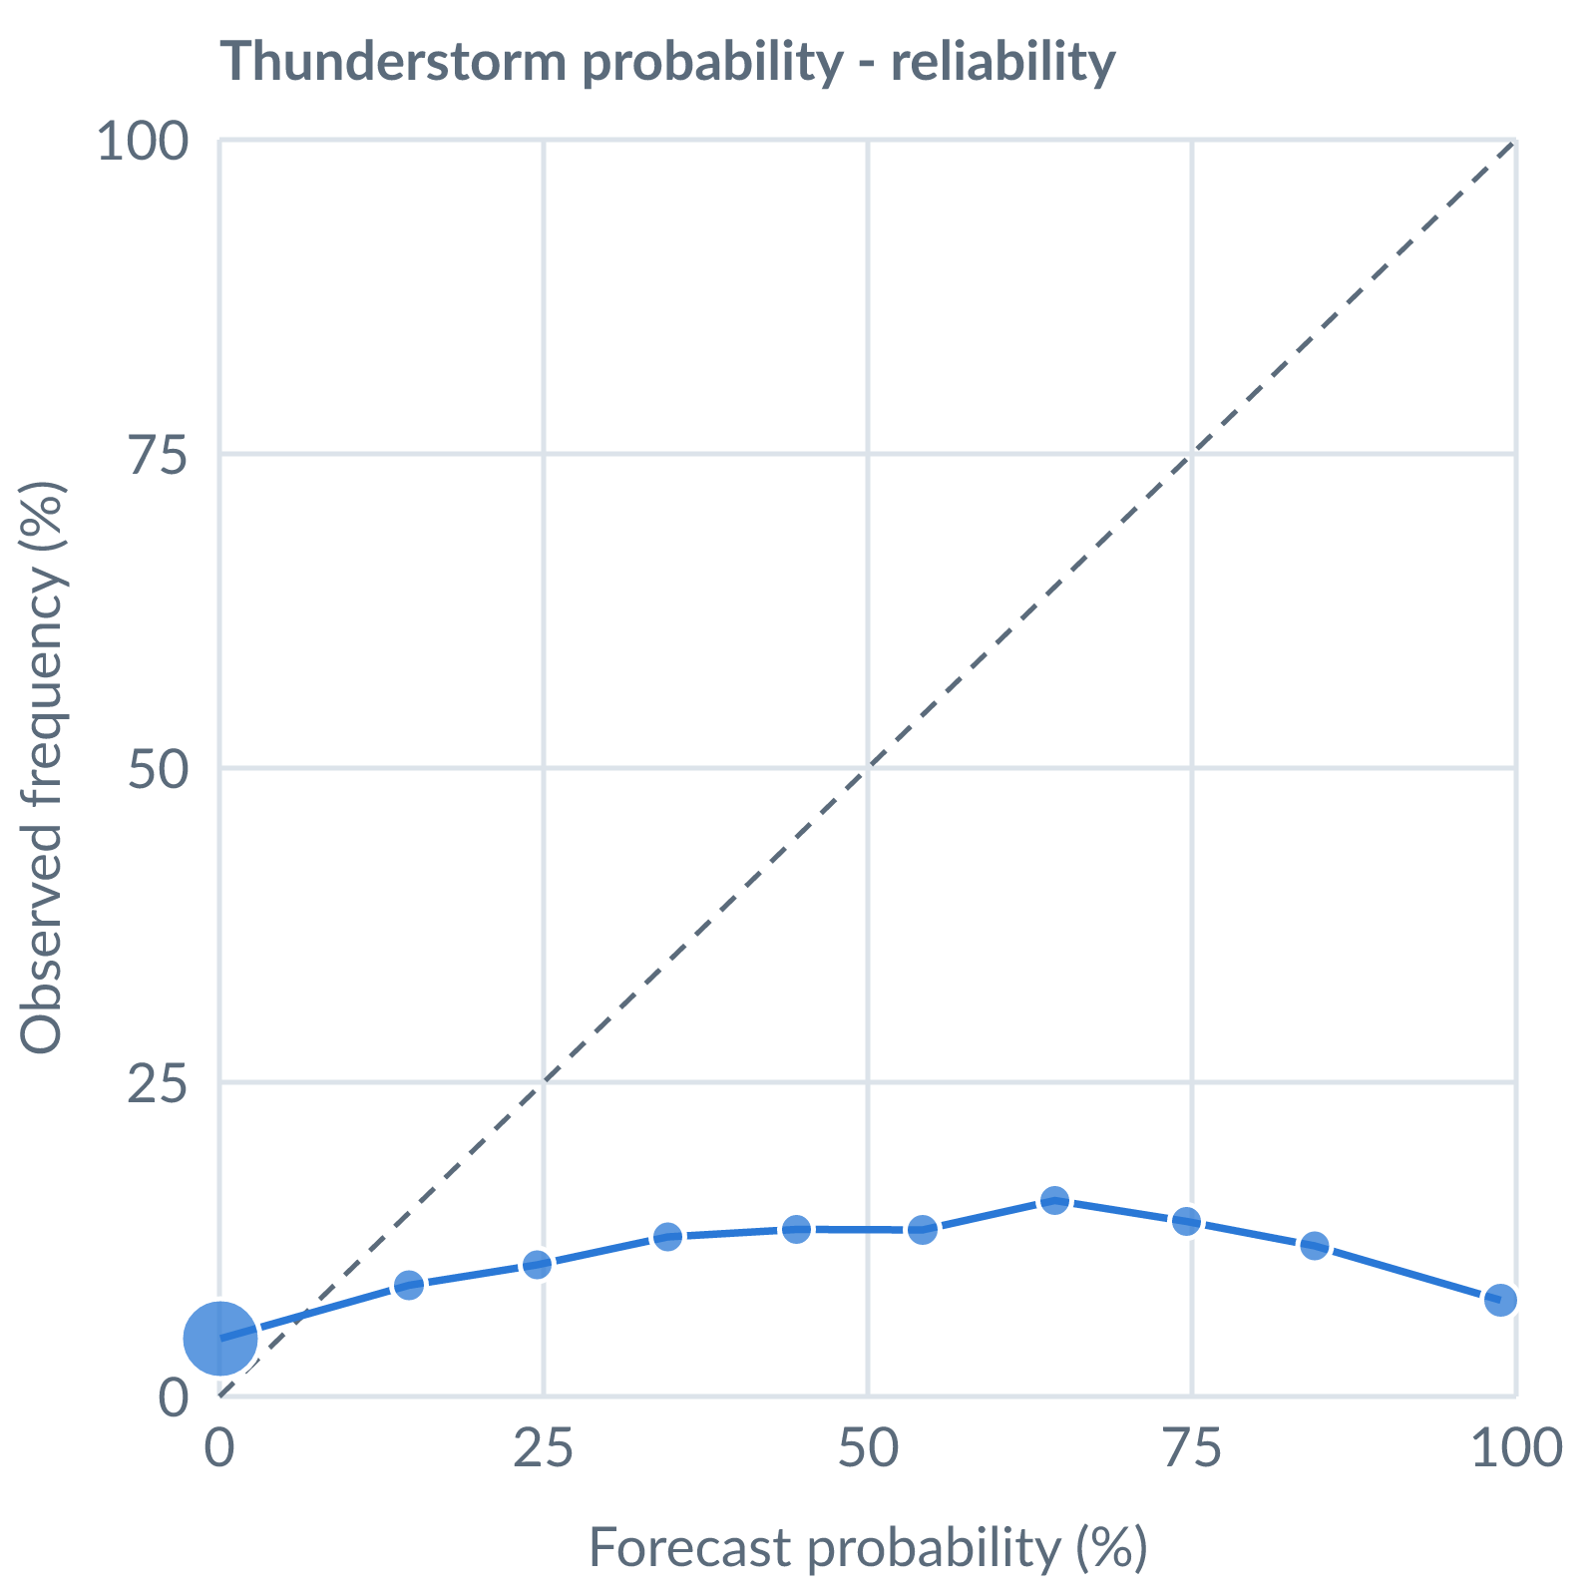
Thunderstorm probability: dots on the dashed line mean a stated probability matched how often it happened (164538 pairs, all places pooled).
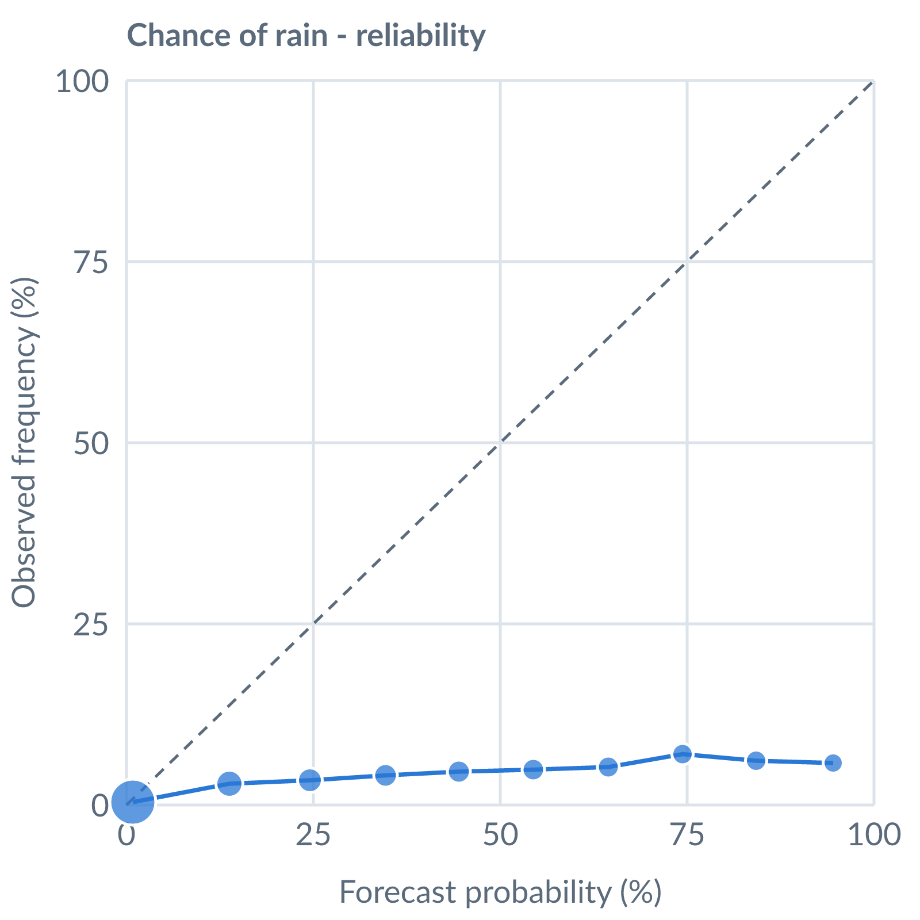
Chance of rain: dots on the dashed line mean a stated probability matched how often it happened (153642 pairs, all places pooled).
Learned bias (forecast minus observed; positive = sources run high), mean over scored sources, by local time of day. These are corrected for before sources are averaged.
Metric | Overall | Night | Morning | Afternoon | Evening | Pairs
(a) | (b) | (c) | (d) | (e) | (f) | (g)
Temperature (°C) | +0.9 | +2.2 | +1.6 | -0.6 | +0.7 | 30780
Dew point (°C) | -6.3 | -6.9 | -5.8 | -6.1 | -6.4 | 26227
Wind speed (kt) | +0.0 | +0.9 | -0.5 | +0.3 | -0.2 | 17665
Not yet available: Scores are decayed over the verification window (half-life 14 days); separate last-7-day and last-30-day windows are not stored. Bias is the current learned value; the history needed for a trend over time is not stored. Flight-window hit / bust / miss is not yet recorded.

