Kaduna — 14-Day Forecast
DNKA · issued 7 Nov 26 00:23Z
Sources: Aviation Weather Center (aviationweather.gov) ≈ 1.0 · Foreca ≈ 1.1 · Met.no (Yr) ≈ 1.0 · Open-Meteo ≈ 1.0 · OpenWeather ≈ 1.0 · Tomorrow.io ▲ 1.1 · Visual Crossing ≈ 1.1
▲ better than the pool · ▽ worse (only when the 95% interval excludes the pool) · ≈ not distinguishable from the pool · unmarked = unproven (accuracy is measured against METAR and SYNOP observations)
Day | 00 | 01 | 02 | 03 | 04 | 05 | 06 | 07 | 08 | 09 | 10 | 11 | 12 | 13 | 14 | 15 | 16 | 17 | 18 | 19 | 20 | 21 | 22 | 23 | Flyable Windows | Conf
Sat 7 Nov 26 | G | G | G | G | G | G | G | G | G | G | G | G | G | G | G | G | E | D | D | D | D | D | D | D | 1700–2300L (Marginal, 7 h) ☾ | 74%
Sun 8 Nov 26 | D | D | D | D | D | D | D | D | D | D | D | D | D | E | E | E | E | E | D | D | D | D | D | D | best window: 0001–1200L (Marginal, 13 h) ☾ · 1800–2300L (Marginal, 6 h) ☾ | 78%
Mon 9 Nov 26 | E | F | G | F | D | D | D | D | E | D | D | D | E | F | F | F | F | F | D | D | E | E | E | E | 0400–0700L (Marginal, 4 h) ☾ · 0900–1100L (Marginal, 3 h) · 1800–1900L (Marginal, 2 h) ☾ | 74%
Tue 10 Nov 26 | D | D | D | D | D | D | D | G | G | E | E | F | F | G | G | G | G | G | G | G | G | E | E | G | 0001–0600L (Marginal, 7 h) ☾ | 73%
Wed 11 Nov 26 | G | G | G | G | G | G | G | G | G | G | G | G | G | G | G | G | G | F | E | E | E | E | D | D | 2200–2300L (Marginal, 2 h) ☾ | 73%
Thu 12 Nov 26 | D | D | · | · | · | · | E | E | F | E | F | G | G | G | G | G | F | F | G | G | G | F | E | E | 0001–0100L (Marginal, 2 h) ☾ | 70%
Fri 13 Nov 26 | F | G | G | G | G | G | G | G | G | G | G | G | G | G | G | G | F | F | G | G | G | G | F | F | no windows | 70%
Sat 14 Nov 26 | E | E | · | · | · | · | · | · | · | E | E | F | G | G | G | G | G | G | G | G | G | G | G | F | no windows | 71%
Sun 15 Nov 26 | F | E | E | E | E | E | E | E | E | E | F | F | F | F | F | F | E | E | E | E | E | E | E | · | no windows | 71%
Mon 16 Nov 26 | · | · | · | · | · | · | · | · | · | · | · | E | E | E | E | E | E | E | G | F | F | F | E | E | no windows | 70%
Tue 17 Nov 26 | E | · | · | · | · | · | · | · | · | E | E | F | E | E | E | E | E | E | E | E | E | E | E | · | no windows | 70%
Wed 18 Nov 26 | · | · | · | · | · | · | · | · | E | E | E | F | F | F | F | F | F | F | F | F | F | F | F | E | no windows | 70%
Thu 19 Nov 26 | E | E | E | E | E | E | E | E | E | F | G | G | G | G | G | G | E | E | E | E | E | E | D | D | 2200–2300L (Marginal, 2 h) ☾ | 69%
Fri 20 Nov 26 | E | E | D | D | E | G | G | G | G | G | E | E | E | E | E | E | E | E | D | E | E | E | E | F | 0200–0300L (Marginal, 2 h) ☾ | 68%
A Excellent · B Good · C Fair · D Marginal · E Poor · F Very Poor · G Unacceptable · · No data
Best window (highest confidence, then grade, then length): Sun 8 Nov 26 0001–1200L (Marginal, 13 h) ☾, confidence 78%.
Learned corrections (METAR-verified): skill weighting — pooled all-field scores for 206; bias corrections — jma wind +3.3 kt, metcheck wind +3.1 kt, meteoblue QNH −3.0 hPa, Met.no (Yr) QNH −3.0 hPa, OpenWeather dewpoint +3.0 °C, OpenWeather QNH −3.0 hPa (+67 more); hour-of-day bias (local time, shrunk toward the all-hours bias) — jma afternoon wind +4.0 kt, metcheck afternoon wind +3.8 kt, meteoblue afternoon wind +3.4 kt, metcheck evening wind +3.1 kt, meteoblue evening wind +3.0 kt, meteoblue afternoon QNH −3.0 hPa (+284 more); cloud base estimated as 410 ft per °C of dewpoint spread for sources that report no ceiling (≥60% cloud cover; flagged estimated, weighted ×0.5); probability calibration — rain chance: meteoblue, Open-Meteo, Foreca, metcheck, OpenWeather, Visual Crossing, Tomorrow.io, wttrin, ecmwf, gfs, icon, ukmo, gem, ecmwfens; storm: Open-Meteo, Met.no (Yr), Foreca, OpenWeather, Visual Crossing, Tomorrow.io, wttrin, ecmwf, gfs, icon, meteofrance, Aviation Weather Center (aviationweather.gov), ukmo, jma, gem, ecmwfens, aifs (each source's stated probability mapped to its verified frequency by an isotonic fit on ≥200 pairs, proven on the holdout); plausibility bounds from ERA5 climatology 2016-2025 (mean ± 5 sd; screening only, not observed truth); skill blend 1 auto-tuned over 9222 holdout pairs (consensus beat the best single source, icon, by 13%); correction gates (newest-7-day holdout; pooled skill is always on) — regional skill: off this week (did not improve holdout); place skill: off this week (did not improve holdout); lead-time skill: off this week (did not improve holdout); small-sample skill shrinkage: off this week (did not improve holdout); bias correction: on (improved holdout by 25.6%); place bias: on (improved holdout by 10.9%); hour-of-day bias: on (improved holdout by 7.0%); QNH bias: on (improved holdout by 57.4%); gust estimates: off this week (did not improve holdout); cloud-base coefficient: off this week (insufficient holdout: 79 of 200 items); recent-form skill: off this week (did not improve holdout); probability calibration: on (improved holdout by 36.3%); nowcast anchor horizon: off this week (did not improve holdout); dust-visibility estimate: off this week (did not improve holdout); fog risk: off this week (did not improve holdout).

Outlook
Day | Date | Outlook | Temp | Max wind | Flight windows | Confidence | Notes
(a) | (b) | (c) | (d) | (e) | (f) | (g) | (h)
Sat | 7 Nov 26 | Unacceptable | 19–35°C | 8 kts NE, g 13 | 1700–2300L (Marginal, 7 h) ☾ | 74% | 8% interpolated
Sun | 8 Nov 26 | Marginal | 20–36°C | 8 kts ENE, g 13 | 0001–1200L (Marginal, 13 h) ☾; 1800–2300L (Marginal, 6 h) ☾ | 78% | 10% interpolated
Mon | 9 Nov 26 | Marginal | 21–36°C | 10 kts NE, g 17 | 0400–0700L (Marginal, 4 h) ☾; 0900–1100L (Marginal, 3 h); 1800–1900L (Marginal, 2 h) ☾ | 74% | 16% interpolated
Tue | 10 Nov 26 | Unacceptable | 20–36°C | 11 kts ENE, g 19 | 0001–0600L (Marginal, 7 h) ☾ | 73% | 22% interpolated
Wed | 11 Nov 26 | Unacceptable | 21–35°C | 9 kts ENE, g 16 | 2200–2300L (Marginal, 2 h) ☾ | 73% | 22% interpolated
Thu | 12 Nov 26 | Unacceptable | 20–35°C | 8 kts ENE, g 17 | 0001–0100L (Marginal, 2 h) ☾ | 70% | 17% interpolated
Fri | 13 Nov 26 | Unacceptable | 19–35°C | 9 kts NE, g 19 | none | 70% | 16% interpolated
Sat | 14 Nov 26 | Unacceptable | 18–33°C | 11 kts ENE, g 20 | none | 71% | 16% interpolated
Sun | 15 Nov 26 | Poor | 18–34°C | 8 kts ENE, g 15 | none | 71% | 16% interpolated
Mon | 16 Nov 26 | Poor | 19–35°C | 7 kts ENE, g 15 | none | 70% | 9% interpolated
Tue | 17 Nov 26 | Poor | 20–36°C | 7 kts ENE, g 15 | none | 70%
Wed | 18 Nov 26 | Very Poor | 20–36°C | 9 kts ENE, g 16 | none | 70%
Thu | 19 Nov 26 | Poor | 20–36°C | 8 kts ENE, g 14 | 2200–2300L (Marginal, 2 h) ☾ | 69%
Fri | 20 Nov 26 | Poor | 20–36°C | 7 kts ENE, g 14 | 0200–0300L (Marginal, 2 h) ☾ | 68%

Today — Sat 7 Nov 26
Conditions are expected to be generally Unacceptable: cloudy, winds up to 8 kts NE and temperatures 19–35°C. Flyable windows: 1700–2300L (Marginal, 7 h). Hazards: thunderstorm risk 0001–2300L and low cloud base (lowest 1100 ft) 0001–1500L.
WEATHER EFFECTS
 | 00–06L | 06–12L | 12–18L | 18–24L
Wind | C | D | E | C
Visibility | A | A | A | A
Cloud / ceiling | G | G | G | D
Precipitation | A | A | A | A
Thunderstorm | D | D | D | D
Fog | · | · | · | ·
A Excellent · B Good · C Fair · D Marginal (flyable) · E Poor · F Very Poor · G Unacceptable · (worst condition in each period)
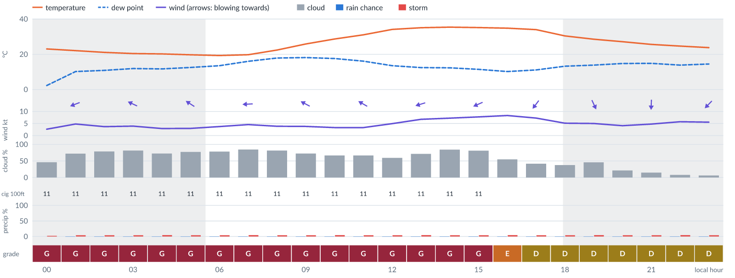
Meteogram — hourly forecast; shaded = before first light / after last light. Gaps mean no data.
Ser | Hrs | Temp | Cloud | Wind | Gust | QNH | Assessment | Driver | Remarks
(a) | (b) | (c) | (d) | (e) | (f) | (g) | (h) | (i) | (j)
1. | 0001 | 23°C | ◑ Partly cloudy (46%) | ← 3 kts ESE | 5 kts | 1014 | G - Unacceptable | ceiling 1100 ft | cloud cover, low ceiling, thunderstorm risk
2. | 0100 | 22 (spread 22–23)°C | ◕ Cloudy (72%) | ← 5 (spread 4–5) kts ENE | 8 kts | 1012 | G - Unacceptable | ceiling 1100 ft · cloud 72% | cloud cover, low ceiling, thunderstorm risk
3. | 0200 | 21 (spread 21–22)°C | ◕ Cloudy (79%) | ← 4 (spread 2–5) kts ENE | 6 kts | 1012 | G - Unacceptable | ceiling 1100 ft · cloud 79% | cloud cover, low ceiling, thunderstorm risk
4. | 0300 | 20 (spread 20–21)°C | ◕ Cloudy (81%) | ↖ 4 (spread 3–4) kts ESE | 6 kts | 1012 | G - Unacceptable | ceiling 1100 ft · cloud 81% | cloud cover, low ceiling, thunderstorm risk
5. | 0400 | 20 (spread 20–21)°C | ◕ Cloudy (72%) | ↖ 3 (spread 2–4) kts ESE | 4 kts | 1012 | G - Unacceptable | ceiling 1100 ft · cloud 72% | cloud cover, low ceiling, thunderstorm risk
6. | 0500 | 20 (spread 19–20)°C | ◕ Cloudy (77%) | ↖ 3 (spread 2–4) kts ESE | 3 kts | 1012 | G - Unacceptable | ceiling 1100 ft · cloud 77% | cloud cover, low ceiling, thunderstorm risk
7. | 0600 | 19 (spread 19–20)°C | ◕ Cloudy (78%) | ← 4 (spread 3–5) kts E | 4 kts | 1012 | G - Unacceptable | ceiling 1100 ft · cloud 78% | cloud cover, low ceiling, thunderstorm risk
8. | 0700 | 20 (spread 19–20)°C | ◕ Cloudy (85%) | ← 5 (spread 4–5) kts E | 6 kts | 1013 | G - Unacceptable | ceiling 1100 ft · cloud 85% | cloud cover, low ceiling, thunderstorm risk
9. | 0800 | 22 (spread 22–23)°C | ◕ Cloudy (81%) | ← 4 (spread 3–5) kts E | 7 kts | 1015 | G - Unacceptable | ceiling 1100 ft · cloud 81% | cloud cover, low ceiling, thunderstorm risk
10. | 0900 | 26 (spread 25–27)°C | ◕ Cloudy (73%) | ↖ 4 kts ESE | 8 kts | 1016 | G - Unacceptable | ceiling 1100 ft · cloud 73% | cloud cover, low ceiling, thunderstorm risk
11. | 1000 | 29 (spread 28–29)°C | ◕ Cloudy (66%) | ↖ 3 (spread 3–4) kts SE | 8 kts | 1016 | G - Unacceptable | ceiling 1100 ft | cloud cover, low ceiling, thunderstorm risk, wind shear
12. | 1100 | 31°C | ◕ Cloudy (67%) | ↖ 3 (spread 2–6) kts ESE | 9 kts | 1016 | G - Unacceptable | ceiling 1100 ft | cloud cover, low ceiling, thunderstorm risk, gusts, wind shear
13. | 1200 | 34 (spread 34–35)°C | ◑ Partly cloudy (59%) | ← 5 (spread 3–8) kts E | 11 kts | 1015 | G - Unacceptable | ceiling 1100 ft | cloud cover, low ceiling, thunderstorm risk, gusts, wind shear
14. | 1300 | 35 (spread 35–36)°C | ◕ Cloudy (71%) | ← 7 (spread 6–8) kts ENE | 12 kts | 1014 | G - Unacceptable | ceiling 1100 ft · cloud 71% | cloud cover, low ceiling, gusts, thunderstorm risk, wind shear
15. | 1400 | 35 (spread 35–36)°C | ◕ Cloudy (84%) | ← 7 (spread 7–8) kts ENE | 13 kts | 1013 | G - Unacceptable | ceiling 1100 ft · cloud 84% | cloud cover, low ceiling, gusts, thunderstorm risk, wind shear
16. | 1500 | 35°C | ◕ Cloudy (81%) | ↙ 8 kts ENE | 13 kts | 1013 | G - Unacceptable | ceiling 1100 ft · cloud 81% | cloud cover, low ceiling, gusts, thunderstorm risk, wind shear
17. | 1600 | 35°C | ◑ Partly cloudy (55%) | ↙ 8 (spread 8–10) kts NE | 13 kts | 1012 | E - Poor | cloud 55% · gust 13 kt | cloud cover, gusts, thunderstorm risk, wind shear
18. | 1700 | 34°C | ◑ Partly cloudy (42%) | ↙ 7 (spread 6–9) kts NE | 11 kts | 1012 | D - Marginal | storm 4% · gust 11 kt | thunderstorm risk, gusts
19. | 1800 | 30 (spread 30–31)°C | ◔ Partly cloudy (37%) | ↓ 5 (spread 3–8) kts N | 7 kts | 1012 | D - Marginal | storm 4% | thunderstorm risk
20. | 1900 | 29 (spread 28–29)°C | ◑ Partly cloudy (46%) | ↘ 5 (spread 3–8) kts NNW | 4 kts | 1013 | D - Marginal | storm 4% · cloud 46% | cloud cover, thunderstorm risk
21. | 2000 | 27°C | ◔ Mostly clear (22%) | ↓ 4 (spread 3–6) kts NNW | 4 kts | 1013 | D - Marginal | storm 4% | thunderstorm risk
22. | 2100 | 26 (spread 25–26)°C | ◔ Mostly clear (15%) | ↓ 5 (spread 4–6) kts N | 6 kts | 1014 | D - Marginal | storm 4% | thunderstorm risk
23. | 2200 | 25 (spread 24–25)°C | ☀ Clear (8%) | ↓ 6 kts NNE | 7 kts | 1014 | D - Marginal | storm 4% | thunderstorm risk
24. | 2300 | 24 (spread 23–24)°C | ☀ Clear (6%) | ↙ 6 (spread 5–6) kts NE | 7 kts | 1014 | D - Marginal | storm 4% | thunderstorm risk
Confidence: 74% — data for 24 of 24 hours; 8% of readings interpolated · first light 0601L · last light 1826L · Moon 4 % illuminated, rises 04:41, sets 16:42.

Tomorrow — Sun 8 Nov 26
Conditions are expected to be generally Marginal: clear, winds up to 8 kts ENE and temperatures 20–36°C. Flyable windows: 0001–1200L (Marginal, 13 h) and 1800–2300L (Marginal, 6 h). Hazards: thunderstorm risk 0001–2300L. Overall an improvement on the previous day.
WEATHER EFFECTS
 | 00–06L | 06–12L | 12–18L | 18–24L
Wind | D | D | E | D
Visibility | A | A | A | A
Cloud / ceiling | A | A | A | B
Precipitation | A | A | A | A
Thunderstorm | D | D | D | D
Fog | · | · | · | ·
A Excellent · B Good · C Fair · D Marginal (flyable) · E Poor · F Very Poor · G Unacceptable · (worst condition in each period)
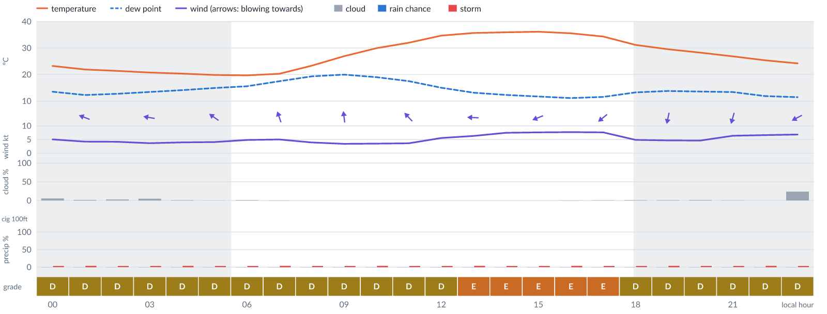
Meteogram — hourly forecast; shaded = before first light / after last light. Gaps mean no data.
Ser | Hrs | Temp | Cloud | Wind | Gust | QNH | Assessment | Driver | Remarks
(a) | (b) | (c) | (d) | (e) | (f) | (g) | (h) | (i) | (j)
1. | 0001 | 23 (spread 22–24)°C | ☀ Clear (6%) | ← 5 (spread 4–6) kts E | 9 kts | 1014 | D - Marginal | storm 4% · gust 9 kt | thunderstorm risk, gusts
2. | 0100 | 22 (spread 21–23)°C | ☀ Clear (2%) | ← 4 kts ESE | 8 kts | 1013 | D - Marginal | storm 4% | thunderstorm risk
3. | 0200 | 21 (spread 21–22)°C | ☀ Clear (3%) | ← 4 (spread 4–5) kts E | 7 kts | 1013 | D - Marginal | storm 4% | thunderstorm risk
4. | 0300 | 21°C | ☀ Clear (5%) | ← 4 (spread 3–5) kts E | 6 kts | 1013 | D - Marginal | storm 4% | thunderstorm risk
5. | 0400 | 20 (spread 20–21)°C | ☀ Clear (1%) | ← 4 (spread 3–5) kts ESE | 7 kts | 1012 | D - Marginal | storm 4% | thunderstorm risk
6. | 0500 | 20°C | ☀ Clear (0%) | ↖ 4 (spread 3–5) kts SE | 6 kts | 1013 | D - Marginal | storm 4% | thunderstorm risk
7. | 0600 | 20 (spread 19–20)°C | ☀ Clear (1%) | ↖ 5 (spread 4–5) kts SE | 6 kts | 1013 | D - Marginal | storm 4% | thunderstorm risk
8. | 0700 | 20 (spread 19–21)°C | ☀ Clear (0%) | ↑ 5 (spread 4–6) kts SSE | 7 kts | 1014 | D - Marginal | storm 4% | thunderstorm risk
9. | 0800 | 23 (spread 22–24)°C | ☀ Clear (0%) | ↑ 4 (spread 3–5) kts SSE | 7 kts | 1015 | D - Marginal | storm 4% | thunderstorm risk
10. | 0900 | 27 (spread 26–28)°C | ☀ Clear (0%) | ↑ 3 (spread 3–4) kts S | 7 kts | 1017 | D - Marginal | storm 4% | thunderstorm risk
11. | 1000 | 30°C | ☀ Clear (0%) | ↑ 3 (spread 3–4) kts SSE | 8 kts | 1018 | D - Marginal | storm 4% · gust spread +4 kt | thunderstorm risk, wind shear
12. | 1100 | 32°C | ☀ Clear (0%) | ↖ 4 (spread 3–4) kts SE | 9 kts | 1017 | D - Marginal | storm 4% · gust 9 kt | thunderstorm risk, gusts, wind shear
13. | 1200 | 35 (spread 34–35)°C | ☀ Clear (0%) | ← 6 (spread 5–6) kts ESE | 11 kts | 1016 | D - Marginal | storm 4% · gust 11 kt | thunderstorm risk, gusts, wind shear
14. | 1300 | 36 (spread 35–36)°C | ☀ Clear (0%) | ← 6 (spread 5–7) kts E | 12 kts | 1015 | E - Poor | gust 12 kt | gusts, thunderstorm risk, wind shear
15. | 1400 | 36°C | ☀ Clear (0%) | ← 7 (spread 7–8) kts E | 13 kts | 1015 | E - Poor | gust 13 kt | gusts, thunderstorm risk, wind shear
16. | 1500 | 36 (spread 36–37)°C | ☀ Clear (0%) | ← 8 kts ENE | 13 kts | 1014 | E - Poor | gust 13 kt | gusts, thunderstorm risk, wind shear
17. | 1600 | 36 (spread 35–36)°C | ☀ Clear (0%) | ↙ 8 (spread 7–8) kts ENE | 13 kts | 1014 | E - Poor | gust 13 kt | gusts, thunderstorm risk, wind shear
18. | 1700 | 34 (spread 34–35)°C | ☀ Clear (1%) | ↙ 8 (spread 7–8) kts NE | 12 kts | 1013 | E - Poor | gust 12 kt | gusts, thunderstorm risk
19. | 1800 | 31 (spread 31–32)°C | ☀ Clear (1%) | ↙ 5 kts NNE | 8 kts | 1014 | D - Marginal | storm 4% | thunderstorm risk
20. | 1900 | 30 (spread 29–30)°C | ☀ Clear (1%) | ↓ 5 (spread 4–5) kts NNE | 6 kts | 1014 | D - Marginal | storm 4% | thunderstorm risk
21. | 2000 | 28 (spread 27–29)°C | ☀ Clear (2%) | ↓ 5 (spread 4–6) kts NNE | 6 kts | 1015 | D - Marginal | storm 4% | thunderstorm risk
22. | 2100 | 27°C | ☀ Clear (1%) | ↓ 6 (spread 6–7) kts NNE | 9 kts | 1015 | D - Marginal | storm 4% · gust 9 kt | thunderstorm risk, gusts
23. | 2200 | 25 (spread 25–26)°C | ☀ Clear (0%) | ↙ 7 (spread 6–7) kts NE | 10 kts | 1015 | D - Marginal | storm 4% · gust 10 kt | thunderstorm risk, gusts
24. | 2300 | 24 (spread 24–25)°C | ◔ Mostly clear (24%) | ↙ 7 (spread 6–7) kts ENE | 10 kts | 1015 | D - Marginal | storm 4% · gust 10 kt | thunderstorm risk, gusts
Confidence: 78% — data for 24 of 24 hours; 10% of readings interpolated · first light 0601L · last light 1826L · Moon 1 % illuminated, rises 05:31, sets 17:24.

Extended Outlook
WEATHER EFFECTS BY DAY
 | Mon | Tue | Wed | Thu | Fri | Sat | Sun | Mon | Tue | Wed | Thu | Fri
Wind | F | G | F | G | G | G | F | G | F | F | E | E
Visibility | A | A | A | A | · | · | · | · | · | A | A | A
Cloud / ceiling | G | G | G | G | G | A | A | A | A | D | G | G
Precipitation | A | A | A | A | A | A | A | A | A | A | A | A
Thunderstorm | D | D | D | D | D | D | D | D | D | D | D | D
Fog | · | · | · | · | · | · | · | · | · | · | · | ·
Overall | G | G | G | G | G | G | F | G | F | F | G | G
A Excellent · B Good · C Fair · D Marginal (flyable) · E Poor · F Very Poor · G Unacceptable · (worst condition in each period)

Mon 9 Nov 26
Conditions are expected to be generally Marginal: partly cloudy, winds up to 10 kts NE, gusting 17 kts and temperatures 21–36°C. Flyable windows: 0400–0700L (Marginal, 4 h), 0900–1100L (Marginal, 3 h) and 1800–1900L (Marginal, 2 h). Hazards: thunderstorm risk 0001–2300L. Overall similar to the previous day.
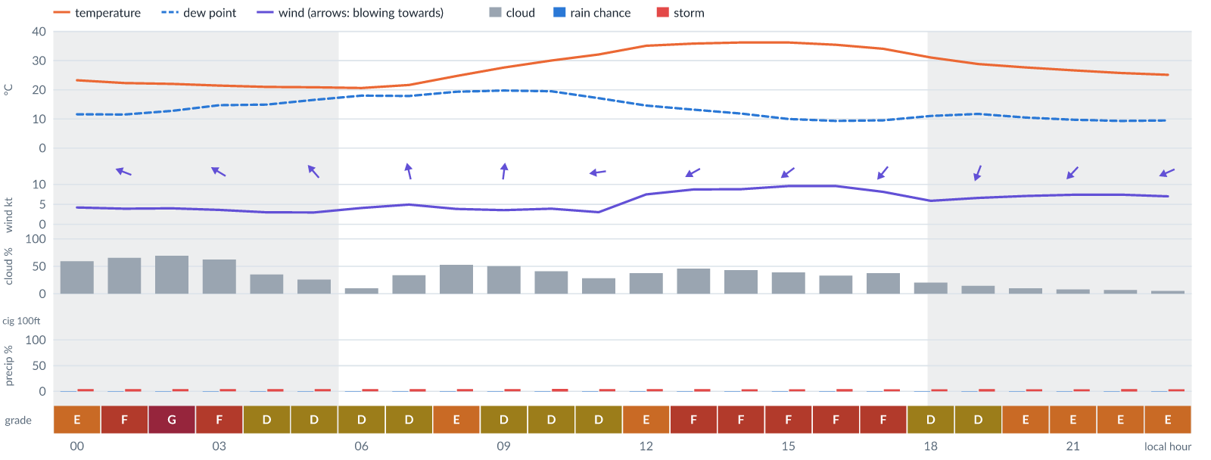
Meteogram — hourly forecast; shaded = before first light / after last light. Gaps mean no data.
Ser | Hrs | Temp | Cloud | Wind | Gust | QNH | Assessment | Driver | Remarks
(a) | (b) | (c) | (d) | (e) | (f) | (g) | (h) | (i) | (j)
1. | 0001 | 23 (spread 23–24)°C | ◑ Partly cloudy (59%) | ← 4 (spread 3–5) kts E | 7 kts | 1015 | E - Poor | cloud 59% | cloud cover, thunderstorm risk
2. | 0100 | 22 (spread 22–23)°C | ◕ Cloudy (66%) | ← 4 (spread 3–5) kts ESE | 6 kts | 1015 | F - Very Poor | cloud 66% | cloud cover, thunderstorm risk
3. | 0200 | 22°C | ◕ Cloudy (69%) | ← 4 (spread 3–5) kts ESE | 6 kts | 1014 | G - Unacceptable | cloud 69% | cloud cover, thunderstorm risk
4. | 0300 | 21 (spread 21–22)°C | ◑ Cloudy (62%) | ↖ 4 (spread 2–5) kts ESE | 5 kts | 1014 | F - Very Poor | cloud 62% | cloud cover, thunderstorm risk
5. | 0400 | 21 (spread 20–22)°C | ◔ Partly cloudy (35%) | ↖ 3 (spread 2–4) kts SE | 4 kts | 1014 | D - Marginal | storm 5% | thunderstorm risk
6. | 0500 | 21 (spread 20–22)°C | ◔ Mostly clear (26%) | ↖ 3 (spread 2–3) kts SE | 4 kts | 1014 | D - Marginal | storm 4% | thunderstorm risk
7. | 0600 | 21 (spread 20–21)°C | ☀ Clear (10%) | ↖ 4 kts SSE | 4 kts | 1015 | D - Marginal | storm 4% | thunderstorm risk
8. | 0700 | 22 (spread 21–22)°C | ◔ Partly cloudy (34%) | ↑ 5 kts SSE | 6 kts | 1015 | D - Marginal | storm 5% | thunderstorm risk
9. | 0800 | 25 (spread 24–25)°C | ◑ Partly cloudy (53%) | ↑ 4 kts SSE | 6 kts | 1017 | E - Poor | cloud 53% | cloud cover, thunderstorm risk
10. | 0900 | 28 (spread 27–29)°C | ◑ Partly cloudy (50%) | ↑ 4 (spread 3–4) kts S | 7 kts | 1019 | D - Marginal | storm 4% · cloud 50% | cloud cover, thunderstorm risk
11. | 1000 | 30°C | ◑ Partly cloudy (41%) | ↑ 4 kts SSW | 8 kts | 1019 | D - Marginal | storm 5% · CAPE 1200 J/kg | thunderstorm risk, convective energy
12. | 1100 | 32 (spread 32–33)°C | ◔ Mostly clear (28%) | ← 3 (spread 2–4) kts E | 8 kts | 1019 | D - Marginal | storm 4% · gust spread +5 kt | thunderstorm risk, wind shear
13. | 1200 | 35°C | ◑ Partly cloudy (38%) | ↙ 7 (spread 7–8) kts ENE | 14 kts | 1018 | E - Poor | gust 14 kt · gust spread +6 kt | gusts, wind shear, thunderstorm risk
14. | 1300 | 36 (spread 35–37)°C | ◑ Partly cloudy (46%) | ↙ 9 (spread 8–9) kts ENE | 15 kts | 1017 | F - Very Poor | gust 15 kt | gusts, cloud cover, thunderstorm risk, strong wind, wind shear
15. | 1400 | 36 (spread 36–37)°C | ◑ Partly cloudy (43%) | ↙ 9 kts ENE | 16 kts | 1016 | F - Very Poor | gust 16 kt | gusts, wind shear, cloud cover, thunderstorm risk, strong wind
16. | 1500 | 36 (spread 36–37)°C | ◑ Partly cloudy (39%) | ↙ 10 (spread 9–10) kts NE | 16 kts | 1016 | F - Very Poor | gust 16 kt | gusts, thunderstorm risk, strong wind, wind shear
17. | 1600 | 35 (spread 35–36)°C | ◔ Partly cloudy (33%) | ↙ 10 (spread 9–10) kts NE | 17 kts | 1015 | F - Very Poor | gust 17 kt | gusts, wind shear, thunderstorm risk, strong wind
18. | 1700 | 34°C | ◑ Partly cloudy (38%) | ↙ 8 kts NE | 15 kts | 1015 | F - Very Poor | gust 15 kt | gusts, wind shear, thunderstorm risk
19. | 1800 | 31 (spread 31–32)°C | ◔ Mostly clear (20%) | ↓ 6 (spread 5–7) kts NNE | 10 kts | 1015 | D - Marginal | storm 4% · gust 10 kt | thunderstorm risk, gusts
20. | 1900 | 29 (spread 28–29)°C | ◔ Mostly clear (15%) | ↓ 7 kts NNE | 10 kts | 1015 | D - Marginal | storm 5% · gust 10 kt | thunderstorm risk, gusts
21. | 2000 | 28 (spread 27–28)°C | ☀ Clear (10%) | ↙ 7 (spread 7–8) kts NE | 12 kts | 1016 | E - Poor | gust 12 kt | gusts, thunderstorm risk, wind shear
22. | 2100 | 27 (spread 26–27)°C | ☀ Clear (8%) | ↙ 7 (spread 7–8) kts NE | 12 kts | 1017 | E - Poor | gust 12 kt | gusts, thunderstorm risk, wind shear
23. | 2200 | 26°C | ☀ Clear (7%) | ↙ 7 (spread 6–8) kts NE | 12 kts | 1017 | E - Poor | gust 12 kt | gusts, thunderstorm risk, wind shear
24. | 2300 | 25 (spread 25–26)°C | ☀ Clear (5%) | ↙ 7 (spread 5–8) kts ENE | 12 kts | 1017 | E - Poor | gust 12 kt | gusts, thunderstorm risk, wind shear
Confidence: 74% — data for 24 of 24 hours; 16% of readings interpolated · first light 0601L · last light 1826L · Moon 0 % illuminated, rises 06:21, sets 18:09.

Tue 10 Nov 26
Conditions are expected to be generally Unacceptable: partly cloudy, winds up to 11 kts ENE, gusting 19 kts and temperatures 20–36°C. Flyable windows: 0001–0600L (Marginal, 7 h). Hazards: thunderstorm risk 0001–2300L. Overall a deterioration from the previous day.
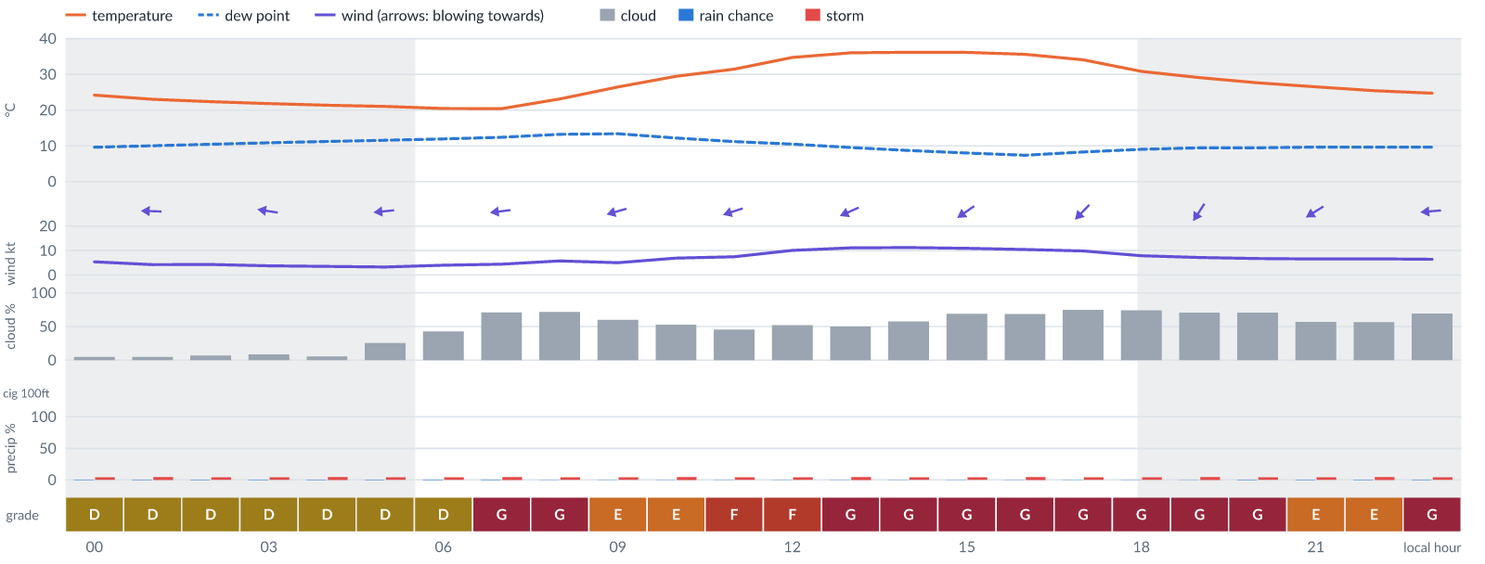
Meteogram — hourly forecast; shaded = before first light / after last light. Gaps mean no data.
Ser | Hrs | Temp | Cloud | Wind | Gust | QNH | Assessment | Driver | Remarks
(a) | (b) | (c) | (d) | (e) | (f) | (g) | (h) | (i) | (j)
1. | 0001 | 24 (spread 23–25)°C | ☀ Clear (5%) | ← 5 (spread 3–7) kts ENE | 10 kts | 1016 | D - Marginal | storm 4% · gust 10 kt | thunderstorm risk, gusts, wind shear
2. | 0100 | 23 (spread 22–24)°C | ☀ Clear (5%) | ← 4 (spread 2–6) kts E | 8 kts | 1016 | D - Marginal | storm 5% | thunderstorm risk
3. | 0200 | 22 (spread 22–23)°C | ☀ Clear (7%) | ← 4 (spread 2–5) kts E | 7 kts | 1016 | D - Marginal | storm 4% | thunderstorm risk
4. | 0300 | 22 (spread 21–22)°C | ☀ Clear (8%) | ← 4 (spread 2–5) kts E | 6 kts | 1016 | D - Marginal | storm 4% | thunderstorm risk
5. | 0400 | 21 (spread 21–22)°C | ☀ Clear (6%) | ← 4 (spread 3–4) kts E | 5 kts | 1016 | D - Marginal | storm 5% | thunderstorm risk
6. | 0500 | 21°C | ◔ Mostly clear (25%) | ← 3 (spread 2–4) kts E | 6 kts | 1016 | D - Marginal | storm 4% | thunderstorm risk
7. | 0600 | 20 (spread 20–21)°C | ◑ Partly cloudy (43%) | ← 4 (spread 3–4) kts E | 5 kts | 1016 | D - Marginal | storm 4% · cloud 43% | cloud cover, thunderstorm risk
8. | 0700 | 20 (spread 20–21)°C | ◕ Cloudy (71%) | ← 4 (spread 3–5) kts E | 6 kts | 1017 | G - Unacceptable | cloud 71% | cloud cover, thunderstorm risk
9. | 0800 | 23 (spread 23–24)°C | ◕ Cloudy (72%) | ← 6 (spread 5–6) kts ENE | 8 kts | 1018 | G - Unacceptable | cloud 72% | cloud cover, thunderstorm risk
10. | 0900 | 26 (spread 26–28)°C | ◑ Cloudy (60%) | ← 5 (spread 4–6) kts ENE | 10 kts | 1019 | E - Poor | cloud 60% | cloud cover, thunderstorm risk, gusts, wind shear
11. | 1000 | 29 (spread 29–30)°C | ◑ Partly cloudy (53%) | ← 7 (spread 6–8) kts ENE | 13 kts | 1019 | E - Poor | cloud 53% · gust 13 kt | cloud cover, gusts, thunderstorm risk, wind shear
12. | 1100 | 31 (spread 31–32)°C | ◑ Partly cloudy (45%) | ← 7 (spread 7–9) kts ENE | 15 kts | 1019 | F - Very Poor | gust 15 kt | gusts, wind shear, cloud cover, thunderstorm risk
13. | 1200 | 35 (spread 34–35)°C | ◑ Partly cloudy (52%) | ← 10 kts ENE | 17 kts | 1018 | F - Very Poor | gust 17 kt | gusts, cloud cover, wind shear, thunderstorm risk, strong wind
14. | 1300 | 36 (spread 35–37)°C | ◑ Partly cloudy (50%) | ↙ 11 (spread 11–12) kts ENE | 18 kts | 1017 | G - Unacceptable | gust 18 kt | gusts, wind shear, cloud cover, thunderstorm risk, strong wind
15. | 1400 | 36 (spread 36–37)°C | ◑ Partly cloudy (58%) | ↙ 11 kts ENE | 19 kts | 1017 | G - Unacceptable | gust 19 kt | gusts, cloud cover, wind shear, thunderstorm risk, strong wind
16. | 1500 | 36 (spread 36–37)°C | ◕ Cloudy (69%) | ↙ 11 kts NE | 18 kts | 1016 | G - Unacceptable | cloud 69% · gust 18 kt | cloud cover, gusts, wind shear, thunderstorm risk, strong wind
17. | 1600 | 36 (spread 35–36)°C | ◕ Cloudy (69%) | ↙ 10 (spread 10–11) kts NE | 17 kts | 1015 | G - Unacceptable | cloud 69% | cloud cover, gusts, wind shear, thunderstorm risk, strong wind
18. | 1700 | 34 (spread 33–35)°C | ◕ Cloudy (75%) | ↙ 10 kts NE | 17 kts | 1015 | G - Unacceptable | cloud 75% | cloud cover, gusts, wind shear, thunderstorm risk, strong wind
19. | 1800 | 31°C | ◕ Cloudy (74%) | ↙ 8 kts NE | 16 kts | 1015 | G - Unacceptable | cloud 74% | cloud cover, gusts, wind shear, thunderstorm risk
20. | 1900 | 29°C | ◕ Cloudy (70%) | ↙ 7 kts NNE | 14 kts | 1015 | G - Unacceptable | cloud 70% | cloud cover, gusts, wind shear, thunderstorm risk
21. | 2000 | 28 (spread 27–28)°C | ◕ Cloudy (70%) | ↙ 7 kts NE | 13 kts | 1016 | G - Unacceptable | cloud 70% | cloud cover, gusts, thunderstorm risk, wind shear
22. | 2100 | 27 (spread 26–27)°C | ◑ Partly cloudy (57%) | ↙ 7 (spread 6–7) kts ENE | 12 kts | 1016 | E - Poor | cloud 57% · gust 12 kt | cloud cover, gusts, thunderstorm risk, wind shear
23. | 2200 | 25 (spread 25–26)°C | ◑ Partly cloudy (57%) | ↙ 7 (spread 6–7) kts ENE | 11 kts | 1017 | E - Poor | cloud 57% | cloud cover, thunderstorm risk, gusts
24. | 2300 | 25°C | ◕ Cloudy (69%) | ← 6 (spread 6–7) kts E | 11 kts | 1016 | G - Unacceptable | cloud 69% | cloud cover, thunderstorm risk, gusts, wind shear
Confidence: 73% — data for 24 of 24 hours; 22% of readings interpolated · first light 0601L · last light 1826L · Moon 2 % illuminated, rises 07:14, sets 18:56.

Wed 11 Nov 26
Conditions are expected to be generally Unacceptable: overcast, winds up to 9 kts ENE, gusting 16 kts and temperatures 21–35°C. Flyable windows: 2200–2300L (Marginal, 2 h). Hazards: thunderstorm risk 0001–2300L. Overall similar to the previous day.
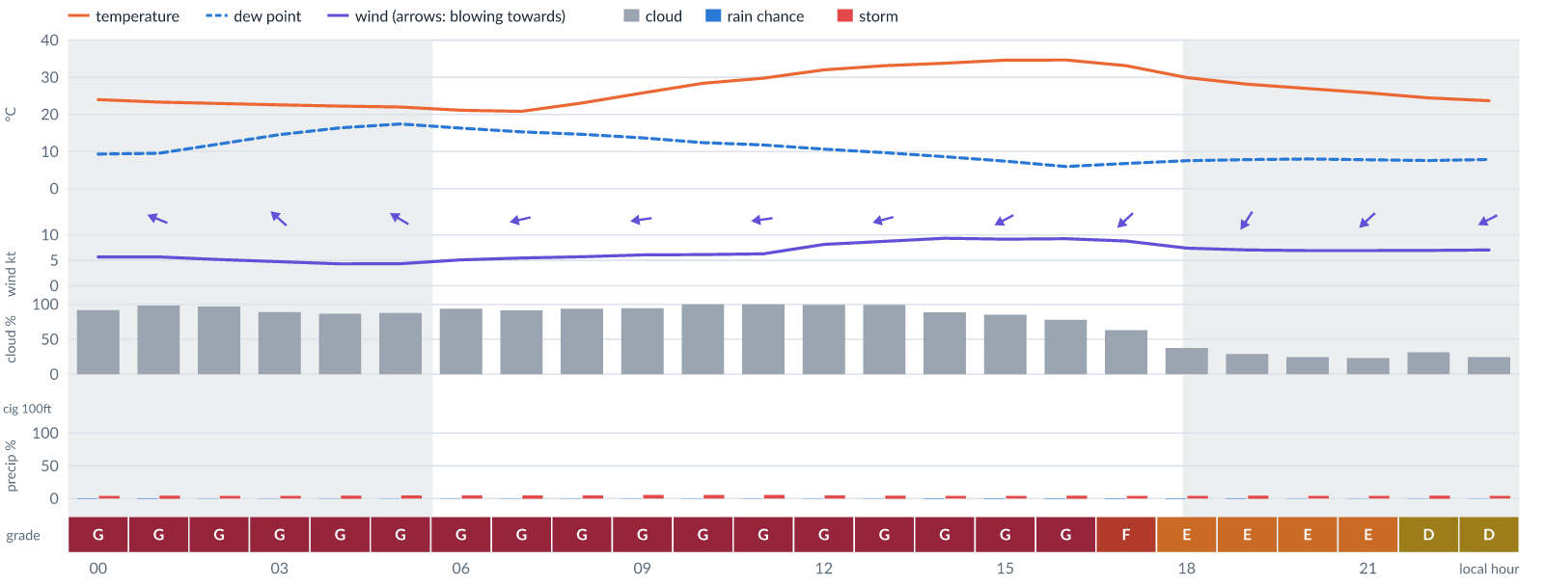
Meteogram — hourly forecast; shaded = before first light / after last light. Gaps mean no data.
Ser | Hrs | Temp | Cloud | Wind | Gust | QNH | Assessment | Driver | Remarks
(a) | (b) | (c) | (d) | (e) | (f) | (g) | (h) | (i) | (j)
1. | 0001 | 24 (spread 23–25)°C | ☁ Overcast (92%) | ← 6 kts E | 11 kts | 1016 | G - Unacceptable | cloud 92% | cloud cover, thunderstorm risk, gusts, wind shear
2. | 0100 | 23 (spread 23–24)°C | ☁ Overcast (98%) | ← 6 (spread 5–6) kts ESE | 11 kts | 1016 | G - Unacceptable | cloud 98% | cloud cover, thunderstorm risk, gusts, wind shear
3. | 0200 | 23 (spread 22–24)°C | ☁ Overcast (97%) | ↖ 5 kts ESE | 9 kts | 1016 | G - Unacceptable | cloud 97% | cloud cover, thunderstorm risk, gusts
4. | 0300 | 23 (spread 22–23)°C | ☁ Cloudy (89%) | ↖ 5 (spread 4–5) kts SE | 9 kts | 1015 | G - Unacceptable | cloud 89% | cloud cover, thunderstorm risk, gusts
5. | 0400 | 22 (spread 22–23)°C | ◕ Cloudy (87%) | ↖ 4 (spread 4–5) kts SE | 9 kts | 1015 | G - Unacceptable | cloud 87% | cloud cover, thunderstorm risk, gusts, wind shear
6. | 0500 | 22°C | ☁ Cloudy (88%) | ↖ 4 (spread 4–5) kts ESE | 10 kts | 1016 | G - Unacceptable | cloud 88% | cloud cover, thunderstorm risk, gusts, wind shear
7. | 0600 | 21 (spread 21–22)°C | ☁ Overcast (94%) | ← 5 (spread 4–6) kts E | 10 kts | 1016 | G - Unacceptable | cloud 94% | cloud cover, thunderstorm risk, gusts, wind shear
8. | 0700 | 21°C | ☁ Overcast (91%) | ← 5 kts ENE | 10 kts | 1017 | G - Unacceptable | cloud 91% | cloud cover, thunderstorm risk, gusts, wind shear
9. | 0800 | 23°C | ☁ Overcast (94%) | ← 6 kts ENE | 11 kts | 1018 | G - Unacceptable | cloud 94% | cloud cover, thunderstorm risk, gusts, wind shear
10. | 0900 | 26 (spread 25–27)°C | ☁ Overcast (94%) | ← 6 kts E | 11 kts | 1019 | G - Unacceptable | cloud 94% | cloud cover, thunderstorm risk, gusts, wind shear
11. | 1000 | 28 (spread 28–29)°C | ☁ Overcast (100%) | ← 6 kts E | 11 kts | 1020 | G - Unacceptable | cloud 100% | cloud cover, thunderstorm risk, gusts, wind shear
12. | 1100 | 30 (spread 29–31)°C | ☁ Overcast (100%) | ← 6 kts E | 13 kts | 1019 | G - Unacceptable | cloud 100% | cloud cover, gusts, wind shear, thunderstorm risk
13. | 1200 | 32°C | ☁ Overcast (99%) | ← 8 (spread 7–9) kts E | 14 kts | 1018 | G - Unacceptable | cloud 99% | cloud cover, gusts, thunderstorm risk, wind shear
14. | 1300 | 33°C | ☁ Overcast (99%) | ← 9 (spread 7–10) kts ENE | 16 kts | 1017 | G - Unacceptable | cloud 99% | cloud cover, gusts, wind shear, thunderstorm risk, strong wind
15. | 1400 | 34°C | ☁ Cloudy (89%) | ← 9 (spread 9–10) kts ENE | 16 kts | 1017 | G - Unacceptable | cloud 89% | cloud cover, gusts, wind shear, thunderstorm risk, strong wind
16. | 1500 | 35 (spread 34–35)°C | ◕ Cloudy (85%) | ↙ 9 kts ENE | 16 kts | 1016 | G - Unacceptable | cloud 85% | cloud cover, gusts, wind shear, thunderstorm risk, strong wind
17. | 1600 | 35 (spread 34–35)°C | ◕ Cloudy (78%) | ↙ 9 (spread 9–10) kts NE | 16 kts | 1016 | G - Unacceptable | cloud 78% | cloud cover, gusts, wind shear, thunderstorm risk, strong wind
18. | 1700 | 33°C | ◕ Cloudy (63%) | ↙ 9 kts NE | 15 kts | 1015 | F - Very Poor | cloud 63% · gust 15 kt | cloud cover, gusts, thunderstorm risk, strong wind, wind shear
19. | 1800 | 30°C | ◔ Partly cloudy (37%) | ↙ 7 kts NE | 14 kts | 1016 | E - Poor | gust 14 kt · gust spread +6 kt | gusts, wind shear, thunderstorm risk
20. | 1900 | 28°C | ◔ Mostly clear (29%) | ↙ 7 (spread 6–8) kts NNE | 13 kts | 1015 | E - Poor | gust 13 kt | gusts, thunderstorm risk, wind shear
21. | 2000 | 27°C | ◔ Mostly clear (24%) | ↙ 7 (spread 6–7) kts NE | 12 kts | 1016 | E - Poor | gust 12 kt | gusts, thunderstorm risk, wind shear
22. | 2100 | 26°C | ◔ Mostly clear (23%) | ↙ 7 kts NE | 12 kts | 1016 | E - Poor | gust 12 kt | gusts, thunderstorm risk, wind shear
23. | 2200 | 24 (spread 24–25)°C | ◔ Mostly clear (31%) | ↙ 7 kts NE | 11 kts | 1016 | D - Marginal | storm 5% · gust 11 kt | thunderstorm risk, gusts
24. | 2300 | 24 (spread 23–24)°C | ◔ Mostly clear (25%) | ↙ 7 kts ENE | 11 kts | 1016 | D - Marginal | storm 4% · gust 11 kt | thunderstorm risk, gusts
Confidence: 73% — data for 24 of 24 hours; 22% of readings interpolated · first light 0602L · last light 1826L · Moon 5 % illuminated, rises 08:07, sets 19:46.

Thu 12 Nov 26
Conditions are expected to be generally Unacceptable: partly cloudy, winds up to 8 kts ENE, gusting 17 kts and temperatures 20–35°C. Flyable windows: 0001–0100L (Marginal, 2 h). Hazards: thunderstorm risk 0001–2300L. Overall similar to the previous day.
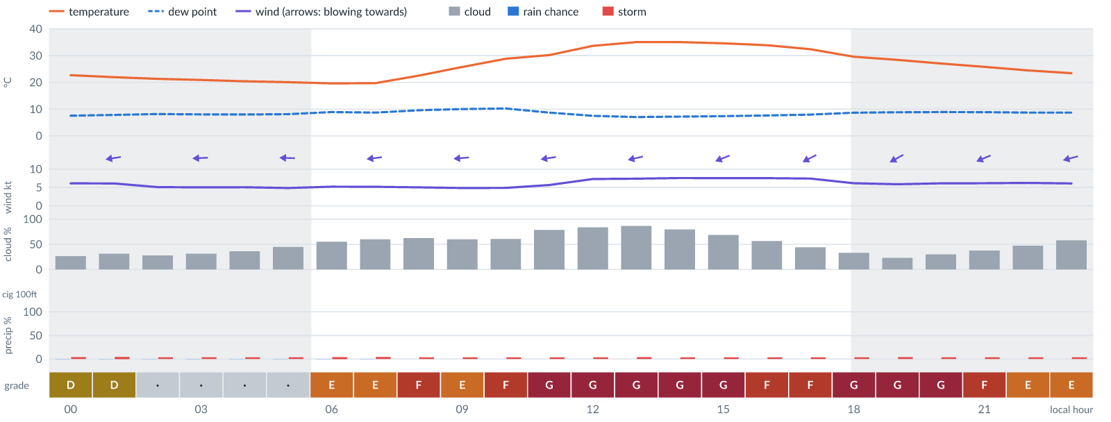
Meteogram — hourly forecast; shaded = before first light / after last light. Gaps mean no data.
Ser | Hrs | Temp | Cloud | Wind | Gust | QNH | Assessment | Driver | Remarks
(a) | (b) | (c) | (d) | (e) | (f) | (g) | (h) | (i) | (j)
1. | 0001 | 23 (spread 22–23)°C | ◔ Mostly clear (26%) | ← 6 (spread 5–7) kts ENE | 11 kts | 1016 | D - Marginal | storm 4% · gust 11 kt | thunderstorm risk, gusts, wind shear
2. | 0100 | 22°C | ◔ Mostly clear (31%) | ← 6 (spread 4–7) kts E | 10 kts | 1016 | D - Marginal | storm 5% · gust 10 kt | thunderstorm risk, gusts
3. | 0200 | 21 (spread 21–22)°C | ◔ Mostly clear (28%) | ← 5 (spread 4–6) kts ENE | 9 kts | 1016 | · - No data | storm 4% · gust 9 kt · visibility not forecast | thunderstorm risk, gusts
4. | 0300 | 21°C | ◔ Mostly clear (31%) | ← 5 (spread 4–6) kts E | 9 kts | 1015 | · - No data | storm 4% · gust 9 kt · visibility not forecast | thunderstorm risk, gusts
5. | 0400 | 20 (spread 20–21)°C | ◔ Partly cloudy (36%) | ← 5 (spread 4–6) kts E | 9 kts | 1015 | · - No data | storm 4% · gust 9 kt · visibility not forecast | thunderstorm risk, gusts
6. | 0500 | 20 (spread 20–21)°C | ◑ Partly cloudy (45%) | ← 5 (spread 4–6) kts E | 9 kts | 1015 | · - No data | storm 4% · cloud 45% · visibility not forecast | cloud cover, thunderstorm risk, gusts
7. | 0600 | 20°C | ◑ Partly cloudy (55%) | ← 5 (spread 4–6) kts E | 9 kts | 1015 | E - Poor | cloud 55% · visibility not forecast | cloud cover, thunderstorm risk, gusts
8. | 0700 | 20°C | ◑ Cloudy (60%) | ← 5 (spread 4–6) kts E | 9 kts | 1016 | E - Poor | cloud 60% · visibility not forecast | cloud cover, thunderstorm risk, gusts
9. | 0800 | 23 (spread 22–23)°C | ◕ Cloudy (63%) | ← 5 (spread 4–6) kts E | 10 kts | 1017 | F - Very Poor | cloud 63% · visibility not forecast | cloud cover, thunderstorm risk, gusts, wind shear
10. | 0900 | 26°C | ◑ Cloudy (60%) | ← 5 kts E | 10 kts | 1018 | E - Poor | cloud 60% · visibility not forecast | cloud cover, thunderstorm risk, gusts, wind shear
11. | 1000 | 29°C | ◑ Cloudy (61%) | ← 5 kts E | 11 kts | 1019 | F - Very Poor | cloud 61% · visibility not forecast | cloud cover, thunderstorm risk, gusts, wind shear
12. | 1100 | 30 (spread 30–31)°C | ◕ Cloudy (79%) | ← 6 (spread 5–6) kts E | 13 kts | 1017 | G - Unacceptable | cloud 79% · visibility not forecast | cloud cover, gusts, wind shear, thunderstorm risk
13. | 1200 | 34 (spread 33–34)°C | ◕ Cloudy (84%) | ← 7 (spread 7–8) kts ENE | 14 kts | 1017 | G - Unacceptable | cloud 84% · visibility not forecast | cloud cover, gusts, wind shear, thunderstorm risk
14. | 1300 | 35 (spread 35–36)°C | ◕ Cloudy (87%) | ← 7 (spread 7–8) kts ENE | 15 kts | 1017 | G - Unacceptable | cloud 87% · visibility not forecast | cloud cover, gusts, wind shear, thunderstorm risk
15. | 1400 | 35°C | ◕ Cloudy (80%) | ← 8 (spread 7–8) kts ENE | 15 kts | 1017 | G - Unacceptable | cloud 80% · visibility not forecast | cloud cover, gusts, wind shear, thunderstorm risk
16. | 1500 | 35°C | ◕ Cloudy (69%) | ← 8 (spread 7–8) kts ENE | 15 kts | 1016 | G - Unacceptable | cloud 69% · visibility not forecast | cloud cover, gusts, wind shear, thunderstorm risk
17. | 1600 | 34°C | ◑ Partly cloudy (56%) | ↙ 8 (spread 7–8) kts ENE | 16 kts | 1016 | F - Very Poor | gust 16 kt · visibility not forecast | gusts, cloud cover, wind shear, thunderstorm risk
18. | 1700 | 32 (spread 32–33)°C | ◑ Partly cloudy (44%) | ↙ 7 (spread 7–8) kts ENE | 16 kts | 1016 | F - Very Poor | gust 16 kt · gust spread +9 kt · visibility not forecast | gusts, wind shear, cloud cover, thunderstorm risk
19. | 1800 | 30 (spread 29–30)°C | ◔ Partly cloudy (33%) | ↙ 6 (spread 6–7) kts ENE | 17 kts | 1016 | G - Unacceptable | gust spread +11 kt · visibility not forecast | wind shear, gusts, thunderstorm risk
20. | 1900 | 28 (spread 28–29)°C | ◔ Mostly clear (23%) | ↙ 6 (spread 5–6) kts ENE | 17 kts | 1015 | G - Unacceptable | gust spread +11 kt · visibility not forecast | wind shear, gusts, thunderstorm risk
21. | 2000 | 27 (spread 27–28)°C | ◔ Mostly clear (30%) | ↙ 6 kts ENE | 16 kts | 1016 | G - Unacceptable | gust spread +10 kt · visibility not forecast | wind shear, gusts, thunderstorm risk
22. | 2100 | 26 (spread 25–27)°C | ◑ Partly cloudy (38%) | ↙ 6 kts ENE | 15 kts | 1015 | F - Very Poor | gust 15 kt · gust spread +9 kt · visibility not forecast | gusts, wind shear, thunderstorm risk
23. | 2200 | 24 (spread 24–25)°C | ◑ Partly cloudy (47%) | ← 6 kts ENE | 14 kts | 1016 | E - Poor | gust 14 kt · gust spread +8 kt · visibility not forecast | gusts, wind shear, cloud cover, thunderstorm risk
24. | 2300 | 23 (spread 23–24)°C | ◑ Partly cloudy (58%) | ← 6 kts ENE | 13 kts | 1016 | E - Poor | cloud 58% · gust 13 kt · visibility not forecast | cloud cover, gusts, wind shear, thunderstorm risk
Confidence: 70% — data for 24 of 24 hours; 17% of readings interpolated · first light 0602L · last light 1826L · Moon 9 % illuminated, rises 08:59, sets 20:38.

Fri 13 Nov 26
Conditions are expected to be generally Unacceptable: cloudy, winds up to 9 kts NE, gusting 19 kts and temperatures 19–35°C. No flyable windows (Marginal or better, ≥2 consecutive hrs) are forecast. Hazards: thunderstorm risk 0001–2300L. Overall similar to the previous day.
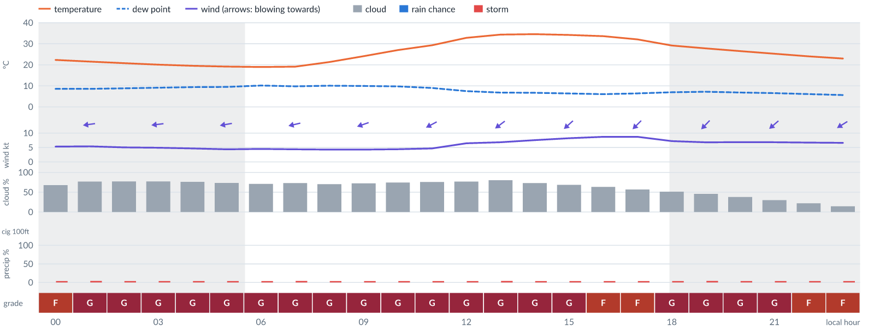
Meteogram — hourly forecast; shaded = before first light / after last light. Gaps mean no data.
Ser | Hrs | Temp | Cloud | Wind | Gust | QNH | Assessment | Driver | Remarks
(a) | (b) | (c) | (d) | (e) | (f) | (g) | (h) | (i) | (j)
1. | 0001 | 22 (spread 22–23)°C | ◕ Cloudy (68%) | ← 5 (spread 5–6) kts E | 11 kts | 1016 | F - Very Poor | cloud 68% · visibility not forecast | cloud cover, thunderstorm risk, gusts, wind shear
2. | 0100 | 22 (spread 21–22)°C | ◕ Cloudy (77%) | ← 5 (spread 5–6) kts E | 10 kts | 1016 | G - Unacceptable | cloud 77% · visibility not forecast | cloud cover, thunderstorm risk, gusts, wind shear
3. | 0200 | 21 (spread 20–22)°C | ◕ Cloudy (77%) | ← 5 (spread 5–6) kts E | 10 kts | 1015 | G - Unacceptable | cloud 77% · visibility not forecast | cloud cover, thunderstorm risk, gusts, wind shear
4. | 0300 | 20 (spread 20–21)°C | ◕ Cloudy (77%) | ← 5 (spread 4–6) kts E | 9 kts | 1015 | G - Unacceptable | cloud 77% · visibility not forecast | cloud cover, thunderstorm risk, gusts
5. | 0400 | 20 (spread 19–20)°C | ◕ Cloudy (76%) | ← 5 (spread 4–5) kts E | 8 kts | 1015 | G - Unacceptable | cloud 76% · visibility not forecast | cloud cover, thunderstorm risk
6. | 0500 | 19 (spread 19–20)°C | ◕ Cloudy (73%) | ← 4 (spread 4–5) kts E | 8 kts | 1015 | G - Unacceptable | cloud 73% · visibility not forecast | cloud cover, thunderstorm risk
7. | 0600 | 19°C | ◕ Cloudy (71%) | ← 5 (spread 4–5) kts ENE | 8 kts | 1015 | G - Unacceptable | cloud 71% · visibility not forecast | cloud cover, thunderstorm risk
8. | 0700 | 19 (spread 19–20)°C | ◕ Cloudy (73%) | ← 4 (spread 3–5) kts ENE | 8 kts | 1015 | G - Unacceptable | cloud 73% · visibility not forecast | cloud cover, thunderstorm risk
9. | 0800 | 21 (spread 21–22)°C | ◕ Cloudy (70%) | ← 4 (spread 3–5) kts ENE | 8 kts | 1016 | G - Unacceptable | cloud 70% · visibility not forecast | cloud cover, thunderstorm risk
10. | 0900 | 24 (spread 24–25)°C | ◕ Cloudy (72%) | ← 4 (spread 4–5) kts ENE | 8 kts | 1016 | G - Unacceptable | cloud 72% · visibility not forecast | cloud cover, thunderstorm risk
11. | 1000 | 27 (spread 27–28)°C | ◕ Cloudy (74%) | ← 4 (spread 4–5) kts ENE | 9 kts | 1017 | G - Unacceptable | cloud 74% · visibility not forecast | cloud cover, thunderstorm risk, gusts, wind shear
12. | 1100 | 29 (spread 29–30)°C | ◕ Cloudy (76%) | ↙ 5 (spread 4–5) kts ENE | 10 kts | 1017 | G - Unacceptable | cloud 76% · visibility not forecast | cloud cover, thunderstorm risk, gusts, wind shear
13. | 1200 | 33 (spread 32–33)°C | ◕ Cloudy (77%) | ↙ 6 (spread 6–7) kts NE | 12 kts | 1017 | G - Unacceptable | cloud 77% · visibility not forecast | cloud cover, gusts, thunderstorm risk, wind shear
14. | 1300 | 34 (spread 34–35)°C | ◕ Cloudy (80%) | ↙ 7 (spread 6–8) kts NE | 14 kts | 1017 | G - Unacceptable | cloud 80% · visibility not forecast | cloud cover, gusts, wind shear, thunderstorm risk
15. | 1400 | 35 (spread 34–35)°C | ◕ Cloudy (73%) | ↙ 8 (spread 7–9) kts NE | 14 kts | 1017 | G - Unacceptable | cloud 73% · visibility not forecast | cloud cover, gusts, thunderstorm risk, wind shear
16. | 1500 | 34°C | ◕ Cloudy (69%) | ↙ 8 (spread 7–10) kts NE | 15 kts | 1017 | G - Unacceptable | cloud 69% · visibility not forecast | cloud cover, gusts, wind shear, thunderstorm risk
17. | 1600 | 34 (spread 33–34)°C | ◕ Cloudy (63%) | ↙ 9 (spread 8–10) kts NE | 16 kts | 1016 | F - Very Poor | cloud 63% · gust 16 kt · visibility not forecast | cloud cover, gusts, wind shear, thunderstorm risk, strong wind
18. | 1700 | 32°C | ◑ Partly cloudy (57%) | ↙ 9 (spread 8–10) kts NE | 17 kts | 1016 | F - Very Poor | gust 17 kt · visibility not forecast | gusts, cloud cover, wind shear, thunderstorm risk, strong wind
19. | 1800 | 29 (spread 29–30)°C | ◑ Partly cloudy (51%) | ↙ 7 (spread 7–8) kts NE | 18 kts | 1016 | G - Unacceptable | gust 18 kt · gust spread +11 kt · visibility not forecast | gusts, wind shear, cloud cover, thunderstorm risk
20. | 1900 | 28 (spread 27–29)°C | ◑ Partly cloudy (46%) | ↙ 7 (spread 6–7) kts NE | 19 kts | 1015 | G - Unacceptable | gust 19 kt · gust spread +12 kt · visibility not forecast | gusts, wind shear, cloud cover, thunderstorm risk
21. | 2000 | 27 (spread 26–27)°C | ◑ Partly cloudy (38%) | ↙ 7 (spread 6–7) kts NE | 18 kts | 1016 | G - Unacceptable | gust 18 kt · gust spread +11 kt · visibility not forecast | gusts, wind shear, thunderstorm risk
22. | 2100 | 25 (spread 25–26)°C | ◔ Mostly clear (30%) | ↙ 7 (spread 6–7) kts NE | 17 kts | 1015 | G - Unacceptable | gust spread +10 kt · visibility not forecast | wind shear, gusts, thunderstorm risk
23. | 2200 | 24 (spread 24–25)°C | ◔ Mostly clear (22%) | ↙ 7 (spread 6–7) kts NE | 16 kts | 1016 | F - Very Poor | gust 16 kt · gust spread +9 kt · visibility not forecast | gusts, wind shear, thunderstorm risk
24. | 2300 | 23 (spread 23–24)°C | ◔ Mostly clear (14%) | ↙ 7 (spread 6–7) kts ENE | 15 kts | 1016 | F - Very Poor | gust 15 kt · visibility not forecast | gusts, wind shear, thunderstorm risk
Confidence: 70% — data for 24 of 24 hours; 16% of readings interpolated · first light 0602L · last light 1826L · Moon 15 % illuminated, rises 09:49, sets 21:29.

Sat 14 Nov 26
Conditions are expected to be generally Unacceptable: clear, winds up to 11 kts ENE, gusting 20 kts and temperatures 18–33°C. No flyable windows (Marginal or better, ≥2 consecutive hrs) are forecast. Hazards: thunderstorm risk 0001–2300L. Overall similar to the previous day.
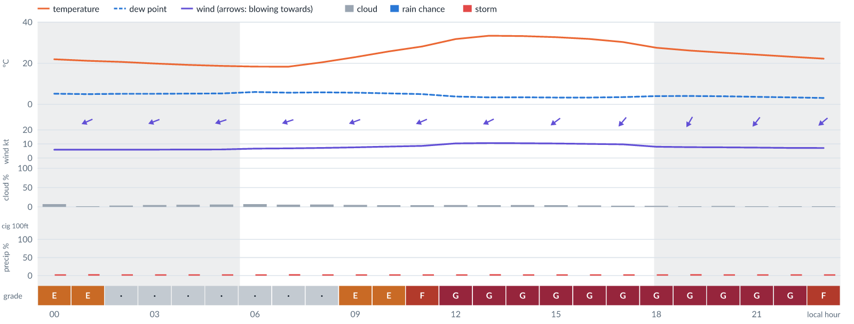
Meteogram — hourly forecast; shaded = before first light / after last light. Gaps mean no data.
Ser | Hrs | Temp | Cloud | Wind | Gust | QNH | Assessment | Driver | Remarks
(a) | (b) | (c) | (d) | (e) | (f) | (g) | (h) | (i) | (j)
1. | 0001 | 22 (spread 21–23)°C | ☀ Clear (7%) | ↙ 6 kts ENE | 13 kts | 1016 | E - Poor | gust 13 kt · gust spread +7 kt · visibility not forecast | gusts, wind shear, thunderstorm risk
2. | 0100 | 21 (spread 21–22)°C | ☀ Clear (2%) | ↙ 6 kts ENE | 12 kts | 1016 | E - Poor | gust 12 kt · visibility not forecast | gusts, thunderstorm risk, wind shear
3. | 0200 | 21 (spread 20–21)°C | ☀ Clear (4%) | ← 6 kts ENE | 11 kts | 1016 | · - No data | storm 4% · gust 11 kt · visibility not forecast | thunderstorm risk, gusts, wind shear
4. | 0300 | 20 (spread 20–21)°C | ☀ Clear (5%) | ← 6 kts ENE | 11 kts | 1016 | · - No data | storm 4% · gust 11 kt · visibility not forecast | thunderstorm risk, gusts, wind shear
5. | 0400 | 19 (spread 19–20)°C | ☀ Clear (6%) | ← 6 kts ENE | 10 kts | 1016 | · - No data | storm 4% · gust 10 kt · visibility not forecast | thunderstorm risk, gusts
6. | 0500 | 19 (spread 18–19)°C | ☀ Clear (6%) | ← 6 kts ENE | 10 kts | 1015 | · - No data | storm 4% · gust 10 kt · visibility not forecast | thunderstorm risk, gusts
7. | 0600 | 18 (spread 18–19)°C | ☀ Clear (7%) | ← 7 (spread 6–7) kts ENE | 10 kts | 1015 | · - No data | storm 4% · gust 10 kt · visibility not forecast | thunderstorm risk, gusts
8. | 0700 | 18 (spread 18–19)°C | ☀ Clear (6%) | ← 7 (spread 6–7) kts ENE | 10 kts | 1015 | · - No data | storm 4% · gust 10 kt · visibility not forecast | thunderstorm risk, gusts
9. | 0800 | 20 (spread 20–21)°C | ☀ Clear (6%) | ← 7 (spread 7–8) kts ENE | 11 kts | 1016 | · - No data | storm 4% · gust 11 kt · visibility not forecast | thunderstorm risk, gusts
10. | 0900 | 23 (spread 22–24)°C | ☀ Clear (5%) | ← 8 (spread 7–8) kts ENE | 13 kts | 1016 | E - Poor | gust 13 kt · visibility not forecast | gusts, thunderstorm risk, wind shear
11. | 1000 | 26 (spread 25–26)°C | ☀ Clear (4%) | ← 8 (spread 7–9) kts ENE | 14 kts | 1016 | E - Poor | gust 14 kt · visibility not forecast | gusts, thunderstorm risk, wind shear
12. | 1100 | 28°C | ☀ Clear (4%) | ↙ 9 (spread 8–9) kts ENE | 16 kts | 1017 | F - Very Poor | gust 16 kt · visibility not forecast | gusts, wind shear, thunderstorm risk, strong wind
13. | 1200 | 32 (spread 31–32)°C | ☀ Clear (5%) | ↙ 10 (spread 10–11) kts ENE | 18 kts | 1017 | G - Unacceptable | gust 18 kt · visibility not forecast | gusts, wind shear, thunderstorm risk, strong wind
14. | 1300 | 33 (spread 33–34)°C | ☀ Clear (4%) | ↙ 11 (spread 10–11) kts ENE | 19 kts | 1016 | G - Unacceptable | gust 19 kt · visibility not forecast | gusts, wind shear, thunderstorm risk, strong wind
15. | 1400 | 33°C | ☀ Clear (5%) | ↙ 11 (spread 10–11) kts ENE | 19 kts | 1016 | G - Unacceptable | gust 19 kt · visibility not forecast | gusts, wind shear, thunderstorm risk, strong wind
16. | 1500 | 33°C | ☀ Clear (4%) | ↙ 10 kts NE | 19 kts | 1016 | G - Unacceptable | gust 19 kt · visibility not forecast | gusts, wind shear, thunderstorm risk, strong wind
17. | 1600 | 32°C | ☀ Clear (4%) | ↙ 10 kts NE | 19 kts | 1015 | G - Unacceptable | gust 19 kt · visibility not forecast | gusts, wind shear, thunderstorm risk, strong wind
18. | 1700 | 30°C | ☀ Clear (3%) | ↙ 10 kts NE | 19 kts | 1015 | G - Unacceptable | gust 19 kt · visibility not forecast | gusts, wind shear, thunderstorm risk, strong wind
19. | 1800 | 28 (spread 27–28)°C | ☀ Clear (3%) | ↙ 8 kts NE | 19 kts | 1015 | G - Unacceptable | gust 19 kt · gust spread +11 kt · visibility not forecast | gusts, wind shear, thunderstorm risk
20. | 1900 | 26 (spread 26–27)°C | ☀ Clear (2%) | ↙ 8 (spread 7–8) kts NNE | 20 kts | 1014 | G - Unacceptable | gust 20 kt · gust spread +12 kt · visibility not forecast | gusts, wind shear, thunderstorm risk
21. | 2000 | 25 (spread 25–26)°C | ☀ Clear (2%) | ↙ 8 (spread 7–8) kts NNE | 19 kts | 1014 | G - Unacceptable | gust 19 kt · gust spread +12 kt · visibility not forecast | gusts, wind shear, thunderstorm risk
22. | 2100 | 24 (spread 24–25)°C | ☀ Clear (2%) | ↙ 7 (spread 7–8) kts NE | 19 kts | 1015 | G - Unacceptable | gust 19 kt · gust spread +11 kt · visibility not forecast | gusts, wind shear, thunderstorm risk
23. | 2200 | 23 (spread 23–24)°C | ☀ Clear (2%) | ↙ 7 kts NE | 18 kts | 1015 | G - Unacceptable | gust 18 kt · gust spread +11 kt · visibility not forecast | gusts, wind shear, thunderstorm risk
24. | 2300 | 22 (spread 22–23)°C | ☀ Clear (2%) | ↙ 7 kts NE | 16 kts | 1015 | F - Very Poor | gust 16 kt · gust spread +9 kt · visibility not forecast | gusts, wind shear, thunderstorm risk
Confidence: 71% — data for 24 of 24 hours; 16% of readings interpolated · first light 0603L · last light 1826L · Moon 23 % illuminated, rises 10:37, sets 22:21.

Sun 15 Nov 26
Conditions are expected to be generally Poor: clear, winds up to 8 kts ENE, gusting 15 kts and temperatures 18–34°C. No flyable windows (Marginal or better, ≥2 consecutive hrs) are forecast. Hazards: thunderstorm risk 0001–2300L. Overall an improvement on the previous day.
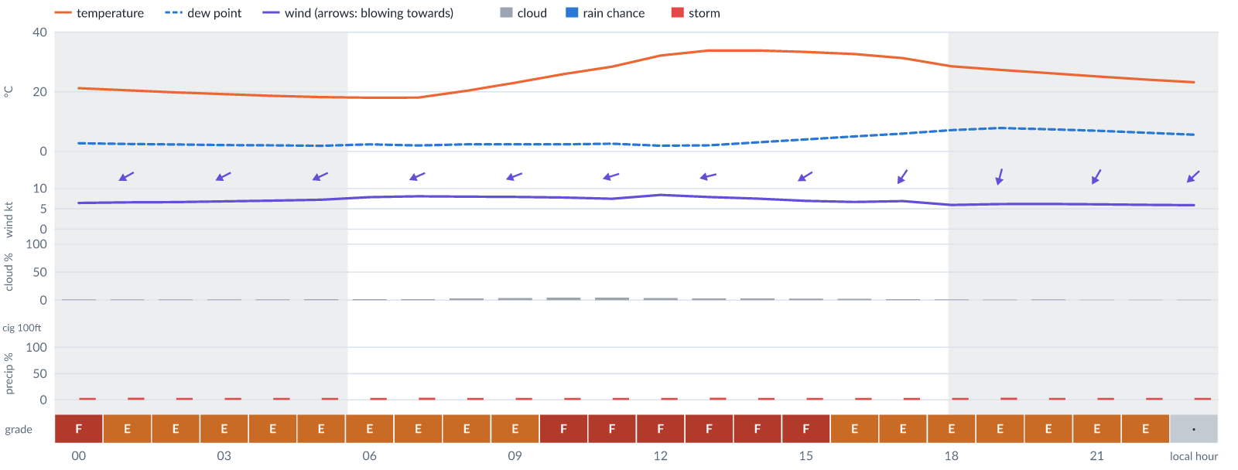
Meteogram — hourly forecast; shaded = before first light / after last light. Gaps mean no data.
Ser | Hrs | Temp | Cloud | Wind | Gust | QNH | Assessment | Driver | Remarks
(a) | (b) | (c) | (d) | (e) | (f) | (g) | (h) | (i) | (j)
1. | 0001 | 21 (spread 21–22)°C | ☀ Clear (2%) | ↙ 6 (spread 6–7) kts NE | 15 kts | 1014 | F - Very Poor | gust 15 kt · gust spread +8 kt · visibility not forecast | gusts, wind shear, thunderstorm risk
2. | 0100 | 20 (spread 20–21)°C | ☀ Clear (1%) | ↙ 7 (spread 6–7) kts ENE | 14 kts | 1014 | E - Poor | gust 14 kt · gust spread +7 kt · visibility not forecast | gusts, wind shear, thunderstorm risk
3. | 0200 | 20°C | ☀ Clear (2%) | ↙ 7 kts ENE | 13 kts | 1014 | E - Poor | gust 13 kt · visibility not forecast | gusts, thunderstorm risk, wind shear
4. | 0300 | 19 (spread 19–20)°C | ☀ Clear (2%) | ↙ 7 kts ENE | 12 kts | 1014 | E - Poor | gust 12 kt · visibility not forecast | gusts, thunderstorm risk, wind shear
5. | 0400 | 19 (spread 18–19)°C | ☀ Clear (2%) | ↙ 7 kts ENE | 12 kts | 1014 | E - Poor | gust 12 kt · visibility not forecast | gusts, thunderstorm risk, wind shear
6. | 0500 | 18 (spread 18–19)°C | ☀ Clear (2%) | ↙ 7 (spread 7–8) kts ENE | 12 kts | 1015 | E - Poor | gust 12 kt · visibility not forecast | gusts, thunderstorm risk, wind shear
7. | 0600 | 18 (spread 17–18)°C | ☀ Clear (2%) | ↙ 8 (spread 7–8) kts ENE | 13 kts | 1015 | E - Poor | gust 13 kt · visibility not forecast | gusts, thunderstorm risk, wind shear
8. | 0700 | 18°C | ☀ Clear (2%) | ↙ 8 (spread 7–8) kts ENE | 13 kts | 1015 | E - Poor | gust 13 kt · visibility not forecast | gusts, thunderstorm risk, wind shear
9. | 0800 | 20 (spread 20–21)°C | ☀ Clear (3%) | ← 8 kts ENE | 13 kts | 1015 | E - Poor | gust 13 kt · visibility not forecast | gusts, thunderstorm risk, wind shear
10. | 0900 | 23 (spread 22–24)°C | ☀ Clear (4%) | ← 8 kts ENE | 14 kts | 1016 | E - Poor | gust 14 kt · visibility not forecast | gusts, thunderstorm risk, wind shear
11. | 1000 | 26 (spread 25–26)°C | ☀ Clear (4%) | ← 8 kts ENE | 15 kts | 1016 | F - Very Poor | gust 15 kt · visibility not forecast | gusts, wind shear, thunderstorm risk
12. | 1100 | 28 (spread 28–29)°C | ☀ Clear (4%) | ← 7 (spread 7–8) kts ENE | 15 kts | 1016 | F - Very Poor | gust 15 kt · visibility not forecast | gusts, wind shear, thunderstorm risk
13. | 1200 | 32°C | ☀ Clear (4%) | ← 8 (spread 8–9) kts ENE | 15 kts | 1016 | F - Very Poor | gust 15 kt · visibility not forecast | gusts, wind shear, thunderstorm risk
14. | 1300 | 34 (spread 33–34)°C | ☀ Clear (3%) | ← 8 kts ENE | 15 kts | 1016 | F - Very Poor | gust 15 kt · visibility not forecast | gusts, wind shear, thunderstorm risk
15. | 1400 | 34°C | ☀ Clear (3%) | ← 7 (spread 7–8) kts ENE | 15 kts | 1016 | F - Very Poor | gust 15 kt · visibility not forecast | gusts, wind shear, thunderstorm risk
16. | 1500 | 33 (spread 33–34)°C | ☀ Clear (3%) | ↙ 7 kts ENE | 15 kts | 1016 | F - Very Poor | gust 15 kt · visibility not forecast | gusts, wind shear, thunderstorm risk
17. | 1600 | 33°C | ☀ Clear (2%) | ↙ 7 (spread 6–7) kts NE | 14 kts | 1015 | E - Poor | gust 14 kt · gust spread +8 kt · visibility not forecast | gusts, wind shear, thunderstorm risk
18. | 1700 | 31°C | ☀ Clear (2%) | ↙ 7 kts NE | 14 kts | 1015 | E - Poor | gust 14 kt · gust spread +7 kt · visibility not forecast | gusts, wind shear, thunderstorm risk
19. | 1800 | 29 (spread 28–29)°C | ☀ Clear (2%) | ↙ 6 kts NNE | 13 kts | 1015 | E - Poor | gust 13 kt · gust spread +7 kt · visibility not forecast | gusts, wind shear, thunderstorm risk
20. | 1900 | 27 (spread 27–28)°C | ☀ Clear (1%) | ↓ 6 kts NNE | 13 kts | 1014 | E - Poor | gust 13 kt · gust spread +7 kt · visibility not forecast | gusts, wind shear, thunderstorm risk
21. | 2000 | 26 (spread 26–27)°C | ☀ Clear (1%) | ↙ 6 kts NNE | 13 kts | 1014 | E - Poor | gust 13 kt · gust spread +6 kt · visibility not forecast | gusts, wind shear, thunderstorm risk
22. | 2100 | 25 (spread 25–26)°C | ☀ Clear (1%) | ↙ 6 kts NNE | 12 kts | 1014 | E - Poor | gust 12 kt · visibility not forecast | gusts, thunderstorm risk, wind shear
23. | 2200 | 24 (spread 24–25)°C | ☀ Clear (1%) | ↙ 6 kts NE | 12 kts | 1014 | E - Poor | gust 12 kt · visibility not forecast | gusts, thunderstorm risk, wind shear
24. | 2300 | 23 (spread 23–24)°C | ☀ Clear (1%) | ↙ 6 kts NE | 11 kts | 1014 | · - No data | storm 4% · gust 11 kt · visibility not forecast | thunderstorm risk, gusts, wind shear
Confidence: 71% — data for 24 of 24 hours; 16% of readings interpolated · first light 0603L · last light 1826L · Moon 31 % illuminated, rises 11:22, sets 23:10.

Mon 16 Nov 26
Conditions are expected to be generally Poor: clear, winds up to 7 kts ENE, gusting 15 kts and temperatures 19–35°C. No flyable windows (Marginal or better, ≥2 consecutive hrs) are forecast. Hazards: thunderstorm risk 0001–2300L. Overall similar to the previous day.
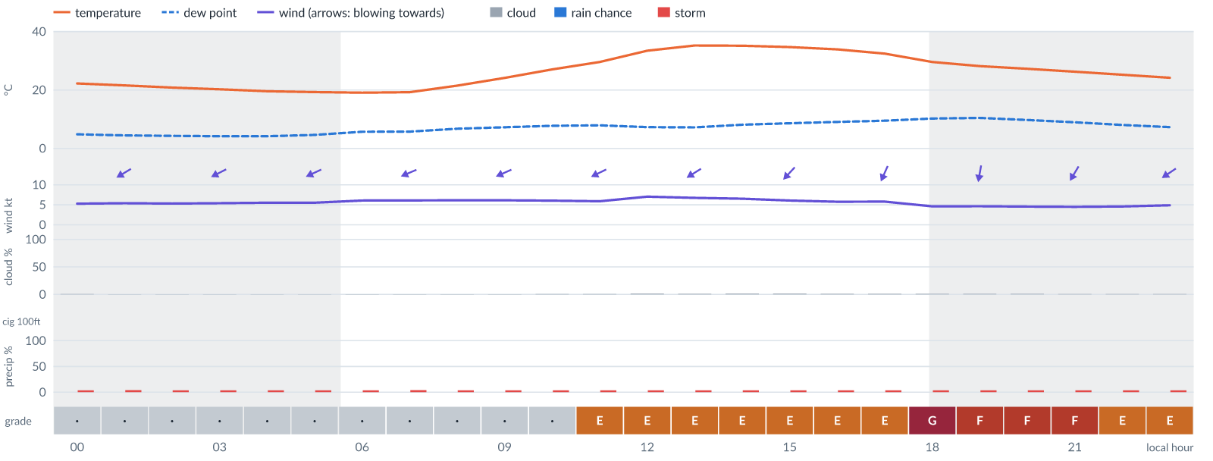
Meteogram — hourly forecast; shaded = before first light / after last light. Gaps mean no data.
Ser | Hrs | Temp | Cloud | Wind | Gust | QNH | Assessment | Driver | Remarks
(a) | (b) | (c) | (d) | (e) | (f) | (g) | (h) | (i) | (j)
1. | 0001 | 22 (spread 22–23)°C | ☀ Clear (1%) | ↙ 5 (spread 5–6) kts NE | 9 kts | 1014 | · - No data | storm 4% · gust 9 kt · visibility not forecast | thunderstorm risk, gusts
2. | 0100 | 22 (spread 21–22)°C | ☀ Clear (0%) | ↙ 5 (spread 5–6) kts ENE | 9 kts | 1014 | · - No data | storm 4% · gust 9 kt · visibility not forecast | thunderstorm risk, gusts
3. | 0200 | 21 (spread 21–22)°C | ☀ Clear (0%) | ↙ 5 (spread 5–6) kts ENE | 8 kts | 1014 | · - No data | storm 4% · visibility not forecast | thunderstorm risk
4. | 0300 | 20 (spread 20–21)°C | ☀ Clear (0%) | ↙ 5 (spread 5–6) kts ENE | 8 kts | 1014 | · - No data | storm 4% · visibility not forecast | thunderstorm risk
5. | 0400 | 20 (spread 19–20)°C | ☀ Clear (0%) | ↙ 6 (spread 5–6) kts ENE | 8 kts | 1014 | · - No data | storm 4% · visibility not forecast | thunderstorm risk
6. | 0500 | 19 (spread 19–20)°C | ☀ Clear (0%) | ↙ 6 (spread 5–6) kts ENE | 8 kts | 1014 | · - No data | storm 4% · visibility not forecast | thunderstorm risk
7. | 0600 | 19°C | ☀ Clear (0%) | ↙ 6 (spread 5–7) kts ENE | 9 kts | 1014 | · - No data | storm 4% · gust 9 kt · visibility not forecast | thunderstorm risk, gusts
8. | 0700 | 19°C | ☀ Clear (0%) | ↙ 6 (spread 5–7) kts ENE | 9 kts | 1014 | · - No data | storm 4% · gust 9 kt · visibility not forecast | thunderstorm risk, gusts
9. | 0800 | 21 (spread 21–22)°C | ☀ Clear (0%) | ↙ 6 (spread 6–7) kts ENE | 10 kts | 1014 | · - No data | storm 4% · gust 10 kt · visibility not forecast | thunderstorm risk, gusts
10. | 0900 | 24 (spread 24–25)°C | ☀ Clear (0%) | ↙ 6 (spread 6–7) kts ENE | 10 kts | 1015 | · - No data | storm 4% · gust 10 kt · visibility not forecast | thunderstorm risk, gusts
11. | 1000 | 27°C | ☀ Clear (1%) | ↙ 6 kts ENE | 11 kts | 1015 | · - No data | storm 4% · gust 11 kt · visibility not forecast | thunderstorm risk, gusts, wind shear
12. | 1100 | 30°C | ☀ Clear (1%) | ↙ 6 kts ENE | 12 kts | 1015 | E - Poor | gust 12 kt · visibility not forecast | gusts, thunderstorm risk, wind shear
13. | 1200 | 33 (spread 33–34)°C | ☀ Clear (1%) | ↙ 7 kts ENE | 13 kts | 1015 | E - Poor | gust 13 kt · visibility not forecast | gusts, thunderstorm risk, wind shear
14. | 1300 | 35°C | ☀ Clear (1%) | ↙ 7 kts ENE | 13 kts | 1015 | E - Poor | gust 13 kt · visibility not forecast | gusts, thunderstorm risk, wind shear
15. | 1400 | 35°C | ☀ Clear (1%) | ↙ 7 kts NE | 13 kts | 1015 | E - Poor | gust 13 kt · visibility not forecast | gusts, thunderstorm risk, wind shear
16. | 1500 | 35°C | ☀ Clear (1%) | ↙ 6 kts NE | 13 kts | 1015 | E - Poor | gust 13 kt · gust spread +7 kt · visibility not forecast | gusts, wind shear, thunderstorm risk
17. | 1600 | 34°C | ☀ Clear (1%) | ↙ 6 kts NNE | 12 kts | 1014 | E - Poor | gust 12 kt · visibility not forecast | gusts, thunderstorm risk, wind shear
18. | 1700 | 32°C | ☀ Clear (1%) | ↙ 6 kts NNE | 12 kts | 1014 | E - Poor | gust 12 kt · visibility not forecast | gusts, thunderstorm risk, wind shear
19. | 1800 | 30°C | ☀ Clear (1%) | ↓ 5 kts NNE | 15 kts | 1014 | G - Unacceptable | gust spread +10 kt · visibility not forecast | wind shear, gusts, thunderstorm risk
20. | 1900 | 28°C | ☀ Clear (1%) | ↓ 5 kts N | 14 kts | 1013 | F - Very Poor | gust spread +10 kt · visibility not forecast | wind shear, gusts, thunderstorm risk
21. | 2000 | 27°C | ☀ Clear (1%) | ↓ 5 kts NNE | 14 kts | 1013 | F - Very Poor | gust spread +9 kt · visibility not forecast | wind shear, gusts, thunderstorm risk
22. | 2100 | 26°C | ☀ Clear (0%) | ↙ 4 kts NNE | 13 kts | 1013 | F - Very Poor | gust spread +9 kt · visibility not forecast | wind shear, gusts, thunderstorm risk
23. | 2200 | 25°C | ☀ Clear (0%) | ↙ 5 kts NE | 12 kts | 1013 | E - Poor | gust 12 kt · gust spread +8 kt · visibility not forecast | gusts, wind shear, thunderstorm risk
24. | 2300 | 24°C | ☀ Clear (0%) | ↙ 5 kts ENE | 12 kts | 1014 | E - Poor | gust 12 kt · gust spread +7 kt · visibility not forecast | gusts, wind shear, thunderstorm risk
Confidence: 70% — data for 24 of 24 hours; 9% of readings interpolated · first light 0603L · last light 1826L · Moon 40 % illuminated, rises 12:04, sets 23:58.

Tue 17 Nov 26
Conditions are expected to be generally Poor: clear, winds up to 7 kts ENE, gusting 15 kts and temperatures 20–36°C. No flyable windows (Marginal or better, ≥2 consecutive hrs) are forecast. Hazards: thunderstorm risk 0001–2300L. Overall similar to the previous day.
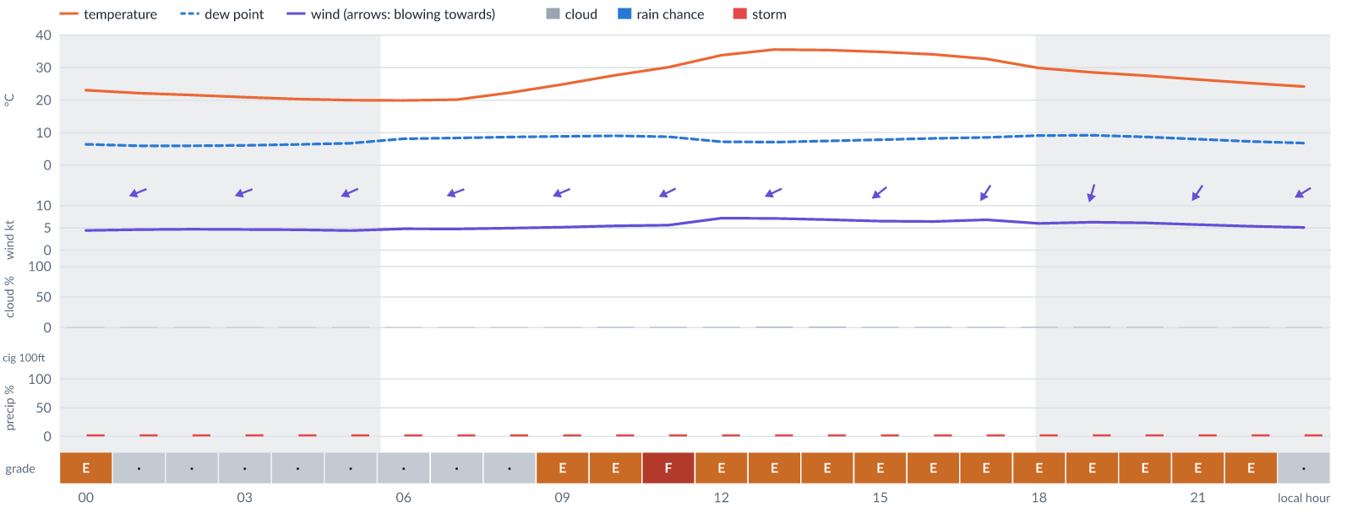
Meteogram — hourly forecast; shaded = before first light / after last light. Gaps mean no data.
Ser | Hrs | Temp | Cloud | Wind | Gust | QNH | Assessment | Driver | Remarks
(a) | (b) | (c) | (d) | (e) | (f) | (g) | (h) | (i) | (j)
1. | 0001 | 23°C | ☀ Clear (0%) | ↙ 4 kts ENE | 11 kts | 1013 | E - Poor | gust spread +6 kt · visibility not forecast | wind shear, thunderstorm risk, gusts
2. | 0100 | 22°C | ☀ Clear (0%) | ← 5 kts ENE | 10 kts | 1013 | · - No data | storm 4% · gust 10 kt · visibility not forecast | thunderstorm risk, gusts, wind shear
3. | 0200 | 22°C | ☀ Clear (0%) | ← 5 kts ENE | 10 kts | 1013 | · - No data | storm 4% · gust 10 kt · visibility not forecast | thunderstorm risk, gusts, wind shear
4. | 0300 | 21°C | ☀ Clear (0%) | ← 5 kts ENE | 10 kts | 1013 | · - No data | storm 4% · gust 10 kt · visibility not forecast | thunderstorm risk, gusts, wind shear
5. | 0400 | 20°C | ☀ Clear (0%) | ↙ 5 kts ENE | 10 kts | 1013 | · - No data | storm 4% · gust 10 kt · visibility not forecast | thunderstorm risk, gusts, wind shear
6. | 0500 | 20°C | ☀ Clear (0%) | ↙ 4 kts ENE | 10 kts | 1013 | · - No data | storm 4% · gust 10 kt · visibility not forecast | thunderstorm risk, gusts, wind shear
7. | 0600 | 20°C | ☀ Clear (0%) | ↙ 5 kts ENE | 10 kts | 1013 | · - No data | storm 4% · gust 10 kt · visibility not forecast | thunderstorm risk, gusts, wind shear
8. | 0700 | 20°C | ☀ Clear (0%) | ← 5 kts ENE | 10 kts | 1013 | · - No data | storm 4% · gust 10 kt · visibility not forecast | thunderstorm risk, gusts, wind shear
9. | 0800 | 22°C | ☀ Clear (0%) | ← 5 kts ENE | 11 kts | 1013 | · - No data | storm 4% · gust 11 kt · visibility not forecast | thunderstorm risk, gusts, wind shear
10. | 0900 | 25°C | ☀ Clear (0%) | ↙ 5 kts ENE | 12 kts | 1013 | E - Poor | gust 12 kt · gust spread +7 kt · visibility not forecast | gusts, wind shear, thunderstorm risk
11. | 1000 | 28°C | ☀ Clear (1%) | ↙ 5 kts ENE | 13 kts | 1014 | E - Poor | gust 13 kt · gust spread +8 kt · visibility not forecast | gusts, wind shear, thunderstorm risk
12. | 1100 | 30°C | ☀ Clear (1%) | ↙ 6 kts ENE | 15 kts | 1014 | F - Very Poor | gust 15 kt · gust spread +9 kt · visibility not forecast | gusts, wind shear, thunderstorm risk
13. | 1200 | 34°C | ☀ Clear (1%) | ↙ 7 kts ENE | 12 kts | 1014 | E - Poor | gust 12 kt · visibility not forecast | gusts, thunderstorm risk, wind shear
14. | 1300 | 36°C | ☀ Clear (1%) | ↙ 7 kts ENE | 13 kts | 1014 | E - Poor | gust 13 kt · visibility not forecast | gusts, thunderstorm risk, wind shear
15. | 1400 | 35°C | ☀ Clear (1%) | ↙ 7 kts ENE | 13 kts | 1014 | E - Poor | gust 13 kt · visibility not forecast | gusts, thunderstorm risk, wind shear
16. | 1500 | 35°C | ☀ Clear (1%) | ↙ 7 kts NE | 13 kts | 1013 | E - Poor | gust 13 kt · visibility not forecast | gusts, thunderstorm risk, wind shear
17. | 1600 | 34°C | ☀ Clear (1%) | ↙ 6 kts NE | 13 kts | 1013 | E - Poor | gust 13 kt · gust spread +7 kt · visibility not forecast | gusts, wind shear, thunderstorm risk
18. | 1700 | 33°C | ☀ Clear (1%) | ↙ 7 kts NNE | 13 kts | 1013 | E - Poor | gust 13 kt · visibility not forecast | gusts, thunderstorm risk, wind shear
19. | 1800 | 30°C | ☀ Clear (1%) | ↙ 6 kts NNE | 13 kts | 1012 | E - Poor | gust 13 kt · gust spread +7 kt · visibility not forecast | gusts, wind shear, thunderstorm risk
20. | 1900 | 29°C | ☀ Clear (1%) | ↓ 6 kts NNE | 13 kts | 1012 | E - Poor | gust 13 kt · gust spread +7 kt · visibility not forecast | gusts, wind shear, thunderstorm risk
21. | 2000 | 28°C | ☀ Clear (1%) | ↙ 6 kts NNE | 13 kts | 1012 | E - Poor | gust 13 kt · gust spread +7 kt · visibility not forecast | gusts, wind shear, thunderstorm risk
22. | 2100 | 26°C | ☀ Clear (0%) | ↙ 6 kts NNE | 12 kts | 1012 | E - Poor | gust 12 kt · visibility not forecast | gusts, thunderstorm risk, wind shear
23. | 2200 | 25°C | ☀ Clear (0%) | ↙ 5 kts NE | 12 kts | 1012 | E - Poor | gust 12 kt · gust spread +6 kt · visibility not forecast | gusts, wind shear, thunderstorm risk
24. | 2300 | 24°C | ☀ Clear (0%) | ↙ 5 kts ENE | 11 kts | 1013 | · - No data | storm 4% · gust 11 kt · visibility not forecast | thunderstorm risk, gusts, wind shear
Confidence: 70% — data for 24 of 24 hours · first light 0604L · last light 1826L · Moon 50 % illuminated, rises 12:44.

Wed 18 Nov 26
Conditions are expected to be generally Very Poor: mostly clear, winds up to 9 kts ENE, gusting 16 kts and temperatures 20–36°C. No flyable windows (Marginal or better, ≥2 consecutive hrs) are forecast. Hazards: thunderstorm risk 0001–2300L. Overall a deterioration from the previous day.
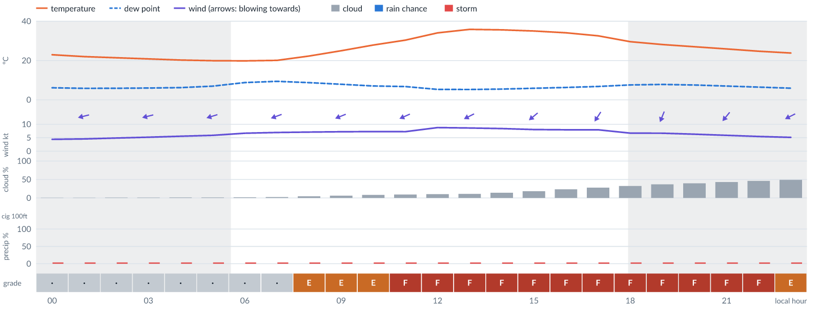
Meteogram — hourly forecast; shaded = before first light / after last light. Gaps mean no data.
Ser | Hrs | Temp | Cloud | Wind | Gust | QNH | Assessment | Driver | Remarks
(a) | (b) | (c) | (d) | (e) | (f) | (g) | (h) | (i) | (j)
1. | 0001 | 23°C | ☀ Clear (0%) | ← 4 kts ENE | 10 kts | 1012 | · - No data | storm 4% · gust 10 kt · visibility not forecast | thunderstorm risk, gusts, wind shear
2. | 0100 | 22°C | ☀ Clear (0%) | ← 5 kts ENE | 10 kts | 1012 | · - No data | storm 4% · gust 10 kt · visibility not forecast | thunderstorm risk, gusts, wind shear
3. | 0200 | 21°C | ☀ Clear (1%) | ← 5 kts ENE | 10 kts | 1012 | · - No data | storm 4% · gust 10 kt · visibility not forecast | thunderstorm risk, gusts, wind shear
4. | 0300 | 21°C | ☀ Clear (1%) | ← 5 kts ENE | 10 kts | 1012 | · - No data | storm 4% · gust 10 kt · visibility not forecast | thunderstorm risk, gusts, wind shear
5. | 0400 | 20°C | ☀ Clear (1%) | ← 6 kts ENE | 10 kts | 1012 | · - No data | storm 4% · gust 10 kt · visibility not forecast | thunderstorm risk, gusts
6. | 0500 | 20°C | ☀ Clear (1%) | ← 6 kts ENE | 10 kts | 1012 | · - No data | storm 4% · gust 10 kt · visibility not forecast | thunderstorm risk, gusts
7. | 0600 | 20°C | ☀ Clear (2%) | ← 7 kts ENE | 10 kts | 1012 | · - No data | storm 4% · gust 10 kt · visibility not forecast | thunderstorm risk, gusts
8. | 0700 | 20°C | ☀ Clear (2%) | ← 7 kts ENE | 11 kts | 1012 | · - No data | storm 4% · gust 11 kt · visibility not forecast | thunderstorm risk, gusts
9. | 0800 | 22°C | ☀ Clear (4%) | ← 7 kts ENE | 12 kts | 1013 | E - Poor | gust 12 kt · visibility not forecast | gusts, thunderstorm risk, wind shear
10. | 0900 | 25°C | ☀ Clear (6%) | ← 7 kts ENE | 13 kts | 1013 | E - Poor | gust 13 kt · visibility not forecast | gusts, thunderstorm risk, wind shear
11. | 1000 | 28°C | ☀ Clear (8%) | ↙ 7 kts ENE | 14 kts | 1014 | E - Poor | gust 14 kt · gust spread +7 kt · visibility not forecast | gusts, wind shear, thunderstorm risk
12. | 1100 | 30°C | ☀ Clear (9%) | ↙ 7 kts ENE | 15 kts | 1014 | F - Very Poor | gust 15 kt · visibility not forecast | gusts, wind shear, thunderstorm risk
13. | 1200 | 34°C | ☀ Clear (10%) | ↙ 9 kts ENE | 15 kts | 1014 | F - Very Poor | gust 15 kt · visibility not forecast | gusts, thunderstorm risk, strong wind, wind shear
14. | 1300 | 36°C | ☀ Clear (11%) | ↙ 9 kts ENE | 16 kts | 1014 | F - Very Poor | gust 16 kt · visibility not forecast | gusts, wind shear, thunderstorm risk, strong wind
15. | 1400 | 36°C | ◔ Mostly clear (14%) | ↙ 8 kts ENE | 16 kts | 1013 | F - Very Poor | gust 16 kt · visibility not forecast | gusts, wind shear, thunderstorm risk
16. | 1500 | 35°C | ◔ Mostly clear (18%) | ↙ 8 kts NE | 15 kts | 1013 | F - Very Poor | gust 15 kt · visibility not forecast | gusts, wind shear, thunderstorm risk
17. | 1600 | 34°C | ◔ Mostly clear (23%) | ↙ 8 kts NE | 15 kts | 1013 | F - Very Poor | gust 15 kt · visibility not forecast | gusts, wind shear, thunderstorm risk
18. | 1700 | 33°C | ◔ Mostly clear (28%) | ↙ 8 kts NNE | 15 kts | 1013 | F - Very Poor | gust 15 kt | gusts, wind shear, thunderstorm risk
19. | 1800 | 30°C | ◔ Partly cloudy (33%) | ↙ 7 kts NNE | 15 kts | 1012 | F - Very Poor | gust 15 kt | gusts, wind shear, thunderstorm risk
20. | 1900 | 28°C | ◔ Partly cloudy (37%) | ↓ 7 kts NNE | 16 kts | 1013 | F - Very Poor | gust 16 kt · gust spread +9 kt | gusts, wind shear, thunderstorm risk
21. | 2000 | 27°C | ◑ Partly cloudy (40%) | ↙ 6 kts NNE | 15 kts | 1012 | F - Very Poor | gust 15 kt · gust spread +9 kt | gusts, wind shear, thunderstorm risk
22. | 2100 | 26°C | ◑ Partly cloudy (43%) | ↙ 6 kts NE | 15 kts | 1012 | F - Very Poor | gust 15 kt · gust spread +9 kt | gusts, wind shear, cloud cover, thunderstorm risk
23. | 2200 | 25°C | ◑ Partly cloudy (46%) | ↙ 5 kts NE | 14 kts | 1013 | F - Very Poor | gust spread +8 kt | wind shear, gusts, cloud cover, thunderstorm risk
24. | 2300 | 24°C | ◑ Partly cloudy (49%) | ↙ 5 kts ENE | 13 kts | 1013 | E - Poor | gust 13 kt · gust spread +8 kt | gusts, wind shear, cloud cover, thunderstorm risk
Confidence: 70% — data for 24 of 24 hours · first light 0604L · last light 1826L · Moon 60 % illuminated, rises 13:22, sets 00:46.

Thu 19 Nov 26
Conditions are expected to be generally Poor: partly cloudy, winds up to 8 kts ENE, gusting 14 kts and temperatures 20–36°C. Flyable windows: 2200–2300L (Marginal, 2 h). Hazards: thunderstorm risk 0001–2300L. Overall an improvement on the previous day.
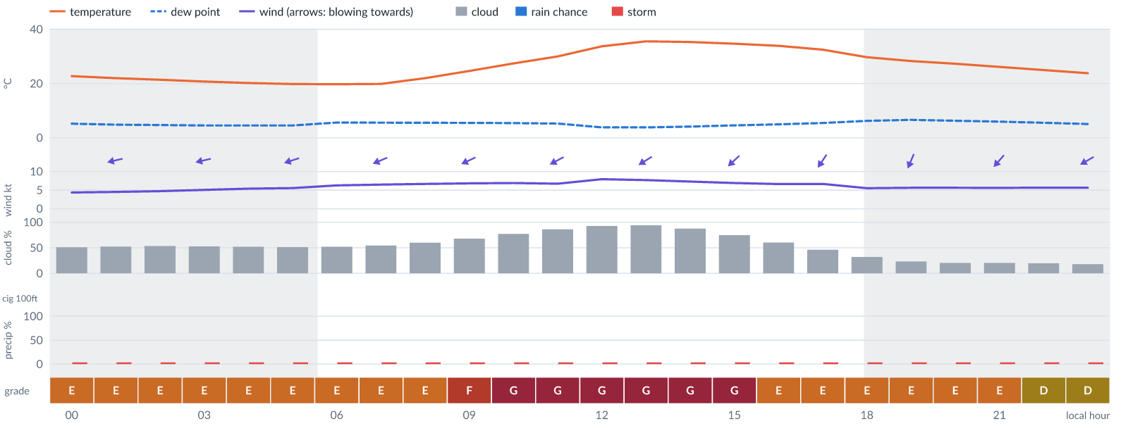
Meteogram — hourly forecast; shaded = before first light / after last light. Gaps mean no data.
Ser | Hrs | Temp | Cloud | Wind | Gust | QNH | Assessment | Driver | Remarks
(a) | (b) | (c) | (d) | (e) | (f) | (g) | (h) | (i) | (j)
1. | 0001 | 23°C | ◑ Partly cloudy (51%) | ← 4 kts ENE | 12 kts | 1012 | E - Poor | gust 12 kt · gust spread +7 kt | gusts, wind shear, cloud cover, thunderstorm risk
2. | 0100 | 22°C | ◑ Partly cloudy (52%) | ← 5 kts ENE | 11 kts | 1012 | E - Poor | cloud 52% | cloud cover, thunderstorm risk, gusts, wind shear
3. | 0200 | 21°C | ◑ Partly cloudy (53%) | ← 5 kts ENE | 10 kts | 1013 | E - Poor | cloud 53% | cloud cover, thunderstorm risk, gusts, wind shear
4. | 0300 | 21°C | ◑ Partly cloudy (53%) | ← 5 kts ENE | 10 kts | 1013 | E - Poor | cloud 53% | cloud cover, thunderstorm risk, gusts, wind shear
5. | 0400 | 20°C | ◑ Partly cloudy (52%) | ← 5 kts ENE | 10 kts | 1013 | E - Poor | cloud 52% | cloud cover, thunderstorm risk, gusts, wind shear
6. | 0500 | 20°C | ◑ Partly cloudy (52%) | ← 6 kts ENE | 9 kts | 1012 | E - Poor | cloud 52% | cloud cover, thunderstorm risk, gusts
7. | 0600 | 20°C | ◑ Partly cloudy (52%) | ← 6 kts ENE | 9 kts | 1013 | E - Poor | cloud 52% | cloud cover, thunderstorm risk, gusts
8. | 0700 | 20°C | ◑ Partly cloudy (54%) | ↙ 6 kts ENE | 10 kts | 1013 | E - Poor | cloud 54% | cloud cover, thunderstorm risk, gusts
9. | 0800 | 22°C | ◑ Cloudy (60%) | ↙ 7 kts ENE | 11 kts | 1013 | E - Poor | cloud 60% | cloud cover, thunderstorm risk, gusts
10. | 0900 | 25°C | ◕ Cloudy (68%) | ↙ 7 kts ENE | 12 kts | 1014 | F - Very Poor | cloud 68% | cloud cover, gusts, thunderstorm risk, wind shear
11. | 1000 | 27°C | ◕ Cloudy (77%) | ↙ 7 kts ENE | 13 kts | 1014 | G - Unacceptable | cloud 77% | cloud cover, gusts, thunderstorm risk, wind shear
12. | 1100 | 30°C | ◕ Cloudy (86%) | ↙ 7 kts ENE | 14 kts | 1014 | G - Unacceptable | cloud 86% | cloud cover, gusts, wind shear, thunderstorm risk
13. | 1200 | 34°C | ☁ Overcast (93%) | ↙ 8 kts ENE | 14 kts | 1015 | G - Unacceptable | cloud 93% | cloud cover, gusts, thunderstorm risk, wind shear
14. | 1300 | 36°C | ☁ Overcast (94%) | ↙ 8 kts ENE | 14 kts | 1014 | G - Unacceptable | cloud 94% | cloud cover, gusts, thunderstorm risk, wind shear
15. | 1400 | 35°C | ☁ Cloudy (88%) | ↙ 7 kts NE | 14 kts | 1014 | G - Unacceptable | cloud 88% | cloud cover, gusts, wind shear, thunderstorm risk
16. | 1500 | 35°C | ◕ Cloudy (75%) | ↙ 7 kts NE | 14 kts | 1014 | G - Unacceptable | cloud 75% | cloud cover, gusts, wind shear, thunderstorm risk
17. | 1600 | 34°C | ◑ Cloudy (60%) | ↙ 7 kts NE | 14 kts | 1014 | E - Poor | cloud 60% · gust 14 kt | cloud cover, gusts, wind shear, thunderstorm risk
18. | 1700 | 32°C | ◑ Partly cloudy (46%) | ↙ 7 kts NE | 13 kts | 1013 | E - Poor | gust 13 kt | gusts, cloud cover, thunderstorm risk, wind shear
19. | 1800 | 30°C | ◔ Mostly clear (32%) | ↙ 6 kts NNE | 13 kts | 1013 | E - Poor | gust 13 kt · gust spread +7 kt | gusts, wind shear, thunderstorm risk
20. | 1900 | 28°C | ◔ Mostly clear (23%) | ↙ 6 kts NNE | 13 kts | 1013 | E - Poor | gust 13 kt · gust spread +7 kt | gusts, wind shear, thunderstorm risk
21. | 2000 | 27°C | ◔ Mostly clear (20%) | ↙ 6 kts NNE | 12 kts | 1013 | E - Poor | gust 12 kt | gusts, thunderstorm risk, wind shear
22. | 2100 | 26°C | ◔ Mostly clear (20%) | ↙ 6 kts NE | 12 kts | 1013 | E - Poor | gust 12 kt | gusts, thunderstorm risk, wind shear
23. | 2200 | 25°C | ◔ Mostly clear (20%) | ↙ 6 kts NE | 11 kts | 1013 | D - Marginal | storm 4% · gust 11 kt | ⚠ thunderstorm risk, gusts, wind shear
24. | 2300 | 24°C | ◔ Mostly clear (18%) | ↙ 6 kts ENE | 10 kts | 1013 | D - Marginal | storm 4% · gust 10 kt | ⚠ thunderstorm risk, gusts
Confidence: 69% — data for 24 of 24 hours · first light 0604L · last light 1826L · Moon 69 % illuminated, rises 14:00, sets 01:33.

Fri 20 Nov 26
Conditions are expected to be generally Poor: partly cloudy, winds up to 7 kts ENE, gusting 14 kts and temperatures 20–36°C. Flyable windows: 0200–0300L (Marginal, 2 h). Hazards: thunderstorm risk 0001–2300L. Overall similar to the previous day.
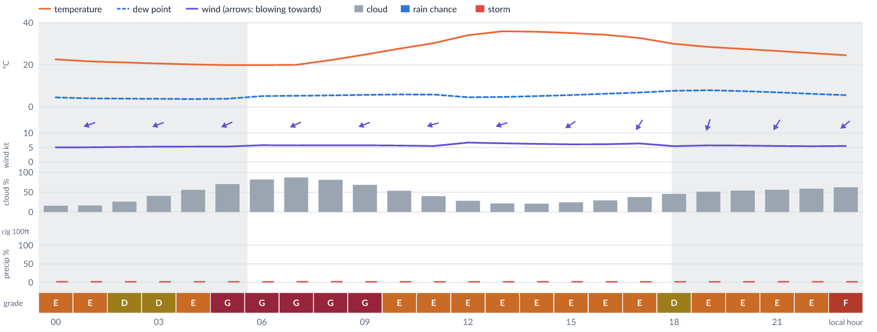
Meteogram — hourly forecast; shaded = before first light / after last light. Gaps mean no data.
Ser | Hrs | Temp | Cloud | Wind | Gust | QNH | Assessment | Driver | Remarks
(a) | (b) | (c) | (d) | (e) | (f) | (g) | (h) | (i) | (j)
1. | 0001 | 23°C | ◔ Mostly clear (16%) | ↙ 5 kts ENE | 12 kts | 1013 | E - Poor | gust 12 kt · gust spread +7 kt | gusts, wind shear, thunderstorm risk
2. | 0100 | 22°C | ◔ Mostly clear (17%) | ← 5 kts ENE | 12 kts | 1013 | E - Poor | gust 12 kt · gust spread +7 kt | gusts, wind shear, thunderstorm risk
3. | 0200 | 21°C | ◔ Mostly clear (26%) | ← 5 kts ENE | 11 kts | 1013 | D - Marginal | storm 4% · gust 11 kt | ⚠ thunderstorm risk, gusts, wind shear
4. | 0300 | 21°C | ◑ Partly cloudy (41%) | ← 5 kts ENE | 11 kts | 1013 | D - Marginal | storm 4% · gust 11 kt | ⚠ thunderstorm risk, gusts, wind shear
5. | 0400 | 20°C | ◑ Partly cloudy (56%) | ← 5 kts ENE | 11 kts | 1013 | E - Poor | cloud 56% | cloud cover, thunderstorm risk, gusts, wind shear
6. | 0500 | 20°C | ◕ Cloudy (71%) | ↙ 5 kts ENE | 11 kts | 1014 | G - Unacceptable | cloud 71% | cloud cover, thunderstorm risk, gusts, wind shear
7. | 0600 | 20°C | ◕ Cloudy (82%) | ↙ 6 kts ENE | 11 kts | 1014 | G - Unacceptable | cloud 82% | cloud cover, thunderstorm risk, gusts, wind shear
8. | 0700 | 20°C | ◕ Cloudy (87%) | ↙ 6 kts ENE | 12 kts | 1014 | G - Unacceptable | cloud 87% | cloud cover, gusts, thunderstorm risk, wind shear
9. | 0800 | 22°C | ◕ Cloudy (81%) | ↙ 6 kts ENE | 12 kts | 1014 | G - Unacceptable | cloud 81% | cloud cover, gusts, thunderstorm risk, wind shear
10. | 0900 | 25°C | ◕ Cloudy (69%) | ← 6 kts ENE | 10 kts | 1015 | G - Unacceptable | cloud 69% | cloud cover, thunderstorm risk, gusts
11. | 1000 | 28°C | ◑ Partly cloudy (54%) | ← 6 kts ENE | 12 kts | 1015 | E - Poor | cloud 54% · gust 12 kt | cloud cover, gusts, thunderstorm risk, wind shear
12. | 1100 | 30°C | ◑ Partly cloudy (40%) | ← 6 kts ENE | 12 kts | 1015 | E - Poor | gust 12 kt | gusts, thunderstorm risk, wind shear
13. | 1200 | 34°C | ◔ Mostly clear (28%) | ← 7 kts ENE | 13 kts | 1015 | E - Poor | gust 13 kt | gusts, thunderstorm risk, wind shear
14. | 1300 | 36°C | ◔ Mostly clear (22%) | ← 6 kts ENE | 14 kts | 1015 | E - Poor | gust 14 kt · gust spread +7 kt | gusts, wind shear, thunderstorm risk
15. | 1400 | 36°C | ◔ Mostly clear (21%) | ↙ 6 kts ENE | 14 kts | 1015 | E - Poor | gust 14 kt · gust spread +7 kt | gusts, wind shear, thunderstorm risk
16. | 1500 | 35°C | ◔ Mostly clear (24%) | ↙ 6 kts NE | 13 kts | 1015 | E - Poor | gust 13 kt · gust spread +7 kt | gusts, wind shear, thunderstorm risk
17. | 1600 | 34°C | ◔ Mostly clear (29%) | ↙ 6 kts NE | 12 kts | 1014 | E - Poor | gust 12 kt | gusts, thunderstorm risk, wind shear
18. | 1700 | 33°C | ◔ Partly cloudy (37%) | ↙ 6 kts NNE | 12 kts | 1014 | E - Poor | gust 12 kt | gusts, thunderstorm risk, wind shear
19. | 1800 | 30°C | ◑ Partly cloudy (46%) | ↙ 5 kts NNE | 11 kts | 1014 | D - Marginal | storm 4% · cloud 46% | ⚠ cloud cover, thunderstorm risk, gusts, wind shear
20. | 1900 | 29°C | ◑ Partly cloudy (52%) | ↓ 6 kts NNE | 11 kts | 1014 | E - Poor | cloud 52% | cloud cover, thunderstorm risk, gusts, wind shear
21. | 2000 | 28°C | ◑ Partly cloudy (54%) | ↙ 6 kts NNE | 13 kts | 1014 | E - Poor | cloud 54% · gust 13 kt | cloud cover, gusts, wind shear, thunderstorm risk
22. | 2100 | 27°C | ◑ Partly cloudy (56%) | ↙ 6 kts NNE | 13 kts | 1014 | E - Poor | cloud 56% · gust 13 kt | cloud cover, gusts, wind shear, thunderstorm risk
23. | 2200 | 26°C | ◑ Partly cloudy (59%) | ↙ 5 kts NE | 13 kts | 1014 | E - Poor | cloud 59% · gust 13 kt | cloud cover, gusts, wind shear, thunderstorm risk
24. | 2300 | 25°C | ◑ Cloudy (62%) | ↙ 6 kts NE | 12 kts | 1014 | F - Very Poor | cloud 62% | cloud cover, gusts, thunderstorm risk, wind shear
Confidence: 68% — data for 24 of 24 hours · first light 0605L · last light 1826L · Moon 79 % illuminated, rises 14:39, sets 02:21.

TAF
Valid (day hh Z) | Type | Wind | Visibility | Weather | Cloud
(a) | (b) | (c) | (d) | (e) | (f)
06 18Z - 07 24Z | prevailing | variable wind 2 kt | 10 km or more | none | broken cloud at 1100 ft
06 20Z-22Z | BECMG | variable wind 2 kt | - | - | -
07 14Z-16Z | BECMG | wind 260 deg 10 kt | - | - | few cloud at 1300 ft
Decoded for reading; the raw TAF below is authoritative.
TAF DNKA 061700Z 0618/0724 VRB02KT 9999 BKN011 BECMG 0620/0622 VRB02KT BECMG 0714/0716 26010KT FEW013

Imagery

Dust RGB (pink/magenta = airborne dust) — captured 7 Nov 01:18 WAT (5 min ago) · ©EUMETSAT (screenshot via EUMETView)

Convection RGB (yellow = vigorous storms) — captured 7 Nov 01:18 WAT (5 min ago) · ©EUMETSAT (screenshot via EUMETView)
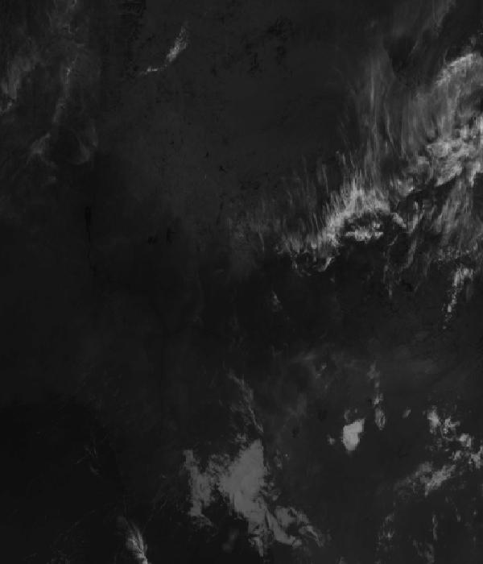
Infrared 10.5 µm (cold tops = deep cloud) — captured 7 Nov 01:18 WAT (5 min ago) · ©EUMETSAT (screenshot via EUMETView)

Accumulated lightning flash area (MTG-LI) — captured 7 Nov 01:18 WAT (5 min ago) · ©EUMETSAT (screenshot via EUMETView)

Source panel
Source | Accuracy | Skill n | Temp °C | Wind kt | Visibility | Storm
(a) | (b) | (c) | (d) | (e) | (f) | (g)
Aviation Weather Center (aviationweather.gov) | ≈ 1.0 | 181 | — | 2 | 10+ km | 0 %
Met.no (Yr) | ≈ 1.0 | 1591 | 19–22 | 4–5 | — | 0 %
Open-Meteo | ≈ 1.0 | 4685 | 20–22 | 2–5 | 10+ km | 0 %
OpenWeather | ≈ 1.0 | 734 | 20–21 | 2–3 | 10+ km | 0 %
Tomorrow.io | ▲ 1.1 | 2102 | 19–22 | 1–4 | 10+ km | 0 %
Visual Crossing | ≈ 1.1 | 3770 | 19–21 | 3–4 | 10+ km | 0 %
Each source's own raw values, min–max over the next 6 hours from the issue hour (before any weighting or bias correction). — means the source does not publish that metric in the window. Wide gaps between rows are real disagreement; the forecast above weights sources by measured skill.

Reading this report
Grades: each hour carries one grade, set by its WORST factor. The bands below are the thresholds in force for this report (Settings); a value in a band earns that grade, and "-" means the factor never produces that grade. Cloud is graded on the worse of cover and ceiling. The Driver column names the limiting factor with its value; open it in the web report for the boundary and sources.
Grade | Cloud cover | Cloud ceiling | Visibility | Wind | Gust | Rain chance | Thunderstorm probability
(a) | (b) | (c) | (d) | (e) | (f) | (g) | (h)
A Excellent | ≤ 17.1% | ≥ 30000 ft | ≥ 8000 m | < 3 kt | < 3 kt | < 5% | 0%
B Good | 17.1–34.3% | 26000–30000 ft | 6666.7–8000 m | 3–6 kt | 3–6 kt | 5–10% | -
C Fair | 34.3–42.9% | 24000–26000 ft | 5333.3–6666.7 m | 6–9 kt | 6–9 kt | 10–15% | -
D Marginal | 42.9–51.4% | 22000–24000 ft | 4000–5333.3 m | 9–12 kt | 9–12 kt | 15–20% | >0–15%
E Poor | 51.4–60% | 16000–22000 ft | 2666.7–4000 m | 12–15 kt | 12–15 kt | 20–25% | 15–30%
F Very Poor | 60–68.6% | 10000–16000 ft | 1333.3–2666.7 m | 15–18 kt | 15–18 kt | 25–30% | 30–60%
G Unacceptable | > 68.6% | < 10000 ft | < 1333.3 m | ≥ 18 kt | ≥ 18 kt | ≥ 30% | > 60%
Flight windows: a window is at least 2 consecutive hours graded Marginal or better; an hour with insufficient data never counts toward one. ☾ marks a window outside first-to-last light.
Time: hours are local time (WAT, UTC+1) unless suffixed Z, which is UTC (TAF, METAR and issue times). Local midnight is labelled 0001.
Units: temperature °C · wind and gusts knots · visibility metres (km in text) · cloud ceiling feet · cloud cover % · rain chance and thunderstorm probability % · QNH hPa (altimeter setting at the field) · CAPE J/kg. A figure like "28 (26–30)°C" gives the p10–p90 range; "spread" marks disagreement between sources.
Symbols: ▲ better than the pool · ▽ worse (only when the 95% interval excludes the pool) · ≈ not distinguishable from the pool · unmarked = unproven (accuracy is measured against METAR and SYNOP observations). ⚠ on a remark means a low-confidence hour; a ⚠ paragraph on the first page is a convective-warning or data-age advisory. ⚡ is lightning observed by satellite near the field (©EUMETSAT).
Hourly glyphs: the wind arrow points the way the air moves (a north wind is ↓, an east wind ←); cloud cover shows as ☀ ◔ ◑ ◕ ☁ (clear, few, scattered, broken, overcast); a shaded hour label is wholly before first light or after last light.
Terms: "No data" - no source forecast the hour, or a core group (cloud, visibility, wind) is missing and the hour could still be flyable; missing data is never given a good grade. "Low-confidence" - few or weak sources behind the load-bearing metrics; treat the grade as indicative. "Insufficient data" - too little to grade at all. "Estimated" (est.) - the value is derived, not reported by a source (dust visibility, cloud base, gusts); it is declared where used and weighted at half. "Derived" - an hour interpolated from a coarser (3-hourly or daily) source, weighted at half and never used to score accuracy.

Data provenance
Source | Fetched (Z) | Age | Skill n | Accuracy
(a) | (b) | (c) | (d) | (e)
Aviation Weather Center (aviationweather.gov) | 7 Nov 00:19Z | 4 min | 181 | ≈ 1.0
Foreca | 7 Nov 00:19Z | 4 min | 363 | ≈ 1.1
Met.no (Yr) | 7 Nov 00:20Z | 3 min | 1591 | ≈ 1.0
Open-Meteo | 7 Nov 00:18Z | 5 min | 4685 | ≈ 1.0
OpenWeather | 7 Nov 00:20Z | 3 min | 734 | ≈ 1.0
Tomorrow.io | 7 Nov 00:19Z | 4 min | 2102 | ▲ 1.1
Visual Crossing | 7 Nov 00:19Z | 5 min | 3770 | ≈ 1.1
Corrections applied (detailed under Learned corrections on the first page): skill weighting, bias correction, hour-of-day bias, cloud-base estimate, probability calibration, climatology bounds, skill blend.

How accurate have we been
Measured against observations (METAR/SYNOP), kaduna only. Verification table computed 2026-11-06. Mean absolute error (MAE): lower is better; "beats persistence" compares the best source with "it will stay as it is now" on the same hours.
Metric | Best source | Best MAE | Typical MAE | Persistence MAE | Beats persistence by | Pairs
(a) | (b) | (c) | (d) | (e) | (f) | (g)
Temperature (°C) | foreca | 1.0 | 1.6 | 5.3 | 83 % | 148
Dew point (°C) | accuweather | 0.9 | 4.2 | 2.6 | 52 % | 28
Wind speed (kt) | ukmo | 1.8 | 2.5 | 2.7 | 17 % | 589
Visibility (m) | aviationweather | 711 | 1439 | 1315 | 7 % | 77
Cloud cover (%) | accuweather | 21 | 48 | 9 | - | 28
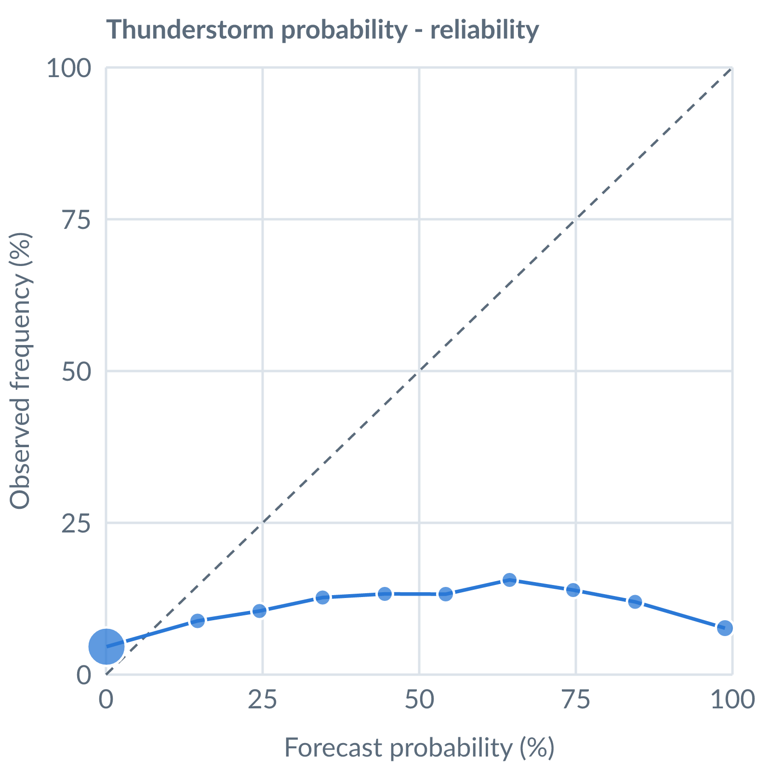
Thunderstorm probability: dots on the dashed line mean a stated probability matched how often it happened (164538 pairs, all places pooled).
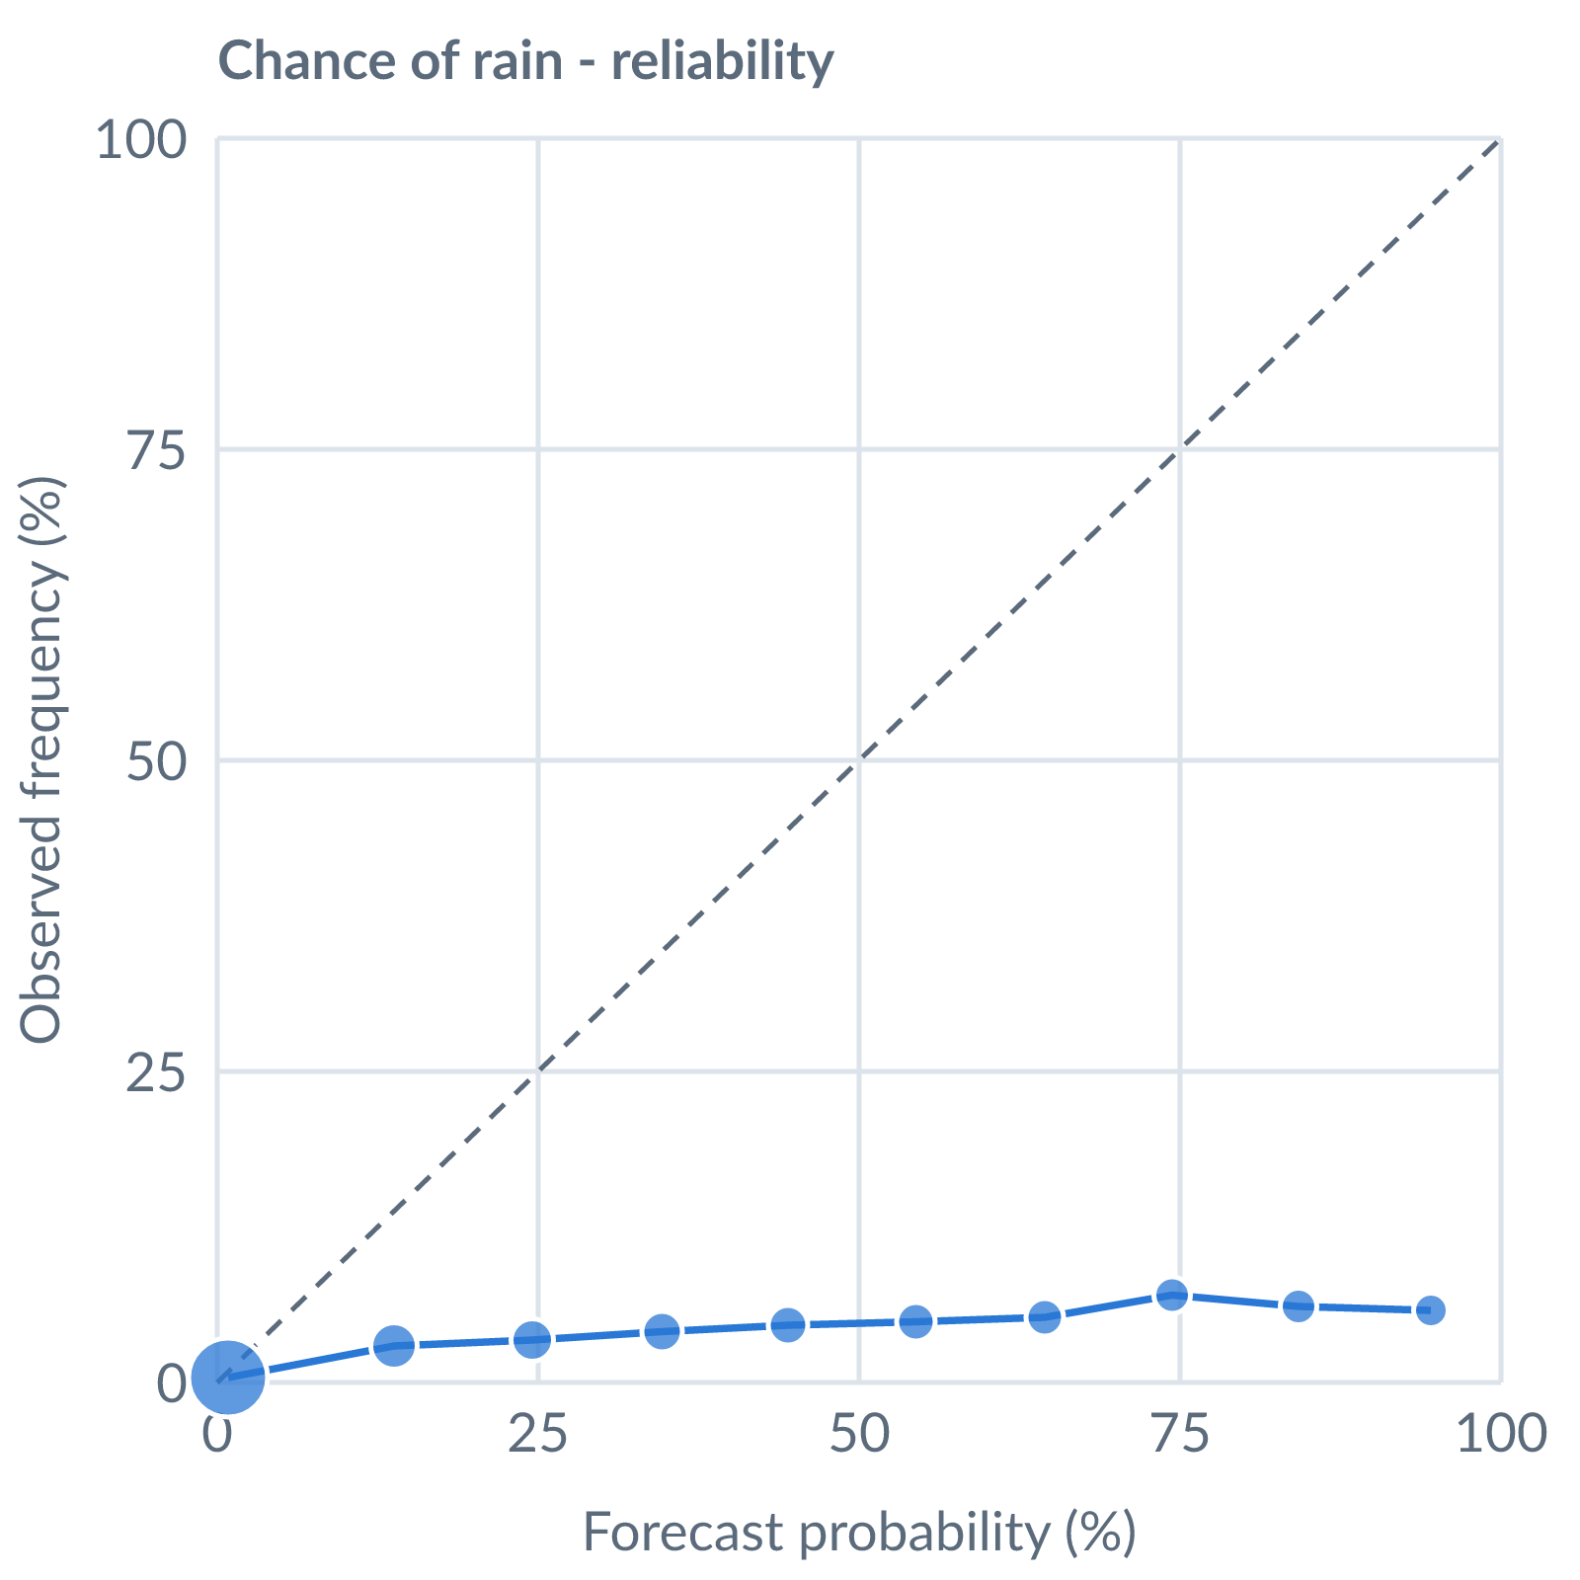
Chance of rain: dots on the dashed line mean a stated probability matched how often it happened (153642 pairs, all places pooled).
Learned bias (forecast minus observed; positive = sources run high), mean over scored sources, by local time of day. These are corrected for before sources are averaged.
Metric | Overall | Night | Morning | Afternoon | Evening | Pairs
(a) | (b) | (c) | (d) | (e) | (f) | (g)
Temperature (°C) | -0.7 | +0.2 | -0.3 | -1.4 | -0.5 | 13001
Dew point (°C) | -1.8 | -1.0 | -1.8 | -1.6 | -2.4 | 12214
Wind speed (kt) | -1.8 | -0.7 | -1.3 | -2.5 | -1.7 | 13081
Not yet available: Scores are decayed over the verification window (half-life 14 days); separate last-7-day and last-30-day windows are not stored. Bias is the current learned value; the history needed for a trend over time is not stored. Flight-window hit / bust / miss is not yet recorded.

