Jos — 14-Day Forecast
DNJO · issued 7 Nov 26 00:23Z
Sources: Aviation Weather Center (aviationweather.gov) ≈ 1.0 · Foreca ≈ 1.1 · Met.no (Yr) ≈ 1.0 · Open-Meteo ≈ 1.0 · OpenWeather ≈ 1.0 · Tomorrow.io ▲ 1.1 · Visual Crossing ≈ 1.1
▲ better than the pool · ▽ worse (only when the 95% interval excludes the pool) · ≈ not distinguishable from the pool · unmarked = unproven (accuracy is measured against METAR and SYNOP observations)
Day | 00 | 01 | 02 | 03 | 04 | 05 | 06 | 07 | 08 | 09 | 10 | 11 | 12 | 13 | 14 | 15 | 16 | 17 | 18 | 19 | 20 | 21 | 22 | 23 | Flyable Windows | Conf
Sat 7 Nov 26 | D | G | G | D | D | D | D | D | D | E | F | F | F | F | F | F | F | F | E | D | D | D | D | D | 0300–0800L (Marginal, 6 h) ☾ · 1900–2300L (Marginal, 5 h) ☾ | 75%
Sun 8 Nov 26 | D | D | D | D | D | D | D | D | D | E | F | G | G | G | G | G | G | F | E | D | D | D | D | D | best window: 0001–0800L (Marginal, 9 h) ☾ · 1900–2300L (Marginal, 5 h) ☾ | 78%
Mon 9 Nov 26 | G | G | G | G | D | D | D | D | D | E | G | G | G | G | G | G | G | G | F | E | D | D | D | D | 0400–0800L (Marginal, 5 h) ☾ · 2000–2300L (Marginal, 4 h) ☾ | 73%
Tue 10 Nov 26 | D | D | D | D | D | D | D | E | F | G | G | G | G | G | G | G | G | G | F | E | E | D | D | D | 0001–0600L (Marginal, 7 h) ☾ · 2100–2300L (Marginal, 3 h) ☾ | 72%
Wed 11 Nov 26 | G | G | G | G | G | G | G | G | G | G | G | G | G | G | G | G | G | E | F | E | D | D | D | D | 2000–2300L (Marginal, 4 h) ☾ | 73%
Thu 12 Nov 26 | D | D | · | · | · | · | · | · | · | E | F | F | G | G | G | G | G | G | G | G | G | G | F | E | 0001–0100L (Marginal, 2 h) ☾ | 70%
Fri 13 Nov 26 | F | E | E | · | · | · | · | · | · | · | E | F | G | G | G | G | G | G | G | G | G | G | F | E | no windows | 69%
Sat 14 Nov 26 | E | · | · | · | · | · | · | · | E | · | E | F | G | G | G | G | G | G | G | G | F | F | E | E | no windows | 69%
Sun 15 Nov 26 | · | · | · | · | · | · | · | · | · | · | E | E | E | E | E | E | E | E | E | F | E | E | · | · | no windows | 69%
Mon 16 Nov 26 | · | · | · | · | · | · | · | · | · | · | · | E | E | F | F | F | G | G | F | E | E | E | · | E | no windows | 69%
Tue 17 Nov 26 | · | · | · | · | · | · | · | · | · | · | E | E | F | F | F | F | F | F | F | F | E | E | · | · | no windows | 69%
Wed 18 Nov 26 | E | E | · | · | · | · | · | · | · | · | E | F | F | F | F | F | F | F | E | E | E | F | E | · | no windows | 69%
Thu 19 Nov 26 | · | · | · | · | · | · | · | · | · | · | · | E | E | E | F | G | G | G | G | G | G | G | E | · | no windows | 69%
Fri 20 Nov 26 | · | · | · | · | · | · | · | · | · | · | · | · | E | E | E | E | E | E | F | E | E | · | E | F | no windows | 69%
A Excellent · B Good · C Fair · D Marginal · E Poor · F Very Poor · G Unacceptable · · No data
Best window (highest confidence, then grade, then length): Sun 8 Nov 26 0001–0800L (Marginal, 9 h) ☾, confidence 78%.
Learned corrections (METAR-verified): skill weighting — pooled all-field scores for 206; bias corrections — metcheck wind +4.6 kt, jma wind +4.1 kt, meteoblue wind +3.5 kt, meteoblue QNH −3.0 hPa, Open-Meteo dewpoint +3.0 °C, Met.no (Yr) dewpoint +3.0 °C (+67 more); hour-of-day bias (local time, shrunk toward the all-hours bias) — jma morning wind +4.6 kt, metcheck morning wind +4.6 kt, metcheck afternoon wind +4.4 kt, meteoblue morning wind +3.8 kt, jma afternoon wind +3.6 kt, meteoblue afternoon wind +3.1 kt (+284 more); cloud base estimated as 410 ft per °C of dewpoint spread for sources that report no ceiling (≥60% cloud cover; flagged estimated, weighted ×0.5); probability calibration — rain chance: meteoblue, Open-Meteo, Foreca, metcheck, OpenWeather, Visual Crossing, Tomorrow.io, wttrin, ecmwf, gfs, icon, ukmo, gem, ecmwfens; storm: Open-Meteo, Met.no (Yr), Foreca, OpenWeather, Visual Crossing, Tomorrow.io, wttrin, ecmwf, gfs, icon, meteofrance, Aviation Weather Center (aviationweather.gov), ukmo, jma, gem, ecmwfens, aifs (each source's stated probability mapped to its verified frequency by an isotonic fit on ≥200 pairs, proven on the holdout); plausibility bounds from ERA5 climatology 2016-2025 (mean ± 5 sd; screening only, not observed truth); skill blend 1 auto-tuned over 9222 holdout pairs (consensus beat the best single source, icon, by 13%); correction gates (newest-7-day holdout; pooled skill is always on) — regional skill: off this week (did not improve holdout); place skill: off this week (did not improve holdout); lead-time skill: off this week (did not improve holdout); small-sample skill shrinkage: off this week (did not improve holdout); bias correction: on (improved holdout by 25.6%); place bias: on (improved holdout by 10.9%); hour-of-day bias: on (improved holdout by 7.0%); QNH bias: on (improved holdout by 57.4%); gust estimates: off this week (did not improve holdout); cloud-base coefficient: off this week (insufficient holdout: 79 of 200 items); recent-form skill: off this week (did not improve holdout); probability calibration: on (improved holdout by 36.3%); nowcast anchor horizon: off this week (did not improve holdout); dust-visibility estimate: off this week (did not improve holdout); fog risk: off this week (did not improve holdout).

Outlook
Day | Date | Outlook | Temp | Max wind | Flight windows | Confidence | Notes
(a) | (b) | (c) | (d) | (e) | (f) | (g) | (h)
Sat | 7 Nov 26 | Marginal | 17–31°C | 10 kts ENE, g 17 | 0300–0800L (Marginal, 6 h) ☾; 1900–2300L (Marginal, 5 h) ☾ | 75% | 9% interpolated
Sun | 8 Nov 26 | Marginal | 18–31°C | 11 kts ENE, g 21 | 0001–0800L (Marginal, 9 h) ☾; 1900–2300L (Marginal, 5 h) ☾ | 78% | 10% interpolated
Mon | 9 Nov 26 | Unacceptable | 19–31°C | 12 kts ENE, g 21 | 0400–0800L (Marginal, 5 h) ☾; 2000–2300L (Marginal, 4 h) ☾ | 73% | 16% interpolated
Tue | 10 Nov 26 | Marginal | 19–31°C | 15 kts ENE, g 26 | 0001–0600L (Marginal, 7 h) ☾; 2100–2300L (Marginal, 3 h) ☾ | 72% | 21% interpolated
Wed | 11 Nov 26 | Unacceptable | 19–30°C | 14 kts ENE, g 24 | 2000–2300L (Marginal, 4 h) ☾ | 73% | 22% interpolated
Thu | 12 Nov 26 | Unacceptable | 17–29°C | 11 kts NE, g 21 | 0001–0100L (Marginal, 2 h) ☾ | 70% | 17% interpolated
Fri | 13 Nov 26 | Unacceptable | 17–29°C | 12 kts NE, g 22 | none | 69% | 16% interpolated
Sat | 14 Nov 26 | Unacceptable | 16–29°C | 8 kts ENE, g 20 | none | 69% | 16% interpolated
Sun | 15 Nov 26 | Poor | 17–31°C | 7 kts ENE, g 14 | none | 69% | 16% interpolated
Mon | 16 Nov 26 | Poor | 18–32°C | 9 kts ENE, g 19 | none | 69% | 9% interpolated
Tue | 17 Nov 26 | Very Poor | 18–32°C | 9 kts ENE, g 16 | none | 69%
Wed | 18 Nov 26 | Very Poor | 18–32°C | 9 kts ENE, g 16 | none | 69%
Thu | 19 Nov 26 | Unacceptable | 18–32°C | 7 kts ENE, g 13 | none | 69%
Fri | 20 Nov 26 | Poor | 18–32°C | 7 kts ENE, g 13 | none | 69%

Today — Sat 7 Nov 26
Conditions are expected to be generally Marginal: partly cloudy, winds up to 10 kts ENE, gusting 17 kts and temperatures 17–31°C. Flyable windows: 0300–0800L (Marginal, 6 h) and 1900–2300L (Marginal, 5 h). Hazards: thunderstorm risk 0001–2300L.
WEATHER EFFECTS
 | 00–06L | 06–12L | 12–18L | 18–24L
Wind | B | F | F | E
Visibility | A | A | A | A
Cloud / ceiling | G | D | E | D
Precipitation | A | A | A | A
Thunderstorm | D | D | D | D
Fog | · | · | · | ·
A Excellent · B Good · C Fair · D Marginal (flyable) · E Poor · F Very Poor · G Unacceptable · (worst condition in each period)
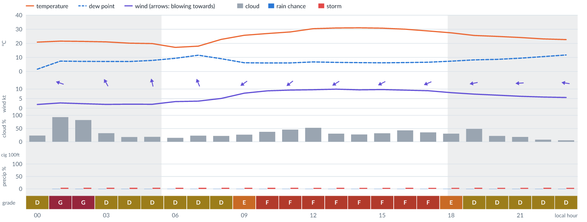
Meteogram — hourly forecast; shaded = before first light / after last light. Gaps mean no data.
Ser | Hrs | Temp | Cloud | Wind | Gust | QNH | Assessment | Driver | Remarks
(a) | (b) | (c) | (d) | (e) | (f) | (g) | (h) | (i) | (j)
1. | 0001 | 21°C | ◔ Mostly clear (24%) | ↗ 2 kts SSW | 1 kts | 1018 | D - Marginal | storm 0% | ⚠ thunderstorm risk
2. | 0100 | 22 (spread 20–24)°C | ☁ Overcast (93%) | ← 3 kts ESE | 5 kts | 1019 | G - Unacceptable | cloud 93% | cloud cover, thunderstorm risk
3. | 0200 | 21 (spread 19–23)°C | ◕ Cloudy (82%) | ↖ 2 (spread 2–3) kts SE | 4 kts | 1018 | G - Unacceptable | cloud 82% | cloud cover, thunderstorm risk
4. | 0300 | 21 (spread 19–23)°C | ◔ Partly cloudy (33%) | ↖ 2 (spread 1–3) kts SSE | 3 kts | 1018 | D - Marginal | storm 4% | thunderstorm risk
5. | 0400 | 20 (spread 18–22)°C | ◔ Mostly clear (18%) | ↑ 2 (spread 1–3) kts SSE | 2 kts | 1018 | D - Marginal | storm 5% | thunderstorm risk
6. | 0500 | 20 (spread 18–21)°C | ◔ Mostly clear (19%) | ↑ 2 (spread 1–3) kts SSE | 2 kts | 1018 | D - Marginal | storm 4% | thunderstorm risk
7. | 0600 | 17 (spread 17–18)°C | ◔ Mostly clear (15%) | ↑ 3 (spread 3–5) kts SSE | 3 kts | 1017 | D - Marginal | storm 4% | thunderstorm risk
8. | 0700 | 18°C | ◔ Mostly clear (23%) | ↑ 4 (spread 3–5) kts SSE | 4 kts | 1018 | D - Marginal | storm 5% | thunderstorm risk
9. | 0800 | 23°C | ◔ Mostly clear (22%) | ↙ 5 (spread 4–6) kts ENE | 8 kts | 1021 | D - Marginal | storm 4% | thunderstorm risk
10. | 0900 | 26 (spread 25–26)°C | ◔ Mostly clear (27%) | ↙ 8 (spread 7–8) kts NE | 14 kts | 1022 | E - Poor | gust 14 kt | gusts, thunderstorm risk, wind shear
11. | 1000 | 27°C | ◑ Partly cloudy (38%) | ↙ 9 (spread 9–10) kts NE | 16 kts | 1022 | F - Very Poor | gust 16 kt | gusts, wind shear, thunderstorm risk, strong wind
12. | 1100 | 28°C | ◑ Partly cloudy (46%) | ↙ 9 (spread 9–10) kts NE | 17 kts | 1022 | F - Very Poor | gust 17 kt | gusts, wind shear, cloud cover, thunderstorm risk, strong wind
13. | 1200 | 30 (spread 30–31)°C | ◑ Partly cloudy (53%) | ↙ 10 (spread 9–10) kts ENE | 17 kts | 1022 | F - Very Poor | gust 17 kt | gusts, cloud cover, wind shear, thunderstorm risk, strong wind
14. | 1300 | 31°C | ◔ Mostly clear (30%) | ↙ 10 (spread 9–11) kts ENE | 17 kts | 1021 | F - Very Poor | gust 17 kt | gusts, wind shear, thunderstorm risk, strong wind
15. | 1400 | 31°C | ◔ Mostly clear (28%) | ↙ 10 (spread 9–10) kts ENE | 17 kts | 1020 | F - Very Poor | gust 17 kt | gusts, wind shear, thunderstorm risk, strong wind
16. | 1500 | 31°C | ◔ Mostly clear (32%) | ↙ 10 kts ENE | 17 kts | 1019 | F - Very Poor | gust 17 kt | gusts, wind shear, thunderstorm risk, strong wind
17. | 1600 | 30°C | ◑ Partly cloudy (43%) | ↙ 9 (spread 9–10) kts ENE | 15 kts | 1019 | F - Very Poor | gust 15 kt | gusts, cloud cover, thunderstorm risk, strong wind, wind shear
18. | 1700 | 29°C | ◔ Partly cloudy (36%) | ↙ 9 (spread 8–9) kts ENE | 15 kts | 1019 | F - Very Poor | gust 15 kt | gusts, thunderstorm risk, strong wind, wind shear
19. | 1800 | 27 (spread 26–29)°C | ◔ Mostly clear (31%) | ← 8 (spread 6–9) kts ENE | 13 kts | 1020 | E - Poor | gust 13 kt | gusts, thunderstorm risk, wind shear
20. | 1900 | 26 (spread 24–28)°C | ◑ Partly cloudy (49%) | ← 7 (spread 6–9) kts E | 11 kts | 1020 | D - Marginal | storm 4% · cloud 49% | cloud cover, thunderstorm risk, gusts
21. | 2000 | 25 (spread 23–27)°C | ◔ Mostly clear (22%) | ← 7 (spread 6–7) kts E | 10 kts | 1021 | D - Marginal | storm 4% · gust 10 kt | thunderstorm risk, gusts
22. | 2100 | 24 (spread 22–26)°C | ◔ Mostly clear (18%) | ← 6 (spread 5–7) kts E | 9 kts | 1021 | D - Marginal | storm 4% · gust 9 kt | thunderstorm risk, gusts
23. | 2200 | 23 (spread 21–25)°C | ☀ Clear (8%) | ← 6 (spread 5–6) kts E | 7 kts | 1021 | D - Marginal | storm 4% | thunderstorm risk
24. | 2300 | 23 (spread 21–25)°C | ☀ Clear (5%) | ← 6 (spread 5–6) kts E | 7 kts | 1021 | D - Marginal | storm 4% | thunderstorm risk
Confidence: 75% — data for 24 of 24 hours; 9% of readings interpolated · first light 0554L · last light 1821L · Moon 4 % illuminated, rises 04:34, sets 16:37.

Tomorrow — Sun 8 Nov 26
Conditions are expected to be generally Marginal: clear, winds up to 11 kts ENE, gusting 21 kts and temperatures 18–31°C. Flyable windows: 0001–0800L (Marginal, 9 h) and 1900–2300L (Marginal, 5 h). Hazards: thunderstorm risk 0001–2300L. Overall similar to the previous day.
WEATHER EFFECTS
 | 00–06L | 06–12L | 12–18L | 18–24L
Wind | C | G | G | E
Visibility | A | A | A | A
Cloud / ceiling | A | A | A | A
Precipitation | A | A | A | A
Thunderstorm | D | D | D | D
Fog | · | · | · | ·
A Excellent · B Good · C Fair · D Marginal (flyable) · E Poor · F Very Poor · G Unacceptable · (worst condition in each period)
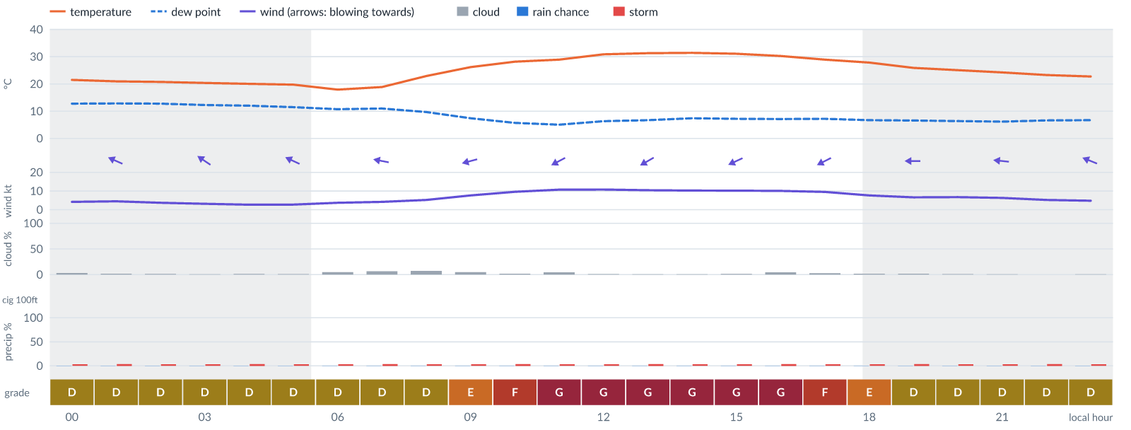
Meteogram — hourly forecast; shaded = before first light / after last light. Gaps mean no data.
Ser | Hrs | Temp | Cloud | Wind | Gust | QNH | Assessment | Driver | Remarks
(a) | (b) | (c) | (d) | (e) | (f) | (g) | (h) | (i) | (j)
1. | 0001 | 21 (spread 20–24)°C | ☀ Clear (3%) | ← 4 (spread 4–5) kts ESE | 6 kts | 1020 | D - Marginal | storm 4% | thunderstorm risk
2. | 0100 | 21 (spread 19–23)°C | ☀ Clear (2%) | ↖ 5 (spread 4–5) kts ESE | 7 kts | 1019 | D - Marginal | storm 4% | thunderstorm risk
3. | 0200 | 21 (spread 19–23)°C | ☀ Clear (1%) | ↖ 4 (spread 3–5) kts ESE | 6 kts | 1019 | D - Marginal | storm 4% | thunderstorm risk
4. | 0300 | 20 (spread 19–23)°C | ☀ Clear (1%) | ↖ 3 (spread 2–4) kts ESE | 5 kts | 1018 | D - Marginal | storm 4% | thunderstorm risk
5. | 0400 | 20 (spread 19–22)°C | ☀ Clear (1%) | ↖ 3 (spread 2–4) kts SE | 4 kts | 1018 | D - Marginal | storm 4% | thunderstorm risk
6. | 0500 | 20 (spread 18–22)°C | ☀ Clear (1%) | ↖ 3 (spread 2–3) kts ESE | 3 kts | 1018 | D - Marginal | storm 4% | thunderstorm risk
7. | 0600 | 18 (spread 17–19)°C | ☀ Clear (5%) | ← 4 (spread 3–6) kts ESE | 4 kts | 1018 | D - Marginal | storm 4% | thunderstorm risk
8. | 0700 | 19 (spread 18–20)°C | ☀ Clear (6%) | ← 4 (spread 3–6) kts E | 4 kts | 1019 | D - Marginal | storm 4% | thunderstorm risk
9. | 0800 | 23 (spread 22–24)°C | ☀ Clear (7%) | ← 5 (spread 5–6) kts E | 8 kts | 1022 | D - Marginal | storm 4% | thunderstorm risk
10. | 0900 | 26°C | ☀ Clear (5%) | ← 8 (spread 7–8) kts ENE | 13 kts | 1023 | E - Poor | gust 13 kt | gusts, thunderstorm risk, wind shear
11. | 1000 | 28 (spread 28–29)°C | ☀ Clear (2%) | ↙ 10 (spread 9–10) kts ENE | 17 kts | 1024 | F - Very Poor | gust 17 kt | gusts, wind shear, thunderstorm risk, strong wind
12. | 1100 | 29°C | ☀ Clear (4%) | ↙ 11 (spread 10–11) kts ENE | 19 kts | 1024 | G - Unacceptable | gust 19 kt | gusts, wind shear, thunderstorm risk, strong wind
13. | 1200 | 31°C | ☀ Clear (1%) | ↙ 11 (spread 10–11) kts ENE | 19 kts | 1023 | G - Unacceptable | gust 19 kt | gusts, wind shear, thunderstorm risk, strong wind
14. | 1300 | 31°C | ☀ Clear (1%) | ↙ 10 (spread 10–11) kts ENE | 21 kts | 1022 | G - Unacceptable | gust 21 kt · gust spread +10 kt | gusts, wind shear, thunderstorm risk, strong wind
15. | 1400 | 31 (spread 31–32)°C | ☀ Clear (1%) | ↙ 10 (spread 10–11) kts ENE | 21 kts | 1022 | G - Unacceptable | gust 21 kt · gust spread +10 kt | gusts, wind shear, thunderstorm risk, strong wind
16. | 1500 | 31°C | ☀ Clear (2%) | ↙ 10 (spread 10–11) kts ENE | 20 kts | 1021 | G - Unacceptable | gust 20 kt · gust spread +10 kt | gusts, wind shear, thunderstorm risk, strong wind
17. | 1600 | 30 (spread 30–31)°C | ☀ Clear (5%) | ↙ 10 (spread 10–11) kts ENE | 18 kts | 1020 | G - Unacceptable | gust 18 kt | gusts, wind shear, thunderstorm risk, strong wind
18. | 1700 | 29°C | ☀ Clear (3%) | ↙ 10 (spread 9–10) kts ENE | 17 kts | 1020 | F - Very Poor | gust 17 kt | gusts, wind shear, thunderstorm risk, strong wind
19. | 1800 | 28 (spread 27–30)°C | ☀ Clear (2%) | ← 8 (spread 6–9) kts ENE | 14 kts | 1021 | E - Poor | gust 14 kt | gusts, thunderstorm risk, wind shear
20. | 1900 | 26 (spread 24–28)°C | ☀ Clear (2%) | ← 7 (spread 6–7) kts E | 10 kts | 1021 | D - Marginal | storm 4% · gust 10 kt | thunderstorm risk, gusts
21. | 2000 | 25 (spread 23–27)°C | ☀ Clear (1%) | ← 7 (spread 5–8) kts E | 10 kts | 1022 | D - Marginal | storm 4% · gust 10 kt | thunderstorm risk, gusts
22. | 2100 | 24 (spread 23–26)°C | ☀ Clear (0%) | ← 6 (spread 4–7) kts E | 9 kts | 1023 | D - Marginal | storm 4% · gust 9 kt | thunderstorm risk, gusts
23. | 2200 | 23 (spread 22–26)°C | ☀ Clear (0%) | ← 5 (spread 4–7) kts E | 7 kts | 1022 | D - Marginal | storm 4% | thunderstorm risk
24. | 2300 | 23 (spread 21–25)°C | ☀ Clear (0%) | ← 5 (spread 3–6) kts ESE | 6 kts | 1022 | D - Marginal | storm 4% | thunderstorm risk
Confidence: 78% — data for 24 of 24 hours; 10% of readings interpolated · first light 0554L · last light 1821L · Moon 1 % illuminated, rises 05:24, sets 17:19.

Extended Outlook
WEATHER EFFECTS BY DAY
 | Mon | Tue | Wed | Thu | Fri | Sat | Sun | Mon | Tue | Wed | Thu | Fri
Wind | G | G | G | G | G | G | F | G | F | F | E | F
Visibility | A | A | A | A | · | · | · | · | · | · | · | ·
Cloud / ceiling | G | G | G | G | F | A | A | A | A | B | G | F
Precipitation | A | A | A | A | A | A | A | A | A | A | A | A
Thunderstorm | D | D | D | D | D | D | D | D | D | D | D | D
Fog | · | · | · | · | · | · | · | · | · | · | · | ·
Overall | G | G | G | G | G | G | F | G | F | F | G | F
A Excellent · B Good · C Fair · D Marginal (flyable) · E Poor · F Very Poor · G Unacceptable · (worst condition in each period)

Mon 9 Nov 26
Conditions are expected to be generally Unacceptable: mostly clear, winds up to 12 kts ENE, gusting 21 kts and temperatures 19–31°C. Flyable windows: 0400–0800L (Marginal, 5 h) and 2000–2300L (Marginal, 4 h). Hazards: thunderstorm risk 0001–2300L. Overall a deterioration from the previous day.
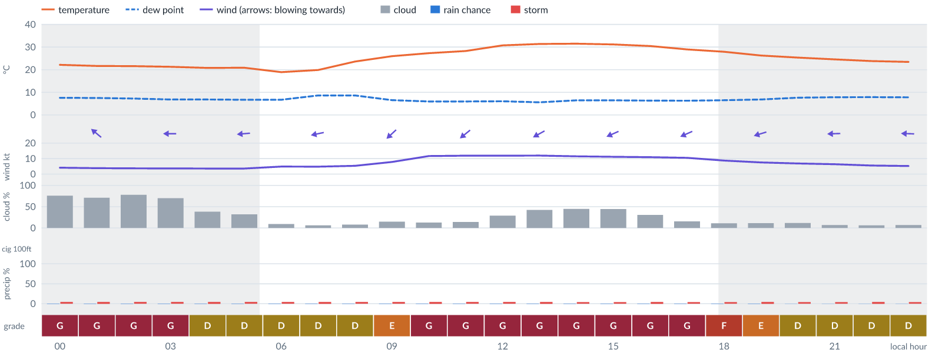
Meteogram — hourly forecast; shaded = before first light / after last light. Gaps mean no data.
Ser | Hrs | Temp | Cloud | Wind | Gust | QNH | Assessment | Driver | Remarks
(a) | (b) | (c) | (d) | (e) | (f) | (g) | (h) | (i) | (j)
1. | 0001 | 22 (spread 20–24)°C | ◕ Cloudy (76%) | ↖ 4 (spread 3–5) kts ESE | 6 kts | 1021 | G - Unacceptable | cloud 76% | cloud cover, thunderstorm risk
2. | 0100 | 22 (spread 20–24)°C | ◕ Cloudy (71%) | ↖ 4 (spread 3–5) kts SE | 6 kts | 1021 | G - Unacceptable | cloud 71% | cloud cover, thunderstorm risk
3. | 0200 | 22 (spread 19–24)°C | ◕ Cloudy (78%) | ↖ 4 (spread 3–5) kts ESE | 6 kts | 1020 | G - Unacceptable | cloud 78% | cloud cover, thunderstorm risk
4. | 0300 | 21 (spread 19–23)°C | ◕ Cloudy (70%) | ← 4 (spread 3–4) kts E | 6 kts | 1020 | G - Unacceptable | cloud 70% | cloud cover, thunderstorm risk
5. | 0400 | 21 (spread 19–23)°C | ◑ Partly cloudy (38%) | ← 4 (spread 3–4) kts E | 5 kts | 1020 | D - Marginal | storm 5% | thunderstorm risk
6. | 0500 | 21 (spread 19–23)°C | ◔ Mostly clear (32%) | ← 4 (spread 3–4) kts E | 5 kts | 1020 | D - Marginal | storm 4% | thunderstorm risk
7. | 0600 | 19 (spread 18–19)°C | ☀ Clear (9%) | ← 5 (spread 5–6) kts E | 5 kts | 1020 | D - Marginal | storm 4% | thunderstorm risk
8. | 0700 | 20 (spread 19–21)°C | ☀ Clear (6%) | ← 5 (spread 4–5) kts ENE | 5 kts | 1021 | D - Marginal | storm 5% | thunderstorm risk
9. | 0800 | 24 (spread 23–24)°C | ☀ Clear (8%) | ↙ 5 (spread 5–6) kts NE | 7 kts | 1024 | D - Marginal | storm 4% | thunderstorm risk
10. | 0900 | 26 (spread 25–27)°C | ◔ Mostly clear (15%) | ↙ 8 (spread 7–9) kts NE | 13 kts | 1025 | E - Poor | gust 13 kt | gusts, thunderstorm risk, wind shear
11. | 1000 | 27°C | ◔ Mostly clear (13%) | ↙ 12 (spread 9–13) kts NE | 20 kts | 1026 | G - Unacceptable | gust 20 kt | gusts, strong wind, wind shear, thunderstorm risk
12. | 1100 | 28 (spread 28–29)°C | ◔ Mostly clear (14%) | ↙ 12 (spread 11–13) kts NE | 21 kts | 1025 | G - Unacceptable | gust 21 kt | gusts, wind shear, strong wind, thunderstorm risk
13. | 1200 | 31°C | ◔ Mostly clear (29%) | ↙ 12 kts NE | 20 kts | 1025 | G - Unacceptable | gust 20 kt | gusts, strong wind, wind shear, thunderstorm risk
14. | 1300 | 31 (spread 31–32)°C | ◑ Partly cloudy (42%) | ↙ 12 kts ENE | 19 kts | 1024 | G - Unacceptable | gust 19 kt | gusts, strong wind, wind shear, thunderstorm risk
15. | 1400 | 31 (spread 31–32)°C | ◑ Partly cloudy (45%) | ↙ 11 (spread 10–12) kts ENE | 20 kts | 1023 | G - Unacceptable | gust 20 kt | gusts, wind shear, cloud cover, thunderstorm risk, strong wind
16. | 1500 | 31°C | ◑ Partly cloudy (45%) | ↙ 11 kts ENE | 19 kts | 1023 | G - Unacceptable | gust 19 kt | gusts, wind shear, cloud cover, thunderstorm risk, strong wind
17. | 1600 | 30 (spread 30–31)°C | ◔ Mostly clear (31%) | ↙ 11 (spread 9–12) kts ENE | 18 kts | 1022 | G - Unacceptable | gust 18 kt | gusts, wind shear, thunderstorm risk, strong wind
18. | 1700 | 29°C | ◔ Mostly clear (15%) | ↙ 10 (spread 8–12) kts ENE | 18 kts | 1022 | G - Unacceptable | gust 18 kt | gusts, wind shear, thunderstorm risk, strong wind
19. | 1800 | 28 (spread 27–29)°C | ☀ Clear (11%) | ↙ 9 (spread 6–10) kts ENE | 15 kts | 1023 | F - Very Poor | gust 15 kt | gusts, thunderstorm risk, strong wind, wind shear
20. | 1900 | 26 (spread 25–28)°C | ☀ Clear (11%) | ← 8 (spread 5–9) kts ENE | 14 kts | 1023 | E - Poor | gust 14 kt | gusts, thunderstorm risk, wind shear
21. | 2000 | 25 (spread 24–27)°C | ☀ Clear (12%) | ← 7 (spread 5–8) kts E | 10 kts | 1023 | D - Marginal | storm 4% · gust 10 kt | thunderstorm risk, gusts
22. | 2100 | 25 (spread 23–26)°C | ☀ Clear (7%) | ← 6 (spread 5–7) kts E | 10 kts | 1024 | D - Marginal | storm 4% · gust 10 kt | thunderstorm risk, gusts
23. | 2200 | 24 (spread 23–26)°C | ☀ Clear (6%) | ← 6 (spread 4–7) kts E | 9 kts | 1024 | D - Marginal | storm 5% · gust 9 kt | thunderstorm risk, gusts
24. | 2300 | 23 (spread 22–26)°C | ☀ Clear (7%) | ← 5 (spread 4–6) kts E | 8 kts | 1024 | D - Marginal | storm 4% | thunderstorm risk
Confidence: 73% — data for 24 of 24 hours; 16% of readings interpolated · first light 0555L · last light 1821L · Moon 0 % illuminated, rises 06:14, sets 18:04.

Tue 10 Nov 26
Conditions are expected to be generally Marginal: partly cloudy, winds up to 15 kts ENE, gusting 26 kts and temperatures 19–31°C. Flyable windows: 0001–0600L (Marginal, 7 h) and 2100–2300L (Marginal, 3 h). Hazards: thunderstorm risk 0001–2300L. Overall an improvement on the previous day.
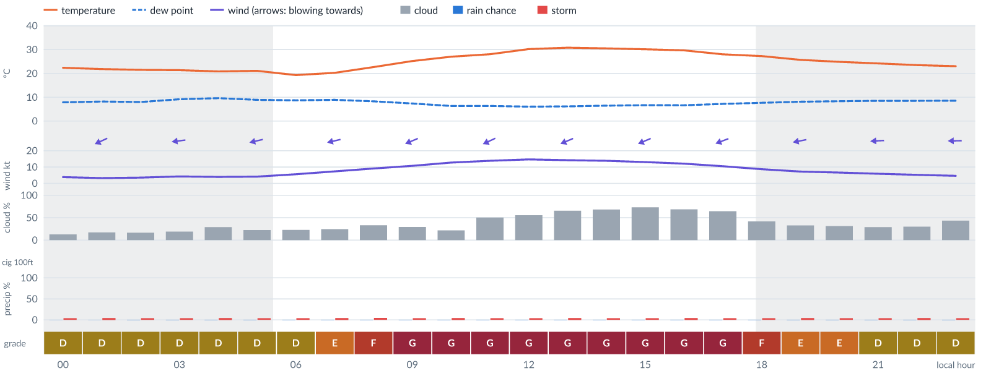
Meteogram — hourly forecast; shaded = before first light / after last light. Gaps mean no data.
Ser | Hrs | Temp | Cloud | Wind | Gust | QNH | Assessment | Driver | Remarks
(a) | (b) | (c) | (d) | (e) | (f) | (g) | (h) | (i) | (j)
1. | 0001 | 22 (spread 21–24)°C | ◔ Mostly clear (13%) | ← 4 (spread 3–5) kts E | 7 kts | 1023 | D - Marginal | storm 4% | thunderstorm risk
2. | 0100 | 22 (spread 20–24)°C | ◔ Mostly clear (17%) | ↙ 3 (spread 2–4) kts ENE | 6 kts | 1023 | D - Marginal | storm 5% | thunderstorm risk
3. | 0200 | 21 (spread 20–24)°C | ◔ Mostly clear (16%) | ← 4 (spread 2–5) kts E | 6 kts | 1022 | D - Marginal | storm 4% | thunderstorm risk
4. | 0300 | 21 (spread 19–24)°C | ◔ Mostly clear (19%) | ← 4 (spread 2–5) kts E | 8 kts | 1022 | D - Marginal | storm 4% | thunderstorm risk
5. | 0400 | 21 (spread 19–24)°C | ◔ Mostly clear (29%) | ← 4 (spread 2–5) kts E | 7 kts | 1022 | D - Marginal | storm 5% | thunderstorm risk
6. | 0500 | 21 (spread 19–24)°C | ◔ Mostly clear (22%) | ← 4 (spread 2–6) kts ENE | 7 kts | 1022 | D - Marginal | storm 4% | thunderstorm risk
7. | 0600 | 19 (spread 18–20)°C | ◔ Mostly clear (23%) | ← 6 (spread 3–7) kts ENE | 8 kts | 1022 | D - Marginal | storm 4% | thunderstorm risk
8. | 0700 | 20 (spread 19–22)°C | ◔ Mostly clear (24%) | ← 7 (spread 4–9) kts ENE | 12 kts | 1023 | E - Poor | gust 12 kt | gusts, thunderstorm risk, wind shear
9. | 0800 | 23 (spread 22–23)°C | ◔ Partly cloudy (33%) | ← 9 (spread 7–11) kts ENE | 15 kts | 1024 | F - Very Poor | gust 15 kt | gusts, thunderstorm risk, strong wind, wind shear
10. | 0900 | 25°C | ◔ Mostly clear (29%) | ↙ 11 (spread 9–12) kts ENE | 19 kts | 1025 | G - Unacceptable | gust 19 kt | gusts, wind shear, thunderstorm risk, strong wind
11. | 1000 | 27°C | ◔ Mostly clear (22%) | ↙ 13 (spread 12–13) kts ENE | 24 kts | 1026 | G - Unacceptable | gust 24 kt · gust spread +11 kt | gusts, wind shear, strong wind, thunderstorm risk
12. | 1100 | 28°C | ◑ Partly cloudy (50%) | ↙ 14 (spread 13–14) kts ENE | 25 kts | 1025 | G - Unacceptable | gust 25 kt · gust spread +12 kt | gusts, wind shear, strong wind, cloud cover, thunderstorm risk
13. | 1200 | 30°C | ◑ Partly cloudy (56%) | ↙ 15 (spread 14–16) kts ENE | 26 kts | 1025 | G - Unacceptable | gust 26 kt · gust spread +11 kt | gusts, wind shear, strong wind, cloud cover, thunderstorm risk
14. | 1300 | 31°C | ◕ Cloudy (65%) | ↙ 14 (spread 13–16) kts ENE | 24 kts | 1024 | G - Unacceptable | gust 24 kt · gust spread +10 kt | gusts, wind shear, cloud cover, strong wind, thunderstorm risk
15. | 1400 | 30 (spread 30–31)°C | ◕ Cloudy (68%) | ↙ 14 (spread 13–15) kts ENE | 24 kts | 1024 | G - Unacceptable | gust 24 kt · gust spread +10 kt | gusts, wind shear, cloud cover, strong wind, thunderstorm risk
16. | 1500 | 30 (spread 30–31)°C | ◕ Cloudy (73%) | ↙ 13 (spread 12–14) kts ENE | 22 kts | 1023 | G - Unacceptable | cloud 73% · gust 22 kt | cloud cover, gusts, wind shear, strong wind, thunderstorm risk
17. | 1600 | 30 (spread 29–30)°C | ◕ Cloudy (68%) | ↙ 12 kts ENE | 20 kts | 1022 | G - Unacceptable | gust 20 kt | gusts, cloud cover, strong wind, wind shear, thunderstorm risk
18. | 1700 | 28°C | ◕ Cloudy (65%) | ← 10 (spread 10–11) kts ENE | 19 kts | 1022 | G - Unacceptable | gust 19 kt | gusts, cloud cover, wind shear, thunderstorm risk, strong wind
19. | 1800 | 27 (spread 27–29)°C | ◑ Partly cloudy (42%) | ← 9 (spread 8–10) kts ENE | 17 kts | 1023 | F - Very Poor | gust 17 kt | gusts, wind shear, thunderstorm risk, strong wind
20. | 1900 | 26 (spread 25–27)°C | ◔ Partly cloudy (33%) | ← 7 (spread 6–8) kts ENE | 14 kts | 1023 | E - Poor | gust 14 kt · gust spread +6 kt | gusts, wind shear, thunderstorm risk
21. | 2000 | 25 (spread 24–27)°C | ◔ Mostly clear (31%) | ← 7 (spread 6–7) kts E | 12 kts | 1023 | E - Poor | gust 12 kt | gusts, thunderstorm risk, wind shear
22. | 2100 | 24 (spread 23–26)°C | ◔ Mostly clear (29%) | ← 6 (spread 5–6) kts E | 10 kts | 1023 | D - Marginal | storm 4% · gust 10 kt | thunderstorm risk, gusts
23. | 2200 | 23 (spread 22–25)°C | ◔ Mostly clear (30%) | ← 5 (spread 5–6) kts E | 9 kts | 1023 | D - Marginal | storm 5% · gust 9 kt | thunderstorm risk, gusts
24. | 2300 | 23 (spread 22–25)°C | ◑ Partly cloudy (44%) | ← 5 (spread 4–5) kts E | 7 kts | 1023 | D - Marginal | storm 4% · cloud 44% | cloud cover, thunderstorm risk
Confidence: 72% — data for 24 of 24 hours; 21% of readings interpolated · first light 0555L · last light 1821L · Moon 2 % illuminated, rises 07:06, sets 18:52.

Wed 11 Nov 26
Conditions are expected to be generally Unacceptable: cloudy, winds up to 14 kts ENE, gusting 24 kts and temperatures 19–30°C. Flyable windows: 2000–2300L (Marginal, 4 h). Hazards: thunderstorm risk 0001–2300L. Overall a deterioration from the previous day.
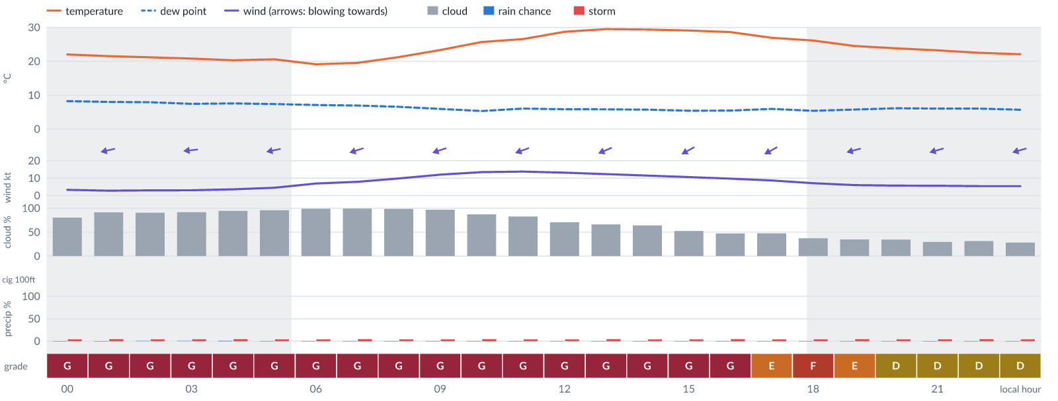
Meteogram — hourly forecast; shaded = before first light / after last light. Gaps mean no data.
Ser | Hrs | Temp | Cloud | Wind | Gust | QNH | Assessment | Driver | Remarks
(a) | (b) | (c) | (d) | (e) | (f) | (g) | (h) | (i) | (j)
1. | 0001 | 22 (spread 21–24)°C | ◕ Cloudy (80%) | ← 3 (spread 2–4) kts E | 6 kts | 1023 | G - Unacceptable | cloud 80% | cloud cover, thunderstorm risk
2. | 0100 | 22 (spread 20–23)°C | ☁ Overcast (91%) | ← 3 (spread 2–4) kts ENE | 6 kts | 1022 | G - Unacceptable | cloud 91% | cloud cover, thunderstorm risk
3. | 0200 | 21 (spread 20–23)°C | ☁ Overcast (91%) | ← 3 (spread 2–4) kts E | 6 kts | 1022 | G - Unacceptable | cloud 91% | cloud cover, thunderstorm risk
4. | 0300 | 21 (spread 19–23)°C | ☁ Overcast (92%) | ← 3 kts E | 6 kts | 1021 | G - Unacceptable | cloud 92% | cloud cover, thunderstorm risk
5. | 0400 | 20 (spread 19–22)°C | ☁ Overcast (95%) | ← 4 (spread 3–4) kts E | 6 kts | 1021 | G - Unacceptable | cloud 95% | cloud cover, thunderstorm risk
6. | 0500 | 21 (spread 19–22)°C | ☁ Overcast (96%) | ← 5 (spread 3–6) kts ENE | 8 kts | 1021 | G - Unacceptable | cloud 96% | cloud cover, thunderstorm risk
7. | 0600 | 19°C | ☁ Overcast (99%) | ← 7 (spread 5–8) kts ENE | 10 kts | 1022 | G - Unacceptable | cloud 99% | cloud cover, thunderstorm risk, gusts
8. | 0700 | 20 (spread 19–20)°C | ☁ Overcast (99%) | ← 8 (spread 6–10) kts ENE | 12 kts | 1023 | G - Unacceptable | cloud 99% | cloud cover, gusts, thunderstorm risk
9. | 0800 | 21°C | ☁ Overcast (99%) | ← 10 (spread 8–11) kts ENE | 17 kts | 1023 | G - Unacceptable | cloud 99% | cloud cover, gusts, wind shear, thunderstorm risk, strong wind
10. | 0900 | 23 (spread 23–24)°C | ☁ Overcast (97%) | ← 12 (spread 11–13) kts ENE | 21 kts | 1024 | G - Unacceptable | cloud 97% · gust 21 kt | cloud cover, gusts, wind shear, strong wind, thunderstorm risk
11. | 1000 | 26 (spread 25–27)°C | ◕ Cloudy (87%) | ← 13 (spread 13–14) kts ENE | 24 kts | 1026 | G - Unacceptable | cloud 87% · gust 24 kt | cloud cover, gusts, wind shear, strong wind, thunderstorm risk
12. | 1100 | 27 (spread 26–28)°C | ◕ Cloudy (83%) | ← 14 (spread 13–14) kts ENE | 24 kts | 1025 | G - Unacceptable | cloud 83% · gust 24 kt | cloud cover, gusts, wind shear, strong wind, thunderstorm risk
13. | 1200 | 29 (spread 28–29)°C | ◕ Cloudy (71%) | ← 13 (spread 12–14) kts ENE | 23 kts | 1025 | G - Unacceptable | cloud 71% · gust 23 kt | cloud cover, gusts, wind shear, strong wind, thunderstorm risk
14. | 1300 | 30 (spread 29–30)°C | ◕ Cloudy (66%) | ↙ 12 (spread 11–14) kts ENE | 21 kts | 1024 | G - Unacceptable | gust 21 kt | gusts, cloud cover, wind shear, strong wind, thunderstorm risk
15. | 1400 | 29 (spread 29–30)°C | ◕ Cloudy (64%) | ↙ 11 (spread 11–12) kts ENE | 21 kts | 1023 | G - Unacceptable | gust 21 kt · gust spread +9 kt | gusts, wind shear, cloud cover, thunderstorm risk, strong wind
16. | 1500 | 29 (spread 29–30)°C | ◑ Partly cloudy (52%) | ↙ 11 (spread 10–11) kts ENE | 20 kts | 1023 | G - Unacceptable | gust 20 kt | gusts, wind shear, cloud cover, thunderstorm risk, strong wind
17. | 1600 | 29 (spread 28–29)°C | ◑ Partly cloudy (47%) | ↙ 10 (spread 9–10) kts ENE | 18 kts | 1022 | G - Unacceptable | gust 18 kt | gusts, wind shear, cloud cover, thunderstorm risk, strong wind
18. | 1700 | 27°C | ◑ Partly cloudy (48%) | ↙ 9 kts ENE | 14 kts | 1022 | E - Poor | gust 14 kt | gusts, cloud cover, thunderstorm risk, strong wind, wind shear
19. | 1800 | 26 (spread 25–28)°C | ◔ Partly cloudy (37%) | ↙ 7 (spread 6–8) kts ENE | 15 kts | 1022 | F - Very Poor | gust 15 kt | gusts, wind shear, thunderstorm risk
20. | 1900 | 25 (spread 23–27)°C | ◔ Partly cloudy (35%) | ← 6 (spread 5–7) kts ENE | 12 kts | 1022 | E - Poor | gust 12 kt | gusts, thunderstorm risk, wind shear
21. | 2000 | 24 (spread 22–26)°C | ◔ Partly cloudy (34%) | ← 6 (spread 5–6) kts ENE | 11 kts | 1022 | D - Marginal | storm 4% · gust 11 kt | thunderstorm risk, gusts, wind shear
22. | 2100 | 23 (spread 22–25)°C | ◔ Mostly clear (30%) | ← 6 (spread 5–6) kts ENE | 9 kts | 1023 | D - Marginal | storm 4% · gust 9 kt | thunderstorm risk, gusts
23. | 2200 | 23 (spread 22–25)°C | ◔ Mostly clear (31%) | ← 5 (spread 5–6) kts ENE | 8 kts | 1023 | D - Marginal | storm 5% | thunderstorm risk
24. | 2300 | 22 (spread 21–24)°C | ◔ Mostly clear (28%) | ← 5 (spread 5–6) kts ENE | 8 kts | 1022 | D - Marginal | storm 4% | thunderstorm risk
Confidence: 73% — data for 24 of 24 hours; 22% of readings interpolated · first light 0555L · last light 1821L · Moon 5 % illuminated, rises 07:59, sets 19:42.

Thu 12 Nov 26
Conditions are expected to be generally Unacceptable: partly cloudy, winds up to 11 kts NE, gusting 21 kts and temperatures 17–29°C. Flyable windows: 0001–0100L (Marginal, 2 h). Hazards: thunderstorm risk 0001–2300L. Overall similar to the previous day.
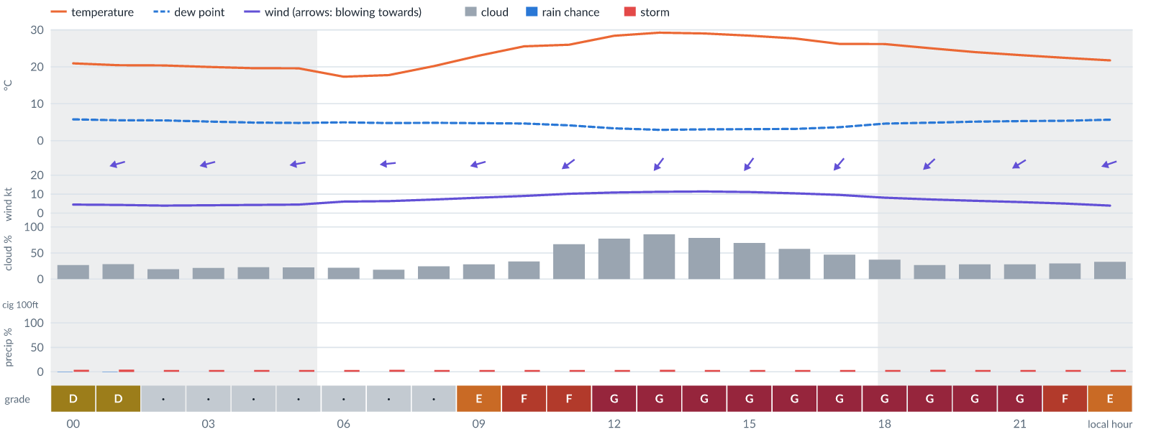
Meteogram — hourly forecast; shaded = before first light / after last light. Gaps mean no data.
Ser | Hrs | Temp | Cloud | Wind | Gust | QNH | Assessment | Driver | Remarks
(a) | (b) | (c) | (d) | (e) | (f) | (g) | (h) | (i) | (j)
1. | 0001 | 21 (spread 20–23)°C | ◔ Mostly clear (27%) | ← 4 (spread 4–5) kts ENE | 8 kts | 1022 | D - Marginal | storm 4% | thunderstorm risk
2. | 0100 | 20 (spread 19–22)°C | ◔ Mostly clear (28%) | ← 4 (spread 3–5) kts ENE | 8 kts | 1022 | D - Marginal | storm 5% | thunderstorm risk
3. | 0200 | 20 (spread 19–22)°C | ◔ Mostly clear (19%) | ← 4 (spread 3–5) kts ENE | 8 kts | 1022 | · - No data | storm 4% · visibility not forecast | thunderstorm risk
4. | 0300 | 20 (spread 19–22)°C | ◔ Mostly clear (22%) | ← 4 (spread 3–5) kts ENE | 8 kts | 1021 | · - No data | storm 4% · visibility not forecast | thunderstorm risk
5. | 0400 | 20 (spread 18–21)°C | ◔ Mostly clear (23%) | ← 4 (spread 4–5) kts ENE | 8 kts | 1021 | · - No data | storm 4% · visibility not forecast | thunderstorm risk
6. | 0500 | 20 (spread 19–21)°C | ◔ Mostly clear (22%) | ← 4 (spread 4–5) kts E | 8 kts | 1021 | · - No data | storm 4% · visibility not forecast | thunderstorm risk
7. | 0600 | 17 (spread 17–18)°C | ◔ Mostly clear (22%) | ← 6 (spread 5–6) kts E | 8 kts | 1021 | · - No data | storm 4% · visibility not forecast | thunderstorm risk
8. | 0700 | 18 (spread 17–18)°C | ◔ Mostly clear (18%) | ← 6 (spread 6–7) kts E | 9 kts | 1021 | · - No data | storm 4% · gust 9 kt · visibility not forecast | thunderstorm risk, gusts
9. | 0800 | 20°C | ◔ Mostly clear (25%) | ← 7 (spread 7–8) kts E | 11 kts | 1022 | · - No data | storm 4% · gust 11 kt · visibility not forecast | thunderstorm risk, gusts
10. | 0900 | 23°C | ◔ Mostly clear (28%) | ← 8 (spread 8–9) kts ENE | 14 kts | 1024 | E - Poor | gust 14 kt · visibility not forecast | gusts, thunderstorm risk, wind shear
11. | 1000 | 26 (spread 25–26)°C | ◔ Partly cloudy (34%) | ↙ 9 (spread 8–10) kts ENE | 16 kts | 1024 | F - Very Poor | gust 16 kt · visibility not forecast | gusts, wind shear, thunderstorm risk, strong wind
12. | 1100 | 26 (spread 25–27)°C | ◕ Cloudy (67%) | ↙ 10 (spread 10–11) kts NE | 17 kts | 1024 | F - Very Poor | cloud 67% · gust 17 kt · visibility not forecast | cloud cover, gusts, wind shear, thunderstorm risk, strong wind
13. | 1200 | 28 (spread 28–29)°C | ◕ Cloudy (78%) | ↙ 11 (spread 10–11) kts NE | 19 kts | 1024 | G - Unacceptable | cloud 78% · gust 19 kt · visibility not forecast | cloud cover, gusts, wind shear, thunderstorm risk, strong wind
14. | 1300 | 29 (spread 29–30)°C | ◕ Cloudy (86%) | ↙ 11 (spread 11–12) kts NE | 21 kts | 1024 | G - Unacceptable | cloud 86% · gust 21 kt · visibility not forecast | cloud cover, gusts, wind shear, thunderstorm risk, strong wind
15. | 1400 | 29°C | ◕ Cloudy (79%) | ↙ 11 (spread 11–12) kts NE | 21 kts | 1023 | G - Unacceptable | cloud 79% · gust 21 kt · visibility not forecast | cloud cover, gusts, wind shear, thunderstorm risk, strong wind
16. | 1500 | 28 (spread 28–29)°C | ◕ Cloudy (69%) | ↙ 11 (spread 10–12) kts NE | 21 kts | 1023 | G - Unacceptable | cloud 69% · gust 21 kt · visibility not forecast | cloud cover, gusts, wind shear, thunderstorm risk, strong wind
17. | 1600 | 28°C | ◑ Partly cloudy (58%) | ↙ 10 (spread 10–11) kts NE | 21 kts | 1023 | G - Unacceptable | gust 21 kt · gust spread +10 kt · visibility not forecast | gusts, wind shear, cloud cover, thunderstorm risk, strong wind
18. | 1700 | 26 (spread 26–27)°C | ◑ Partly cloudy (47%) | ↙ 10 (spread 9–10) kts NE | 20 kts | 1022 | G - Unacceptable | gust 20 kt · gust spread +11 kt · visibility not forecast | gusts, wind shear, cloud cover, thunderstorm risk, strong wind
19. | 1800 | 26 (spread 25–28)°C | ◔ Partly cloudy (37%) | ↙ 8 (spread 8–9) kts NE | 19 kts | 1022 | G - Unacceptable | gust 19 kt · gust spread +11 kt · visibility not forecast | gusts, wind shear, thunderstorm risk
20. | 1900 | 25 (spread 24–27)°C | ◔ Mostly clear (27%) | ↙ 7 (spread 7–8) kts NE | 18 kts | 1022 | G - Unacceptable | gust 18 kt · gust spread +11 kt · visibility not forecast | gusts, wind shear, thunderstorm risk
21. | 2000 | 24 (spread 23–26)°C | ◔ Mostly clear (28%) | ↙ 7 (spread 6–7) kts NE | 17 kts | 1022 | G - Unacceptable | gust spread +11 kt · visibility not forecast | wind shear, gusts, thunderstorm risk
22. | 2100 | 23 (spread 22–25)°C | ◔ Mostly clear (28%) | ↙ 6 (spread 5–6) kts ENE | 16 kts | 1022 | G - Unacceptable | gust spread +10 kt · visibility not forecast | wind shear, gusts, thunderstorm risk
23. | 2200 | 22 (spread 21–24)°C | ◔ Mostly clear (30%) | ↙ 5 kts ENE | 14 kts | 1022 | F - Very Poor | gust spread +9 kt · visibility not forecast | wind shear, gusts, thunderstorm risk
24. | 2300 | 22 (spread 21–24)°C | ◔ Partly cloudy (33%) | ← 4 kts ENE | 12 kts | 1022 | E - Poor | gust 12 kt · gust spread +8 kt · visibility not forecast | gusts, wind shear, thunderstorm risk
Confidence: 70% — data for 24 of 24 hours; 17% of readings interpolated · first light 0555L · last light 1821L · Moon 9 % illuminated, rises 08:51, sets 20:33.

Fri 13 Nov 26
Conditions are expected to be generally Unacceptable: mostly clear, winds up to 12 kts NE, gusting 22 kts and temperatures 17–29°C. No flyable windows (Marginal or better, ≥2 consecutive hrs) are forecast. Hazards: thunderstorm risk 0001–2300L. Overall similar to the previous day.
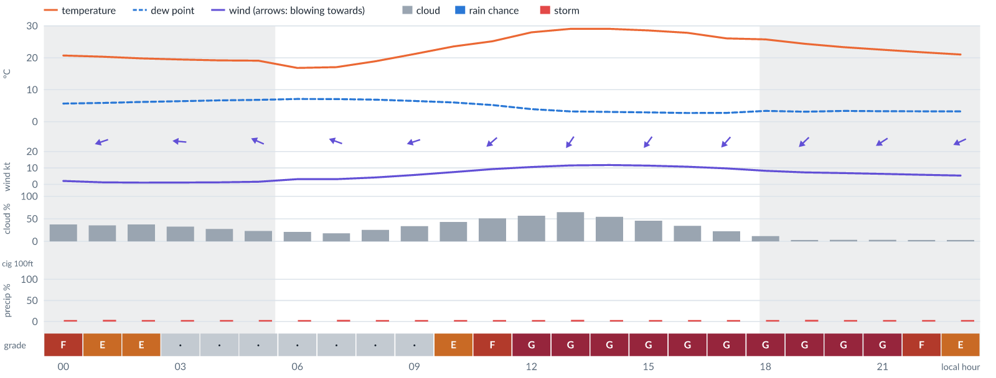
Meteogram — hourly forecast; shaded = before first light / after last light. Gaps mean no data.
Ser | Hrs | Temp | Cloud | Wind | Gust | QNH | Assessment | Driver | Remarks
(a) | (b) | (c) | (d) | (e) | (f) | (g) | (h) | (i) | (j)
1. | 0001 | 21 (spread 19–22)°C | ◑ Partly cloudy (38%) | ← 2 kts ENE | 11 kts | 1021 | F - Very Poor | gust spread +8 kt · visibility not forecast | wind shear, thunderstorm risk, gusts
2. | 0100 | 20 (spread 19–22)°C | ◔ Partly cloudy (36%) | ← 1 (spread 1–2) kts ENE | 9 kts | 1022 | E - Poor | gust spread +8 kt · visibility not forecast | wind shear, thunderstorm risk, gusts
3. | 0200 | 20 (spread 19–22)°C | ◔ Partly cloudy (37%) | ← 1 kts E | 8 kts | 1021 | E - Poor | gust spread +6 kt · visibility not forecast | wind shear, thunderstorm risk
4. | 0300 | 19 (spread 18–21)°C | ◔ Partly cloudy (33%) | ← 1 kts E | 6 kts | 1021 | · - No data | storm 4% · gust spread +5 kt · visibility not forecast | thunderstorm risk, wind shear
5. | 0400 | 19 (spread 18–21)°C | ◔ Mostly clear (28%) | ← 1 (spread 1–2) kts ESE | 5 kts | 1021 | · - No data | storm 4% · visibility not forecast | thunderstorm risk
6. | 0500 | 19 (spread 18–21)°C | ◔ Mostly clear (23%) | ↖ 2 (spread 1–2) kts ESE | 4 kts | 1021 | · - No data | storm 4% · visibility not forecast | thunderstorm risk
7. | 0600 | 17 (spread 16–17)°C | ◔ Mostly clear (21%) | ↖ 3 (spread 2–4) kts ESE | 3 kts | 1020 | · - No data | storm 4% · visibility not forecast | thunderstorm risk
8. | 0700 | 17 (spread 16–18)°C | ◔ Mostly clear (18%) | ← 3 (spread 2–5) kts ESE | 3 kts | 1020 | · - No data | storm 4% · visibility not forecast | thunderstorm risk
9. | 0800 | 19°C | ◔ Mostly clear (26%) | ← 4 (spread 3–6) kts E | 5 kts | 1021 | · - No data | storm 4% · visibility not forecast | thunderstorm risk
10. | 0900 | 21 (spread 21–22)°C | ◔ Partly cloudy (34%) | ← 6 (spread 5–7) kts ENE | 9 kts | 1021 | · - No data | storm 4% · gust 9 kt · visibility not forecast | thunderstorm risk, gusts
11. | 1000 | 24 (spread 23–24)°C | ◑ Partly cloudy (43%) | ↙ 7 (spread 7–8) kts ENE | 12 kts | 1022 | E - Poor | gust 12 kt · visibility not forecast | gusts, cloud cover, thunderstorm risk, wind shear
12. | 1100 | 25 (spread 25–26)°C | ◑ Partly cloudy (51%) | ↙ 9 (spread 9–10) kts NE | 16 kts | 1023 | F - Very Poor | gust 16 kt · visibility not forecast | gusts, wind shear, cloud cover, thunderstorm risk, strong wind
13. | 1200 | 28°C | ◑ Partly cloudy (57%) | ↙ 11 (spread 10–11) kts NE | 19 kts | 1023 | G - Unacceptable | gust 19 kt · visibility not forecast | gusts, cloud cover, wind shear, thunderstorm risk, strong wind
14. | 1300 | 29°C | ◕ Cloudy (65%) | ↙ 12 (spread 11–12) kts NE | 21 kts | 1023 | G - Unacceptable | gust 21 kt · visibility not forecast | gusts, cloud cover, wind shear, strong wind, thunderstorm risk
15. | 1400 | 29°C | ◑ Partly cloudy (55%) | ↙ 12 (spread 11–12) kts NE | 22 kts | 1023 | G - Unacceptable | gust 22 kt · gust spread +10 kt · visibility not forecast | gusts, wind shear, cloud cover, strong wind, thunderstorm risk
16. | 1500 | 29 (spread 28–29)°C | ◑ Partly cloudy (46%) | ↙ 11 (spread 11–12) kts NE | 22 kts | 1023 | G - Unacceptable | gust 22 kt · gust spread +10 kt · visibility not forecast | gusts, wind shear, cloud cover, thunderstorm risk, strong wind
17. | 1600 | 28 (spread 27–28)°C | ◔ Partly cloudy (34%) | ↙ 11 (spread 10–11) kts NE | 22 kts | 1023 | G - Unacceptable | gust 22 kt · gust spread +11 kt · visibility not forecast | gusts, wind shear, thunderstorm risk, strong wind
18. | 1700 | 26°C | ◔ Mostly clear (22%) | ↙ 10 (spread 9–10) kts NE | 21 kts | 1022 | G - Unacceptable | gust 21 kt · gust spread +12 kt · visibility not forecast | gusts, wind shear, thunderstorm risk, strong wind
19. | 1800 | 26 (spread 25–27)°C | ☀ Clear (12%) | ↙ 8 (spread 7–9) kts NE | 20 kts | 1023 | G - Unacceptable | gust 20 kt · gust spread +12 kt · visibility not forecast | gusts, wind shear, thunderstorm risk
20. | 1900 | 24 (spread 23–26)°C | ☀ Clear (3%) | ↙ 7 (spread 7–8) kts NE | 19 kts | 1022 | G - Unacceptable | gust 19 kt · gust spread +12 kt · visibility not forecast | gusts, wind shear, thunderstorm risk
21. | 2000 | 23 (spread 22–25)°C | ☀ Clear (4%) | ↙ 7 (spread 6–7) kts NE | 18 kts | 1022 | G - Unacceptable | gust 18 kt · gust spread +11 kt · visibility not forecast | gusts, wind shear, thunderstorm risk
22. | 2100 | 23 (spread 22–24)°C | ☀ Clear (4%) | ↙ 6 (spread 6–7) kts ENE | 17 kts | 1022 | G - Unacceptable | gust spread +10 kt · visibility not forecast | wind shear, gusts, thunderstorm risk
23. | 2200 | 22 (spread 21–23)°C | ☀ Clear (3%) | ↙ 6 (spread 5–6) kts ENE | 15 kts | 1022 | F - Very Poor | gust 15 kt · gust spread +9 kt · visibility not forecast | gusts, wind shear, thunderstorm risk
24. | 2300 | 21 (spread 20–22)°C | ☀ Clear (3%) | ↙ 5 (spread 5–6) kts ENE | 13 kts | 1022 | E - Poor | gust 13 kt · gust spread +8 kt · visibility not forecast | gusts, wind shear, thunderstorm risk
Confidence: 69% — data for 24 of 24 hours; 16% of readings interpolated · first light 0556L · last light 1821L · Moon 15 % illuminated, rises 09:42, sets 21:25.

Sat 14 Nov 26
Conditions are expected to be generally Unacceptable: clear, winds up to 8 kts ENE, gusting 20 kts and temperatures 16–29°C. No flyable windows (Marginal or better, ≥2 consecutive hrs) are forecast. Hazards: thunderstorm risk 0001–2300L. Overall similar to the previous day.
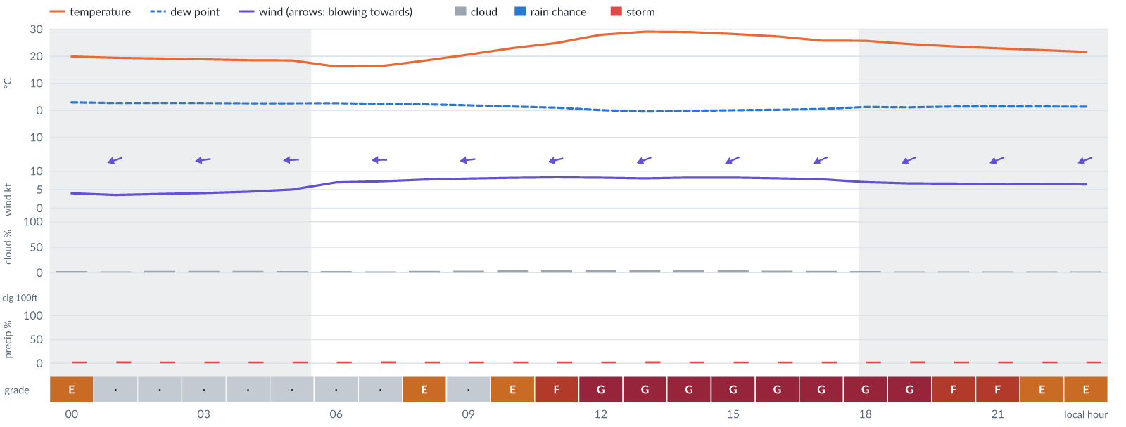
Meteogram — hourly forecast; shaded = before first light / after last light. Gaps mean no data.
Ser | Hrs | Temp | Cloud | Wind | Gust | QNH | Assessment | Driver | Remarks
(a) | (b) | (c) | (d) | (e) | (f) | (g) | (h) | (i) | (j)
1. | 0001 | 20 (spread 19–21)°C | ☀ Clear (3%) | ← 4 (spread 3–4) kts ENE | 11 kts | 1021 | E - Poor | gust spread +7 kt · visibility not forecast | wind shear, thunderstorm risk, gusts
2. | 0100 | 19 (spread 18–20)°C | ☀ Clear (3%) | ← 4 (spread 3–4) kts ENE | 10 kts | 1021 | · - No data | storm 4% · gust 10 kt · visibility not forecast | thunderstorm risk, gusts, wind shear
3. | 0200 | 19 (spread 19–20)°C | ☀ Clear (4%) | ← 4 (spread 3–4) kts ENE | 9 kts | 1021 | · - No data | storm 4% · gust 9 kt · visibility not forecast | thunderstorm risk, gusts, wind shear
4. | 0300 | 19 (spread 18–20)°C | ☀ Clear (4%) | ← 4 (spread 3–5) kts E | 10 kts | 1021 | · - No data | storm 4% · gust 10 kt · visibility not forecast | thunderstorm risk, gusts, wind shear
5. | 0400 | 19 (spread 18–19)°C | ☀ Clear (4%) | ← 4 (spread 4–5) kts E | 10 kts | 1021 | · - No data | storm 4% · gust 10 kt · visibility not forecast | thunderstorm risk, gusts, wind shear
6. | 0500 | 18 (spread 18–19)°C | ☀ Clear (3%) | ← 5 (spread 4–6) kts E | 10 kts | 1021 | · - No data | storm 4% · gust 10 kt · visibility not forecast | thunderstorm risk, gusts, wind shear
7. | 0600 | 16 (spread 16–17)°C | ☀ Clear (3%) | ← 7 (spread 6–7) kts E | 10 kts | 1020 | · - No data | storm 4% · gust 10 kt · visibility not forecast | thunderstorm risk, gusts
8. | 0700 | 16 (spread 16–17)°C | ☀ Clear (3%) | ← 7 (spread 7–8) kts E | 11 kts | 1020 | · - No data | storm 4% · gust 11 kt · visibility not forecast | thunderstorm risk, gusts
9. | 0800 | 18 (spread 18–19)°C | ☀ Clear (4%) | ← 8 (spread 7–8) kts E | 12 kts | 1021 | E - Poor | gust 12 kt · visibility not forecast | gusts, thunderstorm risk
10. | 0900 | 21 (spread 20–22)°C | ☀ Clear (4%) | ← 8 (spread 7–9) kts E | 11 kts | 1021 | · - No data | storm 4% · gust 11 kt · visibility not forecast | thunderstorm risk, gusts
11. | 1000 | 23 (spread 22–24)°C | ☀ Clear (4%) | ← 8 (spread 8–9) kts E | 12 kts | 1022 | E - Poor | gust 12 kt · visibility not forecast | gusts, thunderstorm risk
12. | 1100 | 25 (spread 24–26)°C | ☀ Clear (5%) | ← 8 (spread 8–9) kts ENE | 17 kts | 1022 | F - Very Poor | gust 17 kt · gust spread +9 kt · visibility not forecast | gusts, wind shear, thunderstorm risk
13. | 1200 | 28 (spread 27–29)°C | ☀ Clear (5%) | ← 8 (spread 8–9) kts ENE | 19 kts | 1023 | G - Unacceptable | gust 19 kt · gust spread +10 kt · visibility not forecast | gusts, wind shear, thunderstorm risk
14. | 1300 | 29 (spread 28–30)°C | ☀ Clear (4%) | ← 8 (spread 7–9) kts ENE | 19 kts | 1023 | G - Unacceptable | gust 19 kt · gust spread +11 kt · visibility not forecast | gusts, wind shear, thunderstorm risk
15. | 1400 | 29 (spread 28–30)°C | ☀ Clear (5%) | ← 8 (spread 7–9) kts ENE | 20 kts | 1022 | G - Unacceptable | gust 20 kt · gust spread +11 kt · visibility not forecast | gusts, wind shear, thunderstorm risk
16. | 1500 | 28 (spread 28–29)°C | ☀ Clear (4%) | ↙ 8 (spread 7–9) kts ENE | 20 kts | 1022 | G - Unacceptable | gust 20 kt · gust spread +11 kt · visibility not forecast | gusts, wind shear, thunderstorm risk
17. | 1600 | 27 (spread 27–28)°C | ☀ Clear (4%) | ↙ 8 (spread 7–9) kts ENE | 19 kts | 1022 | G - Unacceptable | gust 19 kt · gust spread +11 kt · visibility not forecast | gusts, wind shear, thunderstorm risk
18. | 1700 | 26 (spread 25–26)°C | ☀ Clear (4%) | ↙ 8 (spread 7–9) kts ENE | 19 kts | 1021 | G - Unacceptable | gust 19 kt · gust spread +11 kt · visibility not forecast | gusts, wind shear, thunderstorm risk
19. | 1800 | 26 (spread 25–27)°C | ☀ Clear (3%) | ← 7 kts ENE | 18 kts | 1022 | G - Unacceptable | gust 18 kt · gust spread +11 kt · visibility not forecast | gusts, wind shear, thunderstorm risk
20. | 1900 | 25 (spread 24–25)°C | ☀ Clear (2%) | ← 7 (spread 6–7) kts ENE | 17 kts | 1021 | G - Unacceptable | gust spread +10 kt · visibility not forecast | wind shear, gusts, thunderstorm risk
21. | 2000 | 24 (spread 23–25)°C | ☀ Clear (2%) | ← 7 (spread 6–7) kts ENE | 16 kts | 1021 | F - Very Poor | gust 16 kt · gust spread +9 kt · visibility not forecast | gusts, wind shear, thunderstorm risk
22. | 2100 | 23 (spread 22–24)°C | ☀ Clear (2%) | ← 7 (spread 6–7) kts ENE | 15 kts | 1021 | F - Very Poor | gust 15 kt · visibility not forecast | gusts, wind shear, thunderstorm risk
23. | 2200 | 22 (spread 22–23)°C | ☀ Clear (2%) | ← 6 (spread 6–7) kts ENE | 13 kts | 1021 | E - Poor | gust 13 kt · gust spread +7 kt · visibility not forecast | gusts, wind shear, thunderstorm risk
24. | 2300 | 22 (spread 21–23)°C | ☀ Clear (2%) | ← 6 (spread 5–7) kts ENE | 12 kts | 1021 | E - Poor | gust 12 kt · visibility not forecast | gusts, thunderstorm risk, wind shear
Confidence: 69% — data for 24 of 24 hours; 16% of readings interpolated · first light 0556L · last light 1821L · Moon 23 % illuminated, rises 10:30, sets 22:16.

Sun 15 Nov 26
Conditions are expected to be generally Poor: clear, winds up to 7 kts ENE, gusting 14 kts and temperatures 17–31°C. No flyable windows (Marginal or better, ≥2 consecutive hrs) are forecast. Hazards: thunderstorm risk 0001–2300L. Overall an improvement on the previous day.
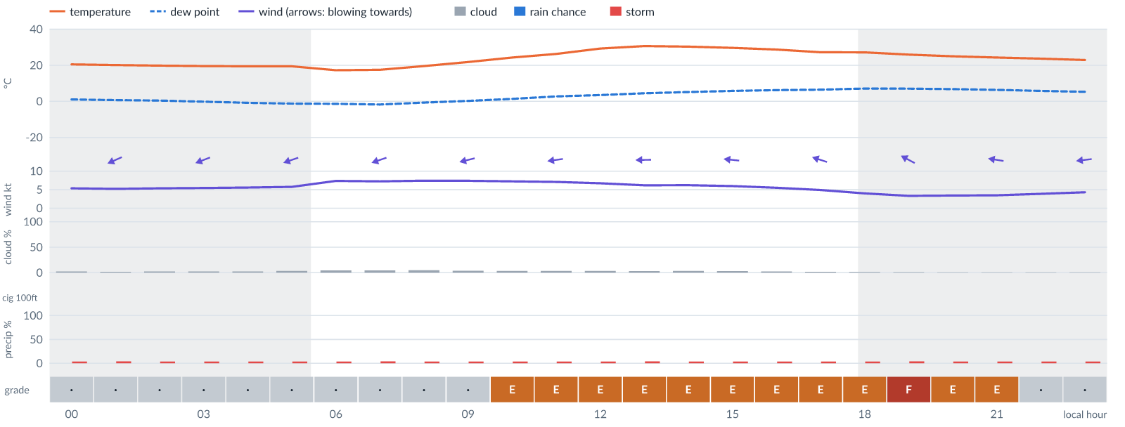
Meteogram — hourly forecast; shaded = before first light / after last light. Gaps mean no data.
Ser | Hrs | Temp | Cloud | Wind | Gust | QNH | Assessment | Driver | Remarks
(a) | (b) | (c) | (d) | (e) | (f) | (g) | (h) | (i) | (j)
1. | 0001 | 21 (spread 20–21)°C | ☀ Clear (2%) | ← 5 (spread 4–6) kts ENE | 11 kts | 1020 | · - No data | storm 4% · gust 11 kt · visibility not forecast | thunderstorm risk, gusts, wind shear
2. | 0100 | 20 (spread 19–21)°C | ☀ Clear (2%) | ↙ 5 (spread 4–6) kts ENE | 10 kts | 1020 | · - No data | storm 4% · gust 10 kt · visibility not forecast | thunderstorm risk, gusts, wind shear
3. | 0200 | 20 (spread 19–21)°C | ☀ Clear (2%) | ← 5 (spread 4–6) kts ENE | 10 kts | 1020 | · - No data | storm 4% · gust 10 kt · visibility not forecast | thunderstorm risk, gusts, wind shear
4. | 0300 | 20 (spread 19–20)°C | ☀ Clear (2%) | ← 5 (spread 4–7) kts ENE | 10 kts | 1020 | · - No data | storm 4% · gust 10 kt · visibility not forecast | thunderstorm risk, gusts, wind shear
5. | 0400 | 19 (spread 19–20)°C | ☀ Clear (2%) | ← 6 (spread 4–7) kts ENE | 10 kts | 1020 | · - No data | storm 4% · gust 10 kt · visibility not forecast | thunderstorm risk, gusts
6. | 0500 | 19 (spread 19–20)°C | ☀ Clear (4%) | ← 6 (spread 5–7) kts ENE | 10 kts | 1020 | · - No data | storm 4% · gust 10 kt · visibility not forecast | thunderstorm risk, gusts
7. | 0600 | 17 (spread 17–18)°C | ☀ Clear (4%) | ← 7 (spread 7–8) kts ENE | 11 kts | 1020 | · - No data | storm 4% · gust 11 kt · visibility not forecast | thunderstorm risk, gusts
8. | 0700 | 18 (spread 17–18)°C | ☀ Clear (4%) | ← 7 (spread 7–8) kts ENE | 11 kts | 1020 | · - No data | storm 4% · gust 11 kt · visibility not forecast | thunderstorm risk, gusts
9. | 0800 | 20 (spread 19–20)°C | ☀ Clear (5%) | ← 7 (spread 7–8) kts ENE | 10 kts | 1020 | · - No data | storm 4% · gust 10 kt · visibility not forecast | thunderstorm risk, gusts
10. | 0900 | 22 (spread 21–22)°C | ☀ Clear (4%) | ← 7 (spread 7–9) kts ENE | 11 kts | 1021 | · - No data | storm 4% · gust 11 kt · visibility not forecast | thunderstorm risk, gusts
11. | 1000 | 24 (spread 24–25)°C | ☀ Clear (4%) | ← 7 (spread 6–9) kts ENE | 12 kts | 1022 | E - Poor | gust 12 kt · visibility not forecast | gusts, thunderstorm risk, wind shear
12. | 1100 | 26 (spread 26–27)°C | ☀ Clear (4%) | ← 7 (spread 6–9) kts E | 13 kts | 1022 | E - Poor | gust 13 kt · visibility not forecast | gusts, thunderstorm risk, wind shear
13. | 1200 | 29 (spread 29–30)°C | ☀ Clear (4%) | ← 7 (spread 6–8) kts E | 13 kts | 1022 | E - Poor | gust 13 kt · visibility not forecast | gusts, thunderstorm risk, wind shear
14. | 1300 | 31 (spread 30–31)°C | ☀ Clear (3%) | ← 6 (spread 5–8) kts E | 14 kts | 1023 | E - Poor | gust 14 kt · gust spread +7 kt · visibility not forecast | gusts, wind shear, thunderstorm risk
15. | 1400 | 30 (spread 30–31)°C | ☀ Clear (4%) | ← 6 (spread 5–8) kts E | 14 kts | 1022 | E - Poor | gust 14 kt · gust spread +8 kt · visibility not forecast | gusts, wind shear, thunderstorm risk
16. | 1500 | 30 (spread 29–30)°C | ☀ Clear (3%) | ← 6 (spread 5–8) kts E | 14 kts | 1022 | E - Poor | gust 14 kt · gust spread +8 kt · visibility not forecast | gusts, wind shear, thunderstorm risk
17. | 1600 | 29°C | ☀ Clear (2%) | ← 6 (spread 4–8) kts ESE | 13 kts | 1021 | E - Poor | gust 13 kt · gust spread +8 kt · visibility not forecast | gusts, wind shear, thunderstorm risk
18. | 1700 | 27°C | ☀ Clear (2%) | ← 5 (spread 3–7) kts ESE | 13 kts | 1021 | E - Poor | gust 13 kt · gust spread +8 kt · visibility not forecast | gusts, wind shear, thunderstorm risk
19. | 1800 | 27 (spread 27–28)°C | ☀ Clear (2%) | ↖ 4 (spread 3–5) kts ESE | 12 kts | 1022 | E - Poor | gust 12 kt · gust spread +8 kt · visibility not forecast | gusts, wind shear, thunderstorm risk
20. | 1900 | 26 (spread 25–27)°C | ☀ Clear (1%) | ↖ 3 (spread 3–5) kts ESE | 12 kts | 1021 | F - Very Poor | gust spread +8 kt · visibility not forecast | wind shear, gusts, thunderstorm risk
21. | 2000 | 25 (spread 24–26)°C | ☀ Clear (1%) | ← 3 (spread 3–5) kts ESE | 11 kts | 1021 | E - Poor | gust spread +7 kt · visibility not forecast | wind shear, thunderstorm risk, gusts
22. | 2100 | 24 (spread 23–26)°C | ☀ Clear (1%) | ← 3 (spread 3–5) kts E | 10 kts | 1021 | E - Poor | gust spread +6 kt · visibility not forecast | wind shear, thunderstorm risk, gusts
23. | 2200 | 24 (spread 23–25)°C | ☀ Clear (1%) | ← 4 (spread 3–5) kts E | 9 kts | 1021 | · - No data | storm 4% · gust 9 kt · visibility not forecast | thunderstorm risk, gusts, wind shear
24. | 2300 | 23 (spread 22–25)°C | ☀ Clear (1%) | ← 4 (spread 4–5) kts E | 10 kts | 1021 | · - No data | storm 4% · gust 10 kt · visibility not forecast | thunderstorm risk, gusts, wind shear
Confidence: 69% — data for 24 of 24 hours; 16% of readings interpolated · first light 0556L · last light 1821L · Moon 31 % illuminated, rises 11:15, sets 23:05.

Mon 16 Nov 26
Conditions are expected to be generally Poor: clear, winds up to 9 kts ENE, gusting 19 kts and temperatures 18–32°C. No flyable windows (Marginal or better, ≥2 consecutive hrs) are forecast. Hazards: thunderstorm risk 0001–2300L. Overall similar to the previous day.
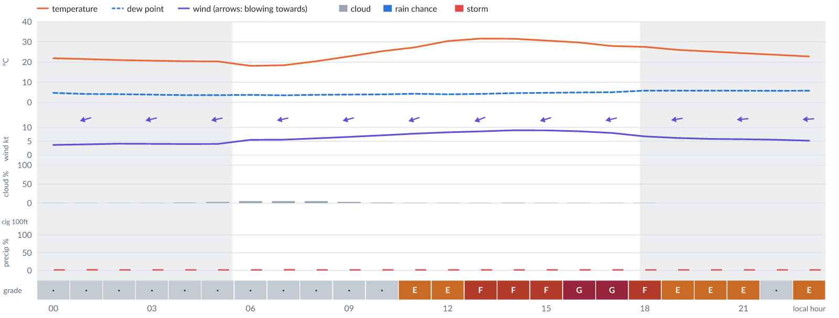
Meteogram — hourly forecast; shaded = before first light / after last light. Gaps mean no data.
Ser | Hrs | Temp | Cloud | Wind | Gust | QNH | Assessment | Driver | Remarks
(a) | (b) | (c) | (d) | (e) | (f) | (g) | (h) | (i) | (j)
1. | 0001 | 22 (spread 21–23)°C | ☀ Clear (1%) | ← 4 (spread 3–4) kts E | 8 kts | 1021 | · - No data | storm 4% · visibility not forecast | thunderstorm risk
2. | 0100 | 21 (spread 20–23)°C | ☀ Clear (1%) | ← 4 (spread 3–5) kts ENE | 8 kts | 1021 | · - No data | storm 4% · visibility not forecast | thunderstorm risk
3. | 0200 | 21 (spread 20–22)°C | ☀ Clear (1%) | ← 4 (spread 3–5) kts ENE | 7 kts | 1020 | · - No data | storm 4% · visibility not forecast | thunderstorm risk
4. | 0300 | 21 (spread 20–22)°C | ☀ Clear (1%) | ← 4 (spread 3–5) kts ENE | 7 kts | 1020 | · - No data | storm 4% · visibility not forecast | thunderstorm risk
5. | 0400 | 20 (spread 20–22)°C | ☀ Clear (2%) | ← 4 (spread 3–5) kts ENE | 7 kts | 1020 | · - No data | storm 4% · visibility not forecast | thunderstorm risk
6. | 0500 | 20 (spread 20–21)°C | ☀ Clear (3%) | ← 4 (spread 3–5) kts ENE | 7 kts | 1020 | · - No data | storm 4% · visibility not forecast | thunderstorm risk
7. | 0600 | 18°C | ☀ Clear (5%) | ← 6 (spread 5–6) kts E | 7 kts | 1019 | · - No data | storm 4% · visibility not forecast | thunderstorm risk
8. | 0700 | 18 (spread 18–19)°C | ☀ Clear (5%) | ← 6 (spread 5–6) kts ENE | 8 kts | 1019 | · - No data | storm 4% · visibility not forecast | thunderstorm risk
9. | 0800 | 20 (spread 20–21)°C | ☀ Clear (5%) | ← 6 kts ENE | 7 kts | 1020 | · - No data | storm 4% · visibility not forecast | thunderstorm risk
10. | 0900 | 23 (spread 22–23)°C | ☀ Clear (3%) | ← 7 (spread 6–7) kts ENE | 9 kts | 1021 | · - No data | storm 4% · gust 9 kt · visibility not forecast | thunderstorm risk, gusts
11. | 1000 | 25 (spread 25–26)°C | ☀ Clear (1%) | ← 7 (spread 7–8) kts ENE | 11 kts | 1021 | · - No data | storm 4% · gust 11 kt · visibility not forecast | thunderstorm risk, gusts
12. | 1100 | 27 (spread 27–28)°C | ☀ Clear (1%) | ← 8 (spread 7–8) kts ENE | 13 kts | 1022 | E - Poor | gust 13 kt · visibility not forecast | gusts, thunderstorm risk, wind shear
13. | 1200 | 30 (spread 30–31)°C | ☀ Clear (1%) | ← 8 (spread 8–9) kts ENE | 14 kts | 1022 | E - Poor | gust 14 kt · visibility not forecast | gusts, thunderstorm risk, wind shear
14. | 1300 | 32 (spread 31–32)°C | ☀ Clear (1%) | ← 9 (spread 8–9) kts ENE | 15 kts | 1022 | F - Very Poor | gust 15 kt · visibility not forecast | gusts, thunderstorm risk, strong wind, wind shear
15. | 1400 | 32°C | ☀ Clear (1%) | ← 9 kts ENE | 16 kts | 1022 | F - Very Poor | gust 16 kt · visibility not forecast | gusts, wind shear, thunderstorm risk, strong wind
16. | 1500 | 31°C | ☀ Clear (0%) | ← 9 kts ENE | 16 kts | 1021 | F - Very Poor | gust 16 kt · visibility not forecast | gusts, wind shear, thunderstorm risk, strong wind
17. | 1600 | 30°C | ☀ Clear (0%) | ← 9 kts ENE | 19 kts | 1021 | G - Unacceptable | gust 19 kt · gust spread +11 kt · visibility not forecast | gusts, wind shear, thunderstorm risk, strong wind
18. | 1700 | 28°C | ☀ Clear (0%) | ← 8 kts ENE | 19 kts | 1020 | G - Unacceptable | gust 19 kt · gust spread +11 kt · visibility not forecast | gusts, wind shear, thunderstorm risk
19. | 1800 | 28°C | ☀ Clear (0%) | ← 7 kts ENE | 15 kts | 1021 | F - Very Poor | gust 15 kt · visibility not forecast | gusts, wind shear, thunderstorm risk
20. | 1900 | 26°C | ☀ Clear (0%) | ← 6 kts E | 14 kts | 1020 | E - Poor | gust 14 kt · gust spread +8 kt · visibility not forecast | gusts, wind shear, thunderstorm risk
21. | 2000 | 25°C | ☀ Clear (0%) | ← 6 kts E | 13 kts | 1020 | E - Poor | gust 13 kt · gust spread +7 kt · visibility not forecast | gusts, wind shear, thunderstorm risk
22. | 2100 | 24°C | ☀ Clear (0%) | ← 6 kts E | 12 kts | 1020 | E - Poor | gust 12 kt · visibility not forecast | gusts, thunderstorm risk, wind shear
23. | 2200 | 24°C | ☀ Clear (0%) | ← 6 kts E | 11 kts | 1020 | · - No data | storm 4% · gust 11 kt · visibility not forecast | thunderstorm risk, gusts, wind shear
24. | 2300 | 23°C | ☀ Clear (0%) | ← 5 kts E | 12 kts | 1019 | E - Poor | gust 12 kt · gust spread +6 kt · visibility not forecast | gusts, wind shear, thunderstorm risk
Confidence: 69% — data for 24 of 24 hours; 9% of readings interpolated · first light 0557L · last light 1821L · Moon 40 % illuminated, rises 11:57, sets 23:53.

Tue 17 Nov 26
Conditions are expected to be generally Very Poor: clear, winds up to 9 kts ENE, gusting 16 kts and temperatures 18–32°C. No flyable windows (Marginal or better, ≥2 consecutive hrs) are forecast. Hazards: thunderstorm risk 0001–2300L. Overall a deterioration from the previous day.
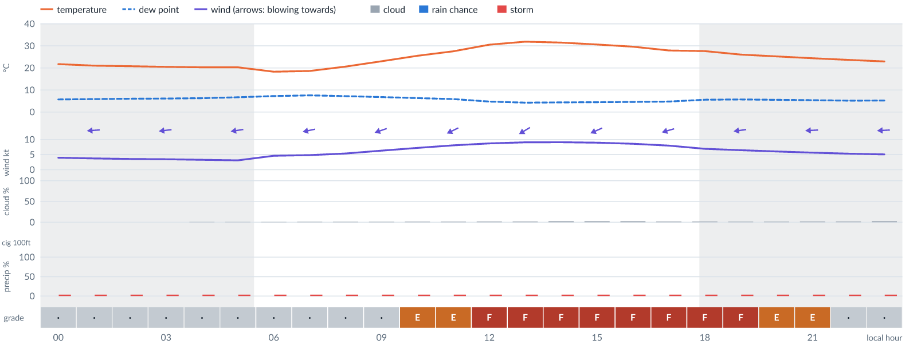
Meteogram — hourly forecast; shaded = before first light / after last light. Gaps mean no data.
Ser | Hrs | Temp | Cloud | Wind | Gust | QNH | Assessment | Driver | Remarks
(a) | (b) | (c) | (d) | (e) | (f) | (g) | (h) | (i) | (j)
1. | 0001 | 22°C | ☀ Clear (0%) | ← 4 kts E | 10 kts | 1019 | · - No data | storm 4% · gust 10 kt · visibility not forecast | thunderstorm risk, gusts, wind shear
2. | 0100 | 21°C | ☀ Clear (0%) | ← 4 kts E | 9 kts | 1019 | · - No data | storm 4% · gust 9 kt · visibility not forecast | thunderstorm risk, gusts, wind shear
3. | 0200 | 21°C | ☀ Clear (0%) | ← 4 kts E | 8 kts | 1018 | · - No data | storm 4% · visibility not forecast | thunderstorm risk
4. | 0300 | 20°C | ☀ Clear (0%) | ← 3 kts E | 7 kts | 1018 | · - No data | storm 4% · visibility not forecast | thunderstorm risk
5. | 0400 | 20°C | ☀ Clear (0%) | ← 3 kts E | 7 kts | 1018 | · - No data | storm 4% · visibility not forecast | thunderstorm risk
6. | 0500 | 20°C | ☀ Clear (0%) | ← 3 kts E | 6 kts | 1018 | · - No data | storm 4% · visibility not forecast | thunderstorm risk
7. | 0600 | 18°C | ☀ Clear (0%) | ← 5 kts E | 7 kts | 1018 | · - No data | storm 4% · visibility not forecast | thunderstorm risk
8. | 0700 | 19°C | ☀ Clear (1%) | ← 5 kts ENE | 6 kts | 1018 | · - No data | storm 4% · visibility not forecast | thunderstorm risk
9. | 0800 | 21°C | ☀ Clear (1%) | ← 5 kts ENE | 7 kts | 1018 | · - No data | storm 4% · visibility not forecast | thunderstorm risk
10. | 0900 | 23°C | ☀ Clear (1%) | ← 6 kts ENE | 9 kts | 1019 | · - No data | storm 4% · gust 9 kt · visibility not forecast | thunderstorm risk, gusts
11. | 1000 | 26°C | ☀ Clear (1%) | ↙ 7 kts ENE | 12 kts | 1020 | E - Poor | gust 12 kt · visibility not forecast | gusts, thunderstorm risk, wind shear
12. | 1100 | 28°C | ☀ Clear (1%) | ↙ 8 kts ENE | 13 kts | 1020 | E - Poor | gust 13 kt · visibility not forecast | gusts, thunderstorm risk, wind shear
13. | 1200 | 31°C | ☀ Clear (2%) | ↙ 9 kts ENE | 15 kts | 1021 | F - Very Poor | gust 15 kt · visibility not forecast | gusts, thunderstorm risk, strong wind, wind shear
14. | 1300 | 32°C | ☀ Clear (2%) | ↙ 9 kts ENE | 15 kts | 1021 | F - Very Poor | gust 15 kt · visibility not forecast | gusts, thunderstorm risk, strong wind, wind shear
15. | 1400 | 31°C | ☀ Clear (2%) | ↙ 9 kts ENE | 16 kts | 1020 | F - Very Poor | gust 16 kt · visibility not forecast | gusts, wind shear, thunderstorm risk, strong wind
16. | 1500 | 31°C | ☀ Clear (2%) | ↙ 9 kts ENE | 16 kts | 1020 | F - Very Poor | gust 16 kt · visibility not forecast | gusts, wind shear, thunderstorm risk, strong wind
17. | 1600 | 30°C | ☀ Clear (2%) | ← 9 kts ENE | 16 kts | 1020 | F - Very Poor | gust 16 kt · visibility not forecast | gusts, wind shear, thunderstorm risk, strong wind
18. | 1700 | 28°C | ☀ Clear (2%) | ← 8 kts ENE | 15 kts | 1019 | F - Very Poor | gust 15 kt · visibility not forecast | gusts, wind shear, thunderstorm risk
19. | 1800 | 28°C | ☀ Clear (2%) | ← 7 kts E | 15 kts | 1020 | F - Very Poor | gust 15 kt · visibility not forecast | gusts, wind shear, thunderstorm risk
20. | 1900 | 26°C | ☀ Clear (1%) | ← 6 kts E | 15 kts | 1019 | F - Very Poor | gust 15 kt · gust spread +8 kt · visibility not forecast | gusts, wind shear, thunderstorm risk
21. | 2000 | 25°C | ☀ Clear (1%) | ← 6 kts E | 14 kts | 1019 | E - Poor | gust 14 kt · gust spread +8 kt · visibility not forecast | gusts, wind shear, thunderstorm risk
22. | 2100 | 24°C | ☀ Clear (2%) | ← 6 kts E | 13 kts | 1019 | E - Poor | gust 13 kt · gust spread +7 kt · visibility not forecast | gusts, wind shear, thunderstorm risk
23. | 2200 | 24°C | ☀ Clear (2%) | ← 5 kts E | 11 kts | 1019 | · - No data | storm 4% · gust 11 kt · visibility not forecast | thunderstorm risk, gusts, wind shear
24. | 2300 | 23°C | ☀ Clear (2%) | ← 5 kts E | 10 kts | 1019 | · - No data | storm 4% · gust 10 kt · visibility not forecast | thunderstorm risk, gusts, wind shear
Confidence: 69% — data for 24 of 24 hours · first light 0557L · last light 1821L · Moon 50 % illuminated, rises 12:37.

Wed 18 Nov 26
Conditions are expected to be generally Very Poor: clear, winds up to 9 kts ENE, gusting 16 kts and temperatures 18–32°C. No flyable windows (Marginal or better, ≥2 consecutive hrs) are forecast. Hazards: thunderstorm risk 0001–2300L. Overall similar to the previous day.
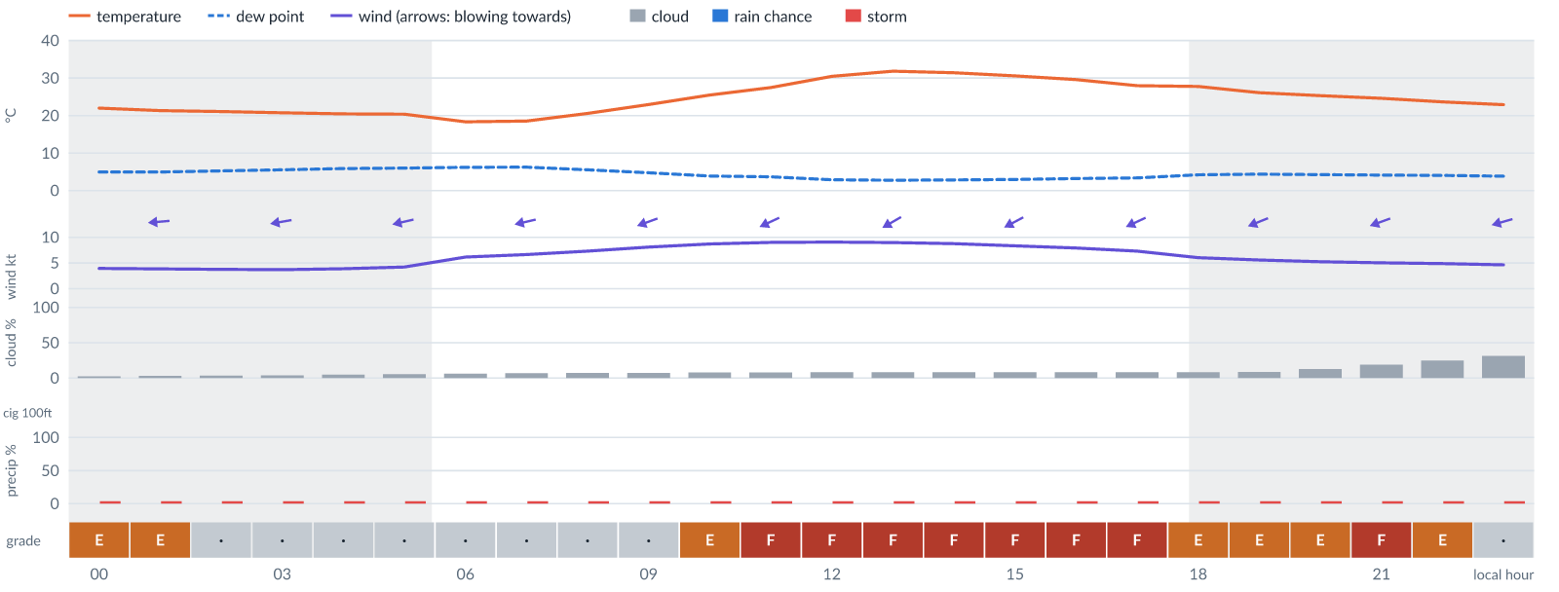
Meteogram — hourly forecast; shaded = before first light / after last light. Gaps mean no data.
Ser | Hrs | Temp | Cloud | Wind | Gust | QNH | Assessment | Driver | Remarks
(a) | (b) | (c) | (d) | (e) | (f) | (g) | (h) | (i) | (j)
1. | 0001 | 22°C | ☀ Clear (2%) | ← 4 kts E | 12 kts | 1018 | E - Poor | gust 12 kt · gust spread +8 kt · visibility not forecast | gusts, wind shear, thunderstorm risk
2. | 0100 | 21°C | ☀ Clear (3%) | ← 4 kts E | 11 kts | 1018 | E - Poor | gust spread +7 kt · visibility not forecast | wind shear, thunderstorm risk, gusts
3. | 0200 | 21°C | ☀ Clear (3%) | ← 4 kts E | 10 kts | 1018 | · - No data | storm 4% · gust 10 kt · visibility not forecast | thunderstorm risk, gusts, wind shear
4. | 0300 | 21°C | ☀ Clear (4%) | ← 4 kts E | 9 kts | 1018 | · - No data | storm 4% · gust 9 kt · visibility not forecast | thunderstorm risk, gusts, wind shear
5. | 0400 | 20°C | ☀ Clear (5%) | ← 4 kts ENE | 8 kts | 1018 | · - No data | storm 4% · visibility not forecast | thunderstorm risk
6. | 0500 | 20°C | ☀ Clear (5%) | ← 4 kts ENE | 8 kts | 1018 | · - No data | storm 4% · visibility not forecast | thunderstorm risk
7. | 0600 | 18°C | ☀ Clear (6%) | ← 6 kts ENE | 8 kts | 1018 | · - No data | storm 4% · visibility not forecast | thunderstorm risk
8. | 0700 | 19°C | ☀ Clear (7%) | ← 7 kts ENE | 7 kts | 1018 | · - No data | storm 4% · visibility not forecast | thunderstorm risk
9. | 0800 | 21°C | ☀ Clear (7%) | ← 7 kts ENE | 9 kts | 1018 | · - No data | storm 4% · gust 9 kt · visibility not forecast | thunderstorm risk, gusts
10. | 0900 | 23°C | ☀ Clear (7%) | ← 8 kts ENE | 11 kts | 1019 | · - No data | storm 4% · gust 11 kt · visibility not forecast | thunderstorm risk, gusts
11. | 1000 | 25°C | ☀ Clear (8%) | ↙ 9 kts ENE | 13 kts | 1020 | E - Poor | gust 13 kt · visibility not forecast | gusts, thunderstorm risk, strong wind
12. | 1100 | 27°C | ☀ Clear (8%) | ↙ 9 kts ENE | 15 kts | 1020 | F - Very Poor | gust 15 kt · visibility not forecast | gusts, thunderstorm risk, strong wind, wind shear
13. | 1200 | 30°C | ☀ Clear (8%) | ↙ 9 kts ENE | 15 kts | 1020 | F - Very Poor | gust 15 kt · visibility not forecast | gusts, thunderstorm risk, strong wind, wind shear
14. | 1300 | 32°C | ☀ Clear (8%) | ↙ 9 kts ENE | 16 kts | 1021 | F - Very Poor | gust 16 kt · visibility not forecast | gusts, wind shear, thunderstorm risk, strong wind
15. | 1400 | 31°C | ☀ Clear (8%) | ↙ 9 kts ENE | 16 kts | 1020 | F - Very Poor | gust 16 kt · visibility not forecast | gusts, wind shear, thunderstorm risk, strong wind
16. | 1500 | 31°C | ☀ Clear (8%) | ↙ 8 kts ENE | 16 kts | 1020 | F - Very Poor | gust 16 kt · visibility not forecast | gusts, wind shear, thunderstorm risk
17. | 1600 | 30°C | ☀ Clear (8%) | ↙ 8 kts ENE | 15 kts | 1020 | F - Very Poor | gust 15 kt · visibility not forecast | gusts, wind shear, thunderstorm risk
18. | 1700 | 28°C | ☀ Clear (8%) | ↙ 7 kts ENE | 15 kts | 1019 | F - Very Poor | gust 15 kt · visibility not forecast | gusts, wind shear, thunderstorm risk
19. | 1800 | 28°C | ☀ Clear (8%) | ↙ 6 kts ENE | 14 kts | 1020 | E - Poor | gust 14 kt · gust spread +8 kt · visibility not forecast | gusts, wind shear, thunderstorm risk
20. | 1900 | 26°C | ☀ Clear (9%) | ← 6 kts ENE | 13 kts | 1019 | E - Poor | gust 13 kt · gust spread +8 kt · visibility not forecast | gusts, wind shear, thunderstorm risk
21. | 2000 | 25°C | ◔ Mostly clear (13%) | ← 5 kts ENE | 12 kts | 1019 | E - Poor | gust 12 kt · gust spread +7 kt · visibility not forecast | gusts, wind shear, thunderstorm risk
22. | 2100 | 25°C | ◔ Mostly clear (19%) | ← 5 kts ENE | 14 kts | 1019 | F - Very Poor | gust spread +9 kt · visibility not forecast | wind shear, gusts, thunderstorm risk
23. | 2200 | 24°C | ◔ Mostly clear (25%) | ← 5 kts ENE | 12 kts | 1019 | E - Poor | gust 12 kt · gust spread +7 kt · visibility not forecast | gusts, wind shear, thunderstorm risk
24. | 2300 | 23°C | ◔ Mostly clear (31%) | ← 5 kts ENE | 10 kts | 1019 | · - No data | storm 4% · gust 10 kt · visibility not forecast | thunderstorm risk, gusts, wind shear
Confidence: 69% — data for 24 of 24 hours · first light 0557L · last light 1821L · Moon 60 % illuminated, rises 13:16, sets 00:40.

Thu 19 Nov 26
Conditions are expected to be generally Unacceptable: partly cloudy, winds up to 7 kts ENE, gusting 13 kts and temperatures 18–32°C. No flyable windows (Marginal or better, ≥2 consecutive hrs) are forecast. Hazards: thunderstorm risk 0001–2300L. Overall a deterioration from the previous day.
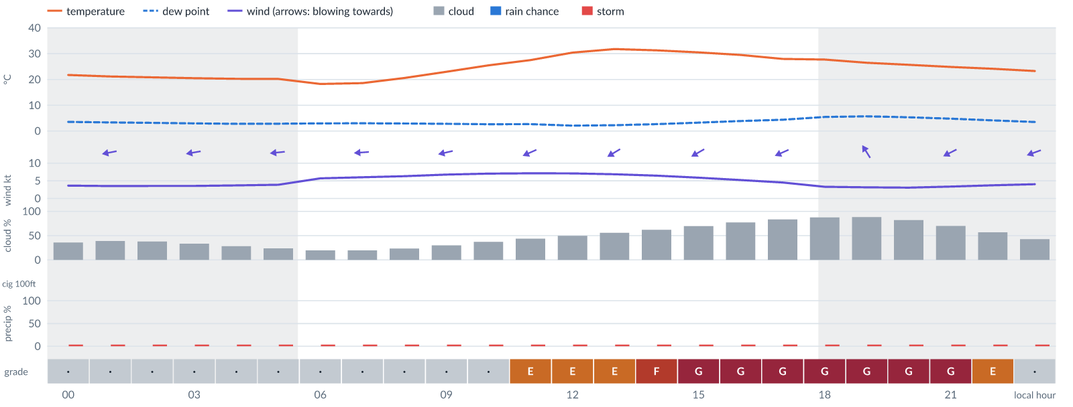
Meteogram — hourly forecast; shaded = before first light / after last light. Gaps mean no data.
Ser | Hrs | Temp | Cloud | Wind | Gust | QNH | Assessment | Driver | Remarks
(a) | (b) | (c) | (d) | (e) | (f) | (g) | (h) | (i) | (j)
1. | 0001 | 22°C | ◔ Partly cloudy (36%) | ← 4 kts ENE | 8 kts | 1018 | · - No data | storm 4% · visibility not forecast | thunderstorm risk
2. | 0100 | 21°C | ◑ Partly cloudy (39%) | ← 4 kts E | 7 kts | 1018 | · - No data | storm 4% · visibility not forecast | thunderstorm risk
3. | 0200 | 21°C | ◑ Partly cloudy (38%) | ← 4 kts ENE | 6 kts | 1018 | · - No data | storm 4% · visibility not forecast | thunderstorm risk
4. | 0300 | 20°C | ◔ Partly cloudy (33%) | ← 4 kts E | 6 kts | 1018 | · - No data | storm 4% · visibility not forecast | thunderstorm risk
5. | 0400 | 20°C | ◔ Mostly clear (28%) | ← 4 kts E | 5 kts | 1018 | · - No data | storm 4% · visibility not forecast | thunderstorm risk
6. | 0500 | 20°C | ◔ Mostly clear (24%) | ← 4 kts E | 5 kts | 1019 | · - No data | storm 4% · visibility not forecast | thunderstorm risk
7. | 0600 | 18°C | ◔ Mostly clear (20%) | ← 6 kts E | 5 kts | 1018 | · - No data | storm 4% · visibility not forecast | thunderstorm risk
8. | 0700 | 19°C | ◔ Mostly clear (20%) | ← 6 kts E | 6 kts | 1018 | · - No data | storm 4% · visibility not forecast | thunderstorm risk
9. | 0800 | 21°C | ◔ Mostly clear (24%) | ← 6 kts E | 7 kts | 1019 | · - No data | storm 4% · visibility not forecast | thunderstorm risk
10. | 0900 | 23°C | ◔ Mostly clear (30%) | ← 7 kts ENE | 9 kts | 1019 | · - No data | storm 4% · gust 9 kt · visibility not forecast | thunderstorm risk, gusts
11. | 1000 | 25°C | ◔ Partly cloudy (37%) | ← 7 kts ENE | 11 kts | 1020 | · - No data | storm 4% · gust 11 kt · visibility not forecast | thunderstorm risk, gusts
12. | 1100 | 27°C | ◑ Partly cloudy (44%) | ↙ 7 kts ENE | 12 kts | 1021 | E - Poor | gust 12 kt · visibility not forecast | gusts, cloud cover, thunderstorm risk, wind shear
13. | 1200 | 30°C | ◑ Partly cloudy (50%) | ↙ 7 kts ENE | 12 kts | 1021 | E - Poor | gust 12 kt · visibility not forecast | gusts, cloud cover, thunderstorm risk, wind shear
14. | 1300 | 32°C | ◑ Partly cloudy (56%) | ↙ 7 kts ENE | 13 kts | 1021 | E - Poor | cloud 56% · gust 13 kt · visibility not forecast | cloud cover, gusts, thunderstorm risk, wind shear
15. | 1400 | 31°C | ◑ Cloudy (62%) | ↙ 6 kts ENE | 13 kts | 1021 | F - Very Poor | cloud 62% · visibility not forecast | cloud cover, gusts, wind shear, thunderstorm risk
16. | 1500 | 30°C | ◕ Cloudy (70%) | ↙ 6 kts ENE | 12 kts | 1020 | G - Unacceptable | cloud 70% · visibility not forecast | cloud cover, gusts, thunderstorm risk, wind shear
17. | 1600 | 29°C | ◕ Cloudy (77%) | ↙ 5 kts ENE | 12 kts | 1020 | G - Unacceptable | cloud 77% · visibility not forecast | cloud cover, gusts, wind shear, thunderstorm risk
18. | 1700 | 28°C | ◕ Cloudy (83%) | ↙ 5 kts ENE | 12 kts | 1020 | G - Unacceptable | cloud 83% · visibility not forecast | cloud cover, gusts, wind shear, thunderstorm risk
19. | 1800 | 28°C | ☁ Cloudy (88%) | ← 3 kts E | 11 kts | 1020 | G - Unacceptable | cloud 88% · visibility not forecast | cloud cover, wind shear, thunderstorm risk, gusts
20. | 1900 | 26°C | ☁ Cloudy (88%) | ↖ 3 kts SSE | 11 kts | 1020 | G - Unacceptable | cloud 88% · visibility not forecast | cloud cover, wind shear, thunderstorm risk, gusts
21. | 2000 | 26°C | ◕ Cloudy (82%) | ↙ 3 kts NE | 10 kts | 1020 | G - Unacceptable | cloud 82% · visibility not forecast | cloud cover, wind shear, thunderstorm risk, gusts
22. | 2100 | 25°C | ◕ Cloudy (70%) | ↙ 3 kts ENE | 9 kts | 1020 | G - Unacceptable | cloud 70% · visibility not forecast | cloud cover, thunderstorm risk, gusts, wind shear
23. | 2200 | 24°C | ◑ Partly cloudy (57%) | ↙ 4 kts ENE | 8 kts | 1020 | E - Poor | cloud 57% · visibility not forecast | cloud cover, thunderstorm risk
24. | 2300 | 23°C | ◑ Partly cloudy (43%) | ← 4 kts ENE | 9 kts | 1020 | · - No data | storm 4% · cloud 43% · visibility not forecast | cloud cover, thunderstorm risk, gusts, wind shear
Confidence: 69% — data for 24 of 24 hours · first light 0558L · last light 1821L · Moon 69 % illuminated, rises 13:54, sets 01:27.

Fri 20 Nov 26
Conditions are expected to be generally Poor: mostly clear, winds up to 7 kts ENE, gusting 13 kts and temperatures 18–32°C. No flyable windows (Marginal or better, ≥2 consecutive hrs) are forecast. Hazards: thunderstorm risk 0001–2300L. Overall an improvement on the previous day.
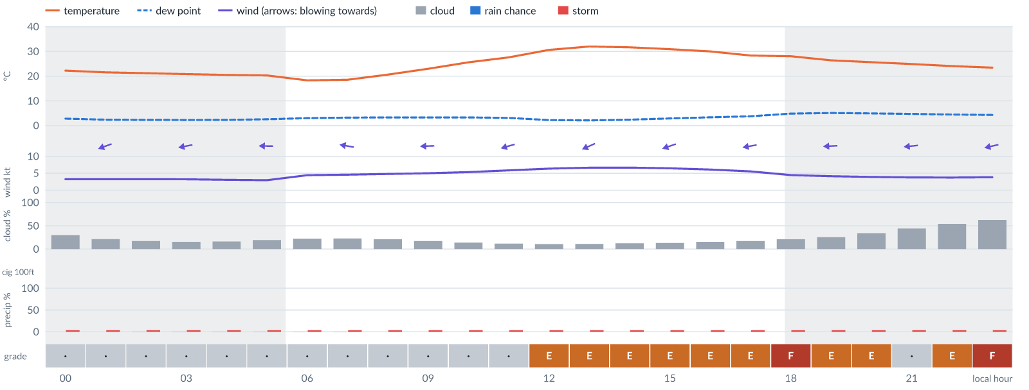
Meteogram — hourly forecast; shaded = before first light / after last light. Gaps mean no data.
Ser | Hrs | Temp | Cloud | Wind | Gust | QNH | Assessment | Driver | Remarks
(a) | (b) | (c) | (d) | (e) | (f) | (g) | (h) | (i) | (j)
1. | 0001 | 22°C | ◔ Mostly clear (30%) | ← 3 kts ENE | 8 kts | 1020 | · - No data | storm 4% · gust spread +5 kt · visibility not forecast | thunderstorm risk, wind shear
2. | 0100 | 22°C | ◔ Mostly clear (22%) | ← 3 kts ENE | 7 kts | 1019 | · - No data | storm 4% · visibility not forecast | thunderstorm risk
3. | 0200 | 21°C | ◔ Mostly clear (17%) | ← 3 kts ENE | 6 kts | 1019 | · - No data | storm 4% · visibility not forecast | thunderstorm risk
4. | 0300 | 21°C | ◔ Mostly clear (16%) | ← 3 kts E | 6 kts | 1019 | · - No data | storm 4% · visibility not forecast | thunderstorm risk
5. | 0400 | 20°C | ◔ Mostly clear (16%) | ← 3 kts E | 6 kts | 1019 | · - No data | storm 4% · visibility not forecast | thunderstorm risk
6. | 0500 | 20°C | ◔ Mostly clear (19%) | ← 3 kts E | 6 kts | 1019 | · - No data | storm 4% · visibility not forecast | thunderstorm risk
7. | 0600 | 18°C | ◔ Mostly clear (22%) | ← 4 kts E | 6 kts | 1019 | · - No data | storm 4% · visibility not forecast | thunderstorm risk
8. | 0700 | 19°C | ◔ Mostly clear (23%) | ← 5 kts E | 6 kts | 1019 | · - No data | storm 4% · visibility not forecast | thunderstorm risk
9. | 0800 | 21°C | ◔ Mostly clear (21%) | ← 5 kts E | 6 kts | 1019 | · - No data | storm 4% · visibility not forecast | thunderstorm risk
10. | 0900 | 23°C | ◔ Mostly clear (17%) | ← 5 kts E | 8 kts | 1020 | · - No data | storm 4% · visibility not forecast | thunderstorm risk
11. | 1000 | 26°C | ◔ Mostly clear (14%) | ← 5 kts E | 9 kts | 1021 | · - No data | storm 4% · gust 9 kt · visibility not forecast | thunderstorm risk, gusts
12. | 1100 | 28°C | ☀ Clear (12%) | ← 6 kts ENE | 11 kts | 1021 | · - No data | storm 4% · gust 11 kt · visibility not forecast | thunderstorm risk, gusts, wind shear
13. | 1200 | 31°C | ☀ Clear (11%) | ← 6 kts ENE | 12 kts | 1022 | E - Poor | gust 12 kt · visibility not forecast | gusts, thunderstorm risk, wind shear
14. | 1300 | 32°C | ☀ Clear (11%) | ↙ 7 kts ENE | 12 kts | 1022 | E - Poor | gust 12 kt · visibility not forecast | gusts, thunderstorm risk, wind shear
15. | 1400 | 32°C | ☀ Clear (12%) | ← 7 kts ENE | 13 kts | 1022 | E - Poor | gust 13 kt · visibility not forecast | gusts, thunderstorm risk, wind shear
16. | 1500 | 31°C | ◔ Mostly clear (13%) | ← 6 kts ENE | 13 kts | 1022 | E - Poor | gust 13 kt · gust spread +7 kt · visibility not forecast | gusts, wind shear, thunderstorm risk
17. | 1600 | 30°C | ◔ Mostly clear (15%) | ← 6 kts ENE | 13 kts | 1021 | E - Poor | gust 13 kt · gust spread +7 kt · visibility not forecast | gusts, wind shear, thunderstorm risk
18. | 1700 | 28°C | ◔ Mostly clear (17%) | ← 6 kts E | 13 kts | 1021 | E - Poor | gust 13 kt · gust spread +7 kt · visibility not forecast | gusts, wind shear, thunderstorm risk
19. | 1800 | 28°C | ◔ Mostly clear (21%) | ← 4 kts E | 13 kts | 1021 | F - Very Poor | gust spread +8 kt · visibility not forecast | wind shear, gusts, thunderstorm risk
20. | 1900 | 26°C | ◔ Mostly clear (26%) | ← 4 kts E | 12 kts | 1021 | E - Poor | gust 12 kt · gust spread +8 kt · visibility not forecast | gusts, wind shear, thunderstorm risk
21. | 2000 | 26°C | ◔ Partly cloudy (34%) | ← 4 kts E | 11 kts | 1021 | E - Poor | gust spread +7 kt · visibility not forecast | wind shear, thunderstorm risk, gusts
22. | 2100 | 25°C | ◑ Partly cloudy (44%) | ← 4 kts E | 10 kts | 1021 | · - No data | storm 4% · cloud 44% · visibility not forecast | cloud cover, thunderstorm risk, gusts, wind shear
23. | 2200 | 24°C | ◑ Partly cloudy (54%) | ← 4 kts E | 10 kts | 1021 | E - Poor | cloud 54% · visibility not forecast | cloud cover, thunderstorm risk, gusts, wind shear
24. | 2300 | 23°C | ◑ Cloudy (62%) | ← 4 kts ENE | 8 kts | 1021 | F - Very Poor | cloud 62% · visibility not forecast | cloud cover, thunderstorm risk
Confidence: 69% — data for 24 of 24 hours · first light 0558L · last light 1821L · Moon 79 % illuminated, rises 14:34, sets 02:15.

TAF
Valid (day hh Z) | Type | Wind | Visibility | Weather | Cloud
(a) | (b) | (c) | (d) | (e) | (f)
06 18Z - 07 24Z | prevailing | - | 10 km or more | none | no significant cloud
06 21Z-23Z | BECMG | variable wind 2 kt | - | - | -
07 10Z-12Z | BECMG | wind 080 deg 10 kt | - | - | scattered cloud at 1000 ft
07 19Z-12Z | BECMG | variable wind 2 kt | - | - | -
Decoded for reading; the raw TAF below is authoritative.
TAF DNJO 061700Z 0618/0724 0900KT CAVOK BECMG 0621/0623 VRB02KT BECMG 0710/0712 08010KT SCT010 BECMG 0719/0712 VRB02KT

Imagery

Dust RGB (pink/magenta = airborne dust) — captured 7 Nov 01:18 WAT (5 min ago) · ©EUMETSAT (screenshot via EUMETView)

Convection RGB (yellow = vigorous storms) — captured 7 Nov 01:18 WAT (5 min ago) · ©EUMETSAT (screenshot via EUMETView)
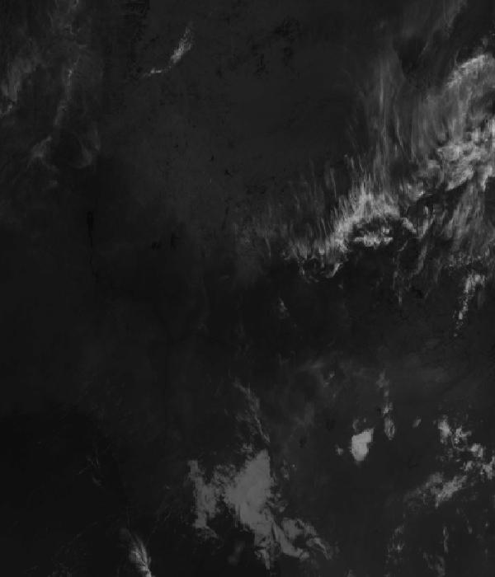
Infrared 10.5 µm (cold tops = deep cloud) — captured 7 Nov 01:18 WAT (5 min ago) · ©EUMETSAT (screenshot via EUMETView)

Accumulated lightning flash area (MTG-LI) — captured 7 Nov 01:18 WAT (5 min ago) · ©EUMETSAT (screenshot via EUMETView)

Source panel
Source | Accuracy | Skill n | Temp °C | Wind kt | Visibility | Storm
(a) | (b) | (c) | (d) | (e) | (f) | (g)
Aviation Weather Center (aviationweather.gov) | ≈ 1.0 | 181 | — | 2 | 10+ km | —
Met.no (Yr) | ≈ 1.0 | 1591 | 18–22 | 2–4 | — | 0 %
Open-Meteo | ≈ 1.0 | 4685 | 18–21 | 0–2 | 10+ km | 0 %
OpenWeather | ≈ 1.0 | 734 | 18 | 3 | 10+ km | 0 %
Tomorrow.io | ▲ 1.1 | 2102 | 19–20 | 1–4 | 10+ km | 0 %
Visual Crossing | ≈ 1.1 | 3770 | 18–19 | 3 | 10+ km | 0 %
Each source's own raw values, min–max over the next 6 hours from the issue hour (before any weighting or bias correction). — means the source does not publish that metric in the window. Wide gaps between rows are real disagreement; the forecast above weights sources by measured skill.

Reading this report
Grades: each hour carries one grade, set by its WORST factor. The bands below are the thresholds in force for this report (Settings); a value in a band earns that grade, and "-" means the factor never produces that grade. Cloud is graded on the worse of cover and ceiling. The Driver column names the limiting factor with its value; open it in the web report for the boundary and sources.
Grade | Cloud cover | Cloud ceiling | Visibility | Wind | Gust | Rain chance | Thunderstorm probability
(a) | (b) | (c) | (d) | (e) | (f) | (g) | (h)
A Excellent | ≤ 17.1% | ≥ 30000 ft | ≥ 8000 m | < 3 kt | < 3 kt | < 5% | 0%
B Good | 17.1–34.3% | 26000–30000 ft | 6666.7–8000 m | 3–6 kt | 3–6 kt | 5–10% | -
C Fair | 34.3–42.9% | 24000–26000 ft | 5333.3–6666.7 m | 6–9 kt | 6–9 kt | 10–15% | -
D Marginal | 42.9–51.4% | 22000–24000 ft | 4000–5333.3 m | 9–12 kt | 9–12 kt | 15–20% | >0–15%
E Poor | 51.4–60% | 16000–22000 ft | 2666.7–4000 m | 12–15 kt | 12–15 kt | 20–25% | 15–30%
F Very Poor | 60–68.6% | 10000–16000 ft | 1333.3–2666.7 m | 15–18 kt | 15–18 kt | 25–30% | 30–60%
G Unacceptable | > 68.6% | < 10000 ft | < 1333.3 m | ≥ 18 kt | ≥ 18 kt | ≥ 30% | > 60%
Flight windows: a window is at least 2 consecutive hours graded Marginal or better; an hour with insufficient data never counts toward one. ☾ marks a window outside first-to-last light.
Time: hours are local time (WAT, UTC+1) unless suffixed Z, which is UTC (TAF, METAR and issue times). Local midnight is labelled 0001.
Units: temperature °C · wind and gusts knots · visibility metres (km in text) · cloud ceiling feet · cloud cover % · rain chance and thunderstorm probability % · QNH hPa (altimeter setting at the field) · CAPE J/kg. A figure like "28 (26–30)°C" gives the p10–p90 range; "spread" marks disagreement between sources.
Symbols: ▲ better than the pool · ▽ worse (only when the 95% interval excludes the pool) · ≈ not distinguishable from the pool · unmarked = unproven (accuracy is measured against METAR and SYNOP observations). ⚠ on a remark means a low-confidence hour; a ⚠ paragraph on the first page is a convective-warning or data-age advisory. ⚡ is lightning observed by satellite near the field (©EUMETSAT).
Hourly glyphs: the wind arrow points the way the air moves (a north wind is ↓, an east wind ←); cloud cover shows as ☀ ◔ ◑ ◕ ☁ (clear, few, scattered, broken, overcast); a shaded hour label is wholly before first light or after last light.
Terms: "No data" - no source forecast the hour, or a core group (cloud, visibility, wind) is missing and the hour could still be flyable; missing data is never given a good grade. "Low-confidence" - few or weak sources behind the load-bearing metrics; treat the grade as indicative. "Insufficient data" - too little to grade at all. "Estimated" (est.) - the value is derived, not reported by a source (dust visibility, cloud base, gusts); it is declared where used and weighted at half. "Derived" - an hour interpolated from a coarser (3-hourly or daily) source, weighted at half and never used to score accuracy.

Data provenance
Source | Fetched (Z) | Age | Skill n | Accuracy
(a) | (b) | (c) | (d) | (e)
Aviation Weather Center (aviationweather.gov) | 7 Nov 00:19Z | 4 min | 181 | ≈ 1.0
Foreca | 7 Nov 00:20Z | 4 min | 363 | ≈ 1.1
Met.no (Yr) | 7 Nov 00:20Z | 3 min | 1591 | ≈ 1.0
Open-Meteo | 7 Nov 00:19Z | 5 min | 4685 | ≈ 1.0
OpenWeather | 7 Nov 00:20Z | 3 min | 734 | ≈ 1.0
Tomorrow.io | 7 Nov 00:20Z | 3 min | 2102 | ▲ 1.1
Visual Crossing | 7 Nov 00:19Z | 5 min | 3770 | ≈ 1.1
Corrections applied (detailed under Learned corrections on the first page): skill weighting, bias correction, hour-of-day bias, cloud-base estimate, probability calibration, climatology bounds, skill blend.

How accurate have we been
Measured against observations (METAR/SYNOP), jos only. Verification table computed 2026-11-06. Mean absolute error (MAE): lower is better; "beats persistence" compares the best source with "it will stay as it is now" on the same hours.
Metric | Best source | Best MAE | Typical MAE | Persistence MAE | Beats persistence by | Pairs
(a) | (b) | (c) | (d) | (e) | (f) | (g)
Temperature (°C) | openweather | 0.9 | 1.4 | 5.3 | - | 86
Dew point (°C) | aifs | 2.2 | 4.8 | 2.6 | - | 46
Wind speed (kt) | aifs | 2.8 | 3.7 | 2.7 | - | 46
Visibility (m) | aviationweather | 589 | 1030 | 1315 | - | 33
Cloud cover (%) | meteofrance | 23 | 45 | 9 | - | 463
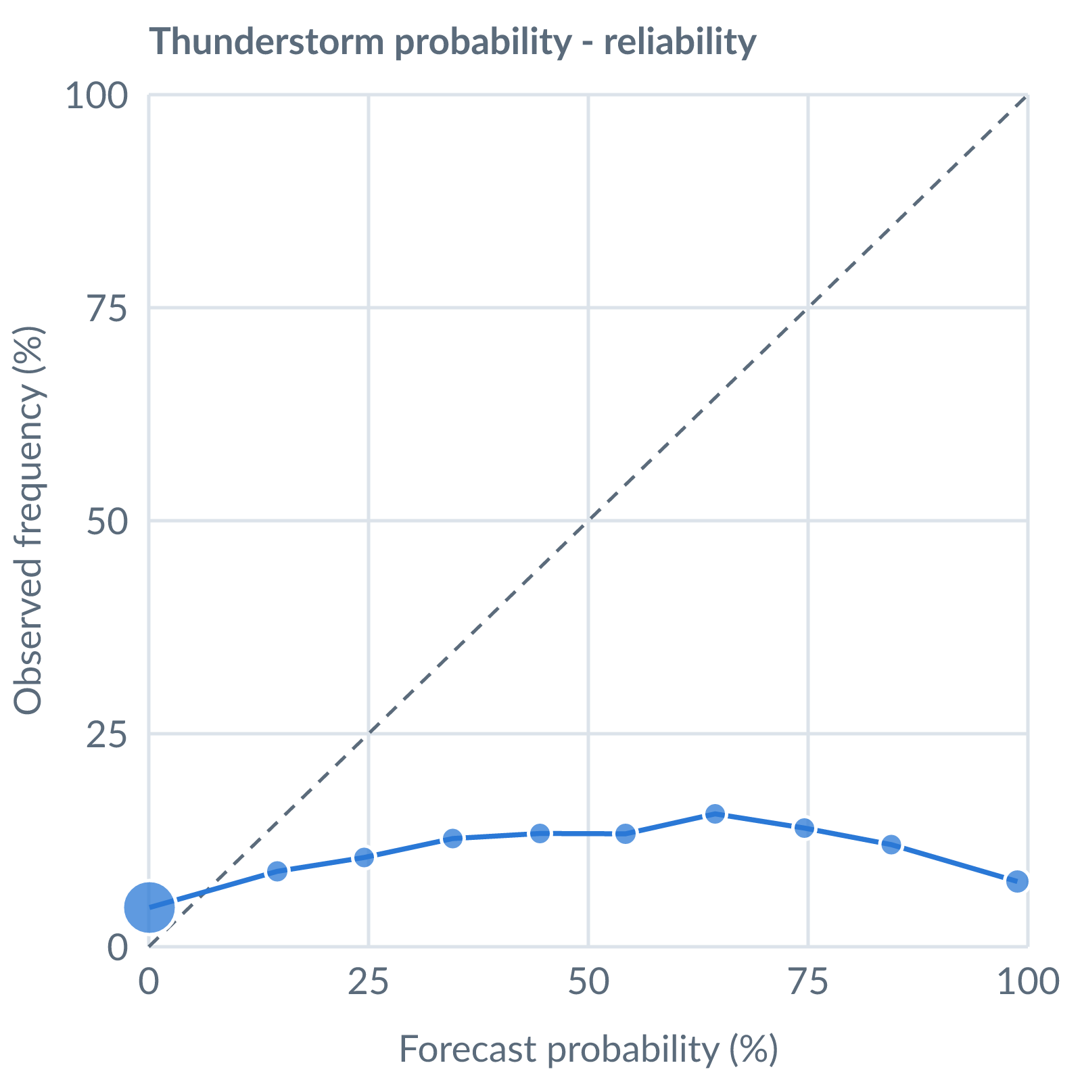
Thunderstorm probability: dots on the dashed line mean a stated probability matched how often it happened (164538 pairs, all places pooled).
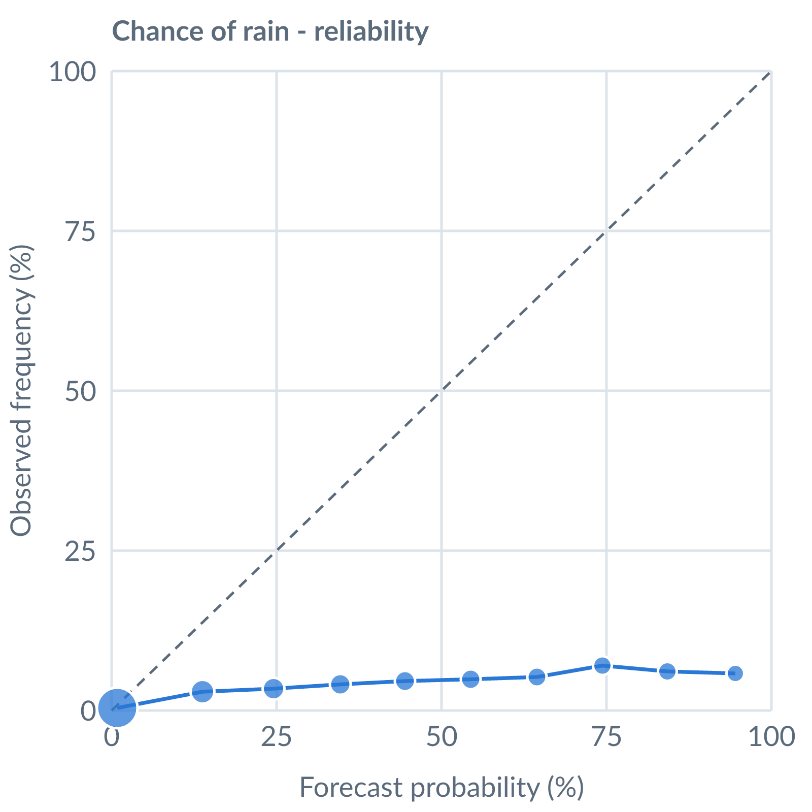
Chance of rain: dots on the dashed line mean a stated probability matched how often it happened (153642 pairs, all places pooled).
Learned bias (forecast minus observed; positive = sources run high), mean over scored sources, by local time of day. These are corrected for before sources are averaged.
Metric | Overall | Night | Morning | Afternoon | Evening | Pairs
(a) | (b) | (c) | (d) | (e) | (f) | (g)
Temperature (°C) | +0.3 | - | +0.9 | -0.3 | - | 5790
Dew point (°C) | -3.0 | - | -3.5 | -2.5 | - | 5471
Wind speed (kt) | -2.0 | - | -2.6 | -1.5 | - | 5823
Not yet available: Scores are decayed over the verification window (half-life 14 days); separate last-7-day and last-30-day windows are not stored. Bias is the current learned value; the history needed for a trend over time is not stored. Flight-window hit / bust / miss is not yet recorded.

