Minna — 14-Day Forecast
DNMN · issued 6 Nov 26 00:22Z
Sources: Tomorrow.io ▲ 1.1
▲ better than the pool · ▽ worse (only when the 95% interval excludes the pool) · ≈ not distinguishable from the pool · unmarked = unproven (accuracy is measured against METAR and SYNOP observations)
Day | 00 | 01 | 02 | 03 | 04 | 05 | 06 | 07 | 08 | 09 | 10 | 11 | 12 | 13 | 14 | 15 | 16 | 17 | 18 | 19 | 20 | 21 | 22 | 23 | Flyable Windows | Conf
Fri 6 Nov 26 | · | G | G | G | D | F | G | G | G | G | G | G | G | G | G | G | G | G | G | G | G | D | D | D | 2100–2300L (Marginal, 3 h) ☾ | 51%
Sat 7 Nov 26 | D | D | D | D | D | D | D | D | D | D | D | D | D | D | D | D | D | D | D | D | D | D | D | D | best window: 0001–2300L (Marginal, 24 h) ☾ | 54%
Sun 8 Nov 26 | D | D | D | D | D | D | D | D | D | D | D | D | D | D | D | D | D | D | D | D | D | D | D | D | 0001–2300L (Marginal, 24 h) ☾ | 54%
Mon 9 Nov 26 | D | D | D | D | G | G | G | D | D | D | D | D | D | D | D | D | D | D | D | D | D | D | D | D | 0001–0300L (Marginal, 4 h) ☾ · 0700–2300L (Marginal, 17 h) ☾ | 54%
Tue 10 Nov 26 | D | D | D | D | D | D | D | D | D | D | D | D | G | G | G | D | D | D | D | D | D | G | G | G | 0001–1100L (Marginal, 12 h) ☾ · 1500–2000L (Marginal, 6 h) ☾ | 54%
Wed 11 Nov 26 | G | G | · | · | · | · | · | · | · | · | · | · | · | · | · | · | · | · | · | · | · | · | · | · | no windows | 5%
A Excellent · B Good · C Fair · D Marginal · E Poor · F Very Poor · G Unacceptable · · No data
Best window (highest confidence, then grade, then length): Sat 7 Nov 26 0001–2300L (Marginal, 24 h) ☾, confidence 54%.
Learned corrections (METAR-verified): skill weighting — pooled all-field scores for 206; bias corrections — meteoblue temperature +3.0 °C, meteoblue QNH −3.0 hPa, openmeteo temperature +3.0 °C, openmeteo dewpoint +3.0 °C, openmeteo QNH −3.0 hPa, metno temperature +3.0 °C (+67 more); hour-of-day bias (local time, shrunk toward the all-hours bias) — aifs afternoon wind +3.3 kt, metcheck afternoon wind +3.2 kt, meteoblue night temperature +3.0 °C, meteoblue morning temperature +3.0 °C, meteoblue afternoon temperature +3.0 °C, meteoblue evening temperature +3.0 °C (+284 more); cloud base estimated as 410 ft per °C of dewpoint spread for sources that report no ceiling (≥60% cloud cover; flagged estimated, weighted ×0.5); probability calibration — rain chance: meteoblue, openmeteo, foreca, metcheck, openweather, visualcrossing, Tomorrow.io, wttrin, ecmwf, gfs, icon, ukmo, gem, ecmwfens; storm: openmeteo, metno, foreca, openweather, visualcrossing, Tomorrow.io, wttrin, ecmwf, gfs, icon, meteofrance, aviationweather, ukmo, jma, gem, ecmwfens, aifs (each source's stated probability mapped to its verified frequency by an isotonic fit on ≥200 pairs, proven on the holdout); plausibility bounds from ERA5 climatology 2016-2025 (mean ± 5 sd; screening only, not observed truth); skill blend 1 auto-tuned over 8814 holdout pairs (consensus beat the best single source, icon, by 16%); correction gates (newest-7-day holdout; pooled skill is always on) — regional skill: off this week (did not improve holdout); place skill: off this week (did not improve holdout); lead-time skill: off this week (did not improve holdout); small-sample skill shrinkage: off this week (did not improve holdout); bias correction: on (improved holdout by 24.3%); place bias: on (improved holdout by 11.1%); hour-of-day bias: on (improved holdout by 5.5%); QNH bias: on (improved holdout by 57.2%); gust estimates: off this week (did not improve holdout); cloud-base coefficient: off this week (insufficient holdout: 77 of 200 items); recent-form skill: off this week (did not improve holdout); probability calibration: on (improved holdout by 22.4%); nowcast anchor horizon: off this week (did not improve holdout); dust-visibility estimate: off this week (did not improve holdout); fog risk: off this week (did not improve holdout).

Outlook
Day | Date | Outlook | Temp | Max wind | Flight windows | Confidence | Notes
(a) | (b) | (c) | (d) | (e) | (f) | (g) | (h)
Fri | 6 Nov 26 | Unacceptable | 25–34°C | 7 kts S, g 11 | 2100–2300L (Marginal, 3 h) ☾ | 51%
Sat | 7 Nov 26 | Marginal | 23–35°C | 7 kts NNE, g 11 | 0001–2300L (Marginal, 24 h) ☾ | 54%
Sun | 8 Nov 26 | Marginal | 23–35°C | 6 kts SW, g 11 | 0001–2300L (Marginal, 24 h) ☾ | 54%
Mon | 9 Nov 26 | Marginal | 25–35°C | 7 kts SSW, g 11 | 0001–0300L (Marginal, 4 h) ☾; 0700–2300L (Marginal, 17 h) ☾ | 54%
Tue | 10 Nov 26 | Marginal | 24–36°C | 8 kts NNE, g 10 | 0001–1100L (Marginal, 12 h) ☾; 1500–2000L (Marginal, 6 h) ☾ | 54%
Wed | 11 Nov 26 | Unacceptable | 26–26°C | 6 kts ENE, g 8 | none | 5%

Today — Fri 6 Nov 26
Conditions are expected to be generally Unacceptable: overcast, winds up to 7 kts S and temperatures 25–34°C. Flyable windows: 2100–2300L (Marginal, 3 h). Hazards: thunderstorm risk 0100–2300L.
WEATHER EFFECTS
 | 00–06L | 06–12L | 12–18L | 18–24L
Wind | D | D | D | B
Visibility | A | A | A | A
Cloud / ceiling | G | G | G | G
Precipitation | A | A | A | A
Thunderstorm | D | D | D | D
Fog | · | · | · | ·
A Excellent · B Good · C Fair · D Marginal (flyable) · E Poor · F Very Poor · G Unacceptable · (worst condition in each period)
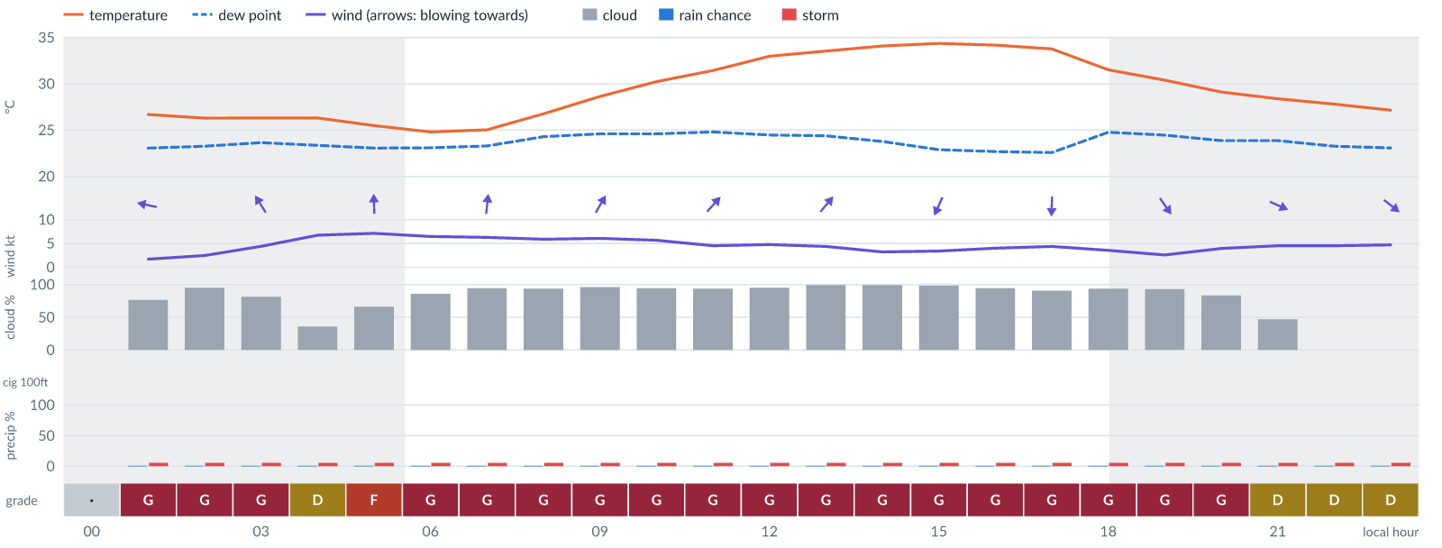
Meteogram — hourly forecast; shaded = before first light / after last light. Gaps mean no data.
Ser | Hrs | Temp | Cloud | Wind | Gust | QNH | Assessment | Driver | Remarks
(a) | (b) | (c) | (d) | (e) | (f) | (g) | (h) | (i) | (j)
1. | 0001 | - | No data | - | - | - | · - No data | cloud, visibility, wind not forecast
2. | 0100 | 27°C | ◕ Cloudy (77%) | ← 2 kts ESE | 1 kts | 1014 | G - Unacceptable | cloud 77% | ⚠ cloud cover, thunderstorm risk
3. | 0200 | 26°C | ☁ Overcast (95%) | ← 2 kts ESE | 3 kts | 1013 | G - Unacceptable | cloud 95% | ⚠ cloud cover, thunderstorm risk
4. | 0300 | 26°C | ◕ Cloudy (81%) | ↖ 4 kts SSE | 6 kts | 1013 | G - Unacceptable | cloud 81% | ⚠ cloud cover, thunderstorm risk
5. | 0400 | 26°C | ◔ Partly cloudy (36%) | ↑ 7 kts S | 10 kts | 1013 | D - Marginal | storm 5% · gust 10 kt | ⚠ thunderstorm risk, gusts
6. | 0500 | 25°C | ◕ Cloudy (66%) | ↑ 7 kts S | 10 kts | 1013 | F - Very Poor | cloud 66% | ⚠ cloud cover, thunderstorm risk, gusts
7. | 0600 | 25°C | ◕ Cloudy (86%) | ↑ 6 kts S | 9 kts | 1014 | G - Unacceptable | cloud 86% | ⚠ cloud cover, thunderstorm risk, gusts
8. | 0700 | 25°C | ☁ Overcast (95%) | ↑ 6 kts S | 9 kts | 1014 | G - Unacceptable | cloud 95% | ⚠ cloud cover, thunderstorm risk, gusts
9. | 0800 | 27°C | ☁ Overcast (94%) | ↑ 6 kts S | 10 kts | 1016 | G - Unacceptable | cloud 94% | ⚠ cloud cover, thunderstorm risk, gusts
10. | 0900 | 29°C | ☁ Overcast (96%) | ↗ 6 kts SSW | 11 kts | 1017 | G - Unacceptable | cloud 96% | ⚠ cloud cover, thunderstorm risk, gusts, wind shear
11. | 1000 | 30°C | ☁ Overcast (95%) | ↗ 6 kts SW | 11 kts | 1017 | G - Unacceptable | cloud 95% | ⚠ cloud cover, thunderstorm risk, gusts, wind shear
12. | 1100 | 31°C | ☁ Overcast (94%) | ↗ 5 kts SW | 10 kts | 1017 | G - Unacceptable | cloud 94% | ⚠ cloud cover, thunderstorm risk, gusts, wind shear
13. | 1200 | 33°C | ☁ Overcast (95%) | ↗ 5 kts SW | 9 kts | 1016 | G - Unacceptable | cloud 95% | ⚠ cloud cover, thunderstorm risk, gusts
14. | 1300 | 34°C | ☁ Overcast (99%) | ↗ 4 kts SW | 8 kts | 1015 | G - Unacceptable | cloud 99% | ⚠ cloud cover, thunderstorm risk
15. | 1400 | 34°C | ☁ Overcast (99%) | ↗ 3 kts SW | 6 kts | 1014 | G - Unacceptable | cloud 99% | ⚠ cloud cover, thunderstorm risk
16. | 1500 | 34°C | ☁ Overcast (98%) | ↙ 3 kts NNE | 6 kts | 1014 | G - Unacceptable | cloud 98% | ⚠ cloud cover, thunderstorm risk
17. | 1600 | 34°C | ☁ Overcast (95%) | ↓ 4 kts N | 5 kts | 1013 | G - Unacceptable | cloud 95% | ⚠ cloud cover, thunderstorm risk
18. | 1700 | 34°C | ☁ Overcast (91%) | ↓ 4 kts N | 4 kts | 1013 | G - Unacceptable | cloud 91% | ⚠ cloud cover, thunderstorm risk
19. | 1800 | 32°C | ☁ Overcast (94%) | ↓ 4 kts NNE | 3 kts | 1013 | G - Unacceptable | cloud 94% | ⚠ cloud cover, thunderstorm risk
20. | 1900 | 30°C | ☁ Overcast (93%) | ↘ 3 kts NW | 2 kts | 1013 | G - Unacceptable | cloud 93% | ⚠ cloud cover, thunderstorm risk
21. | 2000 | 29°C | ◕ Cloudy (84%) | → 4 kts WNW | 4 kts | 1014 | G - Unacceptable | cloud 84% | ⚠ cloud cover, thunderstorm risk
22. | 2100 | 28°C | ◑ Partly cloudy (47%) | ↘ 5 kts WNW | 4 kts | 1014 | D - Marginal | storm 5% · cloud 47% | ⚠ cloud cover, thunderstorm risk
23. | 2200 | 28°C | ☀ Clear (0%) | ↘ 5 kts NW | 4 kts | 1014 | D - Marginal | storm 5% | ⚠ thunderstorm risk
24. | 2300 | 27°C | ☀ Clear (0%) | ↘ 5 kts NW | 4 kts | 1014 | D - Marginal | storm 5% | ⚠ thunderstorm risk
Confidence: 51% — data for 23 of 24 hours · first light 0603L · last light 1831L · Moon 8 % illuminated, rises 03:56, sets 16:07.

Tomorrow — Sat 7 Nov 26
Conditions are expected to be generally Marginal: clear, winds up to 7 kts NNE and temperatures 23–35°C. Flyable windows: 0001–2300L (Marginal, 24 h). Hazards: thunderstorm risk 0001–2300L. Overall an improvement on the previous day.
WEATHER EFFECTS
 | 00–06L | 06–12L | 12–18L | 18–24L
Wind | C | D | D | B
Visibility | A | A | A | A
Cloud / ceiling | A | A | C | B
Precipitation | A | A | A | A
Thunderstorm | D | D | D | D
Fog | · | · | · | ·
A Excellent · B Good · C Fair · D Marginal (flyable) · E Poor · F Very Poor · G Unacceptable · (worst condition in each period)
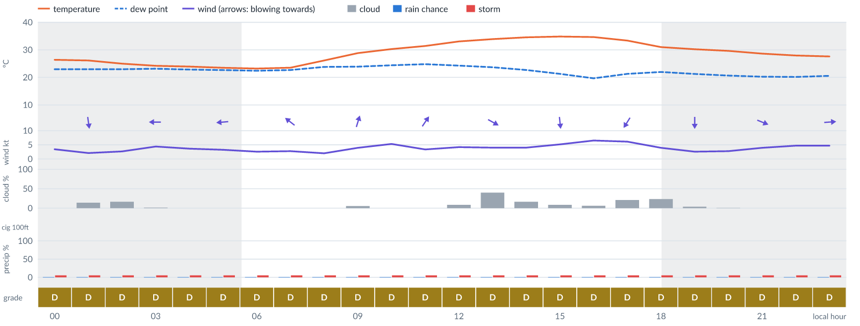
Meteogram — hourly forecast; shaded = before first light / after last light. Gaps mean no data.
Ser | Hrs | Temp | Cloud | Wind | Gust | QNH | Assessment | Driver | Remarks
(a) | (b) | (c) | (d) | (e) | (f) | (g) | (h) | (i) | (j)
1. | 0001 | 26°C | ☀ Clear (0%) | ↘ 3 kts WNW | 4 kts | 1013 | D - Marginal | storm 5% | ⚠ thunderstorm risk
2. | 0100 | 26°C | ◔ Mostly clear (14%) | ↓ 2 kts N | 2 kts | 1013 | D - Marginal | storm 5% | ⚠ thunderstorm risk
3. | 0200 | 25°C | ◔ Mostly clear (16%) | ↙ 3 kts ENE | 3 kts | 1013 | D - Marginal | storm 5% | ⚠ thunderstorm risk
4. | 0300 | 24°C | ☀ Clear (2%) | ← 4 kts E | 6 kts | 1012 | D - Marginal | storm 5% | ⚠ thunderstorm risk
5. | 0400 | 24°C | ☀ Clear (0%) | ← 4 kts E | 4 kts | 1012 | D - Marginal | storm 5% | ⚠ thunderstorm risk
6. | 0500 | 24°C | ☀ Clear (0%) | ← 3 kts E | 4 kts | 1013 | D - Marginal | storm 5% | ⚠ thunderstorm risk
7. | 0600 | 23°C | ☀ Clear (0%) | ← 3 kts E | 3 kts | 1013 | D - Marginal | storm 5% | ⚠ thunderstorm risk
8. | 0700 | 24°C | ☀ Clear (0%) | ↖ 3 kts SE | 3 kts | 1014 | D - Marginal | storm 5% | ⚠ thunderstorm risk
9. | 0800 | 26°C | ☀ Clear (0%) | ↖ 2 kts ESE | 5 kts | 1016 | D - Marginal | storm 5% | ⚠ thunderstorm risk
10. | 0900 | 29°C | ☀ Clear (5%) | ↑ 4 kts SSW | 9 kts | 1017 | D - Marginal | storm 5% · gust 9 kt | ⚠ thunderstorm risk, gusts, wind shear
11. | 1000 | 30°C | ☀ Clear (0%) | ↑ 5 kts SSW | 11 kts | 1017 | D - Marginal | storm 5% · gust 11 kt | ⚠ thunderstorm risk, gusts, wind shear
12. | 1100 | 31°C | ☀ Clear (0%) | ↗ 3 kts SW | 9 kts | 1017 | D - Marginal | storm 5% · gust 9 kt | ⚠ thunderstorm risk, gusts, wind shear
13. | 1200 | 33°C | ☀ Clear (9%) | → 4 kts WSW | 8 kts | 1016 | D - Marginal | storm 5% | ⚠ thunderstorm risk
14. | 1300 | 34°C | ◑ Partly cloudy (40%) | ↘ 4 kts WNW | 8 kts | 1015 | D - Marginal | storm 5% | ⚠ thunderstorm risk
15. | 1400 | 35°C | ◔ Mostly clear (16%) | ↓ 4 kts NNW | 7 kts | 1014 | D - Marginal | storm 5% | ⚠ thunderstorm risk
16. | 1500 | 35°C | ☀ Clear (9%) | ↓ 5 kts N | 8 kts | 1013 | D - Marginal | storm 5% | ⚠ thunderstorm risk
17. | 1600 | 35°C | ☀ Clear (6%) | ↓ 7 kts NNE | 9 kts | 1013 | D - Marginal | storm 5% · gust 9 kt | ⚠ thunderstorm risk, gusts
18. | 1700 | 33°C | ◔ Mostly clear (21%) | ↙ 6 kts NNE | 6 kts | 1013 | D - Marginal | storm 5% | ⚠ thunderstorm risk
19. | 1800 | 31°C | ◔ Mostly clear (23%) | ↙ 4 kts NE | 4 kts | 1013 | D - Marginal | storm 5% | ⚠ thunderstorm risk
20. | 1900 | 30°C | ☀ Clear (4%) | ↓ 3 kts N | 2 kts | 1013 | D - Marginal | storm 5% | ⚠ thunderstorm risk
21. | 2000 | 30°C | ☀ Clear (1%) | ↘ 3 kts NW | 2 kts | 1014 | D - Marginal | storm 5% | ⚠ thunderstorm risk
22. | 2100 | 29°C | ☀ Clear (0%) | → 4 kts WNW | 4 kts | 1014 | D - Marginal | storm 5% | ⚠ thunderstorm risk
23. | 2200 | 28°C | ☀ Clear (0%) | → 5 kts WNW | 4 kts | 1014 | D - Marginal | storm 5% | ⚠ thunderstorm risk
24. | 2300 | 28°C | ☀ Clear (0%) | → 5 kts W | 5 kts | 1014 | D - Marginal | storm 5% | ⚠ thunderstorm risk
Confidence: 54% — data for 24 of 24 hours · first light 0603L · last light 1831L · Moon 4 % illuminated, rises 04:44, sets 16:47.

Extended Outlook
WEATHER EFFECTS BY DAY
 | Sun | Mon | Tue | Wed
Wind | D | D | D | C
Visibility | A | A | A | A
Cloud / ceiling | B | G | G | G
Precipitation | A | A | A | A
Thunderstorm | D | D | D | D
Fog | · | · | · | ·
Overall | D | G | G | G
A Excellent · B Good · C Fair · D Marginal (flyable) · E Poor · F Very Poor · G Unacceptable · (worst condition in each period)

Sun 8 Nov 26
Conditions are expected to be generally Marginal: clear, winds up to 6 kts SW and temperatures 23–35°C. Flyable windows: 0001–2300L (Marginal, 24 h). Hazards: thunderstorm risk 0001–2300L. Overall similar to the previous day.
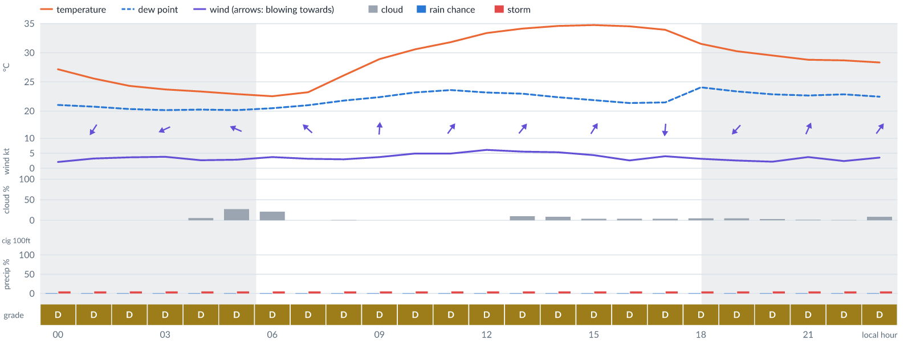
Meteogram — hourly forecast; shaded = before first light / after last light. Gaps mean no data.
Ser | Hrs | Temp | Cloud | Wind | Gust | QNH | Assessment | Driver | Remarks
(a) | (b) | (c) | (d) | (e) | (f) | (g) | (h) | (i) | (j)
1. | 0001 | 27°C | ☀ Clear (0%) | → 2 kts W | 2 kts | 1014 | D - Marginal | storm 5% | ⚠ thunderstorm risk
2. | 0100 | 26°C | ☀ Clear (0%) | ↙ 3 kts NNE | 4 kts | 1014 | D - Marginal | storm 5% | ⚠ thunderstorm risk
3. | 0200 | 24°C | ☀ Clear (0%) | ↙ 4 kts ENE | 4 kts | 1013 | D - Marginal | storm 5% | ⚠ thunderstorm risk
4. | 0300 | 24°C | ☀ Clear (0%) | ↙ 4 kts ENE | 4 kts | 1013 | D - Marginal | storm 5% | ⚠ thunderstorm risk
5. | 0400 | 23°C | ☀ Clear (5%) | ↙ 3 kts NE | 3 kts | 1012 | D - Marginal | storm 5% | ⚠ thunderstorm risk
6. | 0500 | 23°C | ◔ Mostly clear (27%) | ↖ 3 kts ESE | 3 kts | 1013 | D - Marginal | storm 5% | ⚠ thunderstorm risk
7. | 0600 | 23°C | ◔ Mostly clear (21%) | ↖ 4 kts ESE | 4 kts | 1013 | D - Marginal | storm 5% | ⚠ thunderstorm risk
8. | 0700 | 23°C | ☀ Clear (0%) | ↖ 3 kts SE | 4 kts | 1014 | D - Marginal | storm 5% | ⚠ thunderstorm risk
9. | 0800 | 26°C | ☀ Clear (1%) | ↖ 3 kts SE | 6 kts | 1016 | D - Marginal | storm 5% | ⚠ thunderstorm risk
10. | 0900 | 29°C | ☀ Clear (0%) | ↑ 4 kts S | 8 kts | 1018 | D - Marginal | storm 5% | ⚠ thunderstorm risk
11. | 1000 | 31°C | ☀ Clear (0%) | ↑ 5 kts SSW | 11 kts | 1018 | D - Marginal | storm 5% · gust 11 kt | ⚠ thunderstorm risk, gusts, wind shear
12. | 1100 | 32°C | ☀ Clear (0%) | ↗ 5 kts SW | 11 kts | 1018 | D - Marginal | storm 5% · gust 11 kt | ⚠ thunderstorm risk, gusts, wind shear
13. | 1200 | 33°C | ☀ Clear (0%) | ↗ 6 kts SW | 10 kts | 1017 | D - Marginal | storm 5% · gust 10 kt | ⚠ thunderstorm risk, gusts
14. | 1300 | 34°C | ☀ Clear (10%) | ↗ 6 kts SW | 10 kts | 1017 | D - Marginal | storm 5% · gust 10 kt | ⚠ thunderstorm risk, gusts
15. | 1400 | 35°C | ☀ Clear (9%) | ↗ 5 kts SSW | 9 kts | 1016 | D - Marginal | storm 5% · gust 9 kt | ⚠ thunderstorm risk, gusts
16. | 1500 | 35°C | ☀ Clear (4%) | ↗ 4 kts SSW | 7 kts | 1015 | D - Marginal | storm 5% | ⚠ thunderstorm risk
17. | 1600 | 35°C | ☀ Clear (4%) | ↗ 3 kts SW | 4 kts | 1015 | D - Marginal | storm 5% | ⚠ thunderstorm risk
18. | 1700 | 34°C | ☀ Clear (4%) | ↓ 4 kts N | 3 kts | 1014 | D - Marginal | storm 5% | ⚠ thunderstorm risk
19. | 1800 | 32°C | ☀ Clear (5%) | ↙ 3 kts NNE | 3 kts | 1014 | D - Marginal | storm 5% | ⚠ thunderstorm risk
20. | 1900 | 30°C | ☀ Clear (5%) | ↙ 3 kts NE | 2 kts | 1015 | D - Marginal | storm 5% | ⚠ thunderstorm risk
21. | 2000 | 30°C | ☀ Clear (3%) | ↗ 2 kts SSW | 1 kts | 1016 | D - Marginal | storm 5% | ⚠ thunderstorm risk
22. | 2100 | 29°C | ☀ Clear (2%) | ↗ 4 kts SSW | 3 kts | 1016 | D - Marginal | storm 5% | ⚠ thunderstorm risk
23. | 2200 | 29°C | ☀ Clear (1%) | ↗ 2 kts SW | 1 kts | 1016 | D - Marginal | storm 5% | ⚠ thunderstorm risk
24. | 2300 | 28°C | ☀ Clear (9%) | ↗ 4 kts SW | 3 kts | 1016 | D - Marginal | storm 5% | ⚠ thunderstorm risk
Confidence: 54% — data for 24 of 24 hours · first light 0603L · last light 1831L · Moon 1 % illuminated, rises 05:33, sets 17:29.

Mon 9 Nov 26
Conditions are expected to be generally Marginal: mostly clear, winds up to 7 kts SSW and temperatures 25–35°C. Flyable windows: 0001–0300L (Marginal, 4 h) and 0700–2300L (Marginal, 17 h). Hazards: thunderstorm risk 0001–2300L. Overall similar to the previous day.
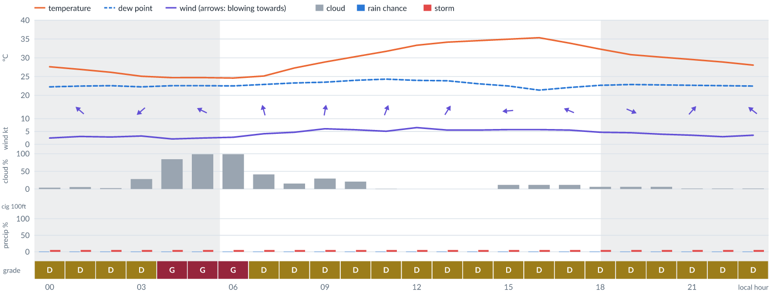
Meteogram — hourly forecast; shaded = before first light / after last light. Gaps mean no data.
Ser | Hrs | Temp | Cloud | Wind | Gust | QNH | Assessment | Driver | Remarks
(a) | (b) | (c) | (d) | (e) | (f) | (g) | (h) | (i) | (j)
1. | 0001 | 28°C | ☀ Clear (4%) | ↑ 2 kts S | 2 kts | 1015 | D - Marginal | storm 5% | ⚠ thunderstorm risk
2. | 0100 | 27°C | ☀ Clear (5%) | ↖ 3 kts SE | 3 kts | 1015 | D - Marginal | storm 5% | ⚠ thunderstorm risk
3. | 0200 | 26°C | ☀ Clear (2%) | ← 3 kts ENE | 3 kts | 1015 | D - Marginal | storm 5% | ⚠ thunderstorm risk
4. | 0300 | 25°C | ◔ Mostly clear (28%) | ↙ 3 kts NE | 4 kts | 1014 | D - Marginal | storm 5% | ⚠ thunderstorm risk
5. | 0400 | 25°C | ◕ Cloudy (84%) | ← 2 kts ESE | 2 kts | 1015 | G - Unacceptable | cloud 84% | ⚠ cloud cover, thunderstorm risk
6. | 0500 | 25°C | ☁ Overcast (98%) | ↖ 2 kts ESE | 2 kts | 1015 | G - Unacceptable | cloud 98% | ⚠ cloud cover, thunderstorm risk
7. | 0600 | 25°C | ☁ Overcast (98%) | ↖ 3 kts SE | 3 kts | 1015 | G - Unacceptable | cloud 98% | ⚠ cloud cover, thunderstorm risk
8. | 0700 | 25°C | ◑ Partly cloudy (41%) | ↑ 4 kts SSE | 5 kts | 1016 | D - Marginal | storm 5% | ⚠ thunderstorm risk
9. | 0800 | 27°C | ◔ Mostly clear (16%) | ↑ 5 kts S | 8 kts | 1018 | D - Marginal | storm 5% | ⚠ thunderstorm risk
10. | 0900 | 29°C | ◔ Mostly clear (30%) | ↑ 6 kts S | 11 kts | 1019 | D - Marginal | storm 5% · gust 11 kt | ⚠ thunderstorm risk, gusts, wind shear
11. | 1000 | 30°C | ◔ Mostly clear (21%) | ↑ 6 kts SSW | 11 kts | 1019 | D - Marginal | storm 5% · gust 11 kt | ⚠ thunderstorm risk, gusts, wind shear
12. | 1100 | 32°C | ☀ Clear (1%) | ↑ 5 kts SSW | 11 kts | 1019 | D - Marginal | storm 5% · gust 11 kt | ⚠ thunderstorm risk, gusts, wind shear
13. | 1200 | 33°C | ☀ Clear (0%) | ↗ 7 kts SSW | 11 kts | 1018 | D - Marginal | storm 5% · gust 11 kt | ⚠ thunderstorm risk, gusts
14. | 1300 | 34°C | ☀ Clear (0%) | ↗ 6 kts SSW | 10 kts | 1018 | D - Marginal | storm 5% · gust 10 kt | ⚠ thunderstorm risk, gusts
15. | 1400 | 35°C | ☀ Clear (0%) | ↖ 6 kts SSE | 9 kts | 1017 | D - Marginal | storm 5% · gust 9 kt | ⚠ thunderstorm risk, gusts
16. | 1500 | 35°C | ☀ Clear (12%) | ← 6 kts E | 8 kts | 1016 | D - Marginal | storm 5% | ⚠ thunderstorm risk
17. | 1600 | 35°C | ☀ Clear (12%) | ↓ 6 kts NNE | 7 kts | 1016 | D - Marginal | storm 5% | ⚠ thunderstorm risk
18. | 1700 | 34°C | ☀ Clear (12%) | ↖ 6 kts ESE | 6 kts | 1016 | D - Marginal | storm 5% | ⚠ thunderstorm risk
19. | 1800 | 32°C | ☀ Clear (6%) | ↗ 5 kts SSW | 5 kts | 1016 | D - Marginal | storm 5% | ⚠ thunderstorm risk
20. | 1900 | 31°C | ☀ Clear (6%) | ↘ 5 kts WNW | 4 kts | 1016 | D - Marginal | storm 5% | ⚠ thunderstorm risk
21. | 2000 | 30°C | ☀ Clear (6%) | → 4 kts WSW | 4 kts | 1016 | D - Marginal | storm 5% | ⚠ thunderstorm risk
22. | 2100 | 30°C | ☀ Clear (2%) | ↗ 4 kts SW | 3 kts | 1017 | D - Marginal | storm 5% | ⚠ thunderstorm risk
23. | 2200 | 29°C | ☀ Clear (2%) | ↑ 3 kts S | 2 kts | 1018 | D - Marginal | storm 5% | ⚠ thunderstorm risk
24. | 2300 | 28°C | ☀ Clear (2%) | ↖ 4 kts SE | 3 kts | 1017 | D - Marginal | storm 5% | ⚠ thunderstorm risk
Confidence: 54% — data for 24 of 24 hours · first light 0604L · last light 1831L · Moon 0 % illuminated, rises 06:24, sets 18:14.

Tue 10 Nov 26
Conditions are expected to be generally Marginal: partly cloudy, winds up to 8 kts NNE and temperatures 24–36°C. Flyable windows: 0001–1100L (Marginal, 12 h) and 1500–2000L (Marginal, 6 h). Hazards: thunderstorm risk 0001–2300L. Overall similar to the previous day.
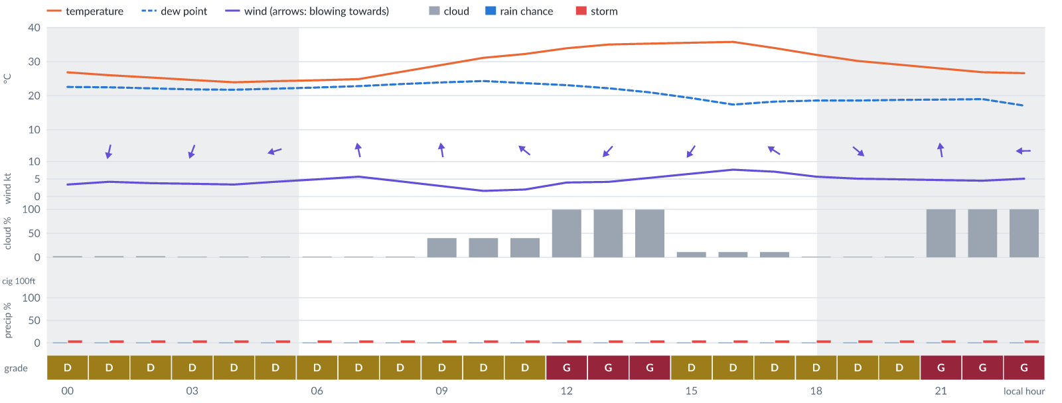
Meteogram — hourly forecast; shaded = before first light / after last light. Gaps mean no data.
Ser | Hrs | Temp | Cloud | Wind | Gust | QNH | Assessment | Driver | Remarks
(a) | (b) | (c) | (d) | (e) | (f) | (g) | (h) | (i) | (j)
1. | 0001 | 27°C | ☀ Clear (2%) | ← 3 kts ENE | 4 kts | 1017 | D - Marginal | storm 5% | ⚠ thunderstorm risk
2. | 0100 | 26°C | ☀ Clear (2%) | ↓ 4 kts NNE | 5 kts | 1016 | D - Marginal | storm 5% | ⚠ thunderstorm risk
3. | 0200 | 25°C | ☀ Clear (2%) | ↓ 4 kts NNE | 5 kts | 1016 | D - Marginal | storm 5% | ⚠ thunderstorm risk
4. | 0300 | 25°C | ☀ Clear (2%) | ↓ 4 kts NNE | 4 kts | 1016 | D - Marginal | storm 5% | ⚠ thunderstorm risk
5. | 0400 | 24°C | ☀ Clear (2%) | ↙ 3 kts NNE | 4 kts | 1015 | D - Marginal | storm 5% | ⚠ thunderstorm risk
6. | 0500 | 24°C | ☀ Clear (2%) | ← 4 kts ENE | 5 kts | 1016 | D - Marginal | storm 5% | ⚠ thunderstorm risk
7. | 0600 | 25°C | ☀ Clear (2%) | ↖ 5 kts ESE | 7 kts | 1016 | D - Marginal | storm 5% | ⚠ thunderstorm risk
8. | 0700 | 25°C | ☀ Clear (2%) | ↑ 6 kts SSE | 8 kts | 1017 | D - Marginal | storm 5% | ⚠ thunderstorm risk
9. | 0800 | 27°C | ☀ Clear (2%) | ↑ 4 kts S | 7 kts | 1018 | D - Marginal | storm 5% | ⚠ thunderstorm risk
10. | 0900 | 29°C | ◑ Partly cloudy (40%) | ↑ 3 kts S | 7 kts | 1019 | D - Marginal | storm 5% | ⚠ thunderstorm risk
11. | 1000 | 31°C | ◑ Partly cloudy (40%) | ↑ 2 kts S | 7 kts | 1020 | D - Marginal | storm 5% · gust spread +5 kt | ⚠ thunderstorm risk, wind shear
12. | 1100 | 32°C | ◑ Partly cloudy (40%) | ↖ 2 kts SE | 7 kts | 1019 | D - Marginal | storm 5% · gust spread +5 kt | ⚠ thunderstorm risk, wind shear
13. | 1200 | 34°C | ☁ Overcast (99%) | ← 4 kts E | 7 kts | 1019 | G - Unacceptable | cloud 99% | ⚠ cloud cover, thunderstorm risk
14. | 1300 | 35°C | ☁ Overcast (99%) | ↙ 4 kts NE | 8 kts | 1018 | G - Unacceptable | cloud 99% | ⚠ cloud cover, thunderstorm risk
15. | 1400 | 35°C | ☁ Overcast (99%) | ↙ 5 kts NE | 9 kts | 1017 | G - Unacceptable | cloud 99% | ⚠ cloud cover, thunderstorm risk, gusts
16. | 1500 | 36°C | ☀ Clear (11%) | ↙ 7 kts NE | 9 kts | 1016 | D - Marginal | storm 5% · gust 9 kt | ⚠ thunderstorm risk, gusts
17. | 1600 | 36°C | ☀ Clear (11%) | ↙ 8 kts NNE | 10 kts | 1016 | D - Marginal | storm 5% · gust 10 kt | ⚠ thunderstorm risk, gusts
18. | 1700 | 34°C | ☀ Clear (11%) | ↖ 7 kts ESE | 9 kts | 1016 | D - Marginal | storm 5% · gust 9 kt | ⚠ thunderstorm risk, gusts
19. | 1800 | 32°C | ☀ Clear (2%) | ↗ 6 kts SW | 7 kts | 1015 | D - Marginal | storm 5% | ⚠ thunderstorm risk
20. | 1900 | 30°C | ☀ Clear (2%) | ↘ 5 kts NW | 5 kts | 1015 | D - Marginal | storm 5% | ⚠ thunderstorm risk
21. | 2000 | 29°C | ☀ Clear (2%) | ↗ 5 kts WSW | 5 kts | 1016 | D - Marginal | storm 5% | ⚠ thunderstorm risk
22. | 2100 | 28°C | ☁ Overcast (100%) | ↑ 5 kts S | 5 kts | 1016 | G - Unacceptable | cloud 100% | ⚠ cloud cover, thunderstorm risk
23. | 2200 | 27°C | ☁ Overcast (100%) | ← 5 kts E | 4 kts | 1017 | G - Unacceptable | cloud 100% | ⚠ cloud cover, thunderstorm risk
24. | 2300 | 27°C | ☁ Overcast (100%) | ← 5 kts E | 6 kts | 1017 | G - Unacceptable | cloud 100% | ⚠ cloud cover, thunderstorm risk
Confidence: 54% — data for 24 of 24 hours · first light 0604L · last light 1831L · Moon 2 % illuminated, rises 07:16, sets 19:02.

Wed 11 Nov 26
Conditions are expected to be generally Unacceptable: overcast, winds up to 6 kts ENE and temperatures 26–26°C. No flyable windows (Marginal or better, ≥2 consecutive hrs) are forecast. Hazards: thunderstorm risk 0001–0100L. Overall a deterioration from the previous day.
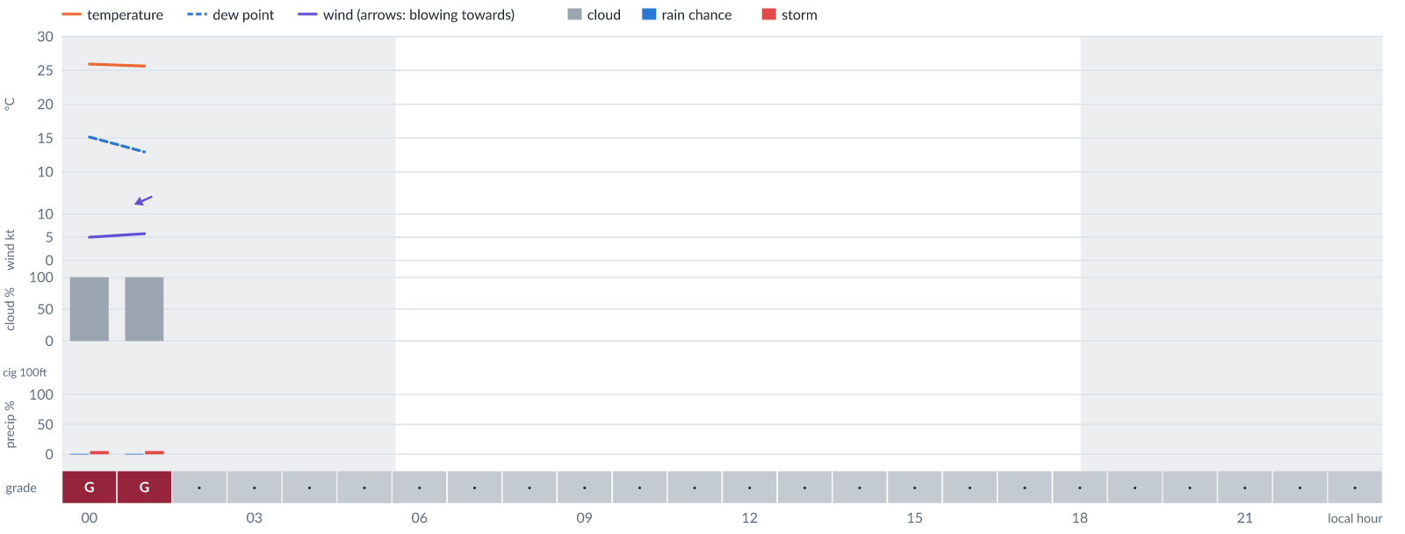
Meteogram — hourly forecast; shaded = before first light / after last light. Gaps mean no data.
Ser | Hrs | Temp | Cloud | Wind | Gust | QNH | Assessment | Driver | Remarks
(a) | (b) | (c) | (d) | (e) | (f) | (g) | (h) | (i) | (j)
1. | 0001 | 26°C | ☁ Overcast (100%) | ← 5 kts ENE | 7 kts | 1016 | G - Unacceptable | cloud 100% | ⚠ cloud cover, thunderstorm risk
2. | 0100 | 26°C | ☁ Overcast (100%) | ↙ 6 kts ENE | 8 kts | 1016 | G - Unacceptable | cloud 100% | ⚠ cloud cover, thunderstorm risk
3. | 0200 | - | No data | - | - | - | · - No data | cloud, visibility, wind not forecast
4. | 0300 | - | No data | - | - | - | · - No data | cloud, visibility, wind not forecast
5. | 0400 | - | No data | - | - | - | · - No data | cloud, visibility, wind not forecast
6. | 0500 | - | No data | - | - | - | · - No data | cloud, visibility, wind not forecast
7. | 0600 | - | No data | - | - | - | · - No data | cloud, visibility, wind not forecast
8. | 0700 | - | No data | - | - | - | · - No data | cloud, visibility, wind not forecast
9. | 0800 | - | No data | - | - | - | · - No data | cloud, visibility, wind not forecast
10. | 0900 | - | No data | - | - | - | · - No data | cloud, visibility, wind not forecast
11. | 1000 | - | No data | - | - | - | · - No data | cloud, visibility, wind not forecast
12. | 1100 | - | No data | - | - | - | · - No data | cloud, visibility, wind not forecast
13. | 1200 | - | No data | - | - | - | · - No data | cloud, visibility, wind not forecast
14. | 1300 | - | No data | - | - | - | · - No data | cloud, visibility, wind not forecast
15. | 1400 | - | No data | - | - | - | · - No data | cloud, visibility, wind not forecast
16. | 1500 | - | No data | - | - | - | · - No data | cloud, visibility, wind not forecast
17. | 1600 | - | No data | - | - | - | · - No data | cloud, visibility, wind not forecast
18. | 1700 | - | No data | - | - | - | · - No data | cloud, visibility, wind not forecast
19. | 1800 | - | No data | - | - | - | · - No data | cloud, visibility, wind not forecast
20. | 1900 | - | No data | - | - | - | · - No data | cloud, visibility, wind not forecast
21. | 2000 | - | No data | - | - | - | · - No data | cloud, visibility, wind not forecast
22. | 2100 | - | No data | - | - | - | · - No data | cloud, visibility, wind not forecast
23. | 2200 | - | No data | - | - | - | · - No data | cloud, visibility, wind not forecast
24. | 2300 | - | No data | - | - | - | · - No data | cloud, visibility, wind not forecast
Confidence: 5% — data for 2 of 24 hours · first light 0604L · last light 1831L · Moon 5 % illuminated, rises 08:08, sets 19:52.

TAF
No TAF available for this location.

Imagery

Dust RGB (pink/magenta = airborne dust) — captured 6 Nov 01:18 WAT (4 min ago) · ©EUMETSAT (screenshot via EUMETView)

Convection RGB (yellow = vigorous storms) — captured 6 Nov 01:18 WAT (4 min ago) · ©EUMETSAT (screenshot via EUMETView)
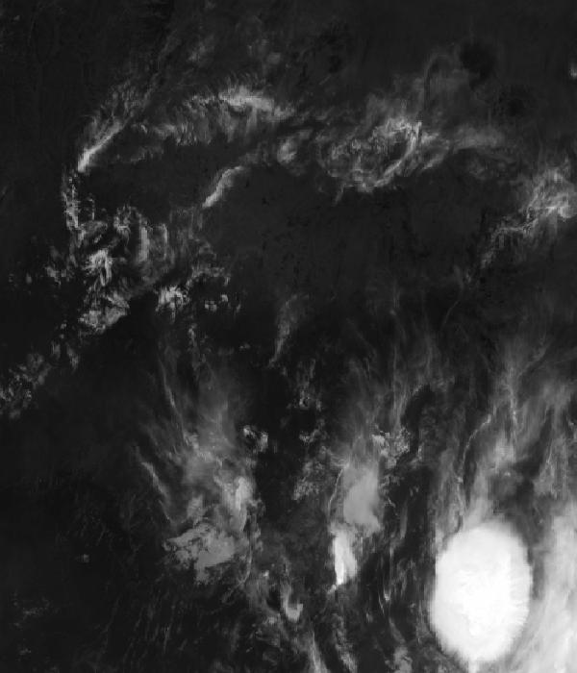
Infrared 10.5 µm (cold tops = deep cloud) — captured 6 Nov 01:18 WAT (4 min ago) · ©EUMETSAT (screenshot via EUMETView)

Accumulated lightning flash area (MTG-LI) — captured 6 Nov 01:18 WAT (4 min ago) · ©EUMETSAT (screenshot via EUMETView)

Source panel
Source | Accuracy | Skill n | Temp °C | Wind kt | Visibility | Storm
(a) | (b) | (c) | (d) | (e) | (f) | (g)
Tomorrow.io | ▲ 1.1 | 1963 | 24–25 | 1–6 | 10+ km | 0 %
Each source's own raw values, min–max over the next 6 hours from the issue hour (before any weighting or bias correction). — means the source does not publish that metric in the window. Wide gaps between rows are real disagreement; the forecast above weights sources by measured skill.

Reading this report
Grades: each hour carries one grade, set by its WORST factor. The bands below are the thresholds in force for this report (Settings); a value in a band earns that grade, and "-" means the factor never produces that grade. Cloud is graded on the worse of cover and ceiling. The Driver column names the limiting factor with its value; open it in the web report for the boundary and sources.
Grade | Cloud cover | Cloud ceiling | Visibility | Wind | Gust | Rain chance | Thunderstorm probability
(a) | (b) | (c) | (d) | (e) | (f) | (g) | (h)
A Excellent | ≤ 17.1% | ≥ 30000 ft | ≥ 8000 m | < 3 kt | < 3 kt | < 5% | 0%
B Good | 17.1–34.3% | 26000–30000 ft | 6666.7–8000 m | 3–6 kt | 3–6 kt | 5–10% | -
C Fair | 34.3–42.9% | 24000–26000 ft | 5333.3–6666.7 m | 6–9 kt | 6–9 kt | 10–15% | -
D Marginal | 42.9–51.4% | 22000–24000 ft | 4000–5333.3 m | 9–12 kt | 9–12 kt | 15–20% | >0–15%
E Poor | 51.4–60% | 16000–22000 ft | 2666.7–4000 m | 12–15 kt | 12–15 kt | 20–25% | 15–30%
F Very Poor | 60–68.6% | 10000–16000 ft | 1333.3–2666.7 m | 15–18 kt | 15–18 kt | 25–30% | 30–60%
G Unacceptable | > 68.6% | < 10000 ft | < 1333.3 m | ≥ 18 kt | ≥ 18 kt | ≥ 30% | > 60%
Flight windows: a window is at least 2 consecutive hours graded Marginal or better; an hour with insufficient data never counts toward one. ☾ marks a window outside first-to-last light.
Time: hours are local time (WAT, UTC+1) unless suffixed Z, which is UTC (TAF, METAR and issue times). Local midnight is labelled 0001.
Units: temperature °C · wind and gusts knots · visibility metres (km in text) · cloud ceiling feet · cloud cover % · rain chance and thunderstorm probability % · QNH hPa (altimeter setting at the field) · CAPE J/kg. A figure like "28 (26–30)°C" gives the p10–p90 range; "spread" marks disagreement between sources.
Symbols: ▲ better than the pool · ▽ worse (only when the 95% interval excludes the pool) · ≈ not distinguishable from the pool · unmarked = unproven (accuracy is measured against METAR and SYNOP observations). ⚠ on a remark means a low-confidence hour; a ⚠ paragraph on the first page is a convective-warning or data-age advisory. ⚡ is lightning observed by satellite near the field (©EUMETSAT).
Hourly glyphs: the wind arrow points the way the air moves (a north wind is ↓, an east wind ←); cloud cover shows as ☀ ◔ ◑ ◕ ☁ (clear, few, scattered, broken, overcast); a shaded hour label is wholly before first light or after last light.
Terms: "No data" - no source forecast the hour, or a core group (cloud, visibility, wind) is missing and the hour could still be flyable; missing data is never given a good grade. "Low-confidence" - few or weak sources behind the load-bearing metrics; treat the grade as indicative. "Insufficient data" - too little to grade at all. "Estimated" (est.) - the value is derived, not reported by a source (dust visibility, cloud base, gusts); it is declared where used and weighted at half. "Derived" - an hour interpolated from a coarser (3-hourly or daily) source, weighted at half and never used to score accuracy.

Data provenance
Source | Fetched (Z) | Age | Skill n | Accuracy
(a) | (b) | (c) | (d) | (e)
Tomorrow.io | 6 Nov 00:19Z | 3 min | 1963 | ▲ 1.1
Corrections applied (detailed under Learned corrections on the first page): skill weighting, bias correction, hour-of-day bias, cloud-base estimate, probability calibration, climatology bounds, skill blend.

How accurate have we been
Measured against observations (METAR/SYNOP), minna only. Verification table computed 2026-11-05. Mean absolute error (MAE): lower is better; "beats persistence" compares the best source with "it will stay as it is now" on the same hours.
Metric | Best source | Best MAE | Typical MAE | Persistence MAE | Beats persistence by | Pairs
(a) | (b) | (c) | (d) | (e) | (f) | (g)
Temperature (°C) | foreca | 0.9 | 3.4 | 5.3 | 79 % | 152
Dew point (°C) | accuweather | 1.3 | 4.1 | 2.5 | -30 % | 35
Wind speed (kt) | gem | 1.5 | 2.1 | 2.6 | 21 % | 648
Visibility (m) | visualcrossing | 237 | 356 | 1333 | -1 % | 1330
Cloud cover (%) | accuweather | 16 | 46 | 9 | - | 35
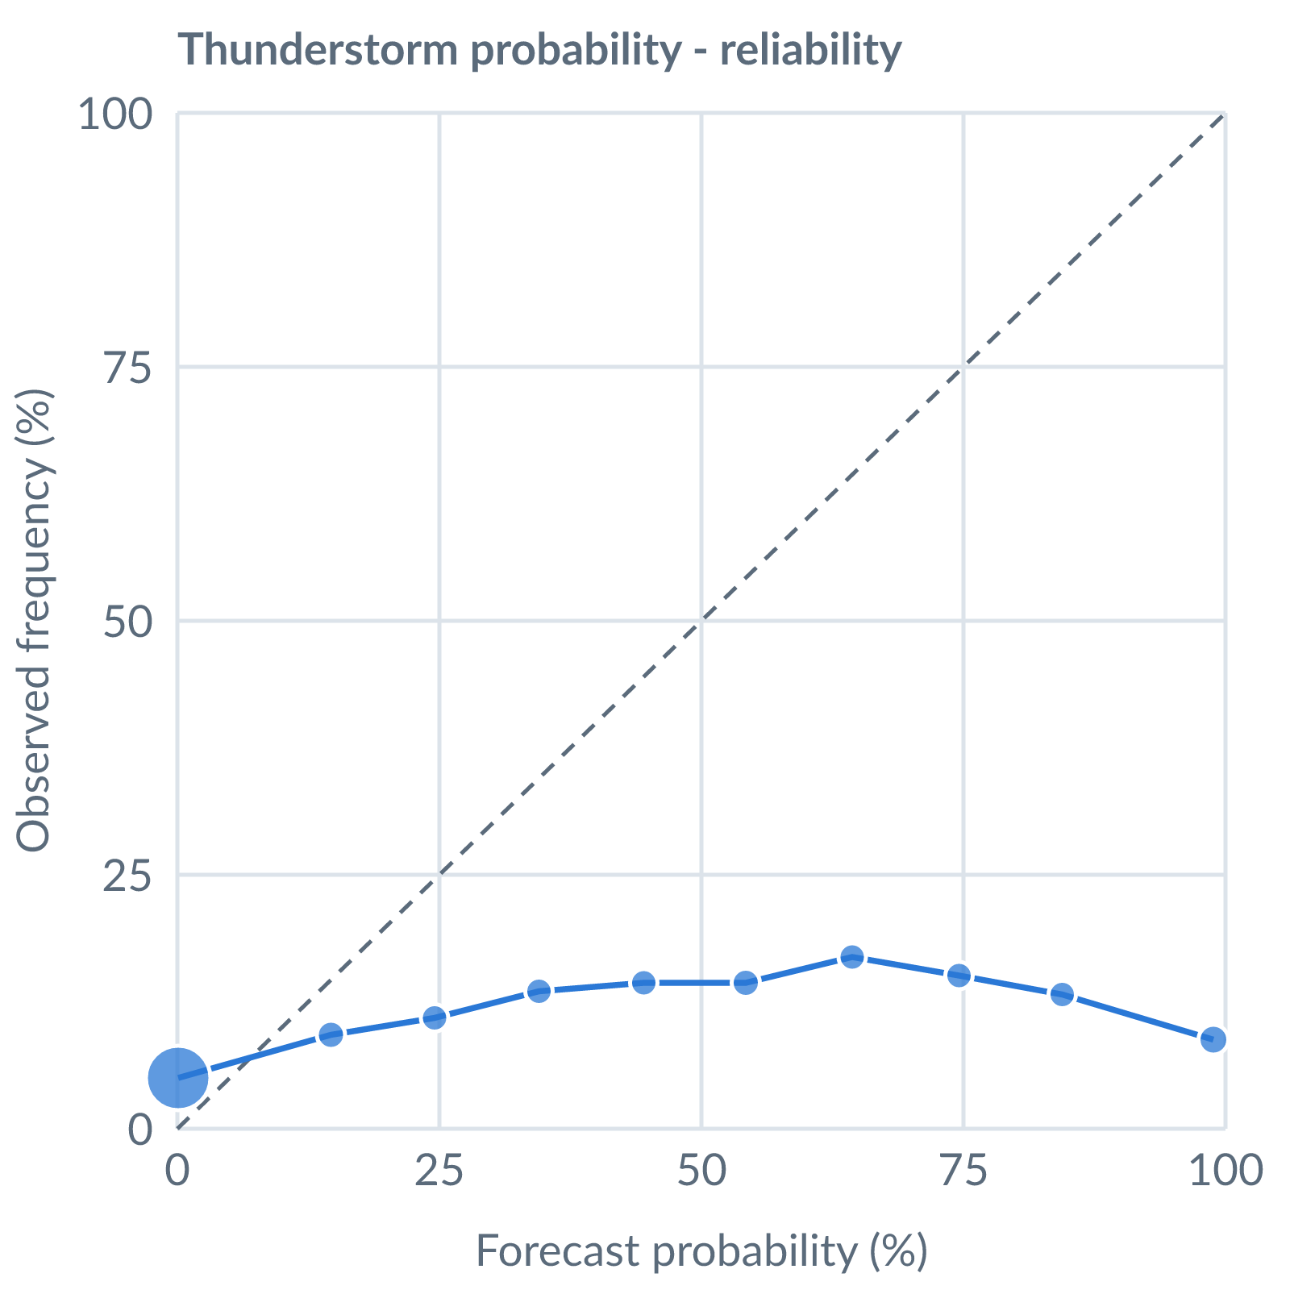
Thunderstorm probability: dots on the dashed line mean a stated probability matched how often it happened (149145 pairs, all places pooled).
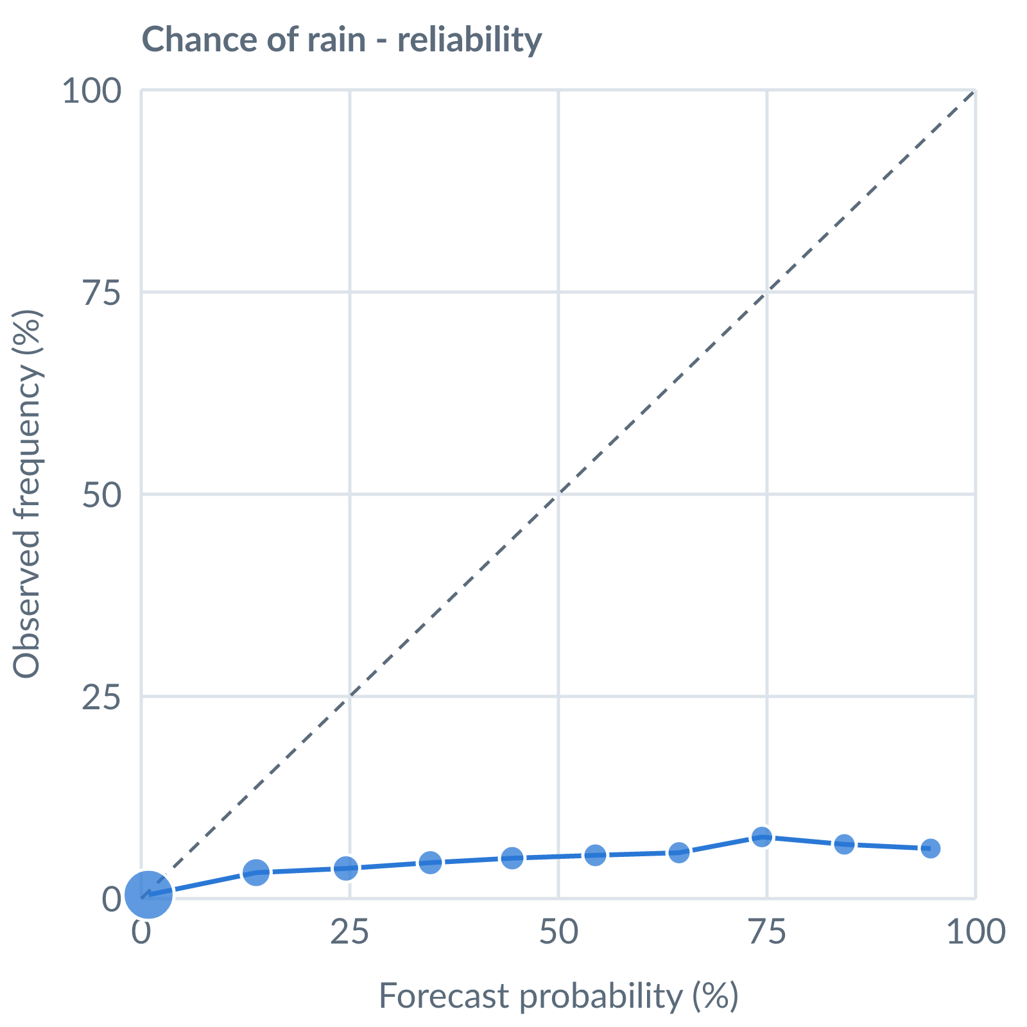
Chance of rain: dots on the dashed line mean a stated probability matched how often it happened (138885 pairs, all places pooled).
Learned bias (forecast minus observed; positive = sources run high), mean over scored sources, by local time of day. These are corrected for before sources are averaged.
Metric | Overall | Night | Morning | Afternoon | Evening | Pairs
(a) | (b) | (c) | (d) | (e) | (f) | (g)
Temperature (°C) | -3.1 | -3.1 | -3.0 | -3.1 | -3.4 | 14516
Dew point (°C) | -3.9 | -3.5 | -3.3 | -3.8 | -4.4 | 13674
Wind speed (kt) | -1.4 | -0.3 | -1.1 | -2.1 | -1.2 | 14534
Not yet available: Scores are decayed over the verification window (half-life 14 days); separate last-7-day and last-30-day windows are not stored. Bias is the current learned value; the history needed for a trend over time is not stored. Flight-window hit / bust / miss is not yet recorded.

