Gusau — 14-Day Forecast
DNGU · issued 6 Nov 26 00:23Z
Sources: Tomorrow.io ▲ 1.2
▲ better than the pool · ▽ worse (only when the 95% interval excludes the pool) · ≈ not distinguishable from the pool · unmarked = unproven (accuracy is measured against METAR and SYNOP observations)
Day | 00 | 01 | 02 | 03 | 04 | 05 | 06 | 07 | 08 | 09 | 10 | 11 | 12 | 13 | 14 | 15 | 16 | 17 | 18 | 19 | 20 | 21 | 22 | 23 | Flyable Windows | Conf
Fri 6 Nov 26 | · | G | G | G | G | G | G | G | G | G | G | G | G | G | G | G | G | G | G | G | G | G | F | D | no windows | 51%
Sat 7 Nov 26 | D | D | D | G | G | F | G | G | G | G | G | G | G | F | F | F | F | D | D | D | D | D | D | D | 0001–0200L (Marginal, 3 h) ☾ · 1700–2300L (Marginal, 7 h) ☾ | 54%
Sun 8 Nov 26 | D | D | D | D | D | D | D | D | D | D | D | E | F | F | E | E | E | E | D | D | D | D | D | D | best window: 0001–1000L (Marginal, 11 h) ☾ · 1800–2300L (Marginal, 6 h) ☾ | 54%
Mon 9 Nov 26 | D | D | D | D | D | D | D | D | D | D | D | E | F | F | F | F | F | E | D | D | D | D | D | D | 0001–1000L (Marginal, 11 h) ☾ · 1800–2300L (Marginal, 6 h) ☾ | 54%
Tue 10 Nov 26 | D | D | D | D | D | D | D | D | D | E | F | G | G | G | G | G | G | F | D | D | D | D | D | D | 0001–0800L (Marginal, 9 h) ☾ · 1800–2300L (Marginal, 6 h) ☾ | 54%
Wed 11 Nov 26 | G | G | · | · | · | · | · | · | · | · | · | · | · | · | · | · | · | · | · | · | · | · | · | · | no windows | 5%
A Excellent · B Good · C Fair · D Marginal · E Poor · F Very Poor · G Unacceptable · · No data
Best window (highest confidence, then grade, then length): Sun 8 Nov 26 0001–1000L (Marginal, 11 h) ☾, confidence 54%.
Learned corrections (METAR-verified): skill weighting — pooled all-field scores for 206; bias corrections — foreca dewpoint +3.0 °C, metcheck dewpoint +3.0 °C, openweather dewpoint +3.0 °C, wttrin dewpoint +3.0 °C, gfs dewpoint +3.0 °C, meteofrance dewpoint +3.0 °C (+67 more); hour-of-day bias (local time, shrunk toward the all-hours bias) — visualcrossing night wind −4.0 kt, wttrin evening wind −3.6 kt, wttrin night wind −3.5 kt, visualcrossing evening wind −3.4 kt, gfs night wind −3.3 kt, gfs evening wind −3.2 kt (+284 more); cloud base estimated as 410 ft per °C of dewpoint spread for sources that report no ceiling (≥60% cloud cover; flagged estimated, weighted ×0.5); probability calibration — rain chance: meteoblue, openmeteo, foreca, metcheck, openweather, visualcrossing, Tomorrow.io, wttrin, ecmwf, gfs, icon, ukmo, gem, ecmwfens; storm: openmeteo, metno, foreca, openweather, visualcrossing, Tomorrow.io, wttrin, ecmwf, gfs, icon, meteofrance, aviationweather, ukmo, jma, gem, ecmwfens, aifs (each source's stated probability mapped to its verified frequency by an isotonic fit on ≥200 pairs, proven on the holdout); plausibility bounds from ERA5 climatology 2016-2025 (mean ± 5 sd; screening only, not observed truth); skill blend 1 auto-tuned over 8814 holdout pairs (consensus beat the best single source, icon, by 16%); correction gates (newest-7-day holdout; pooled skill is always on) — regional skill: off this week (did not improve holdout); place skill: off this week (did not improve holdout); lead-time skill: off this week (did not improve holdout); small-sample skill shrinkage: off this week (did not improve holdout); bias correction: on (improved holdout by 24.3%); place bias: on (improved holdout by 11.1%); hour-of-day bias: on (improved holdout by 5.5%); QNH bias: on (improved holdout by 57.2%); gust estimates: off this week (did not improve holdout); cloud-base coefficient: off this week (insufficient holdout: 77 of 200 items); recent-form skill: off this week (did not improve holdout); probability calibration: on (improved holdout by 22.4%); nowcast anchor horizon: off this week (did not improve holdout); dust-visibility estimate: off this week (did not improve holdout); fog risk: off this week (did not improve holdout).

Outlook
Day | Date | Outlook | Temp | Max wind | Flight windows | Confidence | Notes
(a) | (b) | (c) | (d) | (e) | (f) | (g) | (h)
Fri | 6 Nov 26 | Unacceptable | 21–37°C | 11 kts E, g 20 | none | 51%
Sat | 7 Nov 26 | Marginal | 19–37°C | 10 kts E, g 17 | 0001–0200L (Marginal, 3 h) ☾; 1700–2300L (Marginal, 7 h) ☾ | 54%
Sun | 8 Nov 26 | Marginal | 20–38°C | 9 kts ENE, g 16 | 0001–1000L (Marginal, 11 h) ☾; 1800–2300L (Marginal, 6 h) ☾ | 54%
Mon | 9 Nov 26 | Marginal | 21–37°C | 10 kts ENE, g 17 | 0001–1000L (Marginal, 11 h) ☾; 1800–2300L (Marginal, 6 h) ☾ | 54%
Tue | 10 Nov 26 | Marginal | 21–37°C | 15 kts E, g 25 | 0001–0800L (Marginal, 9 h) ☾; 1800–2300L (Marginal, 6 h) ☾ | 54%
Wed | 11 Nov 26 | Unacceptable | 22–23°C | 5 kts E, g 9 | none | 5%

Today — Fri 6 Nov 26
Conditions are expected to be generally Unacceptable: overcast, winds up to 11 kts E, gusting 20 kts and temperatures 21–37°C. No flyable windows (Marginal or better, ≥2 consecutive hrs) are forecast. Hazards: thunderstorm risk 0100–2300L.
WEATHER EFFECTS
 | 00–06L | 06–12L | 12–18L | 18–24L
Wind | D | F | G | D
Visibility | A | A | A | A
Cloud / ceiling | G | G | G | G
Precipitation | A | A | A | A
Thunderstorm | D | D | D | D
Fog | · | · | · | ·
A Excellent · B Good · C Fair · D Marginal (flyable) · E Poor · F Very Poor · G Unacceptable · (worst condition in each period)
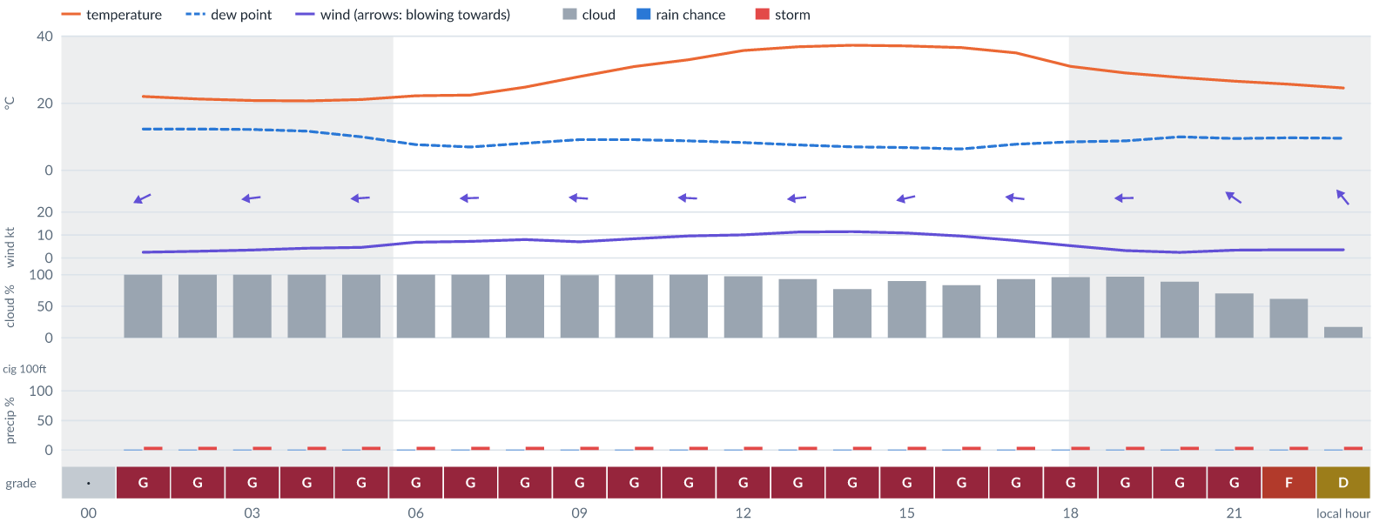
Meteogram — hourly forecast; shaded = before first light / after last light. Gaps mean no data.
Ser | Hrs | Temp | Cloud | Wind | Gust | QNH | Assessment | Driver | Remarks
(a) | (b) | (c) | (d) | (e) | (f) | (g) | (h) | (i) | (j)
1. | 0001 | - | No data | - | - | - | · - No data | cloud, visibility, wind not forecast
2. | 0100 | 22°C | ☁ Overcast (100%) | ↙ 3 kts ENE | 5 kts | 1013 | G - Unacceptable | cloud 100% | ⚠ cloud cover, thunderstorm risk
3. | 0200 | 21°C | ☁ Overcast (100%) | ← 3 kts ENE | 6 kts | 1012 | G - Unacceptable | cloud 100% | ⚠ cloud cover, thunderstorm risk
4. | 0300 | 21°C | ☁ Overcast (100%) | ← 3 kts E | 7 kts | 1012 | G - Unacceptable | cloud 100% | ⚠ cloud cover, thunderstorm risk
5. | 0400 | 21°C | ☁ Overcast (100%) | ← 4 kts E | 8 kts | 1012 | G - Unacceptable | cloud 100% | ⚠ cloud cover, thunderstorm risk
6. | 0500 | 21°C | ☁ Overcast (100%) | ← 5 kts E | 9 kts | 1012 | G - Unacceptable | cloud 100% | ⚠ cloud cover, thunderstorm risk, gusts
7. | 0600 | 22°C | ☁ Overcast (100%) | ← 7 kts E | 9 kts | 1013 | G - Unacceptable | cloud 100% | ⚠ cloud cover, thunderstorm risk, gusts
8. | 0700 | 22°C | ☁ Overcast (100%) | ← 7 kts E | 10 kts | 1014 | G - Unacceptable | cloud 100% | ⚠ cloud cover, thunderstorm risk, gusts
9. | 0800 | 25°C | ☁ Overcast (100%) | ← 8 kts E | 11 kts | 1014 | G - Unacceptable | cloud 100% | ⚠ cloud cover, thunderstorm risk, gusts
10. | 0900 | 28°C | ☁ Overcast (99%) | ← 7 kts E | 12 kts | 1015 | G - Unacceptable | cloud 99% | ⚠ cloud cover, gusts, thunderstorm risk, wind shear
11. | 1000 | 31°C | ☁ Overcast (100%) | ← 8 kts E | 15 kts | 1016 | G - Unacceptable | cloud 100% | ⚠ cloud cover, gusts, wind shear, thunderstorm risk
12. | 1100 | 33°C | ☁ Overcast (100%) | ← 10 kts E | 17 kts | 1016 | G - Unacceptable | cloud 100% | ⚠ cloud cover, gusts, wind shear, thunderstorm risk, strong wind
13. | 1200 | 36°C | ☁ Overcast (98%) | ← 10 kts E | 18 kts | 1015 | G - Unacceptable | cloud 98% · gust 18 kt | ⚠ cloud cover, gusts, wind shear, thunderstorm risk, strong wind
14. | 1300 | 37°C | ☁ Overcast (93%) | ← 11 kts E | 20 kts | 1014 | G - Unacceptable | cloud 93% · gust 20 kt | ⚠ cloud cover, gusts, wind shear, thunderstorm risk, strong wind
15. | 1400 | 37°C | ◕ Cloudy (77%) | ← 11 kts E | 19 kts | 1013 | G - Unacceptable | cloud 77% · gust 19 kt | ⚠ cloud cover, gusts, wind shear, thunderstorm risk, strong wind
16. | 1500 | 37°C | ☁ Overcast (90%) | ← 11 kts ENE | 18 kts | 1012 | G - Unacceptable | cloud 90% · gust 18 kt | ⚠ cloud cover, gusts, wind shear, thunderstorm risk, strong wind
17. | 1600 | 37°C | ◕ Cloudy (84%) | ← 10 kts E | 15 kts | 1012 | G - Unacceptable | cloud 84% | ⚠ cloud cover, gusts, thunderstorm risk, strong wind, wind shear
18. | 1700 | 35°C | ☁ Overcast (93%) | ← 8 kts E | 10 kts | 1012 | G - Unacceptable | cloud 93% | ⚠ cloud cover, thunderstorm risk, gusts
19. | 1800 | 31°C | ☁ Overcast (96%) | ↖ 5 kts ESE | 9 kts | 1012 | G - Unacceptable | cloud 96% | ⚠ cloud cover, thunderstorm risk, gusts
20. | 1900 | 29°C | ☁ Overcast (97%) | ← 3 kts E | 5 kts | 1012 | G - Unacceptable | cloud 97% | ⚠ cloud cover, thunderstorm risk
21. | 2000 | 28°C | ☁ Cloudy (89%) | ← 2 kts E | 4 kts | 1013 | G - Unacceptable | cloud 89% | ⚠ cloud cover, thunderstorm risk
22. | 2100 | 27°C | ◕ Cloudy (70%) | ↖ 3 kts SE | 5 kts | 1013 | G - Unacceptable | cloud 70% | ⚠ cloud cover, thunderstorm risk
23. | 2200 | 26°C | ◑ Cloudy (62%) | ↖ 4 kts SE | 5 kts | 1013 | F - Very Poor | cloud 62% | ⚠ cloud cover, thunderstorm risk
24. | 2300 | 25°C | ◔ Mostly clear (17%) | ↖ 4 kts SE | 5 kts | 1013 | D - Marginal | storm 5% | ⚠ thunderstorm risk
Confidence: 51% — data for 23 of 24 hours · first light 0605L · last light 1828L · Moon 8 % illuminated, rises 03:56, sets 16:04.

Tomorrow — Sat 7 Nov 26
Conditions are expected to be generally Marginal: partly cloudy, winds up to 10 kts E, gusting 17 kts and temperatures 19–37°C. Flyable windows: 0001–0200L (Marginal, 3 h) and 1700–2300L (Marginal, 7 h). Hazards: thunderstorm risk 0001–2300L. Overall an improvement on the previous day.
WEATHER EFFECTS
 | 00–06L | 06–12L | 12–18L | 18–24L
Wind | B | F | F | C
Visibility | A | A | A | A
Cloud / ceiling | G | G | G | A
Precipitation | A | A | A | A
Thunderstorm | D | D | D | D
Fog | · | · | · | ·
A Excellent · B Good · C Fair · D Marginal (flyable) · E Poor · F Very Poor · G Unacceptable · (worst condition in each period)
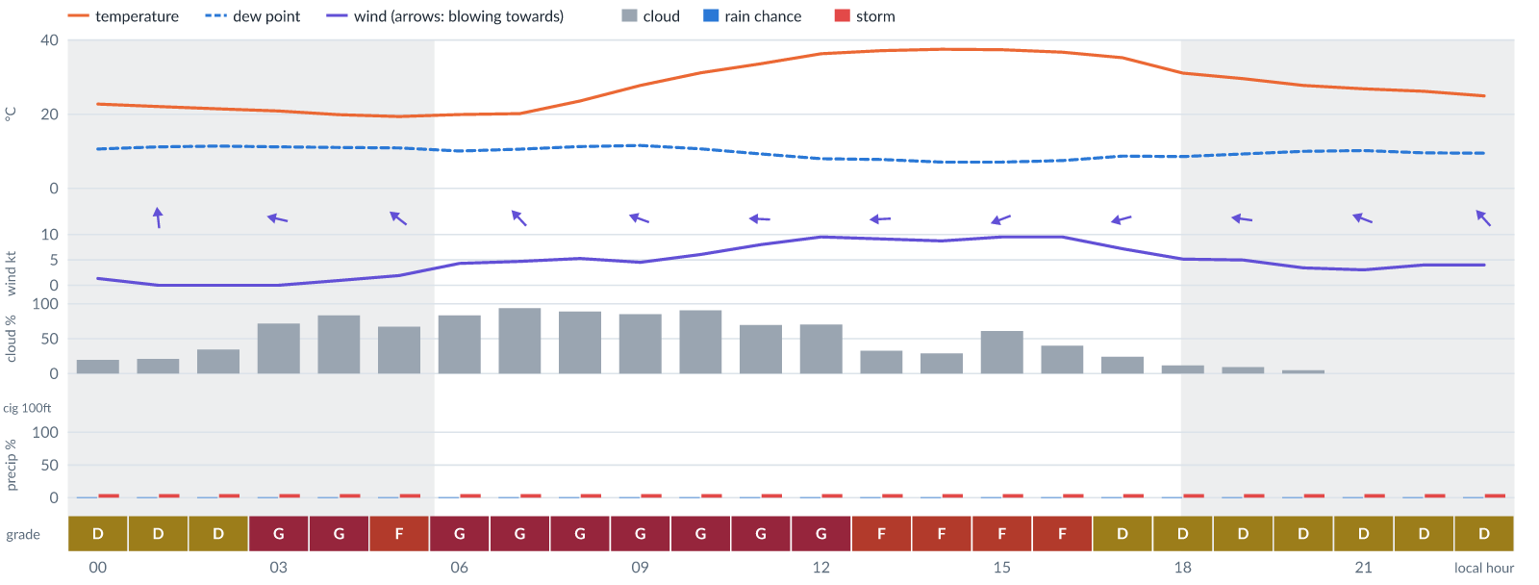
Meteogram — hourly forecast; shaded = before first light / after last light. Gaps mean no data.
Ser | Hrs | Temp | Cloud | Wind | Gust | QNH | Assessment | Driver | Remarks
(a) | (b) | (c) | (d) | (e) | (f) | (g) | (h) | (i) | (j)
1. | 0001 | 23°C | ◔ Mostly clear (20%) | ↖ 1 kts SSE | 3 kts | 1013 | D - Marginal | storm 5% | ⚠ thunderstorm risk
2. | 0100 | 22°C | ◔ Mostly clear (21%) | 0 kts S | 1 kts | 1012 | D - Marginal | storm 5% | ⚠ thunderstorm risk
3. | 0200 | 21°C | ◔ Partly cloudy (34%) | 0 kts SW | 1 kts | 1012 | D - Marginal | storm 5% | ⚠ thunderstorm risk
4. | 0300 | 21°C | ◕ Cloudy (72%) | 0 kts ESE | 1 kts | 1012 | G - Unacceptable | cloud 72% | ⚠ cloud cover, thunderstorm risk
5. | 0400 | 20°C | ◕ Cloudy (84%) | ← 1 kts ESE | 3 kts | 1012 | G - Unacceptable | cloud 84% | ⚠ cloud cover, thunderstorm risk
6. | 0500 | 19°C | ◕ Cloudy (67%) | ↖ 2 kts SE | 4 kts | 1012 | F - Very Poor | cloud 67% | ⚠ cloud cover, thunderstorm risk
7. | 0600 | 20°C | ◕ Cloudy (84%) | ↖ 4 kts SE | 5 kts | 1013 | G - Unacceptable | cloud 84% | ⚠ cloud cover, thunderstorm risk
8. | 0700 | 20°C | ☁ Overcast (94%) | ↖ 5 kts SE | 5 kts | 1013 | G - Unacceptable | cloud 94% | ⚠ cloud cover, thunderstorm risk
9. | 0800 | 24°C | ☁ Cloudy (89%) | ↖ 5 kts SE | 8 kts | 1015 | G - Unacceptable | cloud 89% | ⚠ cloud cover, thunderstorm risk
10. | 0900 | 28°C | ◕ Cloudy (85%) | ← 5 kts ESE | 8 kts | 1016 | G - Unacceptable | cloud 85% | ⚠ cloud cover, thunderstorm risk
11. | 1000 | 31°C | ☁ Overcast (91%) | ← 6 kts E | 11 kts | 1016 | G - Unacceptable | cloud 91% | ⚠ cloud cover, thunderstorm risk, gusts, wind shear
12. | 1100 | 34°C | ◕ Cloudy (70%) | ← 8 kts E | 15 kts | 1016 | G - Unacceptable | cloud 70% | ⚠ cloud cover, gusts, wind shear, thunderstorm risk
13. | 1200 | 36°C | ◕ Cloudy (70%) | ← 10 kts E | 17 kts | 1015 | G - Unacceptable | cloud 70% | ⚠ cloud cover, gusts, wind shear, thunderstorm risk, strong wind
14. | 1300 | 37°C | ◔ Partly cloudy (33%) | ← 9 kts E | 16 kts | 1014 | F - Very Poor | gust 16 kt | ⚠ gusts, wind shear, thunderstorm risk, strong wind
15. | 1400 | 37°C | ◔ Mostly clear (29%) | ← 9 kts E | 15 kts | 1013 | F - Very Poor | gust 15 kt | ⚠ gusts, thunderstorm risk, strong wind, wind shear
16. | 1500 | 37°C | ◑ Cloudy (61%) | ← 10 kts ENE | 16 kts | 1012 | F - Very Poor | cloud 61% · gust 16 kt | ⚠ cloud cover, gusts, thunderstorm risk, strong wind, wind shear
17. | 1600 | 37°C | ◑ Partly cloudy (40%) | ↙ 10 kts ENE | 15 kts | 1012 | F - Very Poor | gust 15 kt | ⚠ gusts, thunderstorm risk, strong wind, wind shear
18. | 1700 | 35°C | ◔ Mostly clear (24%) | ← 7 kts ENE | 10 kts | 1012 | D - Marginal | storm 5% · gust 10 kt | ⚠ thunderstorm risk, gusts
19. | 1800 | 31°C | ☀ Clear (12%) | ← 5 kts E | 8 kts | 1012 | D - Marginal | storm 5% | ⚠ thunderstorm risk
20. | 1900 | 30°C | ☀ Clear (9%) | ← 5 kts E | 8 kts | 1012 | D - Marginal | storm 5% | ⚠ thunderstorm risk
21. | 2000 | 28°C | ☀ Clear (5%) | ← 3 kts E | 5 kts | 1013 | D - Marginal | storm 5% | ⚠ thunderstorm risk
22. | 2100 | 27°C | ☀ Clear (0%) | ← 3 kts ESE | 4 kts | 1013 | D - Marginal | storm 5% | ⚠ thunderstorm risk
23. | 2200 | 26°C | ☀ Clear (0%) | ↖ 4 kts SE | 6 kts | 1013 | D - Marginal | storm 5% | ⚠ thunderstorm risk
24. | 2300 | 25°C | ☀ Clear (0%) | ↖ 4 kts SE | 6 kts | 1013 | D - Marginal | storm 5% | ⚠ thunderstorm risk
Confidence: 54% — data for 24 of 24 hours · first light 0605L · last light 1828L · Moon 4 % illuminated, rises 04:46, sets 16:44.

Extended Outlook
WEATHER EFFECTS BY DAY
 | Sun | Mon | Tue | Wed
Wind | F | F | G | D
Visibility | A | A | A | A
Cloud / ceiling | A | A | G | G
Precipitation | A | A | A | A
Thunderstorm | D | D | D | D
Fog | · | · | · | ·
Overall | F | F | G | G
A Excellent · B Good · C Fair · D Marginal (flyable) · E Poor · F Very Poor · G Unacceptable · (worst condition in each period)

Sun 8 Nov 26
Conditions are expected to be generally Marginal: clear, winds up to 9 kts ENE, gusting 16 kts and temperatures 20–38°C. Flyable windows: 0001–1000L (Marginal, 11 h) and 1800–2300L (Marginal, 6 h). Hazards: thunderstorm risk 0001–2300L. Overall similar to the previous day.
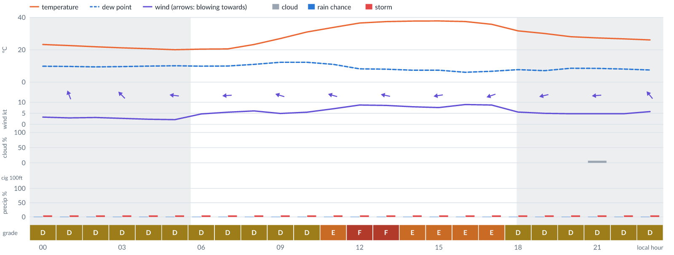
Meteogram — hourly forecast; shaded = before first light / after last light. Gaps mean no data.
Ser | Hrs | Temp | Cloud | Wind | Gust | QNH | Assessment | Driver | Remarks
(a) | (b) | (c) | (d) | (e) | (f) | (g) | (h) | (i) | (j)
1. | 0001 | 23°C | ☀ Clear (0%) | ↑ 3 kts SSE | 6 kts | 1013 | D - Marginal | storm 5% | ⚠ thunderstorm risk
2. | 0100 | 23°C | ☀ Clear (0%) | ↑ 3 kts SSE | 6 kts | 1012 | D - Marginal | storm 5% | ⚠ thunderstorm risk
3. | 0200 | 22°C | ☀ Clear (0%) | ↑ 3 kts SSE | 6 kts | 1012 | D - Marginal | storm 5% | ⚠ thunderstorm risk
4. | 0300 | 21°C | ☀ Clear (0%) | ↖ 3 kts SE | 5 kts | 1012 | D - Marginal | storm 5% | ⚠ thunderstorm risk
5. | 0400 | 21°C | ☀ Clear (0%) | ↖ 2 kts ESE | 4 kts | 1012 | D - Marginal | storm 5% | ⚠ thunderstorm risk
6. | 0500 | 20°C | ☀ Clear (0%) | ← 2 kts E | 4 kts | 1012 | D - Marginal | storm 5% | ⚠ thunderstorm risk
7. | 0600 | 20°C | ☀ Clear (0%) | ← 5 kts ENE | 5 kts | 1013 | D - Marginal | storm 5% | ⚠ thunderstorm risk
8. | 0700 | 21°C | ☀ Clear (0%) | ← 5 kts E | 7 kts | 1014 | D - Marginal | storm 5% | ⚠ thunderstorm risk
9. | 0800 | 23°C | ☀ Clear (0%) | ← 6 kts E | 9 kts | 1015 | D - Marginal | storm 5% · gust 9 kt | ⚠ thunderstorm risk, gusts
10. | 0900 | 27°C | ☀ Clear (0%) | ← 5 kts ESE | 9 kts | 1016 | D - Marginal | storm 5% · gust 9 kt | ⚠ thunderstorm risk, gusts
11. | 1000 | 31°C | ☀ Clear (0%) | ↖ 5 kts ESE | 11 kts | 1017 | D - Marginal | storm 5% · gust 11 kt | ⚠ thunderstorm risk, gusts, wind shear
12. | 1100 | 34°C | ☀ Clear (0%) | ← 7 kts ESE | 13 kts | 1017 | E - Poor | gust 13 kt | ⚠ gusts, thunderstorm risk, wind shear
13. | 1200 | 37°C | ☀ Clear (0%) | ← 9 kts ESE | 16 kts | 1016 | F - Very Poor | gust 16 kt | ⚠ gusts, wind shear, thunderstorm risk, strong wind
14. | 1300 | 37°C | ☀ Clear (0%) | ← 9 kts ESE | 15 kts | 1015 | F - Very Poor | gust 15 kt | ⚠ gusts, thunderstorm risk, strong wind, wind shear
15. | 1400 | 38°C | ☀ Clear (0%) | ← 8 kts E | 14 kts | 1014 | E - Poor | gust 14 kt | ⚠ gusts, thunderstorm risk, wind shear
16. | 1500 | 38°C | ☀ Clear (0%) | ← 8 kts E | 13 kts | 1014 | E - Poor | gust 13 kt | ⚠ gusts, thunderstorm risk, wind shear
17. | 1600 | 37°C | ☀ Clear (0%) | ← 9 kts ENE | 14 kts | 1013 | E - Poor | gust 14 kt | ⚠ gusts, thunderstorm risk, strong wind, wind shear
18. | 1700 | 36°C | ☀ Clear (0%) | ← 9 kts ENE | 12 kts | 1013 | E - Poor | gust 12 kt | ⚠ gusts, thunderstorm risk, strong wind
19. | 1800 | 32°C | ☀ Clear (0%) | ← 6 kts E | 9 kts | 1013 | D - Marginal | storm 5% · gust 9 kt | ⚠ thunderstorm risk, gusts
20. | 1900 | 30°C | ☀ Clear (0%) | ← 5 kts ENE | 8 kts | 1014 | D - Marginal | storm 5% | ⚠ thunderstorm risk
21. | 2000 | 28°C | ☀ Clear (0%) | ↙ 5 kts ENE | 8 kts | 1014 | D - Marginal | storm 5% | ⚠ thunderstorm risk
22. | 2100 | 27°C | ☀ Clear (7%) | ← 5 kts E | 7 kts | 1015 | D - Marginal | storm 5% | ⚠ thunderstorm risk
23. | 2200 | 27°C | ☀ Clear (0%) | ↖ 5 kts ESE | 8 kts | 1015 | D - Marginal | storm 5% | ⚠ thunderstorm risk
24. | 2300 | 26°C | ☀ Clear (0%) | ↖ 6 kts SE | 10 kts | 1015 | D - Marginal | storm 5% · gust 10 kt | ⚠ thunderstorm risk, gusts
Confidence: 54% — data for 24 of 24 hours · first light 0606L · last light 1827L · Moon 1 % illuminated, rises 05:36, sets 17:25.

Mon 9 Nov 26
Conditions are expected to be generally Marginal: clear, winds up to 10 kts ENE, gusting 17 kts and temperatures 21–37°C. Flyable windows: 0001–1000L (Marginal, 11 h) and 1800–2300L (Marginal, 6 h). Hazards: thunderstorm risk 0001–2300L. Overall similar to the previous day.
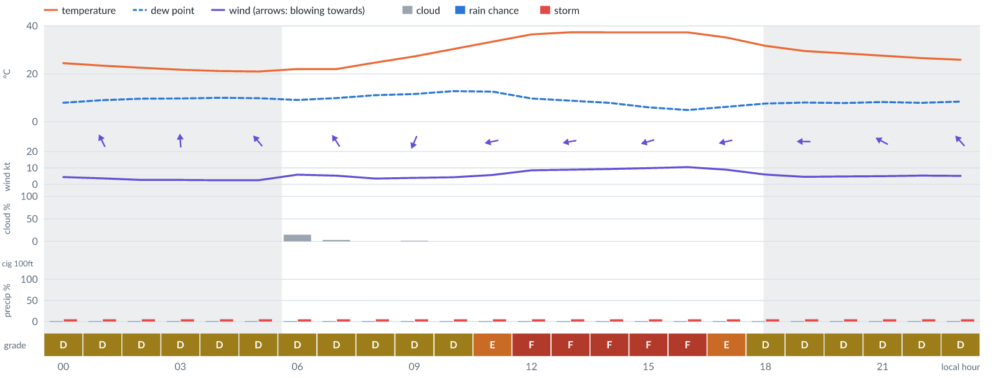
Meteogram — hourly forecast; shaded = before first light / after last light. Gaps mean no data.
Ser | Hrs | Temp | Cloud | Wind | Gust | QNH | Assessment | Driver | Remarks
(a) | (b) | (c) | (d) | (e) | (f) | (g) | (h) | (i) | (j)
1. | 0001 | 24°C | ☀ Clear (0%) | ↖ 4 kts SE | 9 kts | 1014 | D - Marginal | storm 5% · gust 9 kt | ⚠ thunderstorm risk, gusts, wind shear
2. | 0100 | 23°C | ☀ Clear (0%) | ↖ 4 kts SSE | 7 kts | 1014 | D - Marginal | storm 5% | ⚠ thunderstorm risk
3. | 0200 | 23°C | ☀ Clear (0%) | ↑ 3 kts SSE | 5 kts | 1013 | D - Marginal | storm 5% | ⚠ thunderstorm risk
4. | 0300 | 22°C | ☀ Clear (0%) | ↑ 3 kts S | 5 kts | 1013 | D - Marginal | storm 5% | ⚠ thunderstorm risk
5. | 0400 | 21°C | ☀ Clear (0%) | ↑ 3 kts SSE | 5 kts | 1013 | D - Marginal | storm 5% | ⚠ thunderstorm risk
6. | 0500 | 21°C | ☀ Clear (0%) | ↖ 3 kts SE | 5 kts | 1013 | D - Marginal | storm 5% | ⚠ thunderstorm risk
7. | 0600 | 22°C | ◔ Mostly clear (15%) | ↖ 6 kts SE | 7 kts | 1014 | D - Marginal | storm 5% | ⚠ thunderstorm risk
8. | 0700 | 22°C | ☀ Clear (3%) | ↖ 5 kts SSE | 6 kts | 1015 | D - Marginal | storm 5% | ⚠ thunderstorm risk
9. | 0800 | 25°C | ☀ Clear (0%) | ← 4 kts E | 5 kts | 1017 | D - Marginal | storm 5% | ⚠ thunderstorm risk
10. | 0900 | 27°C | ☀ Clear (2%) | ↙ 4 kts NNE | 8 kts | 1018 | D - Marginal | storm 5% | ⚠ thunderstorm risk
11. | 1000 | 30°C | ☀ Clear (0%) | ↙ 4 kts ENE | 9 kts | 1018 | D - Marginal | storm 5% · gust 9 kt | ⚠ thunderstorm risk, gusts, wind shear
12. | 1100 | 33°C | ☀ Clear (0%) | ← 6 kts ENE | 12 kts | 1018 | E - Poor | gust 12 kt | ⚠ gusts, thunderstorm risk, wind shear
13. | 1200 | 36°C | ☀ Clear (0%) | ← 9 kts E | 16 kts | 1018 | F - Very Poor | gust 16 kt | ⚠ gusts, wind shear, thunderstorm risk, strong wind
14. | 1300 | 37°C | ☀ Clear (0%) | ← 9 kts E | 16 kts | 1017 | F - Very Poor | gust 16 kt | ⚠ gusts, wind shear, thunderstorm risk, strong wind
15. | 1400 | 37°C | ☀ Clear (0%) | ← 9 kts ENE | 16 kts | 1016 | F - Very Poor | gust 16 kt | ⚠ gusts, wind shear, thunderstorm risk, strong wind
16. | 1500 | 37°C | ☀ Clear (0%) | ← 10 kts ENE | 16 kts | 1015 | F - Very Poor | gust 16 kt | ⚠ gusts, thunderstorm risk, strong wind, wind shear
17. | 1600 | 37°C | ☀ Clear (0%) | ← 10 kts ENE | 17 kts | 1014 | F - Very Poor | gust 17 kt | ⚠ gusts, wind shear, thunderstorm risk, strong wind
18. | 1700 | 35°C | ☀ Clear (0%) | ← 9 kts ENE | 13 kts | 1015 | E - Poor | gust 13 kt | ⚠ gusts, thunderstorm risk, strong wind
19. | 1800 | 32°C | ☀ Clear (0%) | ← 6 kts E | 10 kts | 1015 | D - Marginal | storm 5% · gust 10 kt | ⚠ thunderstorm risk, gusts
20. | 1900 | 29°C | ☀ Clear (0%) | ← 5 kts E | 7 kts | 1015 | D - Marginal | storm 5% | ⚠ thunderstorm risk
21. | 2000 | 29°C | ☀ Clear (0%) | ← 5 kts ESE | 7 kts | 1016 | D - Marginal | storm 5% | ⚠ thunderstorm risk
22. | 2100 | 28°C | ☀ Clear (0%) | ↖ 5 kts ESE | 8 kts | 1016 | D - Marginal | storm 5% | ⚠ thunderstorm risk
23. | 2200 | 27°C | ☀ Clear (0%) | ↖ 5 kts SE | 8 kts | 1017 | D - Marginal | storm 5% | ⚠ thunderstorm risk
24. | 2300 | 26°C | ☀ Clear (0%) | ↖ 5 kts SE | 8 kts | 1016 | D - Marginal | storm 5% | ⚠ thunderstorm risk
Confidence: 54% — data for 24 of 24 hours · first light 0606L · last light 1827L · Moon 0 % illuminated, rises 06:27, sets 18:09.

Tue 10 Nov 26
Conditions are expected to be generally Marginal: mostly clear, winds up to 15 kts E, gusting 25 kts and temperatures 21–37°C. Flyable windows: 0001–0800L (Marginal, 9 h) and 1800–2300L (Marginal, 6 h). Hazards: thunderstorm risk 0001–2300L. Overall similar to the previous day.
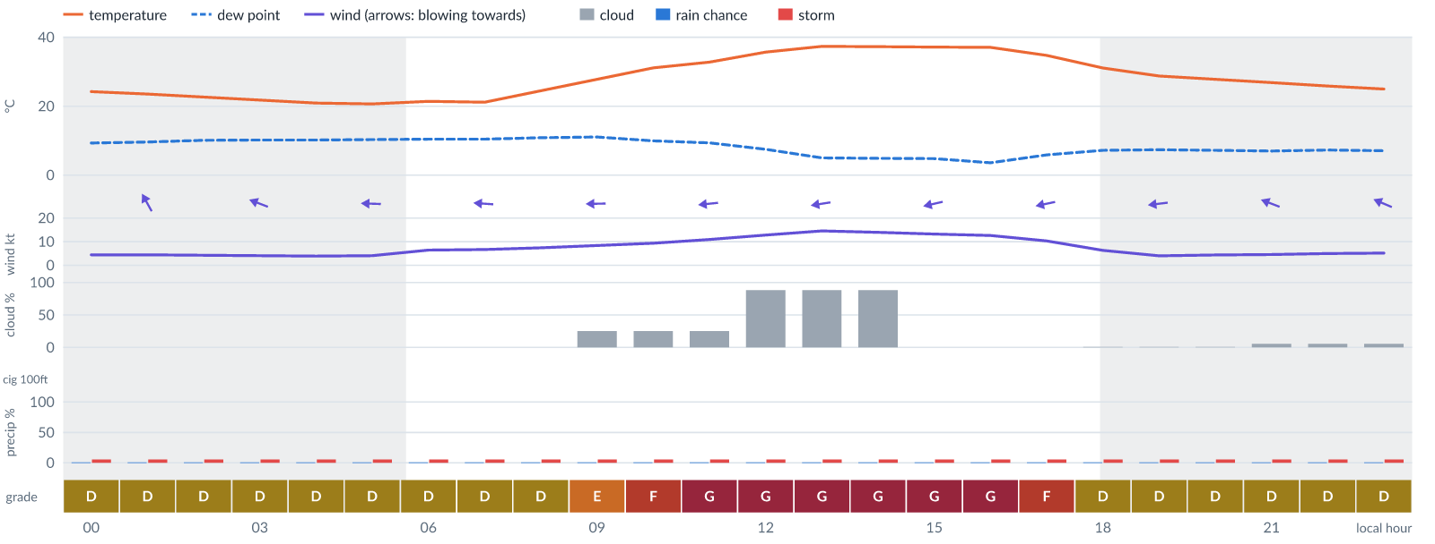
Meteogram — hourly forecast; shaded = before first light / after last light. Gaps mean no data.
Ser | Hrs | Temp | Cloud | Wind | Gust | QNH | Assessment | Driver | Remarks
(a) | (b) | (c) | (d) | (e) | (f) | (g) | (h) | (i) | (j)
1. | 0001 | 24°C | ☀ Clear (0%) | ↖ 4 kts SE | 8 kts | 1016 | D - Marginal | storm 5% | ⚠ thunderstorm risk
2. | 0100 | 24°C | ☀ Clear (0%) | ↖ 4 kts SSE | 8 kts | 1016 | D - Marginal | storm 5% | ⚠ thunderstorm risk
3. | 0200 | 23°C | ☀ Clear (0%) | ↖ 4 kts SE | 8 kts | 1015 | D - Marginal | storm 5% | ⚠ thunderstorm risk
4. | 0300 | 22°C | ☀ Clear (0%) | ← 4 kts ESE | 8 kts | 1015 | D - Marginal | storm 5% | ⚠ thunderstorm risk
5. | 0400 | 21°C | ☀ Clear (0%) | ← 4 kts E | 8 kts | 1015 | D - Marginal | storm 5% | ⚠ thunderstorm risk
6. | 0500 | 21°C | ☀ Clear (0%) | ← 4 kts E | 8 kts | 1015 | D - Marginal | storm 5% | ⚠ thunderstorm risk
7. | 0600 | 21°C | ☀ Clear (0%) | ← 6 kts E | 8 kts | 1016 | D - Marginal | storm 5% | ⚠ thunderstorm risk
8. | 0700 | 21°C | ☀ Clear (0%) | ← 7 kts E | 9 kts | 1016 | D - Marginal | storm 5% · gust 9 kt | ⚠ thunderstorm risk, gusts
9. | 0800 | 24°C | ☀ Clear (0%) | ← 7 kts E | 11 kts | 1017 | D - Marginal | storm 5% · gust 11 kt | ⚠ thunderstorm risk, gusts
10. | 0900 | 28°C | ◔ Mostly clear (25%) | ← 8 kts E | 14 kts | 1018 | E - Poor | gust 14 kt | ⚠ gusts, thunderstorm risk, wind shear
11. | 1000 | 31°C | ◔ Mostly clear (25%) | ← 9 kts E | 17 kts | 1019 | F - Very Poor | gust 17 kt | ⚠ gusts, wind shear, thunderstorm risk, strong wind
12. | 1100 | 33°C | ◔ Mostly clear (25%) | ← 11 kts E | 19 kts | 1019 | G - Unacceptable | gust 19 kt | ⚠ gusts, wind shear, thunderstorm risk, strong wind
13. | 1200 | 36°C | ☁ Cloudy (88%) | ← 13 kts E | 22 kts | 1018 | G - Unacceptable | cloud 88% · gust 22 kt | ⚠ cloud cover, gusts, wind shear, strong wind, thunderstorm risk
14. | 1300 | 37°C | ☁ Cloudy (88%) | ← 15 kts E | 25 kts | 1017 | G - Unacceptable | cloud 88% · gust 25 kt | ⚠ cloud cover, gusts, wind shear, strong wind, thunderstorm risk
15. | 1400 | 37°C | ☁ Cloudy (88%) | ← 14 kts E | 24 kts | 1016 | G - Unacceptable | cloud 88% · gust 24 kt | ⚠ cloud cover, gusts, wind shear, strong wind, thunderstorm risk
16. | 1500 | 37°C | ☀ Clear (0%) | ← 13 kts ENE | 22 kts | 1015 | G - Unacceptable | gust 22 kt | ⚠ gusts, wind shear, strong wind, thunderstorm risk
17. | 1600 | 37°C | ☀ Clear (0%) | ← 13 kts ENE | 20 kts | 1015 | G - Unacceptable | gust 20 kt | ⚠ gusts, strong wind, wind shear, thunderstorm risk
18. | 1700 | 35°C | ☀ Clear (0%) | ← 10 kts ENE | 16 kts | 1015 | F - Very Poor | gust 16 kt | ⚠ gusts, thunderstorm risk, strong wind, wind shear
19. | 1800 | 31°C | ☀ Clear (1%) | ← 6 kts E | 11 kts | 1015 | D - Marginal | storm 5% · gust 11 kt | ⚠ thunderstorm risk, gusts, wind shear
20. | 1900 | 29°C | ☀ Clear (1%) | ← 4 kts E | 6 kts | 1015 | D - Marginal | storm 5% | ⚠ thunderstorm risk
21. | 2000 | 28°C | ☀ Clear (1%) | ← 4 kts E | 7 kts | 1016 | D - Marginal | storm 5% | ⚠ thunderstorm risk
22. | 2100 | 27°C | ☀ Clear (5%) | ← 5 kts ESE | 7 kts | 1016 | D - Marginal | storm 5% | ⚠ thunderstorm risk
23. | 2200 | 26°C | ☀ Clear (5%) | ↖ 5 kts SE | 8 kts | 1017 | D - Marginal | storm 5% | ⚠ thunderstorm risk
24. | 2300 | 25°C | ☀ Clear (5%) | ↖ 5 kts ESE | 8 kts | 1017 | D - Marginal | storm 5% | ⚠ thunderstorm risk
Confidence: 54% — data for 24 of 24 hours · first light 0606L · last light 1827L · Moon 2 % illuminated, rises 07:20, sets 18:56.

Wed 11 Nov 26
Conditions are expected to be generally Unacceptable: overcast, winds up to 5 kts E and temperatures 22–23°C. No flyable windows (Marginal or better, ≥2 consecutive hrs) are forecast. Hazards: thunderstorm risk 0001–0100L. Overall a deterioration from the previous day.
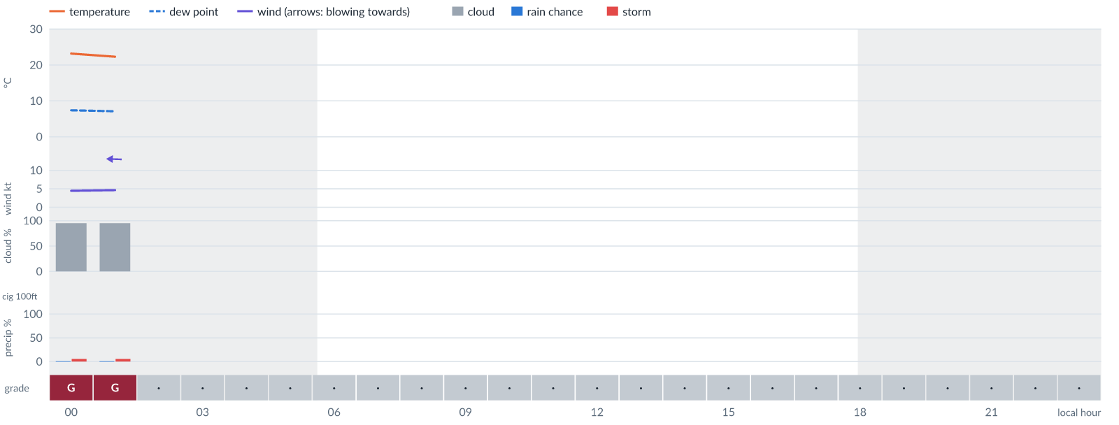
Meteogram — hourly forecast; shaded = before first light / after last light. Gaps mean no data.
Ser | Hrs | Temp | Cloud | Wind | Gust | QNH | Assessment | Driver | Remarks
(a) | (b) | (c) | (d) | (e) | (f) | (g) | (h) | (i) | (j)
1. | 0001 | 23°C | ☁ Overcast (95%) | ← 4 kts ESE | 9 kts | 1016 | G - Unacceptable | cloud 95% | ⚠ cloud cover, thunderstorm risk, gusts, wind shear
2. | 0100 | 22°C | ☁ Overcast (95%) | ← 5 kts E | 9 kts | 1016 | G - Unacceptable | cloud 95% | ⚠ cloud cover, thunderstorm risk, gusts
3. | 0200 | - | No data | - | - | - | · - No data | cloud, visibility, wind not forecast
4. | 0300 | - | No data | - | - | - | · - No data | cloud, visibility, wind not forecast
5. | 0400 | - | No data | - | - | - | · - No data | cloud, visibility, wind not forecast
6. | 0500 | - | No data | - | - | - | · - No data | cloud, visibility, wind not forecast
7. | 0600 | - | No data | - | - | - | · - No data | cloud, visibility, wind not forecast
8. | 0700 | - | No data | - | - | - | · - No data | cloud, visibility, wind not forecast
9. | 0800 | - | No data | - | - | - | · - No data | cloud, visibility, wind not forecast
10. | 0900 | - | No data | - | - | - | · - No data | cloud, visibility, wind not forecast
11. | 1000 | - | No data | - | - | - | · - No data | cloud, visibility, wind not forecast
12. | 1100 | - | No data | - | - | - | · - No data | cloud, visibility, wind not forecast
13. | 1200 | - | No data | - | - | - | · - No data | cloud, visibility, wind not forecast
14. | 1300 | - | No data | - | - | - | · - No data | cloud, visibility, wind not forecast
15. | 1400 | - | No data | - | - | - | · - No data | cloud, visibility, wind not forecast
16. | 1500 | - | No data | - | - | - | · - No data | cloud, visibility, wind not forecast
17. | 1600 | - | No data | - | - | - | · - No data | cloud, visibility, wind not forecast
18. | 1700 | - | No data | - | - | - | · - No data | cloud, visibility, wind not forecast
19. | 1800 | - | No data | - | - | - | · - No data | cloud, visibility, wind not forecast
20. | 1900 | - | No data | - | - | - | · - No data | cloud, visibility, wind not forecast
21. | 2000 | - | No data | - | - | - | · - No data | cloud, visibility, wind not forecast
22. | 2100 | - | No data | - | - | - | · - No data | cloud, visibility, wind not forecast
23. | 2200 | - | No data | - | - | - | · - No data | cloud, visibility, wind not forecast
24. | 2300 | - | No data | - | - | - | · - No data | cloud, visibility, wind not forecast
Confidence: 5% — data for 2 of 24 hours · first light 0607L · last light 1827L · Moon 5 % illuminated, rises 08:13, sets 19:46.

TAF
No TAF available for this location.

Imagery

Dust RGB (pink/magenta = airborne dust) — captured 6 Nov 01:18 WAT (4 min ago) · ©EUMETSAT (screenshot via EUMETView)

Convection RGB (yellow = vigorous storms) — captured 6 Nov 01:18 WAT (4 min ago) · ©EUMETSAT (screenshot via EUMETView)
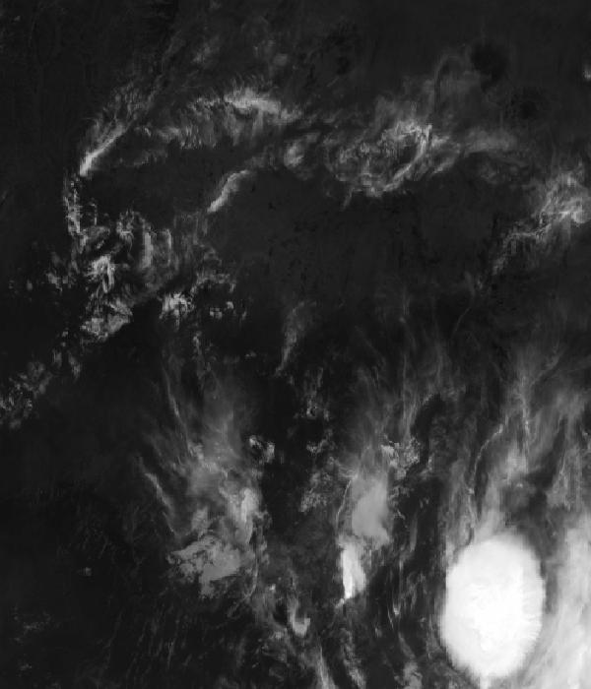
Infrared 10.5 µm (cold tops = deep cloud) — captured 6 Nov 01:18 WAT (4 min ago) · ©EUMETSAT (screenshot via EUMETView)

Accumulated lightning flash area (MTG-LI) — captured 6 Nov 01:18 WAT (4 min ago) · ©EUMETSAT (screenshot via EUMETView)

Source panel
Source | Accuracy | Skill n | Temp °C | Wind kt | Visibility | Storm
(a) | (b) | (c) | (d) | (e) | (f) | (g)
Tomorrow.io | ▲ 1.2 | 3853 | 22–23 | 3–6 | 10+ km | 0 %
Each source's own raw values, min–max over the next 6 hours from the issue hour (before any weighting or bias correction). — means the source does not publish that metric in the window. Wide gaps between rows are real disagreement; the forecast above weights sources by measured skill.

Reading this report
Grades: each hour carries one grade, set by its WORST factor. The bands below are the thresholds in force for this report (Settings); a value in a band earns that grade, and "-" means the factor never produces that grade. Cloud is graded on the worse of cover and ceiling. The Driver column names the limiting factor with its value; open it in the web report for the boundary and sources.
Grade | Cloud cover | Cloud ceiling | Visibility | Wind | Gust | Rain chance | Thunderstorm probability
(a) | (b) | (c) | (d) | (e) | (f) | (g) | (h)
A Excellent | ≤ 17.1% | ≥ 30000 ft | ≥ 8000 m | < 3 kt | < 3 kt | < 5% | 0%
B Good | 17.1–34.3% | 26000–30000 ft | 6666.7–8000 m | 3–6 kt | 3–6 kt | 5–10% | -
C Fair | 34.3–42.9% | 24000–26000 ft | 5333.3–6666.7 m | 6–9 kt | 6–9 kt | 10–15% | -
D Marginal | 42.9–51.4% | 22000–24000 ft | 4000–5333.3 m | 9–12 kt | 9–12 kt | 15–20% | >0–15%
E Poor | 51.4–60% | 16000–22000 ft | 2666.7–4000 m | 12–15 kt | 12–15 kt | 20–25% | 15–30%
F Very Poor | 60–68.6% | 10000–16000 ft | 1333.3–2666.7 m | 15–18 kt | 15–18 kt | 25–30% | 30–60%
G Unacceptable | > 68.6% | < 10000 ft | < 1333.3 m | ≥ 18 kt | ≥ 18 kt | ≥ 30% | > 60%
Flight windows: a window is at least 2 consecutive hours graded Marginal or better; an hour with insufficient data never counts toward one. ☾ marks a window outside first-to-last light.
Time: hours are local time (WAT, UTC+1) unless suffixed Z, which is UTC (TAF, METAR and issue times). Local midnight is labelled 0001.
Units: temperature °C · wind and gusts knots · visibility metres (km in text) · cloud ceiling feet · cloud cover % · rain chance and thunderstorm probability % · QNH hPa (altimeter setting at the field) · CAPE J/kg. A figure like "28 (26–30)°C" gives the p10–p90 range; "spread" marks disagreement between sources.
Symbols: ▲ better than the pool · ▽ worse (only when the 95% interval excludes the pool) · ≈ not distinguishable from the pool · unmarked = unproven (accuracy is measured against METAR and SYNOP observations). ⚠ on a remark means a low-confidence hour; a ⚠ paragraph on the first page is a convective-warning or data-age advisory. ⚡ is lightning observed by satellite near the field (©EUMETSAT).
Hourly glyphs: the wind arrow points the way the air moves (a north wind is ↓, an east wind ←); cloud cover shows as ☀ ◔ ◑ ◕ ☁ (clear, few, scattered, broken, overcast); a shaded hour label is wholly before first light or after last light.
Terms: "No data" - no source forecast the hour, or a core group (cloud, visibility, wind) is missing and the hour could still be flyable; missing data is never given a good grade. "Low-confidence" - few or weak sources behind the load-bearing metrics; treat the grade as indicative. "Insufficient data" - too little to grade at all. "Estimated" (est.) - the value is derived, not reported by a source (dust visibility, cloud base, gusts); it is declared where used and weighted at half. "Derived" - an hour interpolated from a coarser (3-hourly or daily) source, weighted at half and never used to score accuracy.

Data provenance
Source | Fetched (Z) | Age | Skill n | Accuracy
(a) | (b) | (c) | (d) | (e)
Tomorrow.io | 6 Nov 00:20Z | 3 min | 3853 | ▲ 1.2
Corrections applied (detailed under Learned corrections on the first page): skill weighting, bias correction, hour-of-day bias, cloud-base estimate, probability calibration, climatology bounds, skill blend.

How accurate have we been
Measured against observations (METAR/SYNOP), sahel region. Verification table computed 2026-11-05. Mean absolute error (MAE): lower is better; "beats persistence" compares the best source with "it will stay as it is now" on the same hours.
Metric | Best source | Best MAE | Typical MAE | Persistence MAE | Beats persistence by | Pairs
(a) | (b) | (c) | (d) | (e) | (f) | (g)
Temperature (°C) | meteoblue | 1.2 | 2.0 | 5.3 | 83 % | 4144
Dew point (°C) | accuweather | 2.1 | 4.7 | 2.5 | -21 % | 46
Wind speed (kt) | aifs | 2.0 | 2.7 | 2.6 | 26 % | 700
Visibility (m) | aviationweather | 1394 | 2326 | 1333 | 6 % | 1311
Cloud cover (%) | accuweather | 10 | 37 | 9 | - | 27
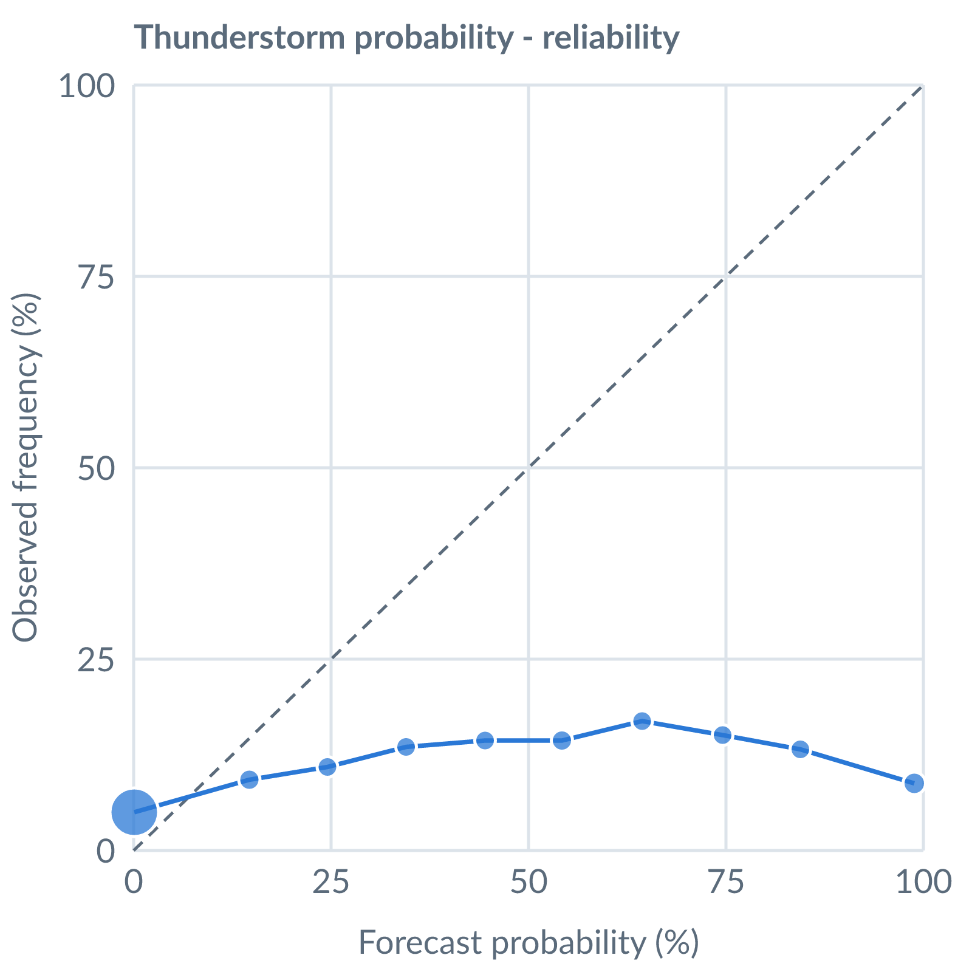
Thunderstorm probability: dots on the dashed line mean a stated probability matched how often it happened (149145 pairs, all places pooled).
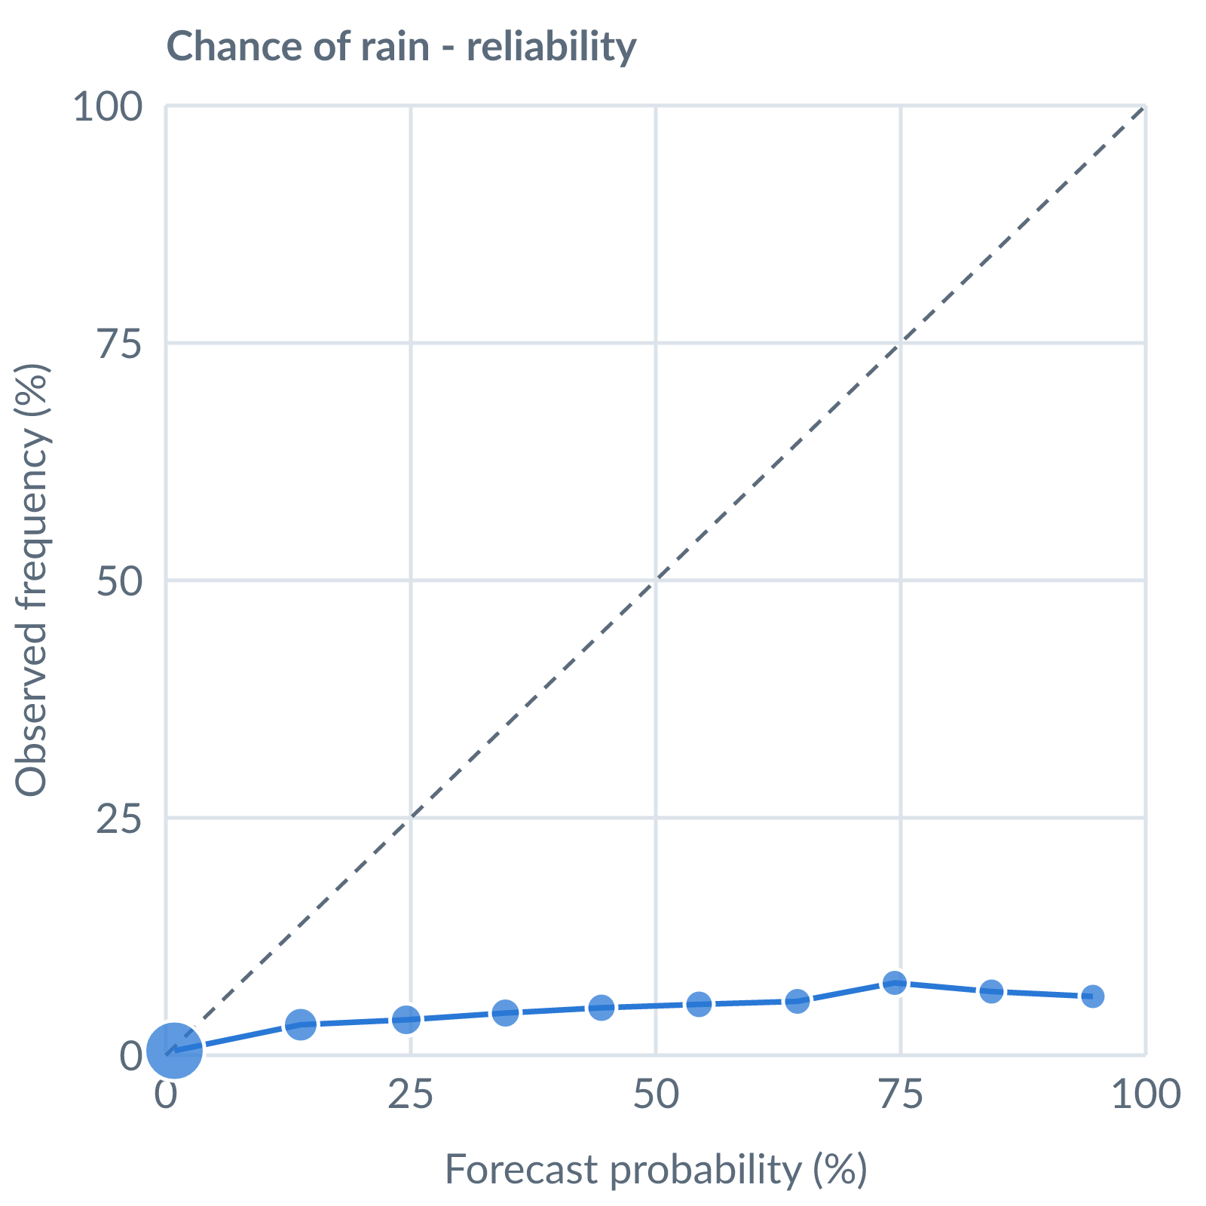
Chance of rain: dots on the dashed line mean a stated probability matched how often it happened (138885 pairs, all places pooled).
Learned bias (forecast minus observed; positive = sources run high), mean over scored sources, by local time of day. These are corrected for before sources are averaged.
Metric | Overall | Night | Morning | Afternoon | Evening | Pairs
(a) | (b) | (c) | (d) | (e) | (f) | (g)
Temperature (°C) | +0.1 | +1.2 | +0.1 | -0.8 | +0.2 | 86041
Dew point (°C) | -3.5 | -5.0 | -3.4 | -2.6 | -3.4 | 76382
Wind speed (kt) | +0.6 | +1.7 | +0.4 | -0.3 | +1.0 | 75510
Pressure (QNH) (hPa) | +0.6 | +0.5 | +0.4 | +0.9 | +0.4 | 37229
Not yet available: Scores are decayed over the verification window (half-life 14 days); separate last-7-day and last-30-day windows are not stored. Bias is the current learned value; the history needed for a trend over time is not stored. Flight-window hit / bust / miss is not yet recorded.

