Maiduguri — 14-Day Forecast
DNMA · issued 5 Nov 26 00:23Z
Sources: ECMWF AIFS ▲ 1.3 · Tomorrow.io ▲ 1.2
▲ better than the pool · ▽ worse (only when the 95% interval excludes the pool) · ≈ not distinguishable from the pool · unmarked = unproven (accuracy is measured against METAR and SYNOP observations)
Day | 00 | 01 | 02 | 03 | 04 | 05 | 06 | 07 | 08 | 09 | 10 | 11 | 12 | 13 | 14 | 15 | 16 | 17 | 18 | 19 | 20 | 21 | 22 | 23 | Flyable Windows | Conf
Thu 5 Nov 26 | · | G | G | G | G | G | G | G | G | E | F | F | F | F | F | F | E | E | D | E | G | G | G | D | no windows | 60%
Fri 6 Nov 26 | E | E | E | G | G | G | G | G | E | F | G | G | G | G | G | G | G | G | G | G | G | G | G | G | no windows | 63%
Sat 7 Nov 26 | G | G | E | D | D | D | D | D | D | D | E | F | G | G | E | F | F | D | D | D | D | D | D | D | best window: 0300–0900L (Marginal, 7 h) ☾ · 1700–2300L (Marginal, 7 h) ☾ | 63%
Sun 8 Nov 26 | D | D | D | D | D | D | D | D | D | D | E | F | F | F | E | E | E | E | D | D | D | D | D | D | 0001–0900L (Marginal, 10 h) ☾ · 1800–2300L (Marginal, 6 h) ☾ | 61%
Mon 9 Nov 26 | D | E | D | D | D | D | D | D | E | F | G | G | G | G | G | F | F | E | E | D | D | G | F | F | 0200–0700L (Marginal, 6 h) ☾ · 1900–2000L (Marginal, 2 h) ☾ | 60%
Tue 10 Nov 26 | D | D | · | · | E | E | F | F | F | G | G | G | G | G | F | F | E | · | · | · | · | · | · | · | 0001–0100L (Marginal, 2 h) ☾ | 35%
Wed 11 Nov 26 | · | · | · | · | · | · | E | F | F | F | F | G | G | G | F | E | E | · | · | · | · | · | · | · | no windows | 29%
A Excellent · B Good · C Fair · D Marginal · E Poor · F Very Poor · G Unacceptable · · No data
Best window (highest confidence, then grade, then length): Sat 7 Nov 26 0300–0900L (Marginal, 7 h) ☾, confidence 63%.
Learned corrections (METAR-verified): skill weighting — pooled all-field scores for 206; bias corrections — openweather wind −3.9 kt, wttrin wind −3.8 kt, meteoblue dewpoint +3.0 °C, openmeteo dewpoint +3.0 °C, metno dewpoint +3.0 °C, foreca dewpoint +3.0 °C (+67 more); hour-of-day bias (local time, shrunk toward the all-hours bias) — wttrin evening wind −4.2 kt, openweather afternoon wind −4.0 kt, wttrin night wind −3.8 kt, openweather evening wind −3.7 kt, openweather night wind −3.6 kt, wttrin afternoon wind −3.4 kt (+284 more); cloud base estimated as 410 ft per °C of dewpoint spread for sources that report no ceiling (≥60% cloud cover; flagged estimated, weighted ×0.5); probability calibration — rain chance: meteoblue, openmeteo, foreca, metcheck, openweather, visualcrossing, Tomorrow.io, wttrin, ecmwf, gfs, icon, ukmo, gem, ecmwfens; storm: openmeteo, metno, foreca, openweather, visualcrossing, Tomorrow.io, wttrin, ecmwf, gfs, icon, meteofrance, aviationweather, ukmo, jma, gem, ecmwfens, ECMWF AIFS (each source's stated probability mapped to its verified frequency by an isotonic fit on ≥200 pairs, proven on the holdout); plausibility bounds from ERA5 climatology 2016-2025 (mean ± 5 sd; screening only, not observed truth); skill blend 1 auto-tuned over 8464 holdout pairs (consensus beat the best single source, icon, by 17%); correction gates (newest-7-day holdout; pooled skill is always on) — regional skill: off this week (did not improve holdout); place skill: off this week (did not improve holdout); lead-time skill: off this week (did not improve holdout); small-sample skill shrinkage: off this week (did not improve holdout); bias correction: on (improved holdout by 24.1%); place bias: on (improved holdout by 12.0%); hour-of-day bias: on (improved holdout by 4.9%); QNH bias: on (improved holdout by 58.2%); gust estimates: off this week (did not improve holdout); cloud-base coefficient: off this week (insufficient holdout: 75 of 200 items); recent-form skill: off this week (did not improve holdout); probability calibration: on (improved holdout by 19.5%); nowcast anchor horizon: off this week (did not improve holdout); dust-visibility estimate: off this week (did not improve holdout); fog risk: off this week (did not improve holdout).

Outlook
Day | Date | Outlook | Temp | Max wind | Flight windows | Confidence | Notes
(a) | (b) | (c) | (d) | (e) | (f) | (g) | (h)
Thu | 5 Nov 26 | Unacceptable | 22–39°C | 8 kts NE, g 17 | none | 60% | 24% interpolated
Fri | 6 Nov 26 | Unacceptable | 22–39°C | 8 kts NE, g 18 | none | 63% | 24% interpolated
Sat | 7 Nov 26 | Marginal | 21–38°C | 7 kts ENE, g 16 | 0300–0900L (Marginal, 7 h) ☾; 1700–2300L (Marginal, 7 h) ☾ | 63% | 24% interpolated
Sun | 8 Nov 26 | Marginal | 20–39°C | 7 kts ENE, g 15 | 0001–0900L (Marginal, 10 h) ☾; 1800–2300L (Marginal, 6 h) ☾ | 61% | 24% interpolated
Mon | 9 Nov 26 | Marginal | 22–39°C | 9 kts ENE, g 21 | 0200–0700L (Marginal, 6 h) ☾; 1900–2000L (Marginal, 2 h) ☾ | 60% | 25% interpolated
Tue | 10 Nov 26 | Very Poor | 22–37°C | 8 kts ENE, g 11 | 0001–0100L (Marginal, 2 h) ☾ | 35% | 76% interpolated
Wed | 11 Nov 26 | Very Poor | 21–35°C | 7 kts NE | none | 29% | 78% interpolated

Today — Thu 5 Nov 26
Conditions are expected to be generally Unacceptable: cloudy, winds up to 8 kts NE, gusting 17 kts and temperatures 22–39°C. No flyable windows (Marginal or better, ≥2 consecutive hrs) are forecast. Hazards: thunderstorm risk 0100–2300L.
WEATHER EFFECTS
 | 00–06L | 06–12L | 12–18L | 18–24L
Wind | D | F | F | E
Visibility | A | A | A | A
Cloud / ceiling | G | G | E | G
Precipitation | A | A | A | A
Thunderstorm | D | D | D | D
Fog | · | · | · | ·
A Excellent · B Good · C Fair · D Marginal (flyable) · E Poor · F Very Poor · G Unacceptable · (worst condition in each period)
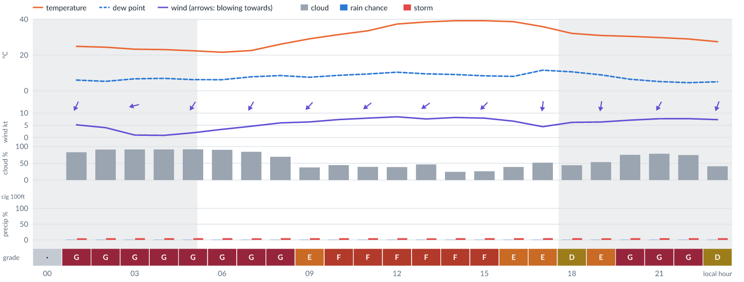
Meteogram — hourly forecast; shaded = before first light / after last light. Gaps mean no data.
Ser | Hrs | Temp | Cloud | Wind | Gust | QNH | Assessment | Driver | Remarks
(a) | (b) | (c) | (d) | (e) | (f) | (g) | (h) | (i) | (j)
1. | 0001 | - | No data | - | - | - | · - No data | cloud, visibility, wind not forecast
2. | 0100 | 25°C | ◕ Cloudy (83%) | ↙ 5 kts NNE | 11 kts | 1010 | G - Unacceptable | cloud 83% | cloud cover, thunderstorm risk, gusts, wind shear
3. | 0200 | 24°C | ☁ Overcast (91%) | ↙ 4 kts NNE | 8 kts | 1010 | G - Unacceptable | cloud 91% | cloud cover, thunderstorm risk
4. | 0300 | 23°C | ☁ Overcast (91%) | ← 1 kts ENE | 2 kts | 1010 | G - Unacceptable | cloud 91% | cloud cover, thunderstorm risk
5. | 0400 | 23°C | ☁ Overcast (91%) | ↙ 1 kts ENE | 2 kts | 1011 | G - Unacceptable | cloud 91% | cloud cover, thunderstorm risk
6. | 0500 | 22°C | ☁ Overcast (91%) | ↙ 2 kts NNE | 4 kts | 1011 | G - Unacceptable | cloud 91% | cloud cover, thunderstorm risk
7. | 0600 | 22°C | ☁ Overcast (90%) | ↙ 3 kts NE | 4 kts | 1011 | G - Unacceptable | cloud 90% | cloud cover, thunderstorm risk
8. | 0700 | 23°C | ◕ Cloudy (84%) | ↙ 5 kts NNE | 7 kts | 1012 | G - Unacceptable | cloud 84% | cloud cover, thunderstorm risk
9. | 0800 | 26°C | ◕ Cloudy (69%) | ↙ 6 kts NE | 9 kts | 1013 | G - Unacceptable | cloud 69% | cloud cover, thunderstorm risk, gusts
10. | 0900 | 29°C | ◔ Partly cloudy (37%) | ↙ 6 kts NE | 12 kts | 1013 | E - Poor | gust 12 kt | gusts, thunderstorm risk, wind shear
11. | 1000 | 31°C | ◑ Partly cloudy (45%) | ↙ 7 kts NE | 15 kts | 1013 | F - Very Poor | gust 15 kt | gusts, wind shear, cloud cover, thunderstorm risk
12. | 1100 | 34°C | ◑ Partly cloudy (39%) | ↙ 8 kts NE | 17 kts | 1012 | F - Very Poor | gust 17 kt · gust spread +9 kt | gusts, wind shear, thunderstorm risk
13. | 1200 | 37°C | ◑ Partly cloudy (38%) | ↙ 8 kts NE | 17 kts | 1011 | F - Very Poor | gust 17 kt · gust spread +9 kt | gusts, wind shear, thunderstorm risk
14. | 1300 | 38°C | ◑ Partly cloudy (46%) | ↙ 8 kts NE | 17 kts | 1011 | F - Very Poor | gust 17 kt · gust spread +9 kt | gusts, wind shear, cloud cover, thunderstorm risk
15. | 1400 | 39°C | ◔ Mostly clear (25%) | ↙ 8 kts NE | 16 kts | 1010 | F - Very Poor | gust 16 kt | gusts, wind shear, thunderstorm risk
16. | 1500 | 39°C | ◔ Mostly clear (26%) | ↙ 8 kts NE | 15 kts | 1010 | F - Very Poor | gust 15 kt | gusts, wind shear, thunderstorm risk
17. | 1600 | 39°C | ◑ Partly cloudy (39%) | ↙ 7 kts NNE | 12 kts | 1009 | E - Poor | gust 12 kt | gusts, thunderstorm risk, wind shear
18. | 1700 | 36°C | ◑ Partly cloudy (52%) | ↓ 4 kts N | 7 kts | 1009 | E - Poor | cloud 52% | cloud cover, thunderstorm risk
19. | 1800 | 32°C | ◑ Partly cloudy (44%) | ↓ 6 kts N | 9 kts | 1009 | D - Marginal | storm 5% · cloud 44% | ⚠ cloud cover, thunderstorm risk, gusts
20. | 1900 | 31°C | ◑ Partly cloudy (54%) | ↓ 6 kts N | 11 kts | 1010 | E - Poor | cloud 54% | cloud cover, thunderstorm risk, gusts, wind shear
21. | 2000 | 30°C | ◕ Cloudy (75%) | ↙ 7 kts NNE | 11 kts | 1010 | G - Unacceptable | cloud 75% | cloud cover, thunderstorm risk, gusts
22. | 2100 | 30°C | ◕ Cloudy (78%) | ↙ 8 kts NNE | 12 kts | 1011 | G - Unacceptable | cloud 78% | cloud cover, gusts, thunderstorm risk
23. | 2200 | 29°C | ◕ Cloudy (74%) | ↙ 8 kts NNE | 12 kts | 1011 | G - Unacceptable | cloud 74% | cloud cover, gusts, thunderstorm risk
24. | 2300 | 27°C | ◑ Partly cloudy (41%) | ↓ 7 kts NNE | 11 kts | 1011 | D - Marginal | storm 5% · gust 11 kt | ⚠ thunderstorm risk, gusts
Confidence: 60% — data for 23 of 24 hours; 24% of readings interpolated · first light 0539L · last light 1803L · Moon 15 % illuminated, rises 02:40, sets 15:00.

Tomorrow — Fri 6 Nov 26
Conditions are expected to be generally Unacceptable: overcast, winds up to 8 kts NE, gusting 18 kts and temperatures 22–39°C. No flyable windows (Marginal or better, ≥2 consecutive hrs) are forecast. Hazards: thunderstorm risk 0001–2300L. Overall similar to the previous day.
WEATHER EFFECTS
 | 00–06L | 06–12L | 12–18L | 18–24L
Wind | E | F | G | B
Visibility | A | A | A | A
Cloud / ceiling | G | G | G | G
Precipitation | A | A | A | A
Thunderstorm | D | D | D | D
Fog | · | · | · | ·
A Excellent · B Good · C Fair · D Marginal (flyable) · E Poor · F Very Poor · G Unacceptable · (worst condition in each period)
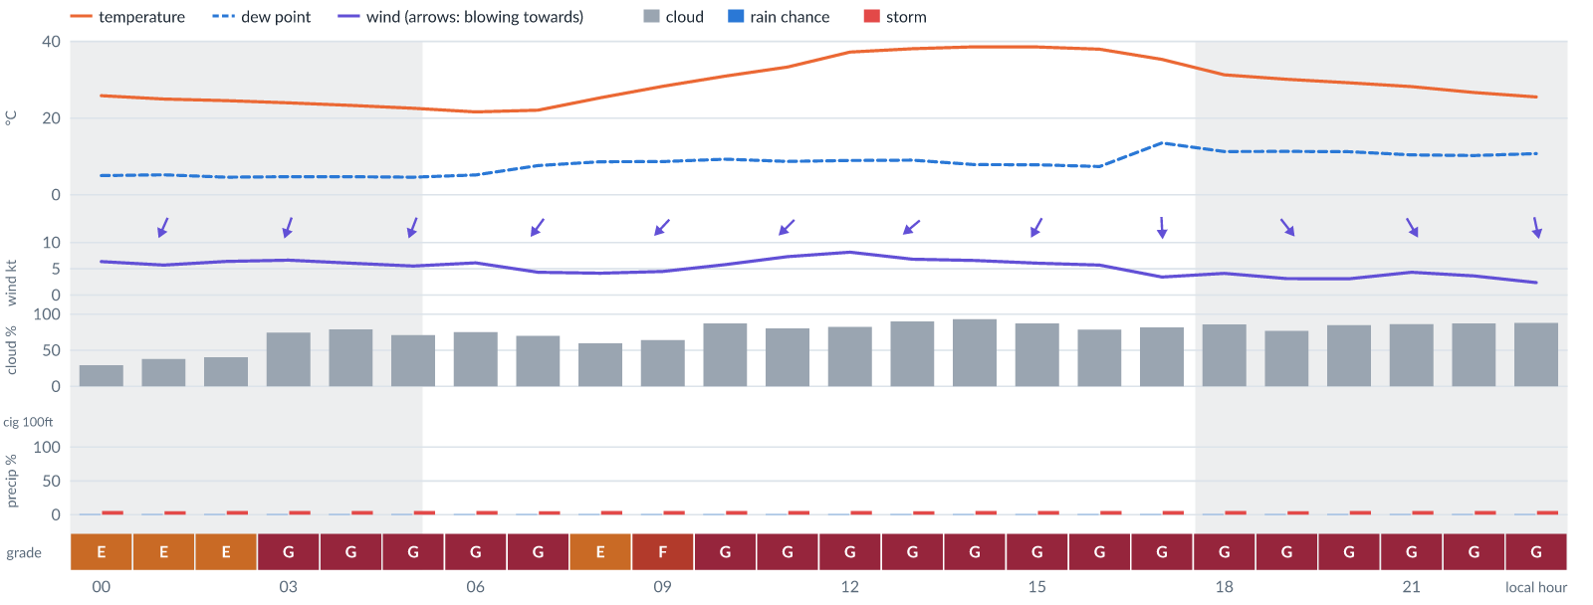
Meteogram — hourly forecast; shaded = before first light / after last light. Gaps mean no data.
Ser | Hrs | Temp | Cloud | Wind | Gust | QNH | Assessment | Driver | Remarks
(a) | (b) | (c) | (d) | (e) | (f) | (g) | (h) | (i) | (j)
1. | 0001 | 26°C | ◔ Mostly clear (29%) | ↙ 6 kts NNE | 12 kts | 1011 | E - Poor | gust 12 kt | gusts, thunderstorm risk, wind shear
2. | 0100 | 25°C | ◑ Partly cloudy (38%) | ↙ 6 kts NNE | 12 kts | 1011 | E - Poor | gust 12 kt | gusts, thunderstorm risk, wind shear
3. | 0200 | 25°C | ◑ Partly cloudy (40%) | ↓ 6 kts NNE | 12 kts | 1011 | E - Poor | gust 12 kt | gusts, thunderstorm risk, wind shear
4. | 0300 | 24°C | ◕ Cloudy (74%) | ↓ 7 kts NNE | 12 kts | 1011 | G - Unacceptable | cloud 74% | cloud cover, gusts, thunderstorm risk, wind shear
5. | 0400 | 23°C | ◕ Cloudy (79%) | ↓ 6 kts NNE | 11 kts | 1011 | G - Unacceptable | cloud 79% | cloud cover, thunderstorm risk, gusts, wind shear
6. | 0500 | 23°C | ◕ Cloudy (71%) | ↓ 6 kts NNE | 11 kts | 1011 | G - Unacceptable | cloud 71% | cloud cover, thunderstorm risk, gusts, wind shear
7. | 0600 | 22°C | ◕ Cloudy (75%) | ↙ 6 kts NNE | 9 kts | 1011 | G - Unacceptable | cloud 75% | cloud cover, thunderstorm risk, gusts
8. | 0700 | 22°C | ◕ Cloudy (70%) | ↙ 4 kts NE | 7 kts | 1012 | G - Unacceptable | cloud 70% | cloud cover, thunderstorm risk
9. | 0800 | 25°C | ◑ Cloudy (60%) | ↙ 4 kts NE | 8 kts | 1013 | E - Poor | cloud 60% | cloud cover, thunderstorm risk
10. | 0900 | 28°C | ◕ Cloudy (64%) | ↙ 4 kts NE | 10 kts | 1013 | F - Very Poor | cloud 64% | cloud cover, thunderstorm risk, gusts, wind shear
11. | 1000 | 31°C | ◕ Cloudy (87%) | ↙ 6 kts NE | 13 kts | 1013 | G - Unacceptable | cloud 87% | cloud cover, gusts, wind shear, thunderstorm risk
12. | 1100 | 33°C | ◕ Cloudy (80%) | ↙ 7 kts NE | 16 kts | 1012 | G - Unacceptable | cloud 80% | cloud cover, gusts, wind shear, thunderstorm risk
13. | 1200 | 37°C | ◕ Cloudy (82%) | ↙ 8 kts NE | 18 kts | 1011 | G - Unacceptable | cloud 82% · gust 18 kt | cloud cover, gusts, wind shear, thunderstorm risk
14. | 1300 | 38°C | ☁ Overcast (90%) | ↙ 7 kts NE | 17 kts | 1010 | G - Unacceptable | cloud 90% · gust spread +10 kt | cloud cover, wind shear, gusts, thunderstorm risk
15. | 1400 | 39°C | ☁ Overcast (93%) | ↙ 7 kts NE | 15 kts | 1010 | G - Unacceptable | cloud 93% | cloud cover, gusts, wind shear, thunderstorm risk
16. | 1500 | 39°C | ◕ Cloudy (87%) | ↙ 6 kts NNE | 13 kts | 1009 | G - Unacceptable | cloud 87% | cloud cover, gusts, wind shear, thunderstorm risk
17. | 1600 | 38°C | ◕ Cloudy (79%) | ↓ 6 kts NNE | 11 kts | 1009 | G - Unacceptable | cloud 79% | cloud cover, thunderstorm risk, gusts, wind shear
18. | 1700 | 35°C | ◕ Cloudy (82%) | ↓ 3 kts N | 5 kts | 1009 | G - Unacceptable | cloud 82% | cloud cover, thunderstorm risk
19. | 1800 | 31°C | ◕ Cloudy (86%) | ↘ 4 kts NNW | 5 kts | 1009 | G - Unacceptable | cloud 86% | cloud cover, thunderstorm risk
20. | 1900 | 30°C | ◕ Cloudy (77%) | ↘ 3 kts NW | 4 kts | 1009 | G - Unacceptable | cloud 77% | cloud cover, thunderstorm risk
21. | 2000 | 29°C | ◕ Cloudy (85%) | ↘ 3 kts NNW | 3 kts | 1009 | G - Unacceptable | cloud 85% | cloud cover, thunderstorm risk
22. | 2100 | 28°C | ◕ Cloudy (86%) | ↘ 4 kts NNW | 4 kts | 1010 | G - Unacceptable | cloud 86% | cloud cover, thunderstorm risk
23. | 2200 | 27°C | ◕ Cloudy (87%) | ↘ 4 kts NNW | 4 kts | 1010 | G - Unacceptable | cloud 87% | cloud cover, thunderstorm risk
24. | 2300 | 26°C | ☁ Cloudy (88%) | ↓ 2 kts NNW | 2 kts | 1011 | G - Unacceptable | cloud 88% | cloud cover, thunderstorm risk
Confidence: 63% — data for 24 of 24 hours; 24% of readings interpolated · first light 0539L · last light 1802L · Moon 8 % illuminated, rises 03:29, sets 15:38.

Extended Outlook
WEATHER EFFECTS BY DAY
 | Sat | Sun | Mon | Tue | Wed
Wind | F | F | G | D | C
Visibility | A | A | A | A | ·
Cloud / ceiling | G | E | G | G | G
Precipitation | A | A | A | A | ·
Thunderstorm | D | D | D | D | D
Fog | · | · | · | · | ·
Overall | G | F | G | G | G
A Excellent · B Good · C Fair · D Marginal (flyable) · E Poor · F Very Poor · G Unacceptable · (worst condition in each period)

Sat 7 Nov 26
Conditions are expected to be generally Marginal: partly cloudy, winds up to 7 kts ENE, gusting 16 kts and temperatures 21–38°C. Flyable windows: 0300–0900L (Marginal, 7 h) and 1700–2300L (Marginal, 7 h). Hazards: thunderstorm risk 0001–2300L. Overall an improvement on the previous day.
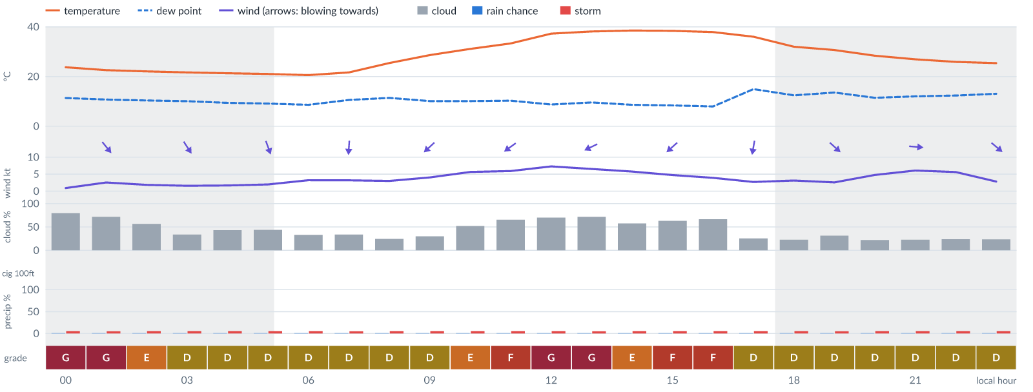
Meteogram — hourly forecast; shaded = before first light / after last light. Gaps mean no data.
Ser | Hrs | Temp | Cloud | Wind | Gust | QNH | Assessment | Driver | Remarks
(a) | (b) | (c) | (d) | (e) | (f) | (g) | (h) | (i) | (j)
1. | 0001 | 24°C | ◕ Cloudy (80%) | ↘ 1 kts NW | 2 kts | 1011 | G - Unacceptable | cloud 80% | cloud cover, thunderstorm risk
2. | 0100 | 23°C | ◕ Cloudy (72%) | ↘ 3 kts NW | 4 kts | 1011 | G - Unacceptable | cloud 72% | cloud cover, thunderstorm risk
3. | 0200 | 22°C | ◑ Partly cloudy (56%) | ↘ 2 kts NW | 3 kts | 1010 | E - Poor | cloud 56% | cloud cover, thunderstorm risk
4. | 0300 | 22°C | ◔ Partly cloudy (34%) | ↘ 2 kts NNW | 3 kts | 1010 | D - Marginal | storm 5% | ⚠ thunderstorm risk
5. | 0400 | 21°C | ◑ Partly cloudy (43%) | ↘ 2 kts NNW | 3 kts | 1011 | D - Marginal | storm 5% · cloud 43% | ⚠ cloud cover, thunderstorm risk
6. | 0500 | 21°C | ◑ Partly cloudy (44%) | ↓ 2 kts NNW | 4 kts | 1011 | D - Marginal | storm 5% · cloud 44% | ⚠ cloud cover, thunderstorm risk
7. | 0600 | 21°C | ◔ Partly cloudy (33%) | ↓ 3 kts NNW | 4 kts | 1011 | D - Marginal | storm 5% | ⚠ thunderstorm risk
8. | 0700 | 22°C | ◔ Partly cloudy (34%) | ↓ 3 kts N | 5 kts | 1012 | D - Marginal | storm 5% | ⚠ thunderstorm risk
9. | 0800 | 25°C | ◔ Mostly clear (24%) | ↙ 3 kts NNE | 6 kts | 1013 | D - Marginal | storm 5% | ⚠ thunderstorm risk
10. | 0900 | 29°C | ◔ Mostly clear (30%) | ↙ 4 kts NE | 9 kts | 1013 | D - Marginal | storm 5% · gust 9 kt | ⚠ thunderstorm risk, gusts, wind shear
11. | 1000 | 31°C | ◑ Partly cloudy (52%) | ↙ 6 kts NE | 13 kts | 1013 | E - Poor | cloud 52% · gust 13 kt | cloud cover, gusts, wind shear, thunderstorm risk
12. | 1100 | 33°C | ◕ Cloudy (66%) | ↙ 6 kts NE | 13 kts | 1013 | F - Very Poor | cloud 66% | cloud cover, gusts, wind shear, thunderstorm risk
13. | 1200 | 37°C | ◕ Cloudy (70%) | ↙ 7 kts ENE | 16 kts | 1012 | G - Unacceptable | cloud 70% | cloud cover, gusts, wind shear, thunderstorm risk
14. | 1300 | 38°C | ◕ Cloudy (72%) | ↙ 7 kts ENE | 15 kts | 1011 | G - Unacceptable | cloud 72% | cloud cover, gusts, wind shear, thunderstorm risk
15. | 1400 | 38°C | ◑ Partly cloudy (58%) | ↙ 6 kts ENE | 12 kts | 1011 | E - Poor | cloud 58% · gust 12 kt | cloud cover, gusts, thunderstorm risk, wind shear
16. | 1500 | 38°C | ◕ Cloudy (63%) | ↙ 5 kts NE | 10 kts | 1010 | F - Very Poor | cloud 63% | cloud cover, thunderstorm risk, gusts, wind shear
17. | 1600 | 38°C | ◕ Cloudy (66%) | ↙ 4 kts NNE | 6 kts | 1010 | F - Very Poor | cloud 66% | cloud cover, thunderstorm risk
18. | 1700 | 36°C | ◔ Mostly clear (25%) | ↓ 3 kts N | 3 kts | 1010 | D - Marginal | storm 5% | ⚠ thunderstorm risk
19. | 1800 | 32°C | ◔ Mostly clear (23%) | ↓ 3 kts N | 2 kts | 1010 | D - Marginal | storm 5% | ⚠ thunderstorm risk
20. | 1900 | 31°C | ◔ Mostly clear (32%) | ↘ 3 kts NW | 1 kts | 1010 | D - Marginal | storm 5% | ⚠ thunderstorm risk
21. | 2000 | 28°C | ◔ Mostly clear (22%) | → 5 kts WSW | 5 kts | 1010 | D - Marginal | storm 5% | ⚠ thunderstorm risk
22. | 2100 | 27°C | ◔ Mostly clear (23%) | → 6 kts W | 7 kts | 1011 | D - Marginal | storm 5% | ⚠ thunderstorm risk
23. | 2200 | 26°C | ◔ Mostly clear (24%) | → 6 kts WNW | 5 kts | 1011 | D - Marginal | storm 5% | ⚠ thunderstorm risk
24. | 2300 | 25°C | ◔ Mostly clear (24%) | ↘ 3 kts NW | 2 kts | 1011 | D - Marginal | storm 5% | ⚠ thunderstorm risk
Confidence: 63% — data for 24 of 24 hours; 24% of readings interpolated · first light 0539L · last light 1802L · Moon 4 % illuminated, rises 04:19, sets 16:18.

Sun 8 Nov 26
Conditions are expected to be generally Marginal: partly cloudy, winds up to 7 kts ENE, gusting 15 kts and temperatures 20–39°C. Flyable windows: 0001–0900L (Marginal, 10 h) and 1800–2300L (Marginal, 6 h). Hazards: thunderstorm risk 0001–2300L. Overall similar to the previous day.
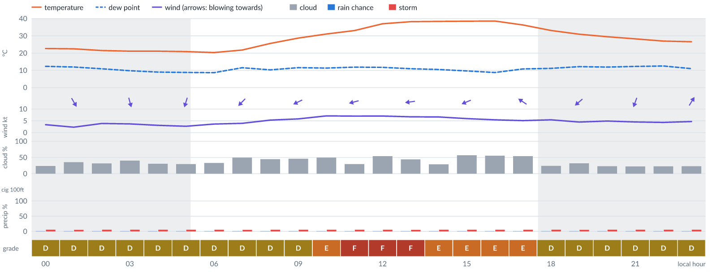
Meteogram — hourly forecast; shaded = before first light / after last light. Gaps mean no data.
Ser | Hrs | Temp | Cloud | Wind | Gust | QNH | Assessment | Driver | Remarks
(a) | (b) | (c) | (d) | (e) | (f) | (g) | (h) | (i) | (j)
1. | 0001 | 23°C | ◔ Mostly clear (24%) | ↓ 3 kts NNW | 4 kts | 1011 | D - Marginal | storm 5% | ⚠ thunderstorm risk
2. | 0100 | 22°C | ◔ Partly cloudy (35%) | ↘ 2 kts NNW | 3 kts | 1011 | D - Marginal | storm 5% | ⚠ thunderstorm risk
3. | 0200 | 21°C | ◔ Mostly clear (32%) | ↘ 4 kts NNW | 6 kts | 1011 | D - Marginal | storm 5% | ⚠ thunderstorm risk
4. | 0300 | 21°C | ◑ Partly cloudy (41%) | ↓ 4 kts NNW | 5 kts | 1011 | D - Marginal | storm 5% | ⚠ thunderstorm risk
5. | 0400 | 21°C | ◔ Mostly clear (31%) | ↓ 3 kts N | 4 kts | 1011 | D - Marginal | storm 5% | ⚠ thunderstorm risk
6. | 0500 | 21°C | ◔ Mostly clear (30%) | ↓ 3 kts NNE | 4 kts | 1012 | D - Marginal | storm 5% | ⚠ thunderstorm risk
7. | 0600 | 20°C | ◔ Partly cloudy (33%) | ↙ 4 kts NE | 3 kts | 1012 | D - Marginal | storm 5% | ⚠ thunderstorm risk
8. | 0700 | 22°C | ◑ Partly cloudy (50%) | ↙ 4 kts NE | 4 kts | 1013 | D - Marginal | storm 5% · cloud 50% | ⚠ cloud cover, thunderstorm risk
9. | 0800 | 26°C | ◑ Partly cloudy (45%) | ↙ 5 kts ENE | 8 kts | 1014 | D - Marginal | storm 5% · cloud 45% | ⚠ cloud cover, thunderstorm risk
10. | 0900 | 29°C | ◑ Partly cloudy (46%) | ↙ 6 kts ENE | 11 kts | 1014 | D - Marginal | storm 5% · cloud 46% | ⚠ cloud cover, thunderstorm risk, gusts, wind shear
11. | 1000 | 31°C | ◑ Partly cloudy (49%) | ← 7 kts ENE | 14 kts | 1014 | E - Poor | gust 14 kt · gust spread +7 kt | gusts, wind shear, cloud cover, thunderstorm risk
12. | 1100 | 33°C | ◔ Mostly clear (30%) | ← 7 kts ENE | 15 kts | 1014 | F - Very Poor | gust 15 kt | gusts, wind shear, thunderstorm risk
13. | 1200 | 37°C | ◑ Partly cloudy (54%) | ← 7 kts ENE | 15 kts | 1013 | F - Very Poor | gust 15 kt | gusts, cloud cover, wind shear, thunderstorm risk
14. | 1300 | 38°C | ◑ Partly cloudy (44%) | ← 7 kts E | 15 kts | 1012 | F - Very Poor | gust 15 kt | gusts, wind shear, cloud cover, thunderstorm risk
15. | 1400 | 38°C | ◔ Mostly clear (29%) | ← 7 kts ENE | 14 kts | 1012 | E - Poor | gust 14 kt · gust spread +7 kt | gusts, wind shear, thunderstorm risk
16. | 1500 | 38°C | ◑ Partly cloudy (57%) | ↙ 6 kts ENE | 12 kts | 1012 | E - Poor | cloud 57% · gust 12 kt | cloud cover, gusts, thunderstorm risk, wind shear
17. | 1600 | 39°C | ◑ Partly cloudy (56%) | ↙ 5 kts ENE | 10 kts | 1011 | E - Poor | cloud 56% | cloud cover, thunderstorm risk, gusts, wind shear
18. | 1700 | 36°C | ◑ Partly cloudy (54%) | ↖ 5 kts ESE | 9 kts | 1011 | E - Poor | cloud 54% | cloud cover, thunderstorm risk, gusts
19. | 1800 | 33°C | ◔ Mostly clear (24%) | ↑ 5 kts SSW | 8 kts | 1011 | D - Marginal | storm 5% | ⚠ thunderstorm risk
20. | 1900 | 31°C | ◔ Mostly clear (32%) | ↙ 5 kts NE | 7 kts | 1011 | D - Marginal | storm 5% | ⚠ thunderstorm risk
21. | 2000 | 30°C | ◔ Mostly clear (23%) | ↓ 5 kts NNE | 7 kts | 1012 | D - Marginal | storm 5% | ⚠ thunderstorm risk
22. | 2100 | 28°C | ◔ Mostly clear (22%) | ↓ 5 kts NNE | 7 kts | 1012 | D - Marginal | storm 5% | ⚠ thunderstorm risk
23. | 2200 | 27°C | ◔ Mostly clear (23%) | ↙ 4 kts NNE | 7 kts | 1012 | D - Marginal | storm 5% | ⚠ thunderstorm risk
24. | 2300 | 27°C | ◔ Mostly clear (23%) | ↗ 5 kts SSW | 8 kts | 1012 | D - Marginal | storm 5% | ⚠ thunderstorm risk
Confidence: 61% — data for 24 of 24 hours; 24% of readings interpolated · first light 0540L · last light 1802L · Moon 1 % illuminated, rises 05:09, sets 16:59.

Mon 9 Nov 26
Conditions are expected to be generally Marginal: partly cloudy, winds up to 9 kts ENE, gusting 21 kts and temperatures 22–39°C. Flyable windows: 0200–0700L (Marginal, 6 h) and 1900–2000L (Marginal, 2 h). Hazards: thunderstorm risk 0001–2300L. Overall similar to the previous day.
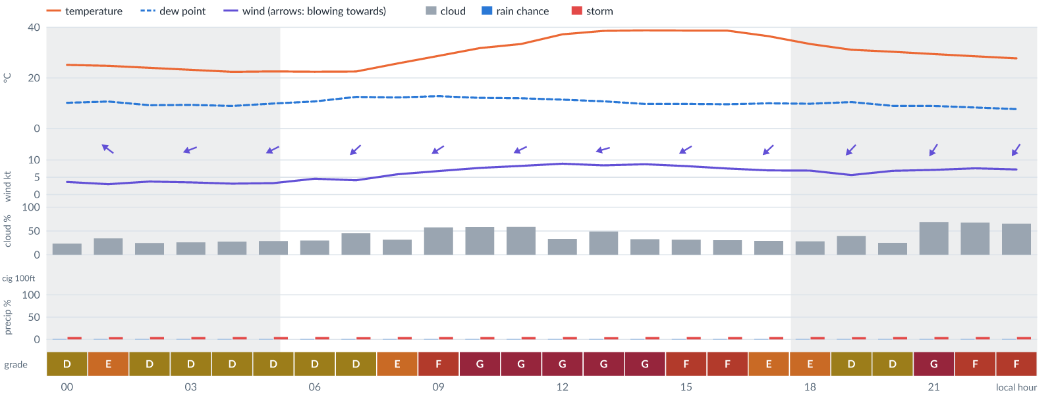
Meteogram — hourly forecast; shaded = before first light / after last light. Gaps mean no data.
Ser | Hrs | Temp | Cloud | Wind | Gust | QNH | Assessment | Driver | Remarks
(a) | (b) | (c) | (d) | (e) | (f) | (g) | (h) | (i) | (j)
1. | 0001 | 25°C | ◔ Mostly clear (23%) | ↖ 4 kts SE | 9 kts | 1012 | D - Marginal | storm 5% · gust 9 kt | ⚠ thunderstorm risk, gusts, wind shear
2. | 0100 | 25°C | ◔ Partly cloudy (34%) | ↖ 3 kts SE | 11 kts | 1013 | E - Poor | gust spread +7 kt | wind shear, thunderstorm risk, gusts
3. | 0200 | 24°C | ◔ Mostly clear (25%) | ↙ 4 kts ENE | 10 kts | 1013 | D - Marginal | storm 5% · gust 10 kt | ⚠ thunderstorm risk, gusts, wind shear
4. | 0300 | 23°C | ◔ Mostly clear (26%) | ← 4 kts ENE | 8 kts | 1013 | D - Marginal | storm 5% | ⚠ thunderstorm risk
5. | 0400 | 22°C | ◔ Mostly clear (27%) | ← 3 kts ENE | 7 kts | 1013 | D - Marginal | storm 5% | ⚠ thunderstorm risk
6. | 0500 | 23°C | ◔ Mostly clear (29%) | ↙ 3 kts ENE | 8 kts | 1014 | D - Marginal | storm 5% · gust spread +4 kt | ⚠ thunderstorm risk, wind shear
7. | 0600 | 22°C | ◔ Mostly clear (30%) | ↙ 5 kts NE | 8 kts | 1014 | D - Marginal | storm 5% | ⚠ thunderstorm risk
8. | 0700 | 23°C | ◑ Partly cloudy (45%) | ↙ 4 kts NE | 9 kts | 1015 | D - Marginal | storm 5% · cloud 45% | ⚠ cloud cover, thunderstorm risk, gusts, wind shear
9. | 0800 | 26°C | ◔ Mostly clear (32%) | ↙ 6 kts NE | 12 kts | 1015 | E - Poor | gust 12 kt | gusts, thunderstorm risk, wind shear
10. | 0900 | 29°C | ◑ Partly cloudy (58%) | ↙ 7 kts ENE | 15 kts | 1015 | F - Very Poor | gust 15 kt | gusts, cloud cover, wind shear, thunderstorm risk
11. | 1000 | 32°C | ◑ Partly cloudy (58%) | ↙ 8 kts ENE | 18 kts | 1016 | G - Unacceptable | gust 18 kt · gust spread +10 kt | gusts, wind shear, cloud cover, thunderstorm risk
12. | 1100 | 33°C | ◑ Partly cloudy (59%) | ↙ 8 kts ENE | 19 kts | 1015 | G - Unacceptable | gust 19 kt · gust spread +11 kt | gusts, wind shear, cloud cover, thunderstorm risk
13. | 1200 | 37°C | ◔ Partly cloudy (34%) | ↙ 9 kts ENE | 20 kts | 1014 | G - Unacceptable | gust 20 kt · gust spread +11 kt | gusts, wind shear, thunderstorm risk, strong wind
14. | 1300 | 39°C | ◑ Partly cloudy (49%) | ← 8 kts ENE | 21 kts | 1014 | G - Unacceptable | gust 21 kt · gust spread +13 kt | gusts, wind shear, cloud cover, thunderstorm risk
15. | 1400 | 39°C | ◔ Partly cloudy (33%) | ↙ 9 kts ENE | 19 kts | 1013 | G - Unacceptable | gust 19 kt · gust spread +11 kt | gusts, wind shear, thunderstorm risk, strong wind
16. | 1500 | 39°C | ◔ Mostly clear (32%) | ↙ 8 kts ENE | 17 kts | 1013 | F - Very Poor | gust 17 kt · gust spread +9 kt | gusts, wind shear, thunderstorm risk
17. | 1600 | 39°C | ◔ Mostly clear (31%) | ↙ 8 kts NE | 16 kts | 1013 | F - Very Poor | gust 16 kt | gusts, wind shear, thunderstorm risk
18. | 1700 | 36°C | ◔ Mostly clear (29%) | ↙ 7 kts NE | 14 kts | 1013 | E - Poor | gust 14 kt · gust spread +7 kt | gusts, wind shear, thunderstorm risk
19. | 1800 | 33°C | ◔ Mostly clear (28%) | ↙ 7 kts NE | 12 kts | 1013 | E - Poor | gust 12 kt | gusts, thunderstorm risk, wind shear
20. | 1900 | 31°C | ◑ Partly cloudy (39%) | ↙ 6 kts NE | 11 kts | 1013 | D - Marginal | storm 5% · gust 11 kt | ⚠ thunderstorm risk, gusts, wind shear
21. | 2000 | 30°C | ◔ Mostly clear (25%) | ↙ 7 kts NE | 11 kts | 1014 | D - Marginal | storm 5% · gust 11 kt | ⚠ thunderstorm risk, gusts
22. | 2100 | 29°C | ◕ Cloudy (69%) | ↙ 7 kts NNE | 12 kts | 1014 | G - Unacceptable | cloud 69% | cloud cover, gusts, thunderstorm risk, wind shear
23. | 2200 | 29°C | ◕ Cloudy (67%) | ↙ 8 kts NNE | 12 kts | 1015 | F - Very Poor | cloud 67% | cloud cover, gusts, thunderstorm risk
24. | 2300 | 28°C | ◕ Cloudy (66%) | ↙ 7 kts NNE | 12 kts | 1015 | F - Very Poor | cloud 66% | cloud cover, gusts, thunderstorm risk, wind shear
Confidence: 60% — data for 24 of 24 hours; 25% of readings interpolated · first light 0540L · last light 1802L · Moon 0 % illuminated, rises 06:00, sets 17:43.

Tue 10 Nov 26
Conditions are expected to be generally Very Poor: partly cloudy, winds up to 8 kts ENE and temperatures 22–37°C. Flyable windows: 0001–0100L (Marginal, 2 h). Hazards: thunderstorm risk 0001–0100L, 0700L, 1300L and 1900L. Overall a deterioration from the previous day.
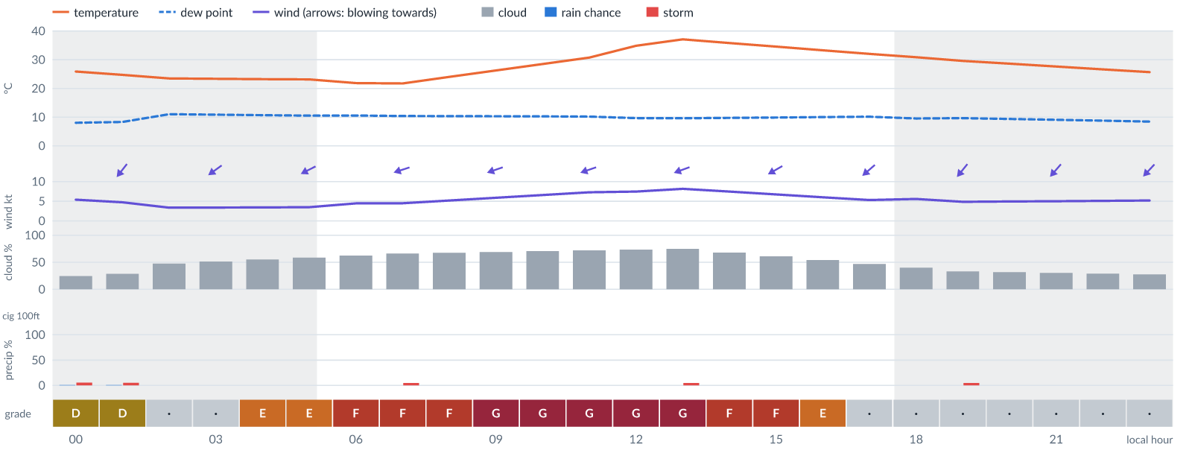
Meteogram — hourly forecast; shaded = before first light / after last light. Gaps mean no data.
Ser | Hrs | Temp | Cloud | Wind | Gust | QNH | Assessment | Driver | Remarks
(a) | (b) | (c) | (d) | (e) | (f) | (g) | (h) | (i) | (j)
1. | 0001 | 26°C | ◔ Mostly clear (24%) | ↙ 5 kts NE | 11 kts | 1015 | D - Marginal | storm 5% · gust 11 kt | ⚠ thunderstorm risk, gusts, wind shear
2. | 0100 | 25°C | ◔ Mostly clear (29%) | ↙ 5 kts NE | 10 kts | 1015 | D - Marginal | storm 5% · gust 10 kt | ⚠ thunderstorm risk, gusts, wind shear
3. | 0200 | 23°C | ◑ Partly cloudy (48%) | ↙ 3 kts NE | - | 1016 | · - No data | cloud 48% · visibility not forecast | ⚠ cloud cover
4. | 0300 | 23°C | ◑ Partly cloudy (51%) | ↙ 3 kts NE | - | 1016 | · - No data | cloud 51% · visibility not forecast | ⚠ cloud cover
5. | 0400 | 23°C | ◑ Partly cloudy (55%) | ↙ 3 kts ENE | - | 1016 | E - Poor | cloud 55% · visibility not forecast | ⚠ cloud cover
6. | 0500 | 23°C | ◑ Partly cloudy (59%) | ↙ 3 kts ENE | - | 1016 | E - Poor | cloud 59% · visibility not forecast | ⚠ cloud cover
7. | 0600 | 22°C | ◑ Cloudy (62%) | ← 4 kts ENE | - | 1016 | F - Very Poor | cloud 62% · visibility not forecast | ⚠ cloud cover
8. | 0700 | 22°C | ◕ Cloudy (66%) | ← 4 kts ENE | - | 1017 | F - Very Poor | cloud 66% · visibility not forecast | ⚠ cloud cover, thunderstorm risk
9. | 0800 | 24°C | ◕ Cloudy (68%) | ← 5 kts ENE | - | 1017 | F - Very Poor | cloud 68% · visibility not forecast | ⚠ cloud cover
10. | 0900 | 26°C | ◕ Cloudy (69%) | ← 6 kts ENE | - | 1017 | G - Unacceptable | cloud 69% · visibility not forecast | ⚠ cloud cover
11. | 1000 | 28°C | ◕ Cloudy (71%) | ← 7 kts ENE | - | 1017 | G - Unacceptable | cloud 71% · visibility not forecast | ⚠ cloud cover
12. | 1100 | 31°C | ◕ Cloudy (72%) | ← 7 kts ENE | - | 1016 | G - Unacceptable | cloud 72% · visibility not forecast | ⚠ cloud cover
13. | 1200 | 35°C | ◕ Cloudy (74%) | ← 7 kts ENE | - | 1016 | G - Unacceptable | cloud 74% · visibility not forecast | ⚠ cloud cover
14. | 1300 | 37°C | ◕ Cloudy (75%) | ← 8 kts ENE | - | 1015 | G - Unacceptable | cloud 75% · visibility not forecast | ⚠ cloud cover, thunderstorm risk
15. | 1400 | 36°C | ◕ Cloudy (68%) | ↙ 7 kts ENE | - | 1015 | F - Very Poor | cloud 68% · visibility not forecast | ⚠ cloud cover
16. | 1500 | 35°C | ◑ Cloudy (61%) | ↙ 7 kts ENE | - | 1015 | F - Very Poor | cloud 61% · visibility not forecast | ⚠ cloud cover
17. | 1600 | 33°C | ◑ Partly cloudy (54%) | ↙ 6 kts NE | - | 1014 | E - Poor | cloud 54% · visibility not forecast | ⚠ cloud cover
18. | 1700 | 32°C | ◑ Partly cloudy (47%) | ↙ 5 kts NE | - | 1014 | · - No data | cloud 47% · visibility not forecast | ⚠ cloud cover
19. | 1800 | 31°C | ◑ Partly cloudy (40%) | ↙ 6 kts NE | - | 1014 | · - No data | cloud 40% · wind 6 kt · visibility not forecast | ⚠ low confidence
20. | 1900 | 30°C | ◔ Partly cloudy (33%) | ↙ 5 kts NE | - | 1014 | · - No data | storm 5% · visibility not forecast | ⚠ thunderstorm risk
21. | 2000 | 29°C | ◔ Mostly clear (32%) | ↙ 5 kts NE | - | 1014 | · - No data | cloud 32% · wind 5 kt · visibility not forecast | ⚠ low confidence
22. | 2100 | 28°C | ◔ Mostly clear (30%) | ↙ 5 kts NE | - | 1014 | · - No data | cloud 30% · wind 5 kt · visibility not forecast | ⚠ low confidence
23. | 2200 | 27°C | ◔ Mostly clear (29%) | ↙ 5 kts NE | - | 1014 | · - No data | cloud 29% · wind 5 kt · visibility not forecast | ⚠ low confidence
24. | 2300 | 26°C | ◔ Mostly clear (28%) | ↙ 5 kts NE | - | 1014 | · - No data | cloud 28% · wind 5 kt · visibility not forecast | ⚠ low confidence
Confidence: 35% — data for 24 of 24 hours; 76% of readings interpolated · first light 0540L · last light 1802L · Moon 2 % illuminated, rises 06:53, sets 18:30.

Wed 11 Nov 26
Conditions are expected to be generally Very Poor: partly cloudy, winds up to 7 kts NE and temperatures 21–35°C. No flyable windows (Marginal or better, ≥2 consecutive hrs) are forecast. Hazards: thunderstorm risk 0100L, 0700L, 1300L and 1900L. Overall similar to the previous day.
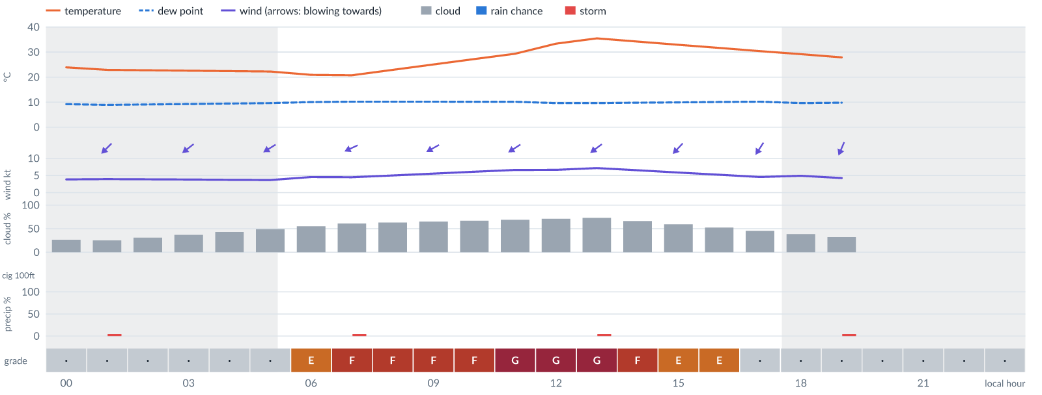
Meteogram — hourly forecast; shaded = before first light / after last light. Gaps mean no data.
Ser | Hrs | Temp | Cloud | Wind | Gust | QNH | Assessment | Driver | Remarks
(a) | (b) | (c) | (d) | (e) | (f) | (g) | (h) | (i) | (j)
1. | 0001 | 24°C | ◔ Mostly clear (26%) | ↙ 4 kts NE | - | 1015 | · - No data | cloud 26% · wind 4 kt · visibility not forecast | ⚠ low confidence
2. | 0100 | 23°C | ◔ Mostly clear (25%) | ↙ 4 kts NE | - | 1015 | · - No data | storm 5% · visibility not forecast | ⚠ thunderstorm risk
3. | 0200 | 23°C | ◔ Mostly clear (31%) | ↙ 4 kts NE | - | 1015 | · - No data | cloud 31% · wind 4 kt · visibility not forecast | ⚠ low confidence
4. | 0300 | 23°C | ◔ Partly cloudy (37%) | ↙ 4 kts NE | - | 1015 | · - No data | cloud 37% · visibility not forecast | ⚠ low confidence
5. | 0400 | 22°C | ◑ Partly cloudy (43%) | ↙ 4 kts NE | - | 1016 | · - No data | cloud 43% · visibility not forecast | ⚠ cloud cover
6. | 0500 | 22°C | ◑ Partly cloudy (49%) | ↙ 4 kts ENE | - | 1016 | · - No data | cloud 49% · visibility not forecast | ⚠ cloud cover
7. | 0600 | 21°C | ◑ Partly cloudy (55%) | ↙ 5 kts ENE | - | 1016 | E - Poor | cloud 55% · visibility not forecast | ⚠ cloud cover
8. | 0700 | 21°C | ◑ Cloudy (61%) | ↙ 4 kts ENE | - | 1016 | F - Very Poor | cloud 61% · visibility not forecast | ⚠ cloud cover, thunderstorm risk
9. | 0800 | 23°C | ◕ Cloudy (63%) | ↙ 5 kts ENE | - | 1016 | F - Very Poor | cloud 63% · visibility not forecast | ⚠ cloud cover
10. | 0900 | 25°C | ◕ Cloudy (65%) | ↙ 6 kts ENE | - | 1016 | F - Very Poor | cloud 65% · visibility not forecast | ⚠ cloud cover
11. | 1000 | 27°C | ◕ Cloudy (67%) | ↙ 6 kts ENE | - | 1016 | F - Very Poor | cloud 67% · visibility not forecast | ⚠ cloud cover
12. | 1100 | 29°C | ◕ Cloudy (69%) | ↙ 7 kts ENE | - | 1016 | G - Unacceptable | cloud 69% · visibility not forecast | ⚠ cloud cover
13. | 1200 | 33°C | ◕ Cloudy (71%) | ↙ 7 kts NE | - | 1015 | G - Unacceptable | cloud 71% · visibility not forecast | ⚠ cloud cover
14. | 1300 | 35°C | ◕ Cloudy (73%) | ↙ 7 kts NE | - | 1015 | G - Unacceptable | cloud 73% · visibility not forecast | ⚠ cloud cover, thunderstorm risk
15. | 1400 | 34°C | ◕ Cloudy (66%) | ↙ 7 kts NE | - | 1014 | F - Very Poor | cloud 66% · visibility not forecast | ⚠ cloud cover
16. | 1500 | 33°C | ◑ Partly cloudy (59%) | ↙ 6 kts NE | - | 1014 | E - Poor | cloud 59% · visibility not forecast | ⚠ cloud cover
17. | 1600 | 32°C | ◑ Partly cloudy (53%) | ↙ 5 kts NE | - | 1014 | E - Poor | cloud 53% · visibility not forecast | ⚠ cloud cover
18. | 1700 | 30°C | ◑ Partly cloudy (46%) | ↙ 5 kts NNE | - | 1014 | · - No data | cloud 46% · visibility not forecast | ⚠ cloud cover
19. | 1800 | 29°C | ◑ Partly cloudy (39%) | ↙ 5 kts NNE | - | 1014 | · - No data | cloud 39% · visibility not forecast | ⚠ low confidence
20. | 1900 | 28°C | ◔ Mostly clear (32%) | ↙ 4 kts NNE | - | 1014 | · - No data | storm 5% · visibility not forecast | ⚠ thunderstorm risk
21. | 2000 | - | No data | - | - | - | · - No data | cloud, visibility, wind not forecast
22. | 2100 | - | No data | - | - | - | · - No data | cloud, visibility, wind not forecast
23. | 2200 | - | No data | - | - | - | · - No data | cloud, visibility, wind not forecast
24. | 2300 | - | No data | - | - | - | · - No data | cloud, visibility, wind not forecast
Confidence: 29% — data for 20 of 24 hours; 78% of readings interpolated · first light 0541L · last light 1802L · Moon 5 % illuminated, rises 07:46, sets 19:20.

TAF
No TAF available for this location.

Imagery

Dust RGB (pink/magenta = airborne dust) — captured 5 Nov 01:18 WAT (5 min ago) · ©EUMETSAT (screenshot via EUMETView)

Convection RGB (yellow = vigorous storms) — captured 5 Nov 01:18 WAT (5 min ago) · ©EUMETSAT (screenshot via EUMETView)
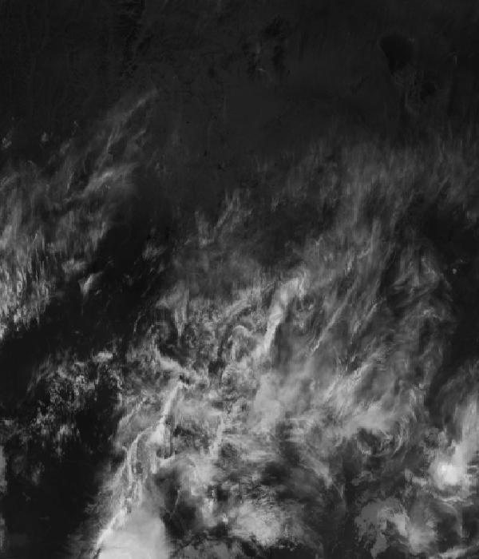
Infrared 10.5 µm (cold tops = deep cloud) — captured 5 Nov 01:18 WAT (5 min ago) · ©EUMETSAT (screenshot via EUMETView)

Accumulated lightning flash area (MTG-LI) — captured 5 Nov 01:18 WAT (5 min ago) · ©EUMETSAT (screenshot via EUMETView)

Source panel
Source | Accuracy | Skill n | Temp °C | Wind kt | Visibility | Storm
(a) | (b) | (c) | (d) | (e) | (f) | (g)
ECMWF AIFS | ▲ 1.3 | 646 | 23–24 | 4–5 | — | 0 %
Tomorrow.io | ▲ 1.2 | 3562 | 23–27 | 1–7 | 10+ km | 0 %
Each source's own raw values, min–max over the next 6 hours from the issue hour (before any weighting or bias correction). — means the source does not publish that metric in the window. Wide gaps between rows are real disagreement; the forecast above weights sources by measured skill.

Reading this report
Grades: each hour carries one grade, set by its WORST factor. The bands below are the thresholds in force for this report (Settings); a value in a band earns that grade, and "-" means the factor never produces that grade. Cloud is graded on the worse of cover and ceiling. The Driver column names the limiting factor with its value; open it in the web report for the boundary and sources.
Grade | Cloud cover | Cloud ceiling | Visibility | Wind | Gust | Rain chance | Thunderstorm probability
(a) | (b) | (c) | (d) | (e) | (f) | (g) | (h)
A Excellent | ≤ 17.1% | ≥ 30000 ft | ≥ 8000 m | < 3 kt | < 3 kt | < 5% | 0%
B Good | 17.1–34.3% | 26000–30000 ft | 6666.7–8000 m | 3–6 kt | 3–6 kt | 5–10% | -
C Fair | 34.3–42.9% | 24000–26000 ft | 5333.3–6666.7 m | 6–9 kt | 6–9 kt | 10–15% | -
D Marginal | 42.9–51.4% | 22000–24000 ft | 4000–5333.3 m | 9–12 kt | 9–12 kt | 15–20% | >0–15%
E Poor | 51.4–60% | 16000–22000 ft | 2666.7–4000 m | 12–15 kt | 12–15 kt | 20–25% | 15–30%
F Very Poor | 60–68.6% | 10000–16000 ft | 1333.3–2666.7 m | 15–18 kt | 15–18 kt | 25–30% | 30–60%
G Unacceptable | > 68.6% | < 10000 ft | < 1333.3 m | ≥ 18 kt | ≥ 18 kt | ≥ 30% | > 60%
Flight windows: a window is at least 2 consecutive hours graded Marginal or better; an hour with insufficient data never counts toward one. ☾ marks a window outside first-to-last light.
Time: hours are local time (WAT, UTC+1) unless suffixed Z, which is UTC (TAF, METAR and issue times). Local midnight is labelled 0001.
Units: temperature °C · wind and gusts knots · visibility metres (km in text) · cloud ceiling feet · cloud cover % · rain chance and thunderstorm probability % · QNH hPa (altimeter setting at the field) · CAPE J/kg. A figure like "28 (26–30)°C" gives the p10–p90 range; "spread" marks disagreement between sources.
Symbols: ▲ better than the pool · ▽ worse (only when the 95% interval excludes the pool) · ≈ not distinguishable from the pool · unmarked = unproven (accuracy is measured against METAR and SYNOP observations). ⚠ on a remark means a low-confidence hour; a ⚠ paragraph on the first page is a convective-warning or data-age advisory. ⚡ is lightning observed by satellite near the field (©EUMETSAT).
Hourly glyphs: the wind arrow points the way the air moves (a north wind is ↓, an east wind ←); cloud cover shows as ☀ ◔ ◑ ◕ ☁ (clear, few, scattered, broken, overcast); a shaded hour label is wholly before first light or after last light.
Terms: "No data" - no source forecast the hour, or a core group (cloud, visibility, wind) is missing and the hour could still be flyable; missing data is never given a good grade. "Low-confidence" - few or weak sources behind the load-bearing metrics; treat the grade as indicative. "Insufficient data" - too little to grade at all. "Estimated" (est.) - the value is derived, not reported by a source (dust visibility, cloud base, gusts); it is declared where used and weighted at half. "Derived" - an hour interpolated from a coarser (3-hourly or daily) source, weighted at half and never used to score accuracy.

Data provenance
Source | Fetched (Z) | Age | Skill n | Accuracy
(a) | (b) | (c) | (d) | (e)
ECMWF AIFS | 5 Nov 00:19Z | 4 min | 646 | ▲ 1.3
Tomorrow.io | 5 Nov 00:19Z | 4 min | 3562 | ▲ 1.2
Corrections applied (detailed under Learned corrections on the first page): skill weighting, bias correction, hour-of-day bias, cloud-base estimate, probability calibration, climatology bounds, skill blend.

How accurate have we been
Measured against observations (METAR/SYNOP), maiduguri only. Verification table computed 2026-11-04. Mean absolute error (MAE): lower is better; "beats persistence" compares the best source with "it will stay as it is now" on the same hours.
Metric | Best source | Best MAE | Typical MAE | Persistence MAE | Beats persistence by | Pairs
(a) | (b) | (c) | (d) | (e) | (f) | (g)
Temperature (°C) | accuweather | 1.5 | 2.4 | 5.2 | 66 % | 46
Dew point (°C) | aifs | 1.6 | 6.5 | 2.4 | 46 % | 200
Wind speed (kt) | aifs | 1.8 | 3.3 | 2.5 | 47 % | 131
Visibility (m) | ukmo | 467 | 681 | 1340 | 68 % | 1258
Cloud cover (%) | accuweather | 10 | 59 | 8 | - | 27
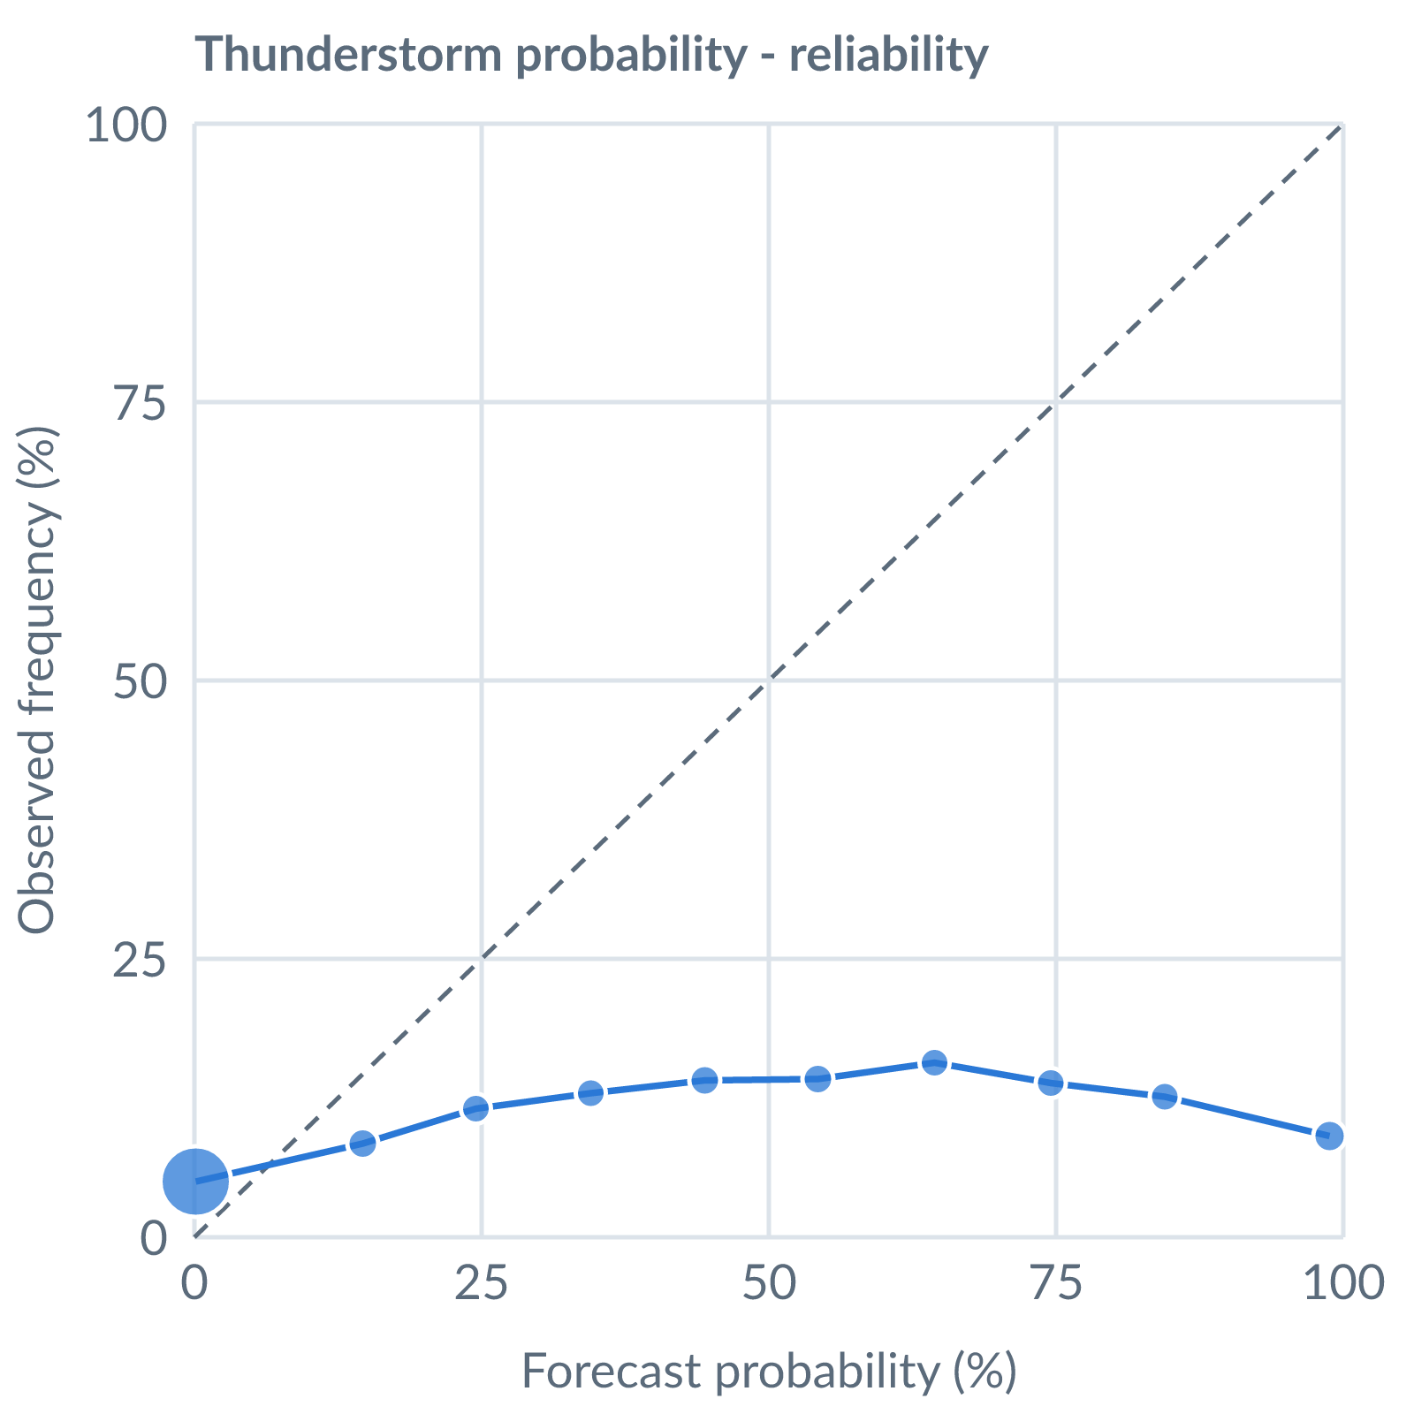
Thunderstorm probability: dots on the dashed line mean a stated probability matched how often it happened (137366 pairs, all places pooled).
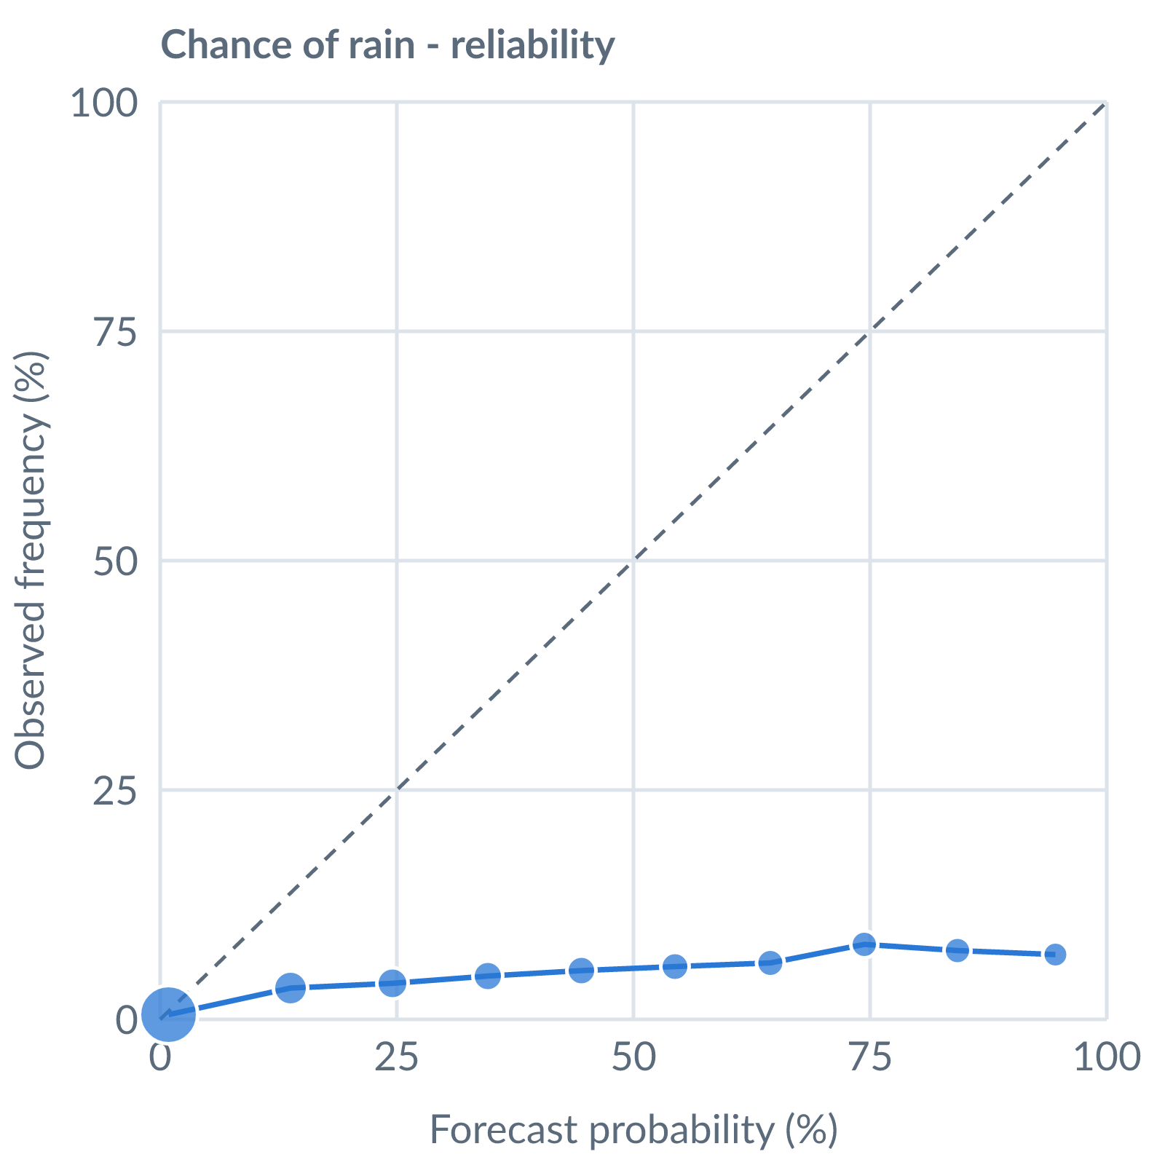
Chance of rain: dots on the dashed line mean a stated probability matched how often it happened (127657 pairs, all places pooled).
Learned bias (forecast minus observed; positive = sources run high), mean over scored sources, by local time of day. These are corrected for before sources are averaged.
Metric | Overall | Night | Morning | Afternoon | Evening | Pairs
(a) | (b) | (c) | (d) | (e) | (f) | (g)
Temperature (°C) | +0.9 | +2.1 | +1.8 | -0.4 | +0.6 | 26938
Dew point (°C) | -6.2 | -6.7 | -5.7 | -6.1 | -6.4 | 22622
Wind speed (kt) | +0.1 | +0.9 | -0.2 | +0.1 | -0.1 | 15566
Not yet available: Scores are decayed over the verification window (half-life 14 days); separate last-7-day and last-30-day windows are not stored. Bias is the current learned value; the history needed for a trend over time is not stored. Flight-window hit / bust / miss is not yet recorded.

