Gusau — 14-Day Forecast
DNGU · issued 4 Nov 26 01:03Z
Sources: ECMWF AIFS ▲ 1.3 · ECMWF ▲ 1.2 · Canada GEM ▲ 1.2 · DWD ICON ▲ 1.2 · JMA GSM ≈ 0.9 · Météo-France ≈ 1.0 · Open-Meteo ≈ 1.0 · wttr.in ▽ 0.9
▲ better than the pool · ▽ worse (only when the 95% interval excludes the pool) · ≈ not distinguishable from the pool · unmarked = unproven (accuracy is measured against METAR and SYNOP observations)
Day | 00 | 01 | 02 | 03 | 04 | 05 | 06 | 07 | 08 | 09 | 10 | 11 | 12 | 13 | 14 | 15 | 16 | 17 | 18 | 19 | 20 | 21 | 22 | 23 | Flyable Windows | Conf
Wed 4 Nov 26 | · | D | D | D | D | D | D | D | D | E | E | F | F | E | E | E | E | E | D | D | D | D | D | D | 0100–0800L (Marginal, 8 h) ☾ · 1800–2300L (Marginal, 6 h) ☾ | 73%
Thu 5 Nov 26 | D | D | D | D | D | D | D | D | D | D | F | G | G | G | G | G | F | F | F | E | E | E | F | F | 0001–0900L (Marginal, 10 h) ☾ | 76%
Fri 6 Nov 26 | G | G | G | G | G | F | F | G | E | E | F | F | G | G | F | F | E | E | D | D | D | D | D | D | best window: 1800–2300L (Marginal, 6 h) ☾ | 77%
Sat 7 Nov 26 | D | D | D | D | D | D | D | D | D | D | E | E | E | F | F | F | F | E | D | D | D | D | D | D | 0001–0900L (Marginal, 10 h) ☾ · 1800–2300L (Marginal, 6 h) ☾ | 76%
Sun 8 Nov 26 | D | D | D | D | D | D | D | D | D | D | E | F | F | G | G | G | G | F | E | F | E | D | D | D | 0001–0900L (Marginal, 10 h) ☾ · 2100–2300L (Marginal, 3 h) ☾ | 75%
Mon 9 Nov 26 | D | D | D | D | D | D | D | D | D | E | G | G | G | G | G | G | G | G | E | G | F | E | E | D | 0001–0800L (Marginal, 9 h) ☾ | 75%
Tue 10 Nov 26 | D | D | D | D | D | D | D | D | D | F | G | G | G | G | G | G | G | G | F | F | G | F | E | E | 0001–0800L (Marginal, 9 h) ☾ | 75%
Wed 11 Nov 26 | E | G | G | F | D | D | D | D | E | E | F | F | G | G | G | G | G | G | G | G | G | G | E | E | 0400–0700L (Marginal, 4 h) ☾ | 67%
Thu 12 Nov 26 | E | D | D | D | D | D | D | D | E | E | F | F | G | G | G | G | G | G | G | G | G | G | G | G | 0100–0700L (Marginal, 7 h) ☾ | 67%
Fri 13 Nov 26 | G | G | G | E | D | E | E | E | F | F | G | G | G | G | G | G | G | G | G | G | G | G | F | E | no windows | 66%
Sat 14 Nov 26 | D | D | D | D | D | E | E | F | F | F | G | G | G | G | G | G | G | G | G | G | G | G | G | E | 0001–0400L (Marginal, 5 h) ☾ | 54%
Sun 15 Nov 26 | D | D | D | D | D | D | E | E | F | F | G | G | G | G | G | G | G | G | G | G | G | G | G | E | 0001–0500L (Marginal, 6 h) ☾ | 54%
Mon 16 Nov 26 | E | D | D | D | D | D | D | E | E | F | F | G | G | G | G | G | G | G | G | G | G | G | F | E | 0100–0600L (Marginal, 6 h) ☾ | 54%
Tue 17 Nov 26 | D | D | D | D | D | D | D | E | E | F | G | G | G | G | G | G | G | G | G | G | G | G | F | E | 0001–0600L (Marginal, 7 h) ☾ | 54%
A Excellent · B Good · C Fair · D Marginal · E Poor · F Very Poor · G Unacceptable · · No data
Best window (highest confidence, then grade, then length): Fri 6 Nov 26 1800–2300L (Marginal, 6 h) ☾, confidence 77%.
Learned corrections (METAR-verified): skill weighting — pooled all-field scores for 206; bias corrections — foreca dewpoint +3.0 °C, metcheck dewpoint +3.0 °C, openweather dewpoint +3.0 °C, wttr.in dewpoint +3.0 °C, gfs dewpoint +3.0 °C, Météo-France dewpoint +3.0 °C (+67 more); hour-of-day bias (local time, shrunk toward the all-hours bias) — visualcrossing night wind −3.9 kt, visualcrossing evening wind −3.6 kt, wttr.in evening wind −3.5 kt, wttr.in night wind −3.4 kt, gfs evening wind −3.3 kt, gfs night wind −3.2 kt (+284 more); cloud base estimated as 410 ft per °C of dewpoint spread for sources that report no ceiling (≥60% cloud cover; flagged estimated, weighted ×0.5); probability calibration — rain chance: meteoblue, Open-Meteo, foreca, metcheck, openweather, visualcrossing, tomorrowio, wttr.in, ECMWF, gfs, DWD ICON, ukmo, Canada GEM, ecmwfens; storm: Open-Meteo, metno, foreca, openweather, visualcrossing, tomorrowio, wttr.in, ECMWF, gfs, DWD ICON, Météo-France, aviationweather, ukmo, JMA GSM, Canada GEM, ecmwfens, ECMWF AIFS (each source's stated probability mapped to its verified frequency by an isotonic fit on ≥200 pairs, proven on the holdout); fog risk (n=1325): observed fog frequency by dewpoint spread, wind, local hour and season for the forecast conditions (shown from 10 %), proven on the holdout; plausibility bounds from ERA5 climatology 2016-2025 (mean ± 5 sd; screening only, not observed truth); skill blend 1 auto-tuned over 8384 holdout pairs (consensus beat the best single source, tomorrowio, by 17%); correction gates (newest-7-day holdout; pooled skill is always on) — regional skill: off this week (did not improve holdout); place skill: off this week (did not improve holdout); lead-time skill: off this week (did not improve holdout); small-sample skill shrinkage: off this week (did not improve holdout); bias correction: on (improved holdout by 24.3%); place bias: on (improved holdout by 12.1%); hour-of-day bias: on (improved holdout by 4.0%); QNH bias: on (improved holdout by 55.4%); gust estimates: off this week (did not improve holdout); cloud-base coefficient: off this week (insufficient holdout: 70 of 200 items); recent-form skill: off this week (did not improve holdout); probability calibration: on (improved holdout by 13.2%); nowcast anchor horizon: off this week (did not improve holdout); dust-visibility estimate: off this week (did not improve holdout); fog risk: on (improved holdout by 1.0%).

Outlook
Day | Date | Outlook | Temp | Max wind | Flight windows | Confidence | Notes
(a) | (b) | (c) | (d) | (e) | (f) | (g) | (h)
Wed | 4 Nov 26 | Marginal | 21–38°C | 8 kts E, g 15 | 0100–0800L (Marginal, 8 h) ☾; 1800–2300L (Marginal, 6 h) ☾ | 73% | 23% interpolated
Thu | 5 Nov 26 | Marginal | 20–38°C | 11 kts ENE, g 19 | 0001–0900L (Marginal, 10 h) ☾ | 76% | 24% interpolated
Fri | 6 Nov 26 | Unacceptable | 21–38°C | 10 kts E, g 19 | 1800–2300L (Marginal, 6 h) ☾ | 77% | 23% interpolated
Sat | 7 Nov 26 | Marginal | 20–38°C | 8 kts E, g 17 | 0001–0900L (Marginal, 10 h) ☾; 1800–2300L (Marginal, 6 h) ☾ | 76% | 13% interpolated
Sun | 8 Nov 26 | Marginal | 20–38°C | 9 kts E, g 19 | 0001–0900L (Marginal, 10 h) ☾; 2100–2300L (Marginal, 3 h) ☾ | 75% | 15% interpolated
Mon | 9 Nov 26 | Marginal | 21–38°C | 12 kts ENE, g 23 | 0001–0800L (Marginal, 9 h) ☾ | 75% | 16% interpolated
Tue | 10 Nov 26 | Marginal | 22–38°C | 13 kts ENE, g 24 | 0001–0800L (Marginal, 9 h) ☾ | 75% | 14% interpolated
Wed | 11 Nov 26 | Unacceptable | 21–36°C | 9 kts ENE, g 19 | 0400–0700L (Marginal, 4 h) ☾ | 67% | 20% interpolated
Thu | 12 Nov 26 | Unacceptable | 19–35°C | 9 kts E, g 20 | 0100–0700L (Marginal, 7 h) ☾ | 67% | 21% interpolated
Fri | 13 Nov 26 | Unacceptable | 19–34°C | 11 kts E, g 22 | none | 66% | 20% interpolated
Sat | 14 Nov 26 | Unacceptable | 18–34°C | 10 kts ENE, g 21 | 0001–0400L (Marginal, 5 h) ☾ | 54%
Sun | 15 Nov 26 | Unacceptable | 17–34°C | 10 kts ENE, g 22 | 0001–0500L (Marginal, 6 h) ☾ | 54%
Mon | 16 Nov 26 | Unacceptable | 16–35°C | 9 kts ENE, g 20 | 0100–0600L (Marginal, 6 h) ☾ | 54%
Tue | 17 Nov 26 | Unacceptable | 16–35°C | 9 kts ENE, g 20 | 0001–0600L (Marginal, 7 h) ☾ | 54%

Today — Wed 4 Nov 26
Conditions are expected to be generally Marginal: partly cloudy, winds up to 8 kts E, gusting 15 kts and temperatures 21–38°C. Flyable windows: 0100–0800L (Marginal, 8 h) and 1800–2300L (Marginal, 6 h). Hazards: thunderstorm risk 0100–2300L.
WEATHER EFFECTS
 | 00–06L | 06–12L | 12–18L | 18–24L
Wind | C | F | F | D
Visibility | A | A | A | A
Cloud / ceiling | B | C | D | B
Precipitation | A | A | A | A
Thunderstorm | D | D | D | D
Fog | · | · | · | ·
A Excellent · B Good · C Fair · D Marginal (flyable) · E Poor · F Very Poor · G Unacceptable · (worst condition in each period)
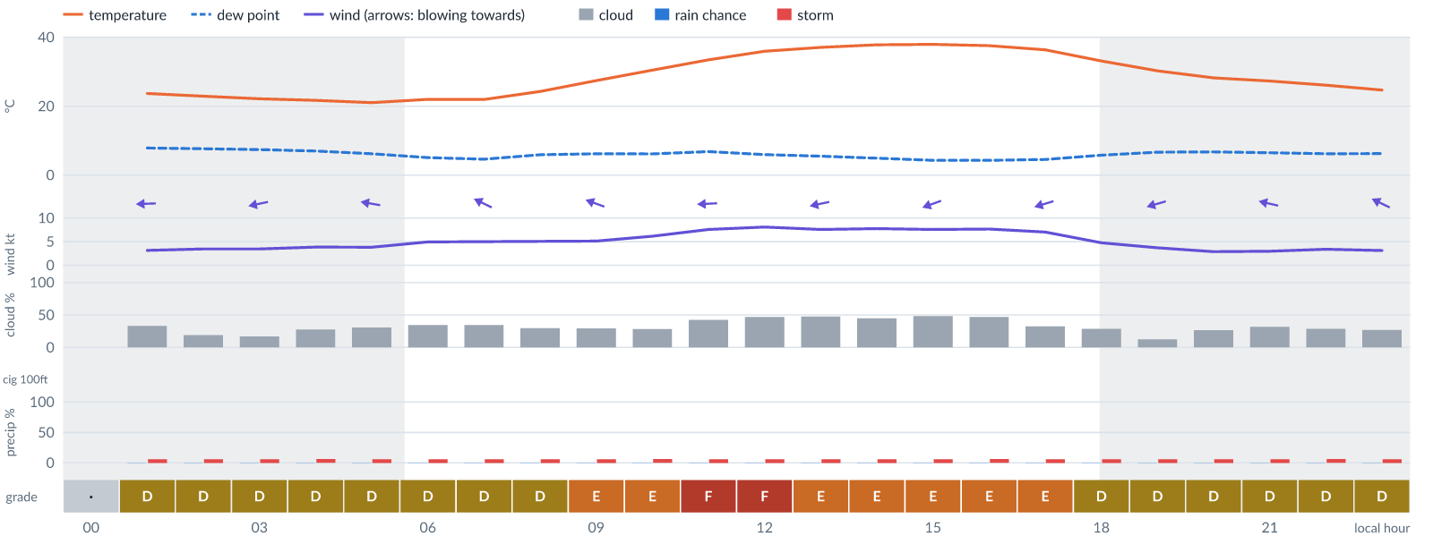
Meteogram — hourly forecast; shaded = before first light / after last light. Gaps mean no data.
Ser | Hrs | Temp | Cloud | Wind | Gust | QNH | Assessment | Driver | Remarks
(a) | (b) | (c) | (d) | (e) | (f) | (g) | (h) | (i) | (j)
1. | 0001 | - | No data | - | - | - | · - No data | cloud, visibility, wind not forecast
2. | 0100 | 24 (spread 23–25)°C | ◔ Partly cloudy (33%) | ← 3 (spread 2–4) kts E | 7 kts | 1012 | D - Marginal | storm 6% | thunderstorm risk
3. | 0200 | 23 (spread 22–24)°C | ◔ Mostly clear (19%) | ← 3 (spread 3–4) kts ENE | 6 kts | 1012 | D - Marginal | storm 6% | thunderstorm risk
4. | 0300 | 22 (spread 21–23)°C | ◔ Mostly clear (17%) | ← 3 (spread 3–5) kts ENE | 6 kts | 1012 | D - Marginal | storm 6% | thunderstorm risk
5. | 0400 | 22 (spread 21–23)°C | ◔ Mostly clear (28%) | ← 4 (spread 2–5) kts E | 8 kts | 1012 | D - Marginal | storm 6% | thunderstorm risk
6. | 0500 | 21 (spread 21–22)°C | ◔ Mostly clear (31%) | ← 4 (spread 2–5) kts E | 7 kts | 1012 | D - Marginal | storm 6% | thunderstorm risk
7. | 0600 | 22 (spread 21–23)°C | ◔ Partly cloudy (34%) | ← 5 (spread 4–7) kts ESE | 7 kts | 1012 | D - Marginal | storm 6% | thunderstorm risk
8. | 0700 | 22 (spread 21–23)°C | ◔ Partly cloudy (34%) | ↖ 5 (spread 4–7) kts ESE | 7 kts | 1013 | D - Marginal | storm 6% | thunderstorm risk
9. | 0800 | 24 (spread 24–25)°C | ◔ Mostly clear (30%) | ↖ 5 (spread 3–7) kts ESE | 8 kts | 1014 | D - Marginal | storm 6% | thunderstorm risk
10. | 0900 | 27 (spread 27–28)°C | ◔ Mostly clear (29%) | ← 5 (spread 3–7) kts ESE | 12 kts | 1015 | E - Poor | gust 12 kt · gust spread +6 kt | gusts, wind shear, thunderstorm risk
11. | 1000 | 30 (spread 29–32)°C | ◔ Mostly clear (28%) | ← 6 (spread 5–7) kts ESE | 13 kts | 1016 | E - Poor | gust 13 kt · gust spread +7 kt | gusts, wind shear, thunderstorm risk
12. | 1100 | 33 (spread 32–34)°C | ◑ Partly cloudy (42%) | ← 8 (spread 6–10) kts E | 15 kts | 1015 | F - Very Poor | gust 15 kt | gusts, wind shear, thunderstorm risk
13. | 1200 | 36 (spread 35–37)°C | ◑ Partly cloudy (47%) | ← 8 (spread 7–11) kts E | 15 kts | 1014 | F - Very Poor | gust 15 kt | gusts, wind shear, cloud cover, thunderstorm risk
14. | 1300 | 37 (spread 36–38)°C | ◑ Partly cloudy (48%) | ← 8 (spread 6–10) kts ENE | 14 kts | 1014 | E - Poor | gust 14 kt | gusts, cloud cover, thunderstorm risk, wind shear
15. | 1400 | 38 (spread 37–39)°C | ◑ Partly cloudy (45%) | ← 8 (spread 6–10) kts ENE | 14 kts | 1013 | E - Poor | gust 14 kt | gusts, cloud cover, thunderstorm risk, wind shear
16. | 1500 | 38 (spread 37–39)°C | ◑ Partly cloudy (48%) | ← 8 (spread 6–9) kts ENE | 14 kts | 1012 | E - Poor | gust 14 kt | gusts, cloud cover, thunderstorm risk, wind shear
17. | 1600 | 38 (spread 37–38)°C | ◑ Partly cloudy (47%) | ← 8 (spread 6–9) kts ENE | 14 kts | 1012 | E - Poor | gust 14 kt | gusts, cloud cover, thunderstorm risk, wind shear
18. | 1700 | 36 (spread 35–37)°C | ◔ Mostly clear (32%) | ← 7 (spread 5–8) kts ENE | 13 kts | 1012 | E - Poor | gust 13 kt | gusts, thunderstorm risk, wind shear
19. | 1800 | 33 (spread 32–34)°C | ◔ Mostly clear (29%) | ← 5 (spread 4–6) kts ENE | 9 kts | 1012 | D - Marginal | storm 6% · gust 9 kt | thunderstorm risk, gusts
20. | 1900 | 30 (spread 29–32)°C | ◔ Mostly clear (13%) | ← 4 (spread 3–5) kts ENE | 6 kts | 1012 | D - Marginal | storm 6% | thunderstorm risk
21. | 2000 | 28 (spread 27–29)°C | ◔ Mostly clear (27%) | ← 3 (spread 2–4) kts E | 5 kts | 1013 | D - Marginal | storm 6% | thunderstorm risk
22. | 2100 | 27 (spread 26–29)°C | ◔ Mostly clear (32%) | ← 3 (spread 2–4) kts ESE | 6 kts | 1013 | D - Marginal | storm 6% | thunderstorm risk
23. | 2200 | 26 (spread 25–27)°C | ◔ Mostly clear (29%) | ↖ 3 (spread 3–4) kts ESE | 5 kts | 1013 | D - Marginal | storm 6% | thunderstorm risk
24. | 2300 | 25 (spread 24–26)°C | ◔ Mostly clear (27%) | ↖ 3 (spread 2–3) kts ESE | 4 kts | 1013 | D - Marginal | storm 6% | thunderstorm risk
Confidence: 73% — data for 23 of 24 hours; 23% of readings interpolated · first light 0605L · last light 1828L · Moon 23 % illuminated, rises 02:16, sets 14:48.

Tomorrow — Thu 5 Nov 26
Conditions are expected to be generally Marginal: partly cloudy, winds up to 11 kts ENE, gusting 19 kts and temperatures 20–38°C. Flyable windows: 0001–0900L (Marginal, 10 h). Hazards: thunderstorm risk 0001–2300L. Overall similar to the previous day.
WEATHER EFFECTS
 | 00–06L | 06–12L | 12–18L | 18–24L
Wind | B | G | G | E
Visibility | A | A | A | A
Cloud / ceiling | B | D | F | F
Precipitation | A | A | A | A
Thunderstorm | D | D | D | D
Fog | · | · | · | ·
A Excellent · B Good · C Fair · D Marginal (flyable) · E Poor · F Very Poor · G Unacceptable · (worst condition in each period)
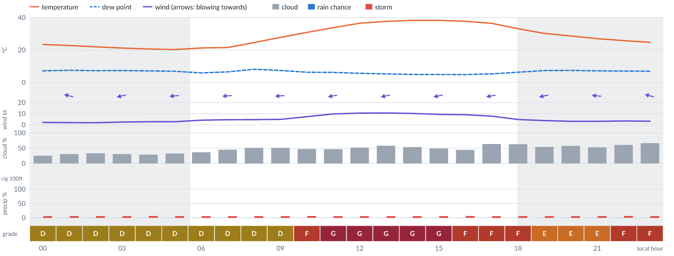
Meteogram — hourly forecast; shaded = before first light / after last light. Gaps mean no data.
Ser | Hrs | Temp | Cloud | Wind | Gust | QNH | Assessment | Driver | Remarks
(a) | (b) | (c) | (d) | (e) | (f) | (g) | (h) | (i) | (j)
1. | 0001 | 23 (spread 22–25)°C | ◔ Mostly clear (26%) | ↖ 2 (spread 1–3) kts ESE | 4 kts | 1013 | D - Marginal | storm 6% | thunderstorm risk
2. | 0100 | 23 (spread 22–24)°C | ◔ Mostly clear (31%) | ← 2 (spread 1–3) kts ESE | 4 kts | 1013 | D - Marginal | storm 6% | thunderstorm risk
3. | 0200 | 22 (spread 21–24)°C | ◔ Partly cloudy (33%) | ← 2 (spread 1–3) kts E | 4 kts | 1013 | D - Marginal | storm 6% | thunderstorm risk
4. | 0300 | 21 (spread 20–23)°C | ◔ Mostly clear (31%) | ← 2 (spread 2–4) kts ENE | 4 kts | 1012 | D - Marginal | storm 6% | thunderstorm risk
5. | 0400 | 21 (spread 19–22)°C | ◔ Mostly clear (29%) | ← 3 kts ENE | 5 kts | 1012 | D - Marginal | storm 6% | thunderstorm risk
6. | 0500 | 20 (spread 19–22)°C | ◔ Mostly clear (32%) | ← 3 (spread 2–3) kts E | 5 kts | 1012 | D - Marginal | storm 6% | thunderstorm risk
7. | 0600 | 21 (spread 20–24)°C | ◔ Partly cloudy (37%) | ← 4 (spread 3–5) kts E | 5 kts | 1013 | D - Marginal | storm 6% | thunderstorm risk
8. | 0700 | 22 (spread 21–23)°C | ◑ Partly cloudy (45%) | ← 5 (spread 4–6) kts E | 6 kts | 1014 | D - Marginal | storm 6% · cloud 45% | cloud cover, thunderstorm risk
9. | 0800 | 25 (spread 24–26)°C | ◑ Partly cloudy (51%) | ← 5 (spread 3–6) kts E | 7 kts | 1014 | D - Marginal | storm 6% · cloud 51% | cloud cover, thunderstorm risk
10. | 0900 | 28 (spread 27–29)°C | ◑ Partly cloudy (51%) | ← 5 (spread 4–6) kts E | 10 kts | 1015 | D - Marginal | storm 6% · cloud 51% | cloud cover, thunderstorm risk, gusts, wind shear
11. | 1000 | 31 (spread 29–32)°C | ◑ Partly cloudy (48%) | ← 7 (spread 6–8) kts E | 15 kts | 1016 | F - Very Poor | gust 15 kt | gusts, wind shear, cloud cover, thunderstorm risk
12. | 1100 | 34 (spread 33–35)°C | ◑ Partly cloudy (47%) | ← 10 (spread 9–11) kts E | 18 kts | 1015 | G - Unacceptable | gust 18 kt | gusts, wind shear, cloud cover, thunderstorm risk, strong wind
13. | 1200 | 36 (spread 35–38)°C | ◑ Partly cloudy (52%) | ← 11 (spread 10–11) kts E | 19 kts | 1015 | G - Unacceptable | gust 19 kt | gusts, cloud cover, wind shear, thunderstorm risk, strong wind
14. | 1300 | 38 (spread 37–39)°C | ◑ Partly cloudy (58%) | ← 11 (spread 10–12) kts ENE | 19 kts | 1014 | G - Unacceptable | gust 19 kt | gusts, cloud cover, wind shear, thunderstorm risk, strong wind
15. | 1400 | 38 (spread 38–39)°C | ◑ Partly cloudy (54%) | ← 10 (spread 10–11) kts ENE | 19 kts | 1013 | G - Unacceptable | gust 19 kt | gusts, wind shear, cloud cover, thunderstorm risk, strong wind
16. | 1500 | 38 (spread 38–39)°C | ◑ Partly cloudy (49%) | ← 9 (spread 9–10) kts ENE | 18 kts | 1012 | G - Unacceptable | gust 18 kt | gusts, wind shear, cloud cover, thunderstorm risk, strong wind
17. | 1600 | 38 (spread 37–38)°C | ◑ Partly cloudy (44%) | ← 9 (spread 9–10) kts E | 17 kts | 1012 | F - Very Poor | gust 17 kt | gusts, wind shear, cloud cover, thunderstorm risk, strong wind
18. | 1700 | 36 (spread 36–37)°C | ◕ Cloudy (64%) | ← 8 (spread 7–8) kts E | 15 kts | 1012 | F - Very Poor | cloud 64% · gust 15 kt | cloud cover, gusts, wind shear, thunderstorm risk
19. | 1800 | 33 (spread 32–35)°C | ◕ Cloudy (63%) | ← 5 (spread 4–6) kts E | 12 kts | 1012 | F - Very Poor | cloud 63% | cloud cover, gusts, wind shear, thunderstorm risk
20. | 1900 | 30 (spread 29–32)°C | ◑ Partly cloudy (54%) | ← 4 (spread 3–5) kts ENE | 6 kts | 1012 | E - Poor | cloud 54% | cloud cover, thunderstorm risk
21. | 2000 | 29 (spread 27–30)°C | ◑ Partly cloudy (58%) | ← 3 (spread 2–4) kts E | 5 kts | 1013 | E - Poor | cloud 58% | cloud cover, thunderstorm risk
22. | 2100 | 27 (spread 26–28)°C | ◑ Partly cloudy (53%) | ← 3 (spread 3–4) kts E | 4 kts | 1013 | E - Poor | cloud 53% | cloud cover, thunderstorm risk
23. | 2200 | 26 (spread 25–27)°C | ◑ Cloudy (61%) | ← 4 (spread 3–4) kts ESE | 5 kts | 1013 | F - Very Poor | cloud 61% | cloud cover, thunderstorm risk
24. | 2300 | 25 (spread 24–26)°C | ◕ Cloudy (66%) | ← 3 (spread 3–4) kts ESE | 5 kts | 1013 | F - Very Poor | cloud 66% | cloud cover, thunderstorm risk
Confidence: 76% — data for 24 of 24 hours; 24% of readings interpolated · first light 0605L · last light 1828L · Moon 15 % illuminated, rises 03:07, sets 15:26.

Extended Outlook
WEATHER EFFECTS BY DAY
 | Fri | Sat | Sun | Mon | Tue | Wed | Thu | Fri | Sat | Sun | Mon | Tue
Wind | G | F | G | G | G | G | G | G | G | G | G | G
Visibility | A | A | A | A | A | A | A | A | A | A | A | A
Cloud / ceiling | G | F | D | B | F | G | G | G | A | E | G | G
Precipitation | A | A | A | A | A | A | A | A | A | A | A | A
Thunderstorm | D | D | D | D | D | D | D | D | D | D | D | D
Fog | · | · | · | · | · | · | · | · | · | · | · | ·
Overall | G | F | G | G | G | G | G | G | G | G | G | G
A Excellent · B Good · C Fair · D Marginal (flyable) · E Poor · F Very Poor · G Unacceptable · (worst condition in each period)

Fri 6 Nov 26
Conditions are expected to be generally Unacceptable: cloudy, winds up to 10 kts E, gusting 19 kts and temperatures 21–38°C. Flyable windows: 1800–2300L (Marginal, 6 h). Hazards: thunderstorm risk 0001–2300L. Overall a deterioration from the previous day.
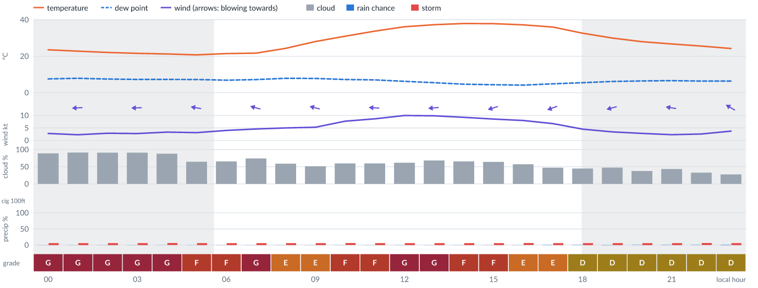
Meteogram — hourly forecast; shaded = before first light / after last light. Gaps mean no data.
Ser | Hrs | Temp | Cloud | Wind | Gust | QNH | Assessment | Driver | Remarks
(a) | (b) | (c) | (d) | (e) | (f) | (g) | (h) | (i) | (j)
1. | 0001 | 24 (spread 22–25)°C | ☁ Cloudy (89%) | ← 3 (spread 2–3) kts E | 5 kts | 1013 | G - Unacceptable | cloud 89% | cloud cover, thunderstorm risk
2. | 0100 | 23 (spread 22–24)°C | ☁ Overcast (91%) | ← 2 (spread 2–3) kts E | 5 kts | 1013 | G - Unacceptable | cloud 91% | cloud cover, thunderstorm risk
3. | 0200 | 22 (spread 21–24)°C | ☁ Overcast (91%) | ← 3 kts E | 5 kts | 1012 | G - Unacceptable | cloud 91% | cloud cover, thunderstorm risk
4. | 0300 | 22 (spread 21–23)°C | ☁ Overcast (91%) | ← 3 kts E | 6 kts | 1012 | G - Unacceptable | cloud 91% | cloud cover, thunderstorm risk
5. | 0400 | 21 (spread 20–22)°C | ☁ Cloudy (88%) | ← 3 (spread 3–4) kts E | 6 kts | 1012 | G - Unacceptable | cloud 88% | cloud cover, thunderstorm risk
6. | 0500 | 21 (spread 20–22)°C | ◕ Cloudy (64%) | ← 3 (spread 3–4) kts E | 6 kts | 1012 | F - Very Poor | cloud 64% | cloud cover, thunderstorm risk
7. | 0600 | 21 (spread 20–23)°C | ◕ Cloudy (66%) | ← 4 (spread 3–6) kts ESE | 6 kts | 1013 | F - Very Poor | cloud 66% | cloud cover, thunderstorm risk
8. | 0700 | 22 (spread 21–23)°C | ◕ Cloudy (74%) | ← 5 (spread 3–6) kts ESE | 6 kts | 1013 | G - Unacceptable | cloud 74% | cloud cover, thunderstorm risk
9. | 0800 | 24 (spread 23–26)°C | ◑ Partly cloudy (59%) | ← 5 (spread 4–6) kts ESE | 8 kts | 1014 | E - Poor | cloud 59% | cloud cover, thunderstorm risk
10. | 0900 | 28 (spread 27–29)°C | ◑ Partly cloudy (52%) | ← 5 (spread 5–6) kts ESE | 13 kts | 1015 | E - Poor | cloud 52% · gust 13 kt | cloud cover, gusts, wind shear, thunderstorm risk
11. | 1000 | 31 (spread 30–32)°C | ◑ Partly cloudy (59%) | ← 8 (spread 7–9) kts ESE | 15 kts | 1016 | F - Very Poor | gust 15 kt | gusts, cloud cover, wind shear, thunderstorm risk
12. | 1100 | 34 (spread 32–35)°C | ◑ Cloudy (60%) | ← 9 (spread 8–9) kts E | 16 kts | 1015 | F - Very Poor | gust 16 kt | gusts, cloud cover, wind shear, thunderstorm risk, strong wind
13. | 1200 | 36 (spread 35–37)°C | ◑ Cloudy (62%) | ← 10 (spread 9–11) kts E | 19 kts | 1014 | G - Unacceptable | gust 19 kt | gusts, cloud cover, wind shear, thunderstorm risk, strong wind
14. | 1300 | 37 (spread 36–38)°C | ◕ Cloudy (68%) | ← 10 (spread 9–11) kts E | 18 kts | 1013 | G - Unacceptable | gust 18 kt | gusts, cloud cover, wind shear, thunderstorm risk, strong wind
15. | 1400 | 38 (spread 37–39)°C | ◕ Cloudy (66%) | ← 9 (spread 8–10) kts ENE | 17 kts | 1013 | F - Very Poor | cloud 66% · gust 17 kt | cloud cover, gusts, wind shear, thunderstorm risk, strong wind
16. | 1500 | 38 (spread 37–38)°C | ◕ Cloudy (64%) | ← 9 (spread 7–9) kts ENE | 16 kts | 1012 | F - Very Poor | cloud 64% · gust 16 kt | cloud cover, gusts, wind shear, thunderstorm risk, strong wind
17. | 1600 | 37 (spread 37–38)°C | ◑ Partly cloudy (57%) | ← 8 (spread 7–9) kts ENE | 14 kts | 1011 | E - Poor | cloud 57% · gust 14 kt | cloud cover, gusts, thunderstorm risk, wind shear
18. | 1700 | 36 (spread 35–36)°C | ◑ Partly cloudy (47%) | ← 7 (spread 6–8) kts ENE | 13 kts | 1011 | E - Poor | gust 13 kt | gusts, cloud cover, thunderstorm risk, wind shear
19. | 1800 | 33 (spread 31–34)°C | ◑ Partly cloudy (45%) | ← 5 (spread 3–6) kts ENE | 10 kts | 1012 | D - Marginal | storm 6% · cloud 45% | cloud cover, thunderstorm risk, gusts, wind shear
20. | 1900 | 30 (spread 29–31)°C | ◑ Partly cloudy (47%) | ← 3 (spread 2–5) kts ENE | 6 kts | 1012 | D - Marginal | storm 6% · cloud 47% | cloud cover, thunderstorm risk
21. | 2000 | 28 (spread 27–29)°C | ◔ Partly cloudy (37%) | ← 3 (spread 2–4) kts ENE | 6 kts | 1012 | D - Marginal | storm 6% | thunderstorm risk
22. | 2100 | 27 (spread 26–27)°C | ◑ Partly cloudy (43%) | ← 2 (spread 1–4) kts E | 4 kts | 1013 | D - Marginal | storm 6% · cloud 43% | cloud cover, thunderstorm risk
23. | 2200 | 26 (spread 25–26)°C | ◔ Partly cloudy (33%) | ↖ 3 (spread 1–4) kts ESE | 4 kts | 1013 | D - Marginal | storm 6% | thunderstorm risk
24. | 2300 | 24 (spread 24–25)°C | ◔ Mostly clear (28%) | ↖ 4 (spread 3–4) kts ESE | 4 kts | 1012 | D - Marginal | storm 6% | ⚠ thunderstorm risk
Confidence: 77% — data for 24 of 24 hours; 23% of readings interpolated · first light 0605L · last light 1828L · Moon 8 % illuminated, rises 03:56, sets 16:04.

Sat 7 Nov 26
Conditions are expected to be generally Marginal: partly cloudy, winds up to 8 kts E, gusting 17 kts and temperatures 20–38°C. Flyable windows: 0001–0900L (Marginal, 10 h) and 1800–2300L (Marginal, 6 h). Hazards: thunderstorm risk 0001–2300L. Overall an improvement on the previous day.
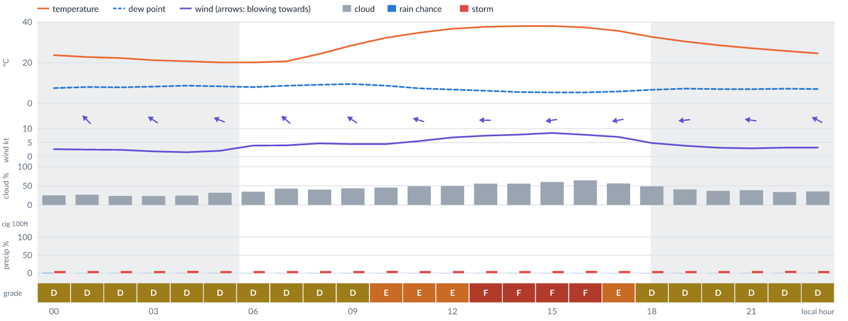
Meteogram — hourly forecast; shaded = before first light / after last light. Gaps mean no data.
Ser | Hrs | Temp | Cloud | Wind | Gust | QNH | Assessment | Driver | Remarks
(a) | (b) | (c) | (d) | (e) | (f) | (g) | (h) | (i) | (j)
1. | 0001 | 24 (spread 23–24)°C | ◔ Mostly clear (25%) | ↖ 3 (spread 2–3) kts SE | 3 kts | 1013 | D - Marginal | storm 6% | ⚠ thunderstorm risk
2. | 0100 | 23 (spread 22–24)°C | ◔ Mostly clear (27%) | ↖ 3 (spread 2–3) kts SE | 4 kts | 1012 | D - Marginal | storm 6% | ⚠ thunderstorm risk
3. | 0200 | 22 (spread 22–23)°C | ◔ Mostly clear (24%) | ↖ 2 (spread 2–3) kts SE | 4 kts | 1012 | D - Marginal | storm 6% | ⚠ thunderstorm risk
4. | 0300 | 21 (spread 20–22)°C | ◔ Mostly clear (23%) | ↖ 2 (spread 1–3) kts ESE | 4 kts | 1011 | D - Marginal | storm 6% | ⚠ thunderstorm risk
5. | 0400 | 21 (spread 20–22)°C | ◔ Mostly clear (25%) | ← 2 (spread 0–3) kts ESE | 3 kts | 1011 | D - Marginal | storm 6% | ⚠ thunderstorm risk
6. | 0500 | 20 (spread 19–21)°C | ◔ Mostly clear (32%) | ← 2 (spread 1–3) kts ESE | 4 kts | 1012 | D - Marginal | storm 6% | ⚠ thunderstorm risk
7. | 0600 | 20 (spread 19–21)°C | ◔ Partly cloudy (35%) | ↖ 4 (spread 3–5) kts SE | 4 kts | 1012 | D - Marginal | storm 6% | ⚠ thunderstorm risk
8. | 0700 | 21 (spread 20–22)°C | ◑ Partly cloudy (43%) | ↖ 4 (spread 2–6) kts SE | 5 kts | 1013 | D - Marginal | storm 6% · cloud 43% | ⚠ cloud cover, thunderstorm risk
9. | 0800 | 24 (spread 23–26)°C | ◑ Partly cloudy (40%) | ↖ 5 (spread 4–6) kts SE | 7 kts | 1014 | D - Marginal | storm 6% | ⚠ thunderstorm risk
10. | 0900 | 29 (spread 27–30)°C | ◑ Partly cloudy (44%) | ↖ 4 (spread 3–6) kts ESE | 9 kts | 1015 | D - Marginal | storm 6% · cloud 44% | ⚠ cloud cover, thunderstorm risk, gusts, wind shear
11. | 1000 | 32 (spread 31–34)°C | ◑ Partly cloudy (46%) | ↖ 4 (spread 4–5) kts ESE | 11 kts | 1015 | E - Poor | gust spread +7 kt | wind shear, cloud cover, thunderstorm risk, gusts
12. | 1100 | 35 (spread 34–36)°C | ◑ Partly cloudy (49%) | ← 6 (spread 5–6) kts ESE | 13 kts | 1015 | E - Poor | gust 13 kt · gust spread +8 kt | gusts, wind shear, cloud cover, thunderstorm risk
13. | 1200 | 37 (spread 36–37)°C | ◑ Partly cloudy (49%) | ← 7 (spread 4–9) kts E | 14 kts | 1014 | E - Poor | gust 14 kt · gust spread +7 kt | gusts, wind shear, cloud cover, thunderstorm risk
14. | 1300 | 38 (spread 37–38)°C | ◑ Partly cloudy (56%) | ← 7 (spread 5–10) kts E | 15 kts | 1013 | F - Very Poor | gust 15 kt | gusts, cloud cover, wind shear, thunderstorm risk
15. | 1400 | 38 (spread 37–39)°C | ◑ Partly cloudy (56%) | ← 8 (spread 6–10) kts E | 16 kts | 1013 | F - Very Poor | gust 16 kt | gusts, cloud cover, wind shear, thunderstorm risk
16. | 1500 | 38°C | ◑ Cloudy (60%) | ← 8 (spread 8–10) kts E | 17 kts | 1012 | F - Very Poor | gust 17 kt · gust spread +9 kt | gusts, wind shear, cloud cover, thunderstorm risk
17. | 1600 | 37 (spread 37–38)°C | ◕ Cloudy (65%) | ← 8 (spread 6–9) kts E | 16 kts | 1011 | F - Very Poor | cloud 65% · gust 16 kt | cloud cover, gusts, wind shear, thunderstorm risk
18. | 1700 | 36 (spread 35–36)°C | ◑ Partly cloudy (56%) | ← 7 (spread 7–8) kts E | 13 kts | 1011 | E - Poor | cloud 56% · gust 13 kt | cloud cover, gusts, thunderstorm risk, wind shear
19. | 1800 | 33 (spread 32–34)°C | ◑ Partly cloudy (49%) | ← 5 (spread 4–6) kts E | 11 kts | 1012 | D - Marginal | storm 6% · cloud 49% | ⚠ cloud cover, thunderstorm risk, gusts, wind shear
20. | 1900 | 30 (spread 30–31)°C | ◑ Partly cloudy (41%) | ← 4 (spread 3–5) kts E | 9 kts | 1012 | D - Marginal | storm 6% · gust 9 kt | ⚠ thunderstorm risk, gusts, wind shear
21. | 2000 | 29 (spread 28–29)°C | ◔ Partly cloudy (37%) | ← 3 (spread 3–4) kts E | 8 kts | 1012 | D - Marginal | storm 6% · gust spread +5 kt | ⚠ thunderstorm risk, wind shear
22. | 2100 | 27 (spread 27–28)°C | ◑ Partly cloudy (39%) | ← 3 (spread 3–4) kts E | 7 kts | 1013 | D - Marginal | storm 6% | ⚠ thunderstorm risk
23. | 2200 | 26 (spread 25–26)°C | ◔ Partly cloudy (34%) | ← 3 (spread 2–4) kts ESE | 6 kts | 1013 | D - Marginal | storm 6% | ⚠ thunderstorm risk
24. | 2300 | 25 (spread 24–25)°C | ◔ Partly cloudy (35%) | ↖ 3 (spread 3–4) kts ESE | 5 kts | 1013 | D - Marginal | storm 6% | ⚠ thunderstorm risk
Confidence: 76% — data for 24 of 24 hours; 13% of readings interpolated · first light 0605L · last light 1828L · Moon 4 % illuminated, rises 04:46, sets 16:44.

Sun 8 Nov 26
Conditions are expected to be generally Marginal: mostly clear, winds up to 9 kts E, gusting 19 kts and temperatures 20–38°C. Flyable windows: 0001–0900L (Marginal, 10 h) and 2100–2300L (Marginal, 3 h). Hazards: thunderstorm risk 0001–2300L. Overall similar to the previous day.
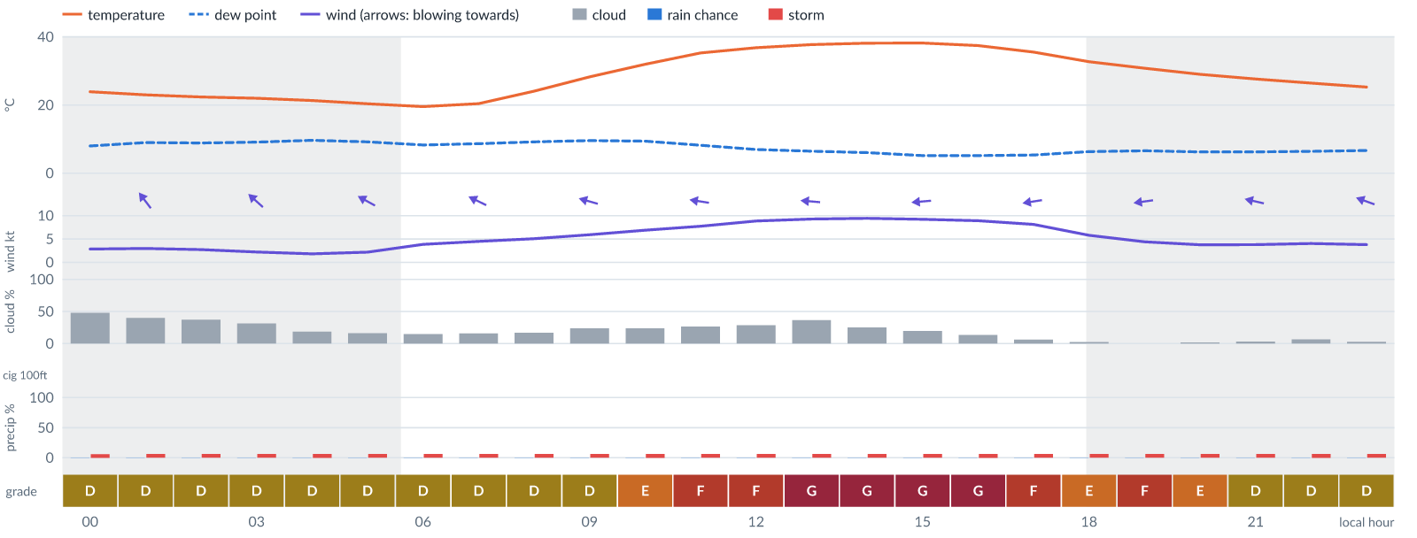
Meteogram — hourly forecast; shaded = before first light / after last light. Gaps mean no data.
Ser | Hrs | Temp | Cloud | Wind | Gust | QNH | Assessment | Driver | Remarks
(a) | (b) | (c) | (d) | (e) | (f) | (g) | (h) | (i) | (j)
1. | 0001 | 24°C | ◑ Partly cloudy (48%) | ↖ 3 (spread 2–3) kts SE | 5 kts | 1013 | D - Marginal | storm 6% · cloud 48% | ⚠ cloud cover, thunderstorm risk
2. | 0100 | 23°C | ◑ Partly cloudy (40%) | ↖ 3 (spread 2–4) kts SE | 6 kts | 1012 | D - Marginal | storm 6% | ⚠ thunderstorm risk
3. | 0200 | 22 (spread 22–23)°C | ◔ Partly cloudy (37%) | ↖ 3 (spread 2–3) kts SE | 6 kts | 1012 | D - Marginal | storm 6% | ⚠ thunderstorm risk
4. | 0300 | 22 (spread 22–23)°C | ◔ Mostly clear (31%) | ↖ 2 (spread 1–3) kts SE | 5 kts | 1012 | D - Marginal | storm 6% | ⚠ thunderstorm risk
5. | 0400 | 21 (spread 21–22)°C | ◔ Mostly clear (19%) | ↖ 2 (spread 0–3) kts ESE | 6 kts | 1012 | D - Marginal | storm 6% | ⚠ thunderstorm risk
6. | 0500 | 20 (spread 20–21)°C | ◔ Mostly clear (16%) | ↖ 2 (spread 1–3) kts ESE | 6 kts | 1012 | D - Marginal | storm 6% | ⚠ thunderstorm risk
7. | 0600 | 20 (spread 19–21)°C | ◔ Mostly clear (15%) | ↖ 4 (spread 3–5) kts ESE | 5 kts | 1013 | D - Marginal | storm 6% | ⚠ thunderstorm risk
8. | 0700 | 20 (spread 20–21)°C | ◔ Mostly clear (16%) | ↖ 4 (spread 4–6) kts ESE | 6 kts | 1014 | D - Marginal | storm 6% | ⚠ thunderstorm risk
9. | 0800 | 24 (spread 23–25)°C | ◔ Mostly clear (17%) | ← 5 (spread 4–6) kts ESE | 7 kts | 1015 | D - Marginal | storm 6% | ⚠ thunderstorm risk
10. | 0900 | 28 (spread 28–29)°C | ◔ Mostly clear (24%) | ← 6 (spread 5–7) kts ESE | 11 kts | 1016 | D - Marginal | storm 6% · gust 11 kt | ⚠ thunderstorm risk, gusts, wind shear
11. | 1000 | 32 (spread 31–33)°C | ◔ Mostly clear (24%) | ← 7 (spread 6–8) kts E | 13 kts | 1017 | E - Poor | gust 13 kt | gusts, thunderstorm risk, wind shear
12. | 1100 | 35 (spread 34–37)°C | ◔ Mostly clear (26%) | ← 8 (spread 6–9) kts E | 15 kts | 1016 | F - Very Poor | gust 15 kt | gusts, wind shear, thunderstorm risk
13. | 1200 | 37°C | ◔ Mostly clear (29%) | ← 9 (spread 7–10) kts E | 17 kts | 1015 | F - Very Poor | gust 17 kt | gusts, wind shear, thunderstorm risk, strong wind
14. | 1300 | 38°C | ◔ Partly cloudy (37%) | ← 9 (spread 7–10) kts E | 19 kts | 1015 | G - Unacceptable | gust 19 kt · gust spread +9 kt | gusts, wind shear, thunderstorm risk, strong wind
15. | 1400 | 38°C | ◔ Mostly clear (25%) | ← 9 (spread 8–10) kts E | 19 kts | 1014 | G - Unacceptable | gust 19 kt · gust spread +9 kt | gusts, wind shear, thunderstorm risk, strong wind
16. | 1500 | 38°C | ◔ Mostly clear (20%) | ← 9 (spread 7–11) kts E | 18 kts | 1013 | G - Unacceptable | gust 18 kt | gusts, wind shear, thunderstorm risk, strong wind
17. | 1600 | 37 (spread 37–38)°C | ◔ Mostly clear (13%) | ← 9 (spread 7–10) kts E | 18 kts | 1013 | G - Unacceptable | gust 18 kt | gusts, wind shear, thunderstorm risk, strong wind
18. | 1700 | 36 (spread 35–36)°C | ☀ Clear (6%) | ← 8 (spread 7–10) kts E | 15 kts | 1013 | F - Very Poor | gust 15 kt | gusts, wind shear, thunderstorm risk
19. | 1800 | 33 (spread 32–33)°C | ☀ Clear (3%) | ← 6 (spread 5–6) kts E | 12 kts | 1013 | E - Poor | gust 12 kt | gusts, thunderstorm risk, wind shear
20. | 1900 | 31°C | ☀ Clear (0%) | ← 4 (spread 3–5) kts E | 13 kts | 1014 | F - Very Poor | gust spread +9 kt | wind shear, gusts, thunderstorm risk
21. | 2000 | 29 (spread 28–30)°C | ☀ Clear (2%) | ← 4 (spread 3–5) kts E | 11 kts | 1014 | E - Poor | gust spread +7 kt | wind shear, thunderstorm risk, gusts
22. | 2100 | 28 (spread 27–28)°C | ☀ Clear (3%) | ← 4 (spread 3–5) kts ESE | 9 kts | 1014 | D - Marginal | storm 6% · gust 9 kt | ⚠ thunderstorm risk, gusts, wind shear
23. | 2200 | 26 (spread 25–27)°C | ☀ Clear (7%) | ← 4 (spread 4–5) kts ESE | 8 kts | 1015 | D - Marginal | storm 6% | ⚠ thunderstorm risk
24. | 2300 | 25 (spread 24–26)°C | ☀ Clear (3%) | ← 4 (spread 3–5) kts ESE | 6 kts | 1015 | D - Marginal | storm 6% | ⚠ thunderstorm risk
Confidence: 75% — data for 24 of 24 hours; 15% of readings interpolated · first light 0606L · last light 1827L · Moon 1 % illuminated, rises 05:36, sets 17:25.

Mon 9 Nov 26
Conditions are expected to be generally Marginal: clear, winds up to 12 kts ENE, gusting 23 kts and temperatures 21–38°C. Flyable windows: 0001–0800L (Marginal, 9 h). Hazards: thunderstorm risk 0001–2300L. Overall similar to the previous day.
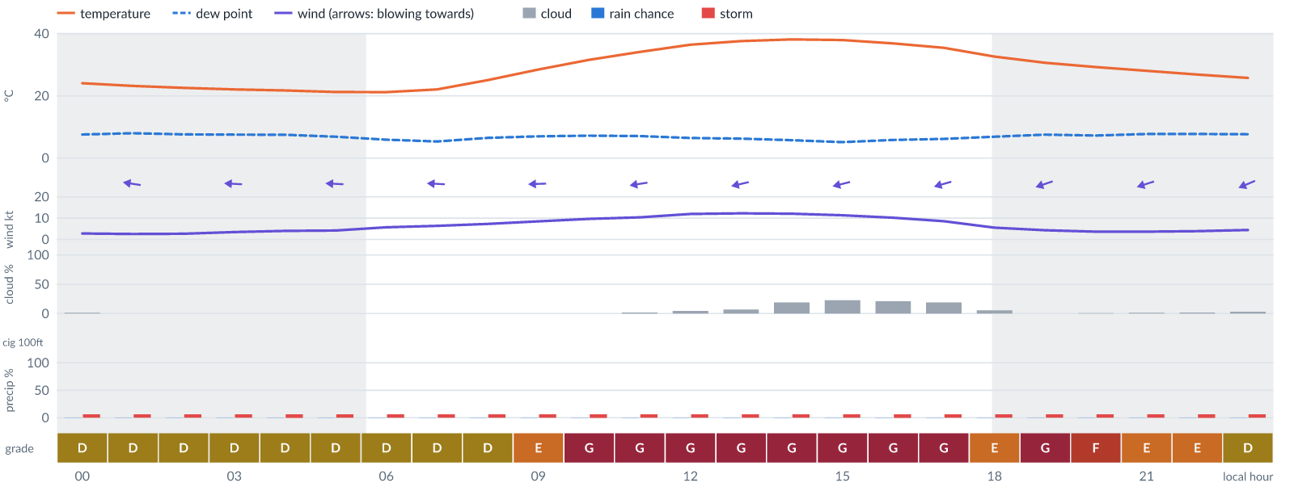
Meteogram — hourly forecast; shaded = before first light / after last light. Gaps mean no data.
Ser | Hrs | Temp | Cloud | Wind | Gust | QNH | Assessment | Driver | Remarks
(a) | (b) | (c) | (d) | (e) | (f) | (g) | (h) | (i) | (j)
1. | 0001 | 24 (spread 24–25)°C | ☀ Clear (1%) | ← 3 (spread 2–4) kts ESE | 5 kts | 1014 | D - Marginal | storm 6% | ⚠ thunderstorm risk
2. | 0100 | 23 (spread 23–24)°C | ☀ Clear (0%) | ← 3 (spread 2–3) kts E | 5 kts | 1014 | D - Marginal | storm 6% | ⚠ thunderstorm risk
3. | 0200 | 23 (spread 22–23)°C | ☀ Clear (0%) | ← 3 (spread 2–3) kts E | 5 kts | 1014 | D - Marginal | storm 6% | ⚠ thunderstorm risk
4. | 0300 | 22 (spread 22–23)°C | ☀ Clear (0%) | ← 3 (spread 3–5) kts E | 6 kts | 1014 | D - Marginal | storm 6% | ⚠ thunderstorm risk
5. | 0400 | 22 (spread 21–22)°C | ☀ Clear (0%) | ← 4 (spread 3–5) kts E | 6 kts | 1014 | D - Marginal | storm 6% | ⚠ thunderstorm risk
6. | 0500 | 21 (spread 21–22)°C | ☀ Clear (0%) | ← 4 (spread 3–6) kts E | 8 kts | 1015 | D - Marginal | storm 6% | ⚠ thunderstorm risk
7. | 0600 | 21 (spread 21–22)°C | ☀ Clear (0%) | ← 6 (spread 4–8) kts E | 8 kts | 1015 | D - Marginal | storm 6% | ⚠ thunderstorm risk
8. | 0700 | 22 (spread 21–23)°C | ☀ Clear (0%) | ← 6 (spread 4–8) kts E | 8 kts | 1016 | D - Marginal | storm 6% | ⚠ thunderstorm risk
9. | 0800 | 25 (spread 24–26)°C | ☀ Clear (0%) | ← 7 (spread 6–9) kts E | 11 kts | 1017 | D - Marginal | storm 6% · gust 11 kt | ⚠ thunderstorm risk, gusts
10. | 0900 | 28 (spread 28–29)°C | ☀ Clear (0%) | ← 9 (spread 8–10) kts E | 14 kts | 1018 | E - Poor | gust 14 kt | gusts, thunderstorm risk, strong wind, wind shear
11. | 1000 | 32 (spread 31–32)°C | ☀ Clear (0%) | ← 10 (spread 8–10) kts E | 18 kts | 1018 | G - Unacceptable | gust 18 kt | gusts, wind shear, thunderstorm risk, strong wind
12. | 1100 | 34 (spread 34–35)°C | ☀ Clear (2%) | ← 10 (spread 9–11) kts E | 20 kts | 1018 | G - Unacceptable | gust 20 kt · gust spread +9 kt | gusts, wind shear, thunderstorm risk, strong wind
13. | 1200 | 36 (spread 36–37)°C | ☀ Clear (5%) | ← 12 (spread 11–13) kts E | 22 kts | 1017 | G - Unacceptable | gust 22 kt · gust spread +10 kt | gusts, wind shear, strong wind, thunderstorm risk
14. | 1300 | 38 (spread 37–38)°C | ☀ Clear (7%) | ← 12 (spread 11–13) kts ENE | 23 kts | 1016 | G - Unacceptable | gust 23 kt · gust spread +10 kt | gusts, wind shear, strong wind, thunderstorm risk
15. | 1400 | 38 (spread 38–39)°C | ◔ Mostly clear (19%) | ← 12 (spread 11–13) kts ENE | 22 kts | 1016 | G - Unacceptable | gust 22 kt · gust spread +10 kt | gusts, wind shear, strong wind, thunderstorm risk
16. | 1500 | 38 (spread 37–39)°C | ◔ Mostly clear (23%) | ← 11 (spread 11–12) kts ENE | 22 kts | 1015 | G - Unacceptable | gust 22 kt · gust spread +10 kt | gusts, wind shear, thunderstorm risk, strong wind
17. | 1600 | 37 (spread 36–38)°C | ◔ Mostly clear (21%) | ← 10 (spread 10–11) kts ENE | 21 kts | 1015 | G - Unacceptable | gust 21 kt · gust spread +11 kt | gusts, wind shear, thunderstorm risk, strong wind
18. | 1700 | 35 (spread 35–36)°C | ◔ Mostly clear (19%) | ← 9 (spread 8–9) kts ENE | 18 kts | 1014 | G - Unacceptable | gust 18 kt | gusts, wind shear, thunderstorm risk, strong wind
19. | 1800 | 33 (spread 31–34)°C | ☀ Clear (6%) | ← 6 (spread 4–7) kts ENE | 14 kts | 1015 | E - Poor | gust 14 kt · gust spread +9 kt | gusts, wind shear, thunderstorm risk
20. | 1900 | 31 (spread 30–32)°C | ☀ Clear (0%) | ← 4 (spread 3–6) kts ENE | 15 kts | 1015 | G - Unacceptable | gust spread +11 kt | wind shear, gusts, thunderstorm risk
21. | 2000 | 29 (spread 29–30)°C | ☀ Clear (1%) | ← 4 (spread 3–5) kts ENE | 13 kts | 1016 | F - Very Poor | gust spread +10 kt | wind shear, gusts, thunderstorm risk
22. | 2100 | 28 (spread 27–29)°C | ☀ Clear (1%) | ← 4 (spread 3–5) kts ENE | 12 kts | 1016 | E - Poor | gust 12 kt · gust spread +8 kt | gusts, wind shear, thunderstorm risk
23. | 2200 | 27 (spread 26–28)°C | ☀ Clear (2%) | ← 4 kts ENE | 12 kts | 1017 | E - Poor | gust 12 kt · gust spread +8 kt | gusts, wind shear, thunderstorm risk
24. | 2300 | 26 (spread 25–27)°C | ☀ Clear (3%) | ↙ 4 (spread 4–5) kts ENE | 9 kts | 1017 | D - Marginal | storm 6% · gust 9 kt | ⚠ thunderstorm risk, gusts, wind shear
Confidence: 75% — data for 24 of 24 hours; 16% of readings interpolated · first light 0606L · last light 1827L · Moon 0 % illuminated, rises 06:27, sets 18:09.

Tue 10 Nov 26
Conditions are expected to be generally Marginal: partly cloudy, winds up to 13 kts ENE, gusting 24 kts and temperatures 22–38°C. Flyable windows: 0001–0800L (Marginal, 9 h). Hazards: thunderstorm risk 0001–2300L. Overall similar to the previous day.
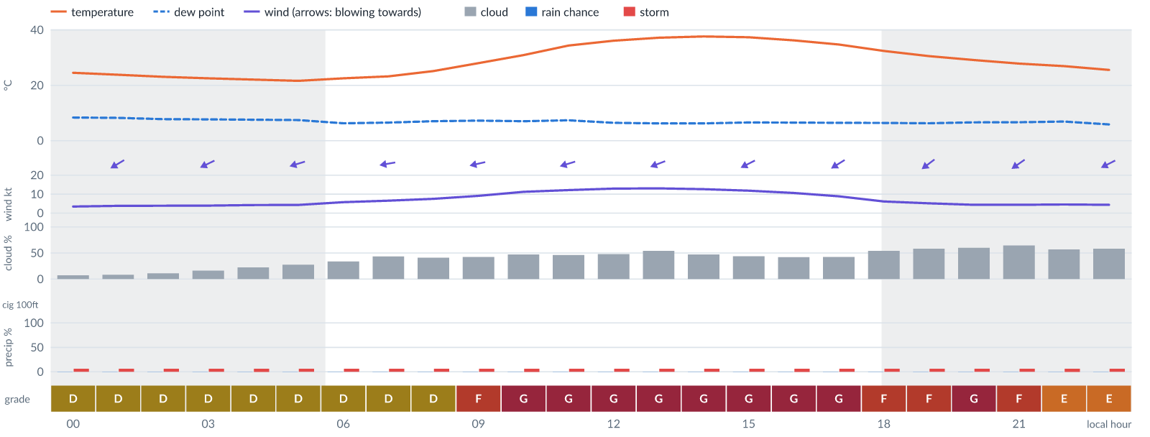
Meteogram — hourly forecast; shaded = before first light / after last light. Gaps mean no data.
Ser | Hrs | Temp | Cloud | Wind | Gust | QNH | Assessment | Driver | Remarks
(a) | (b) | (c) | (d) | (e) | (f) | (g) | (h) | (i) | (j)
1. | 0001 | 25 (spread 24–26)°C | ☀ Clear (7%) | ↙ 3 (spread 3–5) kts ENE | 7 kts | 1017 | D - Marginal | storm 6% | ⚠ thunderstorm risk
2. | 0100 | 24 (spread 23–25)°C | ☀ Clear (8%) | ↙ 4 (spread 3–5) kts ENE | 7 kts | 1017 | D - Marginal | storm 6% | ⚠ thunderstorm risk
3. | 0200 | 23 (spread 22–24)°C | ☀ Clear (11%) | ↙ 4 (spread 3–5) kts ENE | 6 kts | 1017 | D - Marginal | storm 6% | ⚠ thunderstorm risk
4. | 0300 | 23 (spread 22–24)°C | ◔ Mostly clear (16%) | ↙ 4 (spread 3–5) kts ENE | 7 kts | 1017 | D - Marginal | storm 6% | ⚠ thunderstorm risk
5. | 0400 | 22 (spread 21–23)°C | ◔ Mostly clear (22%) | ← 4 (spread 3–5) kts ENE | 8 kts | 1017 | D - Marginal | storm 6% | ⚠ thunderstorm risk
6. | 0500 | 22 (spread 21–23)°C | ◔ Mostly clear (28%) | ← 4 (spread 3–6) kts ENE | 8 kts | 1017 | D - Marginal | storm 6% | ⚠ thunderstorm risk
7. | 0600 | 23 (spread 22–23)°C | ◔ Partly cloudy (34%) | ← 6 (spread 4–8) kts ENE | 8 kts | 1018 | D - Marginal | storm 6% | ⚠ thunderstorm risk
8. | 0700 | 23°C | ◑ Partly cloudy (43%) | ← 7 (spread 5–9) kts E | 9 kts | 1018 | D - Marginal | storm 6% · cloud 43% | ⚠ cloud cover, thunderstorm risk, gusts
9. | 0800 | 25 (spread 24–26)°C | ◑ Partly cloudy (41%) | ← 8 (spread 6–9) kts ENE | 11 kts | 1019 | D - Marginal | storm 6% · gust 11 kt | ⚠ thunderstorm risk, gusts
10. | 0900 | 28 (spread 27–28)°C | ◑ Partly cloudy (43%) | ← 9 (spread 8–10) kts ENE | 16 kts | 1019 | F - Very Poor | gust 16 kt | gusts, wind shear, cloud cover, thunderstorm risk, strong wind
11. | 1000 | 31 (spread 30–32)°C | ◑ Partly cloudy (47%) | ← 11 (spread 11–12) kts ENE | 19 kts | 1019 | G - Unacceptable | gust 19 kt | gusts, wind shear, cloud cover, thunderstorm risk, strong wind
12. | 1100 | 34 (spread 33–36)°C | ◑ Partly cloudy (46%) | ← 12 (spread 11–13) kts ENE | 21 kts | 1019 | G - Unacceptable | gust 21 kt | gusts, wind shear, strong wind, cloud cover, thunderstorm risk
13. | 1200 | 36 (spread 36–37)°C | ◑ Partly cloudy (48%) | ← 13 (spread 12–14) kts ENE | 22 kts | 1018 | G - Unacceptable | gust 22 kt | gusts, wind shear, strong wind, cloud cover, thunderstorm risk
14. | 1300 | 37 (spread 37–38)°C | ◑ Partly cloudy (54%) | ← 13 (spread 12–14) kts ENE | 24 kts | 1017 | G - Unacceptable | gust 24 kt · gust spread +11 kt | gusts, wind shear, cloud cover, strong wind, thunderstorm risk
15. | 1400 | 38 (spread 37–38)°C | ◑ Partly cloudy (47%) | ↙ 13 (spread 12–13) kts ENE | 23 kts | 1017 | G - Unacceptable | gust 23 kt · gust spread +10 kt | gusts, wind shear, strong wind, cloud cover, thunderstorm risk
16. | 1500 | 37 (spread 36–38)°C | ◑ Partly cloudy (44%) | ↙ 12 (spread 11–12) kts ENE | 22 kts | 1016 | G - Unacceptable | gust 22 kt · gust spread +11 kt | gusts, wind shear, strong wind, cloud cover, thunderstorm risk
17. | 1600 | 36 (spread 35–37)°C | ◑ Partly cloudy (42%) | ↙ 11 (spread 10–11) kts ENE | 22 kts | 1016 | G - Unacceptable | gust 22 kt · gust spread +11 kt | gusts, wind shear, thunderstorm risk, strong wind
18. | 1700 | 35 (spread 34–35)°C | ◑ Partly cloudy (42%) | ↙ 9 (spread 8–10) kts ENE | 19 kts | 1015 | G - Unacceptable | gust 19 kt · gust spread +10 kt | gusts, wind shear, thunderstorm risk, strong wind
19. | 1800 | 32 (spread 31–33)°C | ◑ Partly cloudy (54%) | ↙ 6 (spread 5–7) kts NE | 15 kts | 1015 | F - Very Poor | gust 15 kt · gust spread +9 kt | gusts, wind shear, cloud cover, thunderstorm risk
20. | 1900 | 31 (spread 30–31)°C | ◑ Partly cloudy (58%) | ↙ 5 (spread 4–6) kts NE | 14 kts | 1016 | F - Very Poor | gust spread +9 kt | wind shear, cloud cover, gusts, thunderstorm risk
21. | 2000 | 29 (spread 29–30)°C | ◑ Cloudy (60%) | ↙ 4 (spread 3–6) kts NE | 14 kts | 1016 | G - Unacceptable | gust spread +9 kt | wind shear, cloud cover, gusts, thunderstorm risk
22. | 2100 | 28°C | ◕ Cloudy (64%) | ↙ 4 (spread 3–6) kts NE | 12 kts | 1016 | F - Very Poor | cloud 64% | cloud cover, gusts, wind shear, thunderstorm risk
23. | 2200 | 27°C | ◑ Partly cloudy (57%) | ↙ 5 (spread 4–6) kts ENE | 10 kts | 1017 | E - Poor | cloud 57% | cloud cover, thunderstorm risk, gusts, wind shear
24. | 2300 | 26°C | ◑ Partly cloudy (58%) | ↙ 4 (spread 4–5) kts ENE | 8 kts | 1017 | E - Poor | cloud 58% | cloud cover, thunderstorm risk
Confidence: 75% — data for 24 of 24 hours; 14% of readings interpolated · first light 0606L · last light 1827L · Moon 2 % illuminated, rises 07:20, sets 18:56.

Wed 11 Nov 26
Conditions are expected to be generally Unacceptable: partly cloudy, winds up to 9 kts ENE, gusting 19 kts and temperatures 21–36°C. Flyable windows: 0400–0700L (Marginal, 4 h). Hazards: thunderstorm risk 0001–2300L. Overall a deterioration from the previous day.
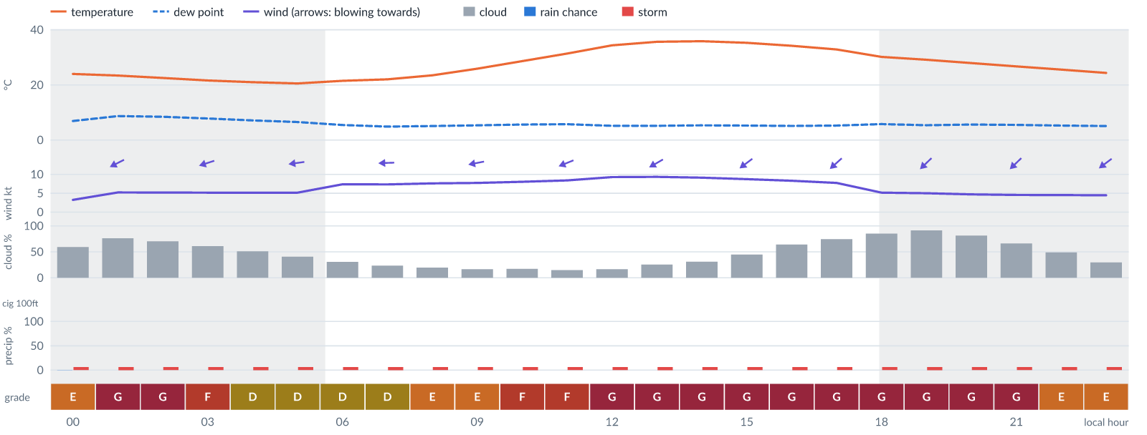
Meteogram — hourly forecast; shaded = before first light / after last light. Gaps mean no data.
Ser | Hrs | Temp | Cloud | Wind | Gust | QNH | Assessment | Driver | Remarks
(a) | (b) | (c) | (d) | (e) | (f) | (g) | (h) | (i) | (j)
1. | 0001 | 24 (spread 24–25)°C | ◑ Partly cloudy (59%) | ↙ 3 (spread 3–4) kts ENE | 8 kts | 1017 | E - Poor | cloud 59% | cloud cover, thunderstorm risk, wind shear
2. | 0100 | 23°C | ◕ Cloudy (76%) | ↙ 5 kts ENE | 10 kts | 1017 | G - Unacceptable | cloud 76% | cloud cover, thunderstorm risk, gusts, wind shear
3. | 0200 | 23°C | ◕ Cloudy (70%) | ↙ 5 kts ENE | 10 kts | 1017 | G - Unacceptable | cloud 70% | cloud cover, thunderstorm risk, gusts, wind shear
4. | 0300 | 22°C | ◑ Cloudy (61%) | ← 5 kts ENE | 9 kts | 1017 | F - Very Poor | cloud 61% | cloud cover, thunderstorm risk, gusts
5. | 0400 | 21°C | ◑ Partly cloudy (51%) | ← 5 kts ENE | 9 kts | 1017 | D - Marginal | storm 6% · cloud 51% | ⚠ cloud cover, thunderstorm risk, gusts
6. | 0500 | 21°C | ◑ Partly cloudy (41%) | ← 5 kts E | 10 kts | 1017 | D - Marginal | storm 6% · gust 10 kt | ⚠ thunderstorm risk, gusts, wind shear
7. | 0600 | 21°C | ◔ Mostly clear (30%) | ← 7 kts E | 10 kts | 1017 | D - Marginal | storm 6% · gust 10 kt | ⚠ thunderstorm risk, gusts
8. | 0700 | 22°C | ◔ Mostly clear (23%) | ← 7 kts E | 10 kts | 1017 | D - Marginal | storm 6% · gust 10 kt | ⚠ thunderstorm risk, gusts
9. | 0800 | 23°C | ◔ Mostly clear (20%) | ← 8 kts E | 12 kts | 1017 | E - Poor | gust 12 kt | gusts, thunderstorm risk
10. | 0900 | 26°C | ◔ Mostly clear (17%) | ← 8 kts ENE | 13 kts | 1017 | E - Poor | gust 13 kt | gusts, thunderstorm risk, wind shear
11. | 1000 | 29°C | ◔ Mostly clear (17%) | ← 8 kts ENE | 15 kts | 1017 | F - Very Poor | gust 15 kt | gusts, wind shear, thunderstorm risk
12. | 1100 | 31°C | ◔ Mostly clear (15%) | ← 8 kts ENE | 16 kts | 1017 | F - Very Poor | gust 16 kt | gusts, wind shear, thunderstorm risk
13. | 1200 | 34°C | ◔ Mostly clear (16%) | ↙ 9 kts ENE | 18 kts | 1017 | G - Unacceptable | gust 18 kt | gusts, wind shear, thunderstorm risk, strong wind
14. | 1300 | 36°C | ◔ Mostly clear (26%) | ↙ 9 kts ENE | 19 kts | 1017 | G - Unacceptable | gust 19 kt · gust spread +9 kt | gusts, wind shear, thunderstorm risk, strong wind
15. | 1400 | 36°C | ◔ Mostly clear (31%) | ↙ 9 kts ENE | 19 kts | 1017 | G - Unacceptable | gust 19 kt · gust spread +10 kt | gusts, wind shear, thunderstorm risk, strong wind
16. | 1500 | 35°C | ◑ Partly cloudy (45%) | ↙ 9 kts NE | 19 kts | 1016 | G - Unacceptable | gust 19 kt · gust spread +10 kt | gusts, wind shear, cloud cover, thunderstorm risk, strong wind
17. | 1600 | 34°C | ◕ Cloudy (64%) | ↙ 8 kts NE | 19 kts | 1016 | G - Unacceptable | gust 19 kt · gust spread +10 kt | gusts, wind shear, cloud cover, thunderstorm risk
18. | 1700 | 33°C | ◕ Cloudy (74%) | ↙ 8 kts NE | 18 kts | 1016 | G - Unacceptable | cloud 74% · gust 18 kt | cloud cover, gusts, wind shear, thunderstorm risk
19. | 1800 | 30°C | ◕ Cloudy (85%) | ↙ 5 kts NE | 18 kts | 1016 | G - Unacceptable | cloud 85% · gust 18 kt | cloud cover, gusts, wind shear, thunderstorm risk
20. | 1900 | 29°C | ☁ Overcast (91%) | ↙ 5 kts NE | 17 kts | 1016 | G - Unacceptable | cloud 91% · gust spread +12 kt | cloud cover, wind shear, gusts, thunderstorm risk
21. | 2000 | 28°C | ◕ Cloudy (81%) | ↙ 5 kts NE | 16 kts | 1016 | G - Unacceptable | cloud 81% · gust spread +11 kt | cloud cover, wind shear, gusts, thunderstorm risk
22. | 2100 | 27°C | ◕ Cloudy (66%) | ↙ 5 kts NE | 15 kts | 1016 | G - Unacceptable | gust spread +10 kt | wind shear, cloud cover, gusts, thunderstorm risk
23. | 2200 | 26°C | ◑ Partly cloudy (49%) | ↙ 5 kts NE | 13 kts | 1017 | E - Poor | gust 13 kt · gust spread +8 kt | gusts, wind shear, cloud cover, thunderstorm risk
24. | 2300 | 24°C | ◔ Mostly clear (30%) | ↙ 4 kts NE | 12 kts | 1017 | E - Poor | gust 12 kt · gust spread +7 kt | gusts, wind shear, thunderstorm risk
Confidence: 67% — data for 24 of 24 hours; 20% of readings interpolated · first light 0607L · last light 1827L · Moon 5 % illuminated, rises 08:13, sets 19:46.

Thu 12 Nov 26
Conditions are expected to be generally Unacceptable: partly cloudy, winds up to 9 kts E, gusting 20 kts and temperatures 19–35°C. Flyable windows: 0100–0700L (Marginal, 7 h). Hazards: thunderstorm risk 0001–2300L. Overall similar to the previous day.
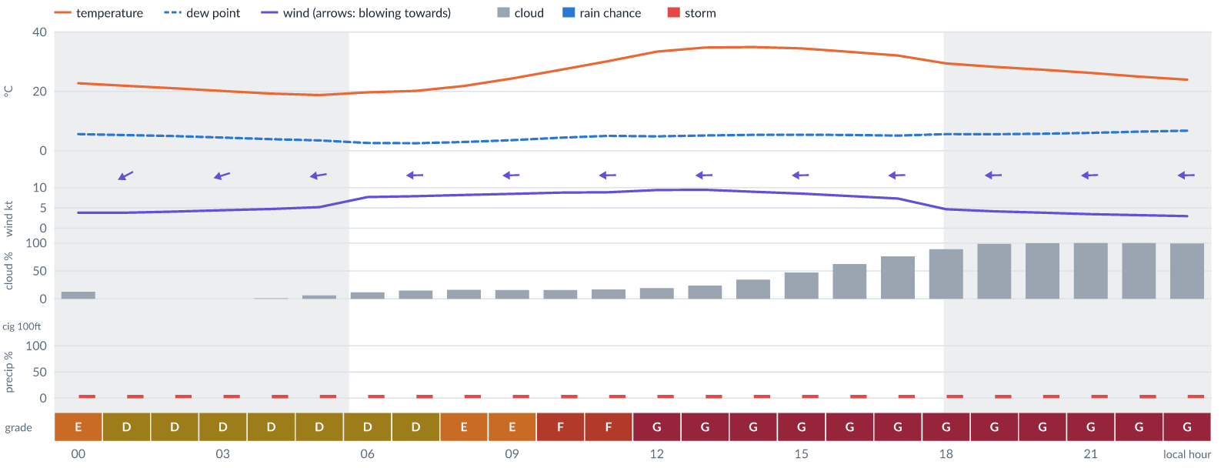
Meteogram — hourly forecast; shaded = before first light / after last light. Gaps mean no data.
Ser | Hrs | Temp | Cloud | Wind | Gust | QNH | Assessment | Driver | Remarks
(a) | (b) | (c) | (d) | (e) | (f) | (g) | (h) | (i) | (j)
1. | 0001 | 23°C | ◔ Mostly clear (13%) | ↙ 4 kts ENE | 11 kts | 1017 | E - Poor | gust spread +7 kt | wind shear, thunderstorm risk, gusts
2. | 0100 | 22°C | ☀ Clear (0%) | ↙ 4 kts ENE | 10 kts | 1017 | D - Marginal | storm 6% · gust 10 kt | ⚠ thunderstorm risk, gusts, wind shear
3. | 0200 | 21°C | ☀ Clear (0%) | ↙ 4 kts ENE | 10 kts | 1017 | D - Marginal | storm 6% · gust 10 kt | ⚠ thunderstorm risk, gusts, wind shear
4. | 0300 | 20°C | ☀ Clear (0%) | ← 4 kts ENE | 10 kts | 1017 | D - Marginal | storm 6% · gust 10 kt | ⚠ thunderstorm risk, gusts, wind shear
5. | 0400 | 19°C | ☀ Clear (1%) | ← 5 kts E | 9 kts | 1017 | D - Marginal | storm 6% · gust 9 kt | ⚠ thunderstorm risk, gusts
6. | 0500 | 19°C | ☀ Clear (6%) | ← 5 kts E | 10 kts | 1017 | D - Marginal | storm 6% · gust 10 kt | ⚠ thunderstorm risk, gusts, wind shear
7. | 0600 | 20°C | ☀ Clear (12%) | ← 8 kts E | 10 kts | 1017 | D - Marginal | storm 6% · gust 10 kt | ⚠ thunderstorm risk, gusts
8. | 0700 | 20°C | ◔ Mostly clear (15%) | ← 8 kts E | 11 kts | 1017 | D - Marginal | storm 6% · gust 11 kt | ⚠ thunderstorm risk, gusts
9. | 0800 | 22°C | ◔ Mostly clear (16%) | ← 8 kts E | 12 kts | 1017 | E - Poor | gust 12 kt | gusts, thunderstorm risk
10. | 0900 | 24°C | ◔ Mostly clear (16%) | ← 8 kts E | 14 kts | 1017 | E - Poor | gust 14 kt | gusts, thunderstorm risk, wind shear
11. | 1000 | 27°C | ◔ Mostly clear (16%) | ← 9 kts E | 16 kts | 1018 | F - Very Poor | gust 16 kt | gusts, wind shear, thunderstorm risk, strong wind
12. | 1100 | 30°C | ◔ Mostly clear (17%) | ← 9 kts E | 17 kts | 1018 | F - Very Poor | gust 17 kt | gusts, wind shear, thunderstorm risk, strong wind
13. | 1200 | 33°C | ◔ Mostly clear (19%) | ← 9 kts E | 19 kts | 1017 | G - Unacceptable | gust 19 kt · gust spread +9 kt | gusts, wind shear, thunderstorm risk, strong wind
14. | 1300 | 35°C | ◔ Mostly clear (24%) | ← 9 kts E | 20 kts | 1017 | G - Unacceptable | gust 20 kt · gust spread +10 kt | gusts, wind shear, thunderstorm risk, strong wind
15. | 1400 | 35°C | ◔ Partly cloudy (34%) | ← 9 kts E | 20 kts | 1017 | G - Unacceptable | gust 20 kt · gust spread +11 kt | gusts, wind shear, thunderstorm risk, strong wind
16. | 1500 | 34°C | ◑ Partly cloudy (47%) | ← 9 kts E | 20 kts | 1017 | G - Unacceptable | gust 20 kt · gust spread +11 kt | gusts, wind shear, cloud cover, thunderstorm risk, strong wind
17. | 1600 | 33°C | ◑ Cloudy (62%) | ← 8 kts E | 19 kts | 1016 | G - Unacceptable | gust 19 kt · gust spread +11 kt | gusts, wind shear, cloud cover, thunderstorm risk
18. | 1700 | 32°C | ◕ Cloudy (76%) | ← 7 kts E | 19 kts | 1016 | G - Unacceptable | cloud 76% · gust 19 kt | cloud cover, gusts, wind shear, thunderstorm risk
19. | 1800 | 29°C | ☁ Cloudy (89%) | ← 5 kts E | 18 kts | 1016 | G - Unacceptable | cloud 89% · gust 18 kt | cloud cover, gusts, wind shear, thunderstorm risk
20. | 1900 | 28°C | ☁ Overcast (99%) | ← 4 kts E | 17 kts | 1016 | G - Unacceptable | cloud 99% · gust spread +13 kt | cloud cover, wind shear, gusts, thunderstorm risk
21. | 2000 | 27°C | ☁ Overcast (100%) | ← 4 kts E | 16 kts | 1016 | G - Unacceptable | cloud 100% · gust spread +12 kt | cloud cover, wind shear, gusts, thunderstorm risk
22. | 2100 | 26°C | ☁ Overcast (100%) | ← 3 kts E | 14 kts | 1016 | G - Unacceptable | cloud 100% · gust spread +11 kt | cloud cover, wind shear, gusts, thunderstorm risk
23. | 2200 | 25°C | ☁ Overcast (100%) | ← 3 kts E | 13 kts | 1016 | G - Unacceptable | cloud 100% · gust spread +9 kt | cloud cover, wind shear, gusts, thunderstorm risk
24. | 2300 | 24°C | ☁ Overcast (99%) | ← 3 kts E | 12 kts | 1016 | G - Unacceptable | cloud 99% | cloud cover, wind shear, gusts, thunderstorm risk
Confidence: 67% — data for 24 of 24 hours; 21% of readings interpolated · first light 0607L · last light 1827L · Moon 9 % illuminated, rises 09:06, sets 20:37.

Fri 13 Nov 26
Conditions are expected to be generally Unacceptable: partly cloudy, winds up to 11 kts E, gusting 22 kts and temperatures 19–34°C. No flyable windows (Marginal or better, ≥2 consecutive hrs) are forecast. Hazards: thunderstorm risk 0001–2300L. Overall similar to the previous day.
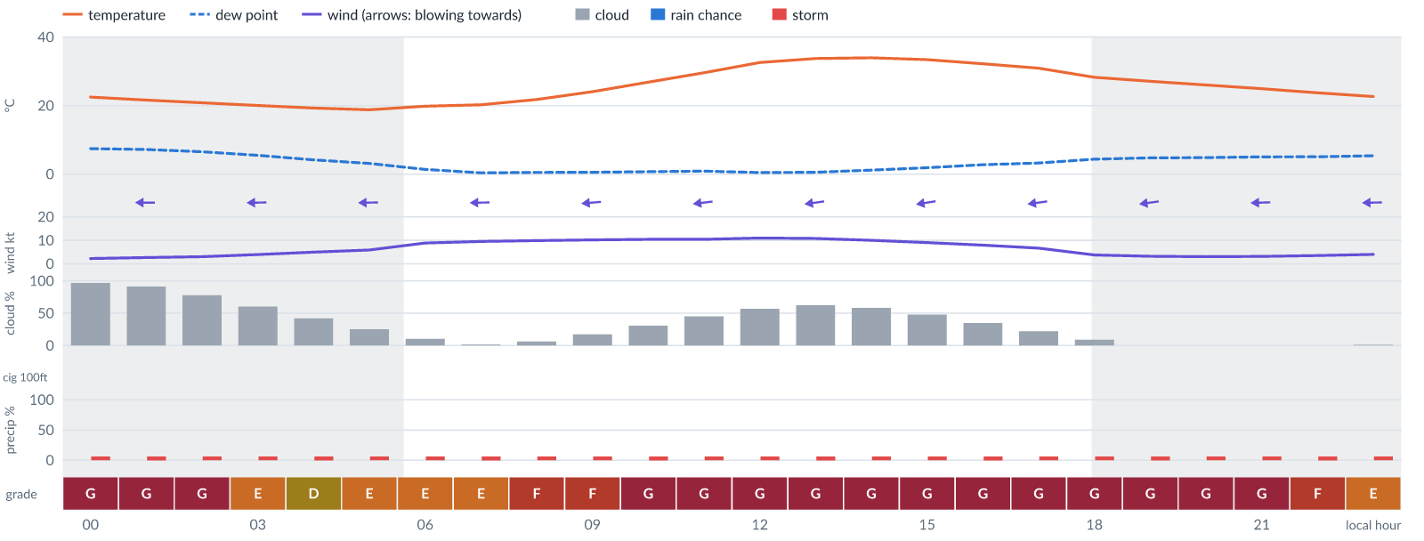
Meteogram — hourly forecast; shaded = before first light / after last light. Gaps mean no data.
Ser | Hrs | Temp | Cloud | Wind | Gust | QNH | Assessment | Driver | Remarks
(a) | (b) | (c) | (d) | (e) | (f) | (g) | (h) | (i) | (j)
1. | 0001 | 22°C | ☁ Overcast (97%) | ← 2 kts E | 11 kts | 1016 | G - Unacceptable | cloud 97% | cloud cover, wind shear, thunderstorm risk, gusts
2. | 0100 | 22°C | ☁ Overcast (91%) | ← 3 kts E | 9 kts | 1016 | G - Unacceptable | cloud 91% | cloud cover, thunderstorm risk, gusts, wind shear
3. | 0200 | 21°C | ◕ Cloudy (78%) | ← 3 kts E | 10 kts | 1016 | G - Unacceptable | cloud 78% | cloud cover, wind shear, thunderstorm risk, gusts
4. | 0300 | 20°C | ◑ Cloudy (60%) | ← 4 kts E | 10 kts | 1016 | E - Poor | cloud 60% | cloud cover, thunderstorm risk, gusts, wind shear
5. | 0400 | 19°C | ◑ Partly cloudy (42%) | ← 5 kts E | 11 kts | 1016 | D - Marginal | storm 6% · gust 11 kt | ⚠ thunderstorm risk, gusts, wind shear
6. | 0500 | 19°C | ◔ Mostly clear (25%) | ← 6 kts E | 12 kts | 1016 | E - Poor | gust 12 kt | gusts, thunderstorm risk, wind shear
7. | 0600 | 20°C | ☀ Clear (10%) | ← 9 kts E | 13 kts | 1017 | E - Poor | gust 13 kt | gusts, thunderstorm risk, strong wind
8. | 0700 | 20°C | ☀ Clear (1%) | ← 10 kts E | 14 kts | 1017 | E - Poor | gust 14 kt | gusts, thunderstorm risk, strong wind
9. | 0800 | 22°C | ☀ Clear (6%) | ← 10 kts E | 16 kts | 1017 | F - Very Poor | gust 16 kt | gusts, thunderstorm risk, strong wind, wind shear
10. | 0900 | 24°C | ◔ Mostly clear (17%) | ← 10 kts E | 17 kts | 1017 | F - Very Poor | gust 17 kt | gusts, wind shear, thunderstorm risk, strong wind
11. | 1000 | 27°C | ◔ Mostly clear (31%) | ← 10 kts E | 18 kts | 1017 | G - Unacceptable | gust 18 kt | gusts, wind shear, thunderstorm risk, strong wind
12. | 1100 | 30°C | ◑ Partly cloudy (45%) | ← 10 kts E | 20 kts | 1018 | G - Unacceptable | gust 20 kt · gust spread +9 kt | gusts, wind shear, cloud cover, thunderstorm risk, strong wind
13. | 1200 | 33°C | ◑ Partly cloudy (57%) | ← 11 kts E | 21 kts | 1017 | G - Unacceptable | gust 21 kt · gust spread +10 kt | gusts, wind shear, cloud cover, thunderstorm risk, strong wind
14. | 1300 | 34°C | ◕ Cloudy (63%) | ← 11 kts E | 22 kts | 1017 | G - Unacceptable | gust 22 kt · gust spread +11 kt | gusts, wind shear, cloud cover, thunderstorm risk, strong wind
15. | 1400 | 34°C | ◑ Partly cloudy (58%) | ← 10 kts E | 22 kts | 1017 | G - Unacceptable | gust 22 kt · gust spread +12 kt | gusts, wind shear, cloud cover, thunderstorm risk, strong wind
16. | 1500 | 33°C | ◑ Partly cloudy (48%) | ← 9 kts E | 22 kts | 1017 | G - Unacceptable | gust 22 kt · gust spread +13 kt | gusts, wind shear, cloud cover, thunderstorm risk, strong wind
17. | 1600 | 32°C | ◔ Partly cloudy (35%) | ← 8 kts E | 22 kts | 1016 | G - Unacceptable | gust 22 kt · gust spread +14 kt | gusts, wind shear, thunderstorm risk
18. | 1700 | 31°C | ◔ Mostly clear (22%) | ← 7 kts E | 21 kts | 1016 | G - Unacceptable | gust 21 kt · gust spread +14 kt | gusts, wind shear, thunderstorm risk
19. | 1800 | 28°C | ☀ Clear (9%) | ← 4 kts E | 20 kts | 1016 | G - Unacceptable | gust 20 kt · gust spread +16 kt | gusts, wind shear, thunderstorm risk
20. | 1900 | 27°C | ☀ Clear (0%) | ← 3 kts E | 19 kts | 1016 | G - Unacceptable | gust 19 kt · gust spread +16 kt | gusts, wind shear, thunderstorm risk
21. | 2000 | 26°C | ☀ Clear (0%) | ← 3 kts E | 18 kts | 1016 | G - Unacceptable | gust 18 kt · gust spread +15 kt | gusts, wind shear, thunderstorm risk
22. | 2100 | 25°C | ☀ Clear (0%) | ← 3 kts E | 16 kts | 1016 | G - Unacceptable | gust spread +12 kt | wind shear, gusts, thunderstorm risk
23. | 2200 | 24°C | ☀ Clear (0%) | ← 4 kts E | 13 kts | 1016 | F - Very Poor | gust spread +10 kt | wind shear, gusts, thunderstorm risk
24. | 2300 | 23°C | ☀ Clear (1%) | ← 4 kts E | 12 kts | 1016 | E - Poor | gust 12 kt · gust spread +8 kt | ⚠ gusts, wind shear, thunderstorm risk
Confidence: 66% — data for 24 of 24 hours; 20% of readings interpolated · first light 0607L · last light 1827L · Moon 15 % illuminated, rises 09:56, sets 21:29.

Sat 14 Nov 26
Conditions are expected to be generally Unacceptable: clear, winds up to 10 kts ENE, gusting 21 kts and temperatures 18–34°C. Flyable windows: 0001–0400L (Marginal, 5 h). Hazards: thunderstorm risk 0001–2300L. Overall similar to the previous day.
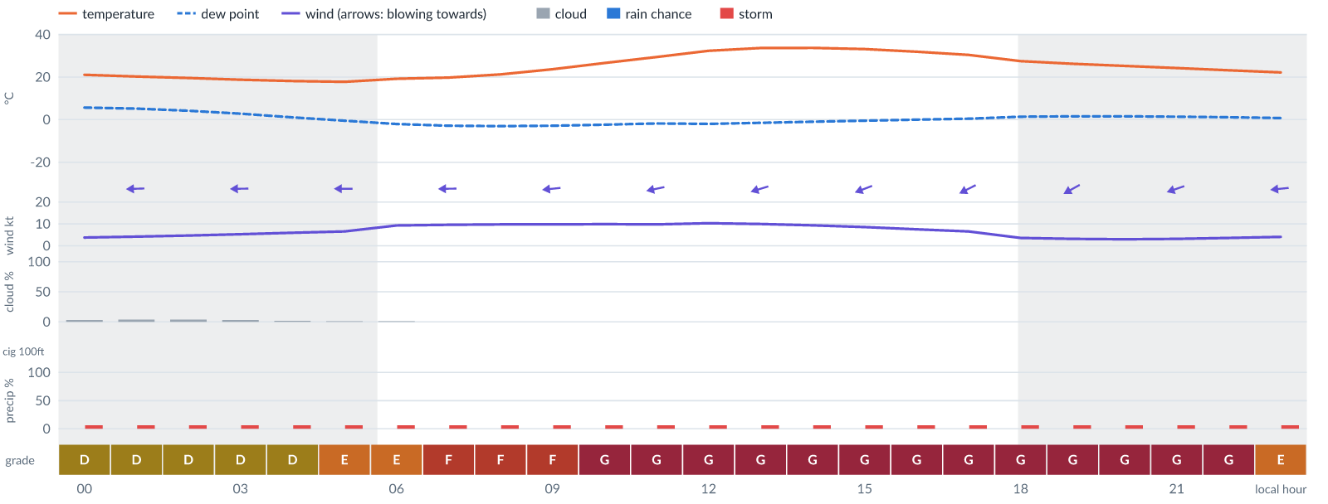
Meteogram — hourly forecast; shaded = before first light / after last light. Gaps mean no data.
Ser | Hrs | Temp | Cloud | Wind | Gust | QNH | Assessment | Driver | Remarks
(a) | (b) | (c) | (d) | (e) | (f) | (g) | (h) | (i) | (j)
1. | 0001 | 21°C | ☀ Clear (3%) | ← 4 kts E | 10 kts | 1015 | D - Marginal | storm 6% · gust 10 kt | ⚠ thunderstorm risk, gusts, wind shear
2. | 0100 | 20°C | ☀ Clear (4%) | ← 4 kts E | 9 kts | 1015 | D - Marginal | storm 6% · gust 9 kt | ⚠ thunderstorm risk, gusts, wind shear
3. | 0200 | 20°C | ☀ Clear (4%) | ← 5 kts E | 9 kts | 1015 | D - Marginal | storm 6% · gust 9 kt | ⚠ thunderstorm risk, gusts
4. | 0300 | 19°C | ☀ Clear (3%) | ← 5 kts E | 10 kts | 1016 | D - Marginal | storm 6% · gust 10 kt | ⚠ thunderstorm risk, gusts, wind shear
5. | 0400 | 18°C | ☀ Clear (2%) | ← 6 kts E | 11 kts | 1016 | D - Marginal | storm 6% · gust 11 kt | ⚠ thunderstorm risk, gusts, wind shear
6. | 0500 | 18°C | ☀ Clear (1%) | ← 7 kts E | 12 kts | 1016 | E - Poor | gust 12 kt | ⚠ gusts, thunderstorm risk, wind shear
7. | 0600 | 19°C | ☀ Clear (1%) | ← 9 kts E | 13 kts | 1016 | E - Poor | gust 13 kt | ⚠ gusts, thunderstorm risk, strong wind
8. | 0700 | 20°C | ☀ Clear (0%) | ← 10 kts E | 15 kts | 1016 | F - Very Poor | gust 15 kt | ⚠ gusts, thunderstorm risk, strong wind, wind shear
9. | 0800 | 21°C | ☀ Clear (0%) | ← 10 kts E | 16 kts | 1016 | F - Very Poor | gust 16 kt | ⚠ gusts, thunderstorm risk, strong wind, wind shear
10. | 0900 | 24°C | ☀ Clear (0%) | ← 10 kts E | 17 kts | 1016 | F - Very Poor | gust 17 kt | ⚠ gusts, wind shear, thunderstorm risk, strong wind
11. | 1000 | 27°C | ☀ Clear (0%) | ← 10 kts E | 18 kts | 1017 | G - Unacceptable | gust 18 kt | ⚠ gusts, wind shear, thunderstorm risk, strong wind
12. | 1100 | 29°C | ☀ Clear (0%) | ← 10 kts ENE | 19 kts | 1017 | G - Unacceptable | gust 19 kt | ⚠ gusts, wind shear, thunderstorm risk, strong wind
13. | 1200 | 32°C | ☀ Clear (0%) | ← 10 kts ENE | 20 kts | 1016 | G - Unacceptable | gust 20 kt · gust spread +10 kt | ⚠ gusts, wind shear, thunderstorm risk, strong wind
14. | 1300 | 34°C | ☀ Clear (0%) | ← 10 kts ENE | 21 kts | 1016 | G - Unacceptable | gust 21 kt · gust spread +11 kt | ⚠ gusts, wind shear, thunderstorm risk, strong wind
15. | 1400 | 34°C | ☀ Clear (0%) | ← 9 kts ENE | 21 kts | 1016 | G - Unacceptable | gust 21 kt · gust spread +12 kt | ⚠ gusts, wind shear, thunderstorm risk, strong wind
16. | 1500 | 33°C | ☀ Clear (0%) | ← 9 kts ENE | 21 kts | 1016 | G - Unacceptable | gust 21 kt · gust spread +12 kt | ⚠ gusts, wind shear, thunderstorm risk, strong wind
17. | 1600 | 32°C | ☀ Clear (0%) | ↙ 8 kts ENE | 21 kts | 1015 | G - Unacceptable | gust 21 kt · gust spread +13 kt | ⚠ gusts, wind shear, thunderstorm risk
18. | 1700 | 30°C | ☀ Clear (0%) | ↙ 7 kts ENE | 20 kts | 1015 | G - Unacceptable | gust 20 kt · gust spread +14 kt | ⚠ gusts, wind shear, thunderstorm risk
19. | 1800 | 27°C | ☀ Clear (0%) | ↙ 4 kts ENE | 19 kts | 1015 | G - Unacceptable | gust 19 kt · gust spread +16 kt | ⚠ gusts, wind shear, thunderstorm risk
20. | 1900 | 26°C | ☀ Clear (0%) | ↙ 3 kts ENE | 19 kts | 1015 | G - Unacceptable | gust 19 kt · gust spread +15 kt | ⚠ gusts, wind shear, thunderstorm risk
21. | 2000 | 25°C | ☀ Clear (0%) | ↙ 3 kts ENE | 17 kts | 1014 | G - Unacceptable | gust spread +14 kt | ⚠ wind shear, gusts, thunderstorm risk
22. | 2100 | 24°C | ☀ Clear (0%) | ← 3 kts ENE | 16 kts | 1014 | G - Unacceptable | gust spread +12 kt | ⚠ wind shear, gusts, thunderstorm risk
23. | 2200 | 23°C | ☀ Clear (0%) | ← 4 kts E | 14 kts | 1014 | G - Unacceptable | gust spread +10 kt | ⚠ wind shear, gusts, thunderstorm risk
24. | 2300 | 22°C | ☀ Clear (0%) | ← 4 kts E | 12 kts | 1014 | E - Poor | gust 12 kt · gust spread +8 kt | ⚠ gusts, wind shear, thunderstorm risk
Confidence: 54% — data for 24 of 24 hours · first light 0608L · last light 1827L · Moon 23 % illuminated, rises 10:44, sets 22:20.

Sun 15 Nov 26
Conditions are expected to be generally Unacceptable: mostly clear, winds up to 10 kts ENE, gusting 22 kts and temperatures 17–34°C. Flyable windows: 0001–0500L (Marginal, 6 h). Hazards: thunderstorm risk 0001–2300L. Overall similar to the previous day.
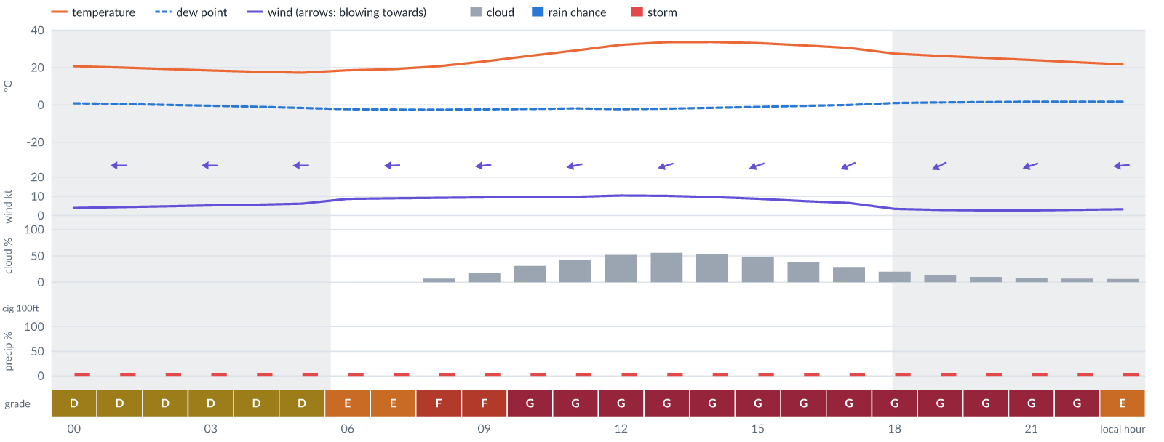
Meteogram — hourly forecast; shaded = before first light / after last light. Gaps mean no data.
Ser | Hrs | Temp | Cloud | Wind | Gust | QNH | Assessment | Driver | Remarks
(a) | (b) | (c) | (d) | (e) | (f) | (g) | (h) | (i) | (j)
1. | 0001 | 21°C | ☀ Clear (0%) | ← 4 kts E | 10 kts | 1014 | D - Marginal | storm 6% · gust 10 kt | ⚠ thunderstorm risk, gusts, wind shear
2. | 0100 | 20°C | ☀ Clear (0%) | ← 4 kts E | 10 kts | 1013 | D - Marginal | storm 6% · gust 10 kt | ⚠ thunderstorm risk, gusts, wind shear
3. | 0200 | 19°C | ☀ Clear (0%) | ← 5 kts E | 9 kts | 1014 | D - Marginal | storm 6% · gust 9 kt | ⚠ thunderstorm risk, gusts
4. | 0300 | 18°C | ☀ Clear (0%) | ← 5 kts E | 10 kts | 1014 | D - Marginal | storm 6% · gust 10 kt | ⚠ thunderstorm risk, gusts, wind shear
5. | 0400 | 18°C | ☀ Clear (0%) | ← 6 kts E | 10 kts | 1014 | D - Marginal | storm 6% · gust 10 kt | ⚠ thunderstorm risk, gusts
6. | 0500 | 17°C | ☀ Clear (0%) | ← 6 kts E | 11 kts | 1014 | D - Marginal | storm 6% · gust 11 kt | ⚠ thunderstorm risk, gusts, wind shear
7. | 0600 | 19°C | ☀ Clear (0%) | ← 9 kts E | 12 kts | 1014 | E - Poor | gust 12 kt | ⚠ gusts, thunderstorm risk, strong wind
8. | 0700 | 19°C | ☀ Clear (0%) | ← 9 kts E | 13 kts | 1015 | E - Poor | gust 13 kt | ⚠ gusts, thunderstorm risk, strong wind
9. | 0800 | 21°C | ☀ Clear (7%) | ← 9 kts E | 15 kts | 1015 | F - Very Poor | gust 15 kt | ⚠ gusts, thunderstorm risk, strong wind, wind shear
10. | 0900 | 23°C | ◔ Mostly clear (18%) | ← 10 kts E | 16 kts | 1015 | F - Very Poor | gust 16 kt | ⚠ gusts, thunderstorm risk, strong wind, wind shear
11. | 1000 | 26°C | ◔ Mostly clear (31%) | ← 10 kts E | 18 kts | 1015 | G - Unacceptable | gust 18 kt | ⚠ gusts, wind shear, thunderstorm risk, strong wind
12. | 1100 | 29°C | ◑ Partly cloudy (43%) | ← 10 kts ENE | 19 kts | 1015 | G - Unacceptable | gust 19 kt | ⚠ gusts, wind shear, cloud cover, thunderstorm risk, strong wind
13. | 1200 | 32°C | ◑ Partly cloudy (52%) | ← 10 kts ENE | 21 kts | 1014 | G - Unacceptable | gust 21 kt · gust spread +10 kt | ⚠ gusts, wind shear, cloud cover, thunderstorm risk, strong wind
14. | 1300 | 34°C | ◑ Partly cloudy (56%) | ← 10 kts ENE | 22 kts | 1014 | G - Unacceptable | gust 22 kt · gust spread +11 kt | ⚠ gusts, wind shear, cloud cover, thunderstorm risk, strong wind
15. | 1400 | 34°C | ◑ Partly cloudy (54%) | ← 10 kts ENE | 22 kts | 1014 | G - Unacceptable | gust 22 kt · gust spread +12 kt | ⚠ gusts, wind shear, cloud cover, thunderstorm risk, strong wind
16. | 1500 | 33°C | ◑ Partly cloudy (48%) | ← 9 kts ENE | 22 kts | 1014 | G - Unacceptable | gust 22 kt · gust spread +13 kt | ⚠ gusts, wind shear, cloud cover, thunderstorm risk, strong wind
17. | 1600 | 32°C | ◑ Partly cloudy (39%) | ← 8 kts ENE | 21 kts | 1013 | G - Unacceptable | gust 21 kt · gust spread +14 kt | ⚠ gusts, wind shear, thunderstorm risk
18. | 1700 | 31°C | ◔ Mostly clear (29%) | ↙ 7 kts ENE | 21 kts | 1013 | G - Unacceptable | gust 21 kt · gust spread +14 kt | ⚠ gusts, wind shear, thunderstorm risk
19. | 1800 | 27°C | ◔ Mostly clear (20%) | ↙ 4 kts ENE | 20 kts | 1013 | G - Unacceptable | gust 20 kt · gust spread +16 kt | ⚠ gusts, wind shear, thunderstorm risk
20. | 1900 | 26°C | ◔ Mostly clear (14%) | ↙ 3 kts ENE | 19 kts | 1013 | G - Unacceptable | gust 19 kt · gust spread +16 kt | ⚠ gusts, wind shear, thunderstorm risk
21. | 2000 | 25°C | ☀ Clear (10%) | ↙ 3 kts ENE | 18 kts | 1013 | G - Unacceptable | gust 18 kt · gust spread +15 kt | ⚠ gusts, wind shear, thunderstorm risk
22. | 2100 | 24°C | ☀ Clear (8%) | ← 3 kts ENE | 16 kts | 1013 | G - Unacceptable | gust spread +13 kt | ⚠ wind shear, gusts, thunderstorm risk
23. | 2200 | 23°C | ☀ Clear (7%) | ← 3 kts ENE | 13 kts | 1013 | G - Unacceptable | gust spread +10 kt | ⚠ wind shear, gusts, thunderstorm risk
24. | 2300 | 22°C | ☀ Clear (6%) | ← 3 kts E | 11 kts | 1013 | E - Poor | gust spread +8 kt | ⚠ wind shear, thunderstorm risk, gusts
Confidence: 54% — data for 24 of 24 hours · first light 0608L · last light 1827L · Moon 31 % illuminated, rises 11:28, sets 23:11.

Mon 16 Nov 26
Conditions are expected to be generally Unacceptable: mostly clear, winds up to 9 kts ENE, gusting 20 kts and temperatures 16–35°C. Flyable windows: 0100–0600L (Marginal, 6 h). Hazards: thunderstorm risk 0001–2300L. Overall similar to the previous day.
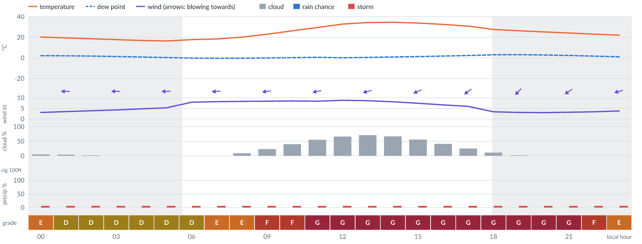
Meteogram — hourly forecast; shaded = before first light / after last light. Gaps mean no data.
Ser | Hrs | Temp | Cloud | Wind | Gust | QNH | Assessment | Driver | Remarks
(a) | (b) | (c) | (d) | (e) | (f) | (g) | (h) | (i) | (j)
1. | 0001 | 20°C | ☀ Clear (5%) | ← 3 kts E | 10 kts | 1013 | E - Poor | gust spread +6 kt | ⚠ wind shear, thunderstorm risk, gusts
2. | 0100 | 19°C | ☀ Clear (4%) | ← 3 kts E | 9 kts | 1013 | D - Marginal | storm 6% · gust 9 kt | ⚠ thunderstorm risk, gusts, wind shear
3. | 0200 | 19°C | ☀ Clear (2%) | ← 4 kts E | 8 kts | 1013 | D - Marginal | storm 6% | ⚠ thunderstorm risk
4. | 0300 | 18°C | ☀ Clear (0%) | ← 4 kts E | 9 kts | 1013 | D - Marginal | storm 6% · gust 9 kt | ⚠ thunderstorm risk, gusts, wind shear
5. | 0400 | 17°C | ☀ Clear (0%) | ← 5 kts E | 9 kts | 1013 | D - Marginal | storm 6% · gust 9 kt | ⚠ thunderstorm risk, gusts
6. | 0500 | 16°C | ☀ Clear (0%) | ← 5 kts E | 10 kts | 1013 | D - Marginal | storm 6% · gust 10 kt | ⚠ thunderstorm risk, gusts, wind shear
7. | 0600 | 18°C | ☀ Clear (0%) | ← 8 kts E | 11 kts | 1014 | D - Marginal | storm 6% · gust 11 kt | ⚠ thunderstorm risk, gusts
8. | 0700 | 18°C | ☀ Clear (0%) | ← 8 kts E | 12 kts | 1014 | E - Poor | gust 12 kt | ⚠ gusts, thunderstorm risk
9. | 0800 | 20°C | ☀ Clear (9%) | ← 8 kts E | 13 kts | 1014 | E - Poor | gust 13 kt | ⚠ gusts, thunderstorm risk, wind shear
10. | 0900 | 23°C | ◔ Mostly clear (23%) | ← 8 kts E | 15 kts | 1014 | F - Very Poor | gust 15 kt | ⚠ gusts, wind shear, thunderstorm risk
11. | 1000 | 26°C | ◑ Partly cloudy (40%) | ← 9 kts E | 16 kts | 1014 | F - Very Poor | gust 16 kt | ⚠ gusts, wind shear, thunderstorm risk, strong wind
12. | 1100 | 29°C | ◑ Partly cloudy (55%) | ← 8 kts E | 18 kts | 1014 | G - Unacceptable | gust 18 kt · gust spread +9 kt | ⚠ gusts, wind shear, cloud cover, thunderstorm risk
13. | 1200 | 33°C | ◕ Cloudy (66%) | ← 9 kts ENE | 19 kts | 1014 | G - Unacceptable | gust 19 kt · gust spread +10 kt | ⚠ gusts, wind shear, cloud cover, thunderstorm risk, strong wind
14. | 1300 | 34°C | ◕ Cloudy (71%) | ← 9 kts ENE | 20 kts | 1014 | G - Unacceptable | cloud 71% · gust 20 kt | ⚠ cloud cover, gusts, wind shear, thunderstorm risk, strong wind
15. | 1400 | 35°C | ◕ Cloudy (67%) | ← 8 kts ENE | 20 kts | 1014 | G - Unacceptable | gust 20 kt · gust spread +12 kt | ⚠ gusts, wind shear, cloud cover, thunderstorm risk
16. | 1500 | 34°C | ◑ Partly cloudy (56%) | ↙ 7 kts ENE | 19 kts | 1013 | G - Unacceptable | gust 19 kt · gust spread +12 kt | ⚠ gusts, wind shear, cloud cover, thunderstorm risk
17. | 1600 | 33°C | ◑ Partly cloudy (41%) | ↙ 7 kts ENE | 19 kts | 1013 | G - Unacceptable | gust 19 kt · gust spread +12 kt | ⚠ gusts, wind shear, thunderstorm risk
18. | 1700 | 31°C | ◔ Mostly clear (25%) | ↙ 6 kts NE | 18 kts | 1013 | G - Unacceptable | gust 18 kt · gust spread +12 kt | ⚠ gusts, wind shear, thunderstorm risk
19. | 1800 | 28°C | ☀ Clear (11%) | ↙ 3 kts NE | 17 kts | 1013 | G - Unacceptable | gust spread +14 kt | ⚠ wind shear, gusts, thunderstorm risk
20. | 1900 | 26°C | ☀ Clear (2%) | ↙ 3 kts NE | 16 kts | 1013 | G - Unacceptable | gust spread +13 kt | ⚠ wind shear, gusts, thunderstorm risk
21. | 2000 | 25°C | ☀ Clear (0%) | ↙ 3 kts NE | 15 kts | 1012 | G - Unacceptable | gust spread +12 kt | ⚠ wind shear, gusts, thunderstorm risk
22. | 2100 | 24°C | ☀ Clear (0%) | ↙ 3 kts NE | 14 kts | 1013 | G - Unacceptable | gust spread +11 kt | ⚠ wind shear, gusts, thunderstorm risk
23. | 2200 | 23°C | ☀ Clear (0%) | ↙ 3 kts ENE | 12 kts | 1013 | F - Very Poor | gust spread +9 kt | ⚠ wind shear, gusts, thunderstorm risk
24. | 2300 | 22°C | ☀ Clear (0%) | ← 4 kts ENE | 11 kts | 1013 | E - Poor | gust spread +7 kt | ⚠ wind shear, thunderstorm risk, gusts
Confidence: 54% — data for 24 of 24 hours · first light 0608L · last light 1827L · Moon 40 % illuminated, rises 12:09.

Tue 17 Nov 26
Conditions are expected to be generally Unacceptable: partly cloudy, winds up to 9 kts ENE, gusting 20 kts and temperatures 16–35°C. Flyable windows: 0001–0600L (Marginal, 7 h). Hazards: thunderstorm risk 0001–2300L. Overall similar to the previous day.
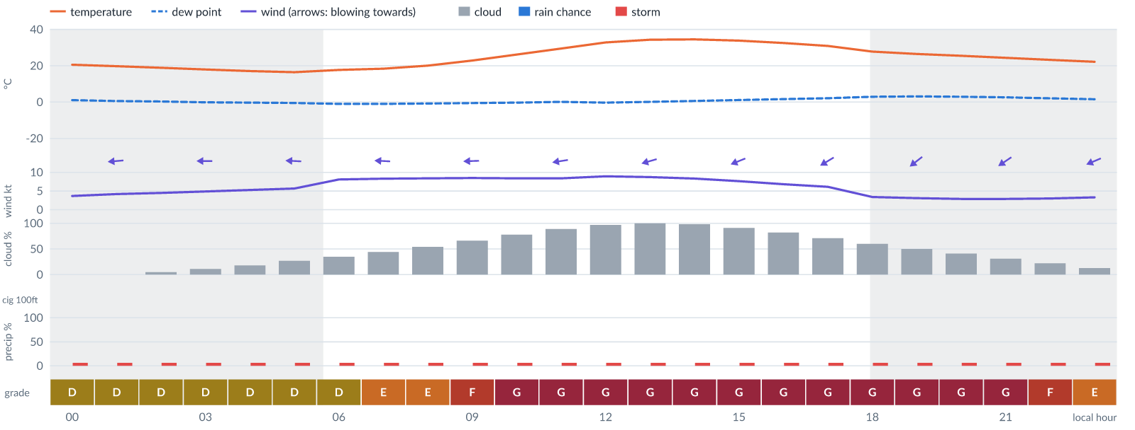
Meteogram — hourly forecast; shaded = before first light / after last light. Gaps mean no data.
Ser | Hrs | Temp | Cloud | Wind | Gust | QNH | Assessment | Driver | Remarks
(a) | (b) | (c) | (d) | (e) | (f) | (g) | (h) | (i) | (j)
1. | 0001 | 21°C | ☀ Clear (0%) | ← 4 kts E | 10 kts | 1012 | D - Marginal | storm 6% · gust 10 kt | ⚠ thunderstorm risk, gusts, wind shear
2. | 0100 | 20°C | ☀ Clear (0%) | ← 4 kts E | 9 kts | 1013 | D - Marginal | storm 6% · gust 9 kt | ⚠ thunderstorm risk, gusts, wind shear
3. | 0200 | 19°C | ☀ Clear (5%) | ← 4 kts E | 9 kts | 1013 | D - Marginal | storm 6% · gust 9 kt | ⚠ thunderstorm risk, gusts, wind shear
4. | 0300 | 18°C | ☀ Clear (11%) | ← 5 kts E | 9 kts | 1013 | D - Marginal | storm 6% · gust 9 kt | ⚠ thunderstorm risk, gusts
5. | 0400 | 17°C | ◔ Mostly clear (18%) | ← 5 kts E | 10 kts | 1013 | D - Marginal | storm 6% · gust 10 kt | ⚠ thunderstorm risk, gusts, wind shear
6. | 0500 | 16°C | ◔ Mostly clear (27%) | ← 6 kts E | 11 kts | 1013 | D - Marginal | storm 6% · gust 11 kt | ⚠ thunderstorm risk, gusts, wind shear
7. | 0600 | 18°C | ◔ Partly cloudy (35%) | ← 8 kts E | 11 kts | 1013 | D - Marginal | storm 6% · gust 11 kt | ⚠ thunderstorm risk, gusts
8. | 0700 | 18°C | ◑ Partly cloudy (44%) | ← 8 kts E | 12 kts | 1014 | E - Poor | gust 12 kt | ⚠ gusts, cloud cover, thunderstorm risk
9. | 0800 | 20°C | ◑ Partly cloudy (54%) | ← 8 kts E | 13 kts | 1014 | E - Poor | cloud 54% · gust 13 kt | ⚠ cloud cover, gusts, thunderstorm risk, wind shear
10. | 0900 | 23°C | ◕ Cloudy (66%) | ← 9 kts E | 15 kts | 1014 | F - Very Poor | cloud 66% · gust 15 kt | ⚠ cloud cover, gusts, thunderstorm risk, strong wind, wind shear
11. | 1000 | 26°C | ◕ Cloudy (78%) | ← 8 kts E | 16 kts | 1014 | G - Unacceptable | cloud 78% | ⚠ cloud cover, gusts, wind shear, thunderstorm risk
12. | 1100 | 29°C | ☁ Cloudy (89%) | ← 8 kts E | 18 kts | 1014 | G - Unacceptable | cloud 89% · gust 18 kt | ⚠ cloud cover, gusts, wind shear, thunderstorm risk
13. | 1200 | 33°C | ☁ Overcast (97%) | ← 9 kts ENE | 19 kts | 1014 | G - Unacceptable | cloud 97% · gust 19 kt | ⚠ cloud cover, gusts, wind shear, thunderstorm risk, strong wind
14. | 1300 | 34°C | ☁ Overcast (100%) | ← 9 kts ENE | 20 kts | 1014 | G - Unacceptable | cloud 100% · gust 20 kt | ⚠ cloud cover, gusts, wind shear, thunderstorm risk, strong wind
15. | 1400 | 35°C | ☁ Overcast (98%) | ← 8 kts ENE | 20 kts | 1014 | G - Unacceptable | cloud 98% · gust 20 kt | ⚠ cloud cover, gusts, wind shear, thunderstorm risk
16. | 1500 | 34°C | ☁ Overcast (91%) | ← 8 kts ENE | 19 kts | 1013 | G - Unacceptable | cloud 91% · gust 19 kt | ⚠ cloud cover, gusts, wind shear, thunderstorm risk
17. | 1600 | 33°C | ◕ Cloudy (82%) | ↙ 7 kts ENE | 19 kts | 1013 | G - Unacceptable | cloud 82% · gust 19 kt | ⚠ cloud cover, gusts, wind shear, thunderstorm risk
18. | 1700 | 31°C | ◕ Cloudy (71%) | ↙ 6 kts ENE | 18 kts | 1013 | G - Unacceptable | cloud 71% · gust 18 kt | ⚠ cloud cover, gusts, wind shear, thunderstorm risk
19. | 1800 | 28°C | ◑ Cloudy (60%) | ↙ 3 kts NE | 17 kts | 1013 | G - Unacceptable | gust spread +14 kt | ⚠ wind shear, gusts, cloud cover, thunderstorm risk
20. | 1900 | 26°C | ◑ Partly cloudy (50%) | ↙ 3 kts NE | 16 kts | 1013 | G - Unacceptable | gust spread +13 kt | ⚠ wind shear, gusts, cloud cover, thunderstorm risk
21. | 2000 | 25°C | ◑ Partly cloudy (41%) | ↙ 3 kts NE | 15 kts | 1013 | G - Unacceptable | gust spread +12 kt | ⚠ wind shear, gusts, thunderstorm risk
22. | 2100 | 24°C | ◔ Mostly clear (31%) | ↙ 3 kts NE | 14 kts | 1013 | G - Unacceptable | gust spread +11 kt | ⚠ wind shear, gusts, thunderstorm risk
23. | 2200 | 23°C | ◔ Mostly clear (22%) | ↙ 3 kts ENE | 12 kts | 1013 | F - Very Poor | gust spread +9 kt | ⚠ wind shear, gusts, thunderstorm risk
24. | 2300 | 22°C | ◔ Mostly clear (13%) | ↙ 3 kts ENE | 11 kts | 1013 | E - Poor | gust spread +7 kt | ⚠ wind shear, thunderstorm risk, gusts
Confidence: 54% — data for 24 of 24 hours · first light 0609L · last light 1827L · Moon 50 % illuminated, rises 12:48, sets 00:00.

TAF
No TAF available for this location.

Imagery

Dust RGB (pink/magenta = airborne dust) — captured 4 Nov 02:00 WAT (3 min ago) · ©EUMETSAT (screenshot via EUMETView)

Convection RGB (yellow = vigorous storms) — captured 4 Nov 02:00 WAT (3 min ago) · ©EUMETSAT (screenshot via EUMETView)
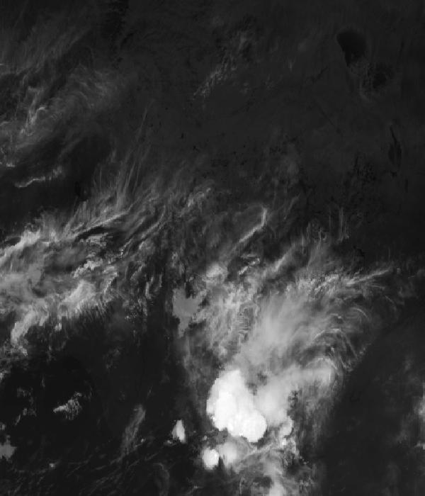
Infrared 10.5 µm (cold tops = deep cloud) — captured 4 Nov 02:00 WAT (3 min ago) · ©EUMETSAT (screenshot via EUMETView)

Accumulated lightning flash area (MTG-LI) — captured 4 Nov 02:00 WAT (3 min ago) · ©EUMETSAT (screenshot via EUMETView)

Source panel
Source | Accuracy | Skill n | Temp °C | Wind kt | Visibility | Storm
(a) | (b) | (c) | (d) | (e) | (f) | (g)
ECMWF AIFS | ▲ 1.3 | 605 | 21–22 | 5 | — | 0 %
ECMWF | ▲ 1.2 | 4080 | 21–22 | 5–6 | — | 0 %
Canada GEM | ▲ 1.2 | 3598 | 20–22 | 4–5 | — | 0 %
DWD ICON | ▲ 1.2 | 5948 | 18–21 | 2 | — | 0 %
JMA GSM | ≈ 0.9 | 3599 | 23–27 | 2–4 | — | 0 %
Météo-France | ≈ 1.0 | 4801 | 24–25 | 4–7 | — | 0 %
Open-Meteo | ≈ 1.0 | 6931 | 22–23 | 5–6 | 10+ km | 0 %
wttr.in | ▽ 0.9 | 686 | 23–26 | 6–8 | 4–8.3 km | 0 %
Each source's own raw values, min–max over the next 6 hours from the issue hour (before any weighting or bias correction). — means the source does not publish that metric in the window. Wide gaps between rows are real disagreement; the forecast above weights sources by measured skill.

Reading this report
Grades: each hour carries one grade, set by its WORST factor. The bands below are the thresholds in force for this report (Settings); a value in a band earns that grade, and "-" means the factor never produces that grade. Cloud is graded on the worse of cover and ceiling. The Driver column names the limiting factor with its value; open it in the web report for the boundary and sources.
Grade | Cloud cover | Cloud ceiling | Visibility | Wind | Gust | Rain chance | Thunderstorm probability
(a) | (b) | (c) | (d) | (e) | (f) | (g) | (h)
A Excellent | ≤ 17.1% | ≥ 30000 ft | ≥ 8000 m | < 3 kt | < 3 kt | < 5% | 0%
B Good | 17.1–34.3% | 26000–30000 ft | 6666.7–8000 m | 3–6 kt | 3–6 kt | 5–10% | -
C Fair | 34.3–42.9% | 24000–26000 ft | 5333.3–6666.7 m | 6–9 kt | 6–9 kt | 10–15% | -
D Marginal | 42.9–51.4% | 22000–24000 ft | 4000–5333.3 m | 9–12 kt | 9–12 kt | 15–20% | >0–15%
E Poor | 51.4–60% | 16000–22000 ft | 2666.7–4000 m | 12–15 kt | 12–15 kt | 20–25% | 15–30%
F Very Poor | 60–68.6% | 10000–16000 ft | 1333.3–2666.7 m | 15–18 kt | 15–18 kt | 25–30% | 30–60%
G Unacceptable | > 68.6% | < 10000 ft | < 1333.3 m | ≥ 18 kt | ≥ 18 kt | ≥ 30% | > 60%
Flight windows: a window is at least 2 consecutive hours graded Marginal or better; an hour with insufficient data never counts toward one. ☾ marks a window outside first-to-last light.
Time: hours are local time (WAT, UTC+1) unless suffixed Z, which is UTC (TAF, METAR and issue times). Local midnight is labelled 0001.
Units: temperature °C · wind and gusts knots · visibility metres (km in text) · cloud ceiling feet · cloud cover % · rain chance and thunderstorm probability % · QNH hPa (altimeter setting at the field) · CAPE J/kg. A figure like "28 (26–30)°C" gives the p10–p90 range; "spread" marks disagreement between sources.
Symbols: ▲ better than the pool · ▽ worse (only when the 95% interval excludes the pool) · ≈ not distinguishable from the pool · unmarked = unproven (accuracy is measured against METAR and SYNOP observations). ⚠ on a remark means a low-confidence hour; a ⚠ paragraph on the first page is a convective-warning or data-age advisory. ⚡ is lightning observed by satellite near the field (©EUMETSAT).
Hourly glyphs: the wind arrow points the way the air moves (a north wind is ↓, an east wind ←); cloud cover shows as ☀ ◔ ◑ ◕ ☁ (clear, few, scattered, broken, overcast); a shaded hour label is wholly before first light or after last light.
Terms: "No data" - no source forecast the hour, or a core group (cloud, visibility, wind) is missing and the hour could still be flyable; missing data is never given a good grade. "Low-confidence" - few or weak sources behind the load-bearing metrics; treat the grade as indicative. "Insufficient data" - too little to grade at all. "Estimated" (est.) - the value is derived, not reported by a source (dust visibility, cloud base, gusts); it is declared where used and weighted at half. "Derived" - an hour interpolated from a coarser (3-hourly or daily) source, weighted at half and never used to score accuracy.

Data provenance
Source | Fetched (Z) | Age | Skill n | Accuracy
(a) | (b) | (c) | (d) | (e)
ECMWF AIFS | 4 Nov 01:01Z | 2 min | 605 | ▲ 1.3
ECMWF | 4 Nov 01:01Z | 2 min | 4080 | ▲ 1.2
Canada GEM | 4 Nov 01:02Z | 1 min | 3598 | ▲ 1.2
DWD ICON | 4 Nov 01:01Z | 2 min | 5948 | ▲ 1.2
JMA GSM | 4 Nov 01:02Z | 1 min | 3599 | ≈ 0.9
Météo-France | 4 Nov 01:01Z | 2 min | 4801 | ≈ 1.0
Open-Meteo | 4 Nov 01:01Z | 2 min | 6931 | ≈ 1.0
wttr.in | 4 Nov 01:02Z | 1 min | 686 | ▽ 0.9
Corrections applied (detailed under Learned corrections on the first page): skill weighting, bias correction, hour-of-day bias, cloud-base estimate, probability calibration, fog risk, climatology bounds, skill blend.

How accurate have we been
Measured against observations (METAR/SYNOP), sahel region. Verification table computed 2026-11-04. Mean absolute error (MAE): lower is better; "beats persistence" compares the best source with "it will stay as it is now" on the same hours.
Metric | Best source | Best MAE | Typical MAE | Persistence MAE | Beats persistence by | Pairs
(a) | (b) | (c) | (d) | (e) | (f) | (g)
Temperature (°C) | meteoblue | 1.2 | 2.0 | 5.2 | 83 % | 3540
Dew point (°C) | accuweather | 2.1 | 4.7 | 2.4 | -21 % | 46
Wind speed (kt) | aifs | 1.9 | 2.7 | 2.6 | 25 % | 584
Visibility (m) | aviationweather | 1428 | 2422 | 1365 | 6 % | 1114
Cloud cover (%) | accuweather | 10 | 35 | 8 | - | 27
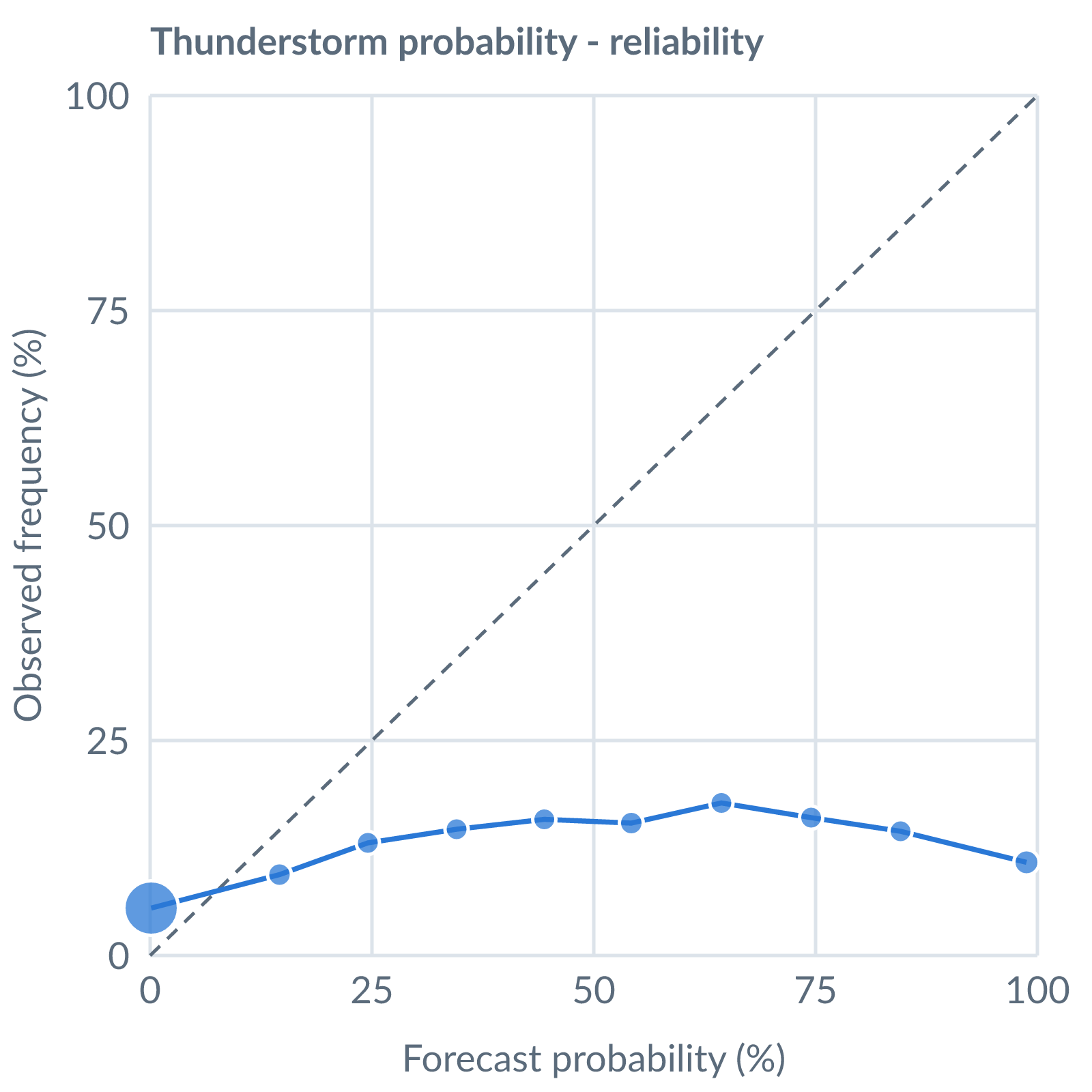
Thunderstorm probability: dots on the dashed line mean a stated probability matched how often it happened (124566 pairs, all places pooled).
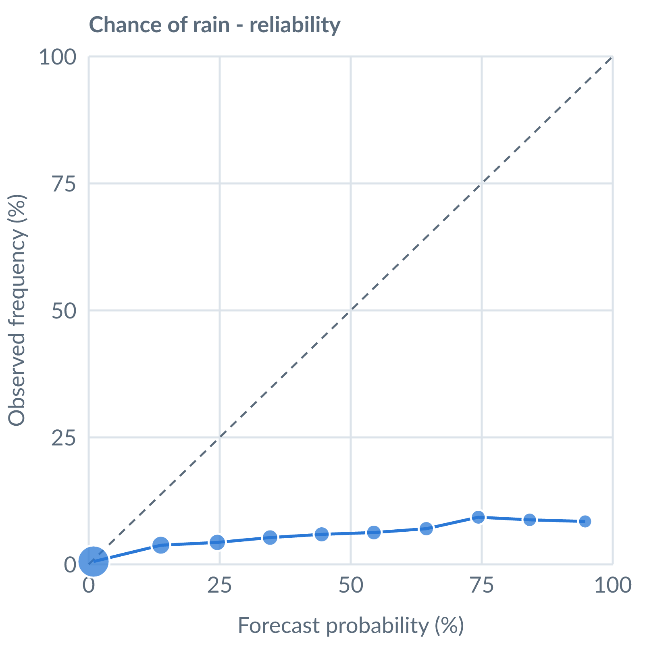
Chance of rain: dots on the dashed line mean a stated probability matched how often it happened (115455 pairs, all places pooled).
Learned bias (forecast minus observed; positive = sources run high), mean over scored sources, by local time of day. These are corrected for before sources are averaged.
Metric | Overall | Night | Morning | Afternoon | Evening | Pairs
(a) | (b) | (c) | (d) | (e) | (f) | (g)
Temperature (°C) | +0.1 | +0.9 | -0.2 | -0.6 | +0.2 | 73758
Dew point (°C) | -3.5 | -5.0 | -3.1 | -2.5 | -3.6 | 66140
Wind speed (kt) | +0.6 | +1.6 | +0.2 | -0.3 | +1.1 | 64561
Pressure (QNH) (hPa) | +0.5 | +0.4 | +0.5 | +0.8 | +0.3 | 30468
Not yet available: Scores are decayed over the verification window (half-life 14 days); separate last-7-day and last-30-day windows are not stored. Bias is the current learned value; the history needed for a trend over time is not stored. Flight-window hit / bust / miss is not yet recorded.

